**Client-Side Scripting Assignment 4**

Animations and Multimedia Page

Create a page that presents a Person/Product or Business in a unique way using animations and multimedia.

Save all files into a folder inside your web folder called FirstNameLastIntitial_Assignment2 (Ex. DylanH_Assignment4)

ZIP the folder contents and then submit the zipped folder to D2L when completed.

All images and text must be school appropriate.

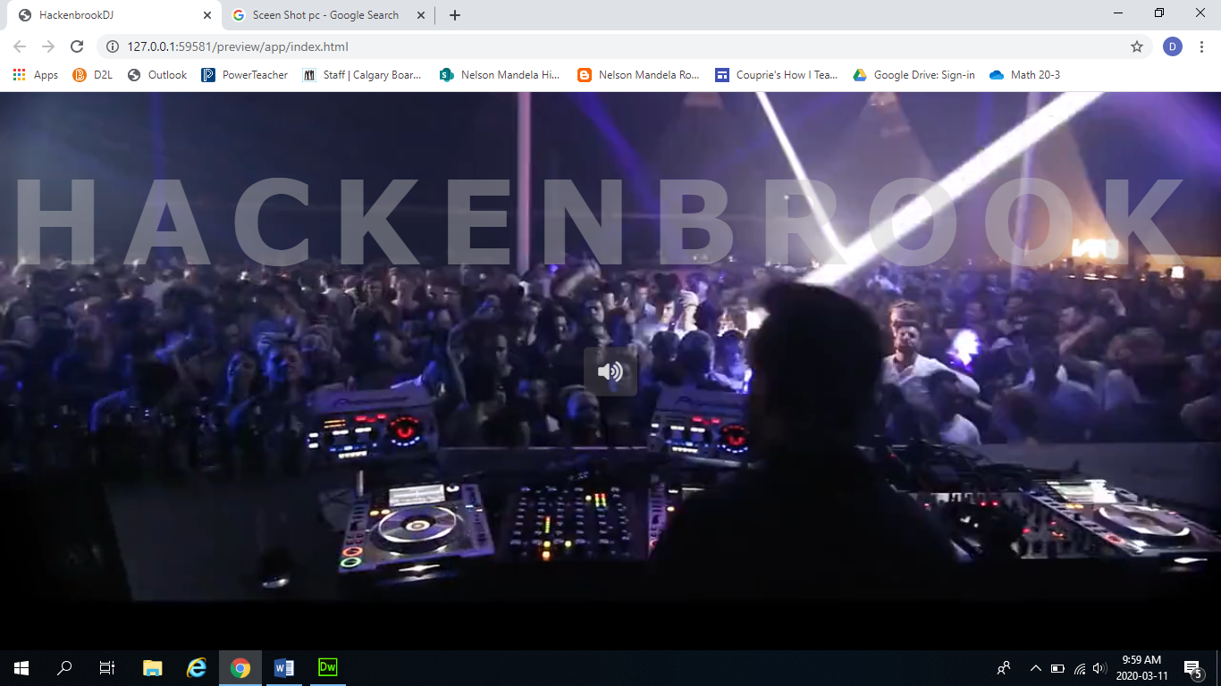

**Assessment**

Include the following to receive exemplary. Any missing parts will take you down the assessment continuum. You will be marked on the complexity of your animations, and how well it adds to the style of the page.

* Title: centred, different colour, different font, and size, should size dynamically with window.
* At least three different CSS animations using Keyframes (e.g., change position, size, opacity, etc.)
* Add audio or video to page
* CSS as external file

**Visual Composition:**

* Get stock videos from <https://www.pexels.com/videos/>
* Focus on Shape with the animation
* Use video and audio to enhance presentation
* Choose colours that are analogous and not too similar
* Make use of the space