**Team members-**

1. Vishal Gupta PRN- 200250120110
2. Sagar Nishad PRN- 200250120082

**Sprint I presentation demo-**

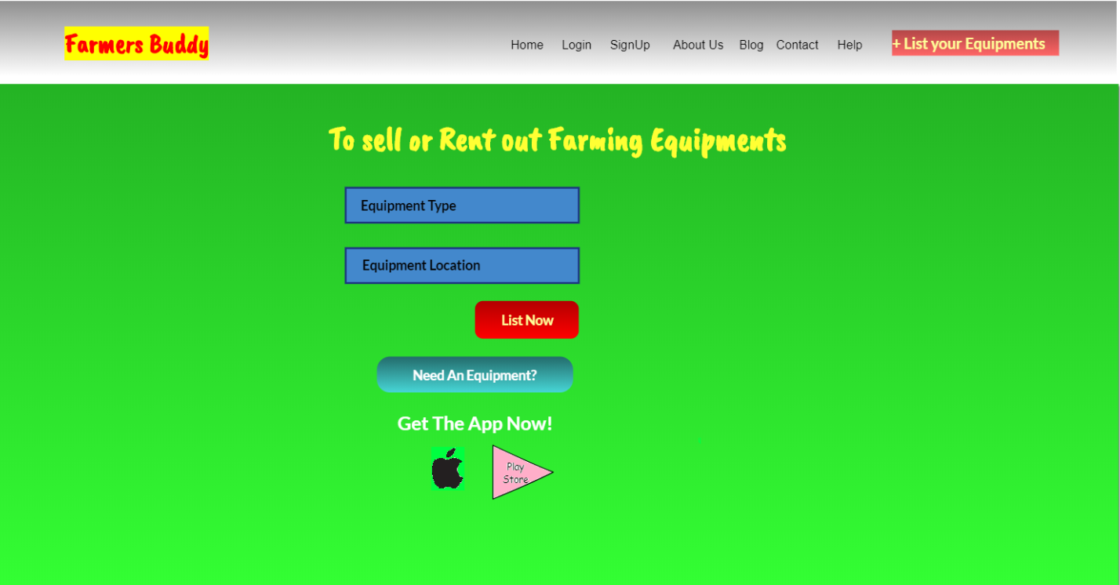

1. Home- on click we will navigate to home page
2. Login- move to login page on click
3. Sign Up- move to sign up page on click
4. About Us- get details about project on about us page
5. Blog- Show blog contents where users will hear from team
6. Contact- shows contact details
7. Help- Shows help menu to solve users issues
8. List your equipment- Put your equipment on rent here
9. List now- will get you registration page to register equipment for rent
10. Need an equipment- If you want to use some equipment and tools on rent click here
11. On click you’ll be moved to search page to get your required equipment
12. Select your choice and book there
13. Get the app now- Just a demo

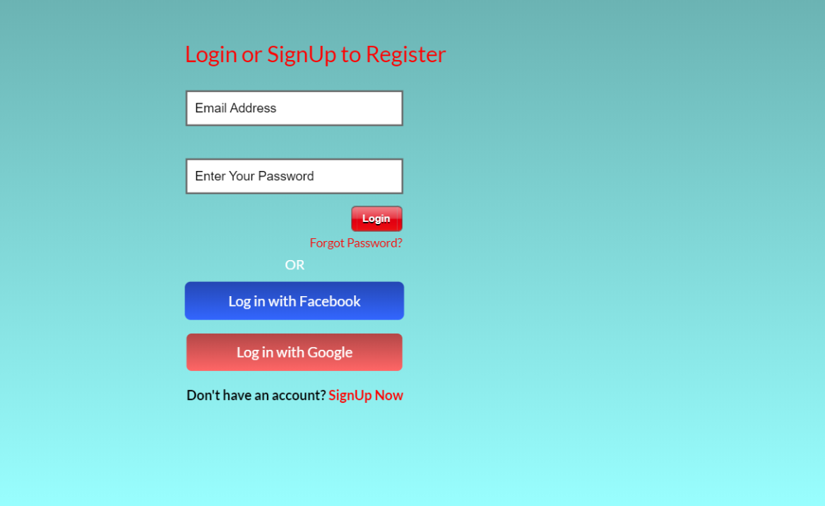

1. Login- put your email id and password and on click you will get into your account
2. Forgot Password? – If you don’t remind password click here
3. You will come to account verification page, verify it and get OTP
4. Verify your OTP and reset your password
5. Log in with Facebook- If you’ve Facebook account you can login with it (just UI)
6. Log in with Google- Login with your google account (just UI)
7. Sign Up now- If you did not have any account, create one here

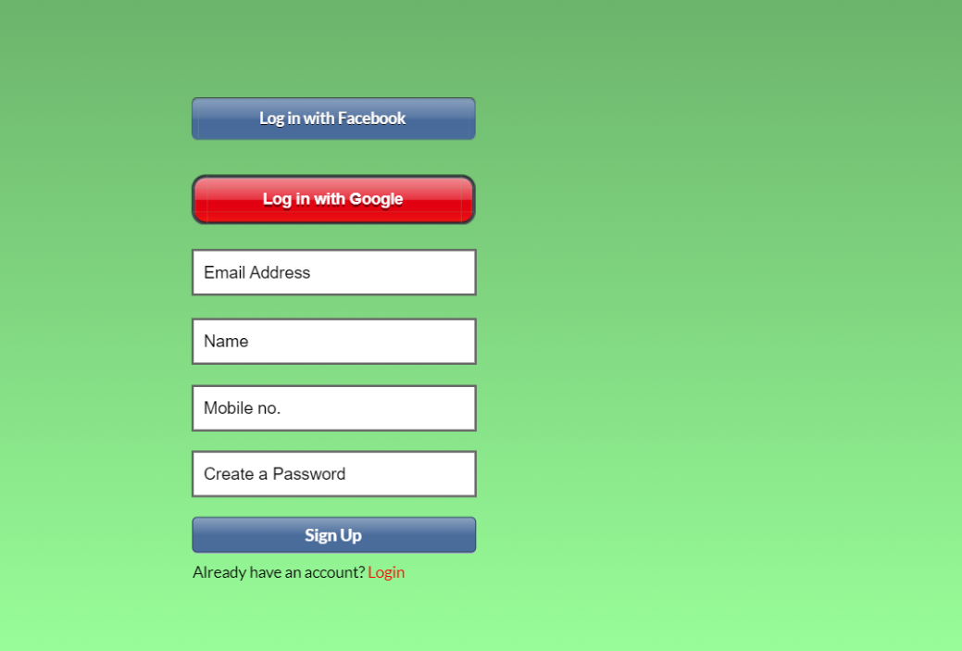

1. Sign Up- Enter all the details here and get your account created
2. Put some other details according to type of your account
3. Move to your account and start using it
4. Login- If already have an account, login here
5. Navigate to login page and enter credentials there

**Sprint II presentation demo-**

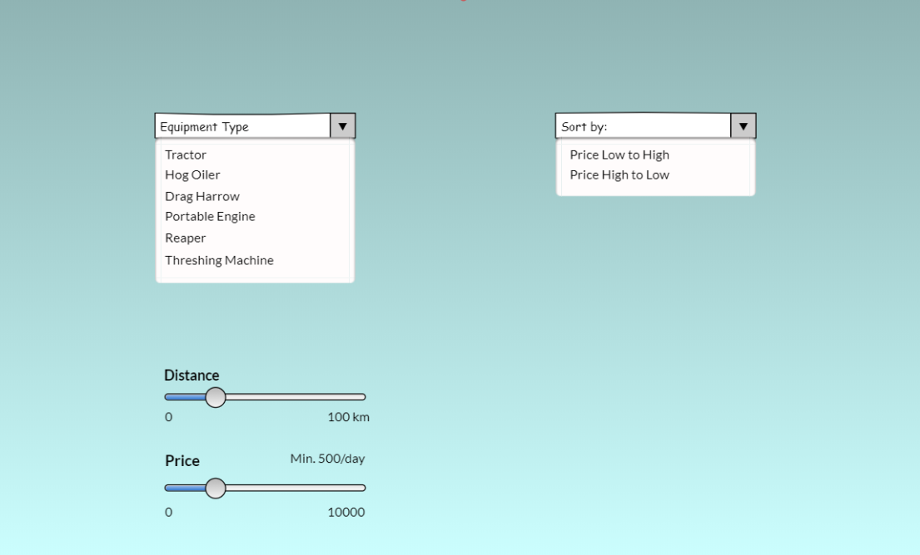

sort

filter

1. Filter- Filter your search here and get most relevant things
2. Equipment type- Select type of equipment you’re searching for
3. Distance- Within how much distance you want to host your service or get it
4. Price- How much can you pay, get results according to that
5. Sort- Get your search result sorted as per some criteria
6. Price- Sort your search result on price as low to high and vice versa

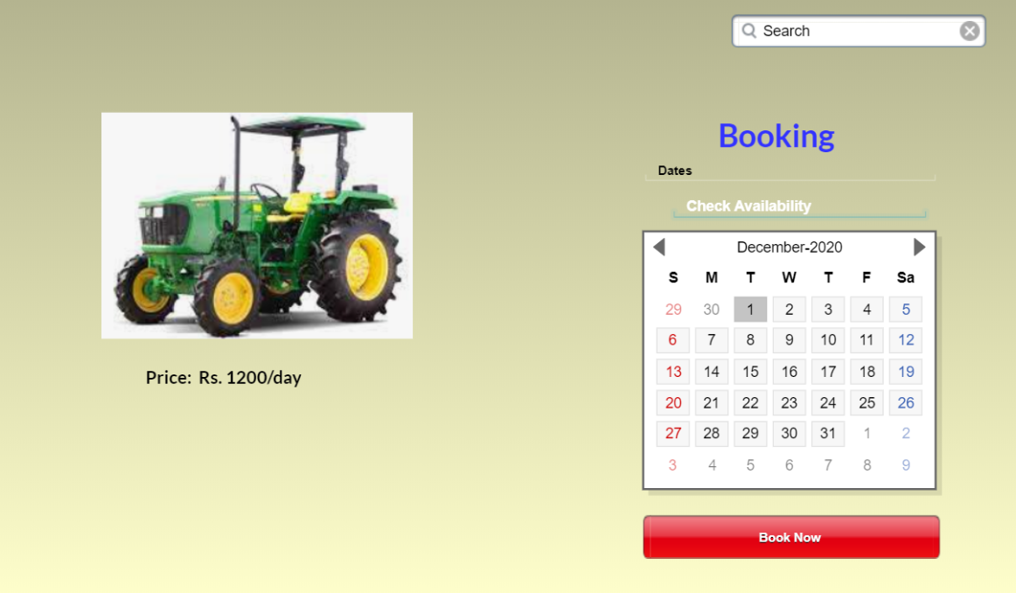

Rs. 500 per hour

1. Check availability- Select dates amidst of which you need equipment on rent
2. If available you can book it
3. Book now- Takes you to booking and payment page
4. Confirm your booking, check the charges
5. Payment gateway to make payment