Day-14

Use of repeat:

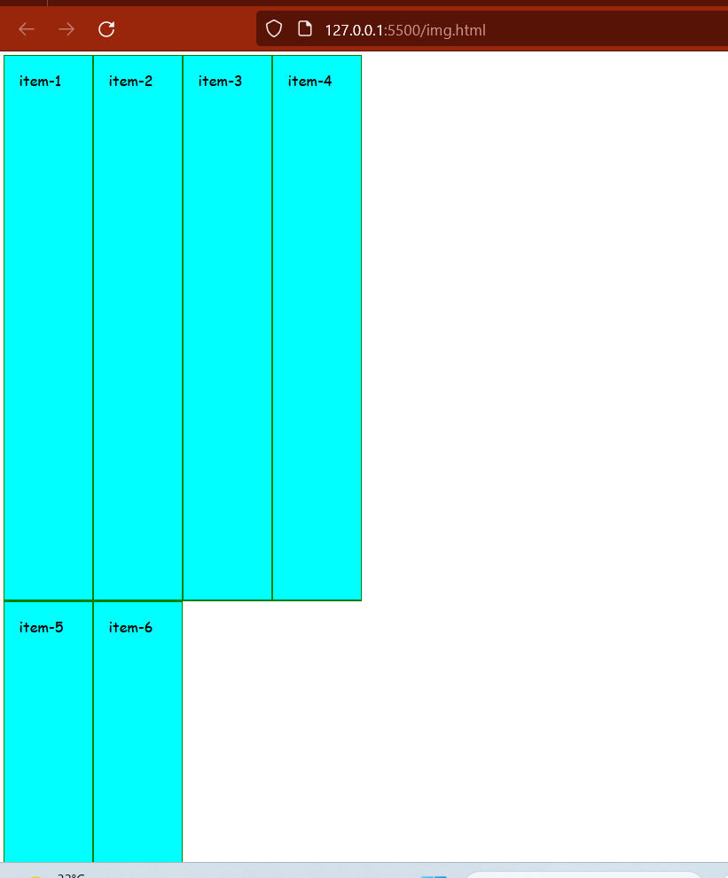

.container {

  display: grid;

  font: 2rem cursive;

  height: 100vh;

  /* Use of repeat to repeat column size */

  grid-template-columns: repeat(4, 200px);

}

.container > * {

  background-color: aqua;

  color: black;

  padding: 2rem;

  border: 2px solid green;

}

Use of auto-fit:

 grid-template-columns: repeat(auto-fit, 100px);

**BootStrap:**

Bootstrap is a free open-source and is the most popular HTML, CSS, and JavaScript framework

Developed by Twitter for creating responsive web design.

It was developed by Mark Otto and Jacob Thomton on Twitter. It was released as an open-source product in August 2011 on GitHub.

**Advantages:**

Support Responsive Design and Mobile First Approach.

Saves lot of Development Time

Customizable

Browser Support

Easy to use

**Getting Started with BootStrap:**

There are two ways to start using BootStrap on your own web site:

=>Download Bootstrap from getbootstrap.com

=>Include Bootstrap form a CDN

**1.Class related to heading:**

**=>h1,h2,h3,h4,h5,h6**

**=><h1 class=”h1”>shiva</shiva>**

2. class name:

=>display-1, display-2, display-3, display-4

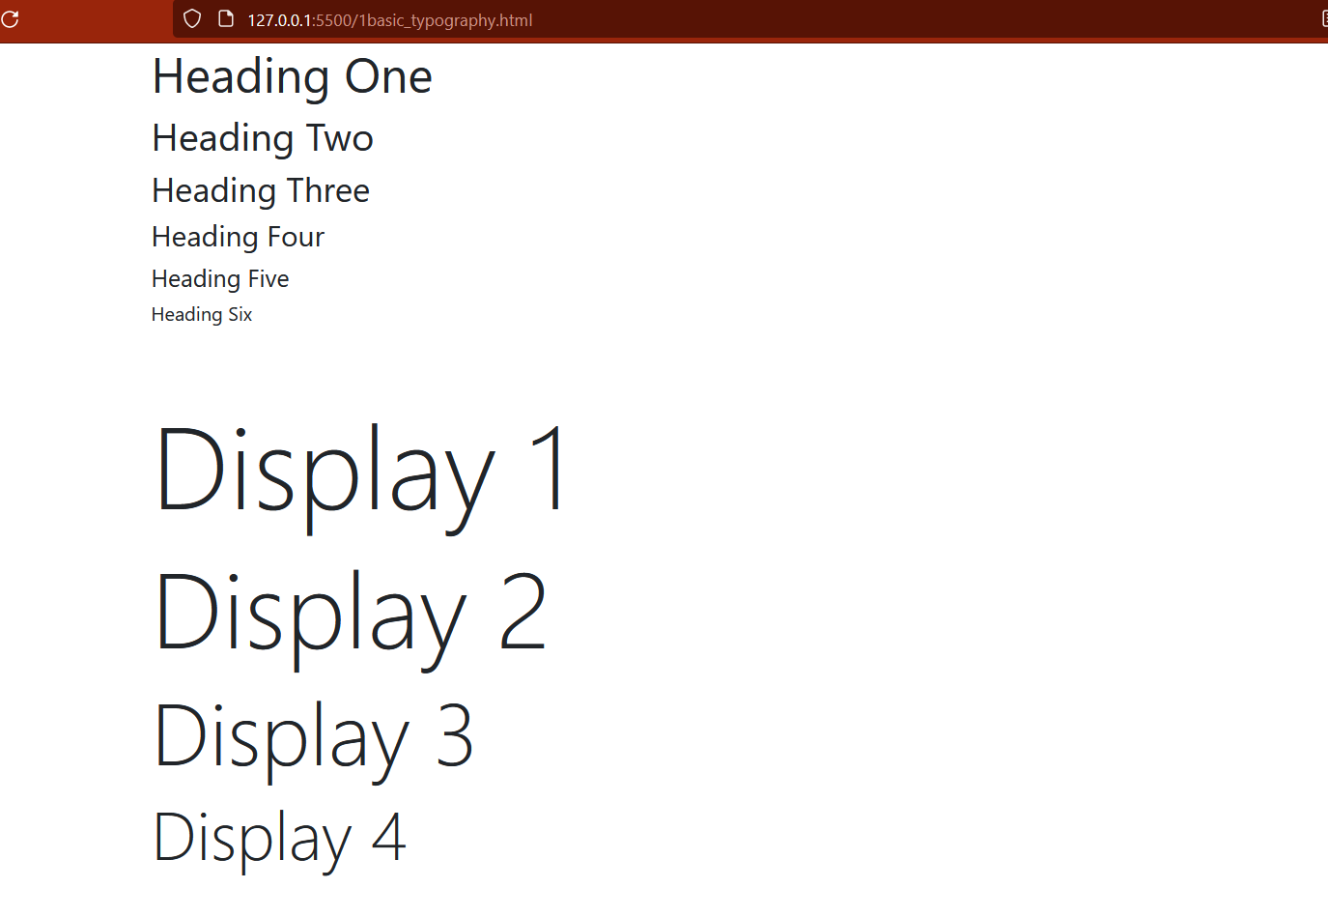

      <!-- HEADINGS -->

      <h1 class="h1">Heading One</h1>

      <h2 class="h2">Heading Two</h2>

      <h3 class="h3">Heading Three</h3>

      <h4 class="h4">Heading Four</h4>

      <h5 class="h5">Heading Five</h5>

      <h6 class="h6">Heading Six</h6>

      <br />

      <br />

      <!-- DISPLAY CLASSES -->

      <h1 class="display-1">Display 1</h1>

      <h1 class="display-2">Display 2</h1>

      <h1 class="display-3">Display 3</h1>

      <h1 class="display-4">Display 4</h1>

3.