Objective: Frame a time table of your class using html

Procedure:

<html>

<head>

<title>my timetable </title>

<style>

table,th,td{border:2px solid black; border-collapse:collapse;}

.monikamam{background-color:#ff3366} .ambujsir{background-color:#6666cc} .areebamam{background-color:#336633} .jiteshsir{background-color:#ff6633} .harvindermam{background-color:yellow} .gauravsir{background-color:#ff6799} .sunilsir{background-color:gray} .lunch{background-color:#ff00ff} .monikamaml{background-color:#ff3399} .jiteshsirl{background-color:#ff6639} .harvindermaml{background-color:#ffa500} .gauravsirl{background-color:#ff6790}

</style>

</title>

</head>

<body>

<table>

<caption style="font-size:150%">Btech(hons)CSE Timetable</caption>

<tr><th colspan="9">GLA UNIVERSITY MATHURA</th></tr>

<tr><th colspan="9">Institue of Engineering Technology</th></tr>

<tr><th colspan="3"><pre>Mr.Neeraj Varshney

PC-Honors Program ,CEA department</th><th colspan="3"><pre>Mr. Gaurav panth

Class Advisor</pre></th><th colspan="3"><pre>Dr.Rohit Agarwal

HOD,CEA department</pre></th></tr>

<tr >

<th>

<table style="border-collapse:collapse">

<tr>

<th>Lecture#</th>

</tr>

<tr>

<th>Day/Time</th>

</tr>

</table>

</th>

<th>

<table>

<tr>

<th>1</th>

</tr>

<tr>

<th>10:00-11:00</th>

</tr>

</table>

</th>

<th>

<table>

<tr>

<th>2</th>

</tr>

<tr>

<th> 11:00-12:00</th>

</tr>

</table>

</th>

<th>

<table>

<tr>

<th>3</th>

</tr>

<tr>

<th> 12:00-01:00</th>

</tr>

</table>

</th>

<th>

<table>

<tr>

<th>4</th>

</tr>

<tr>

<th> 01:00-02:00</th>

</tr>

</table>

</th>

<th>

<table>

<tr>

<th>5</th>

</tr>

<tr>

<th width="50%"> 02:00-03:00</th>

</tr>

</table>

</th>

<th>

<table>

<tr>

<th>6</th>

</tr>

<tr>

<th width="50%"> 03:00-04:00</th>

</tr>

</table>

</th>

<th>

<table>

<tr>

<th>7</th>

</tr>

<tr>

<th width="50%">04:00-05:00 </th>

</tr>

</table>

</th>

<th>

<table>

<tr>

<th width="30%">8</th>

</tr>

<tr>

<th >05:00-06:00</th>

</tr>

</table>

</th>

</tr>

<tr >

<th>Monday</th>

<th title="Dr.Monika Goyal" class="monikamam"><pre>BPHS0004

AB1-424</pre></th>

<th title="Dr.Ambuj Mishra" class="ambujsir"><pre>BMAS0104

AB1-424</pre></th>

<th title="Mr Gaurav Panth" class="gauravsir"><pre>BMEG0003

AB1-424</pre></th>

<th rowspan ="5" class="lunch" ><pre>

l

u

n

c

h

</pre></font></th>

<th title="Harvinder Kaur" class="harvindermam"><pre>BCSC0051

AB1-424</pre></th>

<th title="Dr.Areeba shabbir" class="areebamam"><pre>BELH0014

AB1-424</pre></th>

<th colspan="2" title="Harvinder Kaur" class="harvindermaml" ><pre>BCSC0851/1BT(H)-1A1/Lab-136

</pre></th>

</tr>

<tr >

<th>Tuesday</th>

<th title="Dr.Ambuj Mishra" class="ambujsir"><pre>BMAS0104

AB1-424</pre></th>

<th title="Harvinder Kaur" class="harvindermam"><pre>BCSC0051

AB1424</th>

<th title="Jitesh Bhatia" class="jiteshsir" ><pre>BCSC0050

AB1-424</th>

<th colspan="2" title="Dr.Monika Goyal" class="monikamaml" ><pre>BPHS0801/1BT(H)-A1/

AB8

Second Floor

Lab-303</th>

<th colspan ="2" title="Harvinder Kaur" class="harvindermaml"><pre>BCSC0851/1BT(H)-1A2/Lab-205</th>

</tr>

<tr>

<th>Wednesday</th>

<th title="Jitesh Bhatia" class="jiteshsir" ><pre>BCSC0050

AB1-424</pre></th>

<th title="Dr.Ambuj Mishra" class="ambujsir"><pre>BMAS0104

AB1-424</pre></th>

<th title="Dr.Monika Goyal" class="monikamam" ><pre>BPHS0004

AB1-424</pre></th>

<th title="Harvinder Kaur" class="harvindermam">BCSC0051

AB1-424</pre></th>

<th title="Dr.Areeba shabbir" class="areebamam"><pre>BELH0014

AB1-424</pre></th>

<th colspan ="2" ><table >

<tr >

<th title="Jitesh Bhatia" class="jiteshsirl">BCSC0850/1BT(H)-2A1/Lab-205</th>

</tr>

<tr >

<th title="Harvinder Kaur" class="harvindermaml" >BCSC0851/1BT(h)-2A2/Lab-206</th>

</tr>

</table>

</tr>

<tr >

<th>Thrusday</th>

<th title="Jitesh Bhatia" class="jiteshsir"><pre>BCSC0050

AB1-424</pre></th>

<th title="Dr.Ambuj Mishra" class="ambujsir"><pre>BMAS0104

AB1-424</pre></th>

<th title="Dr.Monika Goyal" class="monikamam"><pre>BPHS0004

AB1-424</pre></th>

<th title="Mr Gaurav Panth" class="gauravsir"><pre>BMEG0003

AB1-424</pre></th>

<th title="Harvinder Kaur" class="harvindermam" ><pre>BCSC0051

AB1-424</pre></th>

<th colspan ="2">

<table><tr><th title="Jitesh Bhatia" class="jiteshsirl">BCSC0850/1BT(H)-2A1/Lab-205</th></tr>

<tr><th title="Harvinder Kaur" class="harvindermaml">BCSC0851/1BT(h)-2A2/Lab-206</th></tr></table>

</tr>

<tr>

<th>Friday</th>

<th title="Dr.Monika Goyal" class="monikamam"><pre>BPHS0004

AB1-424</pre></th>

<th title="Mr Gaurav Panth" class="gauravsir"><pre>BMEG0003

AB1-424</pre></th>

<th title="Dr.Areeba shabbir" class="areebamam"><pre>BELH0014

AB1-424</pre></th>

<th colspan="2" Title="Mr. Sunil kumar" class="sunilsir">BMEG0804/1BT(H)-A1/AB3-201</th>

<th colspan="2" title="Mr Gaurav Panth" class="gauravsirl">BMEG0805/1BT(H)-1A1/AB3-108</th>

</tr>

<tr>

<th>Saturday</th>

<th>-</th>

<th>-</th>

<th >-</th>

<th>-</th>

<th>-</th>

<th>-</th>

<th >-</th>

</tr>

</table>

</body>

</html>

</table>

</body>

</html>

Result:

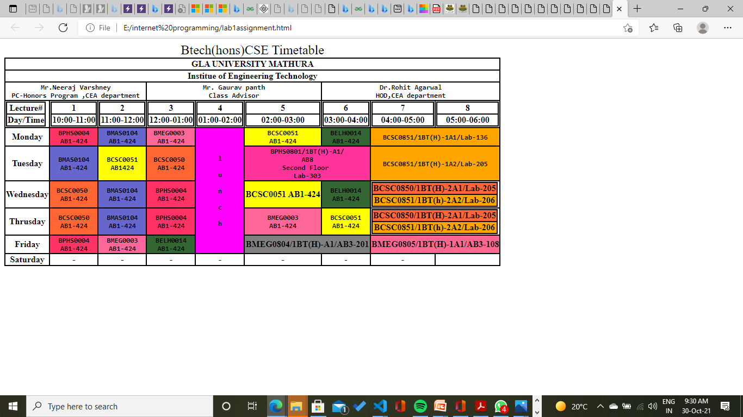

Conclusion:

From this assignment I learn how to make table by using css