**Classes & objects (OOPs)**

* Python is a Powerful language that supports the object-oriented programming paradigm.
* A programming technique that requires the use of objects and classes is known as OOP.
* Object-Oriented Programming is based on the principle of writing reusable code that

the user can access multiple times.

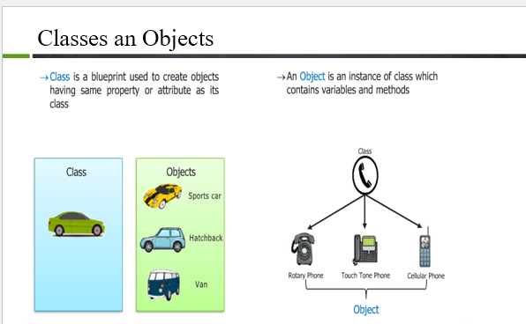

**What is Python Class and Object?**

* A class is a collection of objects, and an object is defined as an instance of a class processing attributes.
* A class is a blueprint of object that formed in future.
* The object is an entity that has a state and behavior. 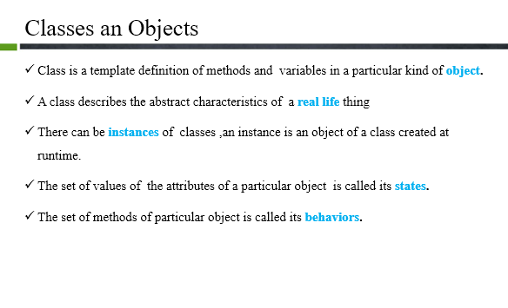
* Along with classes and objects there are some related terminology to OOPs.
* **Instances**
* **Constructor**
* **Methods**
* **Abstraction**
* **Inheritance**
* **Encapsulation**
* **Polymorphism**

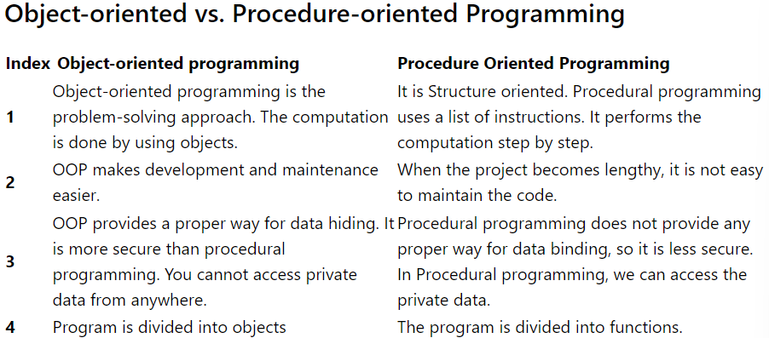

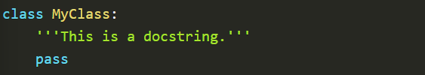

**Some Important Points regarding classes and objects:**

* Classes are not like functions, so we do not have to use the keyword def to create a class.
* we use the keyword **Class** along with the name of the class.
* we do not call a class as a whole; instead, we use an object to access its different attributes.
* We can assign new values and can also overwrite the previous values with the help of an object.
* In short, an object gives us permission to access the whole class.
* We can access variables in a class, like:

Object_name.variable_name = “abc”

* Here we are setting a variable equal to abc. By doing this, its previous value will be overwritten.

**Creating Object:**

* we have a class named Student. We can create an object of it by these certain lines of code:

Stu1 = Student()

Stu2 = Student()

* we have created two objects of class Student. We can access every item in the Student class using these objects.
* There is no restriction on the number of objects a class may have, and also, there is no limit to the number of classes a program may have.

**An Object consists of**:

* The **State**, which is represented by attributes of an object which reflect the properties of an object.
* Methods of an object represent the object’s behaviour and the response of an object with other objects.
* **Identity**, which gives a unique name to an object so that one object can interact with other objects.

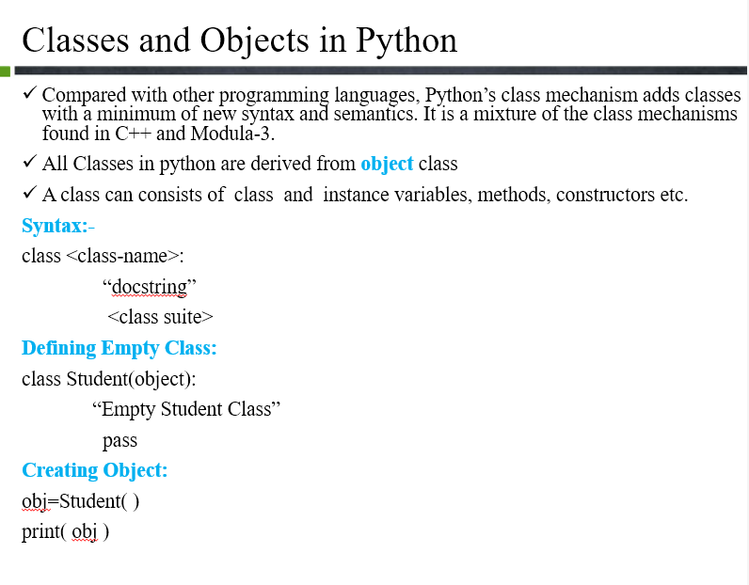

**Code File:**

class Student:

pass

harry = Student()

larry = Student()

harry.name = "Harry"

harry.std = 12

harry.section = 1

larry.std = 9

larry.subjects = ["hindi", "physics"]

print(harry.section, larry.subjects)

**Instance & Class Variables**

**Class** Student:

Pass

shiva=Student()

ritika=Student()

shiva.name=’Shiva’

shiva.std=’B.tech’

shiva.section=’1’

shiva.subjects=[‘Python’,’Mathematics’,’Electronics’,’Data-Structure-Algo’]

ritika.name=’Ritika’

ritika.std=’B.tech’

ritika.section=’1’

ritika.subjects=[‘Python’,’Mathematics’,’Electronics’,’Data-Structure-Algo’]

print(shiva.subject,ritika.subjects)

**we have to work with two types of variables:**

* **Instance variable**
* **Class variable**

**Instance Variable:**

* "Instance variables are the variables for which the value of the variable is different for every instance."
* We can say that value is different for every object that we create.
* When we create a class, we defined a few variables along with it.
* Suppose we create max_marks as class variable which is same for every student object .
* When we change value of max_marks form new instance variable for shiva object of student class.
* Shiva.max_marks=60 form new instance variable.

**Code that show how new instance formed:**  
class Student:  
 max_marks=100  
shiva=Student()  
print(Student.max_marks)  
print(shiva.max_marks)  
*# New instance variable max_marks form*shiva.max_marks=60  
*# Does not effect the value of class variable*print(Student.max_marks)  
print(shiva.max_marks)  
Student.max_marks=80  
*# change only happen in class variable does not effect instance variable max_marks of shiva object*print(Student.max_marks)  
print(shiva.max_marks)  
  
Output:  
100  
100  
100  
60  
80  
60

**Class Variable:**

* ***"Class attributes are owned by the class directly, which means that they are not tied to any object or instance."***
* if we want to change the age for every instance from 16 to 17, then we can do it by using the class variable, which in this case is Student
* **"It is worth noting that updating the value of the class variable will not change it for the instance variables of the objects, such as in the case above."**
* **For example we change Student.max_marks=80 change cannot reflect in shiva.max_marks**

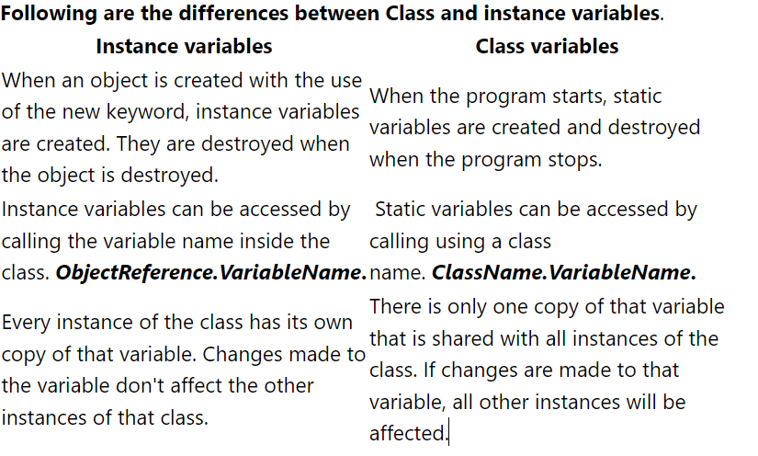

**Method:**

* A method is just like a function, with a **def** keyword and a single parameter in which the object's name has to be passed.
* Using methods makes the process simpler and a lot faster.
* **Using methods makes the process simpler and a lot faster.**

**Self Keyword:**

* The self keyword is used in the method to refer to the instance of the current class we are using.
* The self keyword is passed as a parameter explicitly every time we define a method.
* def read_number(self):
* print(self.num)

**Constructor:**

**__init__method:-**

* **“**__init__” is also called a constructor in object-oriented terminology.
* **“constructor in Python is used to assign values to the variables or data members of a class when an object is created.”**
* Python treats the constructor differently as compared to C++ and Java.
* The constructor is a method with a def keyword and parameters, but the purpose of a constructor is to assign values to the instance variables of different objects.
* We can give the values by accessing each of the variables one by one, but in the case of the constructor, we pass all the values directly as parameters.
* Self keyword is used to assign value to a constructor too.
* We declare a constructor in Python using the def keyword:
* def __init__(self):
* # body of the constructor

Term and how it is uses:

* The def keyword is used to define the function.
* The first argument refers to the current object which binds the instance to the init() method.
* In init() method ,arguments are optional. Constructors can be defined with any number of arguments or with no arguments.

class Person:

def __init__(self, name, age):

self.name = name

self.age = age

p1 = Person("John", 36)

print(p1.name)

#Output: John

**Types of constructors in Python:**

We have two types of constructors in Python.

1. The default constructor is the one that does not take any arguments.
2. Constructor with parameters is known as ***parameterized*** constructor.

**Methods vs Function:**

Methods and Functions are very similar, yet there are some difference:

* Methods are explicitly for Object-Oriented Programming.
* The method can be used by object that it is called for. In simple terms for a method, the parameter must be an object.
* The method can only access the data that is initialized in the class the method is formed in.

**Code:**

**Class** Employee:

no_of_leaves=9

def __init__(self,name,salary,role):

self.name=name

self.salary=salary

self.role=role

def printdetails(self):

return f”The name is {self.name}. Salary is {self.salary} and role is {self.role}”

shiva=Employee(“Shiva”,300,”Hacker”)

#ritika=Employee() ->Throw error because less parameter in Employee

#shiva.name=”shiva”

#shiva.salary=500

#shiva.role=”Instrutor”

print(shiva.salary)

**Class Methods in Python:**

* We have dealing with static methods until now.
* In object-Oriented programming, there is a concept of a class method.
* They are very different from static methods as they are limited in their functionality to the built-in class.
* They can be called by using the class name and also can be accessed by using the object.
* we cannot change the value of a variable defined in the class from outside using an object.
* Instead, if we try that, a new instance variable will be created for the class having the value we assigned.
* But no change will occur in the original value of the variable.
* we are going to know the working of a new keyword, i.e., cls. Class methods take **cls** parameter that points to the class and not the object instance when the method is called.

class myClass:

@classmethod

def myfunc (cls, arg1, arg2, ...):

....

* myfunc defines the function that needs to be converted into a class method .
* returns: @classmethod returns a class method for function.
* Because the class method only has access to the cls argument, it cannot modify the object instance state.

**@classmethod**

* It is decorator is a built-in function in Python. It can be applied to any method of the class.
* We can change the value of variables using this method.
* class Student:  
   max_marks=100  
   def change(self):  
   Student.max_marks=70  
    
   @classmethod  
   def change_classmethod(cls):  
   cls.max_score = 700  
  shiva=Student()  
  shiva.change()  
  shiva.change_classmethod()  
  print(Student.max_score)  
  Student.max_score=600  
  print(Student.max_score)  
  print(Student.max_marks)  
  print(shiva.max_marks)

Output:

700

600

70

70

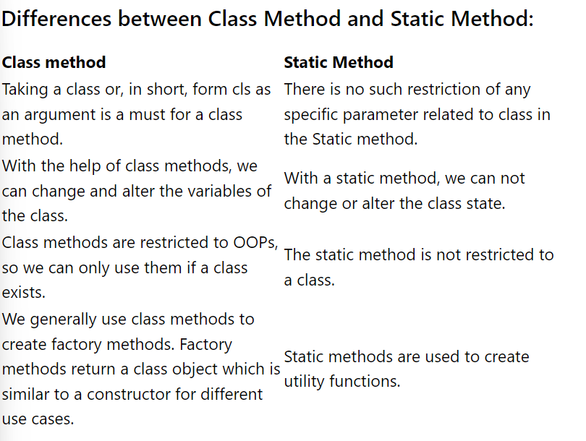

**Alternative constructor:**

class Date:

def __init__(self, year, month, day):

self.year = year

self.month = month

self.day = day

@classmethod

def from_dash(cls,string):

return cls(*string.split("-"))

date1=Date.from_dash("2008-12-5")

print(date1.year)

#Output: 2008

class Employee:

no_of_leaves = 8

def __init__(self, aname, asalary, arole):

self.name = aname

self.salary = asalary

self.role = arole

def printdetails(self):

return f"The Name is {self.name}. Salary is {self.salary} and role is {self.role}"

@classmethod

def change_leaves(cls, newleaves):

cls.no_of_leaves = newleaves

@classmethod

def from_dash(cls, string):

# params = string.split("-")

# print(params)

# return cls(params[0], params[1], params[2])

return cls(*string.split("-"))

harry = Employee("Harry", 255, "Instructor")

rohan = Employee("Rohan", 455, "Student")

karan = Employee.from_dash("Karan-480-Student")

print(karan.no_of_leaves)

# rohan.change_leaves(34)

#

# print(harry.no_of_leaves)

**Static Methods in python:**

* It is also easier to implement than a class method because it can be accessed without any object. However, we can also access it using a class or any instance.
* we use the **@staticmethod** decorator, which is a built-in decorator. Also, there is no need to import any module to use decorators. Using a static method in a class, we permit it to be accessed only by the class objects or inside the class.

**Limitations of static method over class method:**

* Unlike, class method, a static method cannot alter or change any variable value or state of the class.
* Static methods do not have any knowledge related to the

**Advantage of Python static method:**

* Static methods have a very clear use case. When we need some functionality not for an Object but with the complete class, we make a method static. This is advantageous when we need to create utility methods.

**Code:**

class Employee:

no_of_leaves = 8

def __init__(self, aname, asalary, arole):

self.name = aname

self.salary = asalary

self.role = arole

def printdetails(self):

return f"The Name is {self.name}. Salary is {self.salary} and role is {self.role}"

@classmethod

def change_leaves(cls, newleaves):

cls.no_of_leaves = newleaves

@classmethod

def from_dash(cls, string):

return cls(*string.split("-"))

@staticmethod

def printgood(string):

print("This is good " + string)

harry = Employee("Harry", 255, "Instructor")

rohan = Employee("Rohan", 455, "Student")

karan = Employee.from_dash("Karan-480-Student")

Employee.printgood("Rohan")

**Abstraction & Encapsulation:**

**What is Abstraction?**

* **Abstraction** refers to hiding unnecessary details to focus on the whole product instead of parts of the project separately.
* It is a mechanism that represents the important features without including implementation details.
* Abstractions helps us in portioning the program into many independent concepts so we may hide the irrelevant information in the code.
* It offers the greatest flexibility when using abstract data-type objects in different situations
* Example of Abstraction -A car has an engine, tires, windows, steering wheel ,etc. all these things used to form car .Now an engine is composed of various parts such as camshaft ,valves , oil pan, etc. these flayers the engine is an abstraction.

**What is Encapsulation?**

* **Encapsulation**  means hiding under layers. When working with classes and handling sensitive data , global access to all the variables used in the program is not secure . In Encapsulation, the internal representation of an object is generally hidden from the outside to secure the data.

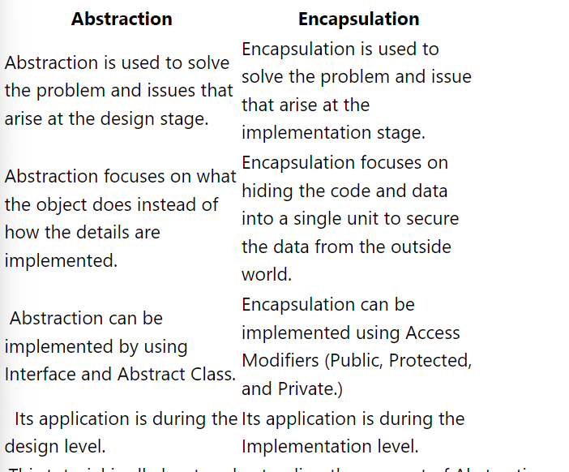

**Types of Inheritance:**

**1)**Single Inheritance

**2)**Multiple Inheritance

**3)**Multilevel Inheritance

**4)**hybrid Inheritance

**Single Inheritance:**

* **Inheritance** means to receive something from one’s parents or ancestors.
* The concept of Inheritance is very similar in cases of classes where a class inherits all the properties and methods of its previous class that it is inheriting from.
* Inheritance is the ability to define a new class(child class) that is modified version of an existing class(parent class).

**Syntax:**

class Parent_class_Name:

#Parent_class code block

class Child_class_Name(Parent_class_name):

#Child_class code block

**Common terms related to inheritance are as follows:**

**Parents:** The parent class is the one that is giving access to its methods or properties to the child class or derived class.

**Child:** Child class is the one that is inheriting methods and properties from parent class.

**Theory:**

The class that is inheriting, i.e., the child class, can inherit all the functionality of the parent class and add its functionalities also. As we have already discussed that each class can have its constructors and methods, so in case of inheritance the child class can make and use its constructor and also can use the constructor of the parent class. We can simply construct it as we did for the parent class but OOP has provided us with a simple and more useful solution known as Super().

We will be discussing super() and overriding in our [***Super() and Overriding In Classes***](https://www.codewithharry.com/videos/python-tutorials-for-absolute-beginners-65) tutorial of the course.

Single inheritance exists when a class is only derived from a single base class. Or in other words when a child class is using the methods and properties of only a single parent class then single inheritance exists. Single inheritance and Multiple inheritance are very similar concepts, the only major difference is the number of classes.

class Employee:

no_of_leaves = 8

def __init__(self, aname, asalary, arole):

self.name = aname

self.salary = asalary

self.role = arole

def printdetails(self):

return f"The Name is {self.name}. Salary is {self.salary} and role is {self.role}"

@classmethod

def change_leaves(cls, newleaves):

cls.no_of_leaves = newleaves

@classmethod

def from_dash(cls, string):

return cls(*string.split("-"))

@staticmethod

def printgood(string):

print("This is good " + string)

class Programmer(Employee):

no_of_holiday = 56

def __init__(self, aname, asalary, arole, languages):

self.name = aname

self.salary = asalary

self.role = arole

self.languages = languages

def printprog(self):

return f"The Programmer's Name is {self.name}. Salary is {self.salary} and role is {self.role}.The languages are {self.languages}"

harry = Employee("Harry", 255, "Instructor")

rohan = Employee("Rohan", 455, "Student")

shubham = Programmer("Shubham", 555, "Programmer", ["python"])

karan = Programmer("Karan", 777, "Programmer", ["python", "Cpp"])

print(karan.no_of_holiday)

Multiple Inheritance:

* In multiple inheritance , a class is derived from more than one class i.e multiple base classes. The child class, in this case, has features of both the parent classes.
* class Base1:
* def func1(self):
* print("this is Base1 class")
* class Base2:
* def func2(self):
* print("this is Base2 class")
* class Child(Base1 , Base2):
* def func3(self):
* print("this is Base3 class")
* obj = Child()
* obj.func1()
* obj.func2()
* obj.func3()

Output:

this is Base1 class

this is Base2 class

this is Base3 class

**Method Overriding:**

Override means having two methods that have the same name. They may perform same tasks or different tasks. In Python, when the same method defined in the parent class is also defined in the child class, the process is know as Method overriding. This is also true when multiple classes have the same method and are linked together somehow.

**There are few rules for Method overriding that should be followed:**

* The name of the child method should be the same as parents.
* **Inheritance** should be there, and we need to derive a child class from a parent class.
* **Both** of their parameters should be the same.

**Code:**

class Employee:

no_of_leaves = 8

var = 8

def __init__(self, aname, asalary, arole):

self.name = aname

self.salary = asalary

self.role = arole

def printdetails(self):

return f"The Name is {self.name}. Salary is {self.salary} and role is {self.role}"

@classmethod

def change_leaves(cls, newleaves):

cls.no_of_leaves = newleaves

@classmethod

def from_dash(cls, string):

return cls(*string.split("-"))

@staticmethod

def printgood(string):

print("This is good " + string)

class Player:

var = 9

no_of_games = 4

def __init__(self, name, game):

self.name = name

self.game =game

def printdetails(self):

return f"The Name is {self.name}. Game is {self.game}"

class CoolProgramer(Player, Employee):

language = "C++"

def printlanguage(self):

print(self.language)

harry = Employee("Harry", 255, "Instructor")

rohan = Employee("Rohan", 455, "Student")

shubham = Player("Shubham", ["Cricket"])

karan = CoolProgramer("Karan",["Cricket"])

# det = karan.printdetails()

# karan.printlanguage()

# print(det)

print(karan.var)

**Multilevel Inheritance:**

* In multilevel inheritance, a class that is already derived from another class is derived by a third class. So in this way, the third class has all the other two former classes' features and functionalities.

class Parent1:

pass

class Derived1(Parent1):

pass

class Derived2(Derived1):

pass

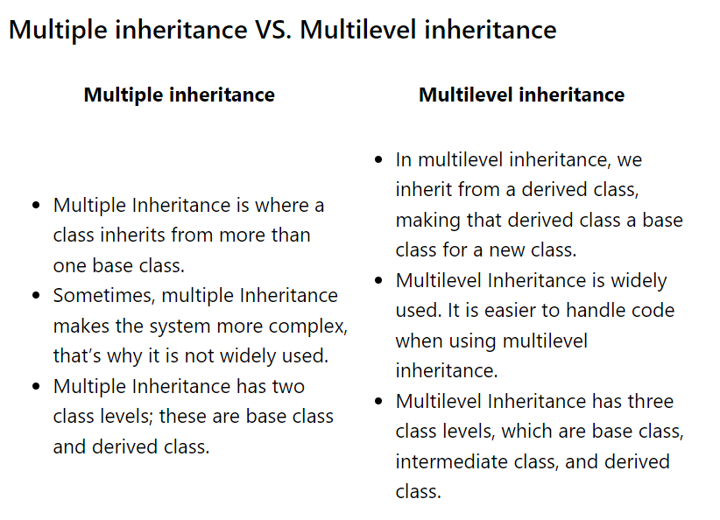

**Advantages of Inheritance:**

**1.**It reduces code redundancy

2.multilevel inheritrance provide code reusability

3.Using multilevel inheritance, code is easy to manage, and it supports code extensibility by overriding the base class functionality within child classes.

**Code:**

class Dad:

basketball =6

class Son(Dad):

dance =1

basketball = 9

def isdance(self):

return f"Yes I dance {self.dance} no of times"

class Grandson(Son):

dance =6

guitar = 1

def isdance(self):

return f"Jackson yeah!" \

f"Yes I dance very awesomely {self.dance} no of times"

darry = Dad()

larry = Son()

harry = Grandson()

# print(darry.guitar)

# electronic device

# pocket gadget

# phone

**Public, Private & Protected Access Specifiers:**

* In high-level programming languages like C++, Java, etc., private, protected, and public keywords are used to control the access of class members or variables. However, Python has no such keywords. Python uses a convention of prefixing the name of the variable or method with a single underscore(_) or double underscore(__) to emulate the behavior of protected and private access specifiers.
* Access modifiers are used for the restrictions of access any other class has on the particular class and its variables and methods. In other words, access modifiers decide whether other classes can use the variables or functions of a specific class or not. The arrangement of private and protected access variables or methods ensures the principle of data encapsulation

**Three types of access modifiers:**

* **Public Access Modifier**
* **Protected Access Modifier**
* **Private Access Modifier**

**Public Access Modifier:**

* In public, all the functions, variables, methods can be used publicly. Meaning, every other class can access them easily without any restriction. Public members are generally methods declared in a class that is accessible from outside the class. Any ordinary class is, by default, a public class. So, all the classes we had made till now in the previous tutorials were all public by default.

class employee:

def __init__(self, name, age):

self.name=name

self.age=age

**e.g public modifier:**

**# program to illustrate public access modifier in a class**

**class Geek:**

**# constructor**

**def __init__(self, name, age):**

**# public data members**

**self.geekName = name**

**self.geekAge = age**

**# public member function**

**def displayAge(self):**

**# accessing public data member**

**print("Age: ", self.geekAge)**

**# creating object of the class**

**obj = Geek("R2J", 20)**

**# accessing public data member**

**print("Name: ", obj.geekName)**

**# calling public member function of the class**

**obj.displayAge()**

**Protected Access Modifier:**

* In the case of a protected class, its members and functions can only be accessed by the classes derived from it, i.e., its child class or classes. No other environment is permitted to access it. To declare the data members as protected, we use a single underscore “_” sign before the data members of the class.

class employee:

def __init__(self, name, age):

self._name=name # protected attribute

self._age=age # protected attribute

**# program to illustrate protected access modifier in a class**

**# super class**

**class Student:**

**# protected data members**

**_name = None**

**_roll = None**

**_branch = None**

**# constructor**

**def __init__(self, name, roll, branch):**

**self._name = name**

**self._roll = roll**

**self._branch = branch**

**# protected member function**

**def _displayRollAndBranch(self):**

**# accessing protected data members**

**print("Roll: ", self._roll)**

**print("Branch: ", self._branch)**

**# derived class**

**class Geek(Student):**

**# constructor**

**def __init__(self, name, roll, branch):**

**Student.__init__(self, name, roll, branch)**

**# public member function**

**def displayDetails(self):**

**# accessing protected data members of super class**

**print("Name: ", self._name)**

**# accessing protected member functions of super class**

**self._displayRollAndBranch()**

**# creating objects of the derived class**

**obj = Geek("R2J", 1706256, "Information Technology")**

**# calling public member functions of the class**

**obj.displayDetails()**

**-------------------------------------------------------------**

**Private Access Modifier:**

* In the case of private access modifiers, the variables and functions can only be accessed within the class. The private restriction level is the highest for any class. To declare the data members as private, we use a double underscore “_­_” sign before the data members of the class. Here is a suggestion not to try to access private variables from outside the class because it will result in an AttributeError.

class employee:

def __init__(self, name, age):

self.__name=name # private attribute

self.__age=age # private attribute

# program to illustrate private access modifier in a class

class Geek:

# private members

__name = None

__roll = None

__branch = None

# constructor

def __init__(self, name, roll, branch):

self.__name = name

self.__roll = roll

self.__branch = branch

# private member function

def __displayDetails(self):

# accessing private data members

print("Name: ", self.__name)

print("Roll: ", self.__roll)

print("Branch: ", self.__branch)

# public member function

def accessPrivateFunction(self):

# accessing private member function

self.__displayDetails()

# creating object

obj = Geek("R2J", 1706256, "Information Technology")

# calling public member function of the class

obj.accessPrivateFunction()

---------------------------------------------------------------------------------------------

**Name mangling in Python:**

* Python does not have any strict rules when it comes to public, protected, or private, like java. So, to protect us from using the private attribute in any other class, Python does name mangling, which means that every member with a double underscore will be changed to _object._class__variable when trying to call using an object.
* The use of single underscore and double underscore is just a way of name mangling because Python does not take the public, private and protected terms much seriously so we have to use our naming conventions by putting single or double underscore to let the fellow programmers know which class they can access or which they can’t.

**Code:**

# Public -

# Protected -

# Private -

class Employee:

no_of_leaves = 8

var = 8

_protec = 9

__pr = 98

def __init__(self, aname, asalary, arole):

self.name = aname

self.salary = asalary

self.role = arole

def printdetails(self):

return f"The Name is {self.name}. Salary is {self.salary} and role is {self.role}"

@classmethod

def change_leaves(cls, newleaves):

cls.no_of_leaves = newleaves

@classmethod

def from_dash(cls, string):

return cls(*string.split("-"))

@staticmethod

def printgood(string):

print("This is good " + string)

emp = Employee("harry", 343, "Programmer")

print(emp._Employee__pr)

**Polymorphism In Python:**

* Polymorphism means to exist in different states. The same object or thing changing its state from one form to another is known as polymorphic. The same function or method, being used differently in different scenarios, can perfectly describe Polymorphism. It occurs mostly with base and derived classes.

**Overriding and Overloading come in Polymorphism:**

**Polymorphism in ‘+’ operator:-**

print(5+6)

print("5" + "6")

class student:  
 def __init__(self,name,roll):  
 self.name=name  
 self.roll=roll  
 def __add__(self,other):  
 return self.name + other.name  
shiva=student("shiva",22)  
ritika=student("ritika",20)  
print(shiva+ritika)

**Super() and Overriding In Classes:**

**How to overrode class methods in Python?**

Overriding occurs when a derived class or child class has the same method that has already been defined in the base or parent class. When called, the same methods with the same name and number of parameters, the interpreter checks for the method first in a child class and runs it ignoring the method in the parent class because it is already overridden. In the case of instance variables, the case is a little different. When the method is called, the program will look for any instance variable having the same name as the one that is called in the child, then in the parent, and after that, it comes again into child class if not found.

class student:  
 def __init__(self,year):  
 self.year=year  
 def std(self,name,roll):  
 self.name=name  
 self.roll=roll  
class child(student):  
 def __init__(self, year,age):  
 self.year = year  
 self.age=age  
  
 def std(self, name):  
 self.name = name  
shiva=child(2002,19)  
shiva.std('shiva')  
print(shiva.name)  
*# print(shiva.roll) give error because std is override by same function*

**Where does super() fit in all this?**

When we want to call an already overridden method, then the use of the super function comes in. It is a built-in function, so no requirement of any module import statement. What super does is it allows us to use the method of our superclass, which in the case of inheritance is the parent class. Syntax of using super() is given below:

class A:

classvar1 = "I am a class variable in class A"

def __init__(self):

self.var1 = "I am inside class A's constructor"

self.classvar1 = "Instance var in class A"

self.special = "Special"

class B(A):

classvar1 = "I am in class B"

def __init__(self):

self.var1 = "I am inside class B's constructor"

self.classvar1 = "Instance var in class B"

# super().__init__()

# print(super().classvar1)

a = A()

b = B()

print(b.special, b.var1, b.classvar1)

**Diamond Shape Problem In Multiple Inheritance:**

* From the start of this course, you may have noticed that I am not just teaching you the syntax so that you may learn just the practical approach to programming and could create a few programs that have no real-world value. Instead, I am trying to teach you all the theoretical and practical concepts together so you may become a successful programmer. You can do the programming by just learning the syntax, but without proper conceptual knowledge, you won’t be able to develop proper logic while writing code. Our today’s tutorial is also based on a theoretical concept.
* we have seen a lot of concepts related to Object-Oriented programming, such as [***Single inheritance***](https://www.codewithharry.com/videos/python-tutorials-for-absolute-beginners-60), [***Multiple Inheritance***](https://www.codewithharry.com/videos/python-tutorials-for-absolute-beginners-61), [***Multilevel Inheritance***](https://www.codewithharry.com/videos/python-tutorials-for-absolute-beginners-62), etc. Today we are going to discuss a problem or, more like a confusion associated with multiple inheritance. The problem is commonly known as the ***“Diamond Shape Problem.”***. It is about priority related confusion, which arises when four classes are related to each other by an inheritance relationship, as shown in the image below:

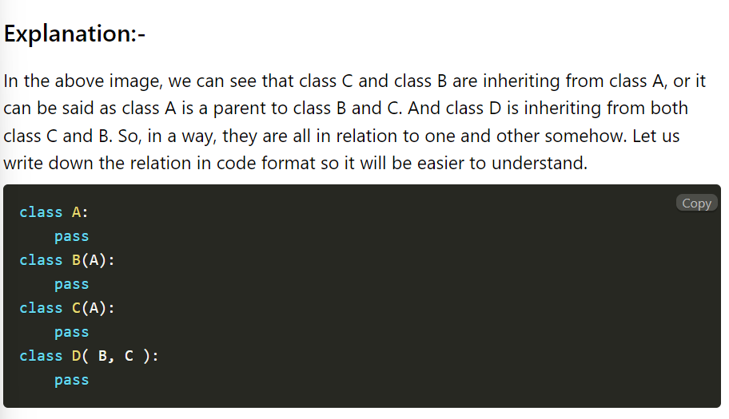

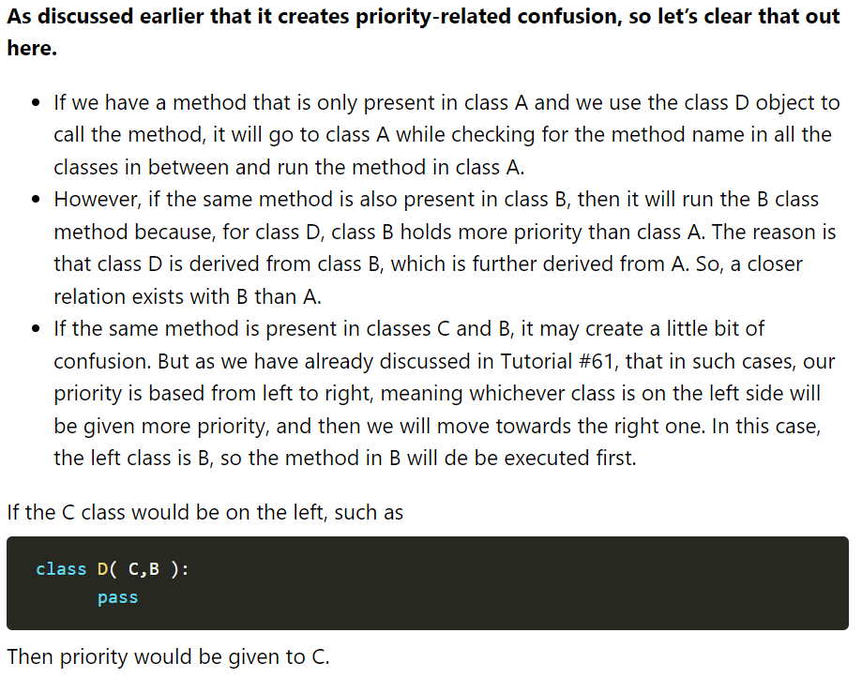

class A:

def met(self):

print("This is a method from class A")

class B(A):

def met(self):

print("This is a method from class B")

class C(A):

def met(self):

print("This is a method from class C")

class D(C, B):

def met(self):

print("This is a method from class D")

a = A()

b = B()

c = C()

d = D()

d.met()

**Operator Overloading and Dunder methods:**

Operator overloading and Dunder Methods may be new concepts for some of you. However, we have already seen similar concepts in which different methods act differently on different occasions and places. Let us understand the Operator overloading first.

**Operator Overloading in Python:**

Operator overloading means giving new meanings to an operator. In simple words, it means to assign new functionality to an operator beyond its normal functioning. We will go with the most common and easiest that we could find related to the concept, i.e., the + sign. For numbers, it is used for addition between them, but in the case of a string, it is used to join or combine two strings, working differently in two different scenarios. The operators are methods defined in respective classes. Defining methods for operators is known as operator overloading.

**Python Dunder Methods Or Special Functions :**

Sunder methods in python are special methods .In python , we sometimes see method names with a double underscore (__), such as the __init__ method that every class has .These methods are called “dunder” methods. In Python, Dunder methods are used for operator overloading and customizing some other functionn’s behavior.

Python usually calls dunder methods under the hood .Suppose we want to join a string with a number using the + sign .Now joining between two different data types is not possible in Python, and the resultant in such a case will be an error .So for this purpose , we can use a function provided to us by python , named as dunder function.We will write such code in it so that it may first convert the number to a string and then join them, or any logic will be fine too until it does what we require .We can even Methods staring with a double underscore(__) and ending with a double underscore (__) represent dunder methods.

* Check <https://docs.python.org/2/library/operator.html> to explore more about operator overloading.

Some Dunder method:

The __init__(), __str__(), __len__() and __del__() methods

**__str__ and __repr__ functions :**

Both of these built-in methods are used to return a presentable description of any object rather than the default one. The difference in them is the way of writing them. The __str__ method is mainly written for the end-user, while __repr__ is written for a developer.It is overridden to return a printable string representation of any user-defined class. An interesting thing to note here is that the priority of __str__ is greater than __repr__. This means that if we pass an object into a print statement, it will return us the __str__ string even if __repr__ is also present there. In such cases, if we want to print __repr__, we have to call it exclusively with the object name in the print statement.

1. **Differnce between __str__and __repr__ functions:**If the implementation of __str__ is missing, then __repr__ function is used as a fallback. If the implementation of __repr__ is missing, then there will be no fallback.
2. If __repr__ function is returning the object's String representation, we can skip the implementation of __str__ function.
3. The priority of __str__ is higher than __repr__.

**Code:**

class Employee:

no_of_leaves = 8

def __init__(self, aname, asalary, arole):

self.name = aname

self.salary = asalary

self.role = arole

def printdetails(self):

return f"The Name is {self.name}. Salary is {self.salary} and role is {self.role}"

@classmethod

def change_leaves(cls, newleaves):

cls.no_of_leaves = newleaves

def __add__(self, other):

return self.salary + other.salary

def __truediv__(self, other):

return self.salary / other.salary

def __repr__(self):

return f"Employee('{self.name}', {self.salary}, '{self.role}')"

def __str__(self):

return f"The Name is {self.name}. Salary is {self.salary} and role is {self.role}"

emp1 =Employee("Harry", 345, "Programmer")

# emp2 =Employee("Rohan", 55, "Cleaner")

print(str(emp1))

Use of __str__ and __repr__:

class student:  
 def __init__(self):  
 pass  
 def __str__(self):  
 return "shiva"  
 def __repr__(self):  
 return "srivastava"  
*# print(student)*shiva=student()  
print(shiva)  
print(shiva.__repr__())

**Special Method:**

**class** Book:

**def** __init__(self, title, author, pages):

print("A book is created")

self**.**title **=** title

self**.**author **=** author

self**.**pages **=** pages

**def** __str__(self):

**return** "Title: %s, author: %s, pages: %s" **%**(self**.**title, self**.**author, self**.**pages)

**def** __len__(self):

**return** self**.**pages

**def** __del__(self):

print("A book is destroyed")

**__del__ dunder method:**

Both __delete__ and __del__ are [dunder or magic methods](https://www.geeksforgeeks.org/dunder-magic-methods-python/) in Python. Dunder or magic methods in Python are the methods having two prefix and suffix underscores in the method name. Dunder here means “Double Under (Underscores)”. These are commonly used for operator overloading.

#### __del__

__del__ is a destructor method which is called as soon as all references of the object are deleted i.e when an object is garbage collected.

*# Creating object of Example  
# class as an descriptor attribute  
# of this class*class Foo(object):  
 exp = Example()  
  
*# Driver's code*f = Foo()  
del f.exp  
   
*# print(exp) since exp deleted after calling del*

**Abstract Base Class & @abstractmethod:**

* An abstract class is a class that holds an abstract method.
* An abstract method is a method defined inside an abstract class.
* It is important to remember that we can not make an object for an abstract class.
* **Following is the syntax for defining an abstract method in an abstract class in Python:**

from abc import ABC, abstractmethod

Class MyClass(ABC):

@abstractmethod

def mymethod(self):

#empty body

pass

from abc import ABC, abstractmethod

**Important Points about abstract class in python:**

1. Abstract methods are defined in the abstract class. They mostly do not have the body, but it is possible to implement abstract methods in the abstract class. Any subclass deriving from such an abstract class still needs to provide an implementation for that abstract method.
2. An abstract class can have both abstract methods as well as concrete methods.
3. The abstract class works as a template for other classes.
4. Using the abstract class, we can define a structure without properly implementing every method.
5. It is not possible to create objects of an abstract class because Abstract class cannot be instantiated.
6. An error will occur if the abstract method has not been implemented in the derived class.

**Code:**

# from abc import ABCMeta, abstractmethod

from abc import ABC, abstractmethod

class Shape(ABC):

@abstractmethod

def printarea(self):

return 0

class Rectangle(Shape):

type = "Rectangle"

sides = 4

def __init__(self):

self.length = 6

self.breadth = 7

def printarea(self):

return self.length * self.breadth

rect1 = Rectangle()

print(rect1.printarea())

**Setters & Property Decorators:**

* **Decorators** are functions that take another function as an argument and their purpose is to modify the other function without changing it.
* A **Property decorator** is a pythonic way to use getters and setters in object-oriented programming, which comes from the Python property class.
* Python property decorator is composed of four thing, i.e., getter ,setter, deleted and Doc. The first three are methods, and the fourth one is a docstring or comment.
* Use @property along with the getter method to access the value of the attribute .
* Without a setter, it is imosssible to update used in Oop to set the value passed as parameter during object creation.
* Setters are usually used in Oop to set the value of private attributes in a class .

**Setters:**

* Setters are a great way of performing encapsulation.
* **@function_name.setter is a setter method with which we can set the value of the attribute**

@function_name.setter

#def function

**Deleter:**

* Deleter is used to delete the values passed as a parameter before.
* **@function_name.deleter is a deleter method which can delete the assigned value by the setter method**

# Deleter method

@function_name.deleter

**Advantages of @property in Python:**

Following are some advantages of using @property in Python:

* The syntax of defining @property is very concise and readable.
* We can access instance attributes while using the getters and setter to validate new values. This will avoid accessing or modifying the data directly.
* By using @property, we can reuse the name of a property. This will prevent us from creating new names for the getters, setters, and deleters.

**Code:**

class Employee:

def __init__(self, fname, lname):

self.fname = fname

self.lname = lname

# self.email = f"{fname}.{lname}@codewithharry.com"

def explain(self):

return f"This employee is {self.fname} {self.lname}"

@property

def email(self):

if self.fname==None or self.lname == None:

return "Email is not set. Please set it using setter"

return f"{self.fname}.{self.lname}@codewithharry.com"

@email.setter

def email(self, string):

print("Setting now...")

names = string.split("@")[0]

self.fname = names.split(".")[0]

self.lname = names.split(".")[1]

@email.deleter

def email(self):

self.fname = None

self.lname = None

hindustani_supporter = Employee("Hindustani", "Supporter")

# nikhil_raj_pandey = Employee("Nikhil", "Raj")

print(hindustani_supporter.email)

hindustani_supporter.fname = "US"

print(hindustani_supporter.email)

hindustani_supporter.email = "this.that@codewithharry.com"

print(hindustani_supporter.fname)

del hindustani_supporter.email

print(hindustani_supporter.email)

hindustani_supporter.email = "Harry.Perry@codewithharry.com"

print(hindustani_supporter.email)

**Object Introspection:**

* **Type(object)**
* **Id(object)**
* **o=Myclass()**

**print(dir(o))**

**Types of introspects:**

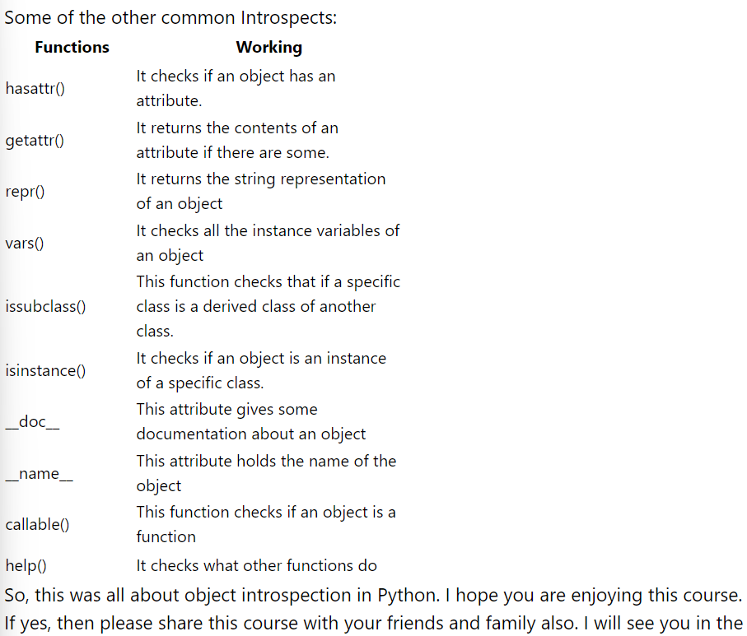

## **Inner Class in Python**

A class defined in another class is known as an **inner class** or nested class. If an object is created using child class means inner class then the object can also be used by parent class or root class. A parent class can have one or more inner classes but generally inner classes are avoided.

We can make our code even more object-oriented by using an inner class. A single object of the class can hold multiple sub-objects. We can use multiple sub-objects to give a good structure to our program.

**Example:**

* First, we create a class and then the constructor of the class.
* After creating a class, we will create another class within that class, the class inside another class will be called an inner class.

|  |
| --- |
| # create a Color class  **class** Color:      # constructor method  **def** __init__(self):      # object attributes      self.name **=** 'Green'      self.lg **=** self.Lightgreen()    **def** show(self):      print("Name:", self.name)      # create Lightgreen class  **class** Lightgreen:  **def** __init__(self):          self.name **=** 'Light Green'          self.code **=** '024avc'    **def** display(self):  **print**("Name:", self.name)          print("Code:", self.code)    # create Color class object  outer **=** Color()    # method calling  outer.show()    # create a Lightgreen  # inner class object  g **=** outer.lg    # inner class method calling  g.display() |

**Output:**

Green

Name:Green

Light Green

023gfd

Name: Light Green

Code: 023gfd

## **Why inner class?**

For the grouping of two or more classes. Suppose we have two classes remote and battery. Every remote needs a battery but a battery without a remote won’t be used. So, we make the Battery an inner class to the Remote. It helps us to save code. With the help of the inner class or nested class, we can hide the inner class from the outside world. Hence, Hiding the code is another good feature of the inner class. By using the inner class, we can easily understand the classes because the classes are closely related. We do not need to search for classes in the whole code, they all are almost together. Though inner or nested classes are not used widely in Python it will be a better feature to implement code because it is straightforward to organize when we use inner class or nested class.

**Syntax:**

# create NameOfOuterClass class

class NameOfOuterClass:

# Constructor method of outer class

def __init__(self):

self.NameOfVariable = Value

# create Inner class object

self.NameOfInnerClassObject = self.NameOfInnerClass()

# create a NameOfInnerClass class

class NameOfInnerClass:

# Constructor method of inner class

def __init__(self):

self.NameOfVariable = Value

# create object of outer class

outer = NameOfOuterClass()

Types of inner classes are as follows:

1. Multiple inner class
2. Multilevel inner class

### **Multiple inner class**

The class contains one or more inner classes known as multiple inner classes. We can have multiple inner class in a class, it is easy to implement multiple inner classes.

**Example:**Multiple inner class

* Python3

|  |
| --- |
| # create outer class  **class** Doctors:  **def** __init__(self):          self.name **=** 'Doctor'          self.den **=** self.Dentist()          self.car **=** self.Cardiologist()    **def** show(self):          print('In outer class')  **print**('Name:', self.name)        # create a 1st Inner class  **class** Dentist:  **def** __init__(self):              self.name **=** 'Dr. Savita'              self.degree **=** 'BDS'  **def** display(self):  **print**("Name:", self.name)              print("Degree:", self.degree)        # create a 2nd Inner class  **class** Cardiologist:  **def** __init__(self):              self.name **=** 'Dr. Amit'              self.degree **=** 'DM'  **def** display(self):              print("Name:", self.name)  **print**("Degree:", self.degree)    # create a object  # of outer class  outer **=** Doctors()  outer.show()    # create a object  # of 1st inner class  d1 **=** outer.den    # create a object  # of 2nd inner class  d2 **=** outer.car  print()  d1.display()  **print**()  d2.display() |

**Output:**

In outer class

Name: Doctor

In inner class 1

Name: Dr. Savita

Degree: BDS

In inner class 2

Name: Dr. Amit

Degree: DM

### **Multilevel inner class**

The class contains an inner class and that inner class again contains another inner class, this hierarchy is known as the multilevel inner class.

**Example:**Multilevel inner class

* Python3

|  |
| --- |
| # create a outer class  **class** Geeksforgeeks:    **def** __init__(gfg):       # create a inner class object       self.inner **=** self.Inner()    **def** show(gfg):  **print**('This is an outer class')      # create a 1st inner class  **class** Inner:    **def** __init__(self):       # create a inner class of inner class object       self.innerclassofinner **=** self.Innerclassofinner()    **def** show(self):  **print**('This is the inner class')       # create a inner class of inner  **class** Innerclassofinner:    **def** show(self):           print()    **def** show(self):           print('This is an inner class of inner class')    # create a outer class object  # i.e.Geeksforgeeks class object  outer **=** Geeksforgeeks()  outer.show()  print()    # create a inner class object  gfg1 **=** outer.inner  gfg1.show()  **print**()    # create a inner class of inner class object  gfg2 **=** outer.inner.innerclassofinner  gfg2.show() |

**Output:**

*This is an outer class This is an inner class This is an inner class of inner class means multilevel inner class*