MACHINE LEARNING

6.PROGRAM

import numpy as np

import matplotlib.pyplot as plt

def estimate_coef(x, y):

n = np.size(x)

m_x = np.mean(x)

m_y = np.mean(y)

SS_xy = np.sum(y*x) - n*m_y*m_x

SS_xx = np.sum(x*x) - n*m_x*m_x

# calculating regression coefficients

b_1 = SS_xy / SS_xx

b_0 = m_y - b_1*m_x

return (b_0, b_1)

# plotting the actual points as scatter plot

def plot_regression_line(x, y, b):

plt.scatter(x, y, color = "m",

marker = "o", s = 30)

y_pred = b[0] + b[1]*x

plt.plot(x, y_pred, color = "g")

plt.xlabel('x')

plt.ylabel('y')

plt.show()

def main():

# observations / data

x = np.array([0, 1, 2, 3, 4, 5, 6, 7, 8, 9])

y = np.array([1, 3, 2, 5, 7, 8, 8, 9, 10, 12])

# estimating coefficients

b = estimate_coef(x, y)

print("Estimated coefficients:\nb_0 = {} \

\nb_1 = {}".format(b[0], b[1]))

# plotting regression line

plot_regression_line(x, y, b)

if __name__ == "__main__":

main()

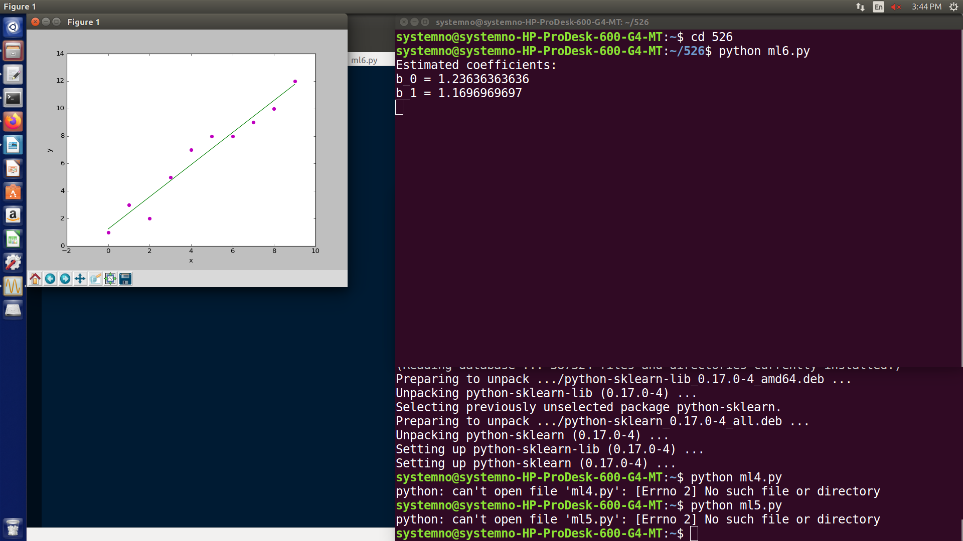

3.PROGRAM

from math import sqrt

def eaclidean_distance(row1,row2):

distance=0

for i in range(len(row1)-1):

distance += (row1[i]-row2[i])**2

return sqrt(distance)

def get_neighbor(train,test_row,num_neighbors):

distances=list()

for train_row in train:

dist=eaclidean_distance(test_row,train_row)

distances.append((dist,train_row))

distances.sort()

neighbors=list()

for i in range(num_neighbors):

neighbors.append(distances[i][1])

return neighbors

dataset=[[1,2,0], [3,4,0] ,[3,3,0],[7,2,1],[5,2,2],[7,3,1]]

neighbors=get_neighbor(dataset,[5,4,2],2)

for neighbor in neighbors:

print(neighbor)

OUTPUT:

python ml3.py

[3, 4, 0]

[5, 2, 2]

4.PROGRAM

from pandas import DataFrame

import matplotlib.pyplot as plt

from sklearn.cluster import KMeans

Data={'x':[1.713,0.180,0.353,0.940,1.486,1.266,1.540,0.5459,0.773],'y':[1.586,1.786,1.240,1.566,1.759,10.106,0.419,1.799,0.816]}

df=DataFrame(Data,columns=['x','y'])

kmeans=KMeans(n_clusters=3).fit(df)

centriods=kmeans.cluster_centers_

print(centriods)

plt.scatter(df['x'],df['y'],c=kmeans.labels_.astype(float),s=50,alpha=0.5)

plt.scatter(centriods[:,0],centriods[:,1],c='red',s=50)

plt.show()

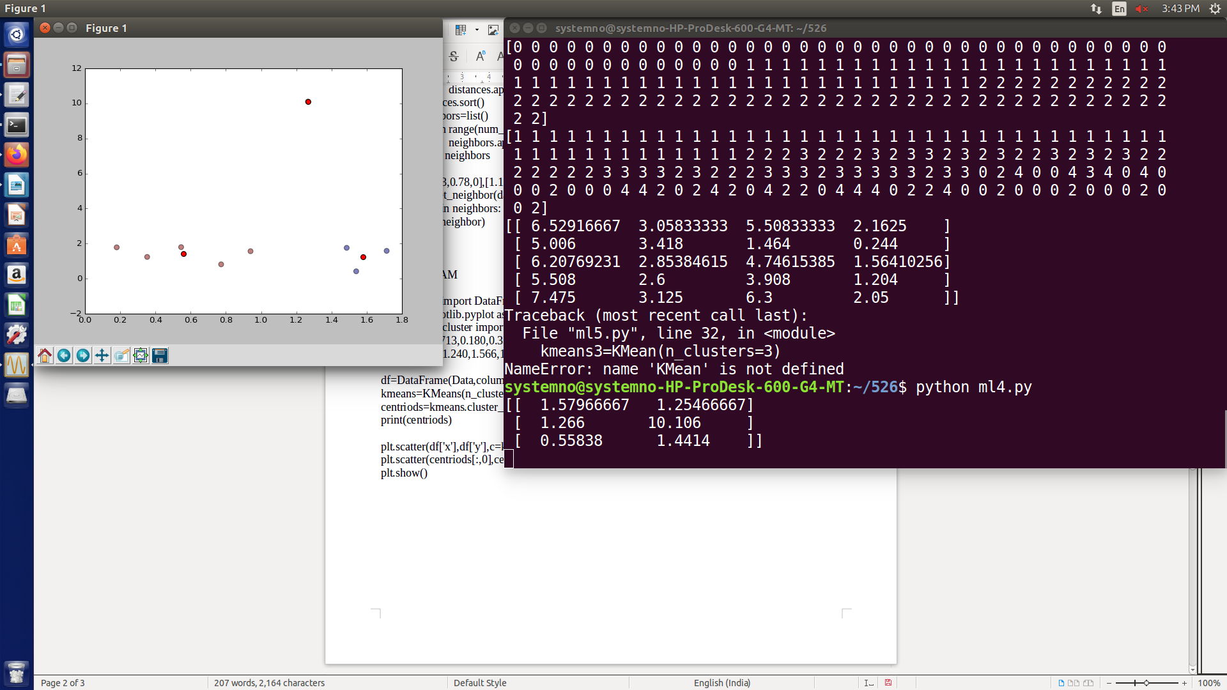

5.PROGRAM

import numpy as np

import pandas as pd

import matplotlib as plt

from sklearn.cluster import KMeans

from sklearn import datasets

df=datasets.load_iris()

x=df.data

y=df.target

print(x)

print(y)

kmean=KMeans(n_clusters=5)

y_kmean=kmean.fit_predict(x)

print(y_kmean)

print(kmean.cluster_centers_)

Error=[]

for i in range(1,11):

kmeans=KMeans(n_clusters=i).fit(x)

kmeans.fit(x)

Error.append(kmeans.inertia_)

import matplotlib.pyplot as plt

plt.plot(range(1,11),Error)

plt.title('Elbow method')

plt.xlabel('no of clusters')

plt.ylabel('Error')

plt.show()

kmeans3=KMean(n_clusters=3)

y_kmeans3=kmeans3.fit_predict(x)

print(y_kmeans3)

print(kmeans3.cluster_centers_)

OUTPUT

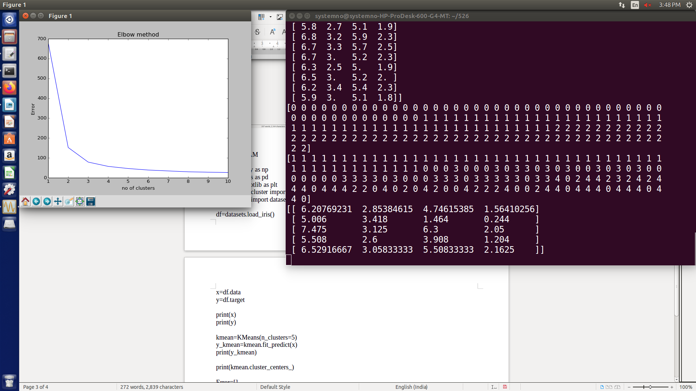

7.PROGRAM

print("NAIVE BAYES ENGLISH TEST CLASSIFICATION")

import numpy as np, pandas as pd

import seaborn as sns

import matplotlib.pyplot as plt

from sklearn.datasets import fetch_20newsgroups

from sklearn.feature_extraction.text import TfidfVectorizer

from sklearn.naive_bayes import MultinomialNB

from sklearn.pipeline import make_pipeline

from sklearn.metrics import confusion_matrix, accuracy_score

sns.set()

data = fetch_20newsgroups()

text_categories = data.target_names

train_data = fetch_20newsgroups(subset="train", categories=text_categories)

test_data = fetch_20newsgroups(subset="test", categories=text_categories)

print("We have {} unique classes".format(len(text_categories)))

print("We have {} training samples".format(len(train_data.data)))

print("We have {} test samples".format(len(test_data.data)))

model = make_pipeline(TfidfVectorizer(), MultinomialNB())

model.fit(train_data.data, train_data.target)

predicted_categories = model.predict(test_data.data)

print(np.array(test_data.target_names)[predicted_categories])

mat = confusion_matrix(test_data.target, predicted_categories)

sns.heatmap(mat.T,square=True,annot=True,fmt="d",xticklabels=train_data.target_names,yticklabels=train_data.target_names)

plt.xlabel("true labels")

plt.ylabel("predicted label")

plt.show()

print("The accuracy is {}".format(accuracy_score(test_data.target, predicted_categories)))

