Wireshark Packet Analysis Project Report

Task 1:
- Screenshot of the packet that contains the username and password details:

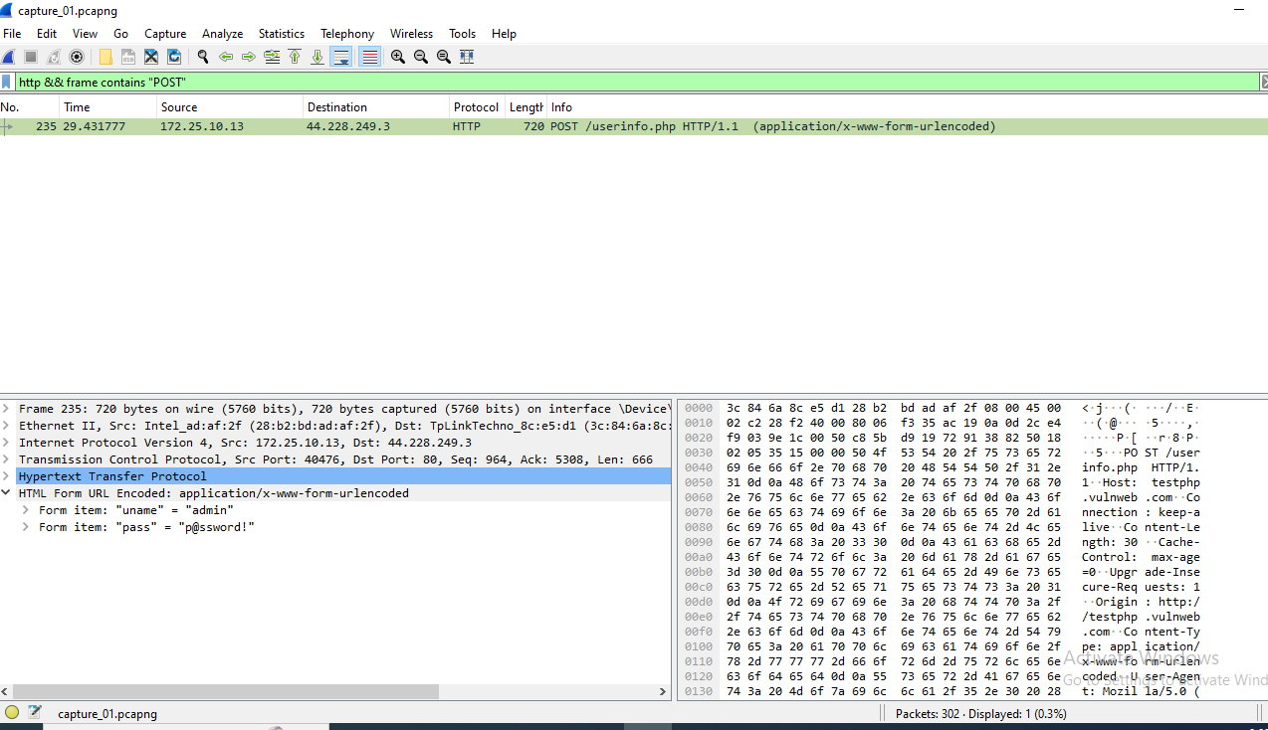

Task 2:
- Screenshot (of the packet list pane) for the 3-way TCP handshake:
[showing that the Frame No., Time, Source, Destination, Protocol, Length and Info details are visible in the screenshot].

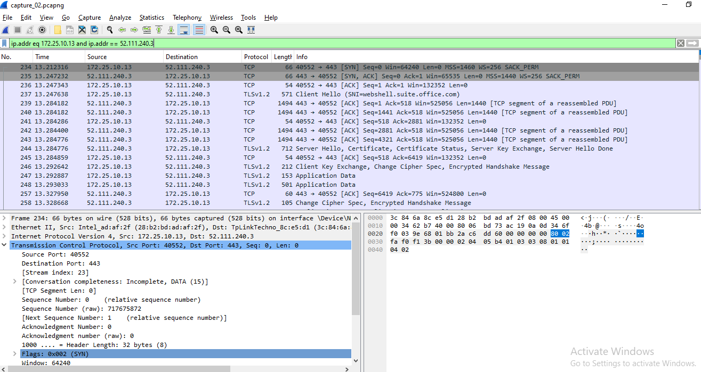

- Complete the following table:

 | Frame No. | Source IP address | Source port number | Destination IP address | Destination port
SYN Packet | 234 | 172.25.10.13 | 40552 | 52.111.240.3 | 443
SYN-ACK Packet | 235 | 52.111.240.3 | 443 | 172.25.10.13 | 40552
ACK-Packet | 236 | 172.25.10.13 | 40552 | 52.111.240.3 | 443

Task 3:
- Screenshot of the DNS response containing the IPv4 address:
[Showing that the Frame No. and the IPv4 address are clearly visible on the screenshot]
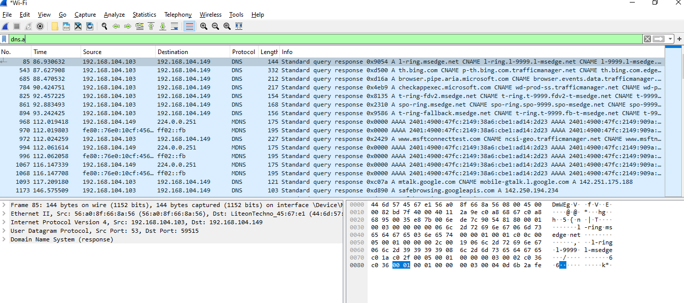

- SHA-1 hash of the .pcap file that we saved: 8d1378e07593030abe78ca464c5987e7bdf36060

[Use the tool - https://emn178.github.io/online-tools/sha1_checksum.html to get the SHA-1 hash]

- Upload the .pcap file on Olympus along with this Word document.

Q&A
1.What is Wireshark used for?

Ans: Wireshark is a powerful network packet analyzer that allows users to capture and examine network traffic in detail. It is widely used by network administrators, security professionals, and developers for troubleshooting, debugging, and learning about network protocols. Wireshark is open-source, free to use, and supports multiple platforms, including Windows, macOS, and Linux.

2.What is a packet?
Ans: A packet is a small segment of data sent over a network, such as the Internet. It is divided into smaller segments for efficient transmission and is reassembled at the destination. Each packet contains essential information, including the source and destination addresses, and may also include error-checking codes to ensure reliable delivery.

3.How to filter packets in Wireshark?
Ans: Wireshark allows filtering packets by protocol using display filters. This helps focus on specific protocols while analyzing network traffic.

4.What is the difference between TCP and UDP?

Ans: Transmission Control Protocol (TCP) and User Datagram Protocol (UDP) are two core transport layer protocols in computer networking, each designed for specific use cases.
TCP is a connection-oriented protocol, meaning it establishes a connection before data transmission and ensures reliable delivery. It provides features like error checking, acknowledgment, retransmission of lost packets, and sequencing of data, ensuring packets arrive in order. However, these features make TCP slower and heavier. It is commonly used in applications requiring reliability, such as HTTP, FTP, and email.
UDP, on the other hand, is a connectionless protocol, which does not establish a connection before sending data. It is faster and lightweight but does not guarantee delivery, order, or retransmission of lost packets. UDP is ideal for real-time applications like VoIP, video streaming, and gaming, where speed is prioritized over reliability.

5.What is a DNS query packet?

Ans: A DNS query packet is a structured message sent by a client to a DNS server to resolve a domain name into an IP address or retrieve other DNS-related information. The packet follows a standardized format defined by the DNS protocol, ensuring consistent communication between clients and servers.

6.How can packet capture help in troubleshooting?

Ans: Packet capture is a critical technique in network troubleshooting, enabling the interception, analysis, and recording of data packets transmitted across a network. Its primary purpose is to provide detailed insights into network behavior, helping administrators identify and resolve issues effectively.

Packet capture is essential for diagnosing performance problems, such as slow traffic or packet loss. By analyzing captured packets, administrators can pinpoint the root cause of issues like network congestion, misconfigured devices, or faulty hardware. This level of visibility is invaluable for ensuring smooth data flow and maintaining optimal network performance.

It is also instrumental in detecting security vulnerabilities and intrusion attempts. Packet capture tools can identify suspicious activities, such as unauthorized access or malicious traffic patterns, allowing for timely intervention to protect the network. This makes it a vital component of intrusion detection systems and overall network security.

Additionally, packet capture aids in managing and optimizing network traffic. By examining the flow of data between devices, administrators can identify bottlenecks, prioritize critical traffic, and ensure efficient utilization of network resources. This is particularly useful in enterprise environments where high-performance networks are crucial
In summary, the primary purpose of packet capture in network troubleshooting is to provide a granular view of network activity, enabling the identification and resolution of performance, security, and traffic management issues.

7.What is a protocol?

Ans: Protocols are essential for enabling communication between devices in a network. Below is a description of the purpose of some widely used protocols:

HTTP (Hypertext Transfer Protocol): Used for transferring hypertext (web pages) between a client (browser) and a server. It operates on a request-response model and is the foundation of data communication on the web.

FTP (File Transfer Protocol): Facilitates the transfer of files between a client and a server. It is commonly used for uploading and downloading files from remote servers.

POP3 (Post Office Protocol v3): Allows email clients to retrieve messages from a mail server. Once emails are downloaded, they are typically deleted from the server.

IMAP (Internet Message Access Protocol): Enables email clients to access and manage emails directly on the server. Unlike POP3, emails remain on the server, allowing synchronization across multiple devices.

SMTP (Simple Mail Transfer Protocol): Used for sending emails from a client to a mail server or between mail servers. It ensures the delivery of outgoing messages.

BitTorrent: A peer-to-peer protocol for sharing large files efficiently. It divides files into smaller chunks, allowing users to download and upload simultaneously, reducing server load.

8.Can Wireshark decrypt encrypted traffic?

Ans: Wireshark is a powerful tool for analyzing encrypted traffic, such as HTTPS or TLS, by decrypting it when provided with the necessary session keys. Below are the steps to analyze encrypted traffic effectively.

1. Capture Encrypted Traffic

Use Wireshark or its command-line counterpart tshark to capture network traffic.

Example command for capturing traffic on a specific port:

sudo tshark -i eth0 -f "tcp port 443" -w capture.pcap
Copy
2. Obtain Session Keys

To decrypt encrypted traffic, you need the TLS session keys. These can be obtained using one of the following methods:

Using SSLKEYLOGFILE Environment Variable

Set the SSLKEYLOGFILE environment variable in your application environment:

export SSLKEYLOGFILE=/path/to/sslkeys.log
Copy
Run your application (e.g., browser) with this variable enabled. The session keys will be logged to the specified file.

Using a Dynamic Library Shim

For applications that do not natively support SSLKEYLOGFILE, you can use a shim library:

Compile a shim library to intercept TLS key generation:

gcc -shared -fPIC -o libsslkeylog.so shim.c -ldl -pthread
Copy
Preload the library and set the key log file:

export LD_PRELOAD=/path/to/libsslkeylog.so
export SSLKEYLOGFILE=/path/to/sslkeys.log
Copy
3. Load Keys into Wireshark

Open Wireshark and navigate to Edit → Preferences → Protocols → TLS.

In the (Pre)-Master-Secret log filename field, browse and select your sslkeys.log file.

Click OK to save settings.

4. Analyze Decrypted Traffic

Open your captured .pcap file in Wireshark.

Decrypted traffic will now be visible under protocols like HTTP or other application-layer protocols.

