

HARMONY



MELODY HIGHER



MELODY LOWER



RHYTHM

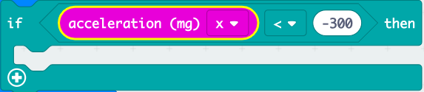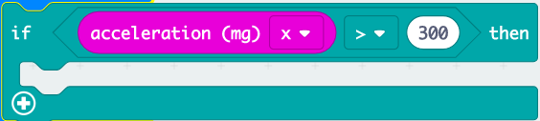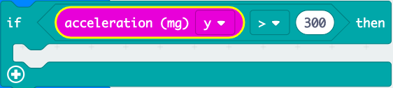

Tilt Left

Tilt Back

Tilt Right

Tilt Forward

GESTURES