Particle Swarm Optimization: An Overview

Jamal J. A. Solomon

Anhui Normal University

School ID Number: 1842010013 _

Date Submitted: June 25, 2019

Abstract

Within the field of computational intelligence (Brownlee, 2012), particle swarm optimization (PSO) comes of out of inspiration by the social behavior of some animals[1] and is considered to be one of the most important algorithms when it comes to swarm intelligence (El-Shorbagy, 2018). PSO comes with several advantages which make is suitable for scientific research and applications in the real world, is easily implemented and is inexpensive in terms of computation resources (El-Shorbagy, 2018). However, in order to use PSO, we must understand what it is, what it can do and its limitations. This paper introduces PSO, taking a look at its history, features, limitations and applications.

**Keywords**: Particle Swarm Optimization, PSO, Optimization Problems, Swarm Intelligence

# Introduction to Particle Swam Optimization

## What is Particle Swam Optimization?

Particle Swarm Optimization is a computational algorithm that depends on the intelligence of the swarm. Introduced by Kennedy and Eberhart in 1995, PSO is a simple computational method for optimizing problems inspired by the social behavior and movement dynamics of insects, birds and fish (Schutte, 2005). PSO is related to other Swarm Intelligence algorithms and it is a base algorithm for numerous variations (Brownlee, 2012). PSO is a population-based optimizer, with an objective of having all the particles locate the optima in a multi-dimensional hyper-volume. It achieves this by preparing a set of random potential solutions, then the search for the ideal solution(s) repetitively. (El-Shorbagy, 2018)

## The Basic Algorithm

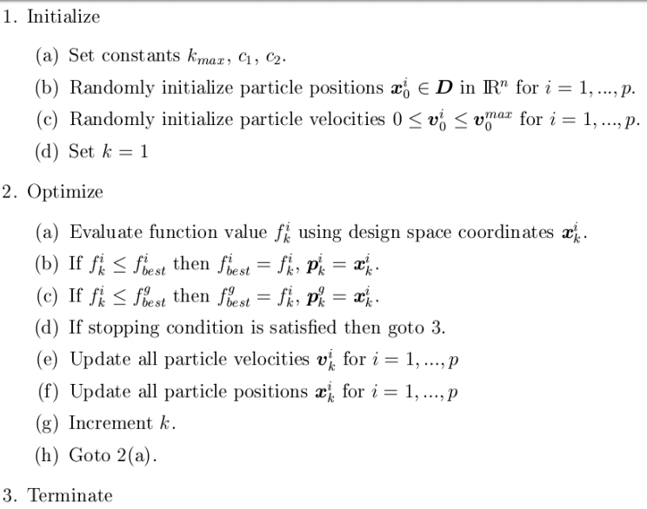

Figure 1 - Terms used in basic PSO (Schutte, 2005)

As proposed by Kennedy and Eberhart in 1995, the basic algorithm is shown in the figure above, with the variables used are defined below.

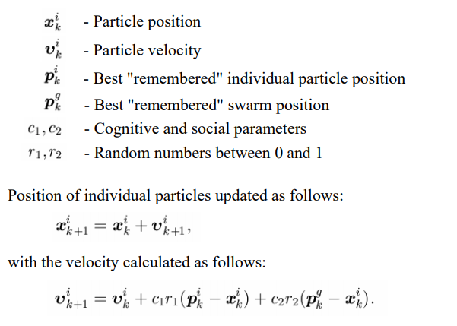

Figure 2 - Basic PSO (Schutte, 2005)

## Particle Swam Optimization Advantages & Limitations

PSO has a number of advantages, some of which are listed below:

1. it is not sensitive to the scale of design variables
2. it is simple to implement
3. the PSO algorithm has very few parameters
4. it is efficient in global searching

However, like any algorithm, PSO does have several limitations. Two of the major limitations are its local searching ability is weak (Schutte, 2005) and due to premature convergence, PSO can get stuck quite easily, thus being unable to explore the domain of search enough (El-Shorbagy, 2018).

# Applications of Particle Swam Optimization

The PSO algorithm has an innumerable amount of applications in many different fields, some of which are:

1. training of neural networks including the identification of Parkinson’s disease and image recognition,
2. optimization of electric power distribution networks,
3. and structural optimization including optimal shape and sizing design and topology optimization

## An implantation of PSO in C#

Posted by Trenki on GitHub in 2019, this PSO was developed to optimize trading systems. In a nutshell, this implementation sets up the boundaries of the search-space and specifies the function to be optimized, stepping the particle swarm is stepped for up to 100 iterations and outputs the currently best-found solution in each iteration. A sample of the usage of the implementation (in C#) is shown in the figure below.

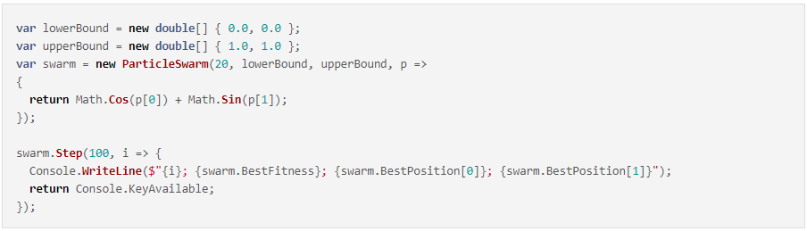

Figure 3 Usage of Trenki's PSO (Trenki, 2019)

References

Brownlee, J. (2012). *Clever Algorithms: Nature-Inspired Programming Recipes.* lulu.com.

El-Shorbagy, M. &. (2018). Particle Swarm Optimization from Theory to Applications. *International Journal of Rough Sets and Data Analysis, 5*(2).

Schutte, J. F. (2005). *The Particle Swarm Optimization Algorithm.* Retrieved from mii.lt: https://www.mii.lt/antanas/uploads/Heuristic%20Algorithms/Lectures/Lect4/PSO2.pdf

Trenki. (2019, March 19). *Particle Swarm Optimization in C#*. Retrieved from Trenki's Dev Blog: https://trenki2.github.io/blog/2019/03/19/particle-swarm-optimization/

1. “Particle Swarm Optimization is inspired by the social foraging behavior of some animals such as flocking behavior of birds and the schooling behavior of fish.” (Brownlee, 2012)