TBMI26 – Computer Assignment Report  
Deep learning

Author/-s: Gustav Wahlquist & William Stokke

Guswa204, Wilst664

**Task 1**

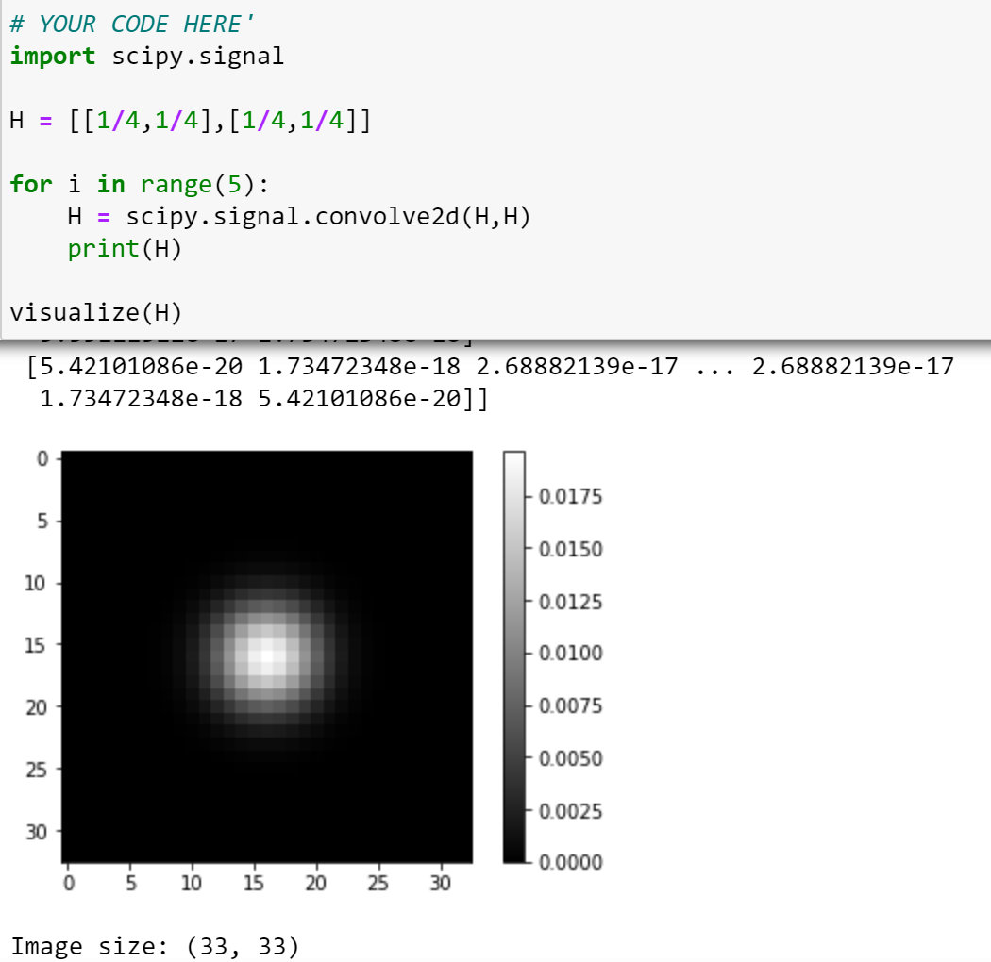

**Task 2**

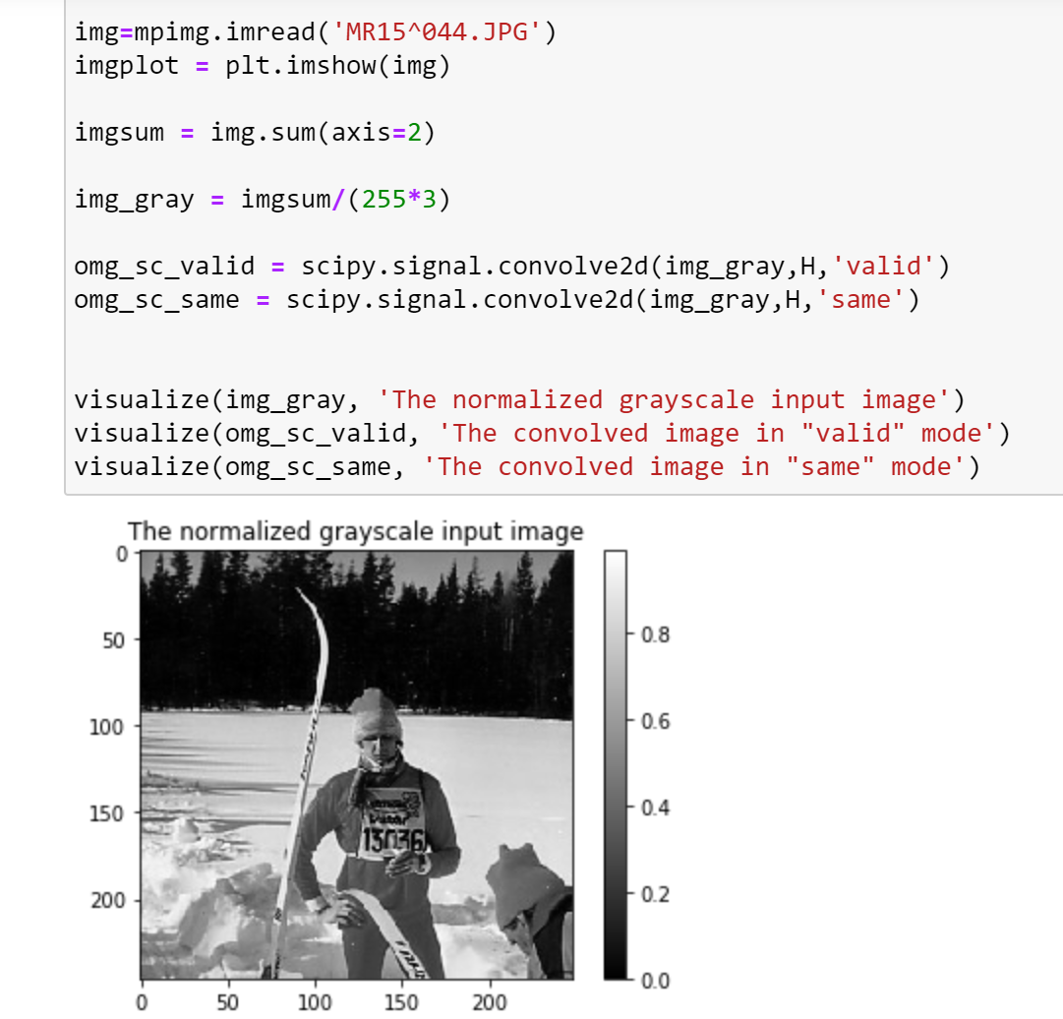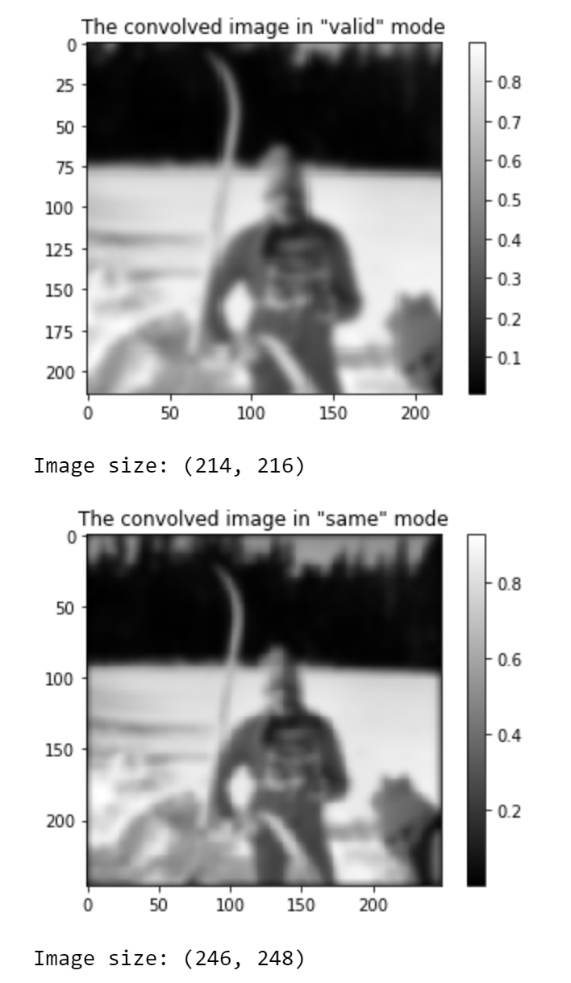

When convolving in “same”-mode, the output is in the same size as the input image, when convolving in the “valid”-mode we do not get any output that would rely on zero-padding which means in this case that we lose 32px in each dimension (the filter is 33x33).

**Task 3**

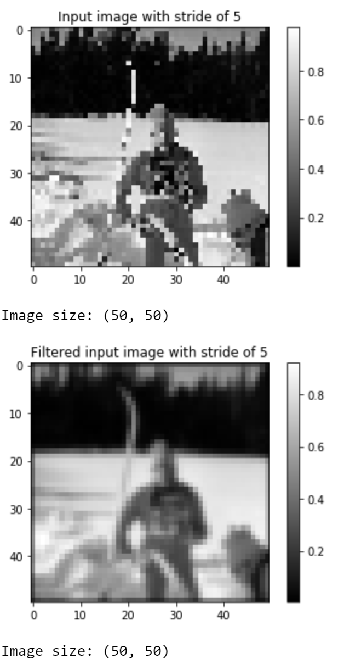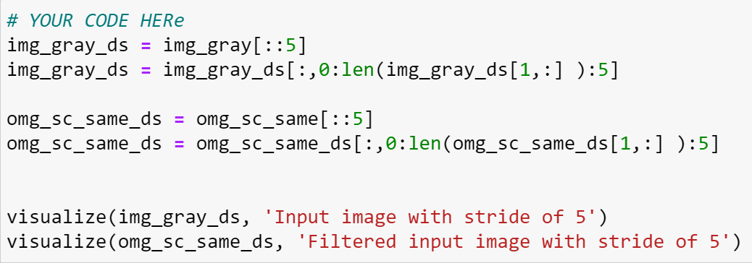

Since the original image is not blurred and has sharp edges, when we now take a small sample of all the pixels the downsampling is not as robust as when we do it on a blurred image(the filtered image).

You can see that the ski in the original image with stride looks “pixely” and it is hard to see what it resembles since you got either very bright or very dark pixels on the ski. In the blurred one the pixels you get in your smaller sample is still influenced by nearby not shown pixels.

**Task 4**

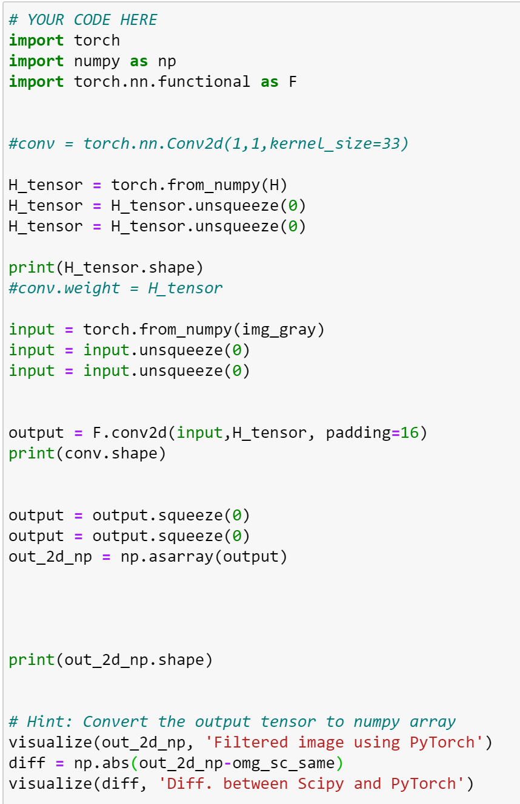 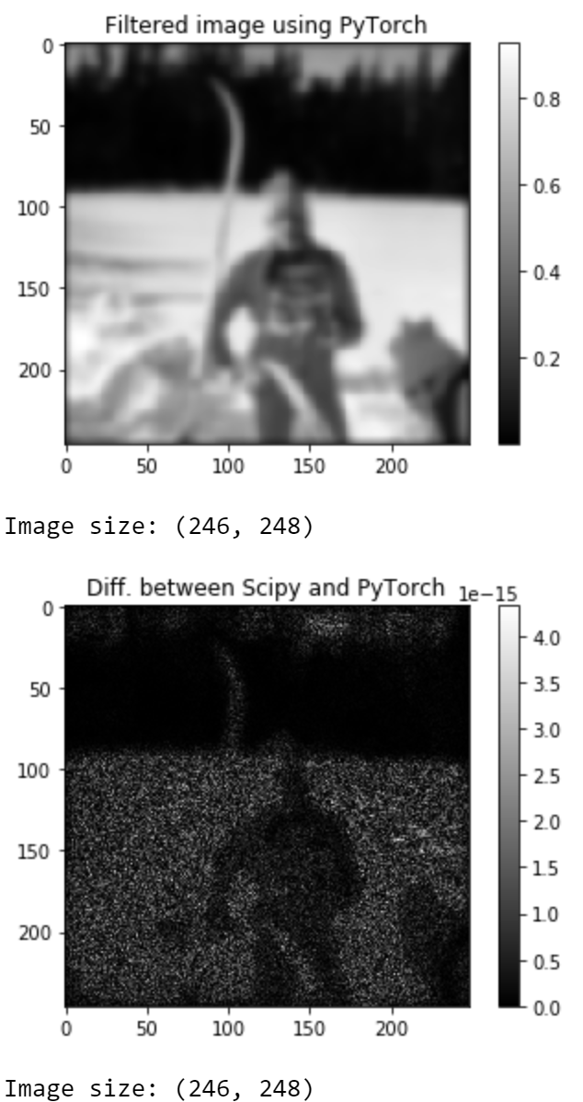

**Task 5**

