Reverse-Engineering & Exploitation
Linux Write up, Dungeon number 1
Thaha Jemni
19091168
This document is a part of the HBO-ICT, Reverse Engineering and Exploitation Minor, Zoetermeer



Linux Dungeon 1
This entire write up was done using Virtualbox 7 (build r154605) with a Ubuntu 18.04 guest running on x86 architecture. The host is Linux Mint 21 on a x86_64 architecture. The Dungeon file was provided as is from Brightspace.
The first thing I did, before trying anything with the binary, was to see what the program did while running it ‘normally’, a.k.a. without any tooling helping me. The program starts up with the text “Guard: Go away or I shall ring the alarm!”. After this the program requires me to input something, without providing anything of a hint. I provided it with the two letter ‘aa’. This result was given back to me:
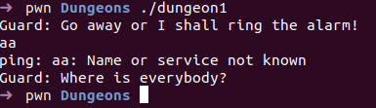
As you can see, it looks like it executes the ‘ping’ command. The arguments given to this commands is the same as the text I’ve written down. Then it returns a ‘Guard: Where is everybody?’ back to me.
Trough this I know it requires input which is send to ‘ping’.
To see what the headers are present in the binary, I ran ‘objdump -x dungeon1’. From this I could see there where 3 functions that where of interest to me: main, gate and vault. Especially the ‘vault’ interested me, so I started up pwndbg to disassamble these functions and see what they did.
In pwndbg I disassembled both main, gate and vault to see anything of interest to me. I called pwndbg with the following command: ‘dbg dungeon1’ and the disassembled the functions with ‘disassemble [function name]’ (so for vault it’s disassemble vault. Out of this information I could see that the main function only calls the gate functions, but the gate function never calls the vault function. Also there is a check to see if the stack has been overwritten, yes or no.
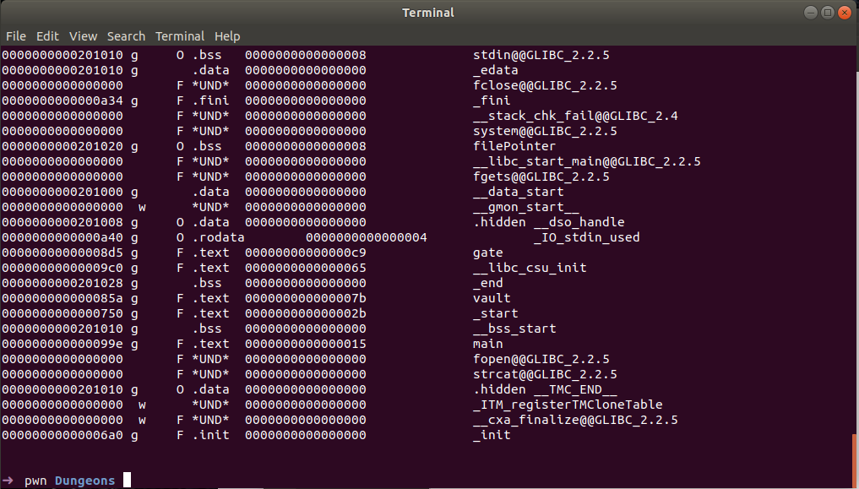Afbeelding 1: Part of the output of the 'objdump -x dungeon1' cowmmand, where you can see the vault, main and gate functions present
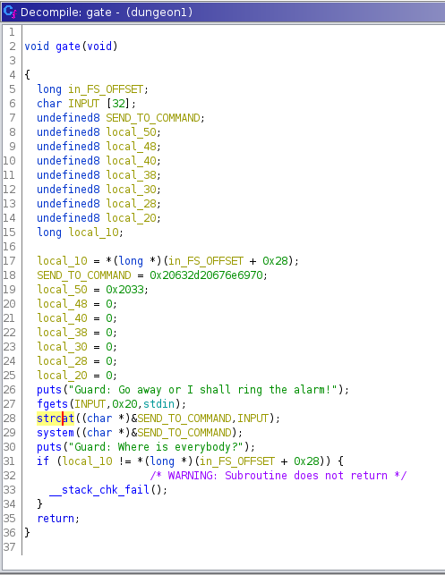
To have a clearer view on what the logic behind the source code is, I ran the binary trough Gidhra, with the following output from the ‘gate’ function:
Here I found something interesting. From the CWE top 25 I could find. CWE-77 (https://cwe.mitre.org/data/definitions/77.html) has some of the same structure as lines 28 en 29 of the output in Gidhra. With this in mind, and looking at the documentation of CWE-77, I tried some of the following things:
I tried to give 127.0.0.1 and echo “hello world” as inputs into the program, divided by a semicolon.
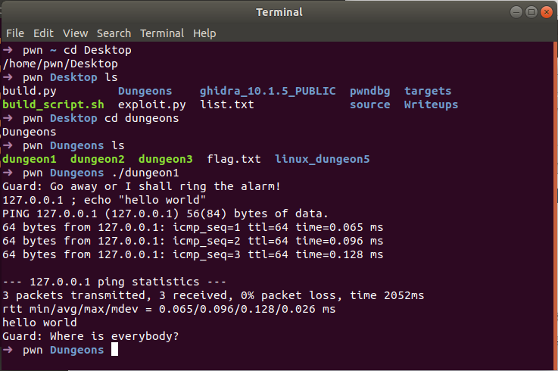
This seemed to work!
Now let’s try and echo cat the flag.txt instead:

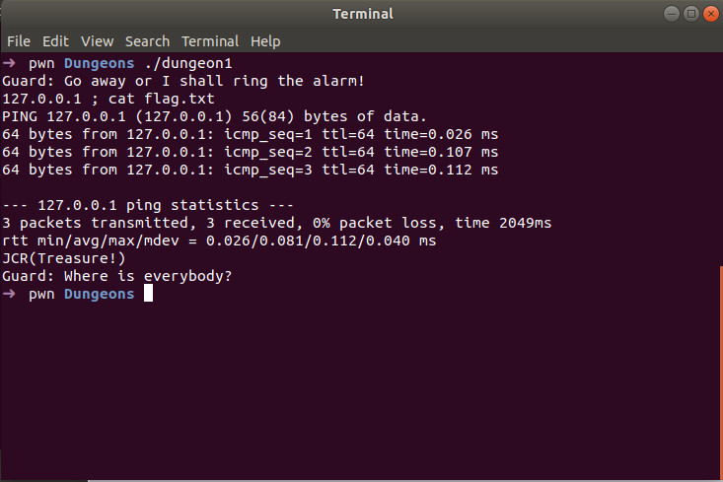
This seemed to do the trick!

Therefore the dungeon1 executable is vulnerable to a CWE-77 (command injection).

