Reverse-Engineering & Exploitation
Windows Write Up, Challenge 2
Thaha Jemni
19091168
This document is a part of the HBO-ICT, Reverse Engineering and Exploitation Minor, Zoetermeer

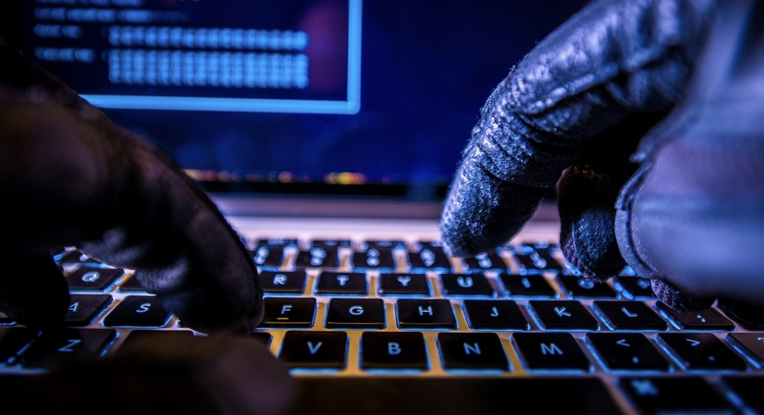

Challenge 2
This Challenge has been done using VirtualBox 7 on a Linux X86_64 hosts with a Windows 7 X86 guest. Please take this into consideration while recreating the steps in this write up.

