Makehuman + Blender + bvh Animations

This is a short tutorial on how to create animations suitable for use in Ely games with Panda3d.
It doesn't explain how to use the various tools, but only their configurations aimed to get the desired results.
It's based on various video tutorials retrieved by googling the net:
- http://www.youtube.com/watch?v=9uqLaEZQg5s
- http://www.youtube.com/watch?v=ryCd8XLVUxI
- http://www.youtube.com/watch?v=kPYbdnPwHuQ
- http://www.youtube.com/watch?v=2hylWVut7z0
- http://www.youtube.com/watch?v=AzYotTZVhcM

Makehuman
Version used: 1.0.2.
Download: http://www.makehuman.org/content/download.html
Create your model as usual, using whatever you want: skins, clothes etc...
You should choose a low-poly version for your model:
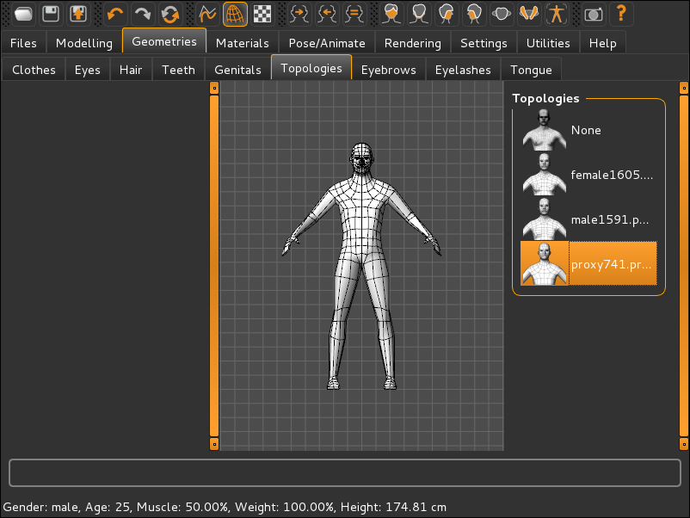
When done, export to Blender exchange (mhx) mesh format, choosing the Export for Rigify option:
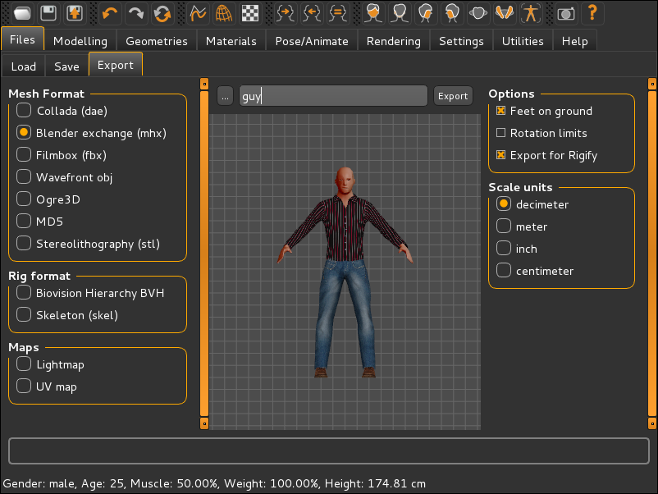

Blender
Version used: 2.72b
Download: http://www.blender.org/download/
First prepare YABEE addon package, i.e. the Blender to Panda3d exporter:
$ git clone https://github.com/09th/YABEE.git
$ cd YABEE
$ git archive --format=zip –output=../YABEE.zip \
--prefix=io_scene_egg/ master
Second install the addon from the prepared package into Blender:
- select File->User Preferences... from menu (Ctrl-Alt-u shortcut)
- choose Addons tab
- push Install from File... button.
- select the package
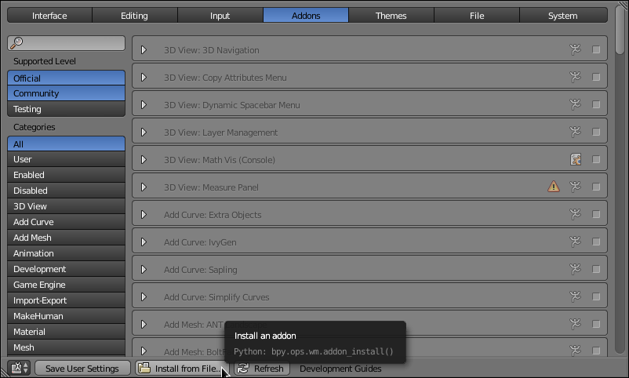
Then enable the exporter addon:
- check Import-Export:Panda3d EGG format box
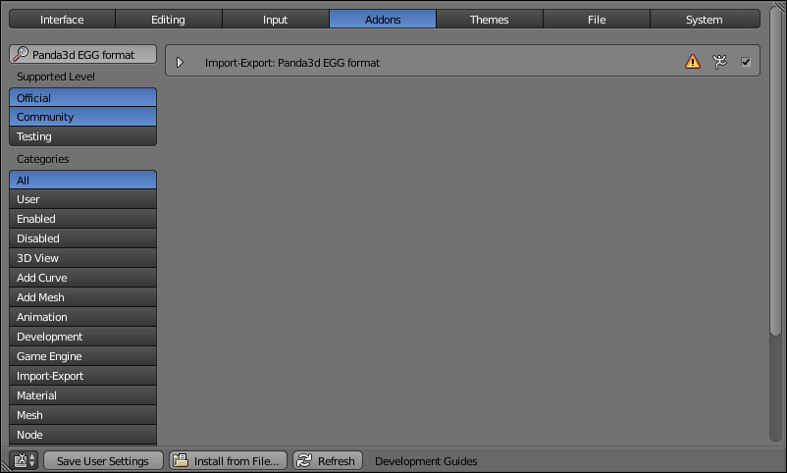

Then download and install Makehuman's Blender tools :
$ wget http://download.tuxfamily.org/makehuman/releases/1.0.2/blendertools-1.0.2-all.zip
$ unzip blendertools-1.0.2-all.zip
$ cd blendertools
$ mv makeclothes maketarget makewalk mhx_importer \
~/.config/blender/2.72/scripts/addons
restart Blender and enable the addons tools:
- select File->User Preferences... from menu (Ctrl-Alt-u shortcut)
- choose Addons tab
- push Makehuman button
- check MakeHuman:Make Clothes, MakeHuman:Make Target, MakeHuman:MakeWalk boxes

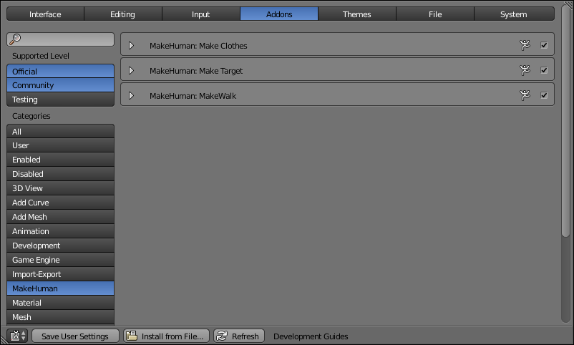
Then enable Makehuman eXchange format:
- select File->User Preferences... from menu (Ctrl-Alt-u shortcut)
- choose Addons tab
- push Import-Export button
- check Import-Export:Import: MakeHuman (.mhx) box
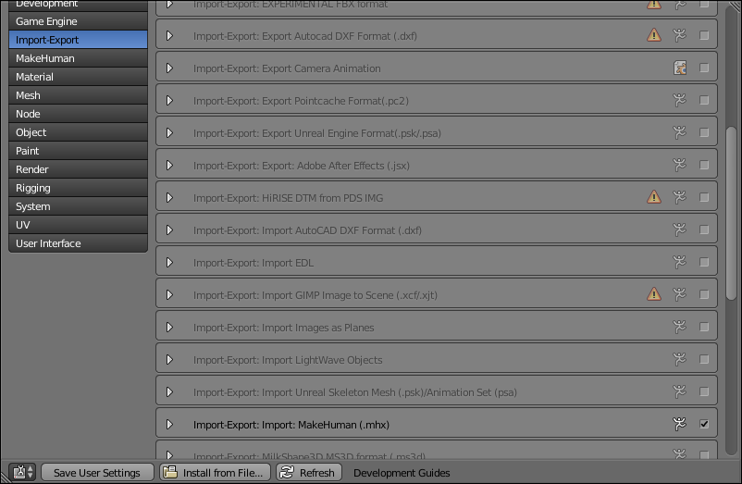
Lastly enable Auto Execution:
- select File->User Preferences... from menu (Ctrl-Alt-u shortcut)
- choose File tab
- check Auto Run Python Scripts box
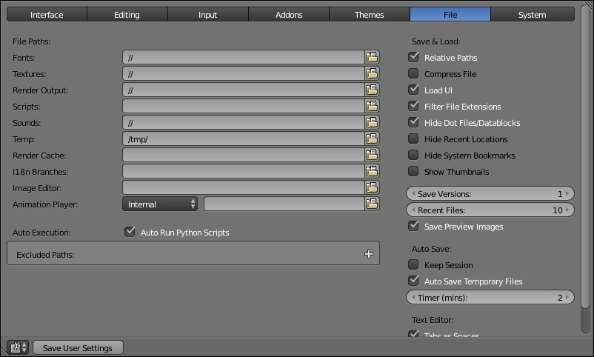
and enable Rigify:
- select File->User Preferences... from menu (Ctrl-Alt-u shortcut)
- choose Addons tab
- push Rigging button
- check Rigging:Rigify box

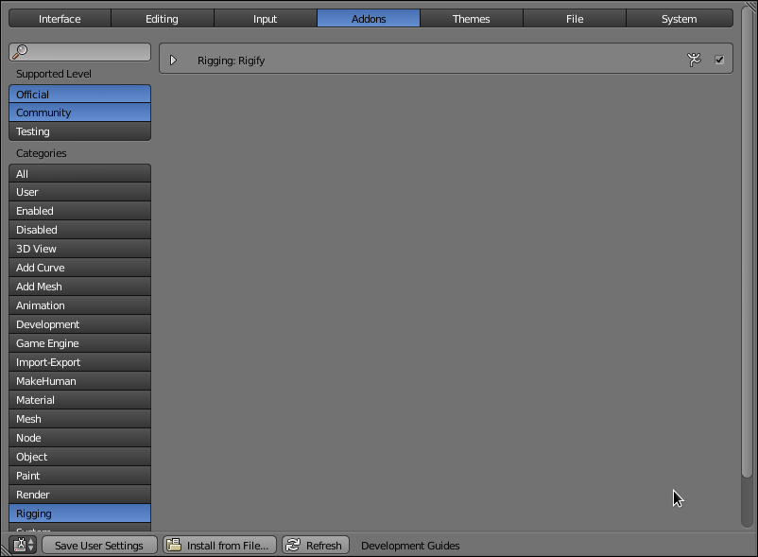

BVH Motion Captures Files
There are many free repositories of mocap files.
You could find many of them in bvh (Biovision Hierarchy) format on this site:
- https://sites.google.com/a/cgspeed.com/cgspeed/motion-capture
Choose to download the Motiobuilder-friendly version (https://sites.google.com/a/cgspeed.com/cgspeed/motion-capture/cmu-bvh-conversion), for example the 01-09 zip file (http://www.mediafire.com/?o6ncxuu1oq5r6z9).

Makehuman + Blender + bvh + Animations
Open Blender and delete all objects in the scene (shortcuts A → A → X).
Import your Makehuman model: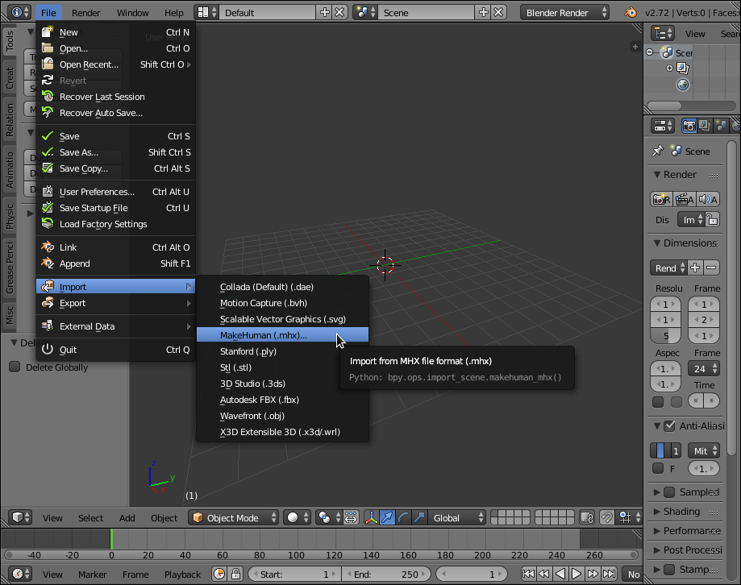
From the Tool Shelf (on the left) choose the Misc tab and on the MakeWalk v 0.943: Main section push the Load And Retarget button to load a bvh animation file (for example cmuconvert-mb2-01-09/07/07_03.bvh):

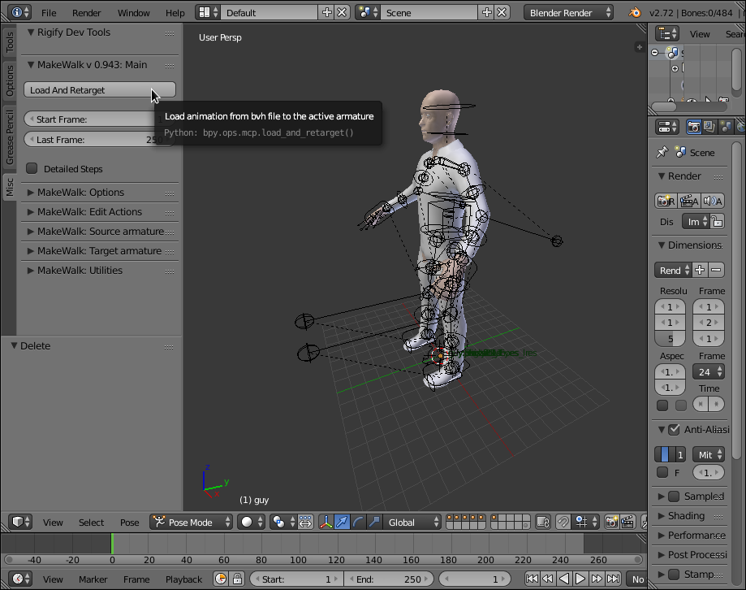
Done!

