File Metadata Cleaner User Guide
Clean image and document properties in batches, then save the results to a folder or ZIP. This guide shows the current Windows GUI with actual sample runs.

Install and select a folder
Install Python 3.10 or later. Open a terminal in the tool folder and run these commands. After setup, launch_cleaner.bat also starts the GUI.
python -m pip install -r requirements.txt
python image_metadata_cleaner.py
Click Browse beside Source folder. Select the folder containing your files. Enable Include subfolders if needed, then choose an export destination.
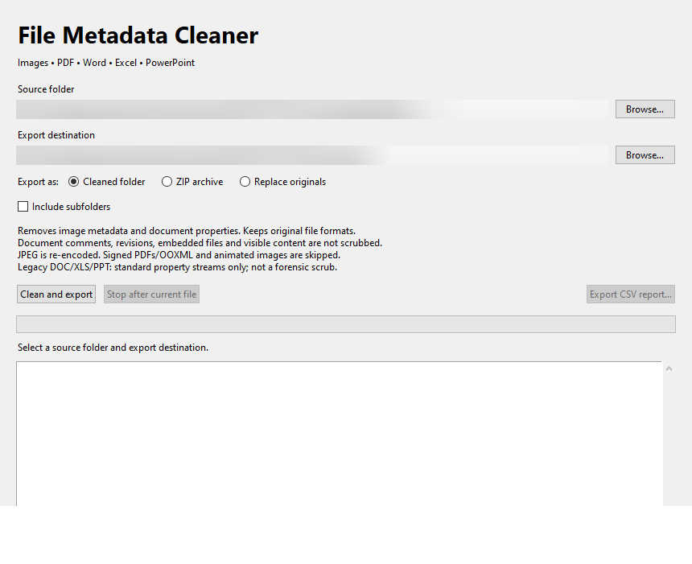
Figure 1 Source and destination selected before cleaning

Choose an export option
Cleaned folder creates a new cleaned_files_ folder inside your chosen destination. Leave the destination blank to use the source folder. Originals remain intact.
ZIP archive saves successful results and a CSV report to a new ZIP filename. Select ZIP archive before browsing for its destination. Existing ZIP files are not overwritten.
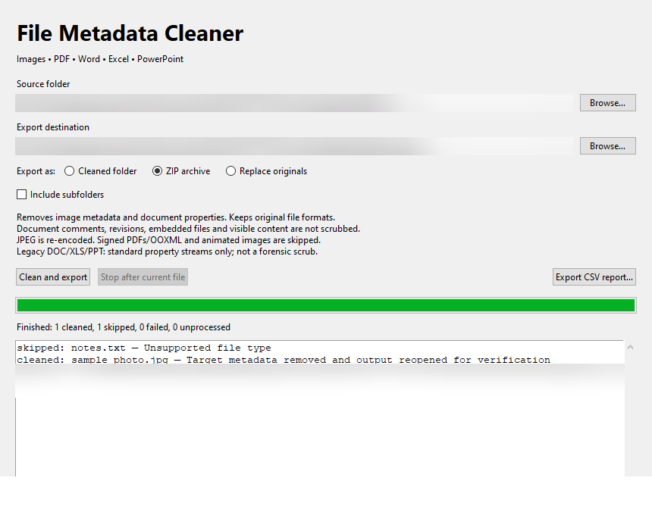
Figure 2 Completed ZIP export using sample files
Replace originals permanently replaces each successfully verified file after confirmation. Keep a backup first. Export destination is unused in this mode.
Exports retain the original file formats and subfolder structure. They do not convert documents or images to other formats.

Run the cleaner and check results
Click Clean and export. The progress bar and log update as files are processed. Stop after current file finishes the active file and exports a partial result.
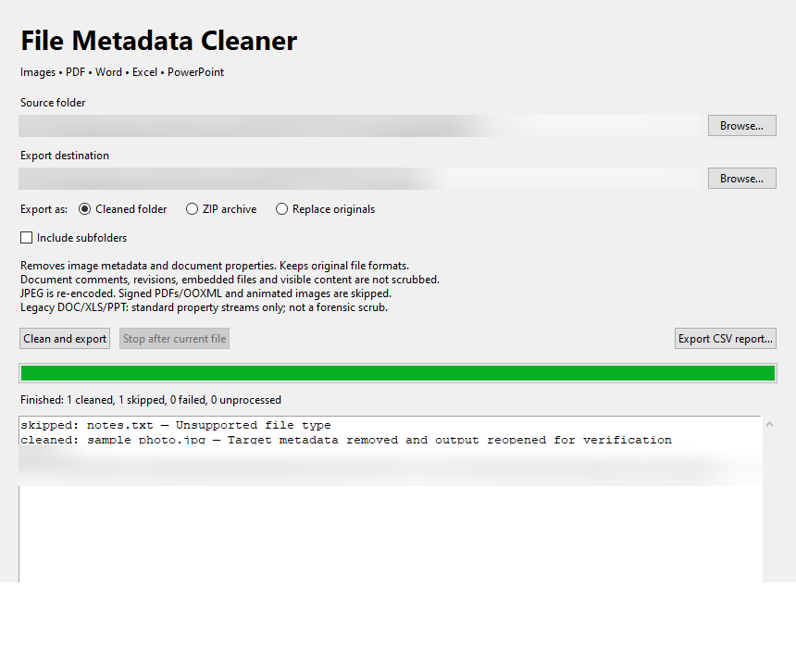
Figure 3 Folder export finished with one cleaned image and one unsupported text file
Cleaned means the targeted metadata was removed and the output reopened for verification. Skipped means the format is unsupported. Failed includes unreadable or rejected files; read the log for the reason. Unprocessed means the batch was stopped.
The log shows the output location. Folder and ZIP exports include a CSV report. Use Export CSV report to save results separately, including after replacing originals.

Supported files and cleaning limits
Metadata properties are removed or emptied, rather than changed to the literal text null. Required file structure remains so the files can still open.
Type | Extensions | Cleaning scope
Images | JPG JPEG PNG WebP BMP TIFF | Removes EXIF, GPS, XMP, comments, text and color profiles. Static images only. JPEG is re-encoded; colors may change.
PDF | PDF | Removes document properties, document ID and XMP. Encrypted PDFs and signature fields are rejected.
Modern Office | DOCX XLSX PPTX | Clears standard core, application and custom properties and property thumbnails. Signed packages are rejected.
Legacy Office | DOC XLS PPT | Clears standard OLE property streams only. Other properties and unused data may remain.
Document comments, tracked changes, visible personal details and metadata within embedded files or images are not scrubbed. Filenames, filesystem timestamps and sidecar files remain. This is not complete document anonymization or forensic erasure.

Verification and troubleshooting
The regression suite passed 11 tests on Windows with Python 3.13.14. Checks covered image metadata, exact PDF rendering and form preservation, Office content preservation, export modes, CSV reports, cancellation and the GUI worker flow.
Legacy Office tests used synthetic OLE containers. Full compatibility in Microsoft Office was not tested. The screenshot demonstration separately completed folder and ZIP exports with one cleaned JPG and one skipped TXT file.
If the app does not start, install requirements.txt and launch it from a terminal to read the error. For a failed file, check the log; the source is not replaced when cleaning fails. Choose a new filename if a ZIP destination already exists.
Run the included tests with python -m pip install -r requirements-test.txt followed by python test_metadata_cleaner.py. Read README.md for the full format limitations.

