The Piece of Mind Project
A Modern Veteran's Memorial
Background
As a Large-scale public work artist I am increasingly interested in using art work to convey difficult messages and using art to facilitate change in minds, communities and the world. In the past I have used Rubik’s Cubes to highlight modern-day social injustice, the need for education reform, tactile education for special needs students and I was also able supplement educators with a good example of cross-discipline education (combining art, math and history in one engaging experience). The PixelPete Project was successful in conveying these messages and it was also a lot of fun.
I created a mural/mosaic of Dr. Martin Luther King Jr. using 4,242 Rubik’s Cubes as part of the 2010 ArtPrize competition. The Imagery itself told of Dr. King’s work, from its start to the present and engaged an audience of roughly 30,000 people from all walks of life. I placed in the top 50 out of 1,700+ artists.
I have kept an idea in my pocket since the culmination of the PixelPete Project and have now found a means to use it in a proper way and to do so withing Code for America’s scope.
Abstract
The issue of the modern-day veteran is one that is close to my heart. My Father dedicated 26 years of his life as an Air Force officer. He is a proud veteran and my brother has followed proudly in his footsteps and is currently serving as an intelligence officer. I have many friends and family either currently serving or now recent veterans. I have seen and heard their stories of struggling to reintegrate themselves into civilian lives. My brother will soon be serving in Afghanistan for 18 months.
The story of the modern-day veteran is one that is being swept under the rug. It’s a story that, like sex trafficking or mental illness, is one that the press feels no-one likes to hear and therefore, press coverage is limited.
These stories ARE being told online. Veterans have taken to the internet to tell about the injustices they have been perry to. It’s a story I’m already well familiar with but the general public needs to hear these stories. Code for America is in a unique position to bring this message forward and through our veterans team, already is. What the team lacks however is a an engaging public relations piece that will catch the attention of the general public and funnel them toward an engaging experience.
The Project
The Piece of Mind Project is a physical mural/mosaic and an online experience developed for veterans, as well as the family and friends of veterans to tell their stories. Using online tools like Kickstarter we will sell blank white tiles for $3. Half of that is a donation to X Foundation and the other half covers hard costs and overhead. Once a person purchases a tile that tile is then shipped to that person. On the back of the tile is a serial number. The person enters that serial number into our website and is presented with a simple graphic; geometric shape or squiggly line. They are asked to copy that graphic onto the tile using a permanent marker. They then are asked to tell a short story about why they choose to support veterans (140 characters of less?) via the website. They ship the tile back to us.
As the tiles are returned to us we enter those serial numbers into the site as “returned”. That tile then becomes visible on the grid view. Over time, as more tile return, the image becomes more complete. Also, a visitor to the website will be able to hover over the individual tile and display the story attached to that tile.
Once all the tiles are returned we can start the construction of the physical mosaic. They website moves into it’s second phase where a contributor can put in their tile’s serial number and locate the tile within the mosaic. A QR code embedded into the mosaic will lead visitors to a mobile version of the site and will allow visitors to read the stories attached to the tiles. Visitors will also be able to leave their own story via the mobile website.
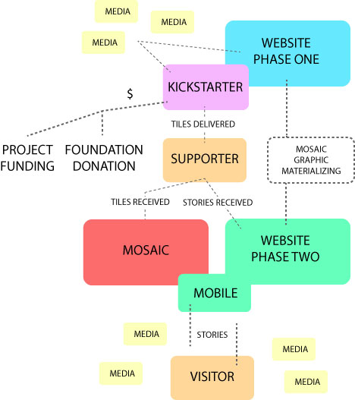
Funding
Funding will be provided from three separate sources: Grants, Kickstarter, and In-kind.
Grants can be approached from a variety of directions:
- Arts & Culture
- Veterans
- Technology
Kickstarter will provide funding in a straight forward way but also provide us with market research and much needed publicity.
In-kind donations could cover the cost of materials and labor. Finding an appropriate wall to install the mosaic on would be required of the city.
Production
Finding an appropriate wall will be paramount to the initiation of the project. The wall will have to be the right size and shape as well as be able to take on the weight of the mosaic. It must also be publicly accessible and free from obstructions.
The tiles and mortar themselves will be fairly inexpensive. If an in-kind donation supplies them, all the better, however the Kickstarter project can handle the expense.
Labor will be a key component, an in-kind donation here would be critical. Allowing the company that donates the labor to place a plaque near the mosaic and offering a tax write-off might entice the company into the donation. With enough publicity we might be able to secure this donation.
The construction itself will be more involved than an average mosaic project as the tiles will have to be installed in order on with the correct orientation. Labor will have to be very careful to install each tile correctly.

