Web Scraping with Python

Overview
This tutorial introduces the fundamentals of web scraping using Python. It covers legality and ethics, HTML structure, XPath, loops, and practical exercises with Selenium and Requests. By the end, participants will know how to extract and organize data from websites responsibly.

Purpose
The purpose of this tutorial is to help learners understand how to programmatically collect structured information from web pages. It teaches skills needed for data projects, automation, and research where APIs are not available.

Prerequisites
- Basic Python knowledge (variables, loops, lists)
- Familiarity with Jupyter Notebook, Visual studio, etc.
- Internet connection and Chrome browser
- Optional: Basic understanding of HTML tags

Setup Before Workshop
Install Python: if you haven’t already Official Python website
Install the core libraries:
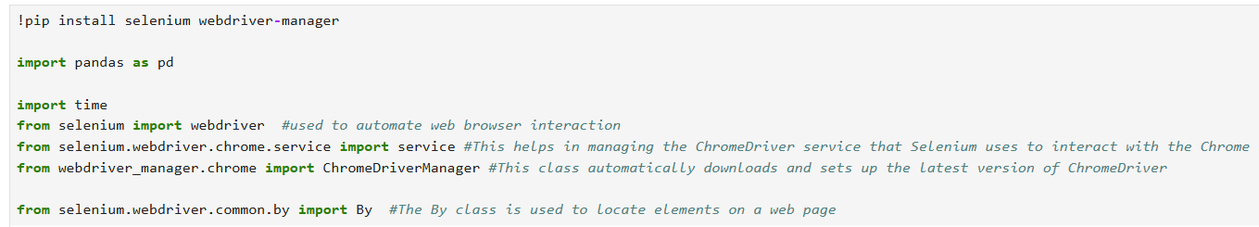

Core Concepts for Web Scraping from websites

Concept 1: [legality] What to do before scraping
- Check (https://example.com/robots.txt) for crawling rules and respect the Robots Exclusion Protocol; it’s the standard site operators use to request crawler behavior. (Robots.txt is a request not a permission; ignoring it can still lead to legal/policy issues.)
- Read the site’s Terms of Service. Don’t collect private/personal data you are not allowed to.
- Use reasonable rate limits (sleep between requests), identify your bot with a clear User Agent, and avoid flooding the target server.
- This link will help you to check website scraping rules. https://medium.com/@datajournal/check-if-a-website-allows-scraping-77122e9aa4fb

Concept 2: [HTML]
Web scraping is one popular method to collect data from the web. This method requires some knowledge of html & xpath.
HTML Elements
Everything from start tag < > to the end tag < / > are elements in HTML.

What is HTML?
- HTML stands for Hyper Text Markup Language
- HTML is the standard markup language for creating Web pages
- HTML describes the structure of a Web page
- HTML consists of a series of elements
- HTML elements tell the browser how to display the content
- HTML elements label pieces of content such as "this is a heading", "this is a paragraph", "this is a link", etc.

1: Root Elements
- The <html> </html> are the root elements and they define the whole HTML document.
- Then, inside the <html> element there is a <body> element for the rest of contents.
2: HTML Headings
- HTML headings are defined with the <h1> to <h6> tags.
- <h1> defines the most important heading. <h6> defines the least important heading
3: HTML Paragraphs
- HTML paragraphs are defined with the <p> tag.
4 HTML Lists
- HTML lists are defined with the <ul>, and <ol>tag. <li> is used for listing the items.
- <ul> stands for "unordered list," and it is used to start a list where the order of the items is not important. Items in an unordered list are typically displayed with bullet points.
- <ol> stands for "ordered list," Items in an unordered list are typically displayed with numbers.
- <li> stands for "list item," and it is used within either <ul> or <ol> tags to define each item in the list.
5: HTML Links
- Learn HTML

Concept 3: [Loop & XPath]
- loops are used to navigate and extract data from web page documents
- Xpath is a query language for selecting nodes from a webpage source.
Cheatsheet for Xpath
Learn ForLoops

Hands-On Lessons & Exercises

Using BeautifulSoup
Step 1: Installing BeautifulSoup
Step 2: Import request for a specific URL
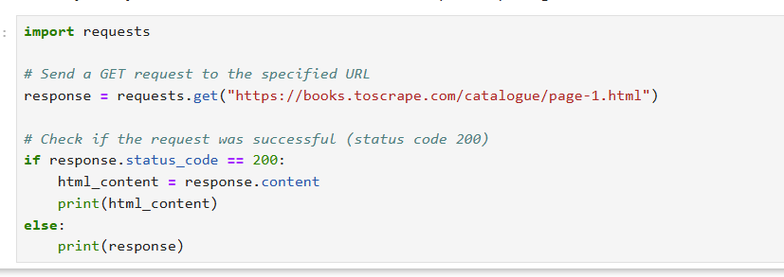

Output:
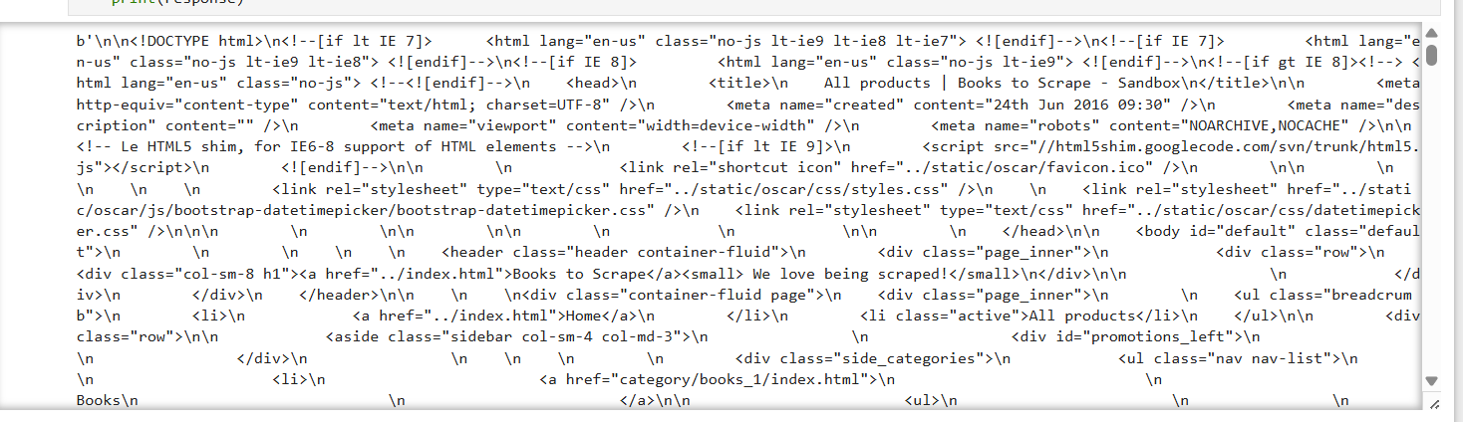
Step 3: Scrape book information with site using BeautifulSoup
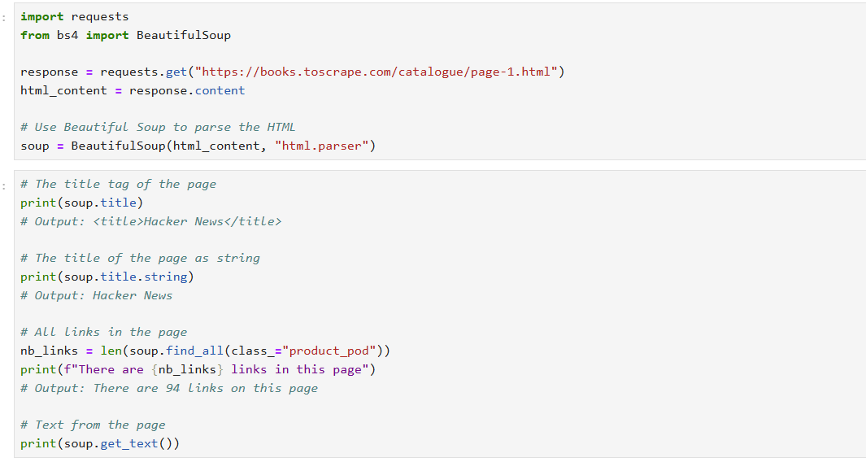
Explanation:
requests.get() sends a GET request to the website.
response stores the server’s response.
response.content contains the raw HTML of the page in bytes format.
Converts raw HTML into a BeautifulSoup object.
Finds the <title> tag of the webpage.
Prints the entire HTML tag, not just the text."html.parser" tells Python to use its built-in HTML parser.
find_all(class_="product_pod") finds all HTML elements with the class product_pod.
Each product_pod represents one book on the page.
len() counts how many such elements exist.

Output:
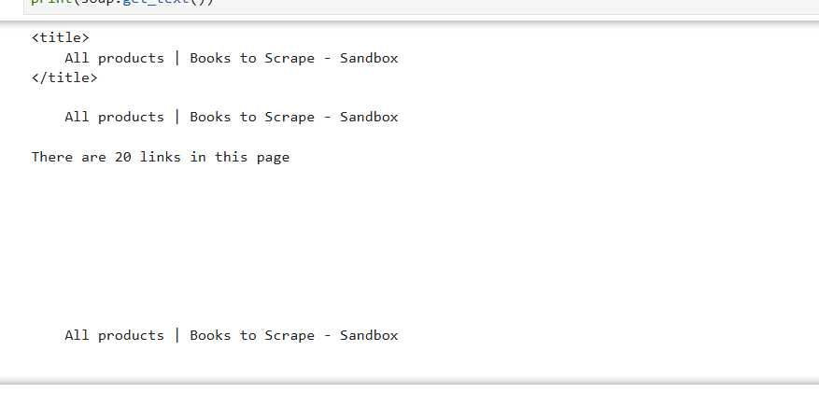
Step 4: Locate Elements
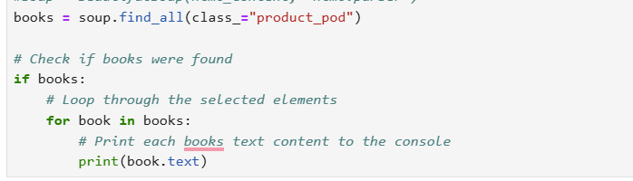
Output:
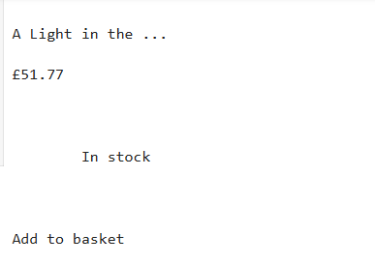

Step 5: Extract Data using loop
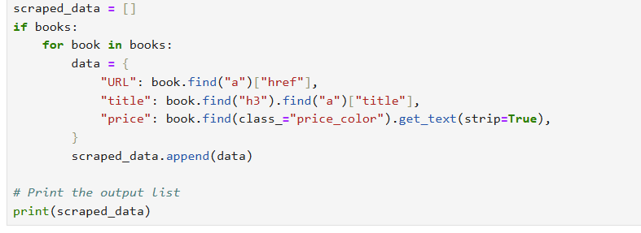
Explanation:
scraped_data Creates an empty list
for book in books Iterates through each HTML element in the books list. Each book represents one book card on the webpage.
book.find("a")["href"] Finds the first <a> (anchor) tag inside the book element. Extracts the href attribute, which contains the book’s detail page URL.
book.find("h3").find("a")["title"] Locates the <h3> tag, which contains the book title. Finds the <a> tag inside it. Extracts the title attribute (full book name).
book.find(class_="price_color").get_text(strip=True) Finds the element with class price_color. Extracts the visible price text. strip=True removes extra whitespace and newline characters.

Output:
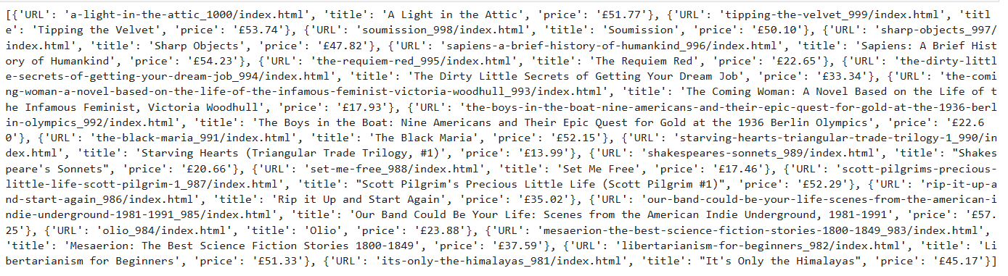
Step 6: Convert data to dataframe
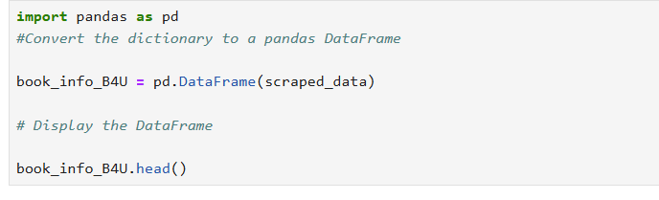
Output:
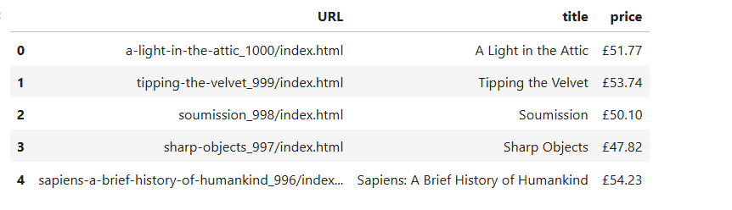

Using Selenium
Step 1: Installing selenium
Newer selenium releases include Selenium Manager to simplify driver management.
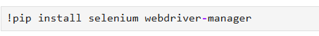
Step 2: Import and Setup: Import Selenium WebDriver and initiate a browser instance
With the code below, it will direct the browser to the Google search page and help us to scrape websites.
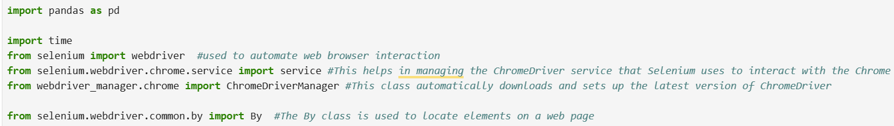
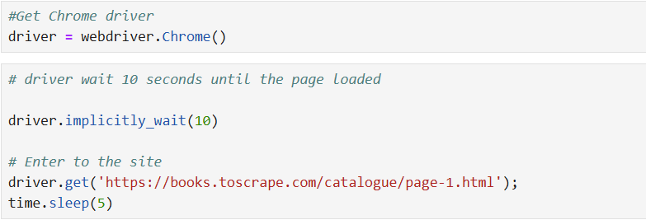
Output:
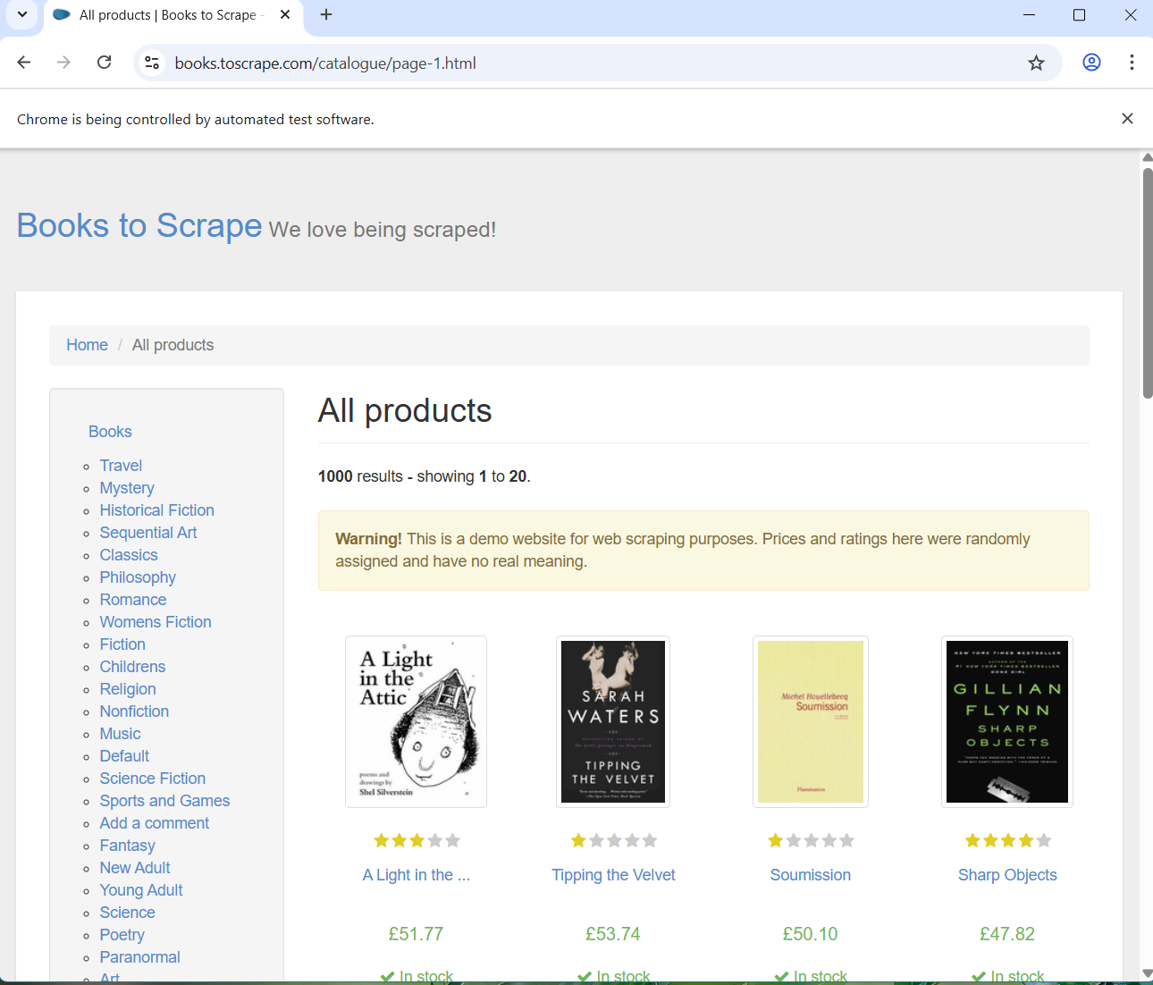
Explanation:
!pip install selenium webdriver-manager
import pandas as pd
import time
from selenium import webdriver: used to automate web browser interaction
from selenium.webdriver.chrome.service import Service: This class helps in managing the ChromeDriver service that Selenium uses to interact with the Chrome browser.
from webdriver_manager.chrome import ChromeDriverManager: This class automatically downloads and sets up the latest version of ChromeDriver
from selenium.webdriver.common.by import By: The By class is used to locate elements on a web page

Step 3: Scrape book information with site using Chorme
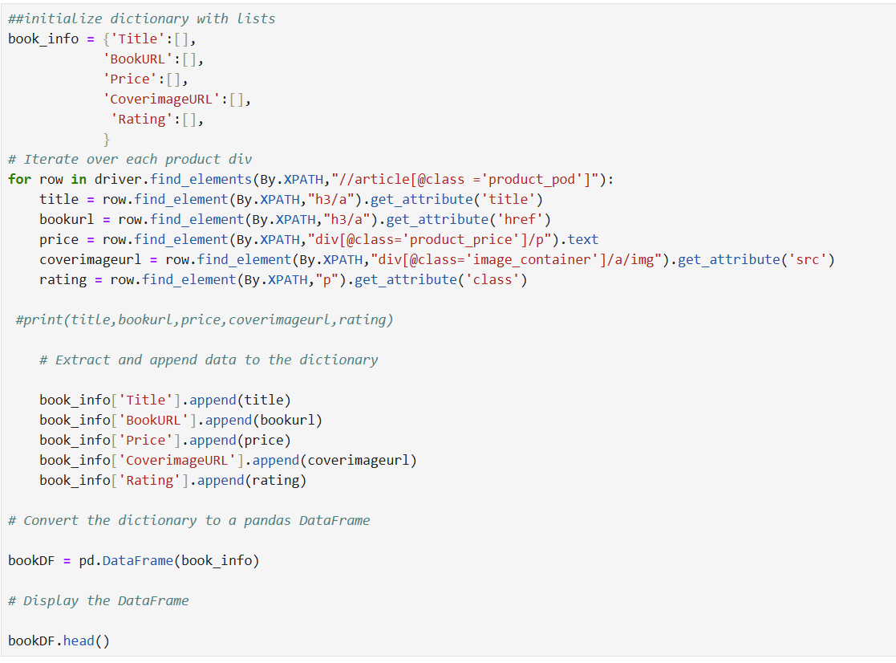
Output:
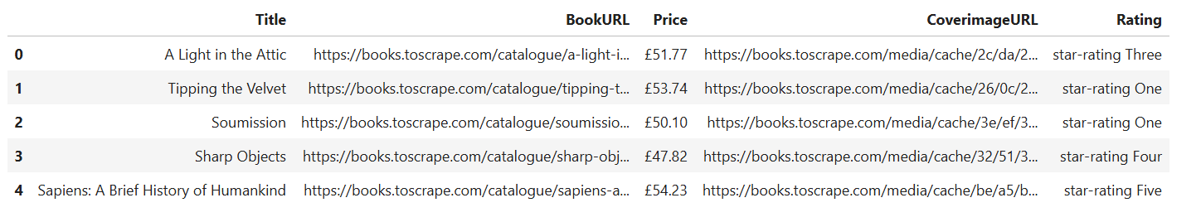
Explanation:
1: Create a dictionary to store book details
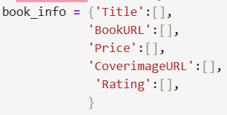
Here, we start with an empty dictionary called book_info.
- Each key (like "Title" or "Price") represents the type of information we want.
- Each value is an empty list. As we scrape data, we’ll fill these lists with the results.
Think of it as creating labeled buckets where we’ll drop the scraped details.
2: Loop through each book on the page
- driver.find_elements(...) finds all book containers on the page.
- Each row represents one book.
- The XPath //article[@class='product_pod'] tells Selenium to look for every book card.
3: Extract book details inside the loop
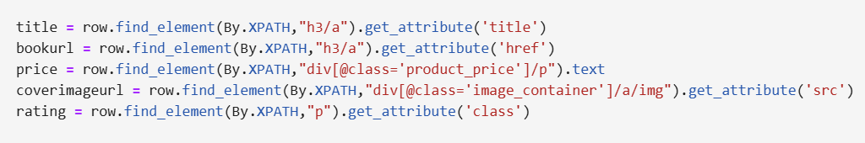
For each book:
- title: gets the title text from the <a> tag.
- bookurl: extracts the link to the book’s detail page (href).
- price: grabs the price text from the product price section.
- coverimageurl: gets the URL of the book’s cover image.
- rating: extracts the CSS class that contains the star rating (e.g., "star-rating Three").
So now we have all the details about one book.
4: Save the scraped data into our dictionary
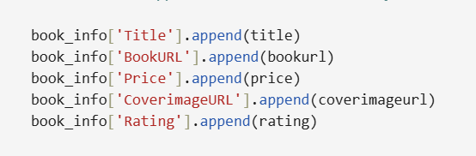
Each value is added (append) to the correct list inside our dictionary. After the loop finishes, every list will have the same length — each index representing one book.
5: Convert dictionary to a DataFrame
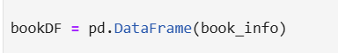
- pd.DataFrame() turns our dictionary into a table (DataFrame) where:
- Each column is one type of data (Title, Price, Rating, etc.)

Using Reddit API key
Step 1: Installing PRAW & other python packages
We will use python package called praw.
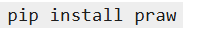
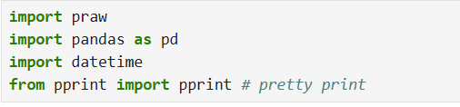
Step 2: Set up a Reddit Developer Application:
- A user account is required to use Reddit API. If you don’t have it follow this link. https://www.reddit.com
- Visit https://old.reddit.com/prefs/apps/
- Scroll down to the 'Developed Applications' section and click on "Create App" or "Create Another App".
- Fill in the form:
- name: Your application's name.
- App type: Choose 'script'.
- description: Can be left blank.
- redirect uri: http://localhost:8080 (required for script type but won't be used here).
- Click "Create app"
- Now, your app has a secret key (e.g., vg8NL-iEOB9uJVS4rexYW2XITqvh1g).
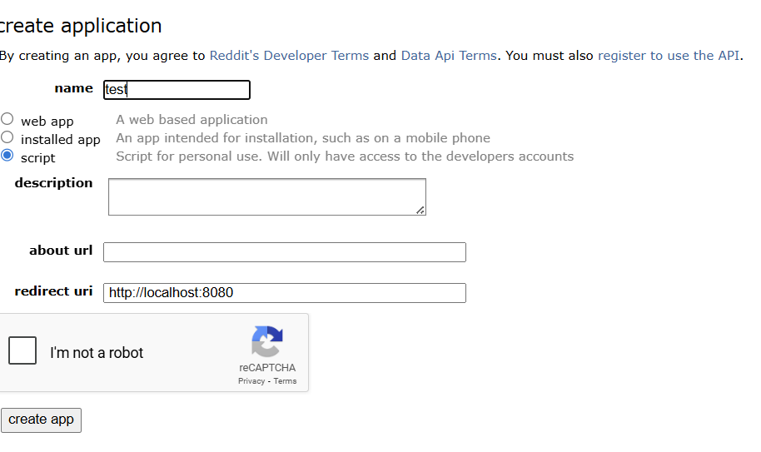
After clicking on create app, the screen with API details and credentials will load. To do web scarping we will need client ID, secret and user agent.
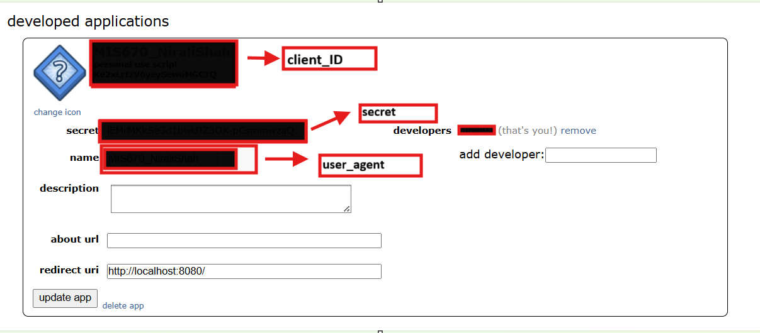

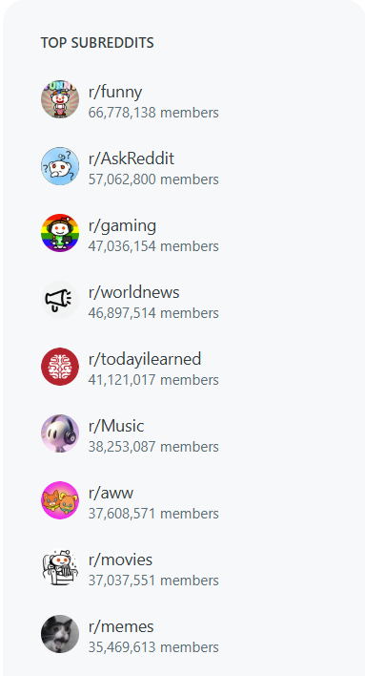
Step 3: Get one hot post from the top subreddit. This code will print hot post from subreddit ‘AskReddit’
Reddit threads can be sorted by the following criteria:
- Best
- Hot
- New
- Controversial
- Top
- Rising
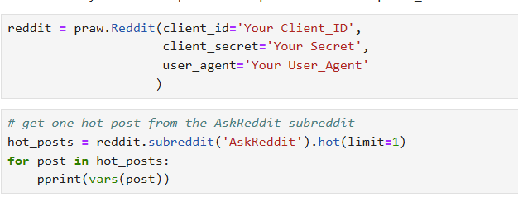
Step 4: Get titles from 10 hot posts. In this step you can collect all the information of top 10 post from subreddit name ‘AskReddit’ and iterated over and features including the post title, id and url can be extracted and saved into an .csv file.
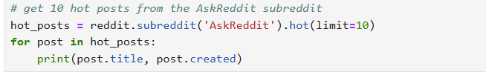
Output:
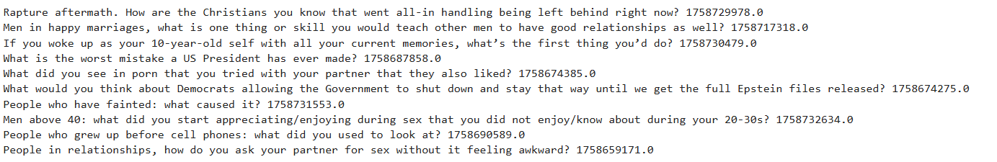
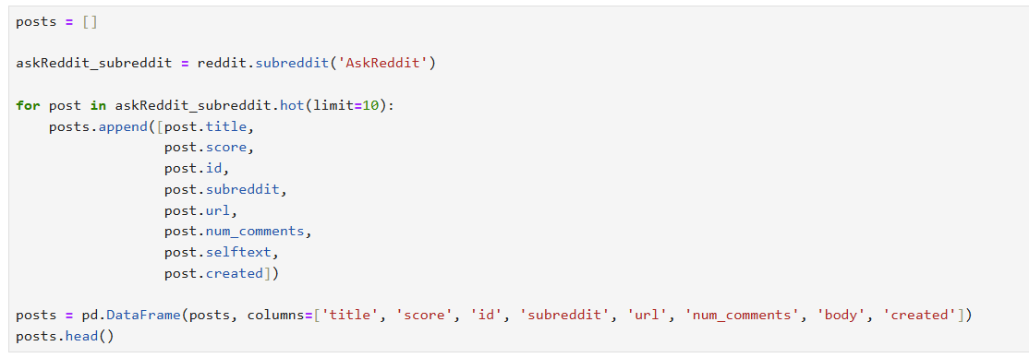

Output:
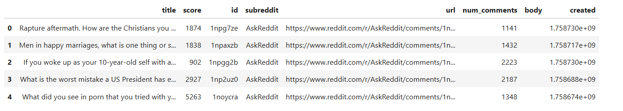
Step 5: Get comments from a specific post
Assume we want to process the comments for this submission(Our 1st post URL from top 10 post of subreddit ‘AskReddit’: https://www.reddit.com/r/AskReddit/comments/1npg7ze/rapture_aftermath_how_are_the_christians_you_know/
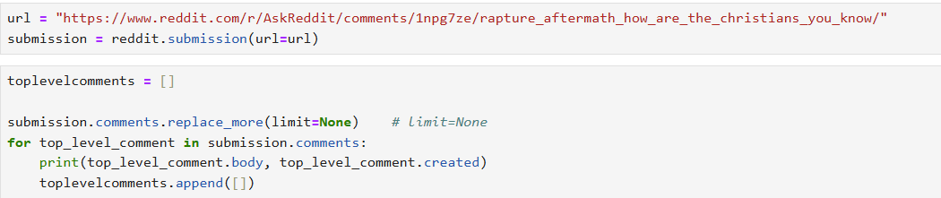
Output:
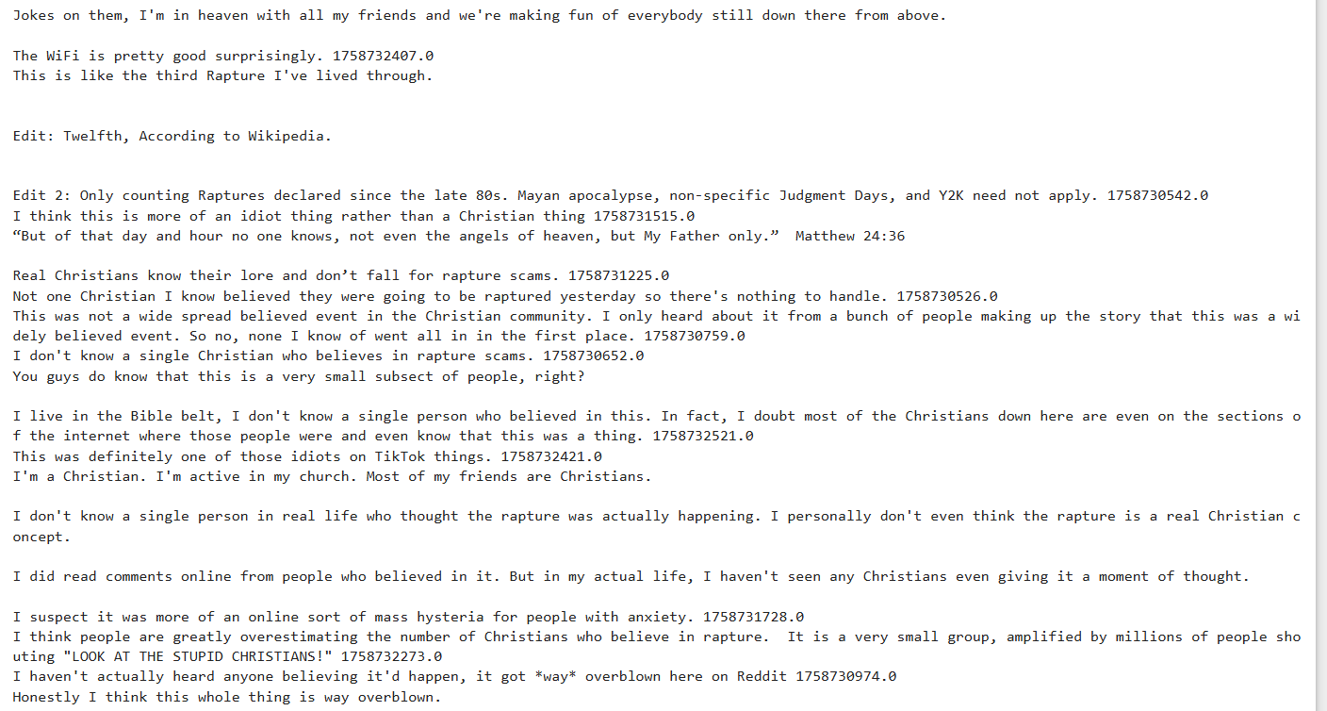

Step 6: If you want scrap replies from the post.
Now we can successfully iterate all the top-level comments. What about their replies? We could output all second-level comments like so.
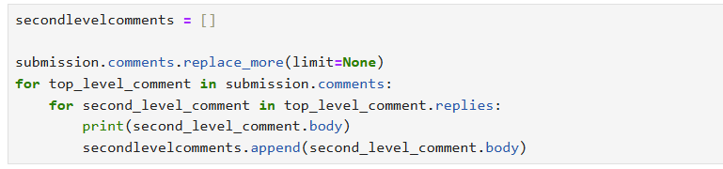
Output:
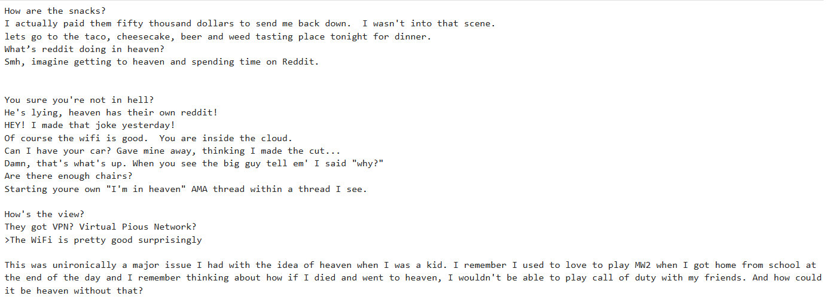

Best Practices & Tips
- Always respect robots.txt and Terms of Service.
- Use time.sleep() or random delays to avoid overloading servers.
- Add headers with a User-Agent to requests.
- Save raw HTML for debugging.
- Use try/except for missing or inconsistent fields.

Additional Resources
- Website Scraping rules: https://medium.com/@datajournal/check-if-a-website-allows-scraping-77122e9aa4fb
- Cheat sheet of Xpath: Cheatsheet for Xpath
- Basics of python For Loops: Learn ForLoops
- Understand HTML: Learn HTML
- Understand Selenium: Learn Selenium
- Follow this link for some best practice of Web Scraping: Tips for Web Scraping

Contributors
Nirali Shah

