USER GUIDE

Socius: a beginner's guide
Statistics and text coding for sociologists, in your browser
Edition 1, September 2026
Web version of this guide: https://hackhead95.github.io/socius/guide/
Socius: https://hackhead95.github.io/socius/
Contents
1 Welcome to Socius 4
Who Socius is for 4
What it costs 4
Your data stays on your computer 4
What you need 4
2 A five-minute tour 5
The sample survey 6
3 Finding anything with Search 8
Open Search 8
What you can search for 8
4 Opening your data 10
Open an SPSS file 10
Open a CSV or Excel file 10
5 Understanding your variables 12
Value labels 12
Missing values 13
Measurement level: nominal, ordinal or scale 13
6 Preparing your data 14
Recode age into groups 14
Reverse-code a question 14
Build a scale and check Cronbach's alpha 15
Select cases 15
Weight cases 16
7 Your first analyses 17
Frequencies: how often does each answer occur? 17
Crosstabs with chi-square: are two categories related? 18
Comparing two groups: the independent-samples t-test 21
Comparing several groups: one-way ANOVA 22
Correlation: do two numbers move together? 23
A simple linear regression 24
Where to go next 25
8 Charts 26
A bar chart 26
A histogram 26
Saving a chart 27
9 Getting results into your report 28
APA style or SPSS style 28
Copy one table into Word 29
Copy the APA sentence 29
Export the whole report 29
10 Coding open-ended answers 30
Start with the worked example 30
Import answers from a survey question 30
The Responses view 31
Build a codebook 32
Code with the number keys 32
Auto-code with keyword rules 33
Turn codes into variables and crosstab them 33
11 Coding interviews 36
Import a transcript 36
Highlight and code a passage 36
Write memos 37
Retrieve quotes 38
Intercoder reliability: do two coders agree? 39
12 Getting help from AI 40
Set it up 40
Before you send anything 42
Where to find AI in Socius 42
Explain a result 43
The Socius assistant 45
AI in Text coding 49
Reporting AI use 50
13 Saving and sharing your work 51
Save a project 51
Save your data for SPSS, Excel or R 51
Share with a colleague 52
14 Troubleshooting and FAQ 53
15 Giving feedback 55
Appendix A: Quick reference card 56
Appendix B: Glossary 58

1 Welcome to Socius
Socius is a free research workbench for sociologists. It runs in your web browser. You can open SPSS files, run the statistics you know from SPSS, and code interviews and open-ended survey answers, all in one place.
This guide is for you if you are new to Socius, and also if you are new to statistics software. It takes you step by step from opening a file to a finished results section. Every example uses a practice survey that comes with Socius, so you can follow along on your own computer.

Who Socius is for
- Students writing a dissertation or a methods assignment.
- Researchers who analyse survey data and interviews.
- SPSS users who want the same menus and tables without a licence. The Data View, Variable View, dialogs and output tables look and work much like SPSS.

What it costs
Nothing. Socius is free to use. There is no account, no sign-up and no trial period.

Your data stays on your computer
Socius runs entirely inside your browser. When you open a file, it is read on your computer and is never uploaded anywhere. Socius keeps a copy of your current work in the browser so it is there when you come back, but that copy lives only in this browser on this computer. To keep your work safe, save a project file (see Saving and sharing your work).
The one exception is the optional AI help. It is off until you set it up, and it never sends anything until you click a button or ask a question. Each AI feature tells you what it will send, and to whom, before it does (see Getting help from AI).

What you need
- A computer with a recent version of Chrome, Edge, Firefox or Safari.
- An internet connection to open the Socius page. After that, your data does not travel anywhere.
- A mouse or trackpad and a keyboard. Socius opens on tablets and phones, which is fine for looking at results, but a computer is much easier for real work.
To start, open Socius at https://hackhead95.github.io/socius/. You can come back to this guide at any time from Help > User guide.

HOW TO READ THIS GUIDE
Menu paths are written like this: Analyze > Descriptive Statistics > Frequencies. It means: click Analyze in the menu bar, then Descriptive Statistics, then Frequencies. In the app, items that open a dialog end with "...". Variable names from the practice survey look like this: life_sat.

2 A five-minute tour
When you open Socius for the first time, you see the welcome screen. It offers four ways to start: open your own data file, open a project you saved before, load the sample survey, or type data into an empty dataset.
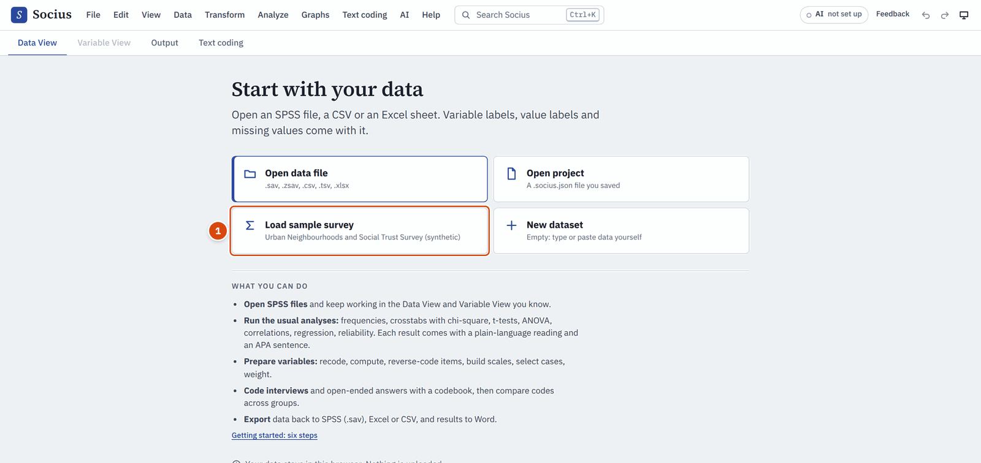
The welcome screen. Click Load sample survey (1) to follow this guide.
Click Load sample survey now. The practice data opens, and you see the main screen.
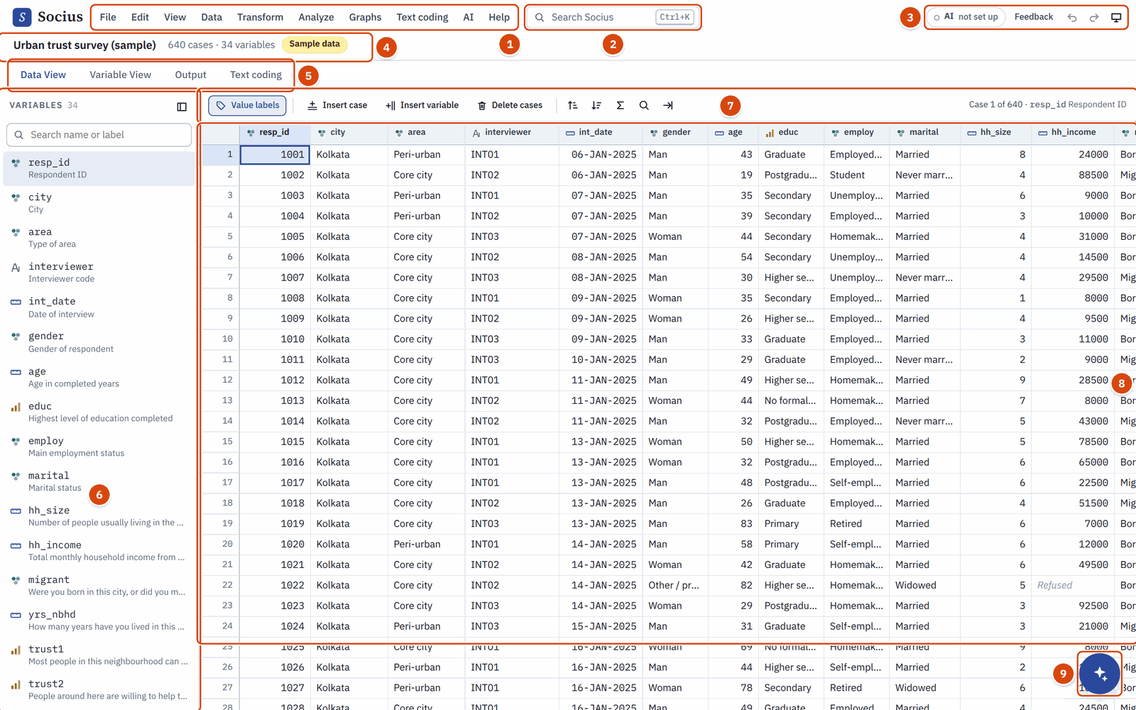
The main screen with the sample survey open.
The numbers in the picture show the parts of the screen:
- Menu bar. Everything Socius can do is in these menus: File, Edit, View, Data, Transform, Analyze, Graphs, Text coding, AI and Help.
- Search. Type what you are looking for, such as "chi square" or a variable name, and Socius finds the menu item, variable, result or help page (see Finding anything with Search).
- AI, Feedback, Undo, Redo and theme. The AI chip shows whether AI help is set up ("not set up" until you choose an option). Feedback opens a form to tell us about a problem. Undo and Redo reverse your last changes. The last button switches between light and dark colours.
- Dataset bar. The name of the open dataset, how many cases (rows) and variables (columns) it has, and small labels that tell you when a weight or a filter is switched on.
- Main tabs. Data View shows the data, one row per respondent. Variable View describes the variables. Output collects your results. Text coding is where you code interviews and open-ended answers.
- Variable list. All your variables with their labels. Type in the search box to find one quickly. View > Variable list hides and shows it.
- Toolbar. Buttons for the current tab. In Data View you can switch between codes and value labels, add cases or variables, sort, and search.
- Data grid. The data itself. Each row is a case (usually a respondent) and each column is a variable (usually a question).
- Assistant button. Opens the Socius assistant, which answers questions about your data and methods once AI help is set up (see The Socius assistant).

FOR SPSS USERS
Data View, Variable View and the Output tab work like their SPSS counterparts. The main difference is that output lives in a tab of the same window instead of a separate viewer window.

The sample survey
The practice data is the "Urban Neighbourhoods and Social Trust Survey": 640 households in Kolkata, Delhi, Mumbai, Bengaluru and Chennai. It is invented for teaching, so no real person is described. You can load it again at any time with File > Load sample survey.
These are the variables this guide uses:

Variable | What it is
gender | 1 = Man, 2 = Woman, 3 = Other / prefer to self-describe
age | Age in years (17 people did not give their age)
educ | Highest education, from 1 = No formal schooling to 6 = Postgraduate
migrant | 0 = Born in this city, 1 = Moved here from another state or district
yrs_nbhd | Years lived in this neighbourhood
trust1 to trust5 | Five statements about trust in the neighbourhood, from 1 = Strongly disagree to 5 = Strongly agree
life_sat | Life satisfaction, from 0 to 10
vote | Voted in the last municipal election (0 = No, 1 = Yes)
wt | A survey weight
q_challenge | Open question: "What is the biggest challenge facing your neighbourhood today?"

3 Finding anything with Search
You do not need to remember where things are in the menus. Search finds commands, variables, results and help pages for you.

Open Search
- Press Ctrl+K ( Cmd+K on a Mac), from anywhere in Socius.
- Or press / when you are not typing in a box or in the Data View grid.
- Or click the Search Socius box in the top bar. On a narrow screen it becomes a magnifying-glass button, and on a phone the search opens full screen.
Start typing. Use the arrow keys to move through the results, Enter to open one and Esc to close Search. Small typing mistakes are fine: "crostabs" still finds Crosstabs.
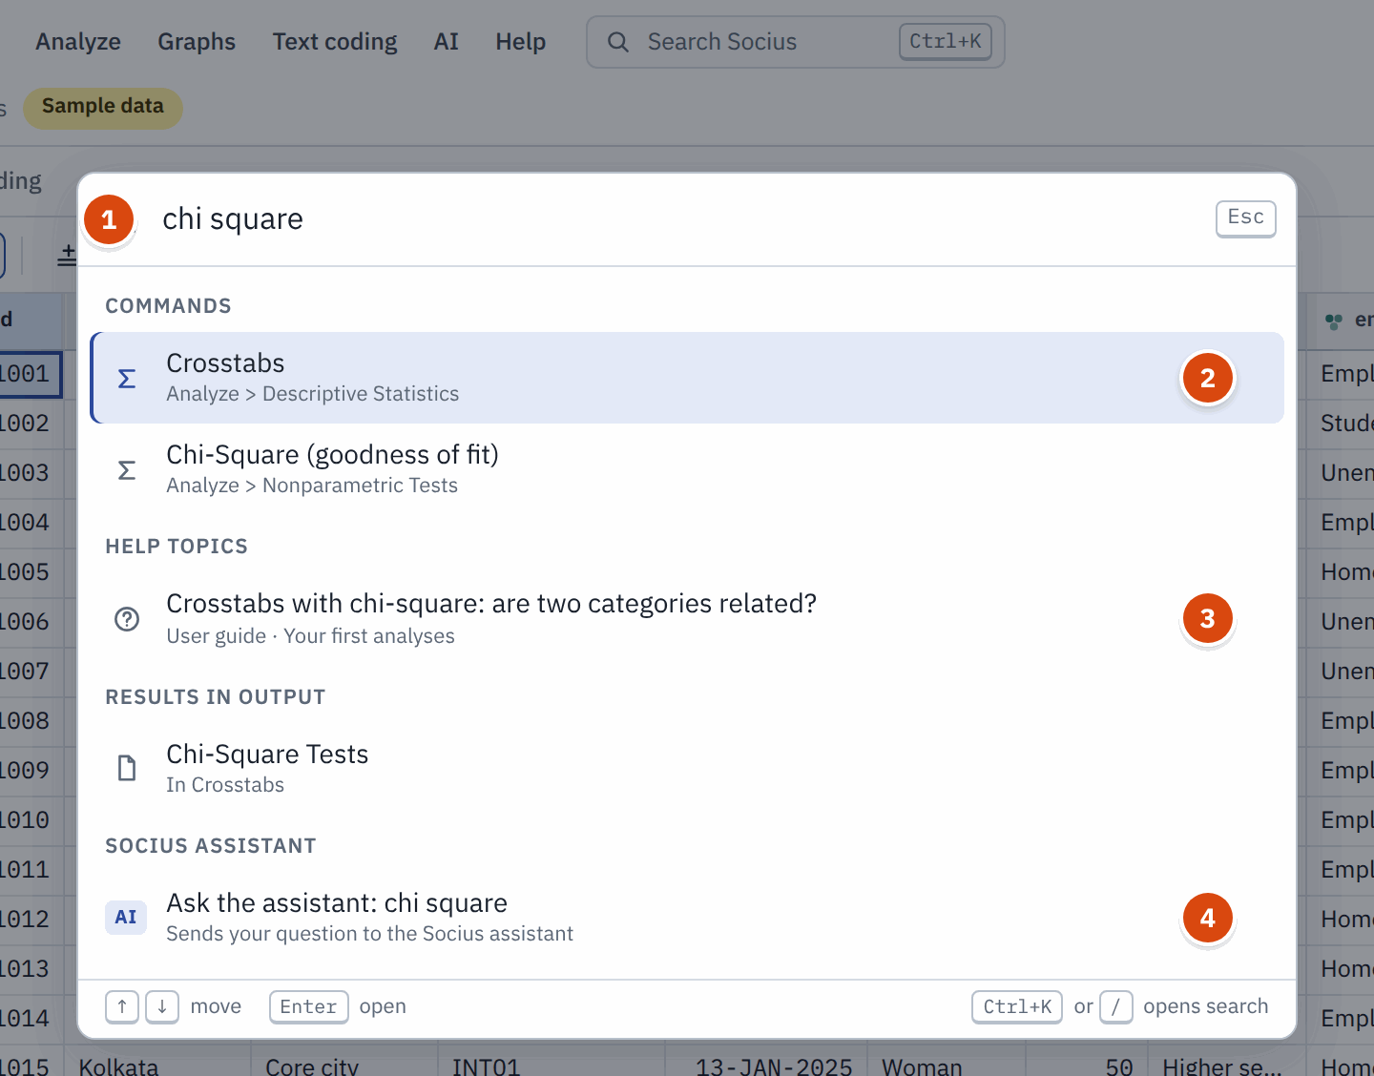
Searching for "chi square". Type in the box (1). Commands (2) run the menu item, Help topics (3) open this guide at the right page, and the last line (4) asks the Socius assistant.

What you can search for

Type this | What you get
chi square | Crosstabs (under Analyze > Descriptive Statistics). Enter opens the dialog.
t test, anova, regression, alpha | The matching analysis. "alpha" or "reliability" finds Reliability Analysis.
recode, weight, filter | The matching Transform or Data command.
trust | Your variables whose name, label or value labels contain "trust". Enter selects its column in Data View; the Variable View and Frequencies buttons on each row open it there or in Frequencies.
the title of a result, such as Crosstabs | Results in Output: jumps to that result.
missing values | Help topics: opens this guide at that section, in a new tab.
a word from your interviews, such as water | Once you have texts in Text coding: Search in texts for "water" lists every passage that contains it (Keyword in context).
any question | Ask the assistant: ... (always the last line) sends your question to the Socius assistant.

With an empty box, Search shows Recent (what you opened from Search lately) and Suggestions. Commands that cannot run yet are greyed out and say why, for example "Open or create a dataset first".

4 Opening your data

Open an SPSS file
- Choose File > Open data file (or press Ctrl+O , Cmd+O on a Mac). You can also drag the file from your computer onto the Socius window.
- Pick your .sav file (or a compressed .zsav file) and click Open.
- A short message tells you how many cases and variables were read.
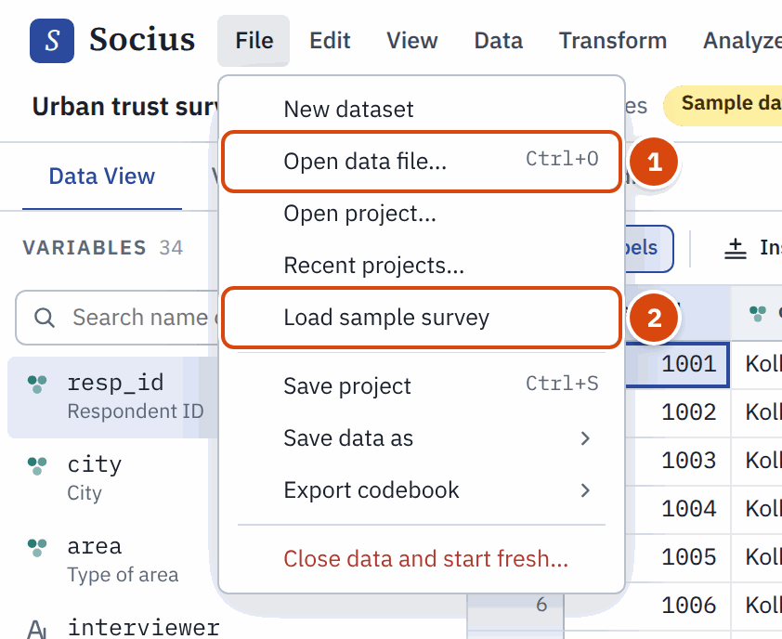
The File menu. Open data file (1) opens your own file; Load sample survey (2) brings back the practice data.
Everything that makes an SPSS file useful comes with it: variable labels (the full question text), value labels (for example 1 = Man, 2 = Woman), missing value codes, measurement levels and the weight variable.

Open a CSV or Excel file
Socius also opens CSV files (.csv, .tsv) and Excel workbooks (.xlsx). Use the same File > Open data file. Before the data opens, Socius shows a preview so you can check that the columns are split correctly.
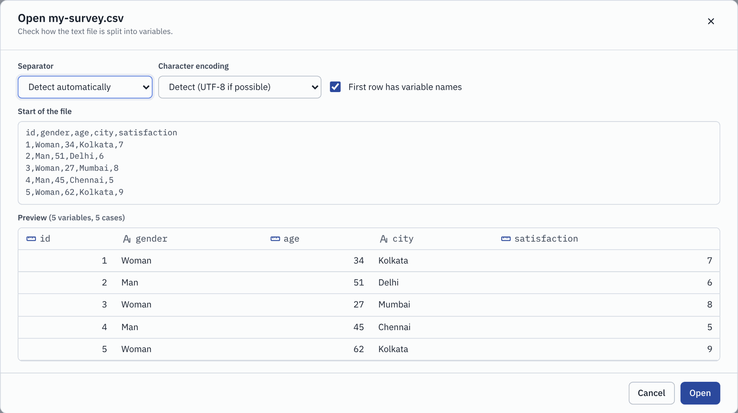
The preview for a CSV file. Check the separator, the character encoding and whether the first row holds variable names, then click Open.
- Separator: leave it on Detect automatically unless the preview looks wrong.
- Character encoding: if letters look strange (for example in Hindi, Bengali or accented names), try another encoding here.
- First row has variable names: keep this ticked if your first row holds column headings.
- For Excel files, you also choose which sheet to open.
CSV and Excel files do not store labels or missing value codes. After opening one, spend a few minutes in Variable View to add them (see the next chapter). If a column holds words, such as "Woman" and "Man", Transform > Automatic recode turns it into numbered categories with value labels, which is what most analyses need.

OPENING A FILE REPLACES THE OPEN DATA
Socius works on one dataset at a time. If you have unsaved changes, it asks before it replaces them.

5 Understanding your variables
Before you analyse anything, spend five minutes in Variable View. It prevents many wrong results later. Click the Variable View tab.
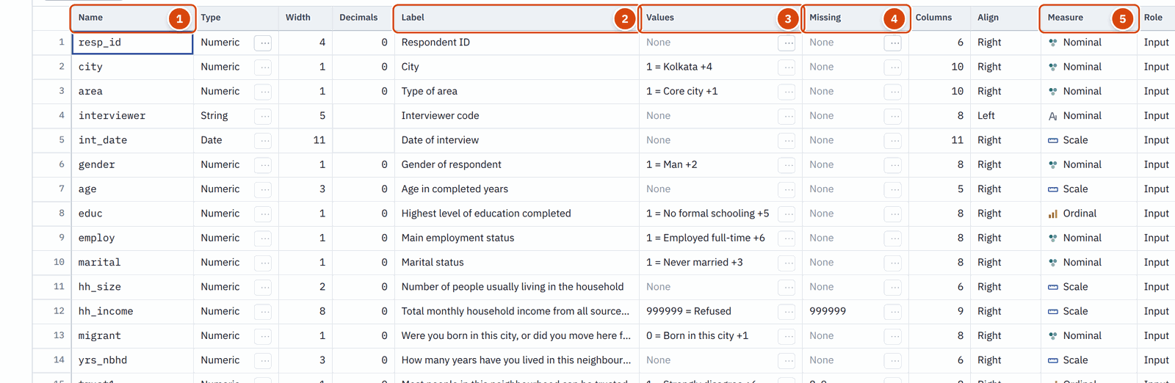
Variable View. Each row describes one variable of your data.
The most important columns are:
- Name. A short name used in menus and output, such as life_sat.
- Label. The full description, often the question wording. Socius shows labels in dialogs and tables.
- Values. Value labels: what each code means, such as 1 = Man.
- Missing. Codes that mean "no real answer", such as 8 = Don't know or 9 = Refused.
- Measure. The measurement level: nominal, ordinal or scale.

Value labels
Click a cell in the Values column and then the small ... button (or press Enter ) to see or edit the value labels.
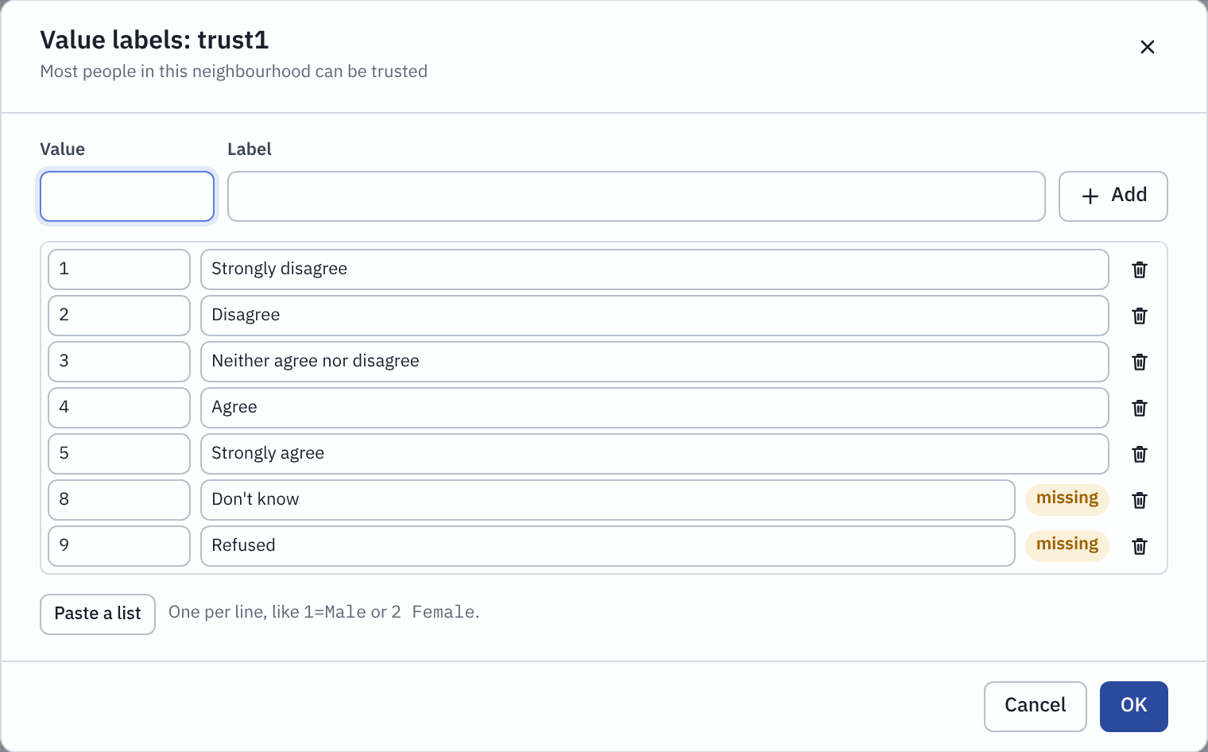
The value labels of trust1. Codes 8 and 9 are marked as missing.
To add a label, type the value and the label at the top and click Add. Paste a list lets you paste many labels at once, one per line, such as 1=Strongly disagree.

Missing values
Surveys often use special codes for "Don't know" or "Refused". If you declare them as missing, Socius leaves them out of every percentage, mean and test. If you forget, a code like 9 would be treated as a real answer and pull your averages up.
Click a cell in the Missing column and then its ... button.
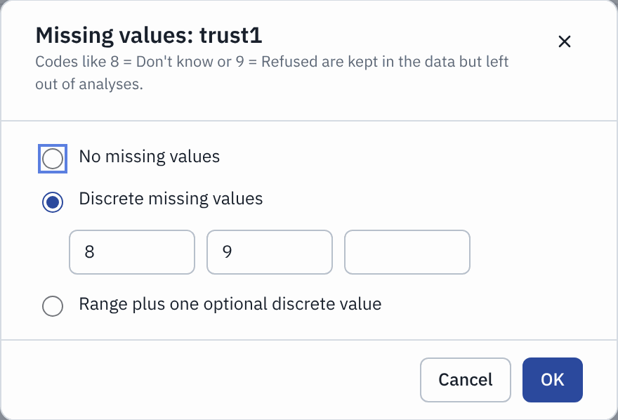
The missing values of trust1: 8 and 9 are declared missing.
You can choose No missing values, Discrete missing values (up to three codes, such as 8 and 9), or Range plus one optional discrete value (for example 90 to 99).

DECLARE IT ONCE, USE IT EVERYWHERE
If many variables share the same coding, such as all items of a Likert scale, set the labels and missing values on one of them. Then use Data > Copy variable properties to copy them to the others.

Measurement level: nominal, ordinal or scale
The measurement level tells Socius what kind of information a variable holds. Socius uses it to suggest suitable analyses and to warn you when a variable does not fit a box in a dialog.
- Nominal: categories with no order. Examples: gender, city, religion. You can count them, but "more" or "less" makes no sense.
- Ordinal: categories with a clear order, but the steps are not necessarily equal. Examples: education level, "Strongly disagree" to "Strongly agree".
- Scale: real numbers where differences are meaningful. Examples: age in years, income, a 0 to 10 satisfaction score.
Small icons next to each variable show its level: a cluster of circles for nominal, rising bars for ordinal and a ruler for scale. To change a level, click the Measure cell and pick another.

6 Preparing your data
Real data rarely arrives ready to analyse. The Transform and Data menus help you reshape it. Each example here uses the sample survey. Every change is written to the Output tab together with the SPSS command that does the same thing, and Edit > Undo ( Ctrl+Z ) reverses it.

Recode age into groups
Goal: a new variable agegrp with four age groups, keeping the original age.
- Choose Transform > Recode into different variables.
- Tick age in the list on the left.
- Under New variables, type the name agegrp and the label Age group.
- Add the rules on the right, one at a time. For each rule, choose the kind of old value, type the numbers, type the new value and click Add:
  - System- or user-missing becomes System-missing (so missing ages stay missing)
  - Lowest through 29 becomes 1
  - Range 30 to 44 becomes 2
  - Range 45 to 64 becomes 3
  - through Highest 65 becomes 4
- Under Labels for the new codes, type 18-29, 30-44, 45-64 and 65 and over.
- Click OK.
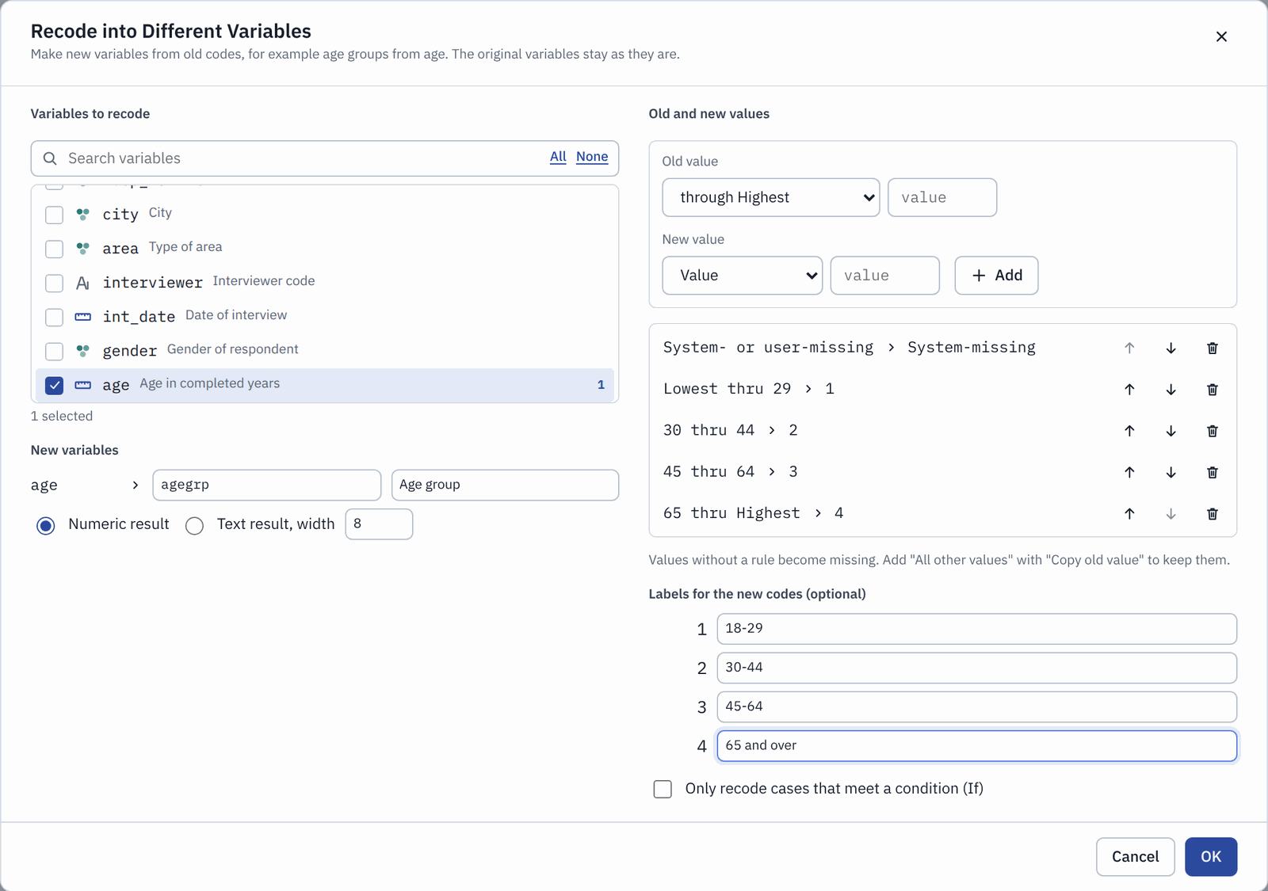
Recoding age into four groups. The rules are checked from top to bottom, and the first rule that fits is used.
The new variable appears at the end of your data. Values without a rule become missing, so check that your rules cover every age.

Reverse-code a question
Four of the trust statements are positive ("Most people in this neighbourhood can be trusted"). One is negative: trust3 says "You have to be very careful with people in this neighbourhood". Agreeing with it means less trust. Before you combine the five items, flip trust3 so that a high score always means more trust.
- Choose Transform > Reverse-code items.
- Tick trust3. Socius reads the answer scale (1 to 5) from the value labels.
- Keep Create new variables, named with the suffix _r and click OK.
You now have trust3_r. Its value labels are flipped too, and the missing codes 8 and 9 stay as they are.

Build a scale and check Cronbach's alpha
A scale (or index) combines several questions about the same idea into one score. It is usually more reliable than any single question.
- Choose Transform > Create scale / index.
- Tick trust1, trust2, trust3_r, trust4 and trust5. Use trust3_r, not trust3.
- Type the name trust and the label Neighbourhood trust (mean of 5 items).
- Keep Mean of the answered items. The score then stays on the familiar 1 to 5 scale.
- Minimum answered items is 4: a person who answered fewer than four of the five gets no score.
- Click OK.
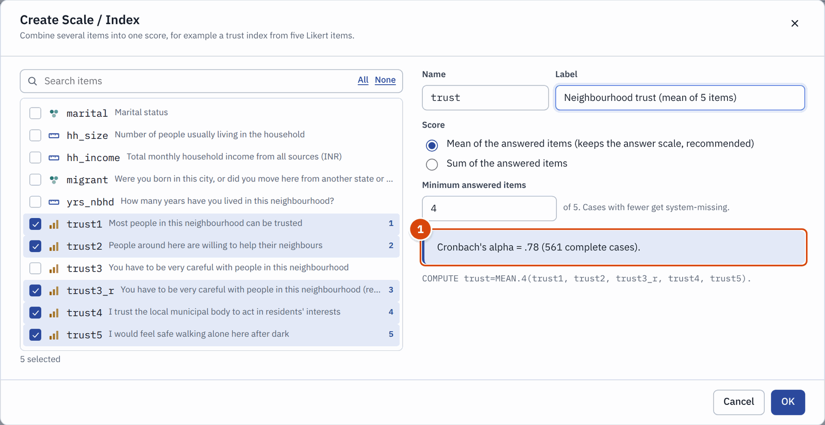
Creating a trust scale. The box (1) shows Cronbach's alpha for the items you picked.
What Cronbach's alpha means. Alpha tells you how well the items hang together, that is, whether people who agree with one tend to agree with the others. It runs from 0 to 1. As a rough guide, .70 or higher is acceptable for a research scale and .80 or higher is good. Here alpha is .78, so the five items form an acceptable scale. If you had used the original trust3 by mistake, alpha would drop and Socius would warn you that the item "goes against the other items".
For the full picture, run Analyze > Scale > Reliability Analysis with the same five items.

Select cases
Sometimes you want to analyse only part of your sample, for example only women aged 30 and over.
- Choose Data > Select cases.
- Choose Cases that meet a condition and type the condition: gender = 2 AND age >= 30.
- Keep Filtered out for unselected cases. They stay in the file but are left out of analyses.
- Click OK.
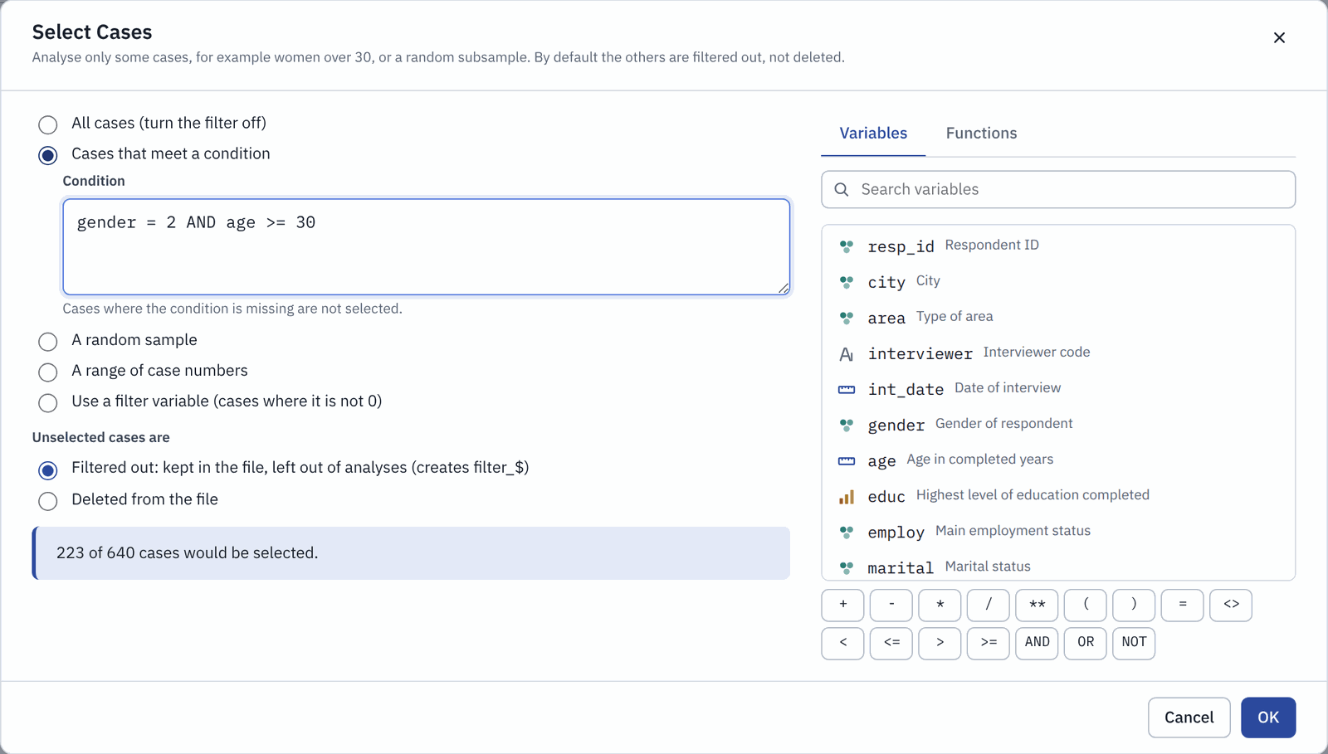
Selecting women aged 30 and over. The box below the condition says how many cases would be selected.
While a filter is on, the dataset bar shows Filter on with the number of cases in use. To use everyone again, choose Data > Turn filter off (use all cases), or click the small cross on that label.

Weight cases
Many surveys come with a weight that corrects for how the sample was drawn. The sample survey has one called wt.
- Choose Data > Weight cases.
- Choose Weight cases by and pick wt.
- Click OK.
The dataset bar now says Weighted by wt, and every analysis uses the weight until you switch it off with Data > Turn weighting off (or the cross on the label).
The label in the dataset bar shows that a weight is on (1).

NOTE
The rest of this guide uses the unweighted data, so switch weighting off again if you tried it. Each result in Output says whether cases were weighted.

7 Your first analyses
All analyses live in the Analyze menu, and they all work the same way:
- Pick an analysis from the menu. A dialog opens.
- Move variables from the list on the left into the boxes on the right. Double-click a variable, drag it, or select it and click the arrow.
- Check the options below the boxes, if you need to.
- Click Run. The result appears in the Output tab.
Every analysis dialog has a When to use this link at the top that explains in plain words what the analysis is for.
Every result comes with two extra boxes. What this means explains the result in plain language, to help you read it. APA-style report gives you a draft sentence for your results section, written in the style of the American Psychological Association (APA 7), which most sociology journals and departments accept.

Frequencies: how often does each answer occur?
When to use it. To describe one variable at a time: how many people gave each answer, and what percentage that is. It is usually the first thing you run on any survey.
Try it. How educated is the sample?
- Choose Analyze > Descriptive Statistics > Frequencies.
- Find educ in the list (1) and move it into Variable(s) (3) with the arrow (2).
- Click Run (4).
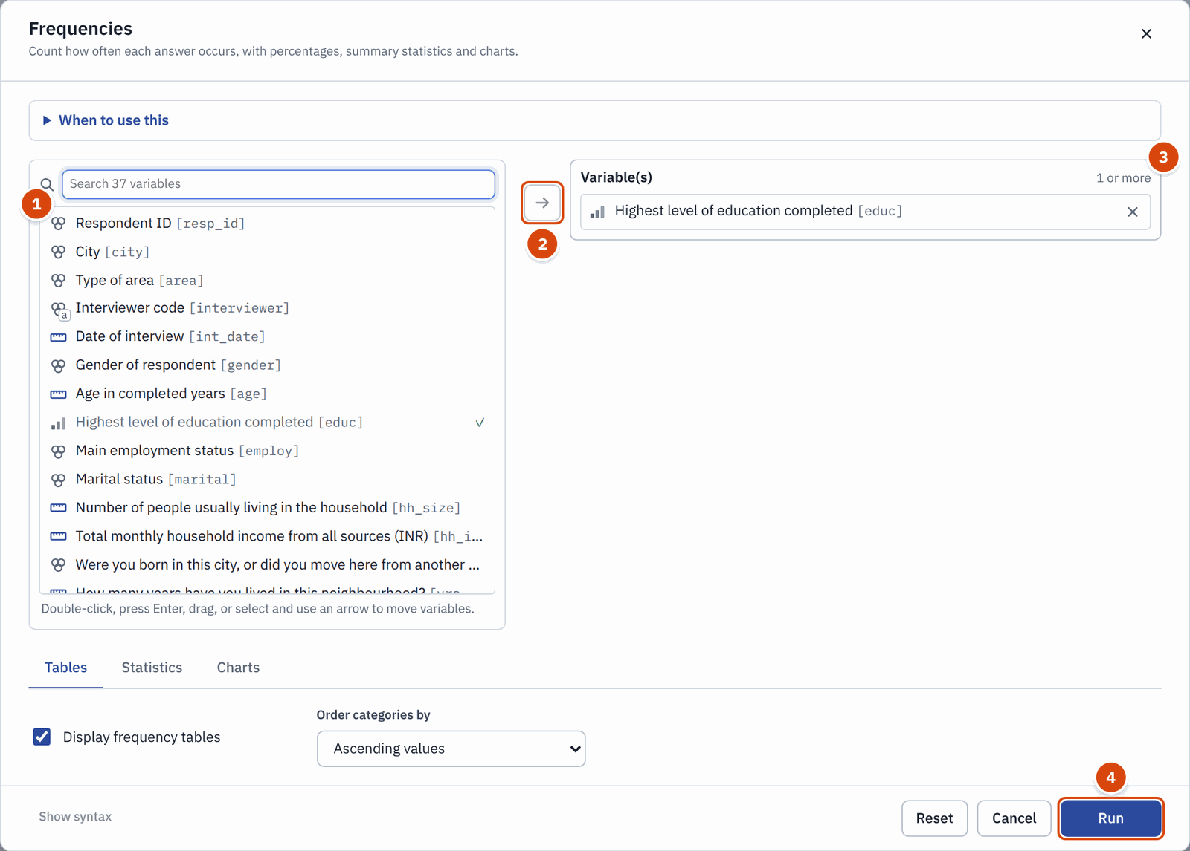
The Frequencies dialog with educ in the Variable(s) box.
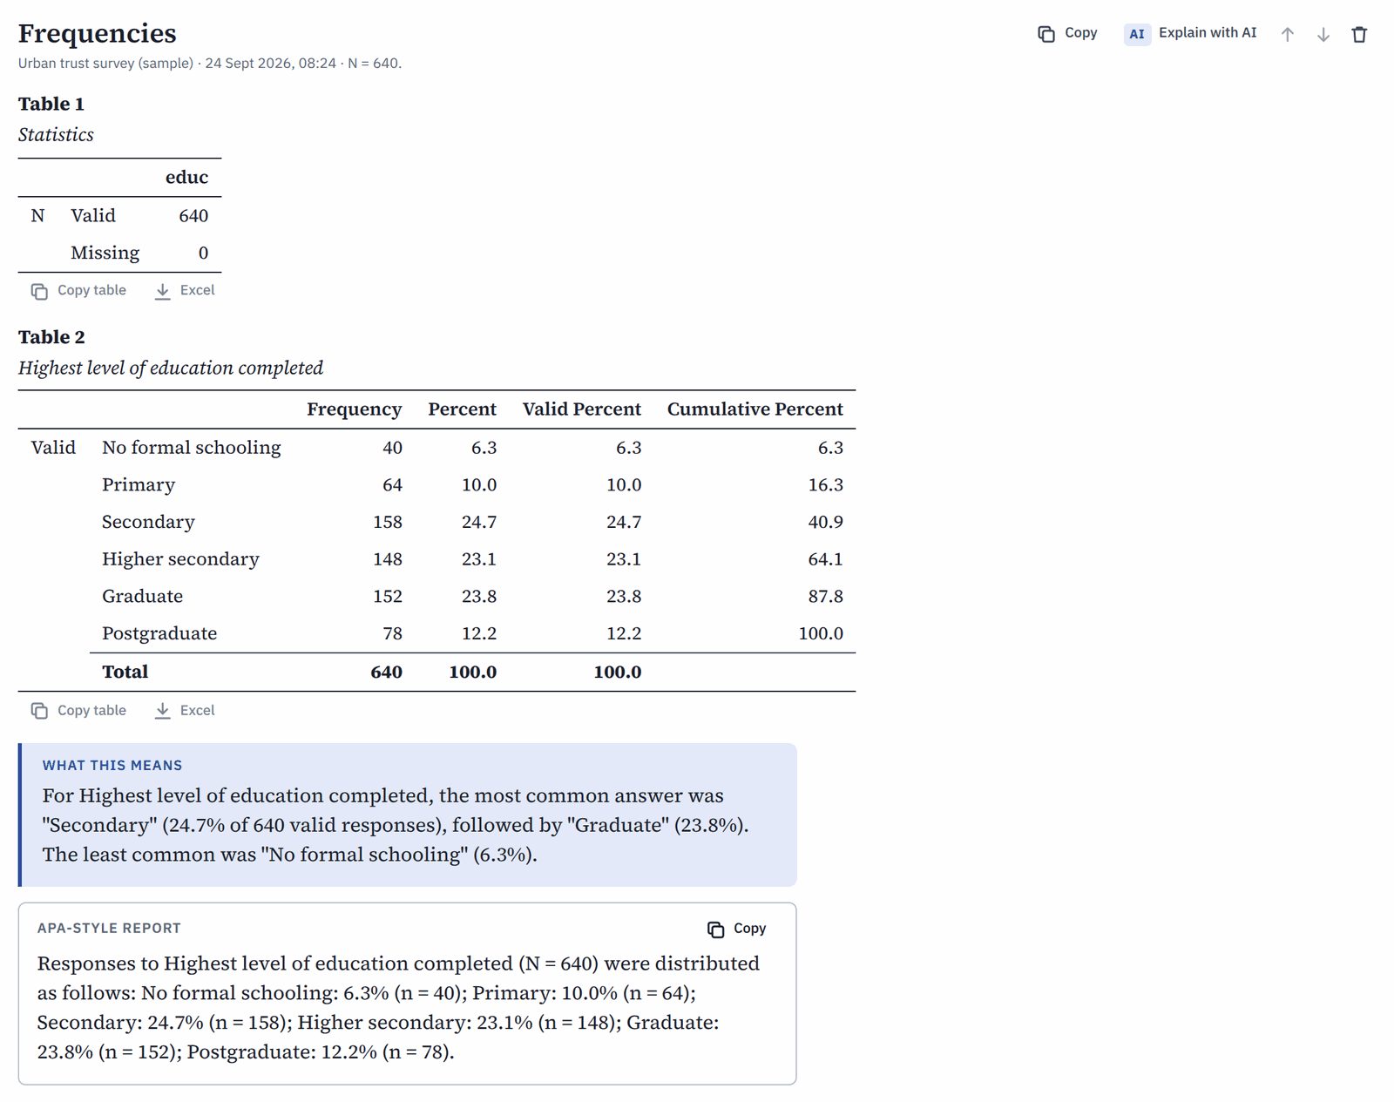
The result: a frequency table for education, a plain-language summary and a draft APA sentence.
How to read it.
- Frequency is the number of people who gave each answer.
- Percent is the share of all cases, including missing ones.
- Valid Percent leaves out missing answers. This is usually the number to report.
- Cumulative Percent adds the valid percentages up as you go down the table. Here 40.9% have secondary education or less.
The most common answer is "Secondary" (24.7%), and the least common is "No formal schooling" (6.3%).

HOW TO REPORT IT
Of the 640 respondents, 24.7% had completed secondary school, 23.8% held a graduate degree and 12.2% a postgraduate degree; 6.3% had no formal schooling.

Crosstabs with chi-square: are two categories related?
When to use it. When both variables are categories (nominal or ordinal), and you want to know whether they are related. For example: do women and men feel equally safe in their neighbourhood?
Try it. Does the feeling of safety after dark differ by gender?
- Choose Analyze > Descriptive Statistics > Crosstabs.
- Put gender in Row(s) and trust5 ("I would feel safe walking alone here after dark") in Column(s).
- On the Cells tab, keep Row percentages ticked. Put the variable that defines your groups in the rows; then each row adds up to 100% and you compare rows.
- On the Statistics tab, Chi-square and Phi and Cramer's V are already ticked.
- Click Run.
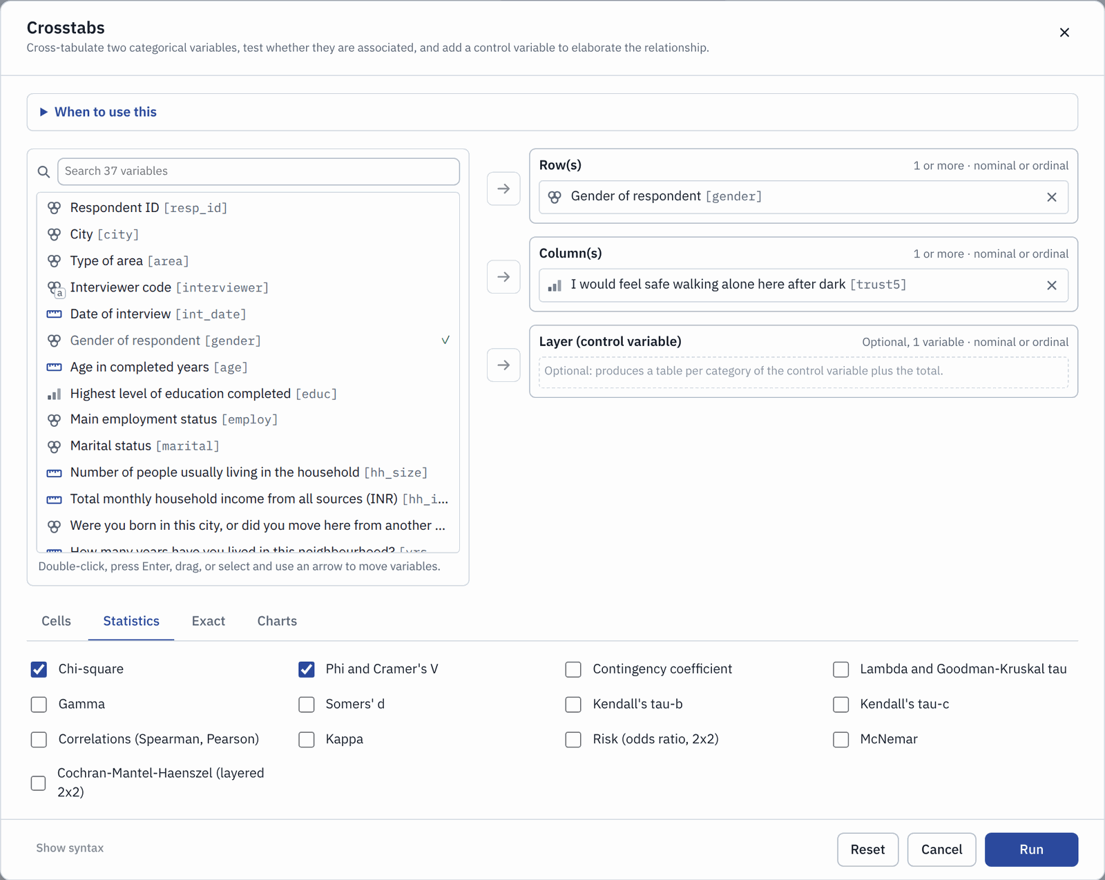
The Crosstabs dialog, Statistics tab. Chi-square and Cramer's V are ticked by default.
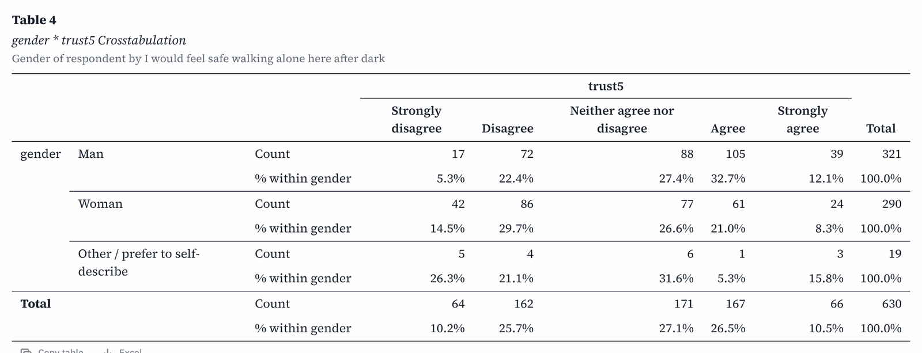
The crosstabulation: counts and row percentages for each gender.
How to read the table. Compare the percentages across each row. Among men, 32.7% agree and 12.1% strongly agree that they feel safe after dark: 44.8% in total. Among women the total is 29.3% (21.0% plus 8.3%). Women are also more likely to strongly disagree (14.5% against 5.3% of men).
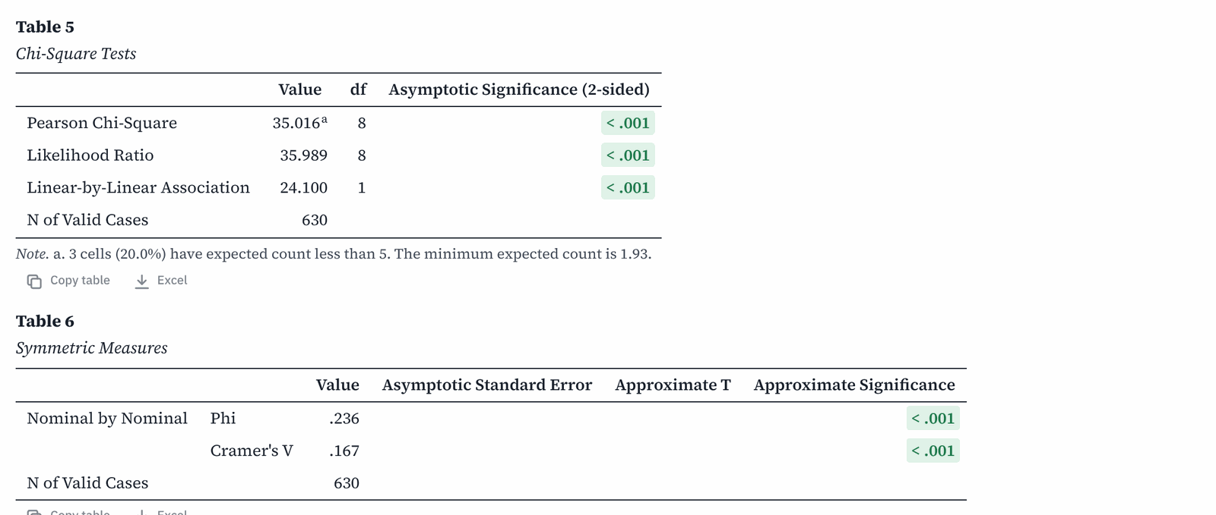
The chi-square test and the strength of the association (Cramer's V).
How to read the test.
- Pearson Chi-Square asks: could a difference this large appear by chance if gender and feeling safe were unrelated? The p-value (in the "Significance" column) answers it. Here p < .001, far below the usual .05 limit, so the difference is very unlikely to be chance. We call it statistically significant.
- Cramer's V tells you how strong the relationship is, from 0 (none) to 1 (perfect). As a rough guide, .10 is weak, .30 moderate and .50 strong. Here V = .17: a real but weak relationship.
- The note under the table warns you if many cells have very few people ("expected count less than 5"). If more than 20% of cells are affected, the test becomes unreliable; merge small categories or use the Exact tab.
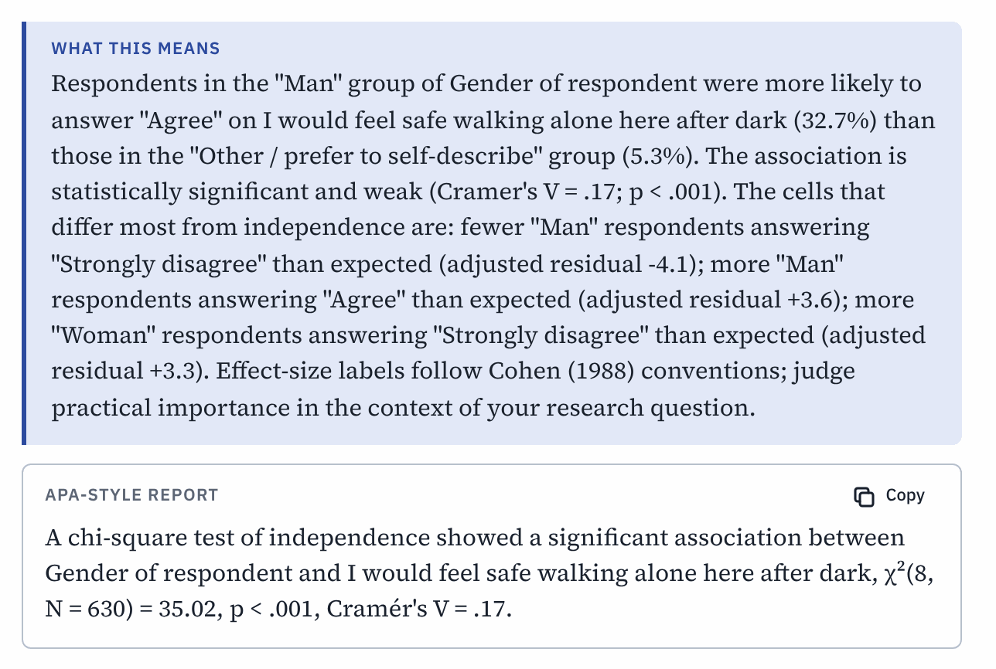
Socius explains the result in plain words and drafts the APA sentence.

HOW TO REPORT IT
A chi-square test of independence showed a significant association between gender and feeling safe walking alone after dark, χ²(8, N = 630) = 35.02, p < .001, Cramér's V = .17. Men were more likely than women to agree that they felt safe (44.8% vs. 29.3%).

Click Copy in the APA box to copy the sentence. Before you paste it into your paper, replace the long question wording with a short description, and put the statistical symbols (χ², N, p, V) in italics.

Comparing two groups: the independent-samples t-test
When to use it. When you compare the average of a scale variable between exactly two groups. For example: are people who were born in the city more satisfied with life than people who moved there?
Try it.
- Choose Analyze > Compare Means > Independent-Samples T Test.
- Put life_sat in Test Variable(s) and migrant in Grouping Variable.
- Under Groups, Socius fills in the two values of migrant: "Born in this city (0)" and "Migrated from another state or district (1)".
- Click Run.
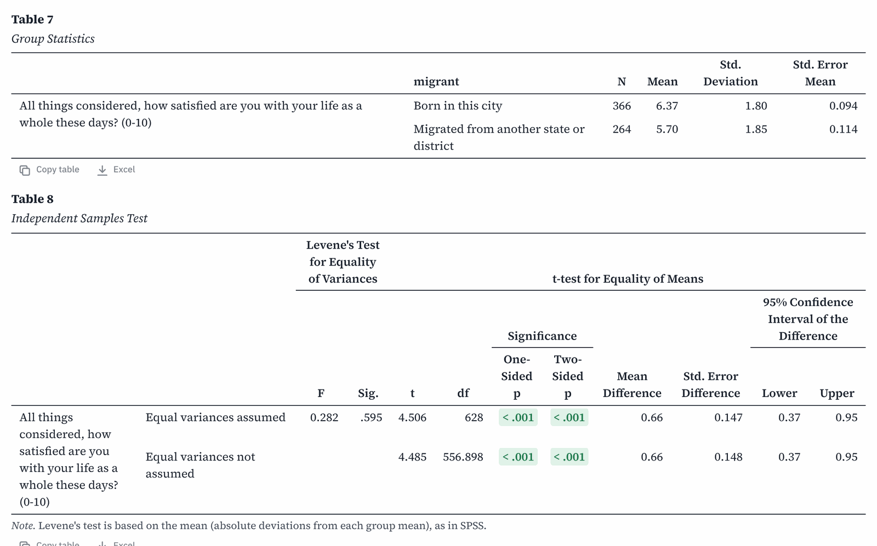
Group means and the t-test.
How to read it.
- Group Statistics shows the mean (average) for each group. People born in the city score 6.37 on average; migrants score 5.70.
- Levene's Test checks whether the two groups are equally spread out. If its "Sig." is above .05 (here .595), read the row Equal variances assumed. If it is below .05, read Equal variances not assumed. The plain-language box tells you which row to read.
- t, df and Two-Sided p give the test. Here t(628) = 4.51, p < .001: the difference is statistically significant.
- Cohen's d (in the effect sizes table) tells you how big the difference is: about 0.2 is small, 0.5 medium and 0.8 large. Here d = 0.36, a small to medium difference.

HOW TO REPORT IT
Respondents born in the city reported higher life satisfaction (M = 6.37, SD = 1.80) than migrants (M = 5.70, SD = 1.85), t(628) = 4.51, p < .001, d = 0.36.

Comparing several groups: one-way ANOVA
When to use it. Like the t-test, but for three or more groups. For example: does life satisfaction differ by level of education?
Try it.
- Choose Analyze > Compare Means > One-Way ANOVA.
- Put life_sat in Dependent List and educ in Factor.
- On the Post hoc tab, tick Tukey. This compares every pair of groups.
- Click Run.
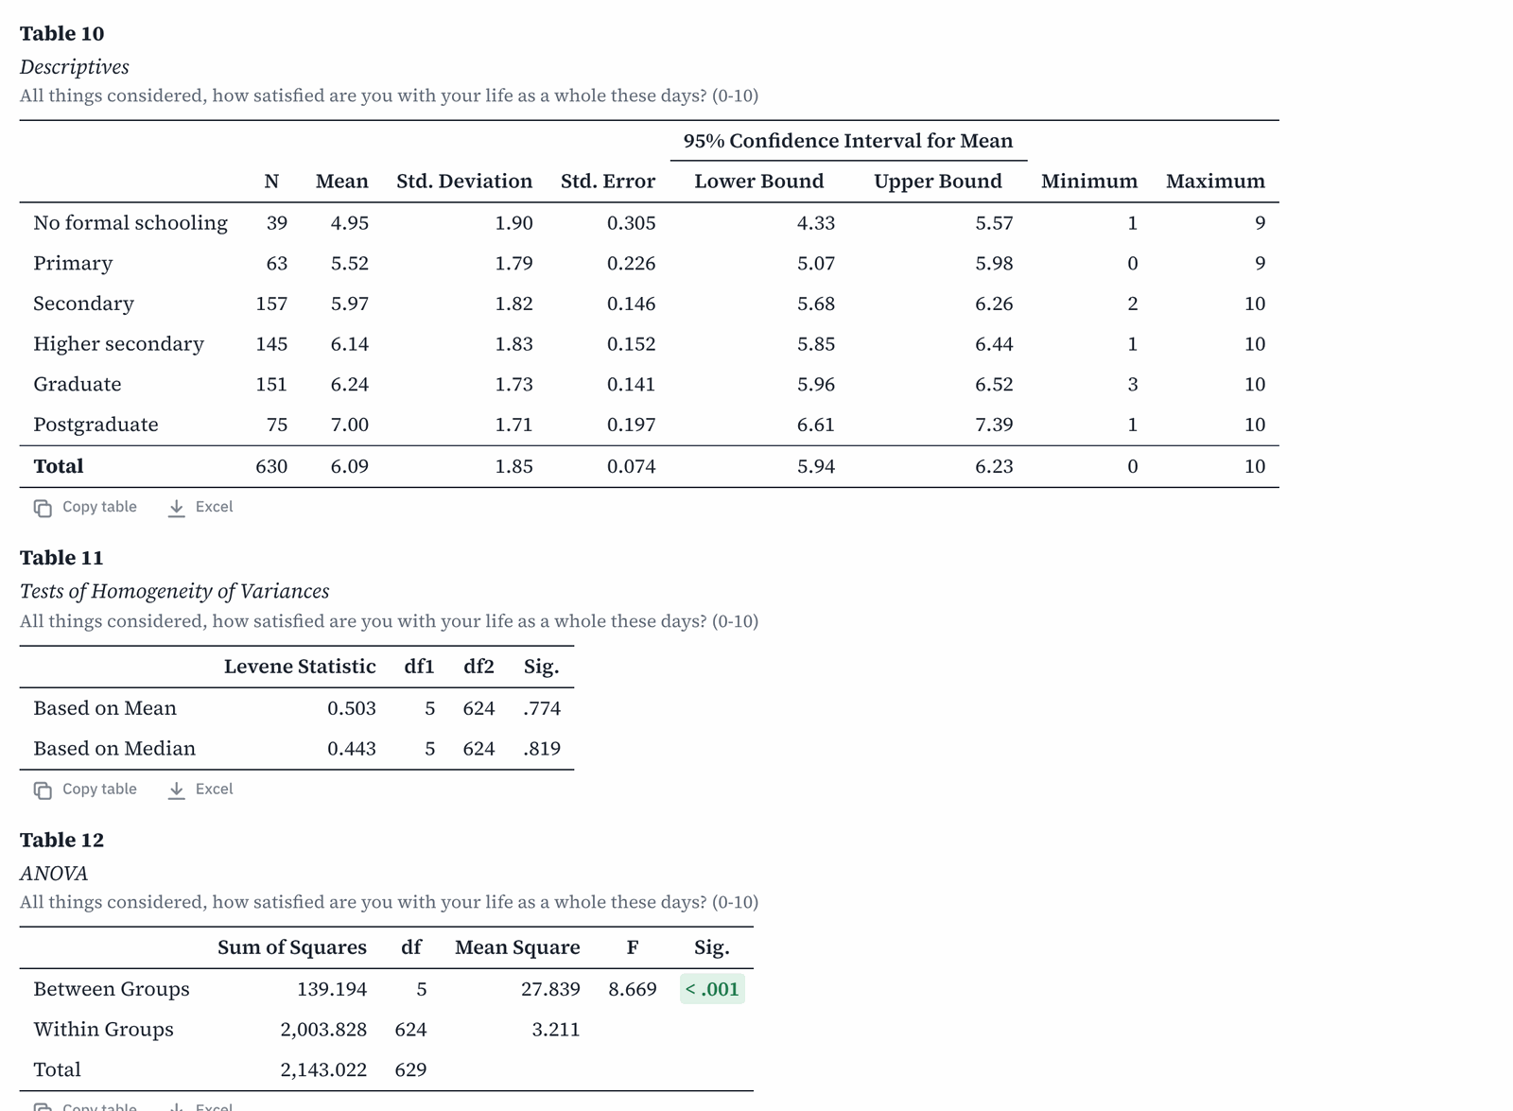
Descriptives, Levene's test and the ANOVA table.
How to read it.
- Descriptives lists the mean for each group. Life satisfaction rises with education, from 4.95 (no formal schooling) to 7.00 (postgraduate).
- ANOVA tests whether any of the group means differ. Here F(5, 624) = 8.67, p < .001, so they do. It does not say which groups differ.
- ANOVA Effect Sizes gives eta squared (η²): the share of the differences in life satisfaction that education accounts for. Here η² = .065, about 6.5%. As a rough guide, .01 is small, .06 medium and .14 large.
- Multiple Comparisons (the Tukey test) shows every pair of groups. A star (*) marks pairs that differ significantly, for example postgraduates and graduates.
- If Levene's test is significant (below .05), the groups are unequally spread. Then rely on the Welch test and choose Games-Howell instead of Tukey.

HOW TO REPORT IT
A one-way ANOVA showed that life satisfaction differed significantly by education, F(5, 624) = 8.67, p < .001, η² = .06. Tukey post hoc tests showed that postgraduates (M = 7.00) were more satisfied than every other group.

Correlation: do two numbers move together?
When to use it. When both variables are scale (or ordinal) and you want to know whether higher values of one go with higher (or lower) values of the other.
Try it. Choose Analyze > Correlate > Bivariate Correlations, move age, yrs_nbhd, life_sat and trust (the scale you built) into Variables, and click Run.
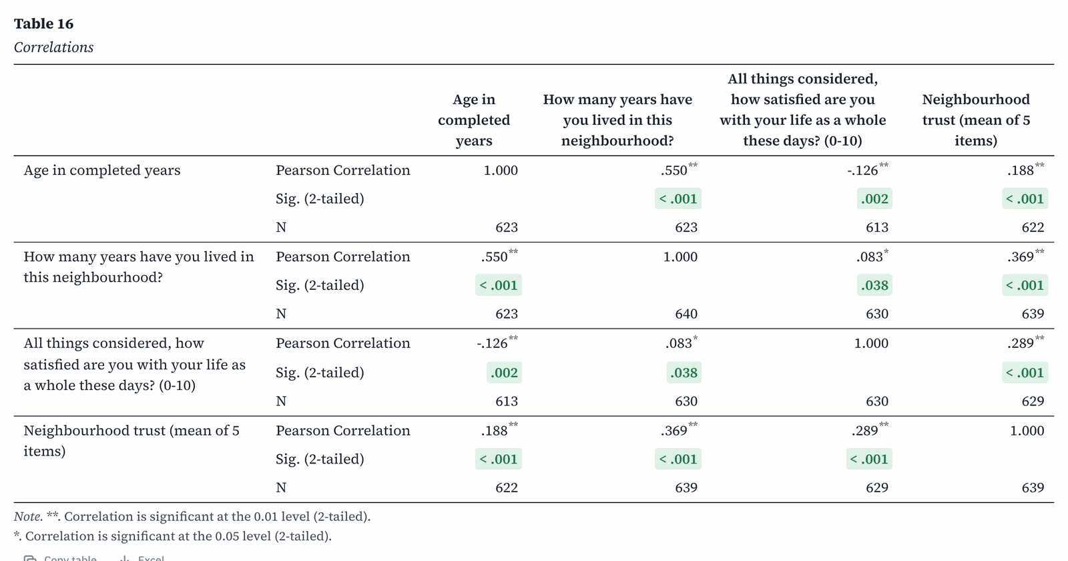
A correlation matrix. Each cell shows Pearson's r, its significance and the number of cases.
How to read it. Each cell pairs two variables. The Pearson Correlation (r) runs from -1 to +1:
- A positive r means both rise together; a negative r means one rises as the other falls.
- As a rough guide, .10 is weak, .30 moderate and .50 strong.
- Stars mark significant correlations.
Here, people who have lived longer in the neighbourhood trust their neighbours more (r = .37, moderate), and people with more trust are more satisfied with life (r = .29, weak). Remember that a correlation does not show which causes which.

HOW TO REPORT IT
Neighbourhood trust was positively correlated with years lived in the neighbourhood, r(637) = .37, p < .001, and with life satisfaction, r(627) = .29, p < .001.

ORDINAL VARIABLES
For a single Likert item or other ordered categories, also tick Spearman in the dialog. It uses ranks and does not assume equal steps between answers.

A simple linear regression
When to use it. To predict a scale outcome from one or more other variables, and to see how much the outcome changes for each one-unit change in a predictor.
Try it. How much does life satisfaction rise with neighbourhood trust?
- Choose Analyze > Regression > Linear Regression.
- Put life_sat in Dependent and trust in Independent(s): Block 1.
- Click Run.
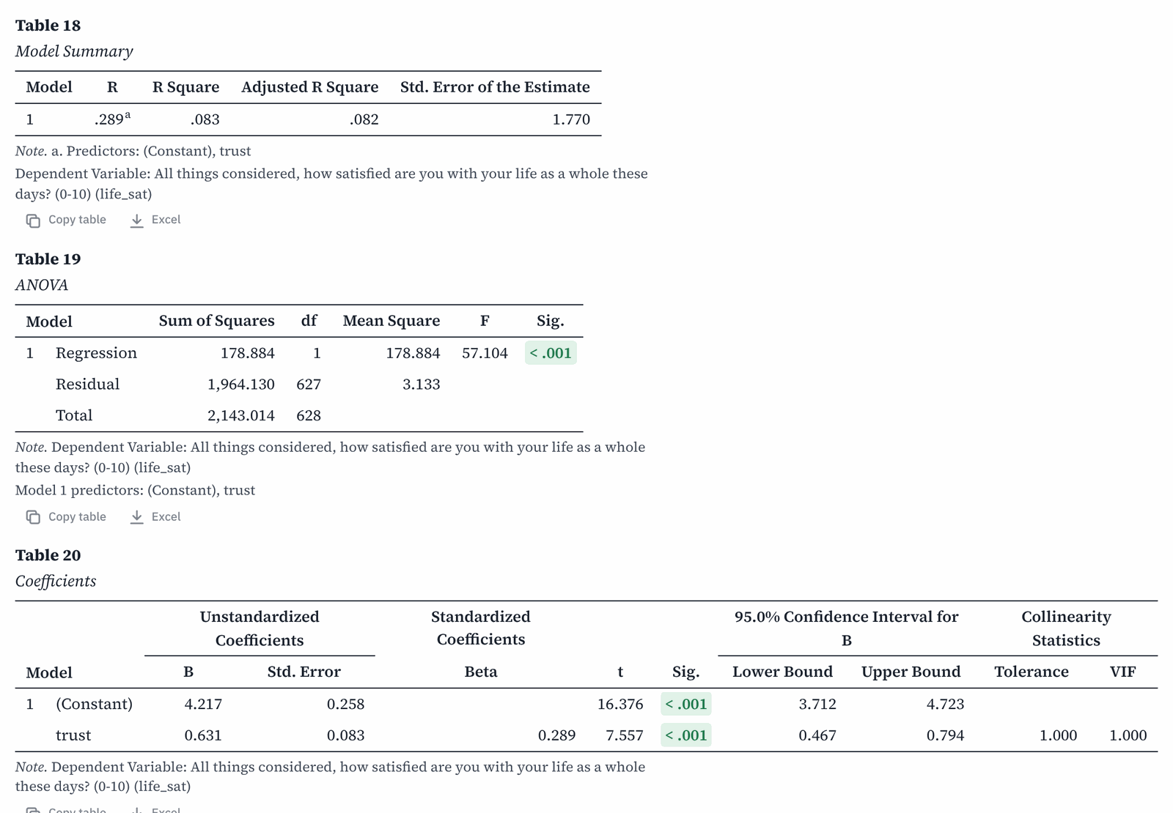
Model Summary, ANOVA and Coefficients tables.
How to read it.
- Model Summary: R Square is the share of the differences in the outcome that the model explains. Here R² = .083: trust explains about 8% of the differences in life satisfaction.
- ANOVA tests the model as a whole. Here it is significant (p < .001).
- Coefficients: B is the key number. For each one-point rise in trust (on its 1 to 5 scale), life satisfaction rises by 0.63 points (on its 0 to 10 scale). The (Constant) is the predicted value when the predictor is zero, and is rarely interpreted.
- Beta is the same effect in standard units, useful for comparing predictors measured in different units.

HOW TO REPORT IT
A simple linear regression showed that neighbourhood trust predicted life satisfaction, B = 0.63, 95% CI [0.47, 0.79], β = .29, t(627) = 7.56, p < .001. The model explained 8.3% of the variance, F(1, 627) = 57.10, p < .001.

With one predictor Socius calls it a "simple" linear regression; with two or more, a "multiple" linear regression.
You can add more predictors to Block 1. Categorical predictors such as gender or educ are turned into 0/1 "dummy" variables for you, each compared with the first category.

Where to go next
Once you are comfortable with the analyses above, these are the natural next steps. They work the same way: pick variables, click Run, and read the plain-language box and the APA sentence.
- Binary logistic regression (Analyze > Regression > Binary Logistic Regression) predicts a yes/no outcome, such as whether someone voted. It reports odds ratios.
- Reliability analysis (Analyze > Scale > Reliability Analysis) gives Cronbach's alpha with item statistics, so you can see which question fits a scale worst.
- Factor analysis (Analyze > Dimension Reduction > Factor Analysis) shows which questions group together, for example whether trust items and civic activity items measure two different things.
- Nonparametric tests (Analyze > Nonparametric Tests) such as Mann-Whitney U and Kruskal-Wallis are alternatives to the t-test and ANOVA for ordinal or very skewed data.

8 Charts
All charts are in the Graphs menu. They appear in Output with a title and the numbers behind them.

A bar chart
Try it. Did the share of voters differ between cities?
- Choose Graphs > Bar Chart.
- Put city in Category axis and vote in Cluster by (optional).
- Set Bars show to Percent of cases and Percentages within to Each category. Each city's bars then add up to 100%.
- Click Run.
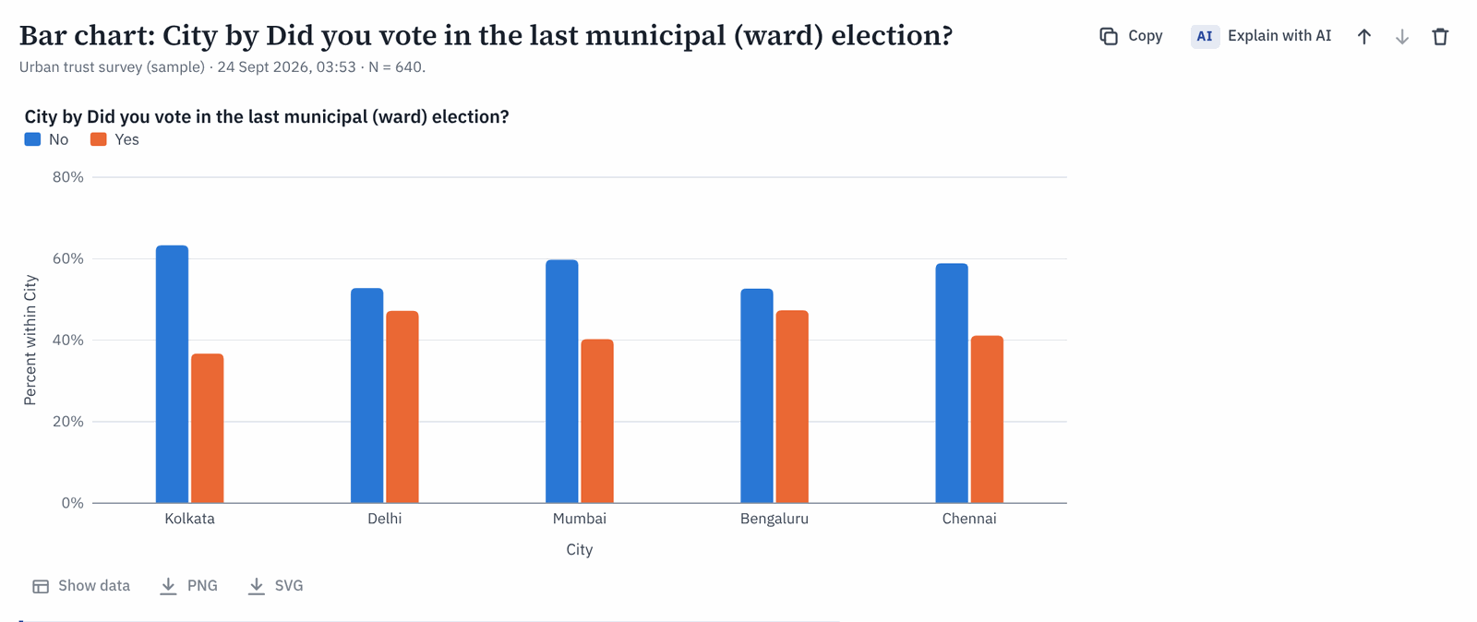
Voting by city. In every city, fewer than half of respondents voted.
For a single variable, leave Cluster by empty. To compare an average, such as mean trust by city, set Bars show to Mean of a variable and put the scale variable in Variable for means.

A histogram
A histogram shows the shape of a scale variable. Choose Graphs > Histogram, put age in Variable and click Run.
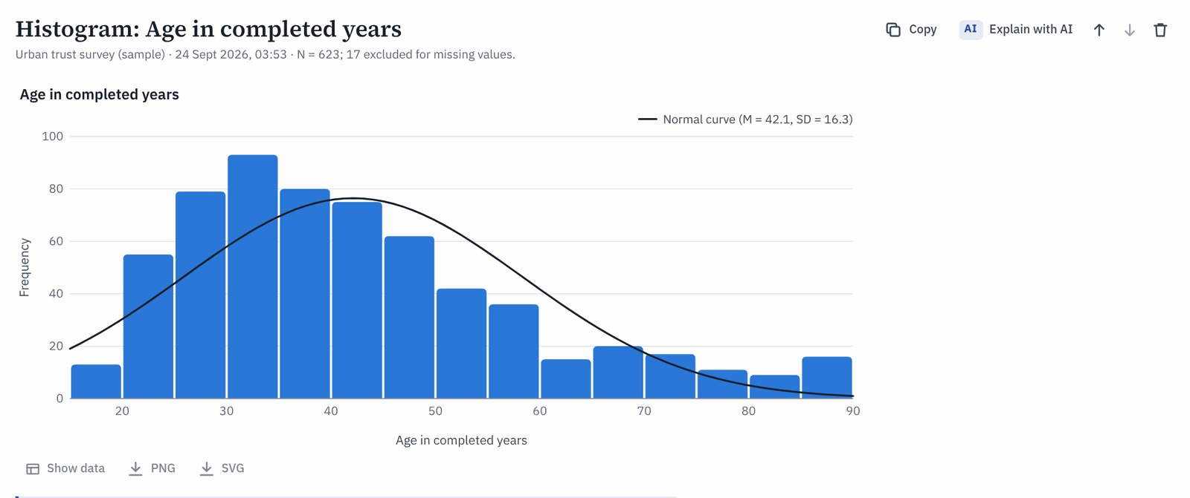
The age distribution with a normal curve. The buttons below the chart (1) show the data or save the chart as a picture.
Here the middle half of respondents are between 30 and 51 years old, with a long tail of older people. Socius calls this "right-skewed".

Saving a chart
Under every chart you find three buttons:
- Show data lists the numbers behind the chart.
- PNG saves a picture you can insert in Word or PowerPoint.
- SVG saves a sharp vector version that stays crisp at any size, useful for publications.
Charts are also included when you export the whole report to Word (see the next chapter).

9 Getting results into your report
Every analysis you run is added to the Output tab, newest at the bottom. The bar at the top of Output controls how results look and how you take them away.
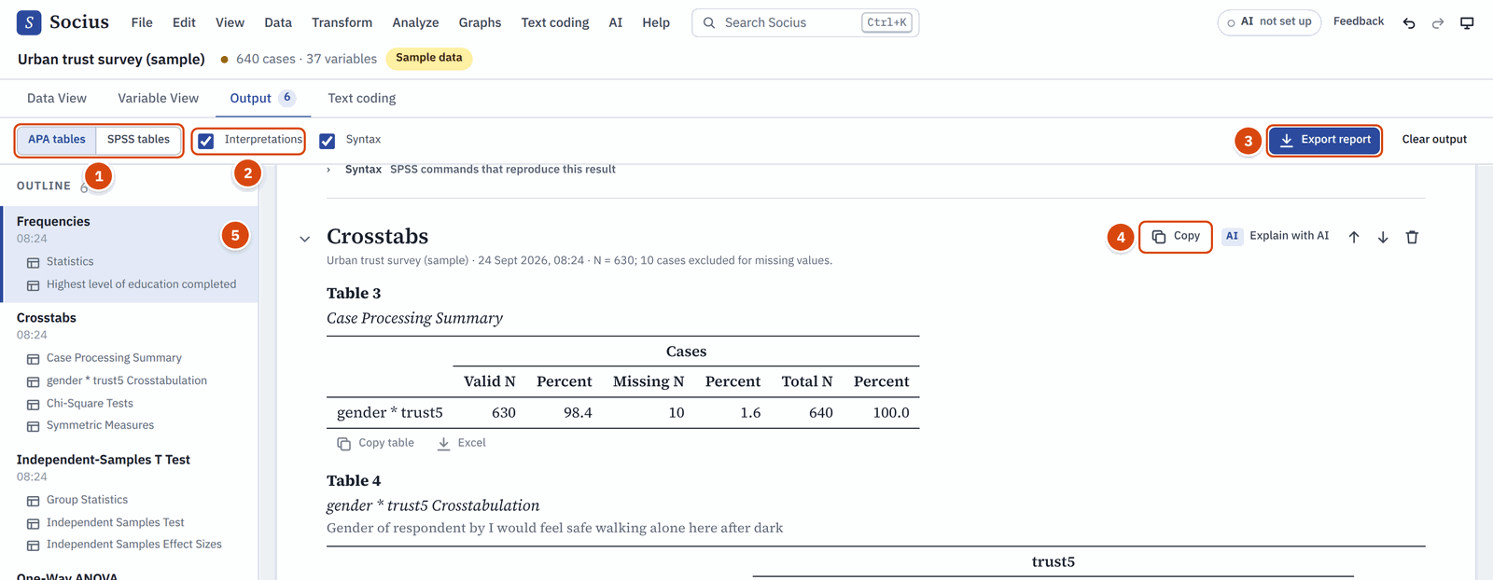
The Output tab. The numbers are explained below.
- APA tables / SPSS tables switches the table style.
- Interpretations and Syntax show or hide the plain-language boxes and the SPSS commands.
- Export report saves all the output in one file.
- Copy at the top right of each result copies that result. Next to it, Explain with AI asks the optional AI help to explain the result (see Explain a result).
- The Outline lists every result, so you can jump between them.

APA style or SPSS style
APA tables have horizontal lines only, a numbered title and an italic heading. This is what most journals and theses expect. SPSS tables look like the SPSS viewer, which helps when you compare your results with SPSS or with a colleague who uses it.
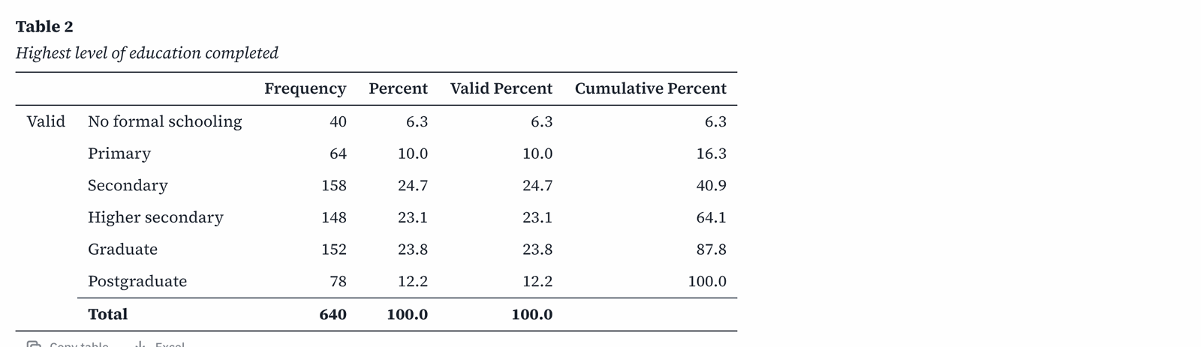
The same frequency table in APA style.

And in SPSS style.

Copy one table into Word
- Choose APA tables at the top of Output.
- Click Copy table under the table you want (or Copy at the top of a result to copy all of it).
- Paste into Word or Google Docs with Ctrl+V . The table keeps its lines and formatting.
Excel, next to Copy table, saves that one table as a spreadsheet.

Copy the APA sentence
Click Copy in the APA-style report box and paste the sentence into your results section. Treat it as a draft:
- Rewrite long question wording into short concepts your reader knows ("feeling safe after dark").
- Put statistical symbols in italics: t, F, p, M, SD, N, r, d. Socius copies plain text, so italics are lost.
- Add the direction and meaning of the result in your own words.

Export the whole report
Click Export report in the Output tab, or choose File > Export output report, and pick a format:
- Word document (.docx): APA tables and charts, ready to edit. This is the one most people want.
- Web page (.html): a standalone page you can open in any browser and print, or save as PDF from the print dialog.
- Excel workbook (.xlsx): one sheet per table.
- Plain text (.txt): tables as aligned text.
To tidy up before exporting, use the small arrows on each result to move it up or down, and the bin icon to delete it. Clear output removes everything.

10 Coding open-ended answers
Surveys often end with an open question, such as "What is the biggest challenge facing your neighbourhood today?". Coding means reading each answer and tagging it with one or more themes, called codes. The list of codes, with a definition for each, is your codebook. Once answers are coded, you can count the themes, compare them between groups, and even test the differences with statistics.
Everything for coding is in the Text coding menu and the Text coding tab. The optional AI helpers for coding are in the AI menu (see AI in Text coding).
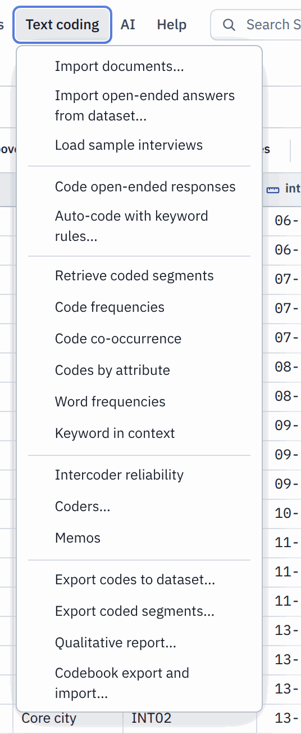
The Text coding menu: import, code, analyse and export. The AI helpers are in the AI menu.

Start with the worked example
The quickest way to learn is the worked example. Click the Text coding tab. With the sample survey open, the start screen of Text coding shows a card called Explore a worked example.
Click it. Socius brings in the 630 answers to q_challenge, adds a starter codebook of 15 codes grouped into 4 themes, and codes most answers automatically with keyword rules, so you have something to review. One click on Undo in the Text coding toolbar removes the whole example again.

Import answers from a survey question
For your own data, bring in the answers yourself:
- Choose Text coding > Import open-ended answers from dataset.
- Under Open-ended question (string variable), pick the question, for example q_challenge.
- Under Name responses by (optional), pick an ID such as resp_id.
- Tick the characteristics you want to compare later, such as gender, city, area and migrant. These travel with each answer as attributes.
- Click Import 630 answers (the button shows how many answers will come in).
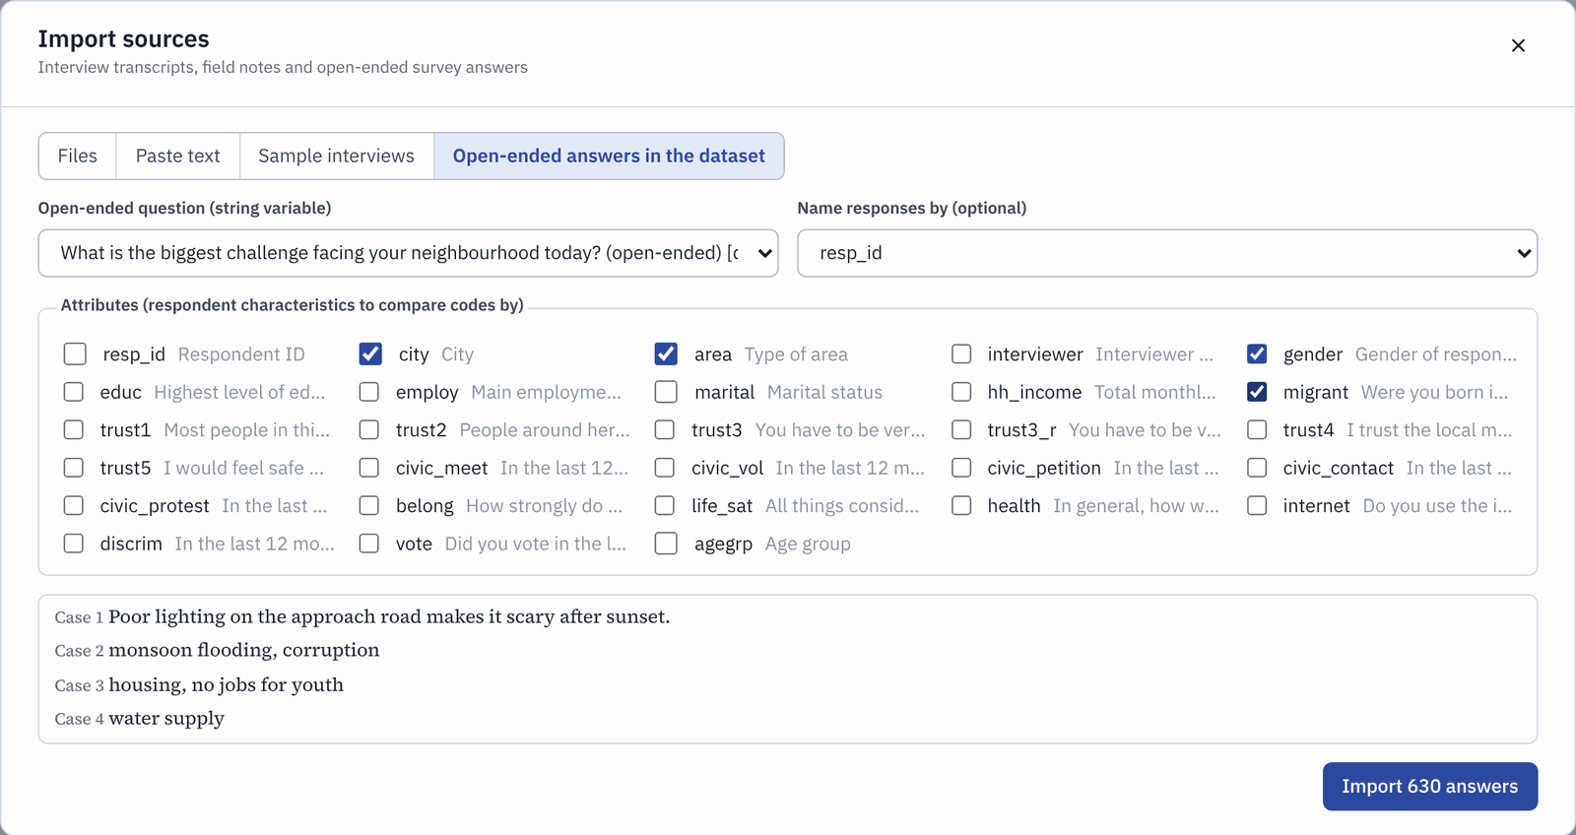
Importing the answers to q_challenge with four attributes.

The Responses view
The answers appear in the Responses view of the Text coding tab.
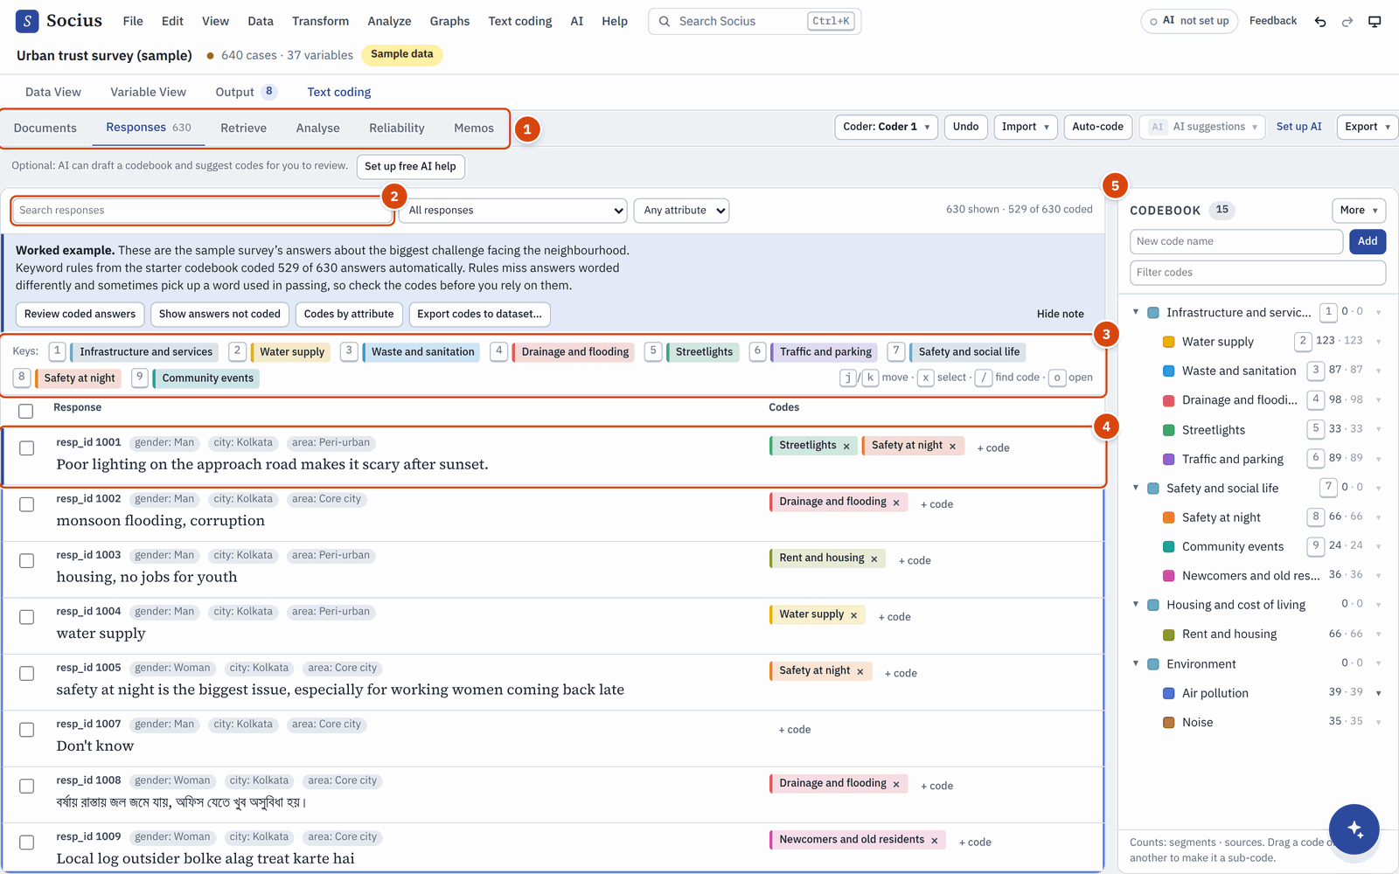
The Responses view with the worked example loaded.
- Views. Switch between Documents, Responses, Retrieve, Analyse, Reliability and Memos.
- Search and filters. Find answers with a word, show only answers not yet coded, or only one group (for example only women).
- Number keys. The first nine codes get the keys 1 to 9.
- An answer with its attributes and its codes. Click + code to add a code with the mouse, or the small cross on a code to remove it.
- Codebook. Your codes, grouped under themes, with how many passages and sources each has.

Build a codebook
To add a code, type its name in New code name at the top of the Codebook panel and click Add. Start with a handful of codes from reading 30 or 40 answers; you can add more as you go.
Good codes have clear definitions. Open a code's menu (the small arrow at the right of its row) and choose Edit definition and rules.
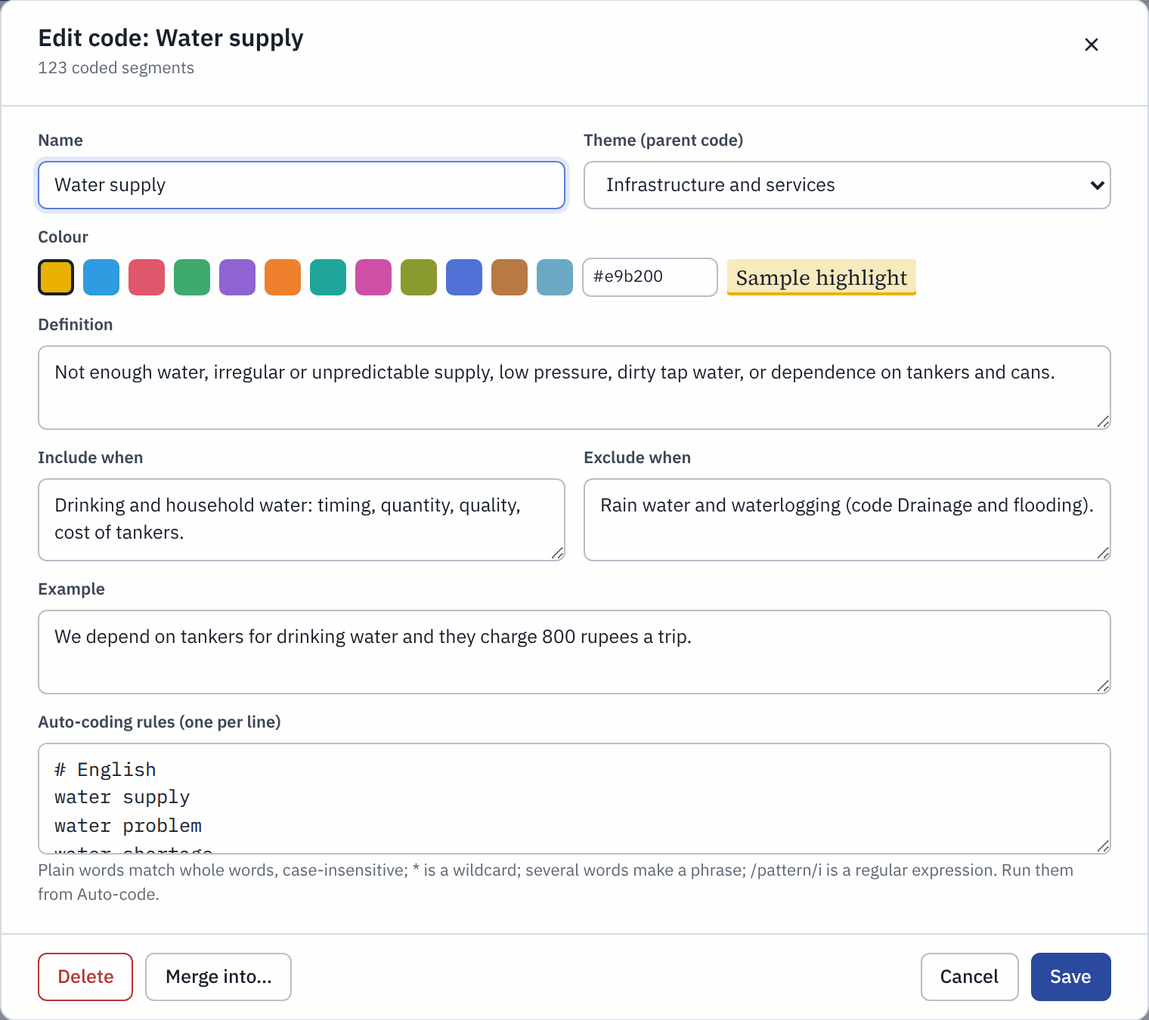
Editing a code: its theme, definition, when to include and exclude it, an example and keyword rules.
- Theme (parent code) groups codes into a hierarchy, such as "Water supply" under "Infrastructure and services".
- Definition, Include when, Exclude when and Example keep your coding consistent over weeks, and they are exactly what a second coder needs.

Code with the number keys
Coding by keyboard is fast. Click in the list of answers, then:

Key | What it does
j or ↓ | Next answer
k or ↑ | Previous answer
1 to 9 | Apply that code; press again to remove it
/ | Find any code by name, or create a new one
x or Space | Select an answer (to code several at once)
o or Enter | Open the answer to code only part of it

An answer can have several codes. The counter at the top right shows how many answers you have coded so far.

Auto-code with keyword rules
For clear-cut themes, rules save time. Choose Text coding > Auto-code with keyword rules (or the Auto-code button).
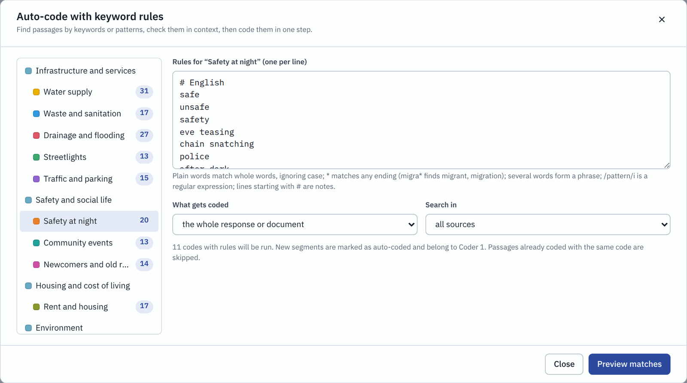
Keyword rules for the code "Safety at night".
- Pick a code on the left.
- Type its rules on the right, one per line. A plain word matches that whole word, ignoring capitals. * matches any ending (flood* finds flood, floods and flooding). Lines starting with # are notes to yourself.
- Choose What gets coded (the whole answer, or only the sentence with the match) and Search in.
- Click Preview matches, untick any wrong hits, then click the button to code them.

ALWAYS CHECK AUTOMATIC CODES
Keyword rules miss answers that describe a theme in other words or in another language, and they sometimes catch a word used in passing. Read a sample of the auto-coded answers, and use the filter Not coded yet to find the ones the rules missed.

Turn codes into variables and crosstab them
This is where qualitative and quantitative work meet. Each code can become a 0/1 variable in your dataset (1 = the person mentioned it, 0 = did not).
- Choose Text coding > Export codes to dataset.
- Tick the codes you want. Each gets a variable name starting with c_, such as c_safety_at_night.
- Click Add ... variables.
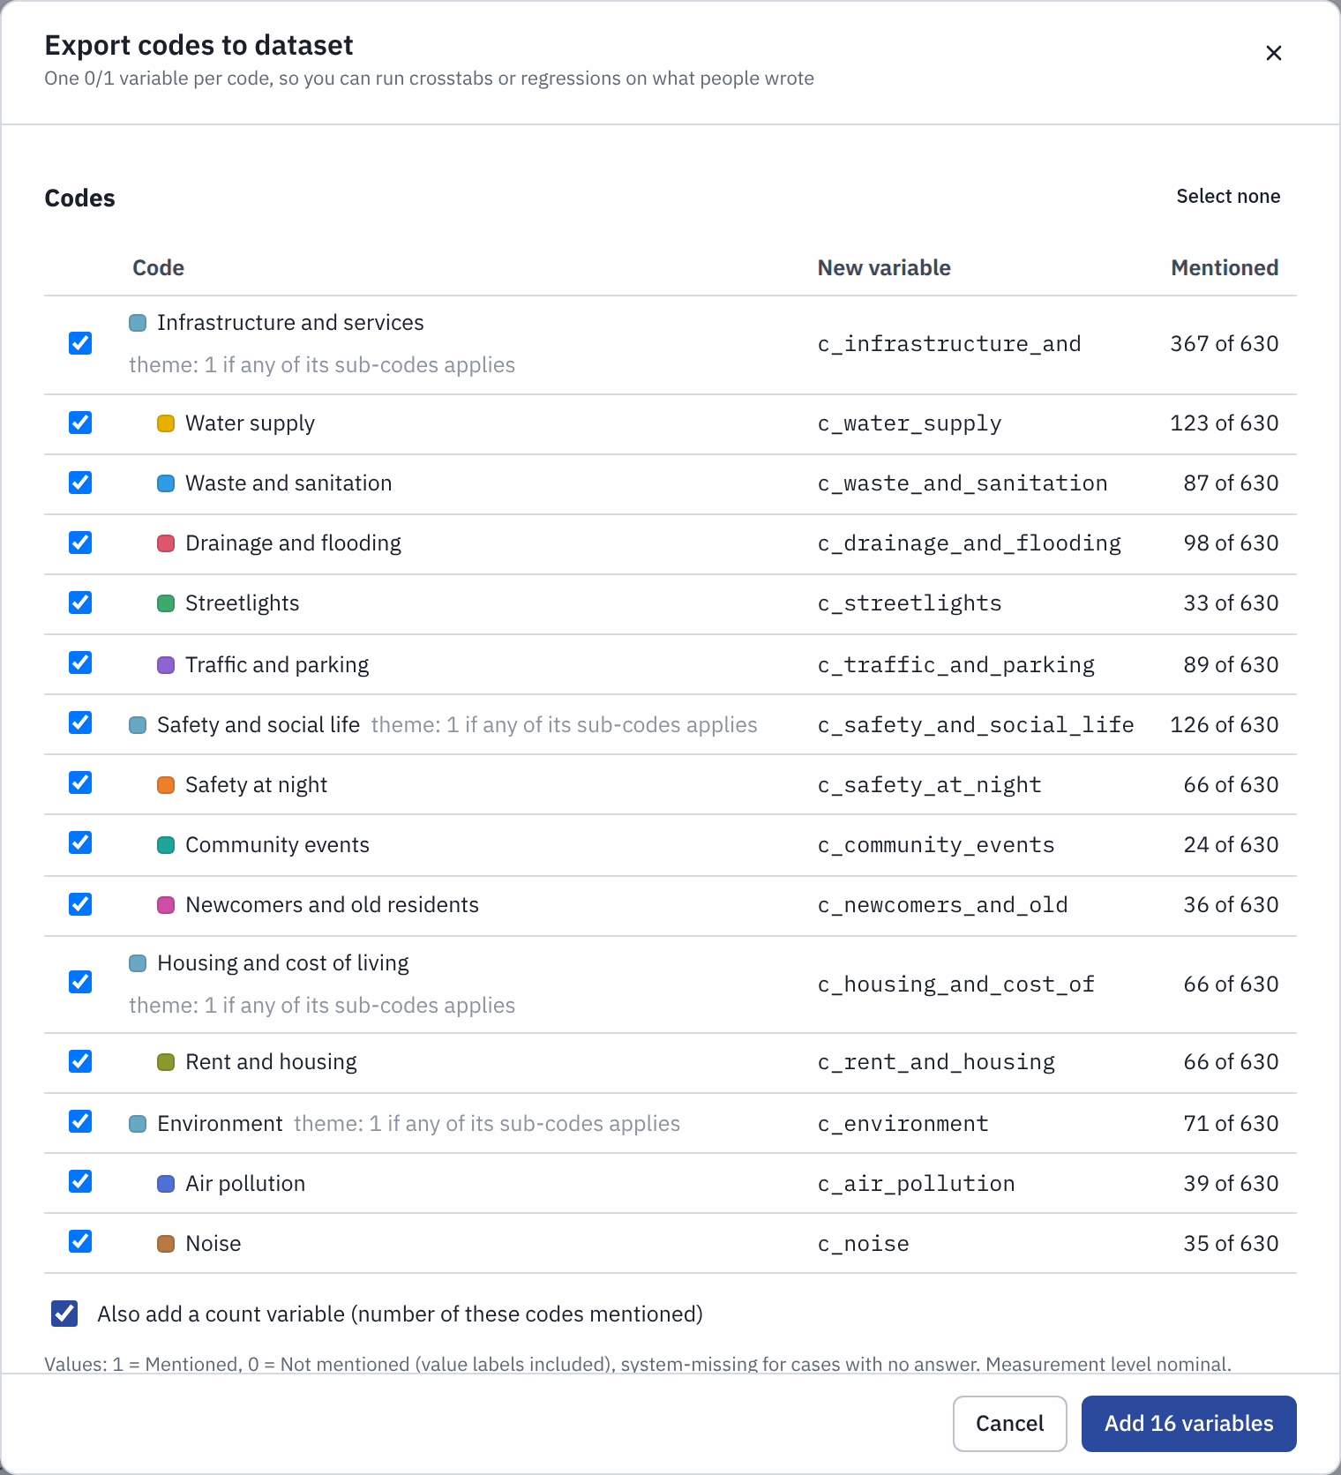
Exporting codes as variables. The last column shows how many answers mention each code.
Now run Analyze > Descriptive Statistics > Crosstabs with gender in Row(s) and c_safety_at_night in Column(s):
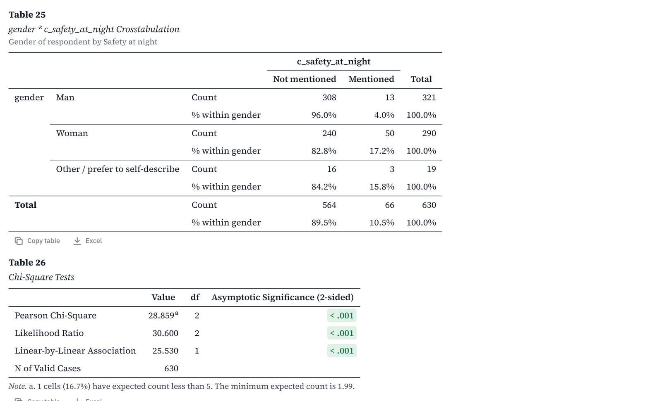
Women mention safety at night far more often than men.
17.2% of women mention safety at night as the biggest challenge, against 4.0% of men, χ²(2, N = 630) = 28.86, p < .001. The answer to an open question has become a testable finding.
To compare codes between groups without leaving Text coding, open the Analyse view and choose Codes by attribute:
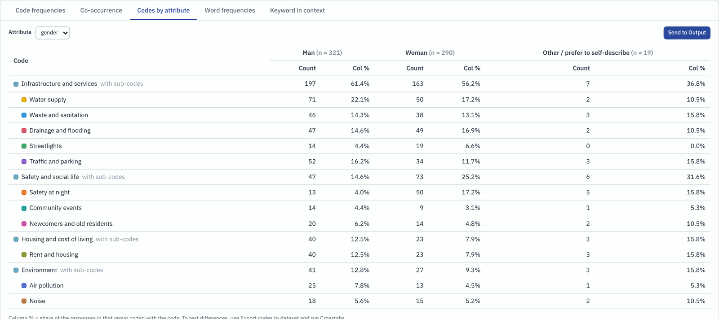
Codes by attribute: how often each code appears among men, women and people of other genders.

11 Coding interviews
Interview transcripts are coded in the Documents view. You highlight a passage and attach one or more codes to it.

Import a transcript
Choose Text coding > Import documents. Drop your files on the dialog, or click to choose them.
- Word (.docx) and plain text (.txt, .md) files: one document per file.
- Paste text lets you paste a transcript directly.
- To practise, choose Text coding > Load sample interviews. It adds three fictional interviews from Kolkata, Bengaluru and Delhi.

Highlight and code a passage
- Open the Documents view and click an interview in the Sources panel on the left.
- Select a passage with the mouse, as you would to copy it.
- A small box appears. Type the name of a code. Press Enter to apply an existing code, or choose Create code to add a new one on the spot.
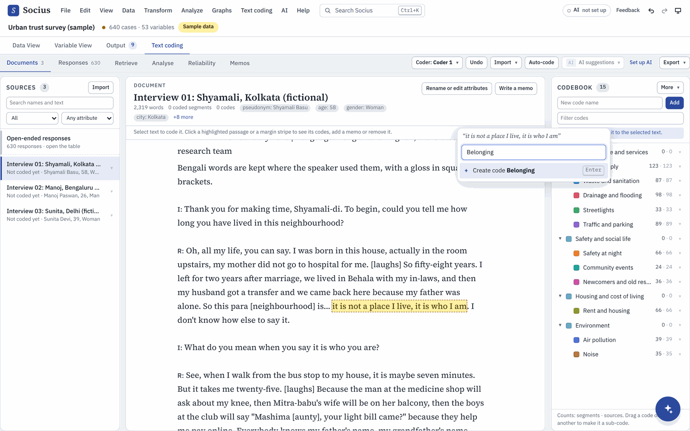
Selecting a passage and creating the code "Belonging".
Coded passages are highlighted in the code's colour, with a stripe in the margin. A passage can have several codes, and codes can overlap.
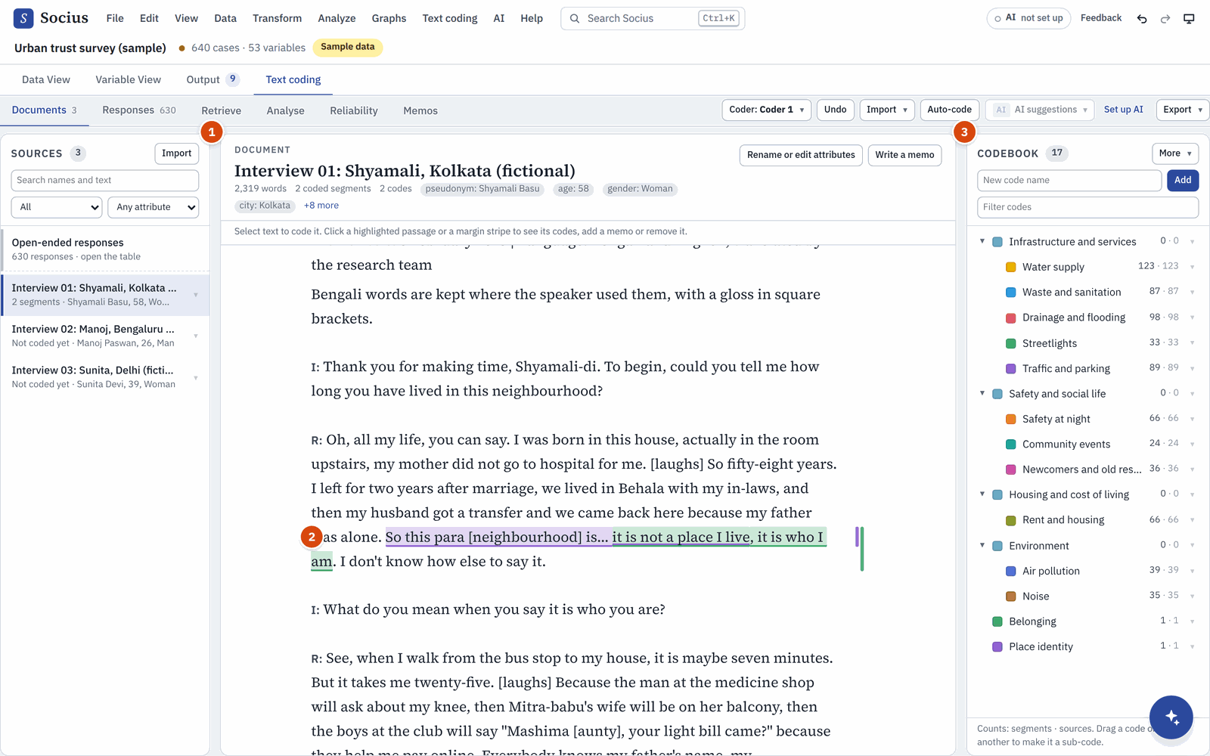
A coded interview: the Sources (1), coded passages (2) and the Codebook (3).

Write memos
Memos are your analytic notes. There are two kinds:
- A memo on a passage. Click a highlighted passage. A panel shows its codes, with a box for a memo on each.
- A memo on the project or a code. Open the Memos view and click New memo, or choose Write a memo on this code from a code's menu.
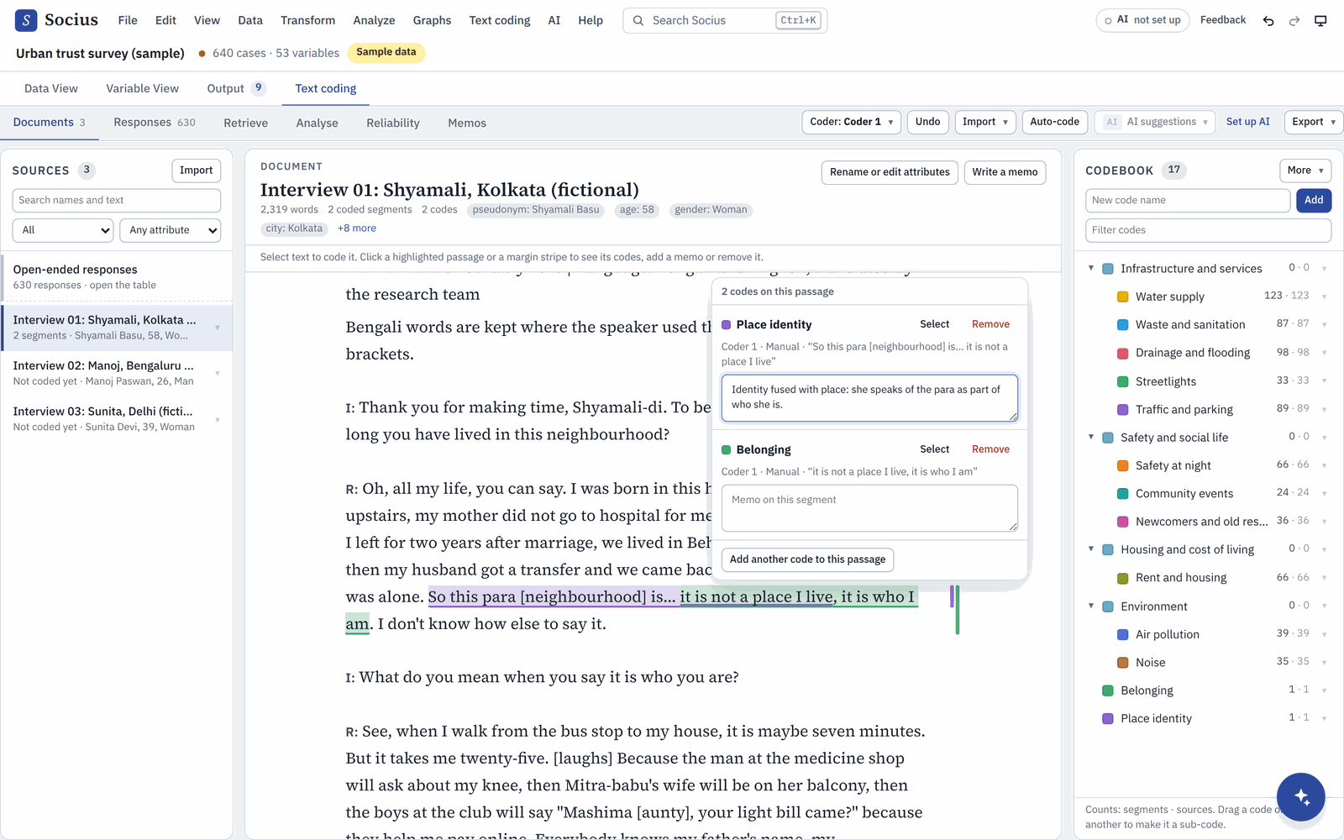
Clicking a coded passage shows its codes and a memo box for each.

Retrieve quotes
The Retrieve view collects every passage with a given code, across all your documents and answers, with the speaker's attributes. Pick a code at the top.
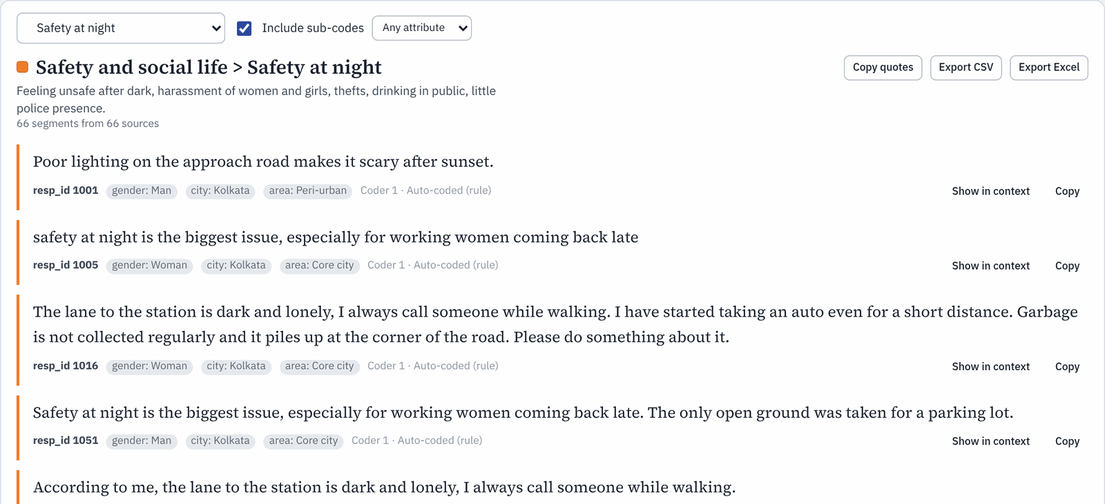
All passages coded "Safety at night".
- Copy quotes copies them with their sources, ready for your write-up.
- Show in context jumps to the passage in its document.
- Export CSV and Export Excel save them as a table.
For a report of the whole codebook with counts and example quotes, choose Text coding > Qualitative report.

Intercoder reliability: do two coders agree?
To show that your coding is trustworthy, a second person codes the same material independently, and you measure how often you agree.
- Agree on the codebook with written definitions first.
- Choose Text coding > Coders (or Coders under the Coder button in the toolbar). Add the second coder, for example "Priya", and click Code as Priya.
- Priya codes the same answers or documents. While she codes, she does not see the first coder's codes, so her coding stays independent.
- If you work on different computers, one person saves the project (File > Save project) and sends the .socius.json file to the other, who opens it, codes, and saves it again.
- Open the Reliability view and choose Coder A and Coder B.
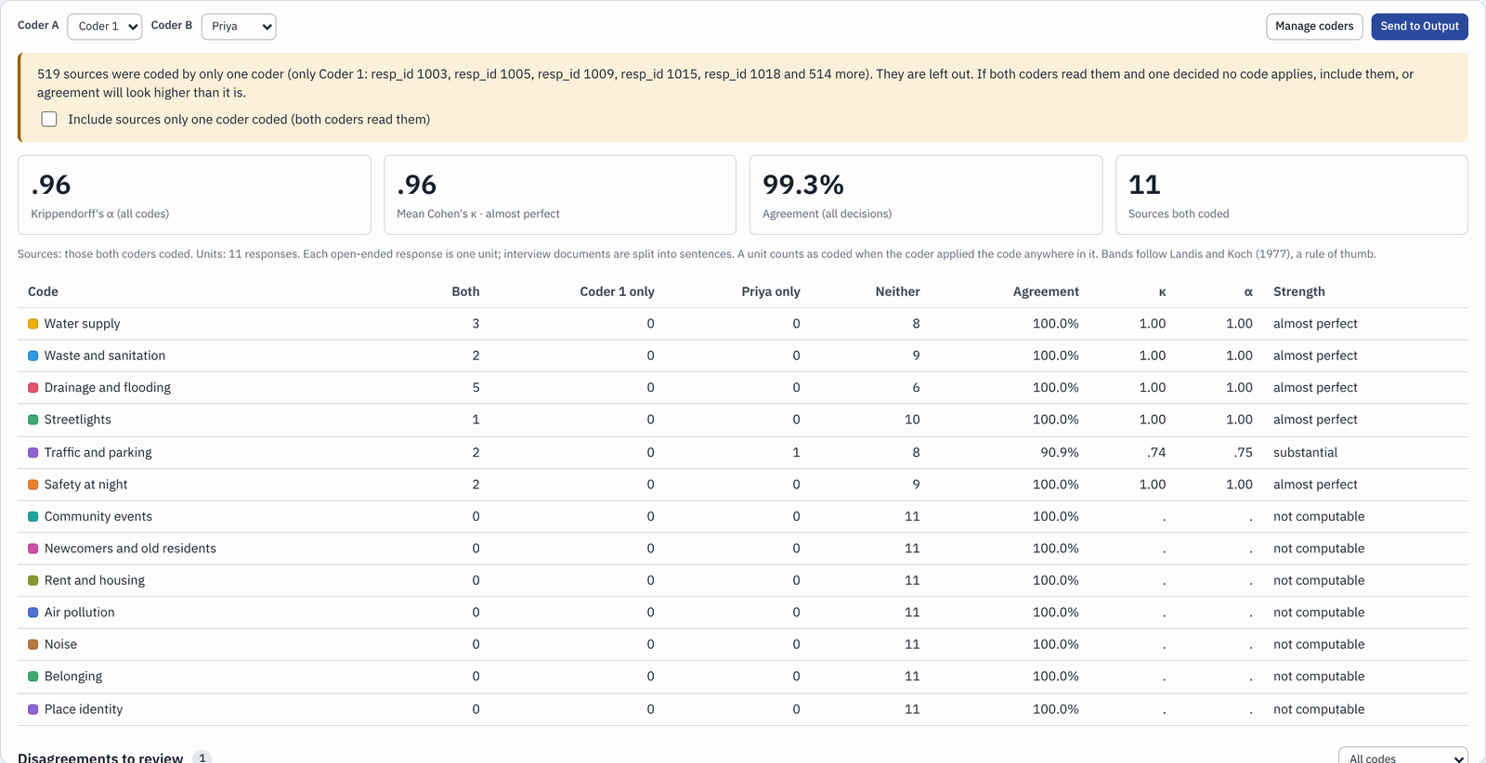
Intercoder reliability between Coder 1 and Priya.
How to read it.
- Agreement is the share of decisions on which both coders agree. It looks high even by chance, because both coders leave most codes off most answers.
- Cohen's κ (kappa) and Krippendorff's α (alpha) correct for agreement by chance. For published work, .70 to .80 or higher is usually expected. The Strength column gives a verbal label ("substantial", "almost perfect").
- Disagreements to review, further down, lists the answers where you differ. Discuss them, sharpen the code definitions, and code a fresh sample if needed.

12 Getting help from AI
Socius can ask an AI model to help you. Once it is set up, AI can:
- answer your questions about your data and methods, and run the analysis for you (the Socius assistant);
- explain a result in plain language, with what to watch out for and how to report it;
- help with text coding: suggest a codebook, suggest codes for open-ended answers and summarise a code.
AI help is optional and free. It is switched off until you set it up, and everything else in Socius works without it. Setting it up takes about two minutes.

Set it up
- Choose AI > AI assistant settings. This is the one place where AI help is set up. The AI chip at the top right and every Set up AI button (next to an AI feature that is greyed out) open the same settings.
- Under Where should the AI run?, choose one of the two free options below.
- Follow the steps for that option, then click Test connection.
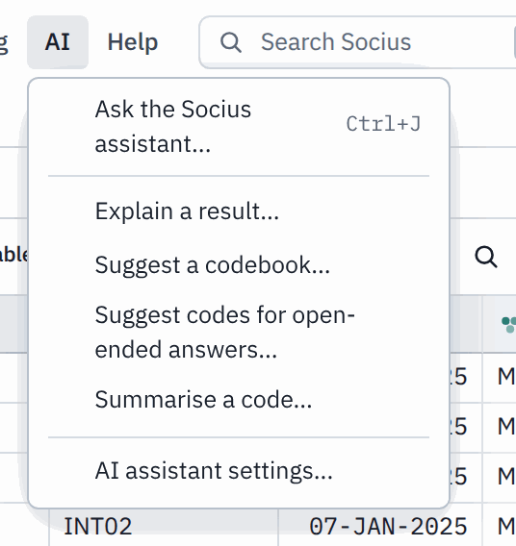
The AI menu. Every AI feature starts here, and the last item opens the settings.

Option 1: Google Gemini with your own free key (recommended)
Google Gemini is fast and gives good answers. You need a free "API key" from Google: a long password that lets Socius use Gemini on your behalf. You only need a Google account (for example a Gmail address).
- In the settings, choose Google Gemini (1).
- Click the link Google AI Studio (2), or go to aistudio.google.com/apikey. Sign in with your Google account.
- Click Create API key. Accept the terms if Google asks.
- Copy the key. It starts with "AIza".
- Back in Socius, paste it into API key (3).
- Leave Model (4) empty. Socius then picks the newest free Gemini model your key can use, and keeps doing so when Google retires old models.
- Click Test connection (5).
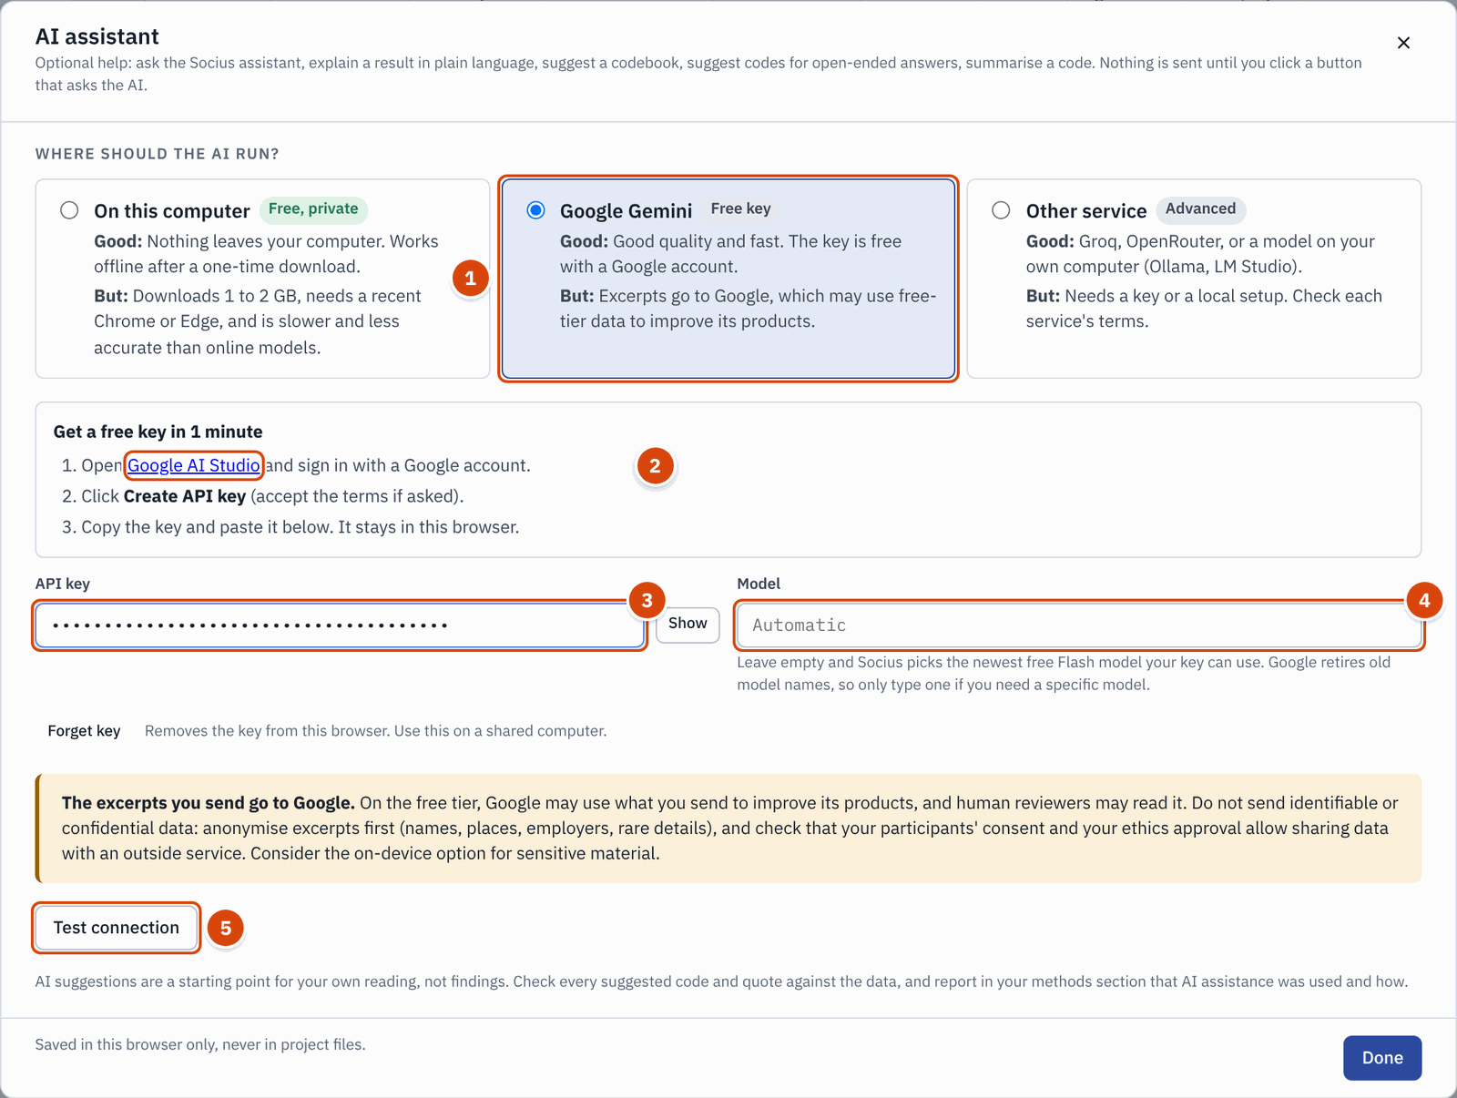
Setting up Google Gemini: choose it (1), get a key from Google AI Studio (2), paste it (3), leave Model empty (4) and click Test connection (5).
The key is stored in this browser only. It never goes into project files or exports. On a shared computer, click Forget key when you are done.

Option 2: On this computer (private)
A small AI model runs inside your browser, on your computer's graphics chip. Nothing leaves your computer, and after a one-time download of 1 to 2 GB it even works offline. This is the right choice for confidential interviews.
- In the settings, choose On this computer.
- Socius checks whether your browser can run the model. It needs a recent Chrome or Edge on a desktop or laptop.
- Pick a model and click Download model. You can also skip this: the first AI request downloads it.
- Click Test connection.
The on-device model is slower and less accurate than Gemini. It is fine for explaining a result or suggesting codes, but it is noticeably weaker as the Socius assistant.

OTHER OPTIONS
Other service connects Socius to Groq, OpenRouter or a model on your own computer (Ollama, LM Studio). These are for experienced users. If you open Socius inside Claude, a Claude option may also appear, which needs no set-up.

"AI is ready. Try it"
When the test works, the settings say "Connected" and a green panel appears.
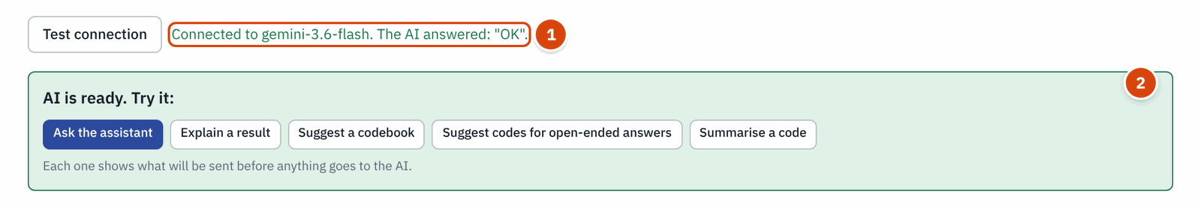
After a successful Test connection (1), the panel "AI is ready. Try it" (2) starts any AI feature with one click.
Click one of the buttons to try a feature straight away, or click Done. The AI chip in the top bar now shows a green dot and the service, for example "AI Gemini".

Before you send anything

PROTECT YOUR PARTICIPANTS
With Google Gemini (or another online service), what you send leaves your computer and goes to that company. On free tiers, the provider may use it to improve its products, and people may read it. Before you use online AI help on real data:
- Know what is sent. Explain a result sends the result's tables and summary, never individual answers. The assistant sends variable information, summary statistics and analysis results; individual cases only if you switch that on. Text coding features send the excerpts you choose.
- Anonymise first. Remove names, places, employers and other details that could identify someone from texts before you send them.
- Check consent and ethics approval. Make sure your participants' consent and your ethics approval allow sharing data with an outside service.
- Use On this computer for confidential material, where nothing leaves your computer.

Every AI feature says what it will send, and to whom, before you click. Nothing is sent until you do.

Where to find AI in Socius
The AI menu in the menu bar lists everything AI can do:

Menu item | What it does
Ask the Socius assistant | Opens the assistant, where you can ask questions in your own words ( Ctrl+J ).
Explain a result | Explains one result from Output in plain language. With several results, you choose which one.
Suggest a codebook | Reads a sample of your interviews or open-ended answers and proposes codes with definitions and example quotes.
Suggest codes for open-ended answers | Applies your codebook to survey answers and suggests codes for each answer, which you accept or reject.
Summarise a code | Drafts a short summary of the passages coded with one code.
AI assistant settings | Set-up, as described above.

If something is missing, the menu tells you what to do first. For example, Explain a result with no results yet says Run an analysis first and offers a button Open Crosstabs. If AI is not set up, any item opens the settings and explains what that feature will do.
The AI chip at the top right shows the status of AI help. Click it to see the same features, each with a one-line description.
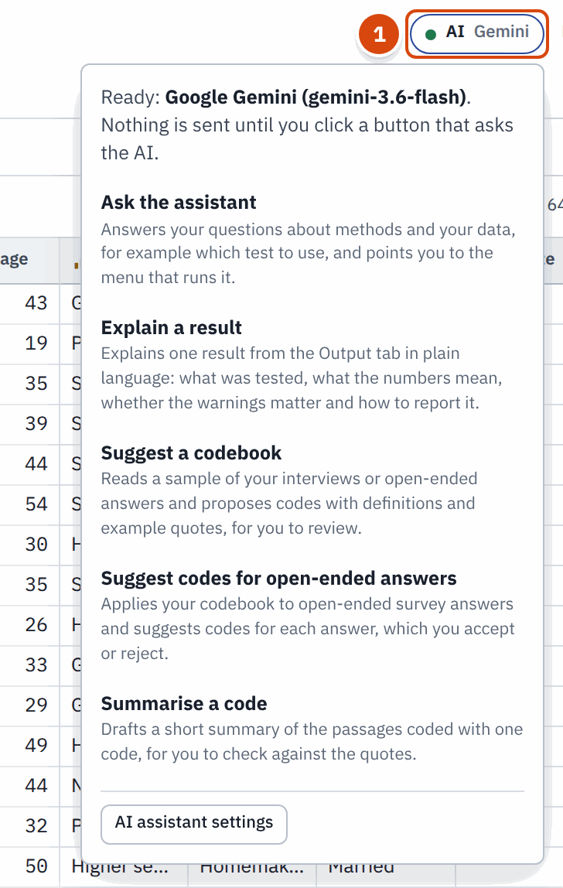
The AI chip (1) with a green dot means AI help is ready. Click it for a list of the AI features.
You also find AI in three other places: the Assistant button at the bottom right of every screen, the Explain with AI button on every result in Output, and AI suggestions in the Text coding toolbar. All three are described below.

Explain a result
Every result in Output has an Explain with AI button. It asks the AI to explain the result as a patient statistics tutor would: what was tested, what the numbers mean, whether the warnings matter and how to report it.
Try it with the crosstab from Crosstabs with chi-square (gender by trust5):
- Run the crosstab, or scroll to it in Output.
- Click Explain with AI at the top right of the result, next to Copy (see the picture below).
- A panel opens under the result. It says what will be sent and to whom (1 in the second picture). Click What will be sent (2) to read the exact text. The tables, Socius's summary, the APA sentence and the warnings are sent; individual answers are not.
- Click Explain (3).
Explain with AI (1) is next to Copy on every result.
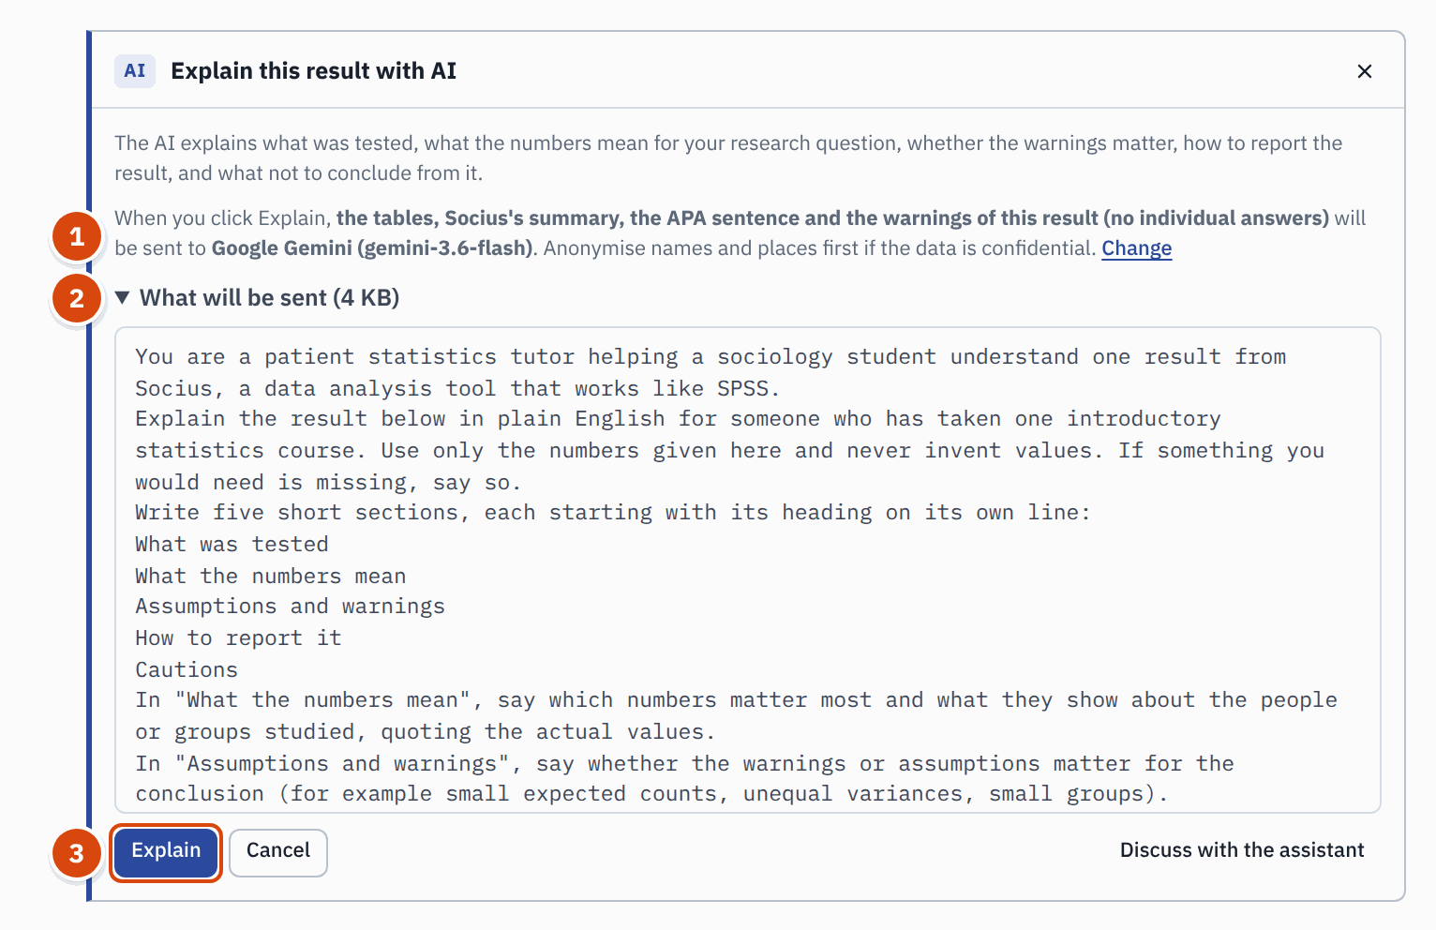
Before anything is sent: who receives what (1), the exact text (2) and the Explain button (3).
The explanation appears under five headings: What was tested, What the numbers mean, Assumptions and warnings, How to report it and Cautions.
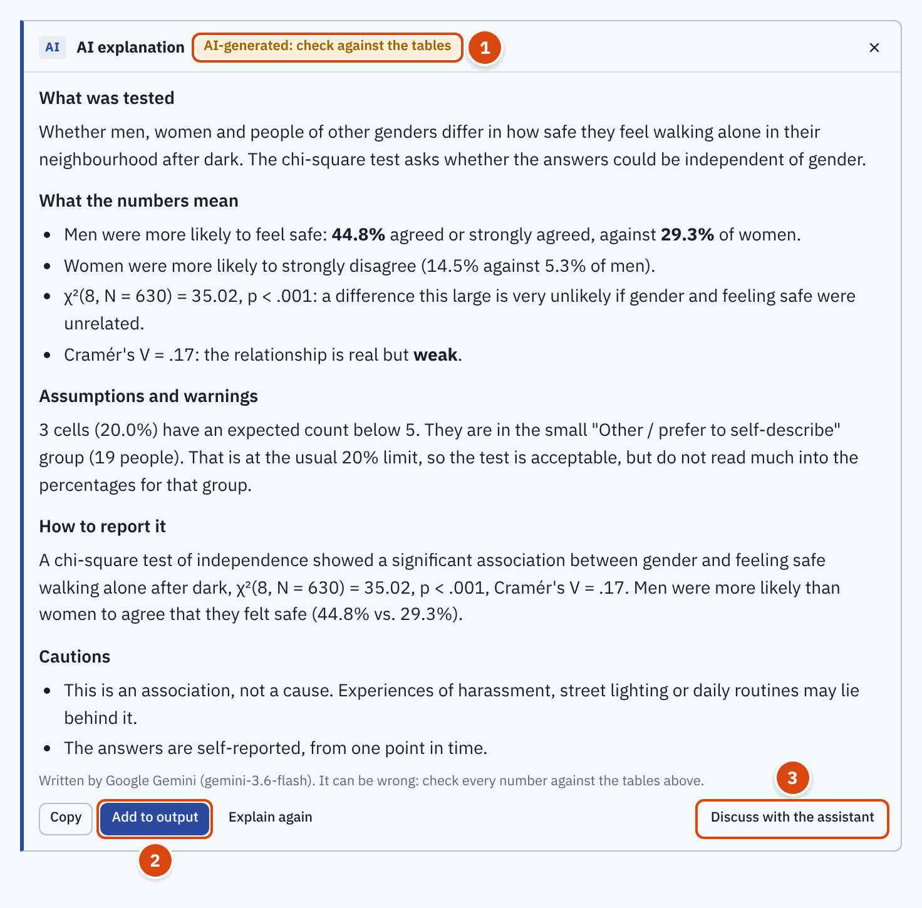
An explanation of the crosstab, labelled as AI-generated (1). Add to output (2) keeps it with the result; Discuss with the assistant (3) lets you ask follow-up questions. Example answer; your AI's wording will differ.
- Add to output (2) attaches the explanation to the result as a note marked AI-GENERATED. It is exported with your report like any note.
- Copy copies the text; Explain again asks for a new version.
- Discuss with the assistant (3) opens the Socius assistant with this result attached, so you can ask follow-up questions such as "What does Cramér's V mean here?".

READ IT CRITICALLY
The AI can be wrong, even when it sounds sure. Check every number against the tables above it: here χ²(8, N = 630) = 35.02 and V = .17 match the Chi-Square Tests and Symmetric Measures tables. Watch for claims the tables cannot support, such as causes ("gender causes fear"). Use the explanation to understand your result, then write the results section in your own words.

The Socius assistant
The assistant is a chat panel where you ask questions in your own words, as you would ask a helpful methods tutor. It can look at your dataset, run analyses on it, read your results, prepare recodes and scales, and answer "how do I" questions from this guide.

Open it
- Click the round blue Assistant button at the bottom right of any screen (number 9 in the tour).
- Or press Ctrl+J ( Cmd+J on a Mac). Press it again to close the panel.
- Or choose AI > Ask the Socius assistant, or type a question in Search and choose Ask the assistant.
The panel opens on the right. Drag its left edge to make it wider. Close it with the cross at the top right or Esc . Your conversation stays while Socius is open, even when you switch tabs; reloading the page clears it.
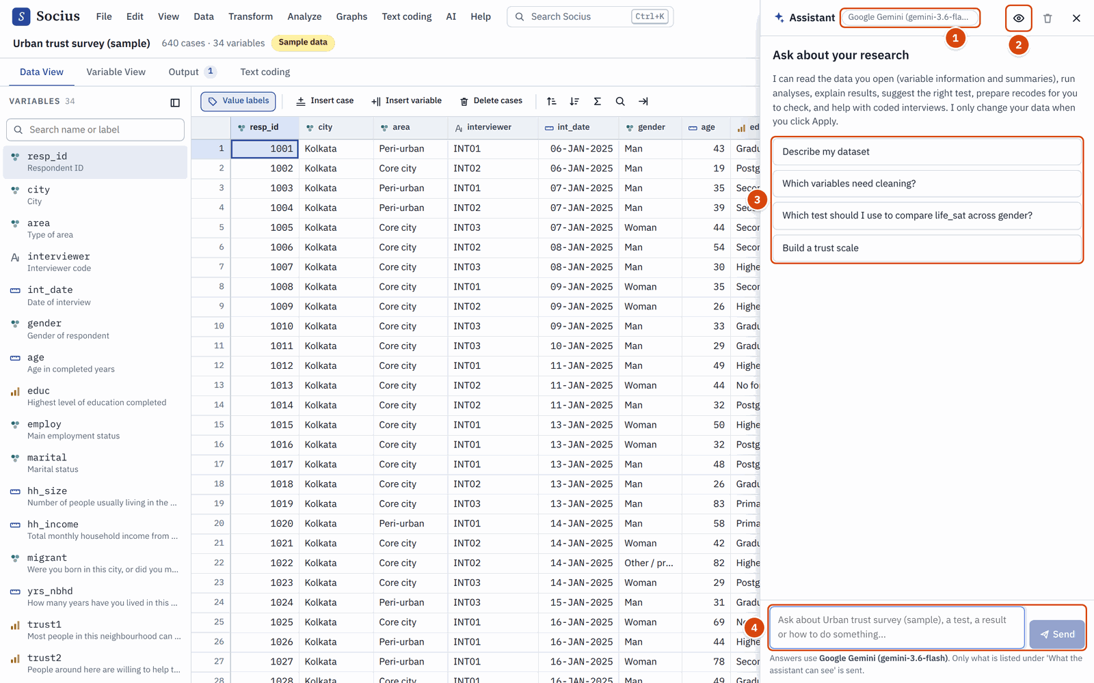
The assistant panel: the AI service in use (1), what the assistant can see (2), suggested questions (3) and the message box (4).
When the conversation is empty, the assistant suggests questions (3) that fit your data and the tab you are on. Click one to send it, or type your own question in the box (4) and press Enter . Shift+Enter starts a new line.

What it can see
Click the eye button (2) to see and change what the assistant may send to the AI service.
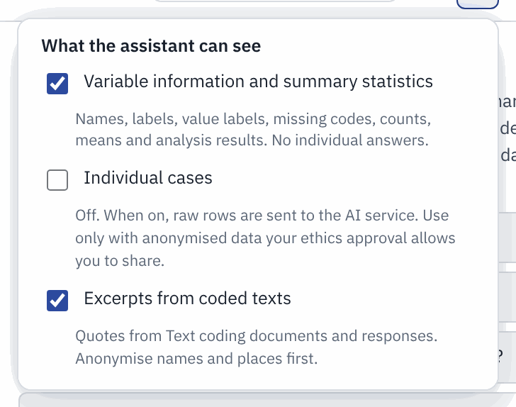
What the assistant can see. Individual cases are off unless you switch them on.
- Variable information and summary statistics (on): names, labels, value labels, missing codes, counts, means and analysis results. No individual answers.
- Individual cases (off): the raw rows of your data, up to 30 at a time. Switch this on only for anonymised data that your ethics approval lets you share. It switches off again every time you reload the page.
- Excerpts from coded texts (on): quotes from your Text coding documents and answers. Anonymise names and places first.
The line at the bottom of the panel always says which AI service answers, and that only what is listed here is sent.

Good first questions
With the sample survey open, try:
- "Describe my dataset"
- "Which test should I use to compare life satisfaction between migrants and non-migrants?"
- "Is trust in neighbours related to gender?"
- "Help me build a trust scale"
- "How do I export my results to Word?"
Ask one thing at a time and use your own words; you do not need variable names. You can ask follow-up questions ("Why not ANOVA?", "How do I report that?").

What it does with your question
The assistant does not guess. It checks your variables, runs the analysis in Socius on your data and reads the real tables before it answers.
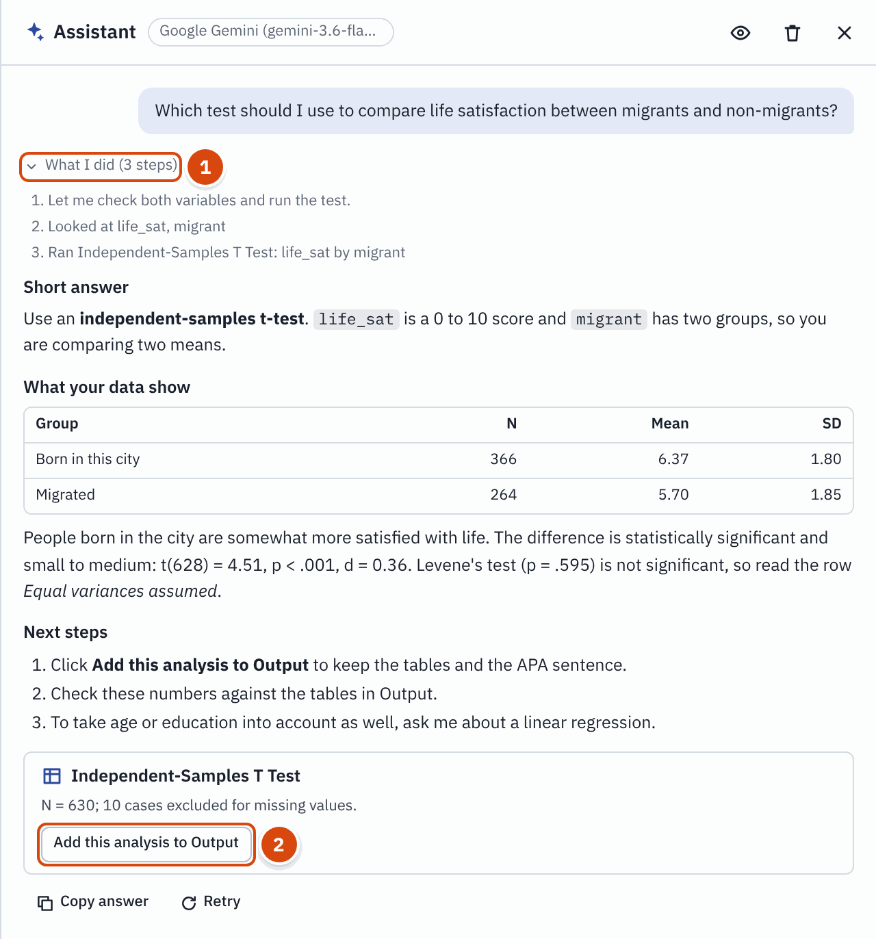
The assistant answers a question about life satisfaction. What I did (1) lists each step; the card (2) adds the t-test to Output. Example answer; your AI's wording will differ.
- What I did (1) lists every step it took, such as "Looked at life_sat, migrant" and "Ran Independent-Samples T Test: life_sat by migrant". Click it to see the steps.
- The answer quotes the real numbers, here t(628) = 4.51, p < .001, d = 0.36, the same as in Comparing two groups.
- An analysis the assistant runs is not added to Output by itself. Click Add this analysis to Output (2) to keep it.
- Some answers end with Open dialog, which opens the analysis dialog with the variables filled in. Check them and click Run.
When a question needs new variables, the assistant prepares the change and shows it to you first.
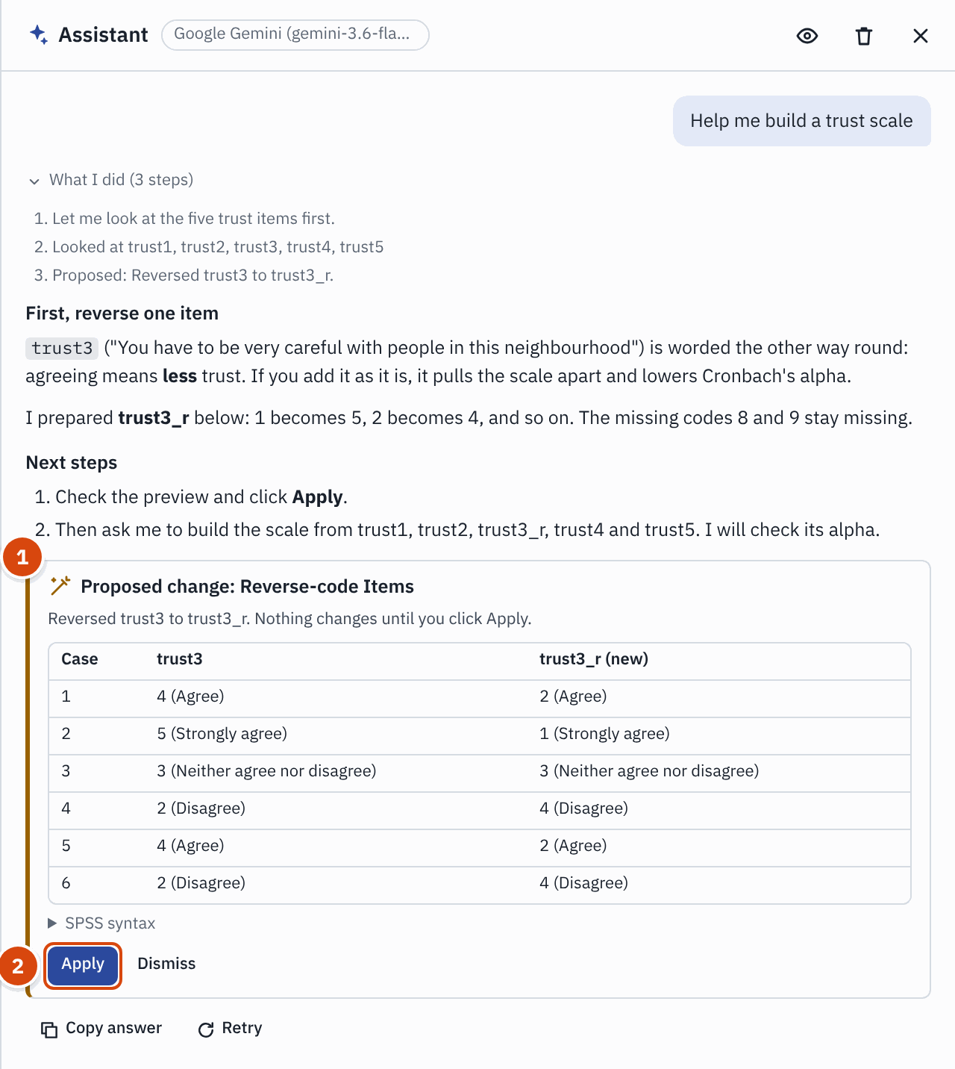
Asked to build a trust scale, the assistant first proposes to reverse trust3 (1). Nothing changes until you click Apply (2). Example answer; your AI's wording will differ.
A Proposed change card (1) describes the recode, reverse-coding, scale or computed variable, shows the first cases before and after, and gives the SPSS syntax. Nothing changes until you click Apply (2); Dismiss throws the proposal away. After Apply, the change is logged in Output like any Transform command, and Edit > Undo reverses it. The assistant only creates new variables; it never overwrites your data.

Know its limits
- It can be wrong. It may misread a table, pick an unsuitable test or phrase a finding too strongly. Check its numbers against the tables in Output, and think about whether its advice fits your research question.
- Free tiers have limits. Google's free tier allows only a few requests a minute and a daily allowance. The assistant paces itself, so a complex question can take 20 to 60 seconds. If you see "Too many AI requests at once, or the free allowance is used up for now", wait a minute (or until the next day) and click Retry.
- The on-device model is weaker. On this computer, the assistant works with a small model: slower, with fewer tools and simpler answers. For the assistant, Gemini works much better. Use anonymised data with it.
- It cannot replace your judgement or your supervisor. It is a tutor at your side, not an authority.

AI in Text coding
The coding helpers live in the AI menu. In the Text coding tab, the AI suggestions button in the toolbar is a shortcut to the same three items. If AI is not set up, the button is greyed out and a Set up AI link sits next to it.
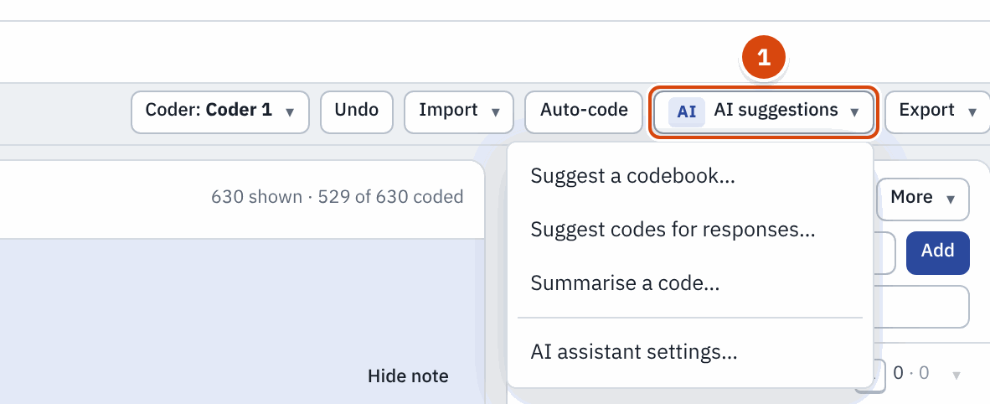
The AI suggestions menu (1) in the Text coding toolbar.
- Suggest a codebook reads a sample of your documents or answers and proposes codes, each with a definition and an example quote. Keep the ones you want and click Add (the button shows how many codes). Treat them as a first draft: rename, merge and define them in your own terms.
- Suggest codes for open-ended answers applies your existing codebook to open-ended answers and suggests codes for each one. You Accept or Reject every suggestion, or Accept all. Accepted codes are marked as AI suggestions, so you can review them later.
- Summarise a code opens the Retrieve view. Pick a code and click Summarise this code for a short summary of its passages. Save as memo keeps it as a memo on the code. Check it against the quotes.
Each dialog says how many excerpts will be sent, and to whom, before you click. For intercoder reliability, AI suggestions do not count as a second coder: a person must code independently.

Reporting AI use
If AI helped with your analysis, say so in your methods section, as you would for any software. Name the tool and the model, say what it did and how you checked it. For example:

AN EXAMPLE FOR YOUR METHODS SECTION
Open-ended answers were coded in Socius. An initial codebook was drafted with AI assistance (Google Gemini, via Socius's "Suggest a codebook"), then revised by the author; all codes were applied and checked by hand. Plain-language explanations of statistical output were generated with the same model and checked against the output tables. No identifiable data were sent to the AI service.

Follow your university's and your journal's rules on AI, which differ and change often. Keep a note of what you used AI for while you work; it is much harder to remember afterwards.

13 Saving and sharing your work

Save a project
A project file keeps everything together: the data (including the variables you created), all your output and the text coding. Choose File > Save project (or press Ctrl+S ). Socius saves one file ending in .socius.json to your downloads folder.
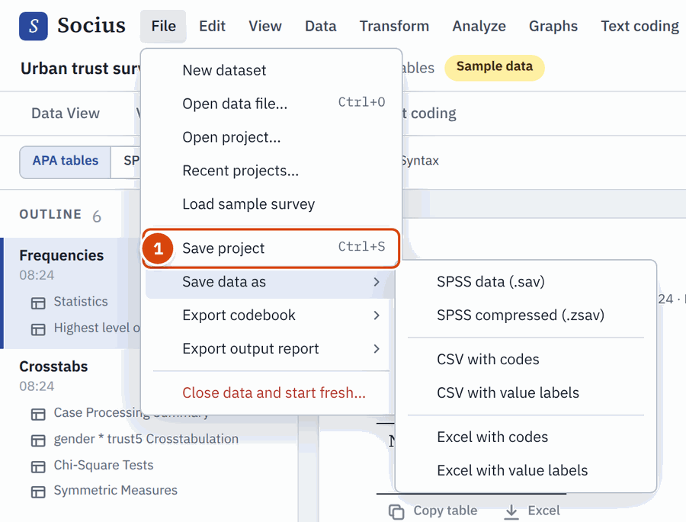
The File menu: Save project (1) and Save data as, with its formats.
To continue later, on this or any other computer, choose File > Open project and pick the file. File > Recent projects lists projects you saved or opened in this browser.

AUTOSAVE IS A CONVENIENCE, NOT A BACKUP
Socius keeps a copy of your current session in the browser and restores it when you come back. But that copy disappears if you clear your browser's history or site data, use a private or incognito window, or switch to another browser or computer. Save a project file regularly and keep it with your other research files.

Save your data for SPSS, Excel or R
File > Save data as writes your data in other formats:
- SPSS data (.sav): opens in SPSS with all labels, value labels and missing values, including the variables you created in Socius. SPSS compressed (.zsav) is a smaller file for SPSS 21 or later.
- CSV with codes or CSV with value labels: plain text that almost any program reads, including R and Stata.
- Excel with codes or Excel with value labels: a spreadsheet.
File > Export codebook saves a list of all variables with their labels, value labels and missing values, handy for a thesis appendix.

Share with a colleague
Send your colleague the .socius.json project file (by email or a shared drive). They open Socius and choose File > Open project. If they use SPSS, send the .sav file instead. Under every result in Output, the Syntax section holds the SPSS commands that reproduce it.

14 Troubleshooting and FAQ
My file will not open. Socius opens .sav, .zsav, .csv, .tsv, .txt and .xlsx files. For other formats:
- Old Excel files (.xls): open in Excel and save as .xlsx or CSV.
- SPSS portable files (.por): open in SPSS or PSPP and save as .sav.
- Stata, SAS or R files: export them as CSV, or save as .sav (in R, haven::write_sav()).
- SPSS output (.spv) and syntax (.sps) files are not data. Open the .sav file instead.
- Zipped files: unzip first.
Letters look wrong (strange symbols instead of Hindi, Bengali or accented letters). This is a text encoding problem. For a CSV file, choose another Character encoding in the preview. In Excel, saving as "CSV UTF-8" avoids the problem. Recent SPSS files open correctly; for a very old one, open and save it again in a recent SPSS.
My results differ from SPSS. Check that the same codes are declared missing (Variable View, Missing column), and that the same weight and filter are on. The line under each result title says how many cases were used and whether they were weighted.
A dialog warns that a variable has the wrong measurement level. It is a warning, not a block. Often the fix is to set the right level in the Measure column of Variable View.
I made a mistake. Edit > Undo ( Ctrl+Z ) reverses changes to the data one step at a time, and Edit > Redo ( Ctrl+Y ) brings them back. Text coding has its own Undo button in its toolbar.
I lost my work after clearing the browser. Clearing browsing data, a private window, or another browser or computer loses the autosaved session. Only a saved project file is safe. Save one regularly with File > Save project.
Where is my data stored? Only in your browser, on your computer. Files you open are never uploaded. The only things that can leave your computer are what you choose to send with the optional online AI help (see Before you send anything).
I set up AI but I don't see a way to use it. Use the AI menu in the menu bar, the Assistant button at the bottom right (or Ctrl+J ), Explain with AI on any result in Output, or AI suggestions in the Text coding toolbar. The AI chip at the top right lists every AI feature. See Where to find AI in Socius.
Test connection fails. Read the red message next to the button; it says what went wrong.
- "The AI service did not accept the key": copy the key again from Google AI Studio, including every character and no spaces, and paste it into API key. If it still fails, create a new key.
- "The AI service did not recognise the model name": empty the Model box, so that Socius picks the model for you.
- "Could not reach the AI service": check your internet connection. Some university or office networks block AI services; try another network.
- Google AI Studio is not available in every country and asks you to be 18 or older. If you cannot create a key, use On this computer instead.
The AI says the free allowance is used up ("rate limit"). Free tiers allow only a few requests a minute and a limited number a day. Wait a minute and click Retry (or Try again). If it keeps happening, try again the next day, send fewer excerpts at a time, or switch to On this computer.
"This browser cannot run the on-device model" (no WebGPU). The on-device model needs WebGPU, which only recent Chrome and Edge on a desktop or laptop offer reliably. Update your browser, or use another computer. Check that hardware acceleration is on (Chrome: Settings > System). Otherwise use Google Gemini with anonymised data.
AI buttons are greyed out. In Text coding, a grey AI suggestions button means AI help is not set up: click Set up AI next to it. If AI is set up but a single item is grey, it has nothing to work on yet: Suggest a codebook needs imported texts, Suggest codes for open-ended answers needs imported answers and at least one code, and Summarise a code needs coded passages. The Explain button in the Explain panel stays grey until AI help is set up.
The assistant's numbers differ from Output. Trust the tables in Output. The assistant runs the same analyses, but it can misread or round them. Run the analysis from the menu (or click Add this analysis to Output) and report the numbers from Output.
Can I use Socius on a phone? Yes, for looking at data and results. For coding and analysis, a computer with a mouse and keyboard is much easier.
Where are the keyboard shortcuts? Help > Keyboard shortcuts lists them all, including the keys of the Responses view in Text coding. The two most useful are Ctrl+K for Search and Ctrl+J for the assistant. Help > Getting started gives a six-step overview.

15 Giving feedback
Socius is young, and your experience helps make it better. If something does not work, confuses you, or you miss a feature, please tell us.
Choose Help > Send feedback or report a problem, or click Feedback at the top right of the screen. A form opens on GitHub in a new tab. You can also go there directly: https://github.com/hackhead95/socius/issues/new/choose
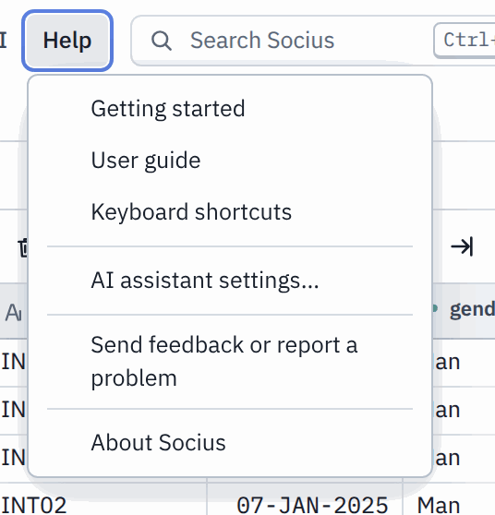
The Help menu, with the user guide, the keyboard shortcuts and the feedback form. AI set-up is in the AI menu.
- Posting on GitHub needs a free GitHub account. Creating one takes a minute.
- Say what you did, what you expected and what happened instead. A screenshot helps.
- Never attach confidential data. If a problem only happens with your file, describe the file (for example "an SPSS file with 300 variables from 2012") instead of sending it.
Thank you for trying Socius.

Appendix A: Quick reference card

I want to... | Where to find it
Find any command, variable or result | Search box at the top, or Ctrl+K
Open an SPSS, CSV or Excel file | File > Open data file
See labels, missing values, measure | Variable View tab
Show labels instead of codes in the data | View > Value labels in Data View
Copy labels to other variables | Data > Copy variable properties
Group ages or incomes | Transform > Recode into different variables
Flip a negatively worded item | Transform > Reverse-code items
Build a scale with Cronbach's alpha | Transform > Create scale / index
Compute a new variable with a formula | Transform > Compute variable
Analyse only some cases | Data > Select cases
Use a survey weight | Data > Weight cases
Count answers | Analyze > Descriptive Statistics > Frequencies
Mean, SD, minimum, maximum | Analyze > Descriptive Statistics > Descriptives
Relate two categorical variables | Analyze > Descriptive Statistics > Crosstabs
Compare two group means | Analyze > Compare Means > Independent-Samples T Test
Compare three or more group means | Analyze > Compare Means > One-Way ANOVA
Correlate scale variables | Analyze > Correlate > Bivariate Correlations
Predict a scale outcome | Analyze > Regression > Linear Regression
Predict a yes/no outcome | Analyze > Regression > Binary Logistic Regression
Check a scale's reliability | Analyze > Scale > Reliability Analysis
Make a bar chart or histogram | Graphs > Bar Chart, Graphs > Histogram
Copy a table into Word | Copy table under the table in Output
Export all results to Word | File > Export output report > Word document (.docx)
Code open-ended answers | Text coding > Import open-ended answers from dataset
Import interview transcripts | Text coding > Import documents
Auto-code with keywords | Text coding > Auto-code with keyword rules
Turn codes into variables | Text coding > Export codes to dataset
Check agreement between coders | Text coding > Intercoder reliability
Set up AI | AI > AI assistant settings
Ask a question about my data or methods | Assistant button (bottom right), or Ctrl+J
Explain a result in plain language | Explain with AI on the result in Output
Save everything | File > Save project ( Ctrl+S )
Save data for SPSS | File > Save data as > SPSS data (.sav)
Undo | Edit > Undo ( Ctrl+Z )
Report a problem | Help > Send feedback or report a problem

Appendix B: Glossary

Term | Meaning
Case | One row of data, usually one respondent.
Variable | One column of data, usually one question.
Value label | The words behind a code, such as 2 = Woman.
Missing value | A code that means "no real answer", such as 9 = Refused. Left out of statistics.
Nominal, ordinal, scale | Measurement levels: unordered categories; ordered categories; real numbers.
p-value | The probability of a result at least this strong if there were really no relationship. Below .05 is usually called statistically significant. It says nothing about how big or important an effect is.
Statistically significant | Unlikely to be due to chance alone (usually p < .05).
Chi-square (χ²) | A test of whether two categorical variables are related, used with crosstabs.
Cramér's V | The strength of a relationship in a crosstab, from 0 (none) to 1 (perfect). About .10 is weak, .30 moderate, .50 strong.
Mean (M) and standard deviation (SD) | The average, and how far values typically lie from it.
t-test | A test of whether the means of two groups differ.
ANOVA | Analysis of variance: a test of whether the means of three or more groups differ.
Effect size | How big a difference or relationship is, regardless of sample size. Examples: Cohen's d, eta squared (η²), Cramér's V, r.
Cohen's d | The difference between two means in standard deviation units. About 0.2 is small, 0.5 medium, 0.8 large.
Correlation (r) | How closely two variables move together, from -1 to +1. About .10 is weak, .30 moderate, .50 strong.
Regression coefficient (B) | How much the outcome changes for a one-unit increase in a predictor, holding other predictors constant.
R squared (R²) | The share of the differences in an outcome that a regression model explains.
Cronbach's alpha | How consistently a set of items measures the same thing, from 0 to 1. .70 or higher is usually acceptable.
Degrees of freedom (df) | A number based on sample size and groups that is reported with a test statistic, as in t(628).
Code | A label for a theme that you attach to a passage of text.
Codebook | The list of your codes with a definition, inclusion and exclusion rules and an example for each.
Theme | A group of related codes (a parent code).
Memo | Your analytic note on a passage, a code or the project.
Intercoder reliability | How far two coders who code the same material independently agree, beyond chance. Measured with Cohen's kappa (κ) or Krippendorff's alpha (α); .70 to .80 or higher is usually expected.
APA style | The reporting style of the American Psychological Association (7th edition), used by many social science journals.
Syntax | The SPSS commands that reproduce a result. Socius shows them under each result.
AI model | A computer program trained on large amounts of text that writes answers in ordinary language. It can be wrong, so check what it says.
API key | A long password from an AI provider, such as Google, that lets Socius use its AI model on your behalf. Keep it private.
Socius assistant | The chat panel ( Ctrl+J ) where an AI model answers your questions, using Socius to look at your data and run analyses.
Search | The box at the top ( Ctrl+K ) that finds commands, variables, results and help pages.

Socius beginner's guide. Edition 1, September 2026. The sample survey and interviews are fictional teaching material.

