LIBRARY MANAGEMENT SYSTEM
Portfolio 1 — Relational Database Design
Design specification • 8 October 2026 • Status: proposed logical design

1. Executive Summary
This portfolio proposes a normalized relational database for a school library. It separates book titles from physical copies, records borrowing and returns independently, associates monetary charges with loans, and links circulation activity to staff. The project prioritizes clarity, historical integrity, and manageable implementation within a two-week learning schedule.
Deliverable status: conceptual and logical design. No claim is made that the schema, automation, access control, or business rules have yet been implemented or tested.

2. Scope, actors, and operations
Core actors: verified student borrower; active library Assistant, Librarian, and Admin. Main operations: search catalogue, register books and copies, issue a loan, request/approve a renewal, process return and condition inspection, calculate charges, record full settlement, restrict borrowing, and change circulation status.
Out of scope for the initial implementation: phone numbers, government identity numbers, multi-part payments, complete repair histories, author cataloguing tables, automatic account-promotion approval workflows, and a full authentication/email delivery service.

3. ER diagram
The diagram below is the canonical logical ERD; an editable Mermaid source is also provided as erd.mmd. Crow’s-foot relationships show permitted numbers of related records. Each loan belongs to exactly one borrower, physical copy, and processing staff member.
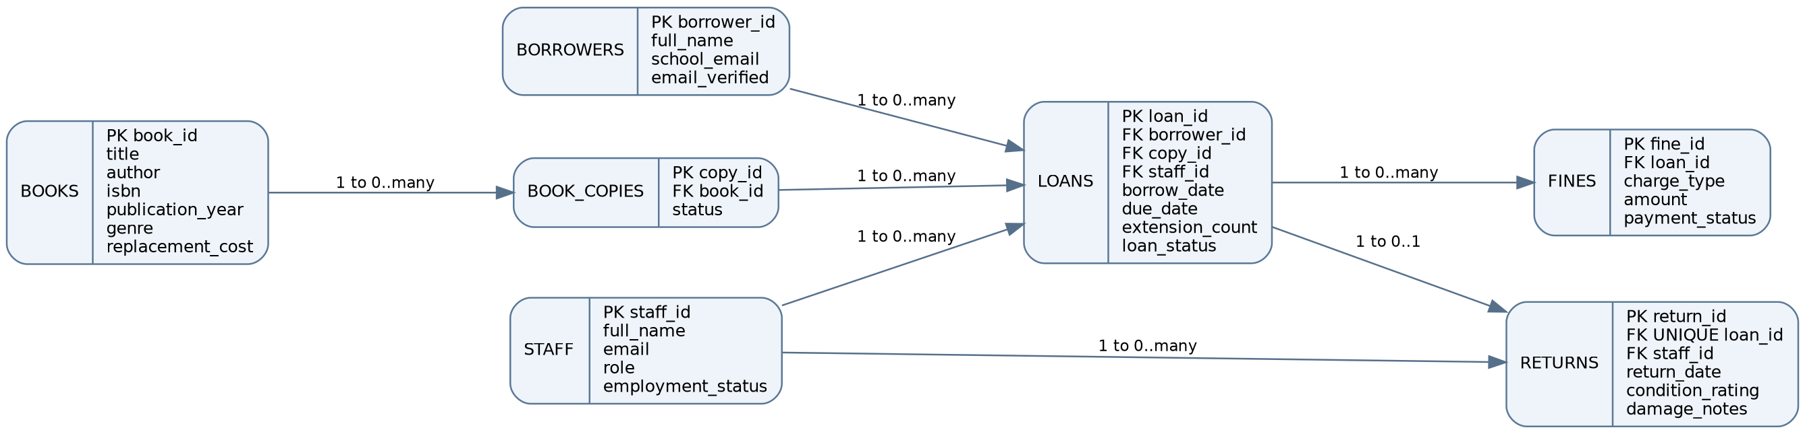

4. Data dictionary and integrity constraints

Books
Attribute | Proposed type | Constraint / meaning
book_id | VARCHAR | PK; unique title/edition identifier
title | VARCHAR | Required
author | VARCHAR | Required; one primary author for initial scope
isbn | VARCHAR | Unique when provided; identifier for edition
publication_year | INTEGER | Optional; sensible year range
genre | VARCHAR | Optional classification
replacement_cost | DECIMAL(10,2) | Required; >= 0

Book_Copies
Attribute | Proposed type | Constraint / meaning
copy_id | VARCHAR | PK; e.g. BK001-1
book_id | VARCHAR | FK -> Books; required
status | VARCHAR | Available, Borrowed, Damaged, Lost, Withdrawn

Borrowers
Attribute | Proposed type | Constraint / meaning
borrower_id | VARCHAR | PK
full_name | VARCHAR | Required
school_email | VARCHAR | Required, unique
email_verified | BOOLEAN | Required; default false

Staff
Attribute | Proposed type | Constraint / meaning
staff_id | VARCHAR | PK
full_name | VARCHAR | Required
email | VARCHAR | Required, unique
role | VARCHAR | Admin, Librarian, Assistant
employment_status | VARCHAR | Active, Inactive, Retired

Loans
Attribute | Proposed type | Constraint / meaning
loan_id | VARCHAR | PK
borrower_id | VARCHAR | FK -> Borrowers; required
copy_id | VARCHAR | FK -> Book_Copies; required
staff_id | VARCHAR | FK -> Staff; required
borrow_date | DATE | Required
due_date | DATE | Required; initially +14 days
extension_count | INTEGER | Default 0; 0 or 1
loan_status | VARCHAR | Active, Returned, Lost; synchronized with lifecycle

Returns
Attribute | Proposed type | Constraint / meaning
return_id | VARCHAR | PK
loan_id | VARCHAR | FK -> Loans; UNIQUE, required
staff_id | VARCHAR | FK -> Staff; required
return_date | DATE | Required
condition_rating | INTEGER | Required; 0–5
damage_notes | VARCHAR/TEXT | Optional; encouraged when rating > 0

Fines
Attribute | Proposed type | Constraint / meaning
fine_id | VARCHAR | PK
loan_id | VARCHAR | FK -> Loans; required, not unique
charge_type | VARCHAR | Late_Return, Damage, Replacement
amount | DECIMAL(10,2) | Required; >= 0
payment_status | VARCHAR | Paid, Unpaid
Implementation notes: loan_status is an explicit lifecycle field to distinguish Active, Returned, and Lost loans; it must remain consistent with Returns and the copy status. A separate return_date is not stored in Loans. Restrict deletion of referenced parent records; deactivate staff instead of deleting them. Copy IDs are generated as book_id plus a per-title sequence.

5. Relationships and cardinality
Parent → child | Cardinality | Reason
Books → Book_Copies | 1 → 0..many | A title can have multiple physical copies.
Book_Copies → Loans | 1 → 0..many | A copy can be loaned repeatedly over time, but only once at a time.
Borrowers → Loans | 1 → 0..many | A borrower can have no loans or many historical loans.
Staff → Loans | 1 → 0..many | Staff process loans.
Staff → Returns | 1 → 0..many | Staff process returns.
Loans → Returns | 1 → 0..1 | Not every loan has a normal return; UNIQUE loan_id.
Loans → Fines | 1 → 0..many | Late, damage, and replacement charges are distinct.

6. Functional business rules

Circulation eligibility
Only available physical copies may be borrowed. Borrowers must have verified school email and no unpaid charges or unresolved overdue loans. Only active, authorized staff can process transactions.

Due dates
At issuance, due_date = borrow_date + 14 calendar days. Save the calculated due date so later policy changes do not rewrite historical loans.

Renewals
One seven-day extension per loan; requested and approved strictly before the current due date by authorized staff, provided there are no outstanding unpaid charges. Extend from the existing due date.

Return processing
Create a Returns record only when a normal return actually occurs. Every return requires a condition rating; a loan can have at most one return.

Late fines
For a normally returned book, days_late = max(0, return_date − due_date) in calendar days. Charge $1 per late day; create no late fine if on time.

Damage fines
Condition 0: 0%; 1: 10%; 2: 25%; 3: 50%; 4: 75%; 5: 100% of the book replacement cost. Rates 1–4 are proposed design assumptions, subject to confirmation. Late and damage charges may coexist.

Damaged copies
Damaged returns stay unavailable until repaired and approved by an authorized librarian; beyond-repair copies become Withdrawn. Rating 5 requires replacement handling.

Lost copies
At 30 days overdue without a normal return, classify the loan and copy as Lost and create a replacement charge equal to current replacement cost plus a proposed $5 administrative fee. Normal return cannot reverse this classification; payment and registering a new copy are separate actions.

Payments
Partial payments are not supported. Borrowers settle all outstanding charges in one transaction; update all associated fines atomically. Track Paid/Unpaid, with detailed receipts deferred.

Staff security
Role permissions apply only when employment_status = Active. Deactivation/retirement denies all access and should invalidate existing sessions in a future application. Historical staff records remain.

Role-change requests
Only active Admin staff can authorize and apply role changes. Optional future approval workflow: if the approver is deactivated before execution, fresh approval is required.

