Exercises Process

Introduction
This document describes the Red Team Process that the Red Team should adhere to when planning and executing a Red Team Exercise against a company, and it should include the phases in Figure 1.

Figure 1 – Red Teaming Phases
The main goal of a Red Team Exercise is to emulate real-world threats and understand how a Threat Actor is able to abuse applications, tools or processes to achieve their objectives. This helps understand how to improve the effectiveness of the people, processes and technologies or our organization.
The Red Team is not focused on Penetration Test, and the its goal is not to deliver a list of vulnerabilities of a specific application or service. It’s emulate Threat Actors Tactics, Techniques and Procedures (TTPs), that include a blended approach (Social Engineering, physical intrusion, application/network pentest) to reach some pre-defined objectives.
These objectives are defined at the end of the 2nd Phase as explained in the following sections, and are agreed upon by both sides, and during the RT Test on the 3rd Phase, anything is in scope to achieve these objectives.

Teams & Responsibilities
On each Red Team exercise, there are three main teams to be considered, each with its own responsibilities on the exercise.
Red Team (RT)
Assumes the role of an hostile attacker who challenges the organization's cyber security, and simulates a realistic attack scenario. Often very few people are aware of the fact that an RT assessment is being carried out so that the realism of the exercise is optimal.
- Provides information and research data for all laws, regulations, policies, programs and operations.
- Executes engagement requirements as directed.
- Complies with all laws, regulations, policies, programs and Rules of Engagement (RoE).
- Implement RT operational methodology and TTPs.
- Identifies and has input to target environment deficiencies.
- Performs Open Source intelligence (OSINT) as required for the engagement.
- Executes operational impacts as approved by the WT.
Threat Intelligence Team (TI)
Responsible for performing Threat Actors investigation to inform the exercise participants on the most relevant threats to the company, and is used to design appropriate scenarios.
- Performs Threat Intelligence Report with Threat Landscape of the Company and OSINT investigation
- Performs OSINT investigation on the company to be used by the Red Team for phishing scenarios
- Suggest Threat Scenarios based on the output of the TI and OSINT report
Blue Team (BT)
Assumes the role of the defensive side, in charge of defending the networks, systems, and applications. This team is generally unaware of this simulation to increase realism and test response.
- All of the components defending the network, unaware the engagement is undergoing, and performs regular daily activities.
White Team (WT)
Link between the RT and the BT, and consists of employees who can escalate and de-escalate with both teams. Informed of all attacks by the Red Team and is mandated to start, stop and approve attacks.
- Establish metrics for engagement.
- Coordinating activities on both sides to ensure engagement goals are achieved.
- Providing information required for efficient engagement.
- Assisting deconfliction between RT and BT.
- Providing list of lessons learned through observation during and after action.
- Approve engagement schedule, objectives and directives.
- Approving red team objective target for planning.
- Provide environment information to construct scenarios that meet all objectives.
- Provide management and direction for execution.
- Determining if, when and what information is shared with BT.
- Determining when actions should be implemented as part of engagement operational impact.

With each team’s responsibilities defined, Figure 2 shows the required Teams on each phase of the RT Exercise.
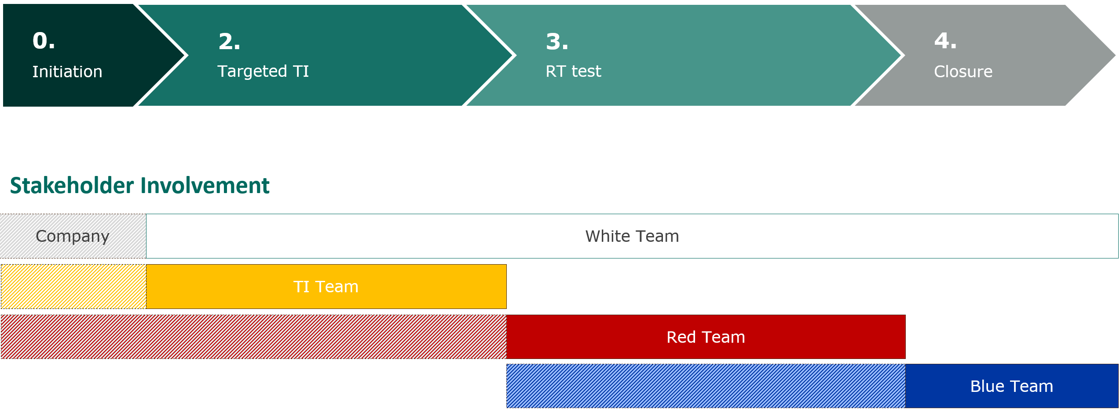
Figure 2 – Teams Involvement in each Phase
Figure 3 represents an expected timeline of activities performed and the estimated time each should take to conclude. This can be adjust based on the size of the targeted company and scenarios defined.
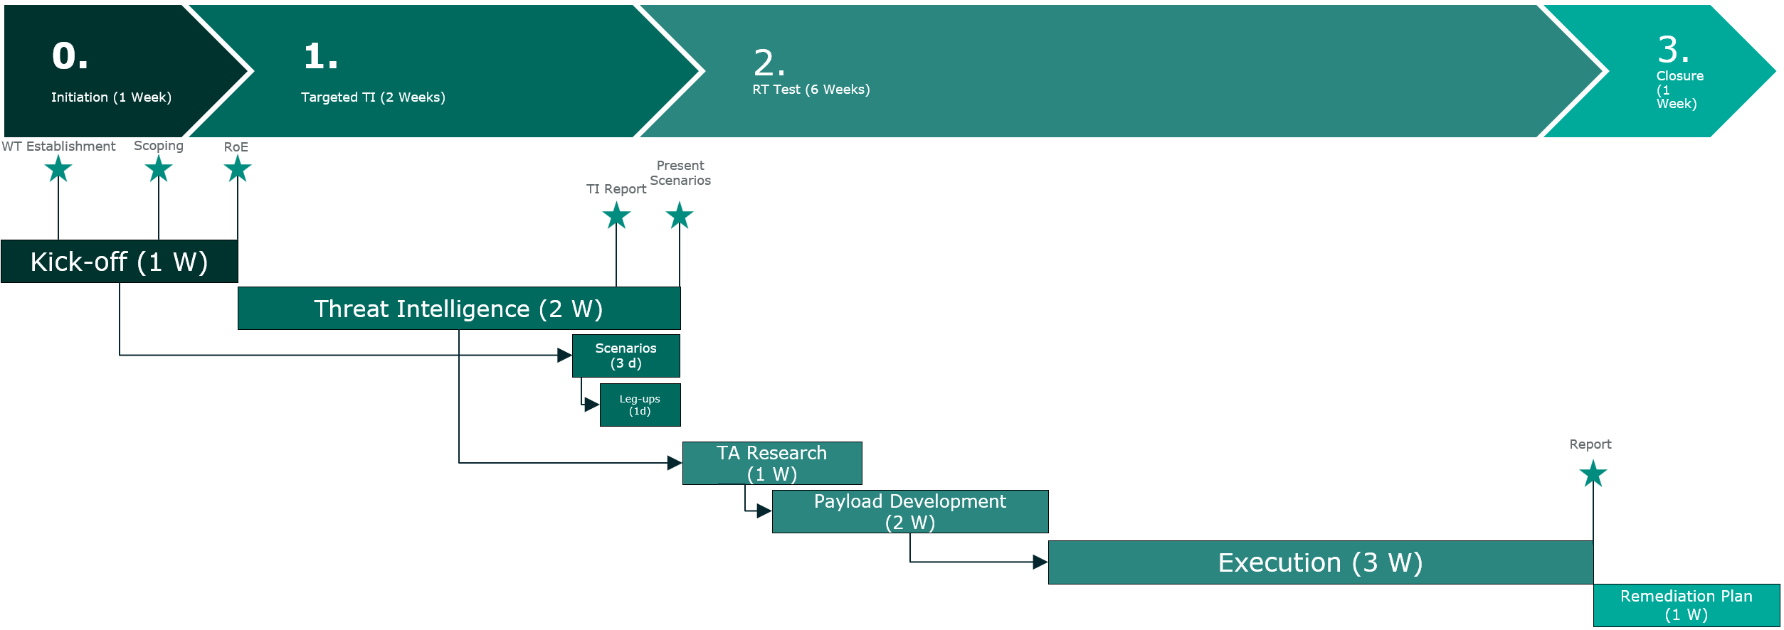
Figure 3 - Expected activities' timeline

Deconfliction
The deconfliction process is used to separate Red Team activity from real-world activity. It mandates Red Team receipt of incident-specific defensive logs, in order to properly correlate those logs with Red Team logs. This process must not be used to identify Red Team specific activities, only to understand if an incident is a real threat or not, and stop the blue team from doing self-inflicting damage to the company through it’s incident response procedures (such as isolating/stopping critical functionalities). It requires all detected incidents (real world or alleged Red Team) to be reported through normal incident reporting process, and additionally, it may require WT PoC to contact the RT PoC to determine if activities are part of engagement.
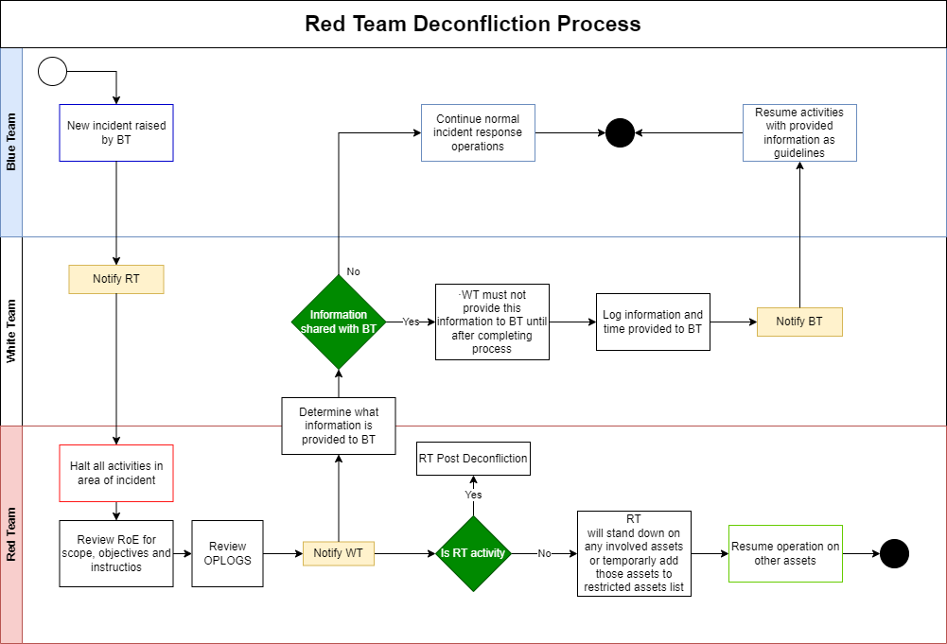
Figure 4 - Deconfliction Process
The workflow depicted in Figure 4 represents the deconfliction process in case there is a new incident raised by the BT. In this situation, the WT should notify immediately the RT about the incident, while the BT resumes their normal incident response activities. Notification to the RT must include source, destination, action, time of action, and alert source.

After the RT reviews the RoE document and its OPLOGS to determine if the incident is RT activity or real activity, it must ensure findings are relayed via email and other channels as well as maintain records of deconfliction information, actions, assessments and findings. In case of RT activity, the Post Deconfliction process should determine and isolate specific activities, scripts and logs supporting the time frame of the incident. If activity is real, deconfliction process is complete, and BT will resume response activities as normal. The RT together with the WT will decide what information, if any, is shared with the BT:
- Activities to be performed by BT in accordance to policies and practices
- How response activities will impact the availability and effectiveness of the BT to detect, identify, and respond to other incidents
- How response activities will impact the systems and networks of the incident location
- How response activities will impact daily operations for those outside response teams
- Amount of effort required to identify and isolate RT vs benefits of responding to incident for training, tooling and metrics.
If no information provided to response teams, full scope activities will resume. BT should not be notified of RT activities. If information is provided, all teams must log information and time provided, and BT should proceed with response activities using provided information as TI or guidelines

If specific actions are too high level of effort, all teams must adjust current activity to accommodate the exclusion effort, such as:
- Continuance of RT but halt BT activities
- Continuance of BT but halt RT activities
- Continuance RT but reduced BT activities
- Continuance BT but reduced RT activities
- Halt all activities
Final deconfliction determinations will be actioned and recoded for event reporting as well as after-action review. These after-action reviews may be used to stimulate improvements to deconfliction process as well as incident response or other security operations.

Data Handling
All RT members should be responsible for safeguarding all target data. During the engagement, the RT Operators will capture files from the target environment for later analysis. Each Operator is fully responsible for guaranteeing the safe transportation and storage of captured data. This includes encryption of files before transmission, as well as the usage of secure transportation methods to upload files to the team server.
During the engagement, the operator will not intentionally compromise Privacy of Information Act (PIA), medical, justice, worship or religious pursuit, or any other protected or privileged information that may fall into one of the following categories:
- Personal confidential data
- Business confidential data
- Financial confidential data
- Regulated data
If the operator considers that these sensitive data files types are among the captured files, the following process must be followed:
- Operator should halt all operations.
- WT Point of Contact should be promptly contacted to confirm the type of data of the files
  - If data is confirmed to belong to one of those categories, it should be immediately deleted from the team server.
    - If applicable, it should be returned to the environment where it was retrieved from.
  - If data is not from one of these categories, normal operations may resume.
    - If the captured data does not belong to these categories, the operator may evaluate if they are valuable to advance towards the objectives.

Requirements
In order to have a successful exercise planning, the RT needs to have some information provided by the WT, that should include the Critical Assets/Function (Servers, applications, sensitive data). This information should be provided during the 1st Phase, as explained in the following sections, and will help the TI Team define the scenarios at the end of the 2nd Phase. This information will be included in the RoE document, along with the restricted assets and actions.

Leg-Ups
During the assessment, the RT may be unable to progress to the next stage due to time constraints, business knowledge constraints or because the entity has been successful in protecting itself. In such scenarios, the RT with agreement from the WT, may be given a leg-up: RT is given access to its system, internal network, etc. to continue with the test and focus on the next flag/target.
For example, when a phishing campaign has no results because no one clicks on the link, the RT can request a leg-up: Someone involved in the exercise can consciously click on the link so that the rest of the test plan can also be carried out.

Terms & Definitions
Vulnerability Scanning | Assess your infrastructure vulnerabilities by using agent based scanning or by employing network based scanners, from either an external or internal perspective. Both of these will scan the targeted assets and will match the information gathered against public databases to identify vulnerabilities on your targeted IT landscape.
Penetration Testing | Also called pentesting, is the practice of testing a computer system, network or Web application to find vulnerabilities that an attacker could exploit.
Red Teaming | Assess a company security using a real-life targeted attack simulation of a threat actor. Simulate threat actors by using their Tactics, Techniques and Procedures (TTPs), using a blended approach (Social Engineering, physical intrusion, application/network Penetration Test) to reach some pre-defined objectives. It is used to not only evaluate technical defences, but also people and processes involved in the organization’s security.
Red Team (RT) | Assumes the role of an hostile attacker who challenges the organization's cyber security, and simulates a realistic attack scenario. Often very few people are aware of the fact that an RT assessment is being carried out so that the realism of the exercise is optimal.
White Team (WT) | Link between the RT and the BT, and consists of employees who can escalate and de-escalate with both teams.  Informed of all attacks by the Red Team and is mandated to start, stop and approve attacks.
Blue Team (BT) | Assumes the role of the defensive side, in charge of defending the networks, systems, and applications. This team is generally unaware of this simulation to increase realism and test response.
Deconfliction | Process of understanding if a certain security event, that occurs during Red Team activity, is originated from that activity, and stop incident response processes of taking self-inflicting damage to the company, such as isolating a critical system that could cause business impact. If Deconfliction process concludes that it is a real activity, then regular incident response activities may resume.
Tactics, Techniques and Procedures (TTP) | Behaviours, processes, actions, and strategies used by a threat actor to develop threats and engage in cyberattacks. Tactics are the overall goal and general strategy behind an attack, Techniques represent the specific methods used to achieve theirs goals, while the Procedures are the different variations and implementations of the Techniques that attackers can use.
Red Team Operator | Technical member of the RT that is responsible for emulating a Threat Actor, and execute their TTPs on the target environment to achieve the predefined objectives.
Victim | Individuals or systems that can be exploited by a Threat Actor to achieve their goals. These usually belong to the target company, but can also be outsiders that have some connection to the company, that can also bring an advantage to the Threat Actor towards their goals.
Threat Actor | Individual or organization that intentionally causes harm to the company by exploiting weaknesses in technology, processes and people to carry out disruptive attacks on individuals or organizations.
Threat Scenario | Logical sequence of the TTPs used by Threat Actors to access a company, establish persistence and achieve their goals.
Command & Control (C2) | Set of tools and techniques attackers use to maintain remote access to a compromised machine. It consists of a Victim machine, an attacker server and a communication channel (TCP, HTTP, DNS…)
Operational Security (OPSEC) | Security and risk management process and strategy that classifies tools and techniques used, to determine the impact certain actions might cause on the target environment. It is used by Red Team Operators to determine how likely their actions are to be caught, and endanger the engagement.
Operational Logs (OPLOGS) | Logs collected by Red Team Operators with all information related to their actions, each command executed, and their output to help in post-engagement actions, where the BT can go through these logs to understand how the attacks where executed and improve security operations. These logs can also be used in the event an incident is trigger, to help the Deconfliction process, to understand if it was caused by Red Team activity or real activity.
Threat Intelligence (TI) | Threat intelligence is data that is collected, processed, and analysed in order to understand the motivations, targets, and attack patterns of a threat actor.
Leg Up | During the assessment, the RT may be unable to progress to the next stage (due to time constraints, business knowledge constraints or because the entity has been successful in protecting itself), RT with agreement from the WT, may be given access to its system, internal network, etc. to continue with the test and focus on the next objective/target.  For example, when a phishing campaign has no results because no one clicks on the link, the RT can request a leg-up: Someone involved in the exercise can consciously click on the link so that the rest of the test plan can also be carried out.

Phases Description

Initiation
This initial phase of the operation is used to establish the initial communications with the target company. This is where the RT is presented to the stakeholders to explain the concept of Red Teaming, and the objectives of the exercise. At the end of this phase, the company stakeholders should choose the members of the WT, that should be the link between the RT and the BT, and consists of employees who can escalate and de-escalate with both teams. Informed of all attacks by the Red Team and is mandated to start, stop and approve attacks.
In this phase of the exercise, the WT provides information to the RT regarding its Critical Systems, Functions, Applications, or Servers. Anything that is considered critical for the target company's operations.
The WT will share details about these critical assets, including their configuration, architecture, dependencies, and any known vulnerabilities or weaknesses. This information enables the RT to gain a comprehensive understanding of the target company's key systems and focus their efforts on identifying potential vulnerabilities and testing the effectiveness of the company's security controls.
By sharing this information, the WT facilitates a realistic and targeted RT engagement. This collaboration between the WT and RT sets the stage for a thorough evaluation of the target company's security posture and helps identify areas for improvement.
The output of this Phase should be a clearly defined the scope and limitations of the engagement. Specify the authorized targets, systems, networks, or applications that are permitted for testing. This section should include information regarding each system, what is their purpose, where they are located and how to access them. Also, include any restrictions on techniques, tools, or attack vectors and the respective locations where these are prohibited.

CODENAME
[REVIEW] [ADD HERE] Append: 'Exercise codenames must follow the team theme: known fictional characters from movies, TV series, or books. Record the chosen character in the codename register alongside the exercise.' Coherence finding -016.
Before starting the next phase, the RT it is required to choose a unique codename for the operation to maintain confidentiality and track the operation internally. The codename should not reveal any information about the target or the techniques being used, to ensure that only authorized personnel have access to the codename and associated documentation.

Targeted Threat Intelligence
The targeted Threat Intelligence (TI) phase is a crucial part of the engagement. It involves the collection, analysis, and dissemination of intelligence related to potential threats and vulnerabilities that are specific to the target company.
During this phase, the RT team focuses on gathering information about emerging and current threats, tactics, techniques, and procedures (TTPs) employed by threat actors. This includes monitoring various sources, such as open-source intelligence, dark web forums, industry-specific threat feeds, and data shared by relevant stakeholders.
The gathered intelligence is then analysed to identify threats that have the potential to impact the target company's critical systems, functions, applications, or servers. This analysis helps in understanding the threat landscape and provides valuable insights into the methods used by potential attackers.
Once the analysis is complete, the RT team shares the findings with the WT. This information helps both teams develop their strategies and ensures that the red team engagement is focused on testing the target company's defences against relevant and realistic threats.
Overall, the targeted TI phase enhances the effectiveness of the red team exercise by providing context-specific intelligence. It allows the WT and RT to simulate real-world attack scenarios aligned with the specific threats faced by the target company. This phase plays a vital role in identifying vulnerabilities, evaluating security controls, and helping the target company improve its overall resilience against cyber threats.

Threat Actors
This Phase should define and document the profiles of potential threat actors that will be emulated during the RT operation. This includes understanding who they are and their capabilities. Research known threat actors relevant to your organization or industry to gain insights into their past activities and behaviours. This information will help build a Threat profile to be followed by the RT when emulating the threat, as for example:
Description | General mid-tier threat that uses common offensive tools and techniques.
Goal and Intent | Exist in the network to enumerate systems and maintain C2 for future attacks
Key IoCs | Cobalt Strike beacon on TCP 443.  Payload path: C:\...  HTTP Trafic to badguy.com  Beacon every x seconds
C2 Overview | HTTPS on port 443 Cobalt Strike beacon, with 5 min callback.  Calling directly threat owned domains.  TTPs: Enumeration, delivery, lateral movement...  Assumed breach model, no initial delivery.  Post exploit via Cobalt Strike commands.  Enumeration and lateral movement through native windows commands
Exploitation | Assumed breach model, no exploitation.
Persistence | User-level persistence using Outlook rule triggered by email.

Scenarios Description
This is where the scenarios are described. Identify and document various threat scenarios that will be tested during the operation. Each scenario should include a description, the threat actors related to the scenario, the objective of the scenario, the techniques that can be leveraged to complete the objective, the targets and the expected impact on the systems, according to the CIA (Confidentiality, Integrity and Availability).
Scenarios need to be objective-oriented, and not vulnerability-oriented. This means that there might be multiple paths to achieving the same objective, each of this paths is considered a different technique for the same objective. This also means that a scenario might lead to multiple associated vulnerabilities that can be chained together to complete the scenario’s objective.
It’s necessary to keep in mind that the techniques defined in this stage are not meant to be restrictive. This means that it is possible that during the Execution phase new information is found that can abused to reach one of the objectives. These are only meant to be a starting point for the Execution phase, and can be subject to changes and updates.

Red Team Test
The RT Test phase is where the scenarios are tested to understand if it’s possible for the defined threat actors to achieve the objectives. In all steps of this phase, the operators should keep in mind the scope and restrictions defined, in order to not cause unwanted damage to normal company operations. It is also important to remember to keep OPLOGS as outlined below.
During the execution, the RT Engagement attacks will be modelled after he Unified Kill Chain framework that it’s Attack Phases can be found summarized in Figure 5.

Figure 5 - Unified Kill Chain

Initial Foothold
This phase involves gaining the initial access or foothold into the target system or network. It typically starts with reconnaissance and vulnerability scanning, followed by exploiting a vulnerability or utilizing a social engineering technique to gain access. After the initial delivery, persistence is achieved to establish a Command & Control (C2) communication to advance to the next step of the attack, Network Propagation.

Network Propagation
Once the Initial Foothold is obtained, this phase focuses on expanding the attacker's presence within the network. It involves lateral movement, where the attacker pivots from one compromised system to another, progressively gaining access to more critical systems and sensitive information. Various techniques such as privilege escalation, password cracking, and exploiting weak security configurations may be employed in this phase. After achieving the right level of permissions within the environment, the last phase of the attack can start, Action on Objectives.

Action on Objectives
Following the Network Propagation phase, the attack can start the final phase where the attacker achieves their objectives, which could be stealing data, disrupting services, or compromising specific targets. The attacker may engage in activities such as exfiltrating valuable information, manipulating or deleting data, planting backdoors, or launching further attacks. The goal is to accomplish the predetermined objective of the engagement.

OPLOGS
It’s important to keep note of all the steps performed, and all exploits attempted in an Operation Log (OPLOG). OPLOGS provide a detailed record of the actions taken, tools used, and methodologies employed during the red team engagement. These logs can be reviewed and analysed to understand the techniques used by the red team, identify vulnerabilities, and improve security measures.
This will not only help to build the final report, but also if some unexpected outcome results from the exploits attempted, they will help understand what went wrong. They can serve as a valuable resource during incident response and forensic investigations. If a real incidents arises during the red team engagement or if there are unintended consequences, the logs can help trace back the steps, diagnose the issue, and identify any systems affected.
It will also help with the clean-up stage and it will help the defending teams to understand the timeline of the attack. They can be used as a training tool for both the red team members and the defenders. The logs provide insights into the tactics, techniques, and procedures used by the red team, which can help inform defensive strategies and facilitate knowledge sharing within the organization.
[REVIEW] CHANGE: "defending teams" → "Blue Team". Naming drift -> canonical 'Blue Team'. Coherence finding -003.
In order to keep these logs relevant, the following should be kept for each command or action performed:
- Date – Date of execution (Day and time)
- Source – Source of action (IP, Host, Account…)
- Destination – Destination of action (Domain, IP, Host, Account…)
- Tool Name – (Optional) Name of the tool used (Rubeus, Impacket, Mimikatz…)
- Command – Command executed.
- Output – Command output
- Description/Comments – (Optional) Provide context or other relevant information.
As a final note, Red teaming is an iterative process intended to improve an organization's security posture. OPLOGS provide a historical record that can be used to evaluate the effectiveness of security controls, identify weaknesses, and suggest improvements in processes, policies, and technical controls.
As an example, members can use One Note to keep all this information as seen in the example in Figure 6. Keep in mind that each member can choose the best note-keeping format for themselves, as long as the same information is stored.
[REVIEW] CHANGE: "One Note" → "OneNote". Vendor's canonical spelling. Coherence finding -005.
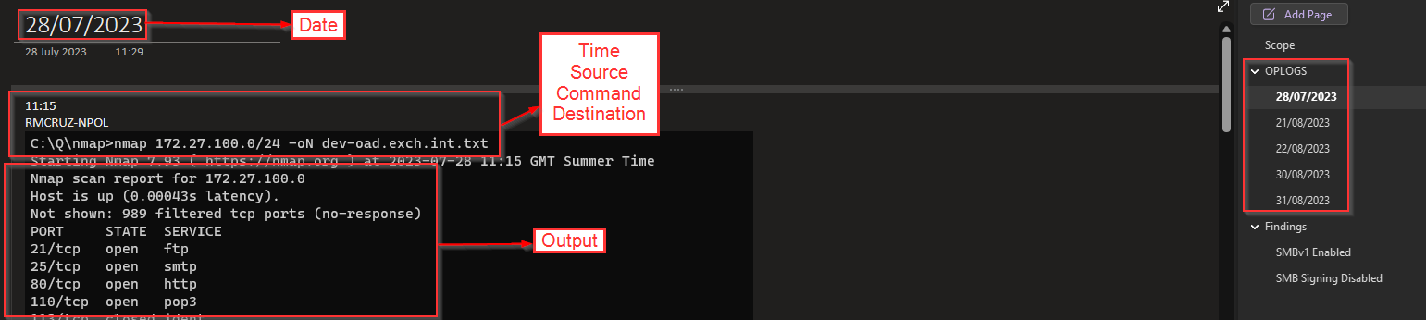
Figure 6 - Example OPLOG entry

Closure
[REVIEW] [ADD HERE] Add an OFI (Opportunities For Improvement) subsection capturing what went well, what to improve for RT and BT, and the Purple-team close-out workshop outcomes. Coherence findings -009, -015.
The final stage for the Exercise is to report the outcome of each scenario. This report should contain information regarding how many scenarios were outlined during the Planning phase, and how many were successful in the Execution phase, and their respective description. It should be reported which scenarios were not concluded, and why it wasn’t possible to execute them. Either because no technique was possible to execute or because the impact of the scenario could be too large and unpredictable. For each successful scenario, the outcome should be reported, if further Escalation was possible and how far it was possible to move.
In this report, there should also be information regarding the vulnerabilities found, similar to a regular Pentesting report, with severity, description, impact and meaningful recommendations that are relevant and applicable to the business. Furthermore, each vulnerability should be associated with a scenario, so there should be a link between the scenarios executed and the vulnerabilities that allowed the Red Team to achieve the objectives.
In the report it should also be explicitly stated the scope of the exercise, threat actors considered and restrictions that were defined. Finally, any test accounts, dropped files or other modifications which were created should be communicated to the WT to be disabled or removed, as appropriate, together with any associated content.

Versioning
The following lists only the most recent modification made to this revision.
Revision No. | Date | Author | Change Description
0.1 | 14 Sep 2023 | Renato Cruz | First Draft
0.2 | 3 Oct 2023 | Tiago Dias | Document Revision
1.0 | 17 Jun 2024 | Renato Cruz | Final Version
1.1 | 28 Jul 2025 | Renato Cruz | Added timeline

