Red Team Research Methodology

Purpose & Objectives
The purpose of this document is to define the Red Team Research and Capability Development process, ensuring that external and internal research signals are consistently assessed, documented, and operationalized in support of red team activities. This process is designed to:
- Continuously identify offensive research relevant to the organization’s threat model
- Reduce time from research publication to operational capability
- Ensure research outputs are actionable, governed, and auditable
- Support red team Exercises, Operations, and Threat Scenarios
- Enable effective collaboration with defensive and purple teams
The process follows an AI-assisted, human-validated model, where automation is used to standardize intake and enrichment, while final decisions and accountability remain with human operators.

Scope & Applicability

In Scope
This process applies to:
- External offensive security research (blogs, whitepapers, …) from a curated list of feeds
- Ad-hoc research submissions initiated by RT members
- Research triggered by knowledge gaps identified during RT Engagements
- Incidents or control observations

Out of Scope
The following are explicitly out of scope:
- Vulnerability management and patch tracking activities
- Purely defensive guidance without offensive relevance
- Marketing content or vendor-driven publications
- Research unrelated to the organization’s threat model or environments
- Tool repositories without any contextual information

Process Overview
This section describes the end-to-end red team research and capability development process, aligned with the workflow presented in Figure 1. The process ensures that external and internal research signals are consistently enriched, validated, operationalized where appropriate, and continuously improved through real-world engagement feedback.
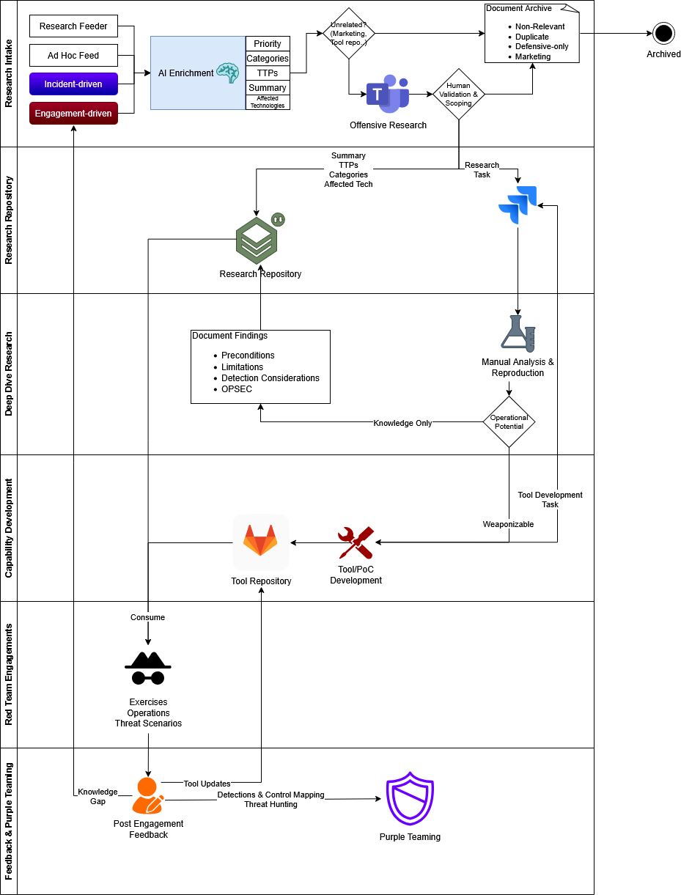
Figure 1 - Research Process Flow

Research Intake
Ensure all research inputs are normalized, enriched, and consistently assessed before any manual effort is invested. The process takes inputs from:
- Daily Research Feeder executed from RSS curated sources.
- Ad-hoc submissions via collaboration Teams chat Offensive Research (/research add)
[REVIEW] CHANGE: "collaboration Teams chat" → "Microsoft Teams chat". Use 'Microsoft Teams chat' for product naming clarity. Coherence finding -006.
[REVIEW] CHANGE: "Teams chat Offensive Research" → "Microsoft Teams chat 'Offensive Research'". Use 'Microsoft Teams chat' (or 'Microsoft Teams chat' as short form) for clarity. Coherence finding -006.
- Engagement-driven research based on knowledge gaps identified during the engagement
- Incident-driven research based on techniques observed during incidents
All research inputs pass through a the AI Enrichment layer that generates:
- Research summary
- MITRE TTPs mapping
- Research categories
- Priority (environment-aware)
- Affected technologies
AI-enriched information is sent to the collaboration Teams chat for human validation, to decide if the enriched data is valid and the research is relevant for the company threat model. If the AI Enrichment layer categorizes the research as not applicable (Not relevant, Marketing post, Duplicate, Defensive only, …) the post is archived with documented motive to avoid duplicated effort.
[REVIEW] CHANGE: "collaboration Teams chat" → "Microsoft Teams chat". Use 'Microsoft Teams chat' for product naming clarity. Coherence finding -006.
If the research post pass both AI and Human validation, the flow moves on to the Research Repository step.
[REVIEW] CHANGE: "Research Repository" → "Red Team Research Repository". Use the qualified canonical on first reference. NOTE: only the FIRST occurrence per section needs rewriting; subsequent uses can keep the short form. Coherence finding -006.

Research Repository
[REVIEW] CHANGE: "Research Repository" → "Red Team Research Repository". Use the qualified canonical on first reference. NOTE: only the FIRST occurrence per section needs rewriting; subsequent uses can keep the short form. Coherence finding -006.
Upon reaching this step, a human operator must trigger an automated workflow on the Teams chat to add this research data to RT Research Repository and open a new research task on Jira to be assigned to an operator. The RT Research Repository serves as the authoritative knowledge base for validated offensive research, a central source of truth for research outputs that supports RT Exercises, Operations, Threat Scenarios, and Purple Teaming.
[REVIEW] CHANGE: "Research Repository" → "Red Team Research Repository". Use the qualified canonical on first reference. NOTE: only the FIRST occurrence per section needs rewriting; subsequent uses can keep the short form. Coherence finding -006.
[REVIEW] CHANGE: "RT Research Repository" → "Red Team Research Repository". Use the qualified canonical on first reference; 'RT Research Repository' acceptable as short form thereafter. Coherence finding -006.
[REVIEW] CHANGE: "Research Repository" → "Red Team Research Repository". Use the qualified canonical on first reference. NOTE: only the FIRST occurrence per section needs rewriting; subsequent uses can keep the short form. Coherence finding -006.
Each initial AI-enriched research entry includes:
- Research summary
- MITRE TTPs mapping
- Categories
- Affected technologies
- References and sources
Research Repository entries should be assigned a Research Lifecycle tag:
[REVIEW] CHANGE: "Research Repository" → "Red Team Research Repository". Use the qualified canonical on first reference. NOTE: only the FIRST occurrence per section needs rewriting; subsequent uses can keep the short form. Coherence finding -006.
- Initial AI-assisted entry
- Enriched during deep-dive research
- Updated post-engagement based on operational feedback
It should be noted that all research-related tasks should have a Research_Repository label to allow a quick check on all previous tasks. Additionally, these tasks are created in the REDS Jira project that only the RT has access to, to avoid leaking sensitive operational information to other teams.

Deep Dive Research
After the Jira task is assigned, the operator must perform a Deep Dive Research to transform validated research into environment-specific, actionable understanding and institutional knowledge.
The assigned operator must reproduce and validate the techniques, perform environment-specific testing and analysis of detection and control impacts.
During the research, the operator must document and update the Research Repository with Deep Dive Research outputs, with the following information, if applicable:
[REVIEW] CHANGE: "Research Repository" → "Red Team Research Repository". Use the qualified canonical on first reference. NOTE: only the FIRST occurrence per section needs rewriting; subsequent uses can keep the short form. Coherence finding -006.
- Preconditions and assumptions
- Limitations
- Detection considerations
- OPSEC considerations
At the end of the Deep Dive, the operator must add one of the following Research Depth tag to the Research Repository entry:
[REVIEW] CHANGE: "Research Repository" → "Red Team Research Repository". Use the qualified canonical on first reference. NOTE: only the FIRST occurrence per section needs rewriting; subsequent uses can keep the short form. Coherence finding -006.
- Awareness: Not directly applicable, but good-to-know general knowledge
- Tactical: New technique or methodology
- Capability: Directly converted into New Tool/PoC/Tool Update
If the research gets assigned either an Awareness or Tactical tag, it means that it is not suitable for weaponization and is retained as knowledge-only content.
Otherwise, if it gets assigned a Capability tag, it must be converted into a new tool, new PoC or tool update of already existing tools during the Capability Development step.

Capability Development
After the Deep Dive step outputs a Capability-tagged research, it is converted into safe, reusable red team capabilities, if operationally viable, reliable in target environments and acceptable from an OPSEC perspective. This step must output either a new tool, PoC or enhance existing tooling.
New capabilities developed must be added on the RT Tool Repository, with clear documentation and usage guidance, linked research references, OPSEC and detection notes. Additionally, they must be attributed a lifecycle state:
[REVIEW] CHANGE: "Tool Repository" → "Red Team Tools Repository". Use the qualified canonical on first reference. Coherence finding -006.
- Experimental: Initial code that hasn’t been battle-tested
- Operational: Tool that has been successfully used during operations
- Deprecated: Tool still works but no longer useful, due to fixed vulnerabilities or widely-known detections
- Retired: Tool that is broken and can’t be used
In order to perform Capability Development, the operator must open a new task in Jira with the Tool_Development label.

Red Team Engagements
This is the general Red Team Process that is followed in parallel with the research efforts documented in this process. Following this documentation, the RT Operators should consume the research knowledge contained in the Research Repository and use the tools documented in the Tools Repository as described above.
[REVIEW] CHANGE: "Research Repository" → "Red Team Research Repository". Use the qualified canonical on first reference. NOTE: only the FIRST occurrence per section needs rewriting; subsequent uses can keep the short form. Coherence finding -006.

Feeback & Purple Teaming
After Red Team Engagements, a Feedback step is performed to ensure continuous improvement of research, tooling, and defensive posture. During this step the operators must analyse what worked and what didn’t work, identifying where the tools failed and where there was a knowledge gap that needs to be addressed in future research. This information feeds back into the process, to update both the Tool Repository and the Research Repository.
[REVIEW] CHANGE: "Tool Repository" → "Red Team Tools Repository". Use the qualified canonical on first reference. Coherence finding -006.
[REVIEW] CHANGE: "Research Repository" → "Red Team Research Repository". Use the qualified canonical on first reference. NOTE: only the FIRST occurrence per section needs rewriting; subsequent uses can keep the short form. Coherence finding -006.
Finally, the RT Engagement should follow the process established with the Purple Team to identify Detections and Controls gaps.

Useful Links
- Tool Repository
[REVIEW] CHANGE: "Tool Repository" → "Red Team Tools Repository". Use the qualified canonical on first reference. Coherence finding -006.
- Research Repository
[REVIEW] CHANGE: "Research Repository" → "Red Team Research Repository". Use the qualified canonical on first reference. NOTE: only the FIRST occurrence per section needs rewriting; subsequent uses can keep the short form. Coherence finding -006.
- Jira Project
- Research Feeder
- Curated feeds

Versioning
The following lists only the most recent modification made to this revision.
Revision No. | Date | Author | Change Description
0.1 | 21 Jan 2026 | Renato Cruz | First Draft
0.2 | 27 Jan 2026 | Tiago Dias | Document Revision

