BloodHound Enterprise Process

Introduction
BloodHound Enterprise is a powerful security assessment tool tailored to analyse and visualize attack paths within Active Directory environments. BloodHound uses graph theory to reveal the hidden and often unintended relationships within Active Directory and Entra ID. Both defenders/blue teams and attackers/red teams can use BloodHound to easily gain a deeper understanding of privileged relationships in an environment. The primary purpose of deploying BloodHound Enterprise is to empower security professionals to understand complex relationships, permissions, and attack paths, enabling more informed decision-making and timely remediation.
BloodHound works by installing an agent on a machine within the Active Directory network, running with a domain account, that periodically collects AD information using Sharphound. This information is then uploaded to Euronext tenant to be analysed and attack paths mapped. Throughout this document, if you need more information on BloodHound Enterprise, please refer to their official documentation.
[REVIEW] Replace 'Sharphound' (lowercase 'h') with 'SharpHound' — vendor canonical casing. The rest of this doc already uses 'SharpHound'. Coherence finding -004.

Objectives
Identifying Security Risks, misconfigurations, and vulnerabilities within our Active Directory environment. Visualizing Attack Paths to represent and analyse attack paths, aiding in the swift identification of potential threats. Enhancing Remediation Efforts by prioritizing and addressing security risks based on the insights provided by BloodHound. Facilitating Collaboration among security teams by providing a centralized platform for analysing and discussing security findings.

System Requirements
The SharpHound Enterprise service is a critical element in your deployment that collects and uploads data about your environment to your BloodHound Enterprise instance for processing and analysis. SharpHound Enterprise is deployed as a signed Windows service, runs under the context of a domain account, and collects from one or more domains utilizing the configured service account.
Following their official system requirements:
Hardware
 | Minimum | Recommended
Processor Cores | 2 physical cores | 4 physical cores
Memory | 4GB R.AM | 16GB RAM
Hard disk space | 1GB for logging | 5GB for logging
Software
- Windows Server 2019+
- .NET 4.5.2+
Network
- TLS on 443/TCP to your tenant URL (provided by your account team)
- LDAP to at least one domain controller in each domain requiring collection. SharpHound will attempt LDAP over SSL first, then fall back to LDAP if SSL is unavailable.
- LDAP over SSL on 636/TCP
- LDAP on 389/TCP
- [OPTIONAL] SMB/RPC on 445/TCP to all domain-joined computers
Service Account Requirements
The SharpHound Enterprise service will run as a domain-joined account and will utilize the permissions of that account for enumeration purposes.
- Authenticated User within any domains requiring collection
- Local Administrator on the SharpHound Enterprise server
- Read privileges to the Deleted Objects container (if tombstoning is enabled)
- [OPTIONAL] Local Administrator on all domain-joined systems

Installation
For complete installation steps, follow the official documentation on the subject. Please find below, an high level overview of the setup of SharpHound Enterprise service:
- Log into your BloodHound Enterprise tenant.
- Click on the gear icon in the top right corner, followed by “Download Collectors”.
- On the SharpHound version marked “Latest,” click “Download SharpHound vX.X.X (.zip)".
- Validate that your SharpHound service account is a member of the local Administrators group of the SharpHound Server.
- Extract the contents of the zip archive on your SharpHound Server, run "SHSetup.exe" and click “Install".
- Provide credentials for your SharpHound service account in the format: DOMAIN\username
- Edit the settings.json file located within the installation directory chosen previously (default: C:\Program Files (x86)\SHService\).
- Modify the "RestEndpoint" value to represent the tenant domain.
- Specify the URL of the proxy in the "Proxy" field, surrounded by double quotation marks.
- Create a SharpHound collector client by following the official instructions. Continue to the next step when you have the Client Token Info / Token ID and Token.
- Edit the auth.json file (default: C:\Program Files (x86)\SHService\), highlight the entire file contents, and paste in the JSON Client Token Info copied from the BloodHound Enterprise UI when creating the new client.
- Locate and start the SharpHound Delegator service.
- Return to the BloodHound Enterprise UI. You should see your client showing 🟢 Ready

Configuration
Following the official documentation, creating a collection schedule on a collector client which will ensure continuous data collection. BHE administrators should use it during the deployment of a new client or when adding an additional schedule to an existing client.
Generally, Azure and Active Directory Structure do not change significantly enough to warrant more than daily collection. Local Groups and Sessions can be scheduled to collect every 7 hours to ensure a good sampling of round-the-clock activity.
- In the top right, click settings -> Administration -> Manage Clients -> Edit Client.
- In the Edit SharpHound Client window, click the + icon to add and configure a new schedule.
  - Start Date: The time on which the first collection should run.
  - Frequency: The frequency of the schedule.
  - Data: The type of data the schedule collects.
  - Advanced Options: See the Collection Scheduling section in the article SharpHound Enterprise Tenant Configuration.
- (Optional) Verify collection is successful after the next schedule in the Finished Jobs Log. Where Status should report Complete and a success is found in Status Message.

Data Collection
To optimize data collection, it will occur on a daily schedule during lunch hours from 12:00 PM to 1:00 PM (local time) on every weekday. This timeframe strikes a balance between obtaining up-to-date insights into our Active Directory environment and minimizing operational disruption. The lunchtime window offers a practical solution, as it typically experiences lower user activity and provides an opportunity for effective session data collection without significant impact on daily operations. This data collection will collect all available information and SOC team should be warned of the recurrent collection, and disregard any alerts during this time coming from the SharpHound Enterprise Server.

Data Analysis
Before starting the Data Analysis, BloodHound Enterprise Tier 0 objects need to be customized, since the default ones might not be enough to cover all critical objects for the AD structure. To perform this customization, please refer to the official documentation on how to find these Tier 0 objects. Nevertheless, find below an high level overview of which objects should be considered a Tier 0 due to their importance:
Systems within an AD environment which are almost always Tier 0, regardless of implementation:
- PKI (Public Key Infrastructure) / ADCS (Active Directory Certificate Services)
- Root CA (Certificate Authority) server
- Subordinate CAs
- ADFS (Active Directory Federation Services)
- Azure AD Connect servers and accounts.
- Privileged Access Management systems (ex: CyberArk)
- GPO Administration tools (such as Quest GPO Admin or AGPM)
- Read-Only Domain Controller (RODC) computer objects
Anything else your organization already classifies as Tier 0, such as Privileged Access Workstations.
After configuring the SharpHound collector and Tier 0 objects, BloodHound should show attack paths that allow to compromise Tier 0 objects as see in the example in Figure 1.
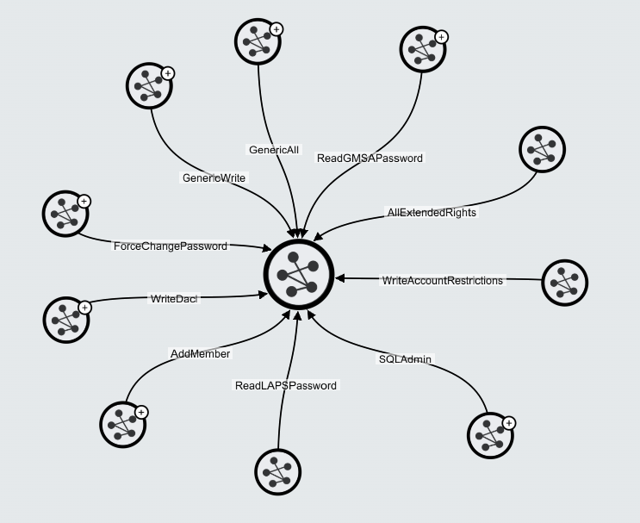
Figure 1 - Tier 0 Attack Paths
Afterwards, the analysis should follow a top-down approach, starting with the paths that lead directly into Tier 0 objects as demonstrated in Figure 1. To exemplify how this can be achieved, it is possible to click the Edge to be analyzed and BloodHound will show which objects can abuse that path as seen in Figure 2 example, showing which principals can Add Members to Tier 0 groups.
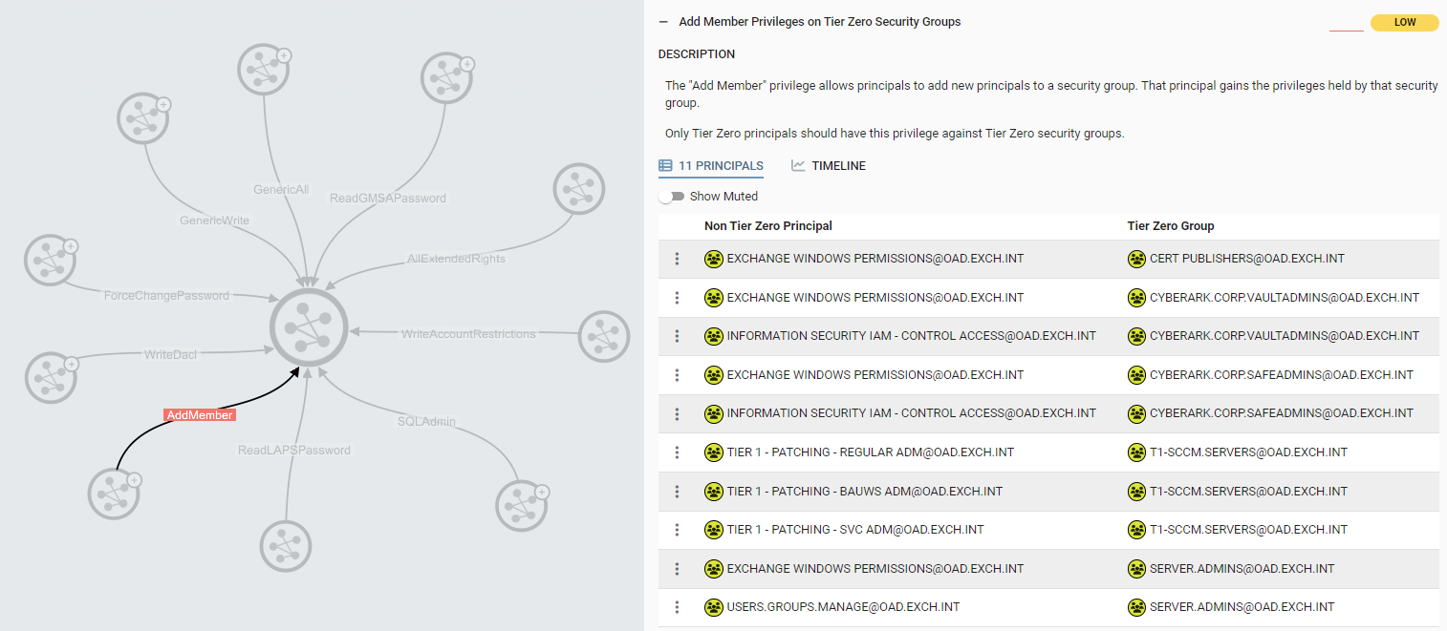
Figure 2 - AddMember to Tier 0 Groups example
The analysis should identify objects that might have too much permissions, that do not make sense to have. In this case, it can be identified that the group Exchange Windows Pemissions can add members to the Cyberark.Corp.Safeadmins group, which does not seem a logical permission to exist.
Furthermore, BloodHound can be used to reveal hidden privileges that might not be immediately apparent. As demonstrated in Figure 3, all Exchange servers have the same AddMember privilege over the CyberArk group due to nested membership. This means that compromising one of the Exchange serves gives an attacker the privilege to add a user account to the Tier 0 group.
Figure 3 - Hidden AddMember Privilege
It should be noted that the previous path is just an example, as demonstrated in Figure 4 there are a lot more paths into the example Tier 0 group that should be reviewed, given that control over Tier 0 objects should be restricted to Tier 0 objects.
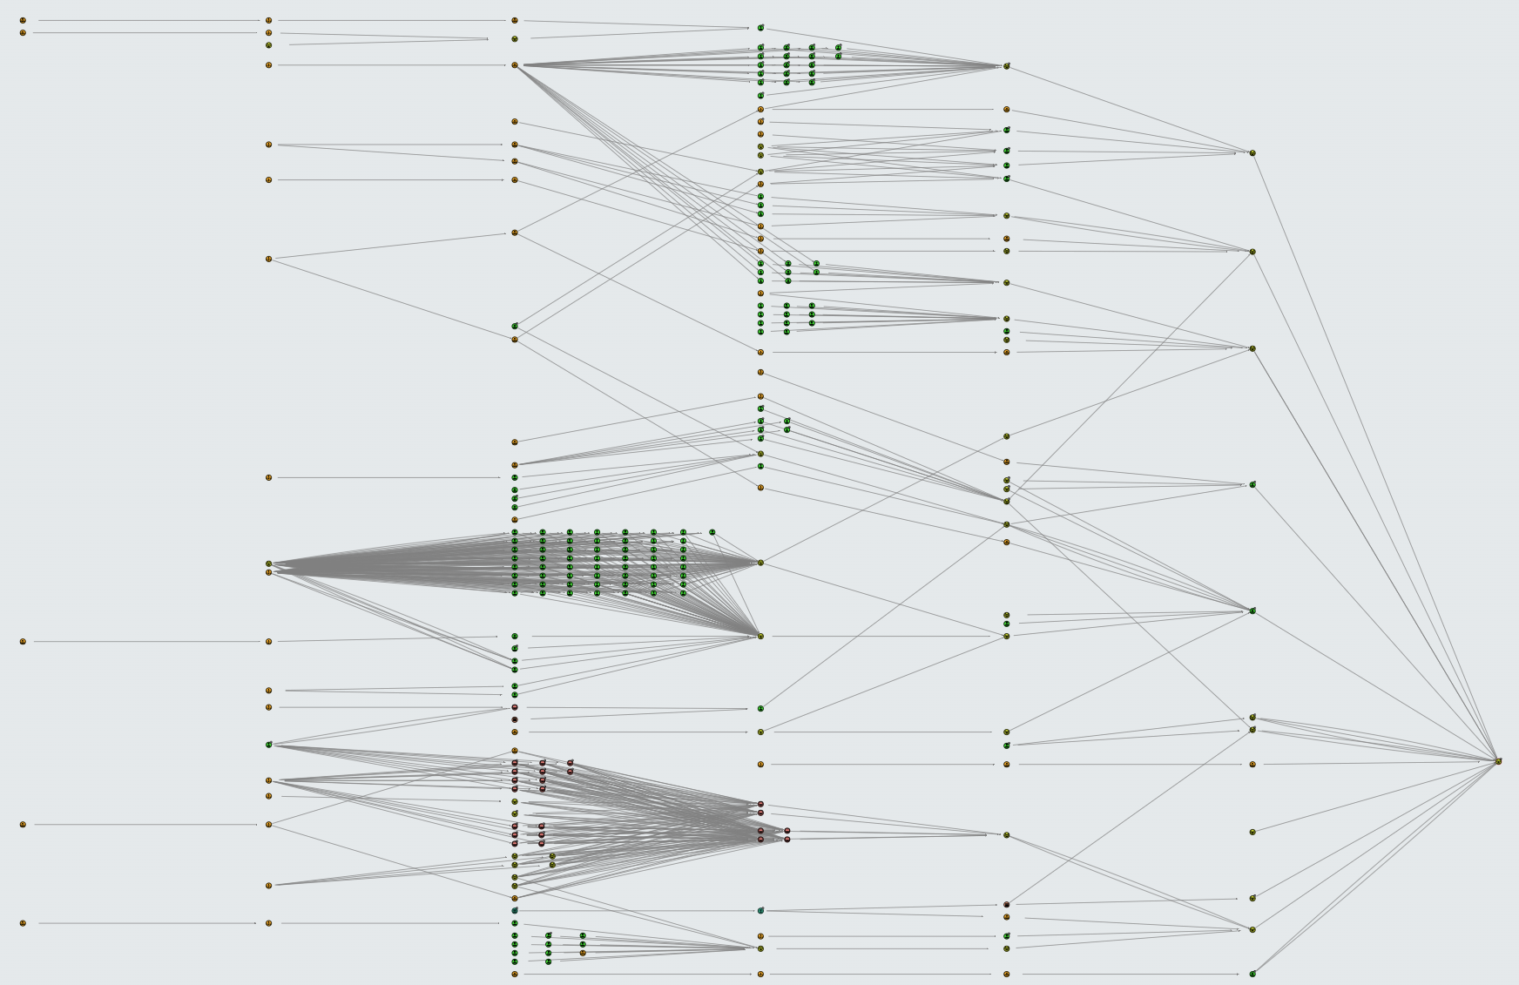
Figure 4 - All paths to example group
Furthermore, the AddMember privileged was also a simple example, has previously show, that are a lot more paths into other Tier 0 objects that have not been demonstrated here. They all should be reviewed if they make sense to exist.
If a PoC is required to demonstrate how each path can be exploited, the BloodHound interface provides information on abusing each Edge both for Windows and Linux, Figure 5.
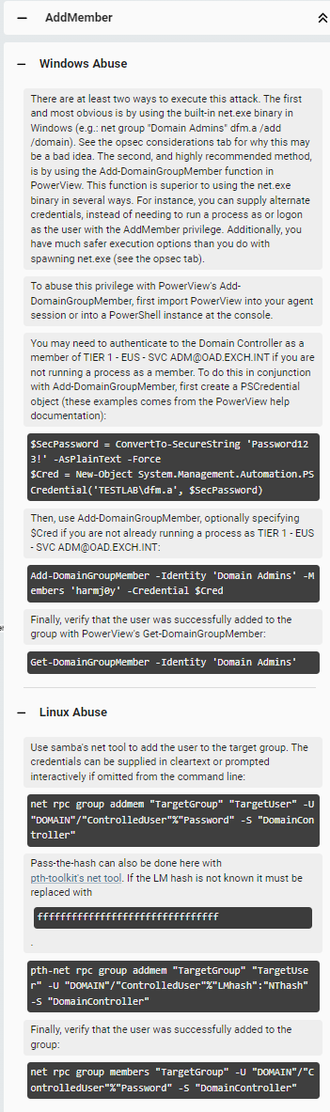
Figure 5 - Exploitation

Remediation
When providing Remediation plan to the proper teams, it is required to give a short explanation on what is the Edge being reported and why it is being reported. To help this, BloodHound provides the General information for each Edge, as demonstrated in Figure 6.
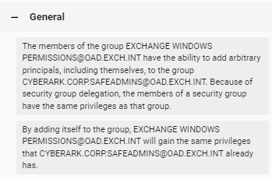
Figure 6 - AddMember description
Furthermore, if this information is not sufficient, BloodHound also provides a References section that has more information regarding the Edge’s description and exploitation, Figure 7.
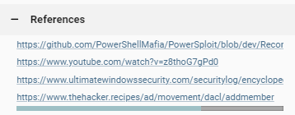
Figure 7 - AddMember References
Most of the Edges are self-explanatory, and remediation should be easy to remove the abusive permission. If this is not the case, it should be reviewed on a case-by-case basis, by the team, on the proper recommendation to give.

Access Management
Access to Euronext BloodHound tenant is fully managed by AET, and access to it is restricted to members of the team. As of writing this document, SAML is not yet implemented, and only application accounts are used. If access to the tool is required, one of the administrators in AET should be contacted to create the account, Figure 8.
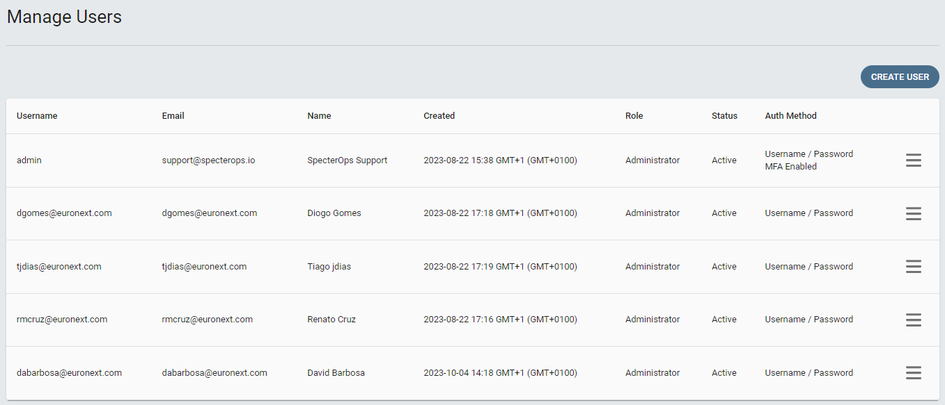
Figure 8 - BloodHound accounts

Best Practices
When exploiting an Edge to demonstrate impact, always take into account the OPSEC considerations provided by BloodHound shown in Figure 9. Try to reduce the amount of alerts generated and attempt to evade some detections and blocks that might stop the impact of the attack from being demonstrated.
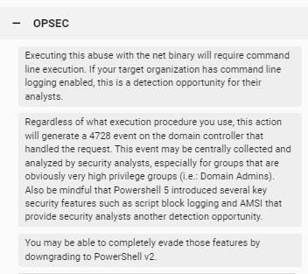
Figure 9 - AddMember OPSEC
Furthermore, always keep in mind that no disruption should occur in normal business operations. Before attempting to exploit any vulnerability, it should be analyzed the possible impact on other users or services. This includes, but not limited to, the ForceChangePassword Edge effectively changes the password of the target account. This means the User will be prevented from using the account, logging in and do their work. If it is done on a service account, the service will most likely stop functioning regularly.
Due to this, no action should be taken on a User account without the user’s acknowledgement and written permission.
After exploitation is completed and the vulnerability is fixed, the changes done during exploitation should be cleaned-up. This means that any user account created or any group membership modified should be deleted or removed accordingly. Any artifacts left on machines, such as C2 implants or any persistence techniques used (Scheduled tasks, Logon Scripts, DLLs modified…) should also be cleaned-up and removed from the compromised machines. To simplify this process, the team member performing the exploitation should keep detailed logs of their activity and use the OPLOGS recommended in the Red Team Exercises process.

Conclusion
BloodHound's capabilities offer valuable insights into our Active Directory environment, enabling identification and mitigation of potential security risks efficiently. These practices will be continually refined and adapted to meet the evolving landscape of cybersecurity.
BloodHound is going to be used to look for overly permissive configurations, that might lead to Tier 0 compromise. It is a powerful tool, and should be used with extreme care.

Versioning
The following lists only the most recent modification made to this revision.
Revision No. | Date | Author | Change Description
0.1 | 15 Jan 2024 | Renato Cruz | First Draft
0.2 | 12 May 2026 | Process Revision Automation | Coherence annotations
0.3 | 12 May 2026 | Renato Cruz | Document Reviewed

