Operations Process

Introduction
This document describes the Red Team Operations Process that the Red Team should adhere to when planning and executing a Red Team Operation against a company, and it should include the phases in Figure 1.

Figure 1 – Red Teaming Phases
Red Team Operation are mainly opportunistic types of exercises, where the Red Team will be continuously looking for new attack vectors. These can come from varied sources, such as research blog posts describing new EDR evasion techniques or new Initial Access attack vectors, exposed/leaked credentials, new CVE’s that affect company assets as indicated by the TI team, TI news describing current techniques used by famous Theart Actors, as well as attack vectors originated from the internal Red Team. This helps understand how to improve the effectiveness of the people, processes and technologies of our organization against novel techniques for which there might not be fixes available.
The Red Team is not focused on Penetration Test, and the its goal is not to deliver a list of vulnerabilities of a specific application or service. It’s to simulate Threat Actors Tactics, Techniques and Procedures (TTPs), that include a blended approach (Social Engineering, physical intrusion, application/network pentest) to reach the pre-defined objective.
These objectives are defined at the end of the 1st Phase as explained in the following sections, and during the RT Test on the 2nd Phase, anything is in scope to achieve these objectives.

Teams & Responsibilities
On each Red Team Operation, there are two main teams to be considered, each with its own responsibilities on the engagement.
[REVIEW] Replace 'two main teams' with 'three main teams' — the Teams & Responsibilities section lists Red Team, Blue Team, and White Team (three teams). Cleanup-pass contradiction fix.
Red Team (RT)
Assumes the role of an hostile attacker who challenges the organization's cyber security, and simulates a realistic attack scenario. Often very few people are aware of the fact that an RT assessment is being carried out so that the realism of the exercise is optimal.
- Provides information and research data for all laws, regulations, policies, programs and operations.
- Executes engagement requirements as directed.
- Complies with all laws, regulations, policies, programs and Rules of Engagement (RoE).
- Implement RT operational methodology and TTPs.
- Identifies and has input to target environment deficiencies.
- Executes operational impacts.
Blue Team (BT)
Assumes the role of the defensive side, in charge of defending the networks, systems, and applications. This team is generally unaware of this simulation to increase realism and test response.
- All of the components defending the network, unaware the engagement is undergoing, and performs regular daily activities.
White Team (WT)
Link between the RT and the BT, and consists of employees who can escalate and de-escalate with both teams. Informed of all attacks by the Red Team and is mandated to start, stop and approve attacks.
- Assisting deconfliction between RT and BT.
- Determining if, when and what information is shared with BT.
- Determining when actions should be implemented as part of engagement operational impact.

Deconfliction
The deconfliction process is used to separate Red Team activity from real-world activity. It mandates Red Team receipt of incident-specific defensive logs, in order to properly correlate those logs with Red Team logs. This process must not be used to identify Red Team specific activities, only to understand if an incident is a real threat or not, and stop the blue team from doing self-inflicting damage to the company through its incident response procedures (such as isolating/stopping critical functionalities). It requires all detected incidents (real world or alleged Red Team) to be reported through normal incident reporting process, and additionally, it may require WT Point of Contact to contact the RT Point of Contact to determine if activities are part of engagement.
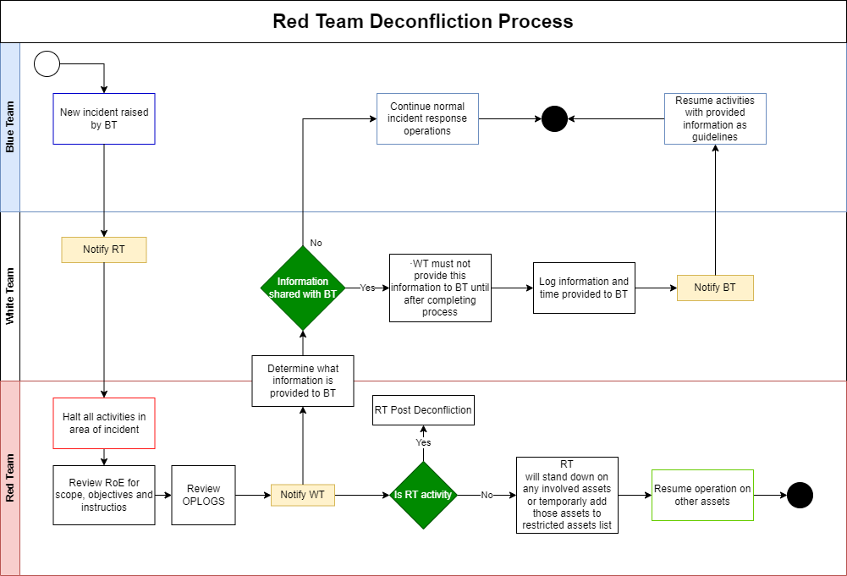
Figure 2 - Deconfliction Process
The workflow depicted in Figure 2 represents the deconfliction process in case there is a new incident raised by the BT. In this situation, the WT should notify immediately the RT about the incident, while the BT resumes their normal incident response activities. Notification to the RT must include source, destination, action, time of action, and alert source.

After the RT reviews its OPLOGS to determine if the incident is RT activity or real activity, it must ensure findings are relayed via email and other channels as well as maintain records of deconfliction information, actions, assessments and findings. In case of RT activity, the Post Deconfliction process should determine and isolate specific activities, scripts and logs supporting the time frame of the incident. If activity is real, deconfliction process is complete, and BT will resume response activities as normal. The RT together with the WT will decide what information, if any, is shared with the BT:
- Activities to be performed by BT in accordance to policies and practices
- How response activities will impact the availability and effectiveness of the BT to detect, identify, and respond to other incidents
- How response activities will impact the systems and networks of the incident location
- How response activities will impact daily operations for those outside response teams
- Amount of effort required to identify and isolate RT vs benefits of responding to incident for training, tooling and metrics.
If no information provided to response teams, full scope activities will resume. BT should not be notified of RT activities. If information is provided, all teams must log information and time provided, and BT should proceed with response activities using provided information as TI or guidelines

If specific actions are too high level of effort, all teams must adjust current activity to accommodate the exclusion effort, such as:
- Continuance of RT but halt BT activities
- Continuance of BT but halt RT activities
- Continuance RT but reduced BT activities
- Continuance BT but reduced RT activities
- Halt all activities
Final deconfliction determinations will be actioned and recoded for event reporting as well as after-action review. These after-action reviews may be used to stimulate improvements to deconfliction process as well as incident response or other security operations.

Data Handling
All RT members should be responsible for safeguarding all target data. During the engagement, the RT Operators will capture files from the target environment for later analysis. Each Operator is fully responsible for guaranteeing the safe transportation and storage of captured data. This includes encryption of files before transmission, as well as the usage of secure transportation methods to upload files to the team server.
During the engagement, the operator will not intentionally compromise Privacy of Information Act (PIA), medical, justice, worship or religious pursuit, or any other protected or privileged information that may fall into one of the following categories:
- Personal confidential data
- Business confidential data
- Financial confidential data
- Regulated data
If the operator considers that these sensitive data files types are among the captured files, the following process must be followed:
- Operator should halt all operations.
- WT Point of Contact should be promptly contacted to confirm the type of data of the files
  - If data is confirmed to belong to one of those categories, it should be immediately deleted from the team server.
    - If applicable, it should be returned to the environment where it was retrieved from.
  - If data is not from one of these categories, normal operations may resume.
    - If the captured data does not belong to these categories, the operator may evaluate if they are valuable to advance towards the objectives.

Terms & Definitions
Vulnerability Scanning | Assess your infrastructure vulnerabilities by using agent based scanning or by employing network based scanners, from either an external or internal perspective. Both of these will scan the targeted assets and will match the information gathered against public databases to identify vulnerabilities on your targeted IT landscape.
Penetration Testing | Also called pentesting, is the practice of testing a computer system, network or Web application to find vulnerabilities that an attacker could exploit.
Red Teaming | Assess a company security using a real-life targeted attack simulation of a threat actor. Simulate threat actors by using their Tactics, Techniques and Procedures (TTPs), using a blended approach (Social Engineering, physical intrusion, application/network Penetration Test) to reach some pre-defined objectives. It is used to not only evaluate technical defences, but also people and processes involved in the organization’s security.
Red Team (RT) | Assumes the role of an hostile attacker who challenges the organization's cyber security, and simulates a realistic attack scenario. Often very few people are aware of the fact that an RT assessment is being carried out so that the realism of the exercise is optimal.
White Team (WT) | Link between the RT and the BT, and consists of employees who can escalate and de-escalate with both teams.  Informed of all attacks by the Red Team and is mandated to start, stop and approve attacks.
Blue Team (BT) | Assumes the role of the defensive side, in charge of defending the networks, systems, and applications. This team is generally unaware of this simulation to increase realism and test response.
Deconfliction | Process of understanding if a certain security event, that occurs during Red Team activity, is originated from that activity, and stop incident response processes of taking self-inflicting damage to the company, such as isolating a critical system that could cause business impact. If Deconfliction process concludes that it is a real activity, then regular incident response activities may resume.
Tactics, Techniques and Procedures (TTP) | Behaviours, processes, actions, and strategies used by a threat actor to develop threats and engage in cyberattacks. Tactics are the overall goal and general strategy behind an attack, Techniques represent the specific methods used to achieve theirs goals, while the Procedures are the different variations and implementations of the Techniques that attackers can use.
Red Team Operator | Technical member of the RT that is responsible for emulating a Threat Actor, and execute their TTPs on the target environment to achieve the predefined objectives.
Victim | Individuals or systems that can be exploited by a Threat Actor to achieve their goals. These usually belong to the target company, but can also be outsiders that have some connection to the company, that can also bring an advantage to the Threat Actor towards their goals.
Threat Actor | Individual or organization that intentionally causes harm to the company by exploiting weaknesses in technology, processes and people to carry out disruptive attacks on individuals or organizations.
Threat Scenario | Logical sequence of the TTPs used by Threat Actors to access a company, establish persistence and achieve their goals.
Command & Control (C2) | Set of tools and techniques attackers use to maintain remote access to a compromised machine. It consists of a Victim machine, an attacker server and a communication channel (TCP, HTTP, DNS…)
Operational Security (OPSEC) | Security and risk management process and strategy that classifies tools and techniques used, to determine the impact certain actions might cause on the target environment. It is used by Red Team Operators to determine how likely their actions are to be caught, and endanger the engagement.
Operational Logs (OPLOGS) | Logs collected by Red Team Operators with all information related to their actions, each command executed, and their output to help in post-engagement actions, where the BT can go through these logs to understand how the attacks where executed and improve security operations. These logs can also be used in the event an incident is trigger, to help the Deconfliction process, to understand if it was caused by Red Team activity or real activity.
Threat Intelligence (TI) | Threat intelligence is data that is collected, processed, and analysed in order to understand the motivations, targets, and attack patterns of a threat actor.
Leg Up | During the assessment, the RT may be unable to progress to the next stage (due to time constraints, business knowledge constraints or because the entity has been successful in protecting itself), RT with agreement from the WT, may be given access to its system, internal network, etc. to continue with the test and focus on the next objective/target.  For example, when a phishing campaign has no results because no one clicks on the link, the RT can request a leg-up: Someone involved in the exercise can consciously click on the link so that the rest of the test plan can also be carried out.

Research & Preparation
This is a continuous phase, that requires the Red Team to constantly be looking for new attack vectors and techniques. These can come from external sources, such as blog posts from research companies (ex: SpecterOps, BishopFox, Bad Sector Labs, …) describing new EDR evasion techniques, new phishing techniques, new delivery methods or new AD vulnerabilities. These opportunities can also come from the TI team, when new CVEs affecting company assets are published with Proof of Concept (PoC) code, or if a Threat Report (ex: Crowdstrike Threat Report 2024) gets published that contains technical details of TTPs currently deployed by relevant Threat Actors.
Finally, scenarios can also arise from internal Red Team own research and vulnerabilities, that can provide the operators with attack scenarios that haven’t been tested yet. This internal research and continuous evaluation of the companies security posture can be performed using our Bloodhound Enterprise instance which can be used to monitor for new attack paths into critical systems. In order to evaluate findings from Bloodhound, the RT makes use of the Attack Paths management file, which is used to help prioritize attack paths. Since there are some attack paths, that are quick and easy to fix, and the exploitation impact is too low, the RT can report them instead of using them in an operation.
[REVIEW] Replace every 'Bloodhound' (lowercase 'h') with 'BloodHound' — vendor canonical casing. BH Process v0.3 already uses 'BloodHound' throughout. Coherence finding -002.
On the other hand, there are some attacks paths, that can lead to greater impact when exploited, that can be chained with multiple attack paths to originate an operation. Furthermore, there are some attack paths in our context that can’t be exploited, such as attacks that change a password, since this would probably lead to impact on the affected user.
Other consideration taken in this prioritization, is that some attacks that are known to be detected (such as Shadow Credentials attacks), so there is an OPSEC flag to marked them as such, which is also evaluated to decide if the RT should report the path or use it for exploitation. Additionally, some paths don’t have known detections in our environment, but they modify or access AD attributes, so it is possible that there are detections in the future. As an example, please find on the table below, a summarized example of how one could fill an entry in this Attack Path management, to decide whether a certain path is exploitable or reported.
Finding | Path to T0 | Severity | Ease of Exploitation | Impact | Mitigation Effort | Edge | Report? | High Level Description | Recommendation
Regular accounts in T0 groups | Yes | Medium | Medium | Moderate | Medium | MemberOf | Exploit | Regular accounts are used daily on regular machines, which increases attack surface for compromission of these accounts, which would compromise the T0 Group. | T0 Groups should only have tiered accounts, to reduce probability of compromise of these groups

Wherever these starting points originate from, after having defined an objective, the operator incorporates the research phase output into the kill-chain of the scenario.

CODENAME
Before starting the next phase, the RT it is required to choose a unique codename for the operation to maintain confidentiality and track the operation internally.
The codename must follow the team theme: known fictional/historical character (movies, books, TV Series, …) and should not reveal any information about the target or the techniques being used, to ensure that only authorized personnel have access to the codename and associated documentation.
The RT Operator should record the chosen character in the codename register alongside the operation.

Red Team Test
The RT Test phase is where the scenarios are tested to understand if it’s possible for the defined threat actors to achieve the objectives. In all steps of this phase, the operators should keep in mind the scope and restrictions defined, in order to not cause unwanted damage to normal company operations. It is also important to remember to keep OPLOGS as outlined below.
During the execution, the RT Engagement attacks will be modelled after he Unified Kill Chain framework that it’s Attack Phases can be found summarized in Figure 3.

Figure 3 - Unified Kill Chain

Initial Foothold
This phase involves gaining the initial access or foothold into the target system or network. It typically starts with reconnaissance and vulnerability scanning, followed by exploiting a vulnerability or utilizing a social engineering technique to gain access. After the initial delivery, persistence is achieved to establish a Command & Control (C2) communication to advance to the next step of the attack, Network Propagation.

Network Propagation
Once the Initial Foothold is obtained, this phase focuses on expanding the attacker's presence within the network. It involves lateral movement, where the attacker pivots from one compromised system to another, progressively gaining access to more critical systems and sensitive information. Various techniques such as privilege escalation, password cracking, and exploiting weak security configurations may be employed in this phase. After achieving the right level of permissions within the environment, the last phase of the attack can start, Action on Objectives.

Action on Objectives
Following the Network Propagation phase, the attack can start the final phase where the attacker achieves their objectives, which could be stealing data, disrupting services, or compromising specific targets. The attacker may engage in activities such as exfiltrating valuable information, manipulating or deleting data, planting backdoors, or launching further attacks. The goal is to accomplish the predetermined objective of the engagement.

OPLOGS
It’s important to keep note of all the steps performed, and all exploits attempted in an Operation Log (OPLOG). OPLOGS provide a detailed record of the actions taken, tools used, and methodologies employed during the red team engagement. These logs can be reviewed and analysed to understand the techniques used by the red team, identify vulnerabilities, and improve security measures.
This will not only help to build the final report, but also if some unexpected outcome results from the exploits attempted, they will help understand what went wrong. They can serve as a valuable resource during incident response and forensic investigations. If a real incidents arises during the red team engagement or if there are unintended consequences, the logs can help trace back the steps, diagnose the issue, and identify any systems affected.
It will also help with the clean-up stage and it will help the Blue Team to understand the timeline of the attack. They can be used as a training tool for both the Red Team members and the Blue Team defenders. The logs provide insights into the tactics, techniques, and procedures used by the red team, which can help inform defensive strategies and facilitate knowledge sharing within the organization.
In order to keep these logs relevant, the following should be kept for each command or action performed:
- Date – Date of execution (Day and time)
- Source – Source of action (IP, Host, Account…)
- Destination – Destination of action (Domain, IP, Host, Account…)
- Tool Name – (Optional) Name of the tool used (Rubeus, Impacket, Mimikatz…)
- Command – Command executed.
- Output – Command output
- Description/Comments – (Optional) Provide context or other relevant information.
As a final note, Red teaming is an iterative process intended to improve an organization's security posture. OPLOGS provide a historical record that can be used to evaluate the effectiveness of security controls, identify weaknesses, and suggest improvements in processes, policies, and technical controls.
As an example, members can use OneNote to keep all this information as seen in the example in Figure 4. Keep in mind that each member can choose the best note-keeping format for themselves, as long as the same information is stored.
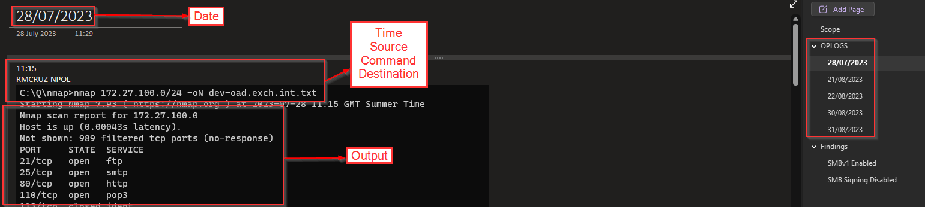
Figure 4 - Example OPLOG entry

Closure
The final stage for the Operation is to report the outcome of the scenario. This report should contain enough information for the BT to understand every step of the attack, and the reasoning behind them. It should describe the scenario objective, starting point and main results. It should be reported if the scenario was not concluded, and why it wasn’t possible to execute them. Either because no technique was possible to execute or because the impact of the scenario could be too large and unpredictable. If the scenario was successful, the outcome should be reported, if further Escalation was possible and how far it was possible to move.
In this report, there should also be information regarding the vulnerabilities found, similar to a regular Pentesting report, with severity, description, impact and meaningful recommendations that are relevant and applicable to the business. In the report outcomes, it should also contain the Opportunities For Improvements (OFIs) for both the Blue Team and the Red Team, highlighting what went well and what went wrong as well as recommendations on how to improve.
Finally, any test accounts, dropped files or other modifications which were created should be communicated to the WT to be disabled or removed, as appropriate, together with any associated content.

Purple Team Close-Out
Every Operation concludes with a mandatory purple-teaming close-out workshop with the Blue Team. The workshop is the Blue Team's first detailed exposure to the engagement (Operations are assumed-breach and the Blue Team is typically unaware during execution).
This should output detection-vs-action map per kill-chain phase, gap register, hunt-hypothesis list for the SOC, OFIs for both teams, and a prioritised remediation backlog with named owners.
For the full procedure, attendees, inputs, outputs and engagement-type-specific guidance, see Purple Teaming Process documentation.
[REVIEW] Replace 'Purple Teaming Process documentation' with 'Purple_Teaming_Process_v0.1.docx'. Coherence finding -005.

Versioning
The following lists only the most recent modification made to this revision.
Revision No. | Date | Author | Change Description
0.1 | 17 Jun 2024 | Renato Cruz | First Draft
1.0 | 28 Oct 2024 | Renato Cruz | Final Version
1.1 | 12 May 2026 | Process Revision Automation | Coherence revision
1.2 | 12 May 2026 | Renato Cruz | Document revision
1.3 | 12 May 2026 | Renato Cruz | Added Purple Team close-out

