
TOP 1000 INNOVATORS
OF POLAND IN SILICON VALLEY
DEC 9–12, 2025 • INAUGURAL SUMMIT

Readiness Workshop Guide
Wednesday, December 10 • Westin San Francisco Airport
Time | Group 1 | Group 2
1:30 – 2:45 | Readiness Workshop | IP Workshop
2:45 – 3:15 | Break
3:15 – 4:30 | IP Workshop | Readiness Workshop

Find Your Track and Workshop Assignment
Contents
Page
Overview 3
Workbook: Track A Explorers (TRL 1-3) 3
Identify Your Blocker 5
Workbook: Track B Builders (TRL 4-6) 7
Identify Your Blocker 8
Workbook: Track C Scalers (TRL 7-9) 10
The Scaling Illusion 10
LTV:CAC Ratio 11
Identify Your Blocker 12

Overview
These are hands-on working sessions — not lectures. You'll work through structured exercises, get peer feedback, and leave with concrete next steps.
What You'll Leave With
- Your #1 blocker clearly identified
- An action plan with executable steps
- A reusable framework specific to your stage
Readiness Tracks
EXPLORERS - Track A (TRL 1-3) — "Is this worth pursuing?"
BUILDERS - Track B (TRL 4-6) — "Am I building the right thing?"
SCALERS - Track C (TRL 7-9) — "Can I scale this profitably?"
Timing:
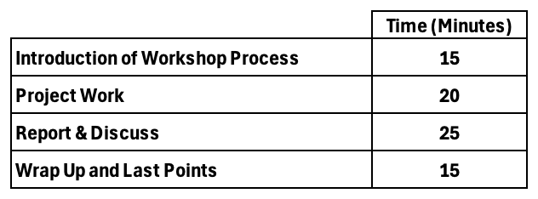

Workbook: EXPLORERS (Track A)
"Is this worth pursuing?"
(TRL 1-3)
Before You Start
Check what you know:
☐ I have talked to 5+ potential customers about this problem
☐ I can describe who has this problem (specific, not "everyone")
☐ I know how they currently solve this problem
☐ I know what they pay for current solutions
☐ I have evidence the problem is painful enough to pay for
💡 Fewer than 3 checked? This workbook will be especially valuable for you.

The Reality Check
At TRL 1-3, most projects die from building solutions to problems nobody has. Your job isn't to build — it's to discover.
⚠️ THE TRAP: You fall in love with your solution → build for months → discover nobody wants it → pivot too late.
Mindset Shift

Lab Thinking
• "My technology is innovative"
• "If we build it, they will come"
• "Everyone could use this"
• "We just need funding to build the prototype"

Market Thinking
• "Who has this problem badly enough to pay?"
• "What are they doing today without my solution?"
• "Who specifically — name, title, company type?"
• "What's the cheapest way to test if they'll pay?"

💡 At TRL 1-3, your advantage is speed. You can pivot faster than anyone. Use it.

Identify Your Blocker
Choose your ONE main blocker:
☐ Problem — I don't know if the problem is real or significant
☐ Customer — I don't know who would actually pay for this
☐ Solution — I don't know if my approach can work
☐ Team — I don't have the right co-founders or skills
☐ Technology — I don't know if it's technically feasible
☐ IP — I don't know if I can protect this or if it matters => Will be discussed during the IP & Patent Issues

Blocker: Problem
What problem are you solving? ___________________________________
Who told you this is a problem? (names) ___________________________________
How do they solve it today? ___________________________________
What does it cost them (time/money/pain)? _________________________
→ Unblock: Talk to 10 people this week. Don't pitch — just listen.
Blocker: Customer
Describe your ideal customer (specific) ___________________________________
Where do you find them? _________________________
Why would they talk to you? ___________________________________
→ Unblock: Get 5 meetings with potential customers. No selling allowed.
Blocker: Solution
Could you test this with: ☐ Mockup ☐ Manual process ☐ Existing tools ☐ Partner tech
Cheapest possible test ___________________________________
What would prove you're wrong? ___________________________________
→ Unblock: Design an experiment that costs <€1000 and takes <2 weeks.
Blocker: Team
What skills are missing? ☐ Technical ☐ Commercial ☐ Domain expertise ☐ Operations
Who could fill this gap? _________________________
What would you need to attract them? ___________________________________
→ Unblock: Find an advisor or part-time help before committing to co-founder.
Blocker: Technology
Technical risk level: ☐ Novel science ☐ Engineering challenge ☐ Integration ☐ Low risk
What's the hardest technical question? ___________________________________
Who could answer it? _________________________
→ Unblock: De-risk the hardest technical question before building anything else.
Blocker: IP
Does IP matter for this? ☐ Critical ☐ Helpful ☐ Not really ☐ Don't know
What can you protect? ___________________________________
What can competitors copy easily? ___________________________________
→ Unblock: Talk to a tech transfer office or IP attorney. One meeting.

Your 30-Day Plan
Week 1-2 — Discover
10 customer conversations. Ask about their problems, not your solution.
Target: who will you talk to? ___________________________________
Week 3 — Synthesize
Pattern recognition: what did you learn?
Biggest surprise ___________________________________
Should you continue? Why? ___________________________________
Week 4 — Test
One small experiment to run ___________________________________
What result would make you stop? ___________________________________

Final Commitment
One thing I will do THIS week:
What __________________________________________________
By when _______________
How I'll know it worked ________________________________________
Talk to customers before you build. Always.

Workbook: BUILDERS (Track B)
"Am I building the right thing?"
(TRL 4-6)
Before You Start
Check what you know:
☐ I have a working prototype or MVP
☐ I have paying customers (even just 1-2)
☐ I know why customers buy (their words, not mine)
☐ I know why some prospects don't buy
☐ I have a hypothesis for my business model
💡 Fewer than 3 checked? This workbook will be especially valuable for you.

The Product-Market Fit (PMF) Challenge
At TRL 4-6, you have proof of concept but not proof of market. The danger is premature scaling.
⚠️ THE TRAP: Early customers love it → you assume everyone will → you scale → discover it only works for a tiny niche.
Mindset Shift

Builder Thinking
• "We need more features"
• "The technology isn't ready yet"
• "Once we perfect it, sales will be easy"
• "We're almost there"

Market Fit Thinking
• "What's the minimum that solves the core problem?"
• "Why do customers actually buy?"
• "What would make them recommend us?"
• "Can we get 10 customers before adding features?"

💡 At TRL 4-6, say NO to features. Every feature you add makes it harder to find fit.

Identify Your Blocker
Choose your ONE main blocker:
☐ Customer — I don't know who my ideal customer really is
☐ Value — Customers don't see enough value to pay full price
☐ Channel — I don't know how to reach more customers
☐ Business Model — I don't know how to make money on this
☐ Team — I need key skills I don't have
☐ Technology — My solution doesn't work reliably enough

Blocker: Customer
Who are your best 2-3 customers? ___________________________________
What do they have in common? ___________________________________
Who are the worst fits? Why? ___________________________________
→ Unblock: Define your ICP. Stop selling to everyone.
Blocker: Value
What do customers say when they buy? ___________________________________
What do they say when they don't? ___________________________________
What's the ROI you deliver? _________________________
→ Unblock: Get 3 customer testimonials with specific results.
Blocker: Channel
How do customers find you today? ☐ Referral ☐ Outbound ☐ Content ☐ Events ☐ Partners
Which channel has best conversion? _________________________
What would 10× that channel? ___________________________________
→ Unblock: Double down on ONE channel. Ignore the rest for now.
Blocker: Business Model
Pricing model: ☐ One-time ☐ Subscription ☐ Usage-based ☐ License ☐ Undecided
Current price _______________
What would 2× price require? ___________________________________
Gross margin estimate _______________
→ Unblock: Raise prices 30% on next 5 deals. See what happens.
Blocker: Team
What's missing? ☐ Sales/BD ☐ Product/Tech ☐ Operations ☐ Domain expertise
Who could fill this (name if possible)? _________________________
Full-time or advisor/contractor? _________________________
→ Unblock: Hire for the blocker, not for the vision.
Blocker: Technology
What fails most often? ☐ Core function ☐ Edge cases ☐ Scale ☐ Integration ☐ UX
Specific failure ___________________________________
Fix effort (days/weeks/months) _______________
→ Unblock: Fix top 3 customer complaints before adding features.

Your 60-Day Plan
Month 1 — Validate
Get to 10 paying customers or 10 clear rejections. Learn why.
Current customer count __________
Target in 30 days __________
Month 2 — Optimize
Improve conversion or retention, not features.
Key metric to improve _________________________
Current value _______________
Target value _______________

Final Commitment
One thing I will do THIS week:
What __________________________________________________
By when _______________
How I'll know it worked ________________________________________
Find the customers who love it. Ignore everyone else.

Workbook: EXPLORERS (Track C)
“Can I scale this profitably?"
(TRL 7-9)
Before You Start
Check what you know:
☐ I know my revenue per customer per year
☐ I know my gross margin
☐ I know my customer acquisition cost (CAC)
☐ I know how many customers churned in the last 12 months
☐ I have talked to at least 3 churned customers
💡 Fewer than 3 checked? This workbook will be especially valuable for you.

The Scaling Illusion
Congratulations. You have customers, revenue, a working product. Here's the bad news: this is where most companies die. Not from lack of customers — from getting too many too fast before the economics work.
⚠️ THE TRAP: You raise money → hire salespeople → revenue goes up → burn rate goes up faster → repeat until dead.
Mindset Shift
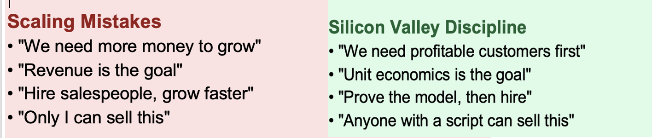
💡 At TRL 7-9, your technology is no longer your advantage. Your unit economics are.

The Churn Conversation Framework
At TRL 1-3, the key skill is finding customers. At TRL 7-9, it's keeping them. Your biggest insights come from customers who left.
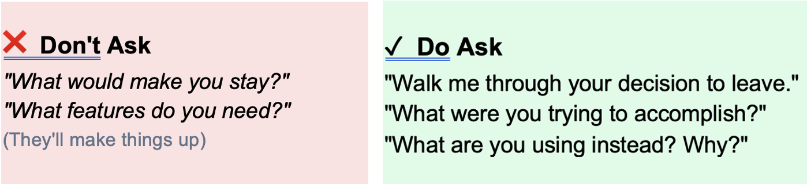

Worksheet: Churn & Retention
Customers lost (12 mo) _______________
Churn conversations done _______________
Top reason for churn ________________________________________
Best customer #1 ______________________________
Why they stay ___________________________________
Best customer #2 ______________________________
Why they stay ___________________________________
Pattern in retained customers ___________________________________

LTV:CAC — The Only Ratio That Matters
If LTV < 3× CAC, you lose money every time you grow.
Calculate Your Numbers
LTV = Revenue/customer/year × Margin % × Lifetime years
Your LTV ____________________
CAC = (Sales + Marketing spend) ÷ New customers acquired
Your CAC ____________________
Ratio = LTV ÷ CAC
Your Ratio _______________
> 3:1 | Scale aggressively
2-3:1 | Fix before scaling
< 2:1 | Stop scaling now
Two Levers to Fix the Ratio
Lever 1 — Increase LTV:
☐ Raise prices 20-30% ☐ Add upsells ☐ Reduce churn ☐ Annual contracts ☐ Improve margins
Lever 2 — Decrease CAC:
☐ Focus on ideal customers ☐ Referral program ☐ Content/inbound ☐ Shorten sales cycle
Which lever will you pull? _________________________
Specific action ___________________________________

Identify Your Blocker
Choose your ONE main blocker:
☐ Customer — I don't know why they stay or leave
☐ Business — LTV < 3× CAC
☐ Funding — need Series A
☐ Team — need sales/ops, only I can sell
☐ Technology — can't scale 10×
☐ IP — unclear licensing strategy

Blocker: Customer
Who left? _________________________
Why? ___________________________________
Pattern? ___________________________________
→ Unblock: 5 churn + 5 retention conversations. Define ICP based on who stays.
Blocker: Business
Your LTV:CAC _______________
Which lever? ☐ Increase LTV ☐ Decrease CAC
Action to improve ___________________________________
→ Unblock: Test raising prices 30% on next 5 deals.
Blocker: Funding (Series A Checklist)
☐ ARR €500K-2M ☐ Growth 2-3× YoY ☐ LTV:CAC >3:1 ☐ NRR >100%
☐ Repeatable sales ☐ Key hires in place ☐ €1B+ market
Checked _____
/7 — 6-7: Ready | 4-5: Close | <4: Not yet
→ Unblock: Fix weakest item before fundraising.
Blocker: Team
Could someone else close with a script? ☐ Yes ☐ Somewhat ☐ No
Your 5-step sales process:
1 __________________________________________________
2 __________________________________________________
3 __________________________________________________
4 __________________________________________________
5 __________________________________________________
💡 Can't write 5 steps? You don't have a repeatable process. That's your blocker.
→ Unblock: Document process. Have someone else close 3 deals. Then hire.
Blocker: Technology
What breaks at 10×? ☐ Manufacturing ☐ Cost/unit ☐ Quality ☐ Support ☐ Infrastructure
Specific bottleneck ___________________________________
→ Unblock: Identify 10× bottleneck. Solve before scaling demand.
Blocker: IP
Strategy: ☐ Build & defend ☐ License ☐ Acquisition positioning ☐ Undecided
Competitors who could copy _________________________
Your defense _________________________
→ Unblock: Choose strategy. Speed often matters more than patents.

Your 90-Day Plan
Month 1 — Understand
5 churn + 5 retention conversations. Know exactly why they stay/leave.
Month 2 — Fix
Choose lever: ☐ Increase LTV ☐ Decrease CAC
Specific action ________________________________________
Month 3 — Prove
Target LTV:CAC ratio _______________
What does that unlock? ___________________________________

Final Commitment
One thing I will do THIS week:
What __________________________________________________
By when ______________________________
How I'll know it worked ________________________________________
Revenue is vanity. Unit economics is sanity. Fix the math. Then scale.

Cheat Sheet
Unit Economics Formula  LTV = Rev × Margin × Lifetime  CAC = (Sales+Mktg) / New customers  Ratio must be > 3:1 |  | Churn Questions  • Walk me through your decision to leave  • What were you trying to accomplish?  • What are you using instead? Why?
90-Day Plan  M1: 5 churn + 5 retention conversations  M2: Pull one lever (LTV or CAC)  M3: Prove improved ratio |  | Quick Unblocks  Customer → Churn interviews  Business → Raise prices 30%  Team → Document sales process  Tech → Solve 10× bottleneck first

