Table of Contents
Solving First-degree Equations 2
Finding the Formula for First-degree Equations 3
Writing the equation() Function 4
Exercise 4-1: X-Games 5
Using Return Instead of Print 5
Exercise 4-2: Fractions as Coefficients 7
Solving Higher Degree Equations 7
Writing the quad() Function 8
Using plug() to Solve a Cubic Equation 10
Solving Equations Graphically 11
Downloading Processing 11
Creating Your Own Graphing Tool 12
Setting Graph Dimensions 12
Drawing a Grid 13
Creating the x- and y- Axes 16
Writing the grid() function 19
Graphing the Equation 20
Using Guess and Check to Find the Roots 21
Writing the halving() Function 22
Exercise 4-3: Finding More Roots 24
Summary 24
Linear Functions 24
Exercise 3.6: Rising and Running 25
Solution: 25
Exercise 3.7: A Tale of Two Points: 25
Solution: 26
Exercise 3.8: Making connections 26
Solution 27
Interactive Lines 27
Adding Text 29
In Conclusion… 31

4
“Mathematics may be defined as the subject in which we never know what we are talking about, nor whether what we are saying is true.”
- Bertrand Russell
Algebra: Transforming and Storing Numbers
If you learned algebra in school, you’re probably familiar with the idea of replacing numbers with letters. For example, you can write 2x where x is a placeholder that can represent any number. So 2x represents the idea of multiplying two by some unknown number. In math class, variables become “mystery numbers” and you’re required to find what numbers the letters represent. Figure 4-1 shows a student's cheeky response to the problem, “Find x”:
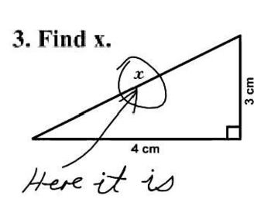
Figure 4-1: Locating the x variable instead of solving for its value.
As you can see, this student has located the variable x in the diagram instead of solving for its value. Algebra class is all about solving equations like this: Solve 2x + 5 = 13. In this context, “to solve” means to figure out which number, when you replace x with that number, makes the equation true. You can solve algebra problems by balancing equations, which requires a lot of rules you have to memorize and follow.
Using letters as placeholders in this way is just like using variables in Python. In fact, you already learned how to use variables to store and calculate numerical values in previous chapters. In this chapter you’ll use variables to write programs that solve for unknown values in complex equations quickly and automatically without having to balance equations! You’ll also learn to solve them graphically using Processing.
Solving First-degree Equations
One way to solve a simple equation like 2x + 5 = 13 with programming is using brute force by plugging in random numbers until we find the right one. For this particular equation we need to find a number x that, when you multiply it by 2 and then add 5, returns 13. I’ll make an educated guess that x is a value between -100 and 100, since we’re working with mostly double digit numbers or lower.
This means that we can write a program that plugs all the integers between -100 and 100 into the above equation, checks the output, and prints the number that makes the equation true. Open a new file in IDLE, save as X.py, and enter the code in Listing 4-1 to see such a program in action:
def plug():
u x = -100 #start at -100
while x < 100: #go up to 100
v if 2*x + 5 == 13: #if it makes the equation true
print("x =",x) #print it out
w x += 1 #make x go up by 1 to test the next number

plug() #run the plug function
Listing 4-1: Brute force program that plugs in numbers to see which satisfies the equation
Here, we define the plug() function and initialize the x variable at -100 u. On the next line we start a while loop that repeats until x equals 100, which is the upper limit of the range we set. We then multiply x by 2 and add 5 v. If the output equals 13, we tell the program to print the number, because that’s the solution.
If not, we tell the program to keep going through the code. The loop then starts over, and the program tests the next number which we get by incrementing x by 1 w. We continue the loop until we hit a match. Be sure to include the last line, which makes the program run the plug() function that we just defined; if you don’t, your program won’t do anything! The output should be something like this:
x = 4
The trial and error method is a perfectly valid way to solve this problem if you don't know how to balance equations. Plugging in all the digits by hand can be laborious, but using Python makes it a cinch! If you suspect the solution isn’t an integer, you might have to increment by smaller numbers by changing the line at w to x += .25 or some other decimal value.
Finding the Formula for First-degree Equations
Another way to solve an equation like 2x + 5 = 13 is to create a general formula for this type of equation. We can then use this formula to write a program in Python. You might recall from math calss that the equation 2x + 5 = 13 is an example of a first-degree equation, because the highest exponent a variable has in this equation is 1. And you probably know that a number raised to the 1st power equals the number itself.
In fact, all first degree equations fit into this general formula: ax + b = cx + d where a, b, c and d represent different numbers. Here are some examples of other first-degree equations:
3x - 5 = 22
4x - 12 = 2x - 9

On each side of the equals sign, you can see an x-term and a constant, which is a number with no x attached to it. The number that precedes the x variable is called a coefficient. For example, the coefficient of 3x is 3.
But sometimes there's no x term at all on one side of the equation, which means that the coefficient of that x is zero. You can see this in the first example, 3x - 5 = 22, where 22 is the only term on the right side of the equal sign.
ax + b = cx + d
3x - 5 = 0 + 22
Using the general formula, you can see that a = 3, b = -5, and d = 22. The only thing that seems to be missing is the value of c. But it’s not actually missing. In fact, the fact that there’s nothing there means cx = 0, which means that c must equal zero. Now let’s use a little algebra to solve the equation ax + b = cx + d for x. If we can find what x is in the formula, we can use it to solve virtually all equations of this form. To solve this equation we first get all the x's on one side of the equals sign by subtracting cx and b from both sides of the equation, like this:
ax - cx = d - b
Then we can factor out the x from ax and cx:
x(a - c) = d - b
Finally, divide both sides by a – c to isolate x, which gives you the value of x in terms of a, b, c, and d.

Now you can use this general equation to solve for any variable x when the equation is a first-degree equation and all coefficients (a, b, c and d) are known. Let's use this to write a Python program that can solve first-degree algebraic equations for us.
Writing the equation() Function
To write a program that will take the four coefficients of the general equation and print out the solution for x, open a new Python file in IDLE and create a new blank file. Save it as algebra.py. We’ll write a function that takes the four numbers a, b, c and d as parameters and plug them into the formula:
def equation(a,b,c,d):
'''solves equations of the
form ax + b = cx + d'''
return (d - b)/(a - c)
Listing 4-2: Using programming to solve for x
Recall that the general formula of a first-degree equation was this:. This means that for any equation with the form ax + b = cx + d, if we take their coefficients and plug them into this formula, we can calculate the x value. First, set the equation() function to take the four coefficients as its parameters. Then use the expression (d - b)/(a – c) to represent the general equation.
Now let's test it with an equation you saw already, 2x + 5 = 13:
>>> equation(2,5,0,13)
4.0
If you input the coefficients of this equation into the function, we get 4 as the solution. You can confirm that it’s correct by plugging 4 in place of x. It works!
Exercise 4-1: X-Games
Solve 12x + 18 = -34x + 67 using the program you wrote in Listing 4-2.

Using Return Instead of Print
In Listing 4-2, we used return instead of print to display our results. This is because return gives us our result as a number that we can assign to a variable and then use again. Listing 4-3 shows what would happen if we used print instead of return to find x:
def equation(a,b,c,d):
'''solves equations of the
form ax + b = cx + d'''
print((d - b)/(a – c))
When you run this, you get the same output:
>>> x = equation(2,5,0,13)
4.0
>>> print(x)
None
Listing 4-3: Using print doesn’t let us save the output
But when you try to call the x value using print, the program doesn’t recognize your command because it hasn’t saved the result. As you can see, return can be more useful in programming because it lets you save the output of a function so you can apply it elsewhere. This is why we used return in Listing 4-1.
To see how you can work with the returned output, use the equation 12x + 18 = -34x + 67 from Exercise 4-1 and assign the result to the x variable, as shown here:
>>> x = equation(12,18,-34,67)
>>> x
1.065217391304348
First, we pass the coefficients and constants of our equation to the equation() function so it calculates x for us, and assigns the result to the variable x. Then we can simply enter x to see its value. Now that the variable x stores the solution, we can plug it back into the equation to check that it's the correct answer.
Enter the following to find out what 12x + 18, the left side of the equation, evaluates to:
>>> 12*x + 18
30.782608695652176
We get 30.782608695652176. Now enter the following to do the same for -34x + 67, the right side of the equation:
>>> -34*x + 67
30.782608695652172
Despite a slight rounding discrepancy at the 15th decimal place, you can see that both sides of the equation evaluates to around 30.782608. So we can be confident that 1.065217391304348 is indeed the correct solution for x! Good thing we returned the solution and saved the value instead of just printing it out once. After all, who wants to type in a number like “1.065217391304348” again and again?
Exercise 4-2: Fractions as Coefficients
Use the equation() function to solve the last, most sinister-looking equation you saw in the previous examples:

Solving Higher Degree Equations
Now that you know how to write programs that solve for unknown values in first-degree equations, let’s try something harder. For example, things get a little more complicated when an equation has a term raised to the second degree, like x² + 3x – 10 = 0. These are called quadratic equations and their general formula looks like this: ax² + bx + c = 0 wherea, b and c can be any number: positive or negative, whole numbers, fractions or decimals. The only exceptions is that a can’t be 0 because that would make this a first degree equation. Unlike first-degree equations which have one solution, quadratic equations have two possible solutions.
To solve an equation with a squared term, you can use the quadratic formula – which is what you get when you isolate x by balancing the equation ax² + bx + c = 0:
.
The quadratic formula is a very powerful tool for solving equations, because no matter what a, b and c are in ax² + bx + c = 0, you can just plug them in to the formula and use basic arithmetic to find your solutions.
We know that the coefficients of x² + 3x – 10 = 0 are 1, 3 and -10. When we plug those in to the formula, we get
Isolate the x and this simplifies to
There are two solutions: which is equal to 2 and which is equal to -5.
We can see that replacing x in the qudratic formula with either of these solutions makes the equation true:
(2)² + 3(2) – 10 = 4 + 6 – 10 = 0
(-5)² + 3(-5) – 10 = 25 – 15 – 10 = 0
Next, we’ll write a function that uses this formula to return two solutions for any quadratic equation.
Writing the quad() Function
We'll call the function quad(). Let’s say we want to use Python to solve this quadratic equation: 2x² + 7x – 15 = 0. To do this, we’ll write a function called quad() that takes the three coefficients (a, b and c) and returns two solutions. But before we do anything, we'll need to import the sqrt method from the math module. The sqrt method allows you to find the square root of a number in Python, just like a square root button on a calculator. It works great for positive numbers, but if you try finding the square root of a negative number you’ll see an error like this:
>>> from math import sqrt
>>> sqrt(-4)
Traceback (most recent call last):
File "<pyshell#11>", line 1, in <module>
sqrt(-4)
ValueError: math domain error
Open a new Python file in IDLE and add the following line to the top of your file to import sqrt from math:
from math import sqrt
Then enter the following to create the quad() function:
def quad(a,b,c):
'''Returns the solutions of an equation
of the form a*x**2 + b*x + c = 0'''
x1 = (-b + sqrt(b**2 - 4*a*c))/(2*a)
x2 = (-b - sqrt(b**2 - 4*a*c))/(2*a)
return x1,x2
Listing 4-3: Using the quadratic equation to solve an equation
The quad() function takes the numbers a, b and c as parameters and plugs them in to the quadratic formula. We use x1 to assign the result of (the first solution) and x2 will store the value of (the second solution).
Now, let's test this program to solve for x in 2x² + 7x – 15 = 0. Plugging in the numbers 2, 7 and -15 for a, b, and c should return the following output:
>>> quad(2,7,-15)
(1.5, -5.0)
As you can see, the two solutions for x are 1.5 and -5, which means both values should satisfy the equation 2x² + 7x – 15 = 0 . To test this, replace all the x variables in the original equation 2x² + 7x – 15 = 0 with 1.5, the first solution, and then with -5, the second solution, as shown here:
>>> 2*1.5**2 + 7*1.5 - 15
0.0
>>> 2*(-5)**2 + 7*(-5) - 15
0
Success! This confirms that both values work in the original equation. Now you can use your equation() and quad() functions anytime in the future. Now that you’ve learned to write functions to solve first-degree and second-degree equations, let’s learn how to solve even higher degree equations!
Using plug() to Solve a Cubic Equation
In algebra class students are often asked to solve a cubic equation like 6x³ + 31x² + 3x – 10 = 0, which has a term raised to the third degree. We can tweak the plug() function we wrote in Listing 4-1 to solve this cubic equation using the brute force method. Enter the following into IDLE to see this in action:
def g(x):
return 6*x**3 + 31*x**2 + 3*x – 10

def plug():
x = -100
while x < 100:
if g(x) == 0:
print("x =",x)
x += 1
print("done.")
Listing 4-4: Using plug() to solve a cubic equation
First, we define g(x) to be a function that evaluates the expression 6*x**3 + 31*x**2 + 3*x – 10, the left side of our cubic equation. Then we tell the program to plug all numbers between -100 and 100 into the g(x) function we just defined. If the program finds a number that makes g(x) equal zero, then it means it’s found the solution and prints it for the user.
When you call plug() you should see the following output:
>>> plug()
x = -5
done.
That gives you -5 as the solution, but as you might suspect from working with quardratic equations previously, the term x³ means there could be as many as three possible solutions to this equation. As you can see, you can brute force your way to a solution this way, but you won’t be able to determine whether other solutions exit or what they are. Fortunately, there's a way to see all the possible inputs and corresponding outputs of a function; it's called graphing.
Solving Equations Graphically
In the next section, you'll buildTo a graph higher degree equations, we’ll usinge a nifty tool called Processing. This will help you find solutions to higher degree equations in a fun and visual way!
Downloading Processing
Processing is a programming environment that makes it easy to visualize your code. You can think of it as a sketchbook for your programming ideas. In fact, each Processing program you create is called a sketch. In this section, we’ll use Processing to graph higher degree equations.
Before we start, you’ll need to download Processing. Navigate to https://processing.org/download/?processing and download the appropriate version of Processing for your operating system. Once downloaded, open Processing and click the box on the upper right corner that says Java. This should open a drop down menu. Click Add Mode... to open a list of Modes you can install. Choose Python Mode for Processing 3 and click Install. When you’re done downloading the Python Mode, return to your sketch and select Python to turn on Python Mode.
You should see a blank Python workspace labelled “sketch_XXXX.” Figure 4-2 shows what a Processing sketch in Python mode looks like:
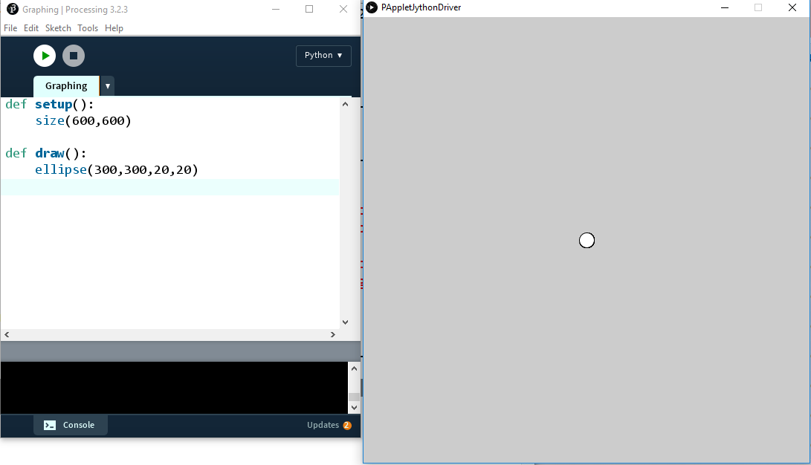
Figure 4-2: Example of a Processing sketch
As you can see, there’s a programming enviroment where you enter code. And a separate display window that shows the visualization of the code. This is a sketch of a simple program that creates a small circle.

Creating Your Own Graphing Tool
Now that you've downloaded Processing, let's use it to create a graphing tool that will allow us to see how many solutions an equation has. First, we'll create a grid of blue lines that look like graphing paper. Then, we'll create the x- and y-axes using black lines.
Setting Graph Dimensions
Before we can make a grid for our graphing tool, we'll need to set the dimensions of the display window. In Processing, you can use the size() function to indicate the width and height of the screen in pixels. The default screen size is 600 pixels by 600 pixels, but for our graphing tool we'll create a graph that includes x- and y- values ranging from -10 to 10.
Open a new file in Processing (make sure you’re in Python mode) and enter the following code in Listing 4-5 to declare the range of x- and y-values we're interested in displaying for our graph:
#grid.pyde

#set the range of x-values
xmin = -10
xmax = 10

#range of y-values
ymin = -10
ymax = 10

#calculate the range
rangex = xmax - xmin
rangey = ymax - ymin

def setup()
size(600,600)
Listing 4-5: Setting the range of x- and y-values for the graph
In Listing 4-5 we create two variables: xmin and xmax for the minimum and maximum x-values in our grid. Then we declare rangex for the x-range and rangey variable for the y-range. We calculate the value of rangex by subtracting xmin from xmax and do the same for the y-values.
Because we don't need a graph that's 600 units by 600 units, we'll need to scale the coordinates down by multiplying the x- or y-coordinates by scale factors. When graphing we'll have to remember to multiply all our x-coordinates and y-coordinates by these scale factors or they won't show up correctly on the screen. To do this, update the existing code in setup() definition with the following lines of code:
def setup()
global xscl, yscl
size(600,600)
xscl = width/rangex
yscl = height/rangey
Listing 4-6: Scaling coordinates using scale factors
First, we declare the global variables xscl and yscl, which we'll use to scale our screen. xscl and yscl stand for the x-scale factor and y-scale factor, respectively. For example, the x-scale factor would be 1 if we want our x-range to be 600 pixels, or the full width of the screen. But if we want our screen to be between -300 and 300, the x-scale factor would be 2, which we get by dividing the width (600) by the rangex (300).
In our case, we can calculate the scale factor by dividing 600 by the x-range, which is 20. So the scale factor has to be 30. From now on, we’ll need to scale up all of our x- and y-coordinates by a factor of 30 so that they show on the screen. The good news is the computer will do all the dividing and scaling for us. We just have to remember to use xscl and yscl when graphing!
Drawing a Grid
Now that we set the proper dimentions for our graph, we can draw grid lines like the ones you see on graphing paper. Add the code in Listing 4-7 to existing code to create the draw() function.
def draw():
global xscl, yscl
background(255) #white
translate(width/2,height/2)
#cyan lines
strokeWeight(1)
stroke(0,255,255)
for i in range(xmin,xmax+1):
line(i*xscl,-10*yscl,i*xscl,10*yscl)
line(-10*xscl,i*yscl, 10*xscl,i*yscl)
Listing 4-7: Creating blue grid lines for the graph
First, we use global xscl, yscl to tell Python we’re not creating new variables but just using the global ones that we already created. Then we set the background color to white using the value 255. We use the translate(width/2,height/2) to move the origin (where x and y are both 0) to the center of the screen. Then we set the thickness of the lines with strokeWeight where 1 is the thinnest. You can make them thicker if you want by using higher numbers. You can also change the color of the lines using stroke. Here, we’re using cyan (“sky blue”) whose RGB value is (0,255,255), which means no red values, maximum green and maximum blue. After that we use a for loop to avoid having to type 40 lines of code to draw 40 blue lines. We want the blue lines to go from xmin to xmax, including xmax because that’s how wide our graph should be.
In Processing, you can draw a line by declaring four numbers: the x- and y- coordinates of the beginning and endpoints of the line. The vertical lines would look something like this:
line(-10,-10, -10,10)
line(-9,-10, -9,10)
line(-8,-10,-8,10)
For example, the first set of coordinates (-10, -10) tells the program where the first line begins and the next set (-10, 10) tells it where the line should end. You should see a pattern here: all the x-values go from -10, -9, -8, and so on while the y values are constant at -10 and 10. They’re all the numbers from xmin to xmax. So we could put that in a for loop like this:
for i in range(xmin,xmax+1):
line(i,-10,i,10)
But because range(x) doesn’t include x (as you learned previously), our for loop needs to go from xmin to xmax + 1 to include xmax.
Similarly, the horizontal lines would go like this:
line(-10,-10,10, -10)
line(-10,-9, 10, -9)
line(-10,-8, 10, -8)
This time, you can see that the y-values are -10, -9, -8 and so on, while the x-values stay constnat at -10 and 10. Let’s add the following line inside our loop:
for i in range(xmin,xmax+1):
line(i,-10,i,10)
line(-10,i,10,i)
If you graphed this right now you would see a tiny splotch in the middle of the screen because the x and y-coordinates go from -10 to 10 but the screen goes from 0 to 600 by default. This is because we haven’t multiplied all our x- and y-coordinates by their scale factor yet! To display the grid properly, update your code as follows:
line(i*xscl,-10*yscl,i*xscl,10*yscl)
line(-10*xscl,i*yscl, 10*xscl,i*yscl)
Now you’re ready to create the x- and y-axes.
Creating the x- and y- Axes
To add the two black lines for the x- and y-axes, we first set the stroke color to black by calling the stroke() function (with 0 being black and as white). Then we draw a vertical line from (0, -10) to (0, 10) and a horizontal line from (-10,0) to (10,0). Don’t forget to multiply the values by their respective scale factors, unless they’re 0 in which case multiplying them wouldn’t change them anyway.
Listing 4-8 shows the complete code for creating the grid:

stroke(0) #black axes
line(0,-10*yscl,0,10*yscl)
line(-10*xscl,0, 10*xscl,0)

When you click Run you should get a nice grid, like in Figure 4-3:
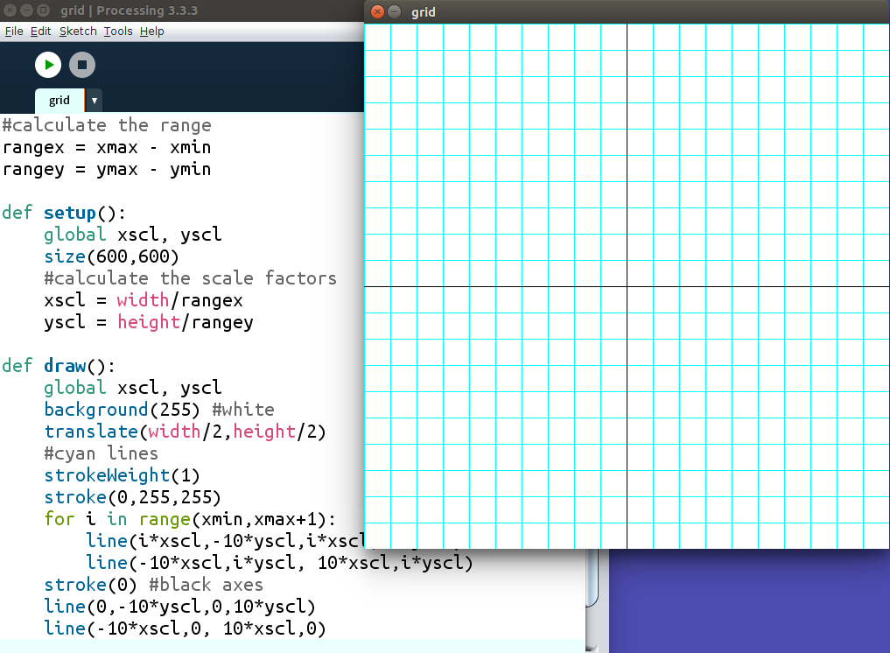
Figure 4-3: Creating a grid for graphing. You only have to do it once!
This looks done, but if we try to put a point (a tiny ellipse, actually) at (3,6), we see a problem:
#test with a circle
fill(0)
ellipse(3*xscl, 6*yscl,10,10)
You'll see an output like in Figure 4-4:
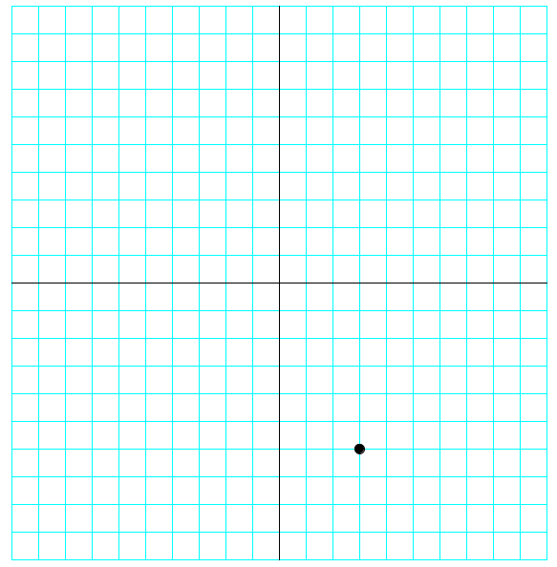
Figure 4-4: Checking our graphing program. Almost there!
As you can see, the point ends up on (3, -6) instead of at (3, 6). Our graph is upside-down! To fix this, we can add a negative sign to the y-scale factor in the setup function to flip it over:
yscl = -height/rangey
Now, you should see the point at the correct location, like in Figure 4-5:
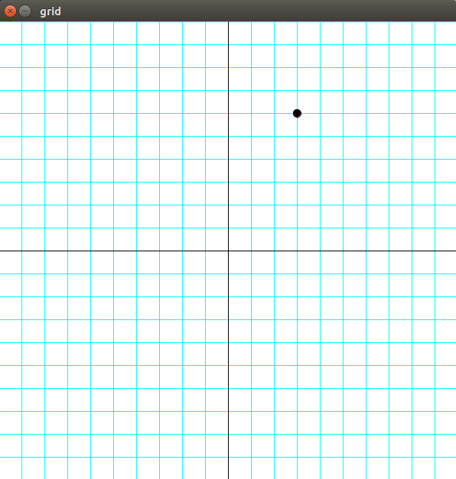
Figure 4-5: The grapher is working properly!
Now that we’ve written the graphing tool, let’s put it into a function so we can reuse it whenever we need to graph an equation.
Writing the grid() function
To keep our code organized, we'll separate all the code that makes the grid into its own functionwhich we’ll call grid(). Then we'll call the grid() function in the draw function. It should look like Listing 4-9:
def draw():
global xscl, yscl
background(255)
translate(width/2,height/2)
grid(xscl,yscl) #draw the grid

def grid(xscl,yscl):
#cyan lines
strokeWeight(1)
stroke(0,255,255)
for i in range(xmin,xmax+1):
line(i*xscl,-10*yscl,i*xscl,10*yscl)
line(-10*xscl,i*yscl, 10*xscl,i*yscl)
stroke(0) #black axes
line(0,-10*yscl,0,10*yscl)
line(-10*xscl,0, 10*xscl,0)
Listing 4-9: ______________
Now we're ready to solve our cubic equation: 6x³ + 31x² + 3x – 10 = 0
Graphing the Equation
We'll add this function after the draw function:
def f(x):
return 6*x**3 + 31*x**2 + 3*x – 10
It defines the function we’re calling f. We’re telling Python what to do with a number x to produce the output of the function.
Next we’ll draw lines from every point to every “next” point, going up a tenth of a unit at a time. Even if our function produces a curve, you probably won’t notice if we’re drawing a straight lines between two points that are really close together. For example, the distance from (2, f(2)) to (2.1, f(2.1)) is tiny, so overall the output will look curved. We’ll define a function to draw a graph of f(x) by starting at xmin and going all the way up to xmax. While the x-value is less than xmax, we’ll draw a line from (x, f(x)) to ((x + 0.1), f(x + 0.1)). We can’t forget to increment x by 0.1 at the end of the loop.
def graphFunction():
x = xmin
while x <= xmax:
stroke(255,0,0) #red function
line(x*xscl,f(x)*yscl,(x+0.1)*xscl,f(x+0.1)*yscl)
x += 0.1
Finally, call the “graphFunction” function in draw and you'll see the output in Figure 4.8:
def draw():
global xscl, yscl
background(255) #white
translate(width/2,height/2)
grid(xscl,yscl)
graphFunction()
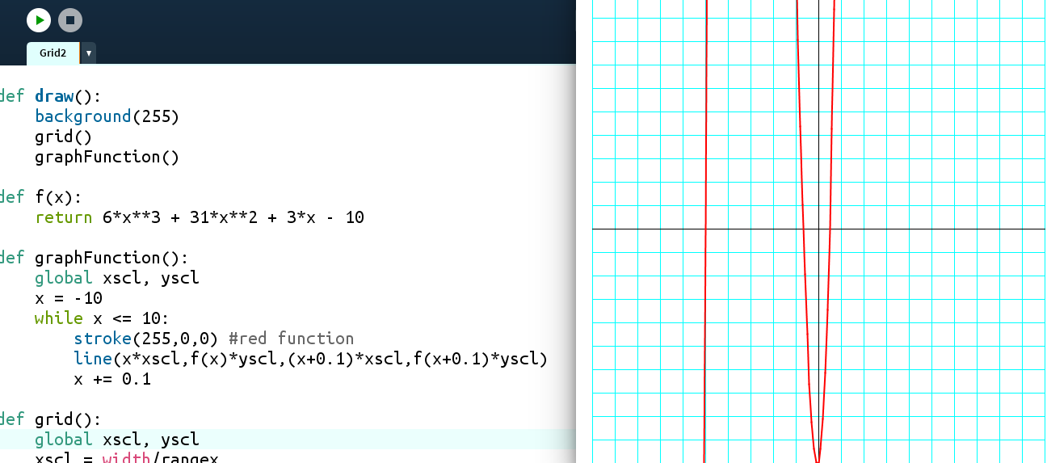
Figure 4-6: Graphing a polynomial function
The solutions (called the “roots”) of the equation are where the graph crosses the x-axis. We can see three places: one where x = -5, another where x is between -1 and 0, and a third where x is between 0 and 1.

Using Guess and Check to Find the Roots
We already saw how effective our guess and check method was in Chapter 3. Now we can use it to approximate the roots, or solutions, for this equation. Let's start with the root between 0 and 1. Is it 0.5 or something else? To test this, we can easily plug 0.5 into the equation. Enter the following in IDLE for this.
def f(x):
return 6*x**3 + 31*x**2 + 3*x – 10

>>> f(0.5)
0.0
As you can see, x = 0.5 makes the function 0, so another solution of our equation is 0.5. Next, let’s try the root between -1 and 0. We’ll try the average of -1 and 0 to start:
>>> f(-0.5)
-4.5
At x = -0.5, the function is negative, not zero. Looking at the graph, we can tell we guessed too high, so the root must be somewhere between -1 and -0.5. We'll average those endpoints and try again:
>>> f(-0.75)
2.65625
We get a positive number, so we guessed too low: the solution must be between -0.75 and -0.5.
>>> f(-0.625)
-1.23046875
Still too high. This is getting a bit tedious. Let’s see how we might use Python to do these steps for us.
Writing the halving() Function
Let’s create a function that will find the roots of an equation by averaging the lower and upper values and adjusting its next guesses accordingly. Listing 4-10 shows the complete code for this function:

'''The halving method'''
def f(x):
return 6*x**3 + 31*x**2 + 3*x - 10

def average(a,b):
return (a + b)/2.0

def halving():
lower = -1
upper = 0
for i in range(20):
midpt = average(lower,upper)
if f(midpt) == 0:
return midpt
elif f(midpt) < 0:
upper = midpt
else:
lower = midpt
return midpt

x = halving()

print(x, f(x))
Listing 4-10: _____________
First, we declare the function we’re looking for the equation we’re trying to solve using f(x). Then we create the average() function to find the average of two numbers, which we’ll be using at every step. Finally, we write a halving() function that start with a lower limit of -1 and and upper limit of 0, since that’s where our graph crossed the x-axis.
We then use for i in range(20): to create a loop that “halves” the range 20 times. Our guess will be the average, or midpoint, of the upper and lower limits. We’ll put that midpoint into our f(x) and if the output equals 0, we’ll know that’s our root. If the output is negative, we’ll know we guessed too high. Then the midpoint will replace our upper limit and we’ll take another guess. Otherwise, if we guessed too low, the midpoint will become our lower limit and we’ll guess again.
If we haven’t returned the solution in 20 guesses we’ll return the latest midpoint and the function of that midpoint.
When we run this you should get two values as the output:
-0.6666669845581055 9.642708896251406e-06
The first output is the x value, which is around around -2/3. The second output iswhat f(x) evaluates to when we plug in -2/3 as the x value. The e-06 at the end means scientific notation. It means you take 9.64 and move the decimal place to the left 6 places. So f(x) evaluates to 0.00000964, which is very close to zero.
If we increase the number of iterations from 20 to 40, we'll get a number even closer to 0:
-0.6666666666669698 9.196199357575097e-12
Let's check f(-0.6666666666669698):
>>> f(-2/3)
0.0
This checks out, so the three solutions to 6x³ + 31x² + 3x – 10 = 0 are x = -5, -2/3 and ½.
Exercise 4-3: Finding More Roots
Use the graphing tool you just created to find the roots of 2x² + 7x – 15 = 0. Remember, the roots are where the graph crosses the x-axis, or where the function equals 0.
Summary
All we have to do to solve an equation, no matter how complicated, graph it and approximate where it crosses the x-axis. By iterating and “halving” the range of values that work, we can get as accurate as we want. Later in this book when we use a Calculus trick called the derivative, we'll have another method to solve equations like this. And when we learn to use lists of lists, called arrays or matrices, we'll learn how to solve systems of equations, too!
In the next chapter, you’ll….

Linear Functions
In math we often need to be able to deal with functions like y = 2x + 5, which are called “linear functions,” because when you graph them, they make a straight line. The slope, or direction, from one point to the next is always the same in a line. The formula is
slope = rise / run
which means we calculate the slope of a line by dividing the vertical change between two points by the horizontal change between the same two points.. The slope is usually represented by the letter m
Exercise 3.6: Rising and Running
Write a program to find the slope of the line between two points. You should be able to enter any two points and it should return the slope as a number, like this:
>>> slope((1,2),(5,6))
1.0
>>> pt1 = (-2,5)
>>> pt2 = (10,-4)
>>> slope(pt1,pt2)
-0.75
Solution:
Using the points above, (1,2) and (5,6), you calculate the slope by dividing the rise by the run. We find the rise by subtracting the y-values: 6 – 2 = 4. If in Python we’re using lists a and b to represent those points, then it’s the second element in b minus the second element in a, or b[1] – a[1]. Remember, the first element in b would be b[0].
Then we find the run by subtracting the x-values in the same order as the y-values. So the run would be b[0] – a[0]. Finally we return the rise divided by the run.
def slope(a,b):
'''Returns the slope of the line
between points a and b'''
#find the difference between the
#y-values:
rise = a[1] - b[1]
#the difference between the
#x-values:
run = a[0] - b[0]
return rise/run

Exercise 3.7: A Tale of Two Points:
Remember the equation of a line is y = mx + b, where m is the slope and b is the y-intercept, where the graphed line crosses the vertical y-axis. Write a function (you can use your slope function!) that will return the slope and y-intercept of a line between two given points. It should return values like this:
>>> line2pts((1,2),(5,6))
(1.0, 1.0)
>>> pt1 = (-2,5)
>>> pt2 = (10,-4)
>>> line2pts(pt1,pt2)
(-0.75, 3.5)
Solution:
It's not so hard to solve y = mx + b for b, the y-intercept of the line:
b = y – mx
y is the second element in one of the points, and x is the first element in the point list. The slope is the output of the slope function we just wrote. So we only have to plug y, m and x into the equation above to find the y-intercept, b:
def line2pts(a,b):
'''Returns the slope and y-intercept
of the line between points a and b'''
#find the slope:
rise = a[1] - b[1]
run = a[0] - b[0]
slope = rise/run
#y-intercept: b = y - mx
yint = a[1] - slope*a[0]
return slope, yint
Exercise 3.8: Making connections
Write a program that will find the intersection point of two lines, given their slope and y-intercept. For example, if I want the intersection of the lines y = 2x + 5 and y = -3x – 10, I can just enter the numbers like this:
>>> intersection([2,5],[-3,-10])
(-3.0, -1.0)
Solution
If the y-value of the intersection point has to work in both equations y = 2x + 5 and y = -3x – 10, then the right sides must be equal:
2x + 5 = -3x – 10
But we can easily solve that with our “equation” function from earlier in this chapter! Use that to solve for the x-value of the intersection, then plug x into either line to find the y-value:
def intersection(line1, line2):
'''returns the intersection point of two
lines, given their slopes and y-intercepts'''
#find the x-value of the intersection
x = equation(line1[0],line1[1],line2[0],line2[1])
#find the y-value by plugging it in to either line
y = line1[0]*x + line1[1]
return x,y
To check, the graph of the lines and their intersection is in Figure 4.13:
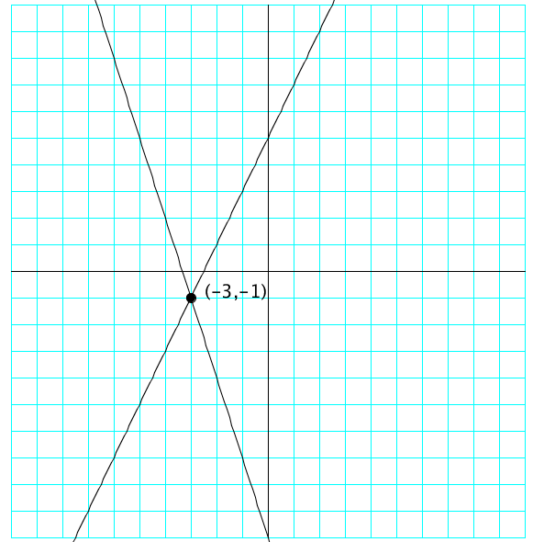
Figure 3-10: The intersection of two lines.
Interactive Lines
Let’s use the mouse to make a number change in a line. We’ll use the graphing program we made earlier but use the mouse location to change the slope and y-intercept. There’s nothing else you can change in a line, is there?
Change f(x) to the general form of a line f(x) = m*x + b:
def f(x,m,b):
return m*x + b
In the draw function, just before graphing the function, create a slope function to be the mouse’s x-coordinate, and the y-intercept to be the mouse’s y-intercept.
def draw():
global xscl, yscl
background(255) #white
translate(width/2,height/2)
grid(xscl,yscl)
m = mouseX
b = mouseY
graphFunction(m,b)
And we’ll have to change the graphFunction function to this:
def graphFunction(m,b):
x = xmin
while x <= xmax:
stroke(255,0,0) #red function
line(x*xscl,f(x,m,b)*yscl,(x+0.1)*xscl,f(x+0.1,m,b)*yscl)
x += 0.1
But when you run this it doesn’t change the slope or y-intercept very dynamically. That’s because they’re taking the value of the mouse’s x- and y-coordinates, which go from 0 to 600. We’d like our slope and y-intercept to go from, for example, -10 to 10. We could use xscl and yscl but there’s a function in Processing which allows us to map a variable from one range to another. It’ll make it easier to see the slope and y-intercept.
We have to tell Processing which variable we’re mapping, in this case mouseX or mouseY. Then we tell it the old range, in this case 0 to 600, and then the new range: -10 to 10. This is how it should look:
m = map(mouseX, 0, 600, -10,10)
b = map(mouseY, 0, 600, 10,-10)
Now you can run this, move the mouse around and see the slope and y-intercept of the line change dynamically!
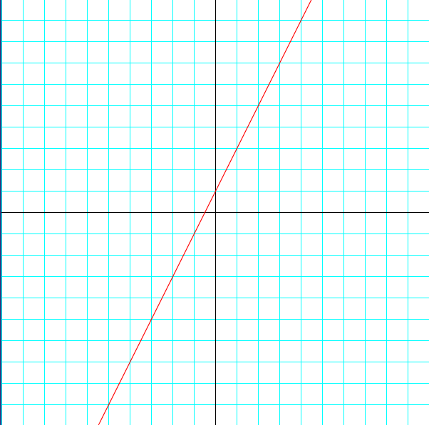
Figure 3-11 Our dynamic line!
Adding Text
Finally, let’s add some text to our sketch so we can display the exact equation of the line and update it as we move the mouse around. To add text, all you have to do is use Processing’s “text” function in the draw function. You tell it what to write, and where to write it. So you need a string, an x-coordinate and a y-coordinate.
grid(xscl,yscl)
m=map(mouseX, 0, 600, -10,10)
b=map(mouseY, 0, 600, 10,-10)
graphFunction(m,b)
fill(0)#black text
textSize(48)
text("Hello!",-250,-250)
That’ll look like this:
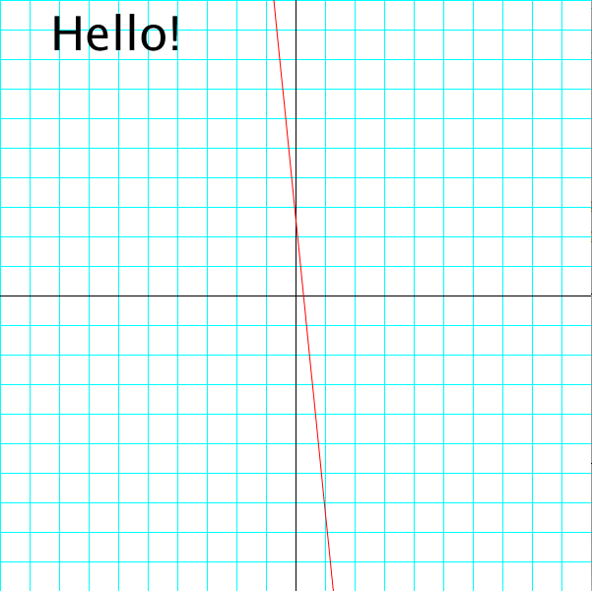
Figure 3-12: Writing text on our screen
We’ll just replace the string “Hello” with the string of values for the equation of our line. We can write “y = mx + b” but we need to replace m and b with their values. Processing wants the text to be a string, so we have to convert our numbers m and b to strings. But if you ran this code you’d get some long decimals:
text("y="+str(m)+"x+"+str(b),-250,-250)
So we’ll use the Python code for rounding numbers. There’s a function called “round” and you tell it how many decimal places you want:
>>> number = 0.123456789
>>> round(number,1)
0.1
>>> round(number,4)
0.1235
So our text function can look like this so we’ll only get 1 decimal place:
text("y="+str(round(m,1))+"x+"+str(round(b,1)),-250,-250)
Now we can see the equation of all the lines we make!
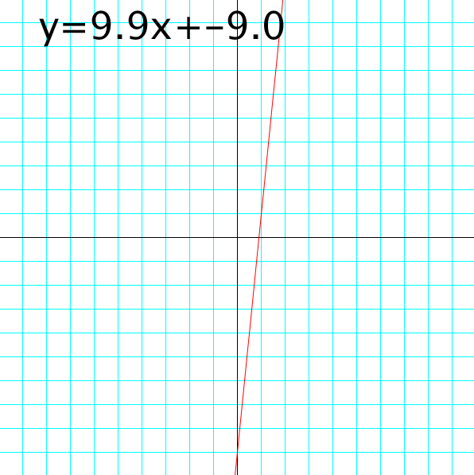
Figure 3-13: The equation of the line

