10 [ChapterStart]
Fractals
Fractals are delightfully complicated designs, each part of which contains the whole. There's a picture of a fractal in every math book these days, but textbooks never show you how to make one, because to do that you need a computer. You're going to learn how to make a bunch of fractals in this chapter, and with the tools you learn, you'll be able to make your own!
It all starts with defining a simple function, and then you add a call to the function inside the function itself! It sounds like it shouldn't work, but it does. Let's make a fractal tree, like this one:
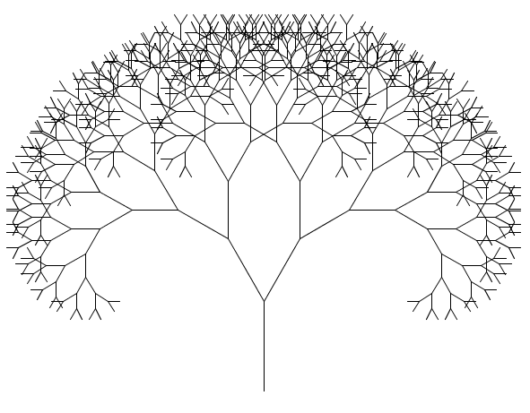
Exercise 10.1: Seek the Y
Using translations, rotations and the line function, draw a Y in Processing, like this one:
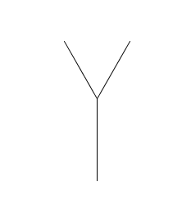
Solution:
Your Y doesn't have to be perfect or symmetrical but here's my Y:
def y(sz):
line(0,0,0,-sz)
translate(0,-sz)
rotate(radians(30))
line(0,0,0,-0.8*sz) #right branch
rotate(radians(-60))
line(0,0,0,-0.8*sz) #left branch
rotate(radians(30))
translate(0,sz)
My draw function looks like this:
def draw():
background(255)
translate(width/2,height-50)
y(100)
We can make this into a fractal by making the “branches” into smaller Y's. But if you simply replace “line” with “y” your program will get stuck in an infinite loop:
RuntimeError: maximum recursion depth exceeded
We have to introduce a “level” parameter to the y function. Then each branch up the tree will be a level down, so they'll get the parameter “level – 1.” Here's how to change the y function:
def y(sz,level):
if level > 0:
line(0,0,0,-sz)
translate(0,-sz)
rotate(radians(30))
y(0.8*sz,level-1)
rotate(radians(-60))
y(0.8*sz,level-1)
rotate(radians(30))
translate(0,sz)
Now if you run “y(100,2)” you'll get a tree with two levels. Try a three-level tree, and a four-level one, and so on!
Map the Mouse
We can vary the shape of our tree by linking the angle we rotated to the x-coordinate of the mouse. The angle should only go up to 180, but the mouse can go up to 600. We could do a little math or we could use Processing's built-in “map” function. You say what variable you're going to map, its minimum and maximum values, and the desired minimum and maximum values. For the angle, it should look like this:
angle = map(mouseX,0,width,0,180)
rotate(radians(angle))
y(0.8*sz,level-1)
rotate(radians(-2*angle))
y(0.8*sz,level-1)
rotate(radians(angle))
Now you can change how much the branches rotate just by moving the mouse left or right:
