Hey Peter, here are some general global points I wanted to draw your attention to. You'll see examples where we've done this throughout:
Always talk through code, even if it's a couple of lines. Pay special attention to any new code
Introduce a new piece of code, let the readers know what we are about to do. That will give them context when they are reading through.
Any new code needs to be in text rather than in screenshots only – that helps a reader know it's an integral part of the book, among other things
Separate output from the program --- much less confusing, and also interesting to see

4
“Mathematics may be defined as the subject in which we never know what we are talking about, nor whether what we are saying is true.”
- Bertrand Russell
Algebra: Transforming and Storing Numbers
Algebra is often introduced in school as the idea of replacing numbers with letters. For example, instead of using 2·3 you might use 2x where x is a placeholder that can be any number, meaning “2 times some unknown number.” It’s just like variables, which we've already used to replace numbers we can change the value of: it's a vital tool in programming.
In traditional math class, variables are often used to represent a mystery number that a student is required to find. Figure 4.1 shows a student's cheeky response to the problem, “Find x”:
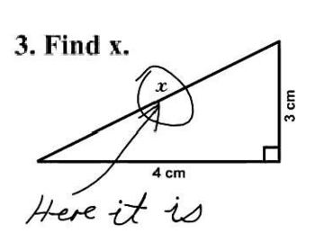
Figure 3-1: Locating the x variable instead of solving for its value.
As you can see, the student has located the variable x in the diagram instead of solving for its possible value. Often in algebra, students are given an equation with an unknown element (or two or three…) and are tasked with finding out what number or numbers will make the equation true, like this:
Solve 2x + 5 = 13.
In this context, solve means to find out which number, when you replace x with that number, makes both sides of the equation equal. Equations of this form may not take too much effort to solve, but even at this level we can use Python and the brute force method to plug in random numbers and find the right one.
Brute Forcing an Algebra Equation
So we’re trying to find a number x that, when you multiply it by 2 and add 5, you get 13. I’ll make a guess that it’s somewhere between -100 and 100. So we'll write a program that plugs all the integers between -100 and 100 in to the above equation, checks the output and prints out the number that makes the equation true.

def plug():
u x = -100 #start at -100
while x < 100: #go up to 100
v if 2*x + 5 == 13: #if it makes the equation true
print("x =",x) #print it out
w x += 1 #make x go up by 1 to test the next number

plug() #run the plug function
Listing 3-1: Brute force program that plugs in numbers to see which satisfies the equation
Here we define the function as plug() and initialize the x variable at -100 u On the next line we start a while loop that will keep repeating until x equals 100. On line v we multiply whatever x is by 2 and add 5. If the output equals 13, it prints out the number. On line w we “increment” x by 1 which means we make it go up by 1. It starts the loop over. The last line makes the program run the plug function. If you don’t include that line it won’t do anything! The output should be something like this:
x = 4
This is a perfectly valid way to solve this problem if you don't know how to balance equations! The trial and error method of plugging in all those digits by hand is too laborious, but using a computer it's a cinch. If you suspect the solution won't be an integer, you might have to increment by smaller numbers by changing the line at w to x += .25 or some other decimal.
Solving First-degree Equations
Another way to solve an equation like 2x + 5 = 13 is to find a general formula for the type of equation. We can then use this formula to write a program in Python. The equation 2x + 5 = 13 is an example of a first-degree equation, because the highest exponent a variable has is 1. And a number to the 1 power is just the number itself.All first degree equations fit into this general pattern:
ax + b = cx + d
where a, b, c and d are numbers. Like these ones
3x - 5 = 22
4x - 12 = 2x - 9

In each equation, you usually have an x-term and a constant (a number with no x) on each side of the equals sign.Sometimes there's no x term on one side, so the coefficient of x is zero. You can see this in the first example, 3x - 5 = 22, where 22 is the only term on the right side of the equal sign. In the general formula, a is represented by 3, b by -5, c by 0 and d by 22. In the second example, a = 4, b = -12, c = 2 and d = -9.
Using a little algebra, you can solve ax + b = cx + d for x, which means you can solve virtually all equations of this form.
To solve this equation we first get all the x's on one side of the equals sign by subtracting cx and b from both sides of the equation:
ax - cx = d - b
Now factor out the x from ax and cx:
x(a - c) = d - b
Finally, divide both sides by a – c to isolate x, which gives you the value of x in terms of a, b, c, and d.

This is the general equation you can use to solve for any variable x when the equation is a first-degree equation and all four numbers (a, b, c and d) are known. Now let's write this into a Python program that can solve algebraic equations of thos form for us.
Using Coefficients to Solve for x
We'll write a program that will take the four coefficients of the general equation above and print out the solution for x. Open a new Python file in IDLE and create a new blank file. Save it as “algebra.py.” We’re going to write a function that will take the four numbers a, b, c and d as parameters and plug them into the solution above:def equation(a,b,c,d):
'''solves equations of the
form ax + b = cx + d'''
return (d - b)/(a - c)
Listing 3-2: Using coefficients to solve for x
We had to do a little algebra to find the general solution above, then we wrote a Python function to transform the numbers a, b, c and d into the solution to that family of equations. Does it work? Let's test it with an equation we've solved already:
>>> equation(2,5,0,13)
4.0
It works!, We get 4 as the solution for the equation..
Exercise 3.1: X-Games
Solve 12x + 18 = -34x + 67 using the program you wrote in Listing 3-2.

Solution:
In Listing 3-2, we didn't use print to display our results, but used return instead. The return term gives us our result as a number that we can assign to a variable and then use again. If we had used print instead we could only print out the solution once:
def equation(a,b,c,d):
'''solves equations of the
form ax + b = cx + d'''
print((d - b)/(a – c))

>>> x = equation(2,5,0,13)
4.0
>>> print(x)
None
Yes, it gave us the answer once, but it didn’t save it. There are many times in programming where you want the program to just save the output of a function and apply it elsewhere. Like this next example. (Make sure your “equation” code uses return.)
Let's reuse the equation 12x + 18 = -34x + 67 from Exercise 3.1 and assign the result to the x variable, as shown here:
>>> x = equation(12,18,-34,67)
>>> x
1.065217391304348
Here, we pass the coefficients and constants of our equation to the equation() function so it calculates x for us, and assigns the result to the variable x. Then we can see the value of x by simply entering it.Now that the variable x stores the solution, let's plug it back into the equation to check that it's the correct answer. Enter the following to find out what 12x + 18, the left side of the equation, evaluates to:
>>> 12*x + 18
30.782608695652176
We get 30.782608695652176. Now enter the following to do the same for -34x + 67, the right side of the equation:
>>> -34*x + 67
30.782608695652172
Despite a slight rounding discrepancy at the 15th decimal place, you can see that both sides of the equation evaluates to around 30.782608. So we can be confident that 1.065217391304348 is the correct solution for x! Good thing we returned the solution and saved the value instead of just printing it out once. You wouldn’t have wanted to type in “1.065217391304348” again and again, would you?
Solving Higher Degree Equations
Things get a little more complicated when an equation has a term raised to the second degree, like x² + 3x – 10 = 0. Equations of this form are called quadratic equations and have a general format that looks like this: ax² + bx + c = 0. a, b and c can be any number (well, a can’t be 0 or you’d be back to a first degree equation), positive or negative, whole numbers, fractions or decimals. But they can all be expressed in that form. To solve an equation with a squared term, you can use the Quadratic Formula:.
The Quadratic Formula is a very powerful tool for solving equations. No matter what a, b and c are in ax² + bx + c = 0, you just plug them in to the Formula and do the arithmetic to find your solutions. Like x² + 3x – 10 = 0. a = 1, b = 3 and c = -10. Plugging those in to the Quadratic Formula, we get

Which simplifies to

There are two solutions, one for which is 4/2 or 2
The other is which is -10/2 or -5.
Both of those numbers, when you replace x with them, make the original formula true:
(2)² + 3(2) – 10 = 4 + 6 – 10 = 0
(-5)² + 3(-5) – 10 = 25 – 15 – 10 = 0
Exercise 4.3: Working on our Quads
Write a function that will take the three numbers (a, b and c), from a quadratic equation ax² + bx + c = 0 and return the two solutions to the quadratic formula. Use it to solve 2x² + 7x – 15 = 0.Solution:We'll call the function quad(). Before we do anything, we'll need to import the sqrt method from the math module. The sqrt method allows you to find the square root of a number, just like a square root button on a calculator. It works great for positive numbers, but if you try finding the square root of a negative number this is what you’ll see:
>>> from math import sqrt
>>> sqrt(-4)
Traceback (most recent call last):
File "<pyshell#11>", line 1, in <module>
sqrt(-4)
ValueError: math domain error
Open a new Python file in IDLE and add the following line to the top of your file to import sqrt from math:
from math import sqrt
Then enter the following to create the quad() function:
def quad(a,b,c):
'''Returns the solutions of an equation
of the form a*x**2 + b*x + c = 0'''
x1 = (-b + sqrt(b**2 - 4*a*c))/(2*a)
x2 = (-b - sqrt(b**2 - 4*a*c))/(2*a)
return x1,x2
Listing 3-3: Using the quadratic equation to solve an equation
The quad() function takes the numbers a, b and c as parameters and plugs them in to the Quadratic Formula. x1 is the solution when we’re adding and x2 is the solution when we’re subtracting
Now, let's test this program using the equation 2x² + 7x – 15 = 0 . Plugging in the numbers 2, 7 and -15 for a, b, and c should return the following output:
>>> quad(2,7,-15)
(1.5, -5.0)
The two solutions for x are 1.5 and -5, which means both values should satisfy the equation 2x² + 7x – 15 = 0 . To test this, we check the answers by replacing all the x's in the original equation 2x² + 7x – 15 = 0 with 1.5, the first solution, and then with -5, the second solution, as shown here:
>>> 2*1.5**2 + 7*1.5 - 15
0.0
>>> 2*(-5)**2 + 7*(-5) - 15
0
Yes! Both values work in the original equation. You can use your “equation” and “quad” functions anytime in the future. Now that you’ve learned to write functions to solve first-degree and second-degree equations, let’s learn how to solve even higher degree equations!
Solving Higher Degree Equations with Visualizations
In algebra class students are often asked to solve a cubic equation like 6x³ + 31x² + 3x – 10 = 0, which has a term raised to the third degree. We can use the plug() function we made in Listing 3-1 to look for solutions manually. Enter the following into IDLE to see this in action:
def g(x):
return 6*x**3 + 31*x**2 + 3*x – 10

def plug():
x = -100
while x < 100:
if g(x) == 0:
print("x =",x)
x += 1
print("done.")
Listing 3-4: Using plug() to solve a cubic polynomial
First, we define g(x) to be a function that evaluates the expression 6*x**3 + 31*x**2 + 3*x – 10. Then we tell the program to plug all numbers between -100 and 100 into g(x) we defined initially. If the program finds a number that makes g(x) equal zero, it prints it for the user.
When you call plug() you should see the following output:
>>> plug()
x = -5
done.
That gives you -5 as the solution, but as you might suspect from the term x³, there could be as many as three possible solutions to this equation. Fortunately, there's a way to see all the possible inputs and corresponding outputs of a function; it's called graphing.
In the next section, you'll build a graph using a nifty tool called Processing to make visualizations that will help you solve higher degree polynomials.
Downloading and Setting up Processing
The basic setup of a Processing sketch in Python mode is shown in Figure 4.2:
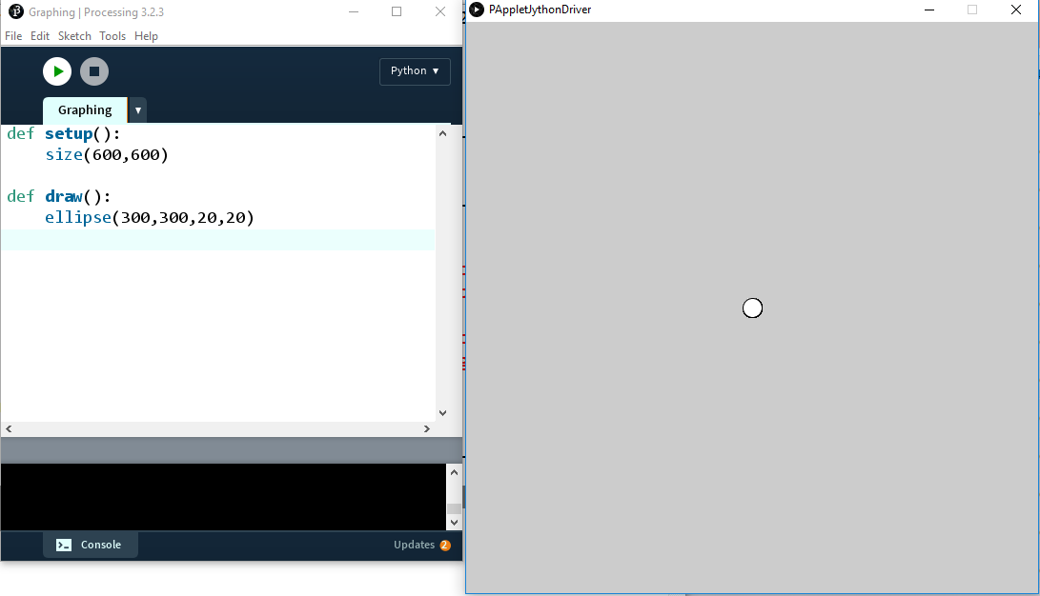
Figure 3-2:
Surprisingly, computer graphics usually have their “origin” in the top left corner of the screen and the y-coordinates get larger as they go down the screen, not up, like in Figure 4.3:
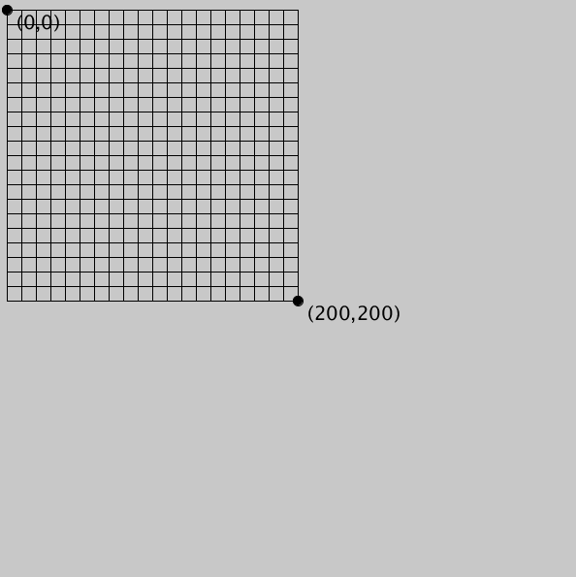
Figure 4.3
To move the origin to the center of the screen, we use the “translate” function, like this:
translate(width/2, height/2)
Now the origin will be in the middle of the screen. Figure 4.4 shows you what the grid looks like after translating the origin to the middle of the screen:
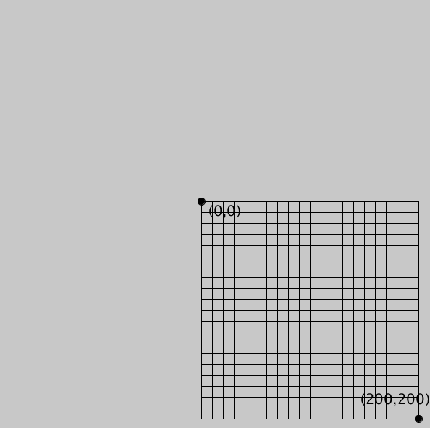
Figure 4.4
Creating Your Own Graphing Tool
Now that you've downloaded Processing, let's use it to create a graphing tool that will allow us to see how many solutions an equation has. First, we'll create a grid of blue lines that will look like graph paper. Then, we'll create the x- and y-axes using black lines.
Setting Graph Dimensions
Before we can make a grid for our graphing tool, we'll need to set the dimensions of the display window. In Processing, you can use the size() function to indicate the width and height of the screen in pixels. The default screen is 600 pixels by 600 pixels, but for our graphing tool we'll create a graph that includes x- and y- values ranging from -10 to 10. Open a new file in Processing and enter the following code to declare the range of x- and y-values we're interested in displaying for our graph:
#grid.pyde

#set the range of x-values
xmin = -10
xmax = 10

#range of y-values
ymin = -10
ymax = 10

#calculate the range
rangex = xmax - xmin
rangey = ymax - ymin

def setup()
size(600,600)
Listing 3-5: Setting the range of x- and y-values for the graph
In Listing 3-5 we can create two variables: xmin and xmax for the minimum and maximum x-values in our grid. Then we declare rangex for the x-range and rangey variable for the y-range. We calculate rangex by subtracting the xmin from the xmax and do the same for the y-values.
Because we don't need a graph that's 600 units by 600 units, we'll need to scale the coordinates down by multiplying the x- or y-coordinates by scale factors. When graphing we'll have to remember to multiply all our x-coordinates and y-coordinates by these scale factors or they won't show up correctly on the screen. To do this, add the following lines of code below
def setup()
global xscl, yscl
size(600,600)
xscl = width/rangex
yscl = height/rangey

Listing 3-6: Scaling coordinates using scale factors
First, we create a setup() function and declare global variables xscl and yscl, which we'll use to scale our screen. xscl and yscl stand for the x-scale factor and y-scale factor, respectively. For example, the x-scale factor would be 1 if we want our x-range to be 600 pixels, or the full width of the screen. But if we want our screen to be between -300 and 300, the x-scale factor would be 2, which we get by dividing the width (600) by the x-range (300). In our case, the scale factor would be 600 divided by the x-range, which is 20. So the scale factor is 30. All our x- and y-coordinates will have to be scaled up by a factor of 30 to be able to see them on the screen. The good news is the computer will do all the dividing and scaling for us from now on. We just have to remember to use the xscl and yscl when graphing!
Drawing a Grid
Now we'll draw in lines for the grid like on a graph paper. All the drawing will go in a draw() function, the infinite loop.
def draw():
global xscl, yscl
background(255) #white
translate(width/2,height/2)
#cyan lines
strokeWeight(1)
stroke(0,255,255)
for i in range(xmin,xmax+1):
line(i*xscl,-10*yscl,i*xscl,10*yscl)
line(-10*xscl,i*yscl, 10*xscl,i*yscl)
Listing 3-7: Creating blue grid lines for the graph
First we have to tell Python we’re not creating new variables called xscl and yscl, we want to use the global ones that were already created. Then we set the background color to white using the value 255. Translate means slide, and we move the origin (where x and y are both 0) to the center of the screen using translate(width/2,height/2). “strokeWeight” is the thickness of the lines and 1 is the thinnest. You can make them thicker if you want by using higher numbers. “Stroke” means the color of the lines, and for cyan (“sky blue”) the RGB value is (0,255,255), meaning no red, maximum green and maximum blue.
After that we use a for loop to save us having to type 40 lines of code to draw 40 blue lines. We want the blue lines to go from xmin to xmax, including xmax. But remember, we saw “range(4)” contains 4 numbers, not including 4:
>>> for i in range(4):
print(i)
0
1
2
3
In order for us to get from 1 to 4 we have to “start” at 1 and “stop” at 5:
>>> for i in range(1,5):
print(i)
1
2
3
4
So our for loop goes from xmin to xmax + 1 to include xmax.
The “line” code might be hard to figure out at first. In Processing, you draw a line by declaring its endpoints, so you need 4 numbers: the x and y of the beginning of the line and the x and y of the end. Written out, the vertical lines would be
line(-10,-10, -10,10)
line(-9,-10, -9,10)
line(-8,-10,-8,10)
and so on. See a pattern? The x-values go from xmin to xmax. So we could put that in a for loop like this:
for i in range(xmin,xmax+1):
line(i,-10,i,10)
Similarly, the horizontal lines would go like this:
line(-10,-10,10, -10)
line(-10,-9, 10, -9)
line(-10,-8, 10, -8)
and so on. We could just add another line inside our loop:
for i in range(xmin,xmax+1):
line(i,-10,i,10)
line(-10,i,10,i)
If you graphed this right now you might see a tiny splotch in the middle of the screen (or you might not!) because the x and y-coordinates go from -10 to 10 but the screen goes from 0 to 600. We need to multiply all our x- and y-coordinates by their scale factor in order for them to display properly. That’s why the lines are
line(i*xscl,-10*yscl,i*xscl,10*yscl)
line(-10*xscl,i*yscl, 10*xscl,i*yscl)
Now we'll create the axes
Exercise : I Walk The Line
Now add the two black lines for the x- and y-axes.
Solution:
First we set the stroke color to black by calling the stroke() function, with 0 being black (255 would be white). Then we draw a vertical line from the point (0, -10) to the point(0, 10) and a horizontal line from (-10,0) to (10,0). Don’t forget to multiply the values by their respective scale factors, unless they’re 0, in which case, multiplying them wouldn’t change them anyway.
stroke(0) #black axes
line(0,-10*yscl,0,10*yscl)
line(-10*xscl,0, 10*xscl,0)
The above code gives us a nice grid, like in Figure 4.5:
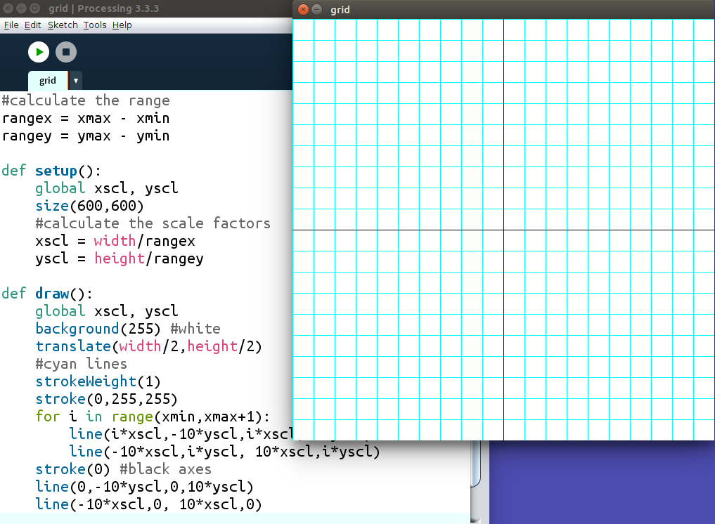
Figure 4.5: Creating a grid for graphing. You only have to do it once!
This looks done, but if we try to put a point, an ellipse actually, at (3,6), we see a problem:
#test with a circle
fill(0)
ellipse(3*xscl, 6*yscl,10,10)
You'll see what's in Figure 4.6:
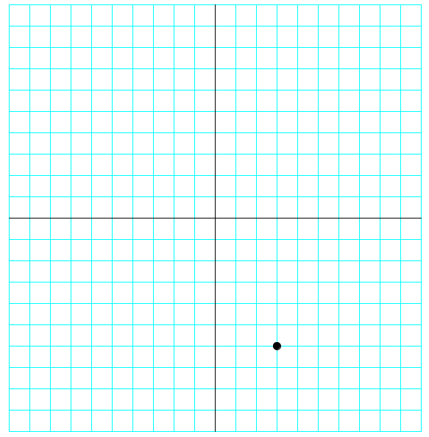
Figure 4.6: Checking our graphing program. Almost there!
The y-coordinates go up as we go down the screen, so our graph is upside-down. We can add a negative sign to the y-scale factor in the setup function to flip that over:
yscl = -height/rangey
This flips the output to how we want it , like in Figure 4.7:
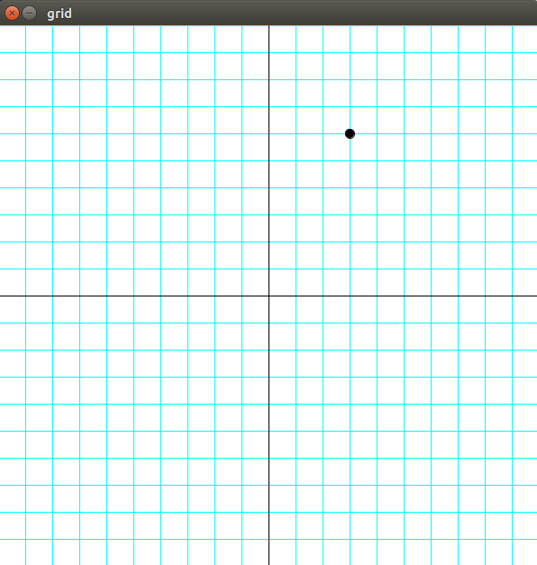
Figure 4.7: The grapher is working!
The grid function
To keep our code organized, we'll separate all the code that makes the grid into its own function and call it “grid.” Then we'll call the “grid” function in the draw function. It should look like this:
def draw():
global xscl, yscl
background(255)
translate(width/2,height/2)
grid(xscl,yscl) #draw the grid

def grid(xscl,yscl):
#cyan lines
strokeWeight(1)
stroke(0,255,255)
for i in range(xmin,xmax+1):
line(i*xscl,-10*yscl,i*xscl,10*yscl)
line(-10*xscl,i*yscl, 10*xscl,i*yscl)
stroke(0) #black axes
line(0,-10*yscl,0,10*yscl)
line(-10*xscl,0, 10*xscl,0)
Now we're ready to solve our cubic equation:
6x³ + 31x² + 3x – 10 = 0
We'll add this function after the draw function:
def f(x):
return 6*x**3 + 31*x**2 + 3*x – 10
It defines the function we’re calling f. We’re telling Python what to do with a number x to produce the output of the function.
Next we’ll draw lines from every point to every “next” point, going up a tenth of a unit at a time. Even if our function produces a curve, you probably won’t notice if we’re drawing a straight lines between two points that are really close together. For example, the distance from (2, f(2)) to (2.1, f(2.1)) is tiny, so overall the output will look curved. We’ll define a function to draw a graph of f(x) by starting at xmin and going all the way up to xmax. While the x-value is less than xmax, we’ll draw a line from (x, f(x)) to ((x + 0.1), f(x + 0.1)). We can’t forget to increment x by 0.1 at the end of the loop.
def graphFunction():
x = xmin
while x <= xmax:
stroke(255,0,0) #red function
line(x*xscl,f(x)*yscl,(x+0.1)*xscl,f(x+0.1)*yscl)
x += 0.1
Finally, call the “graphFunction” function in draw and you'll see the output in Figure 4.8:
def draw():
global xscl, yscl
background(255) #white
translate(width/2,height/2)
grid(xscl,yscl)
graphFunction()
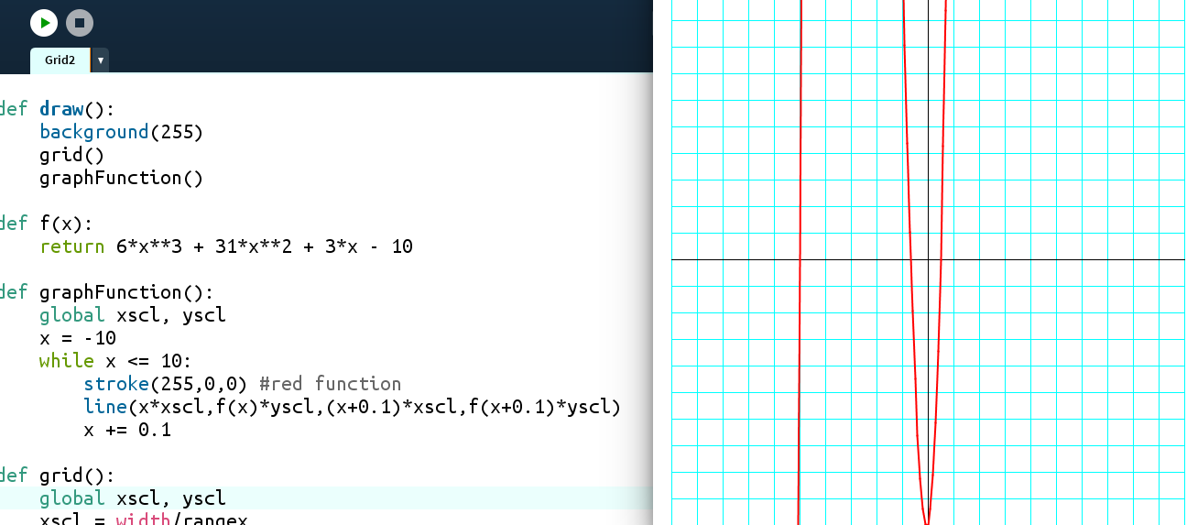
Figure 4.8: Graphing a polynomial function
The solutions (called the “roots”) of the equation are where the graph crosses the x-axis. We can see three places: one where x = -5, another where x is between -1 and 0, and a third where x is between 0 and 1.
The Halving Method
We already saw how effective our “Halving Method” was in the last chapter. Now we can use that method to approximate the roots. Let's start with the root between 0 and 1. Is it 0.5? We can easily plug in 0.5 and see. We'll move to IDLE for this.
def f(x):
return 6*x**3 + 31*x**2 + 3*x – 10

>>> f(0.5)
0.0
Yes! x = 0.5 makes the function 0, so another solution of our equation is 0.5. Finally, we'll try the root between -1 and 0. We’ll try the average of -1 and 0:
>>> f(-0.5)
-4.5
At x = -0.5, the function is negative. Looking at the graph, we can tell we guessed too high, so the root is somewhere between -1 and -0.5. We'll average those endpoints and try again:
>>> f(-0.75)
2.65625
That's positive, so we guessed too low: the solution is between -0.75 and -0.5.
>>> f(-0.625)
-1.23046875
Too high. Do you see how we might use Python to do these steps for us?
Exercise 4.5 Halving Your Roots Done
Create a function that will use the “halving method” to check for roots to the polynomial between a lower and upper value and adjust its “guesses” accordingly.
Solution:
First we’ll need to declare the function we’re looking for the equation we’re trying to solve. That’s f(x). Then we’ll need the function to average two numbers, since we’ll do that every step. Finally, we’ll write a “halving” function that will start with a lower limit of -1 and and upper limit of 0. We’ll create a loop so we’ll “half” the range 20 times. Our “guess” will be the average, or midpoint, of the upper and lower limits. We’ll put that midpoint into our function and if the output equals 0, we’ll know that’s our root. If the output is negative, we’ll know we guessed too high, like in our first guess above. The midpoint will replace our upper limit and we’ll take another guess. Otherwise, we guessed too low and the midpoint will become our lower limit and we’ll guess again.
If we haven’t returned the solution in 20 guesses we’ll return the latest midpoint and the function of that midpoint. Here’s what the code looks like:
'''The halving method'''
def f(x):
return 6*x**3 + 31*x**2 + 3*x - 10

def average(a,b):
return (a + b)/2.0

def halving():
lower = -1
upper = 0
for i in range(20):
midpt = average(lower,upper)
if f(midpt) == 0:
return midpt
elif f(midpt) < 0:
upper = midpt
else:
lower = midpt
return midpt

x = halving()

print(x, f(x))
When we run this the output is
-0.6666669845581055 9.642708896251406e-06
x looks like it's around -2/3 and f(x) is close to 0. The “e-06” at the end means scientific notation. You take 9.64 and move the decimal place to the left 6 places. That number is 0.00000964. If we increase the number of iterations from 20 to 40, we'll get a number even closer to 0:
-0.6666666666669698 9.196199357575097e-12
Let's check f(-2/3):
>>> f(-2/3)
0.0
The three solutions to the equation
6x³ + 31x² + 3x – 10 = 0
are x = -5, -2/3 and ½.
Algebra Has Been Transformed!
All we have to do to solve an equation, no matter how complicated, is graph it and approximate where it crosses the x-axis. By iterating and “halving” the range of values that work, we can get as accurate as we want. When we learn a Calculus trick called the derivative, we'll have another method to solve equations like this. And when we learn to use lists of lists, called arrays or matrices, we'll learn how to solve systems of equations, too!
Linear Functions
In math we often need to be able to deal with functions like y = 2x + 5, which are called “linear functions,” because when you graph them, they make a straight line. The slope, or direction, from one point to the next is always the same in a line. The formula is
slope = rise / run
which means we calculate the slope of a line by dividing the vertical change between two points by the horizontal change between the same two points.. The slope is usually represented by the letter m
Exercise 4.6: Rising and Running
Write a program to find the slope of the line between two points. You should be able to enter any two points and it should return the slope as a number, like this:
>>> slope((1,2),(5,6))
1.0
>>> pt1 = (-2,5)
>>> pt2 = (10,-4)
>>> slope(pt1,pt2)
-0.75
Solution:
Using the points above, (1,2) and (5,6), you calculate the slope by dividing the rise by the run. We find the rise by subtracting the y-values: 6 – 2 = 4. If in Python we’re using lists a and b to represent those points, then it’s the second element in b minus the second element in a, or b[1] – a[1]. Remember, the first element in b would be b[0].
Then we find the run by subtracting the x-values in the same order as the y-values. So the run would be b[0] – a[0]. Finally we return the rise divided by the run.
def slope(a,b):
'''Returns the slope of the line
between points a and b'''
#find the difference between the
#y-values:
rise = a[1] - b[1]
#the difference between the
#x-values:
run = a[0] - b[0]
return rise/run

Exercise 4.7: A Tale of Two Points:
Remember the equation of a line is y = mx + b, where m is the slope and b is the y-intercept, where the graphed line crosses the vertical y-axis. Write a function (you can use your slope function!) that will return the slope and y-intercept of a line between two given points. It should return values like this:
>>> line2pts((1,2),(5,6))
(1.0, 1.0)
>>> pt1 = (-2,5)
>>> pt2 = (10,-4)
>>> line2pts(pt1,pt2)
(-0.75, 3.5)
Solution:
It's not so hard to solve this equation for b:
b = y – mx
def line2pts(a,b):
'''Returns the slope and y-intercept
of the line between points a and b'''
#find the slope:
rise = a[1] - b[1]
run = a[0] - b[0]
slope = rise/run
#y-intercept: b = y - mx
yint = a[1] - slope*a[0]
return slope, yint
The equation of a line is y = mx + b, meaning all the x- and y-values of every point in the line are connected by the same formula. In y = 2x + 5, you multiply the x-value by 2 and add 5, and you get the y-value of that point. For example, for x = 3, the y-value of the point on the line y = 2x + 5 where the x-value is 3 is 2(3) + 5 = 11. The point on that line whose x-value is 3 is (3, 11). Let's graph it and see.
Lists of Points
Remember when we learned about variables? They were the way to save one value:
x = 5
playing = True
name = “Peter”
Then we wanted to save more than one number, so we learned to make lists:
myList = [2,4,6,8]
What shapes really do is store a bunch of values, usually points. When those points are put on a screen, it looks like an ellipse or a rectangle. Even the equation of a line or curve is a way to link the x-values and y-values of all the points that make up that shape.
y = 2x + 5
Obviously we can think of a bunch of points that work in this equation: (0,5), (1,7) and so on. If we were to use our graphing tool and put those points on the grid, we'd see the shape that equation represents, as in Figure 4.9:
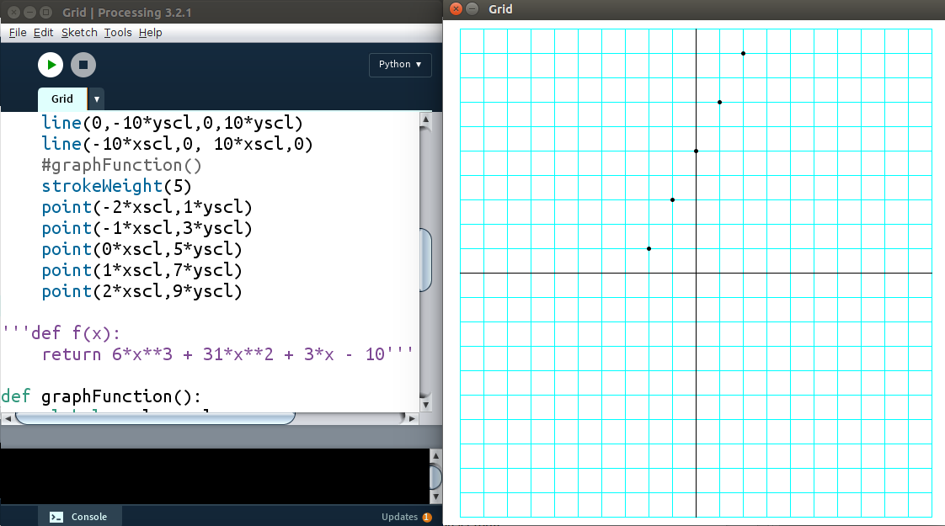
Figure 4.9: Plotting points one by one.
That's very time consuming and there is an easier way. We just need a list of points and we can put them in the code automatically. Here's a function to make a list full of points from that function:
a = list() #or a = []
for i in range(-10,11):
a.append([i*xscl,(2*i+5)*yscl])
The list looks like this:
[[-10, -15], [-9, -13], [-8, -11], [-7, -9], [-6, -7], [-5, -5], [-4, -3],
[-3, -1], [-2, 1], [-1, 3], [0, 5], [1, 7], [2, 9], [3, 11], [4, 13], [5, 15],
[6, 17], [7, 19], [8, 21], [9, 23], [10, 25]]
List Comprehensions
Python has a way to create lists in a compact form. Instead of the three lines above, you can do it all in one line:
a = [[i,2*i+5] for i in range(-10,11)]
Here's the function for graphing points, given a list:
def graphPoints(pointList):
'''Graphs the points in a list'''
for p in pointList:
point(p[0]*xscl,p[1]*yscl)
However, you might remember “range” only contains integers. That means when we graph the points in list a, we'll see what's in Figure 4.10:
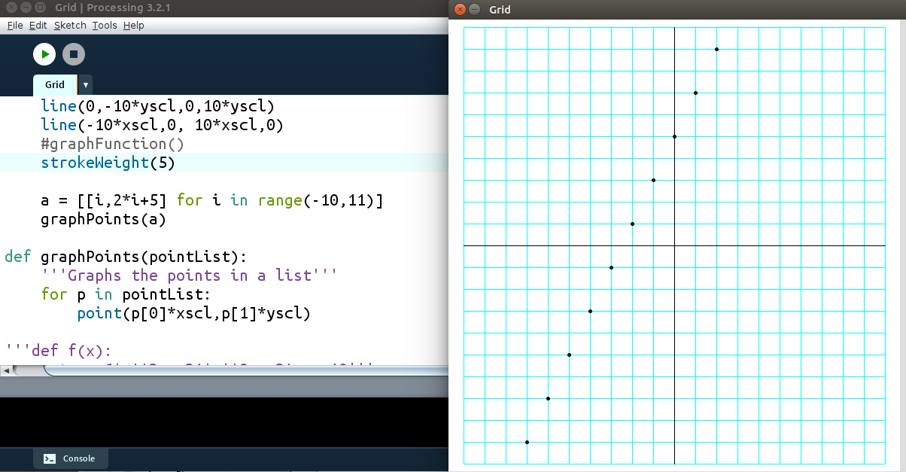
Figure 4.10: The points generated by the list comprehension.
Python has a terrific numerical package called Numpy which contains “arange,” which can go up by decimals. However, you can't import Numpy into Processing yet. Let's create our own “arange” function:
Exercise 4.8: Home on arange
Create a function called “arange” that creates a list. It should start at a given “start” value, go up by a given “step” value and put all the values into the list until it reaches a “stop” number, like this, which means “all the numbers from 1 to 3, going up by 0.25.” Like “range,” it doesn't contain the “stop” value.
>>> print(arange(1,3,0.25))
[1, 1.25, 1.5, 1.75, 2.0, 2.25, 2.5, 2.75]
Solution:
def arange(start,stop,step):
output = []
x = start
while x < stop:
output.append(x)
x += step
return output
Once we put that in our Processing sketch, we can generate a list of points using arange:
b = [[i,2*i+5] for i in arange(-10,11,0.1)]
and graph the points in that list. The output looks like figure 4.11:
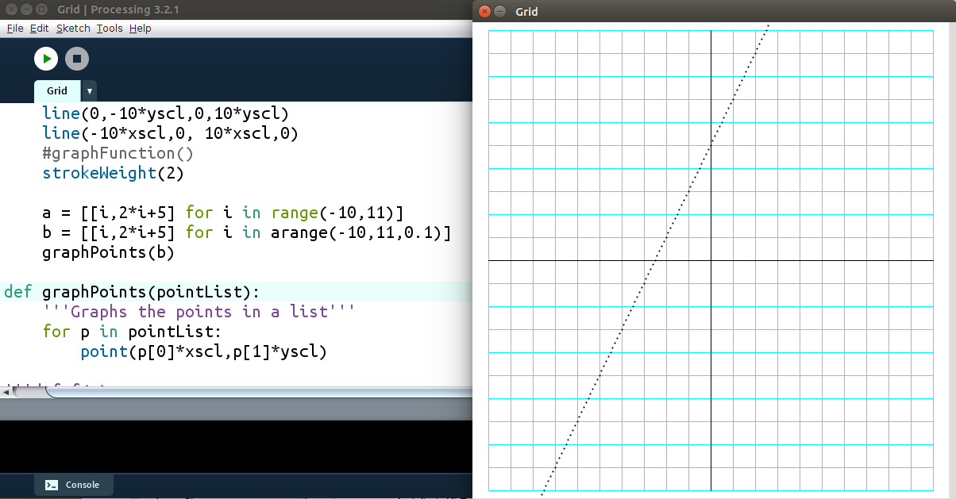
Figure 4.11: Graphing a function by generating the points
We could get a better looking graph by connecting the dots with lines:
def graphPoints2(pointList):
'''Graphs the points in a list using segments'''
for i,p in enumerate(pointList):
if i<len(pointList)-1:
line(p[0]*xscl,p[1]*yscl,
pointList[i+1][0]*xscl,pointList[i+1][1]*yscl)
This gets us the output in Figure 4.12:
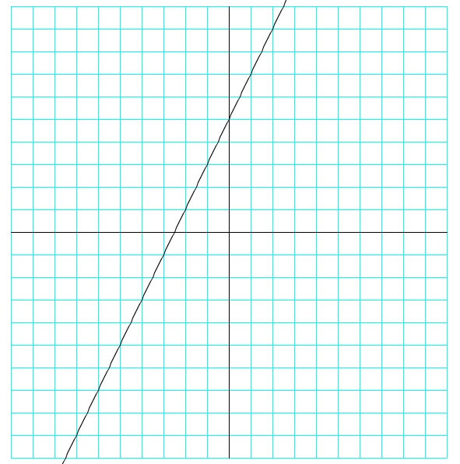
Figure 4.12
Exercise 4.9: Making connections
Write a program that will find the intersection point of two lines, given their slope and y-intercept. For example, if I want the intersection of the lines y = 2x + 5 and y = -3x – 10, I can just enter the numbers like this:
>>> intersection([2,5],[-3,-10])
(-3.0, -1.0)
Solution
If the y-value of the intersection point has to work in both equations y = 2x + 5 and y = -3x – 10, then the right sides must beequal:
2x + 5 = -3x – 10
But we can easily solve that with our “equation” function from earlier in this chapter! Use thtat to solve for the x-value of the intersection, then plug x into either line to find the y-value:
def intersection(line1, line2):
'''returns the intersection point of two
lines, given their slopes and y-intercepts'''
#find the x-value of the intersection
x = equation(line1[0],line1[1],line2[0],line2[1])
#find the y-value by plugging it in to either line
y = line1[0]*x + line1[1]
return x,y
To check, the graph of the lines and their intersection is in Figure 4.13:
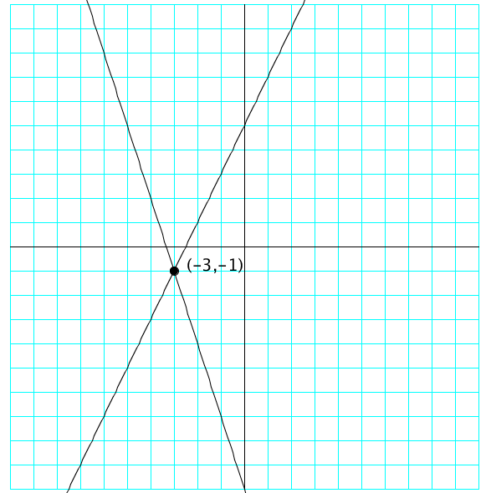
Figure 4.13: The intersection of two lines.
In Conclusion…
We've created a lot of tools in this chapter:
Plug and Check
Equation Solver
Quadratic Formula
Grid for Graphing
Graphing a Function
Find Roots by Halving
List Comprehensions
arange
PointList
Graphing from a Point List
Find Line Through Two Points
Intersection of Two Lines

Now we're going to use these to build even more powerful tools!

