Table of Contents
Downloading and Installing the Processing Python Package 1
Drawing a Circle 2
Specifying Location Using Coordinates 3
Transformation Functions 4
Translating Objects with translate() 4
Rotating Objects with rotate() 5
Exercise 5.1 6
Exercise 5.2: Squaring the Circle 6
Animating Objects 6
Creating the t Variable 6
pushMatrix() and popMatrix() 7
Rotating Around the Center 8
Creating an Interactive Rainbow Grid 8
Drawing a Grid of Objects 8
Exercise 5.4 Rocking the Grid 10
Adding the Rainbow Color to Objects 10
Drawing Triangles with triangle() 11
30-60-90 Triangle 12
Drawing an Equilateral Triangle 13
Exercise 5-5: Spin Cycle 13
Exercise 5-6: Triangulation 13
Drawing Multiple Rotating Triangles 14
Phase Shifting the Rotation 15
Finalizing the Design 15
Exercise 5.7: Whole Lot of Rotating Going On 16
Summary 16

Geometry
In the teahouse one day Nasrudin announced he was selling his house. When the other patrons asked him to describe it, he brought out a brick. “It's just a collection of these.” - Idries Shah
In geometry class everything you learn about involves dimensions in space using shapes. You typically start with examining one-dimensional lines and two-dimensional circles, squares, or triangles, then move on to three-dimensional objects like spheres and cubes. These days, creating geometric shapes is easy with technology and free software, though manipulating and changing the shapes you create can be more of a challenge. In this chapter, you’ll learn how to manipulate and transform geometric shapes using the Processing graphics package. You’ll start with basic shapes like circles and triangles, and in future chapters you’ll be working with complicated shapes like fractals and cellular automata.
Downloading and Installing the Processing Python Package
Processing is a programming environment that makes it easy to visualize your code. You can think of it as a sketchbook for your programming ideas. In fact, each Processing program you create is called a sketch. In this chapter, we’ll use Processing to visualize our code output as shapes and movement.
Before you can begin creating shapes, you’ll need to download Processing. Navigate to https://processing.org/download/?processing and download the appropriate version of Processing for your operating system. Once downloaded, unzip the files and save them somewhere appropriate on your computer, then open the Processing.exe program.

Processing actually has its own programming language, but you can choose to use Python within the Processing sketchbook. Click the box on the upper right corner that should currently say Java. This should open a drop down menu. Click Add Mode... to open a list of modes you can install. Choose Python Mode for Processing 3 and click Install. When you’re done downloading the Python Mode, close this window to return to your sketch and select Python to turn on Python Mode.
You should see a blank Python workspace labeled “sketch_XXXX.” Now you’re ready to start creating shapes.
Drawing a Circle
Let’s start with a simple one-dimensional circle. With a new sketch open in Processing, use the code shown in Figure 5-1 to create a circle on the screen:
#geometry.pyde

def setup():
size(600,600)

def draw():
ellipse(200,100,20,20)Figure 5-1: Code to draw a circle in Processing’s Python mode
Before we draw the shape, we first define the size of our sketchbook, known as the coordinate plane. In this example, we use the size() function to say that our grid will be 600 pixels wide and 600 pixels tall. With our coordinate plane set up, we use the drawing function ellipse() to create our circle on this plane. The first two parameters show where the center of the circle is located. Here, 200 is the x-coordinate and the second number 100 is the y-coordinate of this circle’s center, placing it at (200,100) on the 600x600 plane. The last two parameters determine the width and height of the shape in pixels. In the example, the shape is 20 pixels wide and 20 pixels tall. Because the points on the circumference are equidistant from its center, this forms a perfectly round circle.
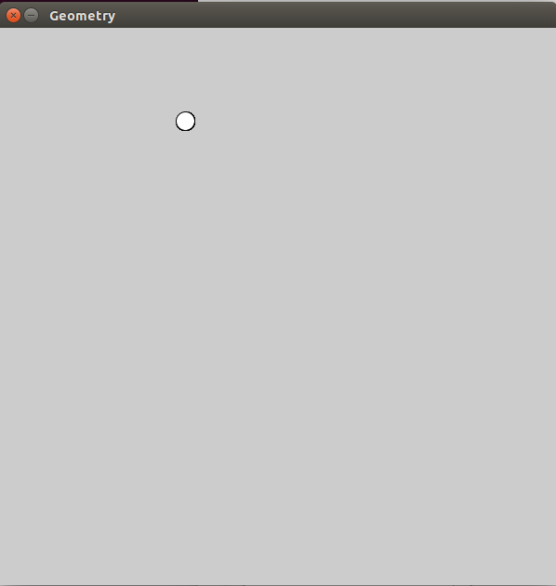
When you click the Run button (it looks like the Play symbol), a new window should open, in which you should see a small circle like in Figure 5-2:
Figure 5-2: The output of the above code showing a small circle
Processing has a number of other functions that make it easy to draw shapes. To see the full list, look at the reference pages at https://processing.org/reference/ to find functions for drawing ellipses, triangles, rectangles, arcs and much more. Figure 5-3 shows a screenshot of the reference page:
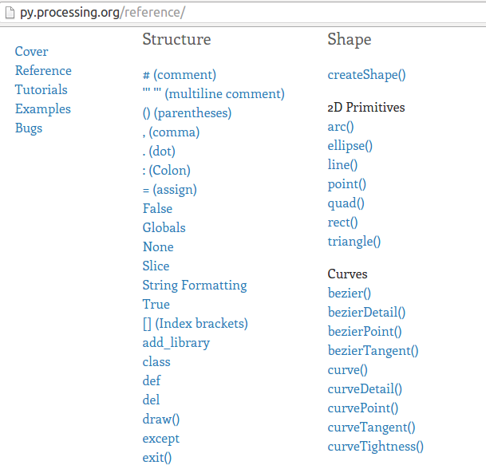
Figure 5-3: The reference page of the Python mode of Processing
Now that you know how to draw a circle in Processing, you’ll learn how to use these simple shapes to create dynamic, interactive graphics. In order to do that, you’ll first need to learn about location and transformations. Let’s start with location.
Specifying Location Using Coordinates
In Figure 3-X, we used the first two parameters of the ellipse() to specify our circle’s location on the grid. Likewise, each shape we create using Processing needs a location that we specify with the coordinate system, where each point on the graph is represented by two numbers: (x, y). The first number tells you where it is on the x-coordinate (horizontal line) and the second number tells you the y-coordinate (vertical line). In traditional math graphs, as you likely know, e the origin where x=0 and y = 0 is at the center of the graph as in Figure 5.4
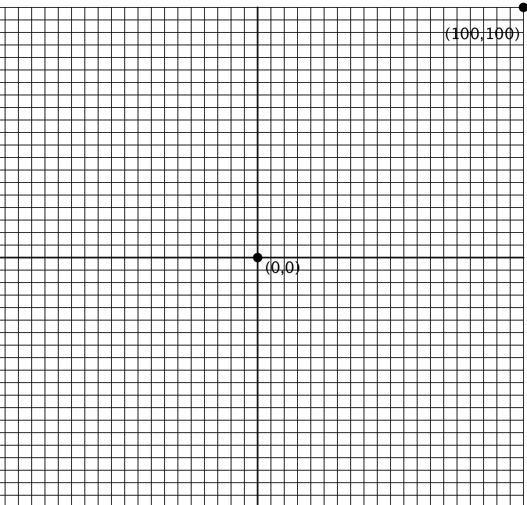
Figure 5-4: A traditional coordinate system with the origin in the center
In computer graphics, however, the coordinate system is a little different,as the origin is in the top-left corner of the screen, so that x and y increase as you move right and down respectively, as in Figure 5.5:

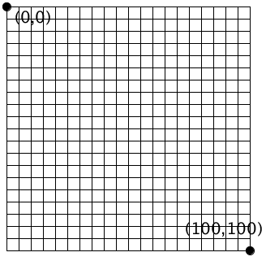
Figure 5-5 The coordinate system for computer graphics with the origin in the top-left corner
Each coordinate on this plane represents a pixel on the screen. As you can see with this graph, this means you don’t have to deal with negative coordinates. We'll use functions to transform and translate increasingly complex shapes.
Drawing a single circle was fairly easy, but drawing multiple shapes can get complicated pretty quickly. For example, imagine drawing a design like the one shown in Figure 5-6:
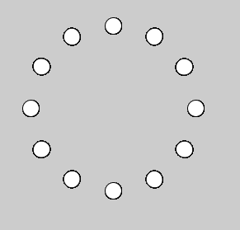
Figure 5-6: A circle made up of circles
This seems like it would take a lot of repeated code, specifying the size and location of each individual circle, spaced perfectly equally. Fortunately, you don’t really need to know the absolute x- and y-coordinates of each circle to do this. With Processing, you can easily place objects wherever you want on the grid. Let’s see how you can do this.
Transformation Functions
You might remember doing transformations with pencil and paper in geometry class. Geometric transformations, like translation and rotation, change where and how your objects appear without altering the objects themselves. For example, a triangle can be moved to a different location or spun around without changing its shape or size.. Processing has a number of built-in transformation functions that make it easy to translate and rotate objects.
Translating Objects with translate()
To translate means to move a shape on a grid so that all points of the shape move the same direction and the same distance. It's basically just moving a shape on a grid without changing the shape at all, not even tilting it. In math class that means all the points in the object change their coordinates. But in Processing, you translate an object by moving the grid itself, while the object’s coordinates stay the same. For an example of this, let’s put a rectangle on the screen. You just need to tell Processing the x- and y-coordinates of the rectangle (it’s measured from the top-left corner), its width and its height:
#geometry.pyde

def setup():
size(600,600)

def draw():
rect(20,40,50,30)
Run this and you should see the rectangle, as in Figure 5-7:
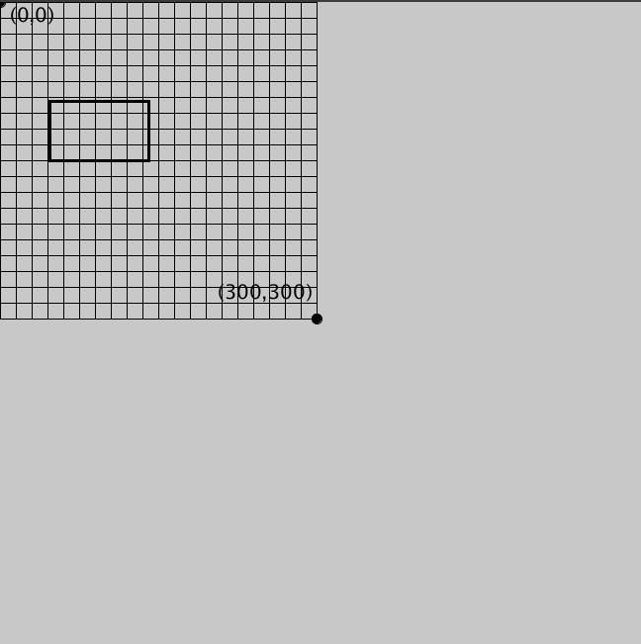
Figure 5-7: The default coordinate setup with the origin at the top left
You won’t see the grid. I just put that in there to show you how it’ll move. Now we’ll tell Processing to translate the rectangle using the following code. Notice the coordinates of the rectangle don’t change/
#geometry.pyde

def setup():
size(600,600)

def draw():
translate(50,80);
rect(50,100,100,60)
This should move the entire grid 50 pixels to the right and 80 pixels down, as shown in Figure 5-7:
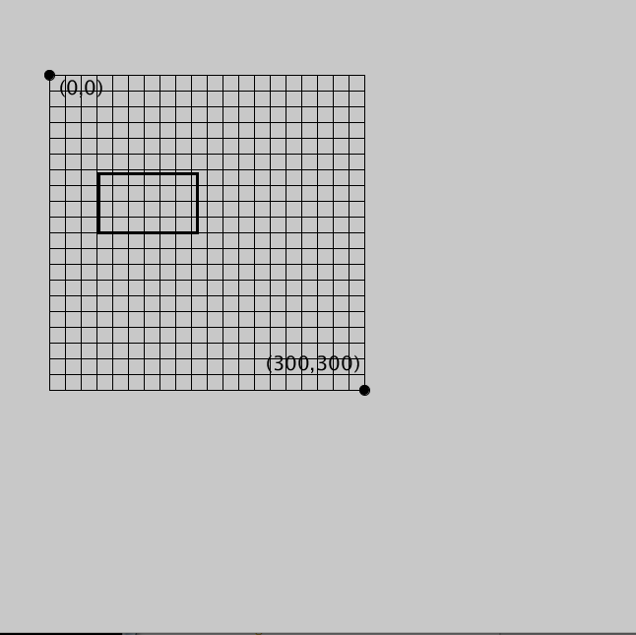
Figure 5-7: Translating a grid and a rectangle 50 pixels to the right and 80 pixels down
Very often it’s useful (and easier!) to have the origin (0,0) in the center of the canvas and it’s easy to move it using translate. You might change the width and height of your canvas if you want it bigger or smaller, so it’s handy to be able to use Processing’s built-in “width” and “height” variables instead of changing the numbers manually. Whatever numbers you put in the size declaration in the setup function will become the “width” and “height.” In this case, since I used size(600,600), they’re both 600. Change the translate line to this:
translate(width/2, height/2);

This should look like Figure 5-8:
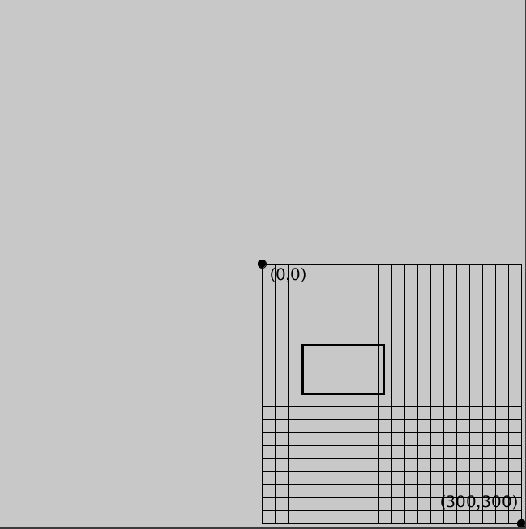
Figure 5-8: The grid is translated to the center of the screen
Notice that the origin is still located at (0, 0). This shows that we haven’t actually moved the origin point but the entire coordinate plane itself.
Rotating Objects with rotate()
In geometry, rotation is a kind of transformation where you turn an object around a center point, as if it's turning on an axis. The rotate() function in Processing rotates the grid around the origin (0,0). It takes a number as its argument to specify how many radians you want to rotate the grid. If you think in degrees, like I do, you can use the radians() function to convert your figure in degrees to radians so you don't have to do the math.
To see how the function works, enter the following two examples into the sketch and run them. Figure 5-9 shows the result:
rotate(radians(20)); | translate(200,200);  rotate(radians(20));
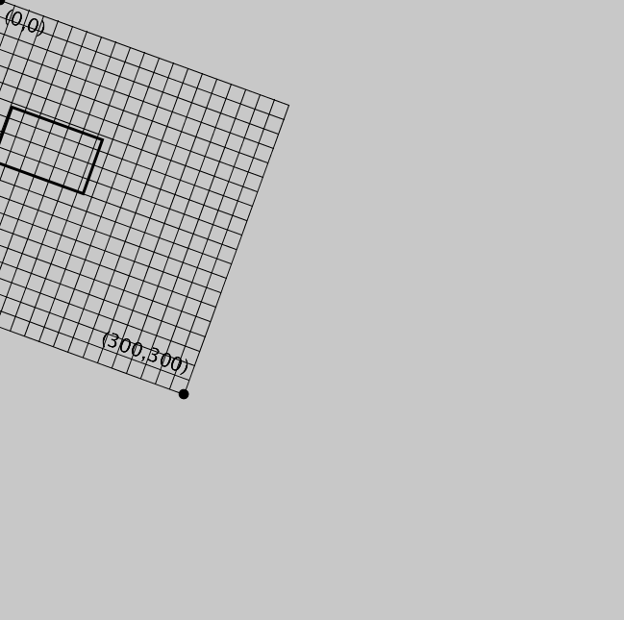 | 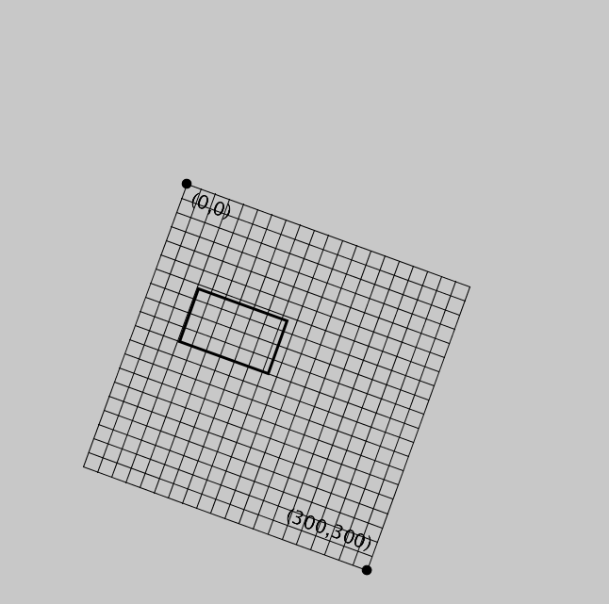
Figure 5-9: The grid always rotates about (0,0)

On the left of Figure 5-9, the grid is rotated 20 degrees around (0,0), which is at the top left corner of the screen. On the right, the origin is first translated 200 units to the right and 200 units down and then the grid was rotated. In Processing rotation is always in radians, not degrees. If you think in degrees (like I do), just convert the number to radians using the “radians” function first.
The rotate() function makes it easy to make circles of objects like the one in Figure 5-6 using the following steps:
- Translate to where you want the center of the circle to be.
- Rotate the grid and put the objects along the circumference of the circle.

A Circle of Circles Sketch
Here’s how to generate the design in Figure 5.6 using the steps above. We’ll need to use a for i in range() command to make sure the circles are evenly spaced. Think about how many degrees the smaller circles will have to be spaced to make a full circle, remembering that a circle is 360 degrees.
First we have to translate to the center of the screen:
translate(width/2,height/2)
Then we have to start a loop that will place an ellipse at some point and rotate after each one.
for i in range(12):
ellipse(200,0,50,50)
rotate(radians(360/12))
You'll get what's in Figure 5.6
Figure 5.10: The codefor translating, rotating and repeating.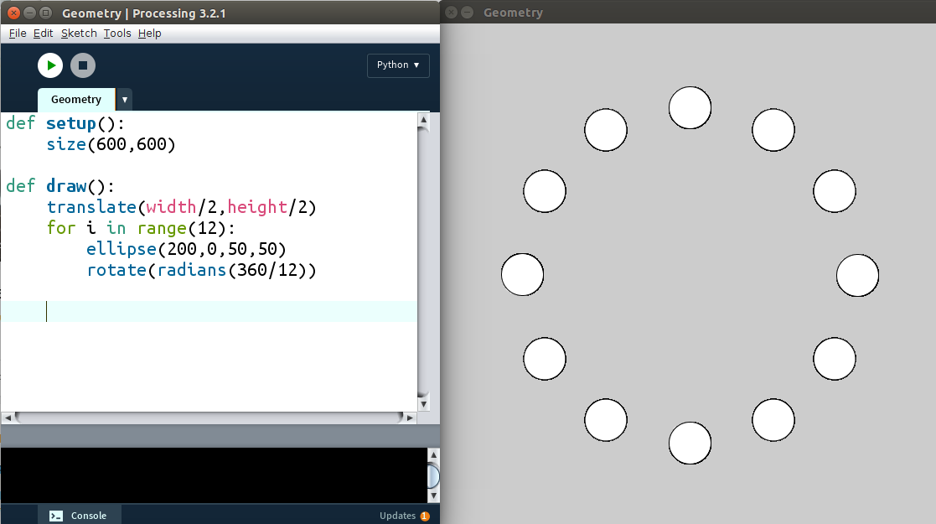
#geometry.pyde
def setup():
size(600,600)

def draw():
translate(width/2,height/2)
for i in range(12):
ellipse(200,0,50,50)
rotate(radians(360/12))
If you add another step to that sequence, you can rotate the objects in the circle. Obviously we can't tell if the circles are rotating, so we'll replace them with squares for now.
Exercise 5.2: Squaring the Circle

Modify the program you wrote in Exercise 5.1 and change the circles into squares.

This was an easy one. Just change “ellipse” in the above code to “rect” to make the circles into squares:
#geometry.pyde
def setup():
size(600,600)

def draw():
translate(width/2,height/2)
for i in range(12):
rect(200,0,50,50)
rotate(radians(360/12))
Animating ObjectsProcessing is great for animating your objects to create dynamic graphics. As you can tell from the output when you run Exercise 5.1 and 5.2, rotate is done instantly. In order to see the rotation unfold in real-time, we have to introduce the time variable t.
Creating the t Variable
The time variable, t,___________________. will allow us to
To start, create the variable and initialize it with 0 by adding t = 0 before the setup function. Then insert the following code before the for loop:
geometry.pyde
def setup():
size(600,600)

def draw():
translate(width/2,height/2)
rotate(radians(t))
for i in range(12):
rect(200,0,50,50)
rotate(radians(360/12))

However, if you try to run this, you'll get the following error message:
UnboundLocalError: local variable 't' referenced before assignment
This is because Python doesn't know whether you're creating a whole new local variable t inside the function that doesn't have anything to do with the global variable t outside the function. You have to add global t at the beginning of your draw function and the program should now know you’re referring to the same t.
We need some additional code to tell the squares how XXXX to rotate.

Also notice that we've swapped ellipse() with rect() to turn the circles into squares. Enter the code in Listing XX and run it and you should see the whole circle of squares start to rotate in a circle, as in Figure 5-11:
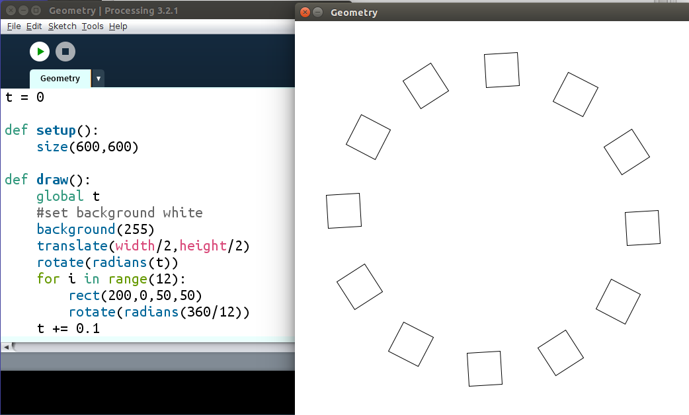
Figure 5-11: Making squares rotate in a circle

Please explain what t += 0.1 means?
Now let’s try rotating each square. Since rotating is done around (0,0) in Processing, inside the loop we have to first translate each square to where it to be, then rotate, and finally draw the square. Run the following code in Listing 4-1:
for i in range(12):
translate(200,0)
rotate(radians(t))
rect(0,0,50,50)
rotate(radians(360/12))

pushMatrix() and popMatrix()
When you run Listing 4-1, you should see that it creates some strange behavior. That's because of changing the center, and changing the orientation of the grid so much. We need to figure out how to rotate each square but also keep them along the circumference of the bigger circle. Processing has two built-in functions that save the orientation of the grid at a certain point then return to that orientation: pushMatrix and popMatrix. In this case, we want to save the orientation when we're in the center of the screen. So revise the loop to look like this:
for i in range(12):
pushMatrix() #save this orientation
translate(200,0) rotate(radians(t))
rect(0,0,50,50)
popMatrix() #return to the saved orientation
rotate(radians(360/12))
The pushMatrix() saves the position of the coordinate system at the point where ____________. Then we translate _______
Then we use popMatrix() to
Rotating Around the Center
This should work perfectly, but the rotation may looks strange; that’s because Processing by default locates a rectangle at its top left corner and rotates it about its top left corner. This makes the squares look like they’re veering off the path of the larger circle. If you want t your squares to rotate around their centers, add this line to your setup function:
rectMode(CENTER)
Note that the capitalization in rectMode() matters. Adding rectMode(CENTER) should make each square rotate around its center. If you want them to spin more quickly, change the rotate line to increase the time in t like so:
rotate(radians(5*t))
The 5 is the frequency of the rotation. This means ________. Change it to see what happens!
Creating an Interactive Rainbow Grid
Now that you’ve learned how to create designs using loops and rotate them in different ways, we'll create something pretty awesome: a grid of rainbow-colored squares that follows your mouse cursor! The first step is to make a grid.
Drawing a Grid of Objects
We'll make a 12x12 grid of squares, evenly sized and spaced, to begin with. Making a grid this size may seem like a time-consuming task but in fact, it’s easy to do using a loop.
Make a 12 x 12 grid of squares on a white background. Your squares will need to be rects, and you'll need to use a for loop within a for loop to make sure they are all the same size and spaced equally.
The code in Listing 4-X should create the grid in Figure 4-X.
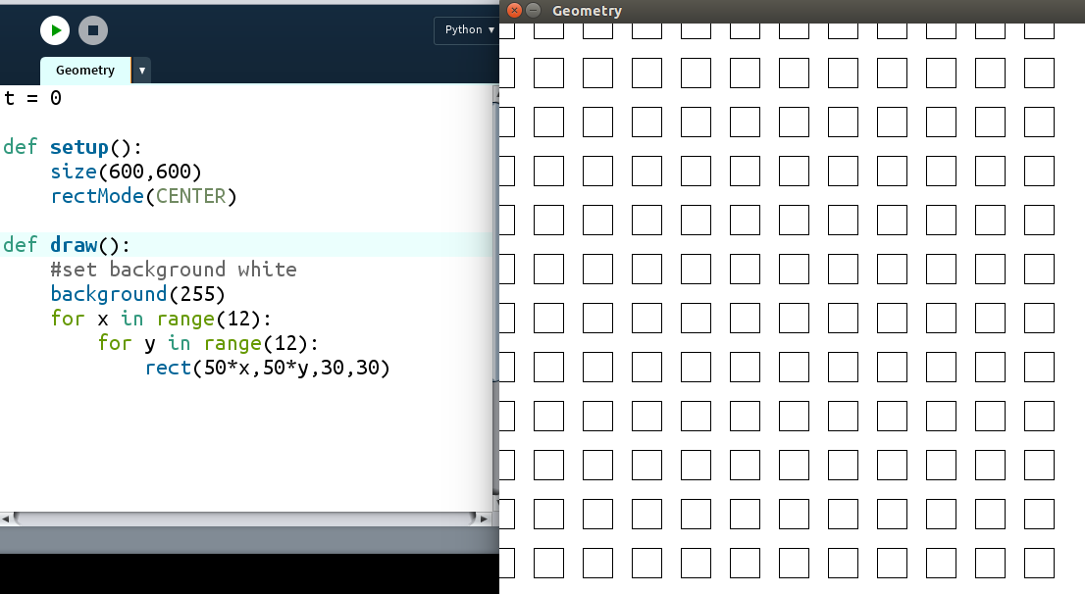
Listing 4-X:
Figure 4-X:
We first set up the background to be 600 by 600 pixels and XXX it with rectMode(CENTER).

Then in the def draw() section we first set the background to white by setting it to 255, then center the grid by translating it to (20,20).
XXX
We vary the variables x and y by regular intervals to ....

.

The result should look like Figure 5-13

Exercise 5.4 Rocking the Grid
Make each square in the grid spin using the rotate function. Once you've done that, return to the static grid, you'll need it for the next section.
Adding the Rainbow Color to Objects
The Processing XX also lets you add colors to your shapes. The colorMode() function helps us add some cool color to our sketches! It’s used to switch between the RGB and HSB modes. RGB is three numbers indicating amounts of Red, Green and Blue. In HSB the three numbers will be amounts of Hue, Saturation, and Brightnessand the only one we need to change is the first number, the hue.

We’ll use the previous example of rotating squares to practice adding colors. Use the following code to add a time variable and a couple of rotate functions to make each square rotate:
def setup():
size(600,600)
rectMode(CENTER)
colorMode(HSB)

def draw():
#set background black
background(0)
translate(20,20)
for x in range(30):
for y in range(30):
d = dist(25*x,25*y,mouseX,mouseY)
t = 100/(d+0.01) #to prevent zero division
fill(400*t,360,360)
rect(25*x,25*y,20,20)
We insert the colorMode() function and pass HSB to it.

The hue is the only thing we change: we update the hue according to the distance the rectangle is from the mouse. We do this with the “dist” function, which takes 4 arguments: the x and y coordinates of two points. It returns the distance between the points.
Run this code and you should see a very colorful design that changes colors according to the mouse’s location, as shown in Figure 5-14:

Figure 5-14: Adding colors to your shapes
Now that you’ve learned how to add colors to your objects, let’s explore how we can create more complicated shapes.
Drawing Complex Triangle Patterns
In this section, we’ll create more complicated spirograph-style patterns using triangles. For example, take a look at the sketch made up of rotating triangles in Figure 5-12, created by the University of Oslo's Roger Antonsen:

Figure 5-15: Sketch of 90 rotating equilateral triangles by the University of Oslo's Roger Antonsen
This sketch blew me away! But though this design looks very complicated, it’s not that difficult to make. Antonsen gave us a helpful clue to creating this design when he named the sketch “90 Rotating Equilateral Triangles.” It tells us that all we have to do is figure out how to draw an equilateral triangle and rotate it, then repeat that for 90 of them. Let’s first learn how to draw an equilateral triangle using the triangle() function. Using the code in Listing 4-x is one way to create a rotating triangle:
def setup():
size(600,600)
rectMode(CENTER)

t = 0

def draw():
global t
translate(width/2,height/2)
rotate(radians(t))
triangle(0,0,100,100,200,-200)
t += 0.5When you run this code, you should see something like Figure 5-16.
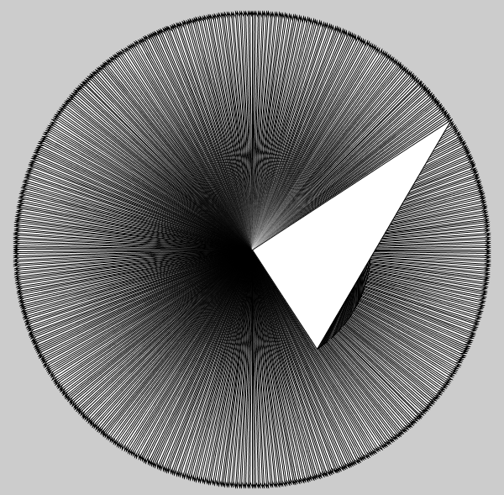
Figure 5-16: Rotating a triangle around one of its vertices

As you can see in Figure 5-16, the triangle rotates around one of its vertices, or points, and so creates a circle with the outer point. You’ll also notice that this is a right triangle. In order to recreate Roger's sketch, we need to draw an equilateral triangle, a triangle with equal sides. We also need to find the center of the equilateral triangle to be able to rotate it about its center. To do this, we’ll need to find the location of the three vertices of our triangle. Let's learn how to draw an equilateral triangle by locating it at its center and specifying the location of its vertices.
30-60-90 Triangle
In order to find the location of the three vertices of our equilateral triangle, you’ll need to review a particular triangle you've likely seen in geometry class: the 30-60-90 triangle. First we need an equilateral triangle, shown in Figure 4-17.
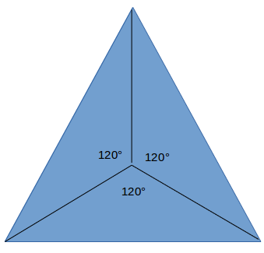
Figure 5-17: An equilateral triangle divided into three equal parts
This equilateral triangle is made up of three equal parts. The point in the middle is the center of the triangle, with each dissecting line meeting at a 120 degree angle. To find the y-coordinate of the vertices, let's cut the bottom triangle in half again, as shown in Figure 5-18:
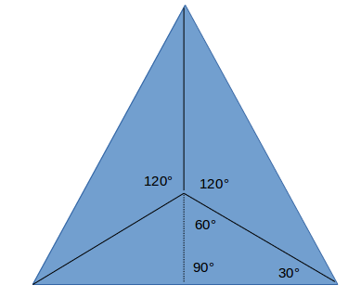
Figure 5-18 Dividing up the equilateral triangle into special triangles
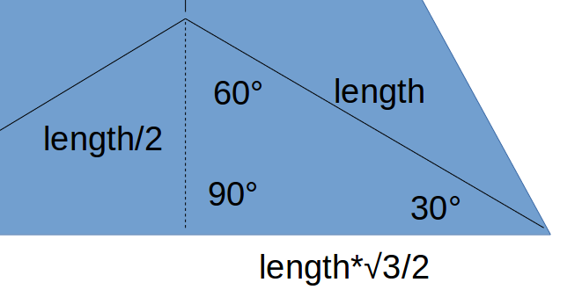
Dividing the bottom triangle in half creates two right angle triangles. These right triangles are classic 30-60-90 triangles, a special triangle studied in geometry and trigonometry classes. A 30-60-90 triangle is a right triangle whose internal angles are 30, 60, and 90 degrees and whose sides have special relationships with respect to its hypotenuse, the longest side of a right triangle. You may be familiar with this from Pythagoras, which will come up again shortly. You need to know the lengths of the sides of this special triangle, because it'll help you find the three vertices with respect to the center. Figure 5-19 zooms in on a 30-60-90 triangle:
Figure 5-19: The 30-60-90 triangle up close and personal
The distance from the center of the equilateral triangle to the vertex is the hypotenuse of the 30-60-90 triangle inside the equilateral. We can find the lengths of the other sides with reference to the length variable.
The shorter leg is always half the hypotenuse and the longer leg is the measure of the shorter leg times the square root of 3. So if we use the center point for drawing the triangle, the coordinates of the three vertices would be as shown in Figure 5-20:
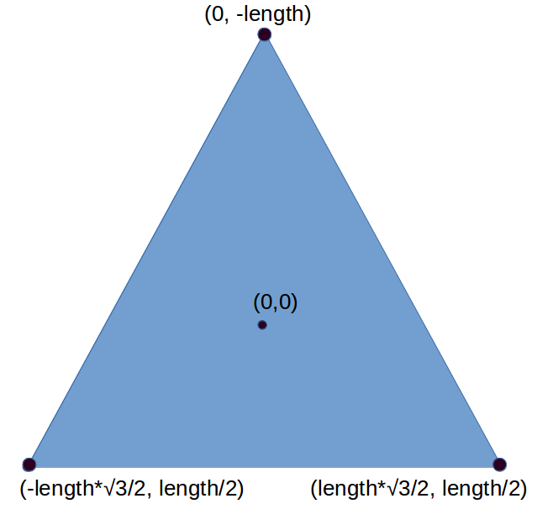
Figure 5-20: The vertices of the equilateral triangle

As you can see, because this triangle is made up of 30-60-90 triangles on all sides, we can use them to figure out how far each vertex lies from with respect to the origin.
Drawing an Equilateral Triangle
Now we know what we need to do, let's do it. We can use the vertices we derived from the 30-60-90 triangle to create an equilateral triangle. The following code will create an equilateral triangle:
def setup():
size(600,600)
rectMode(CENTER)

t = 0

def draw():
global t
translate(width/2,height/2)
rotate(radians(t))
tri(200) #draw the equilateral triangle
t += 0.5

def tri(length):
‘’’Draws an equilateral triangle
around center of triangle’’’
triangle(0, -length,
-length*sqrt(3)/2, length/2,
length*sqrt(3)/2, length/2)

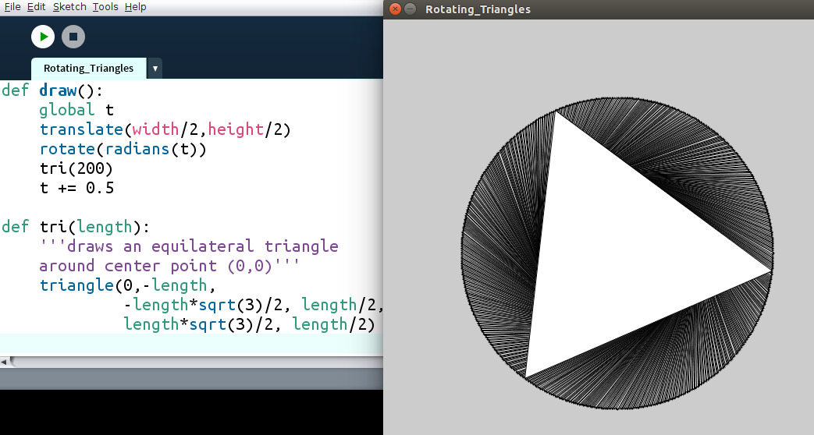
Figure 5-21: Code drawing an equilateral triangle
First, we write the tri() function to take the variable length, the hypotenuse of the special 30-60-90 triangles we cut the equilateral triangle into. We then make a triangle using the three vertices we found above. __________________. Using the triangle() function, we then specify the location of each of the three vertices of the triangle: (0, -length), (-length*sqrt(3)/2, length/2) and (length*sqrt(3)/2, length/2).
Now we can cover up all the triangles created during rotation by adding this line to the beginning of the draw function:
background(255) #white
This should erase all the rotating triangles except for one, so we just have a single equilateral triangle on the screen.
All we have to do is put 90 of them in a circle, just like we did earlier in this chapter, using the rotate() function.
Exercise 5-5: Spin Cycle
Create a circle of equilateral triangles in a Processing sketch and rotate them using the rotate function.

Drawing Multiple Rotating Triangles
Now that we’ve learned how to rotate a single equilateral triangle, we need to figure out how to arrange multiple equilateral triangles into a circle. This is similar to what you created while rotating squares, but will use our tri function. Enter the code in Listing 4-X in place of the def draw() section in Processing and run it.
def draw():
global t
background(255)#white
translate(width/2,height/2)
for i in range(90):
#space the triangles evenly
#around the circle
rotate(radians(360/90))
pushMatrix() #save this orientation
#go to circumference of circle
translate(200,0)
#spin each triangle
rotate(radians(t))
#draw the triangle
tri(100)
#return to saved orientation
popMatrix()
t += 0.5
First, we use the for loop to arrange 90 triangles around the circle, making sure they’re evenly spaced by dividing 360 by 90. Then we use pushMatrix() to save this position before moving the grid around. _At the end of the loop we use “popMatrix()” to return to the saved position._______
However, if you run this, you'll notice the triangles aren't transparent, like in Aronsen's sketch. In order to make the triangles transparent, we need to add this line to our tri function, just before drawing the triangle:
def tri(length):
'''Draws an equilateral triangle
around center of triangle'''
noFill() #makes the triangles transparent
triangle(0, -length,
-length*sqrt(3)/2, length/2,
length*sqrt(3)/2, length/2)
Now we have 90 rotating transparent triangles but they're all rotating in the same way. We need to make each one rotate a little differently from the adjacent ones to make the pattern a little more interesting.
Phase Shifting the Rotation
We can change the pattern that the triangles rotate in with a phase shift, which makes each triangle lag a little bit behind its neighbor, giving the sketch that “wave” or “cascade” look.___________ Each triangle was assigned a number in the loop, represented by i. We need to add i to t in the rotate(radians(t)) function, like this _______________________:
rotate(radians(t + i))
You should see something like Figure 5-22:
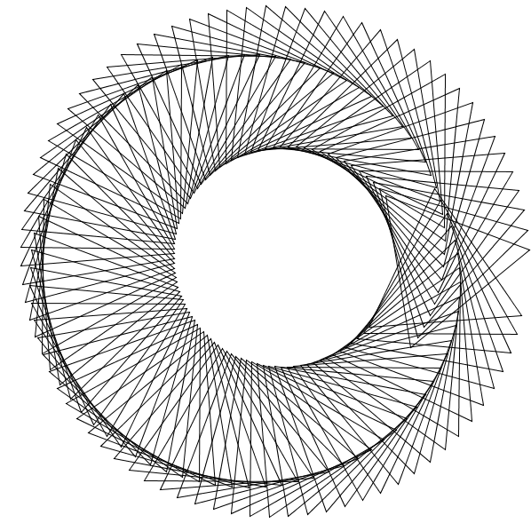
Figure 5-22: Rotating triangles with phase shift
Notice there's a break in the pattern on the right side of the screen. This break in the pattern is caused by the phase shifts not matching up from the beginning triangle to the last.____________________. We want a nice, seamless pattern, so we have to make the phase shifts add up to a multiple of 360 degrees to complete the circle. Because there are 90 triangles in the design, we'll divide 360 by 90 and multiply that by i:
rotate(radians(t + i*360/90))
it's easy to work out that 360/90 is 4, but I'm leaving the calculation in because we'll need it in case we want to change the number of triangles later. For now this should create a nice seamless pattern, as shown in Figure 5-23:
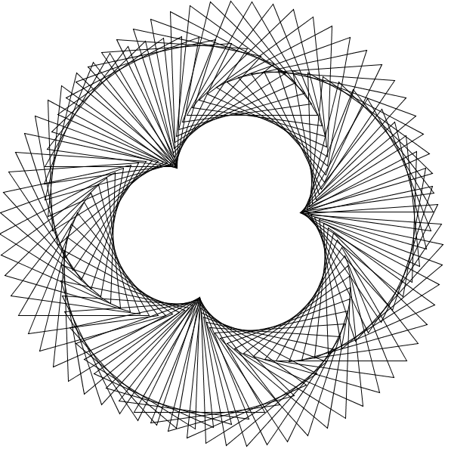
Figure 5-23: Seamlessly rotating triangles with phase shift
By making our phase shifts add up to a multiple of 360, we were able to remove the break in the pattern.
Finalizing the Design
To make the design look more like the one in Figure 4-XX, we need to change the phase shift a little. Play around with it yourself and see how it changes the look of the sketch!
I’m going to change the phase shift to multiply i by 2, which will increase the shift between a triangle and its neighbor., Change the rotate() line in your code to the following:
rotate(radians(t + 2*i*360/90))
Making this change and run the code, as you can see in Figure 5-24, our design now looks very close to the design we were trying to recreate:
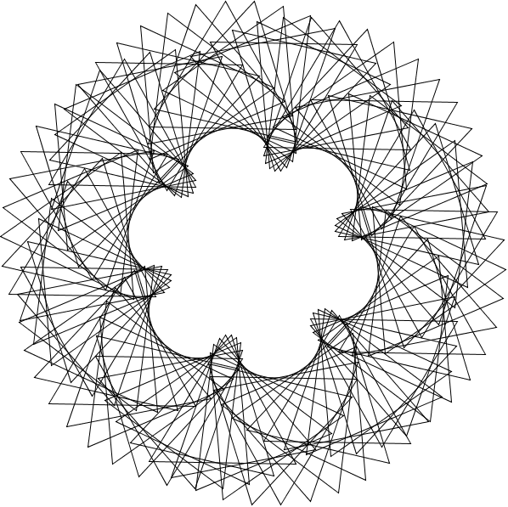
Figure 5-24: Recreation of Roger’s “90 Rotating Equilateral Triangles” seen in Figure 5-15
Now that you’ve learned how to recreate a complicated design like this, try the next exercise to test your transformation skills!
Exercise 5.7: Whole Lot of Rotating Going On
Create a sketch of 120 rotating triangles in a circle.
Summary
In this chapter you learned how to break down some complicated-looking designs into their simple components. You learned how to draw shapes like circles, squares, and triangles, and arrange them into different patterns using Processing’s built-in transformation functions. You also learned how to make your shapes dynamic by animating your graphics, adding color. Just like how Nasrudin's house in the epigraph was just a collection of bricks, the complicated code examples in this chapter were just a collection of simpler instructions.
In the next chapter you'll build on this chapter and learn new functions to create even more complicated behaviors, like leaving a trail and creating any shape from a bunch of vertices.

