4 [ChapterStart]
Mathematics may be defined as the subject in which we never know what we are talking about, nor whether what we are saying is true. - Bertrand Russell
Algebra: Transforming and Storing Numbers
Algebra is introduced in school as the idea of replacing numbers with letters. Instead of 2·3 you have 2x or 2y, for example, meaning “2 times some unknown number.” We've already used variables to replace numbers, and it's a vital tool in programming.
Unfortunately, in traditional math class variables are often used to represent a “mystery number” that a student is required to find. Not “find” as in Figure 4.1:
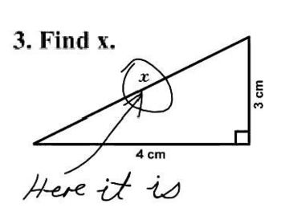
Figure 4.1: Math questions are subject to interpretation.
Every day in Algebra students are given an equation with an unknown (or two or three…) and they have to find what number or numbers make the equation true, like:
1. Solve 2x + 5 = 13.
“Solve” means “find out which number, when you replace x with that number, makes both sides of the equation equal.” Equations of this form don't take too much effort to solve, but even at this level we can use Python and “brute force” to plug in random numbers.
Exercise 4.1: Plug and Chug
Write a program that will plug all the integers between -100 and 100 into the above equation and if one works, print out the number.
Solution:
def plug():
x = -100 #start at -100
while x < 100: #go up to 100
if 2*x + 5 == 13: #if it makes the equation true
print("x =",x) #print it out
x += 1 #make x go up by 1

plug() #run the plug function
The output is
x = 4
This is a valid way to solve a problem! It's too laborious for a human to do by hand, but using a computer it's a cinch. If the solution isn't an integer, you might have to increment by smaller numbers.
Find a formula
All “first-degree” equations, meaning those in which the highest exponent is one, fit into this pattern:
ax + b = cx + d
where a, b, c and d are numbers. Like these ones:
3x - 5 = 22
4x - 12 = 2x - 9

Sometimes there's no x term on one side, so the coefficient is zero. Using a little Algebra, you can solve the general form of the equation and that will help you solve all equations of that form.
ax + b = cx + d
Get all the x's on one side of the equals sign:
ax - cx = d - b
Now factor out an x:
x(a - c) = d - b
Divide both sides by a – c and you have the value of x:

Exercise 4.2: X-Games
Write a program that will take the four coefficients of the general equation above and print out the solution, like this:
>>> equation(2,5,0,13)
4.0
Solution:
def equation(a,b,c,d):
'''solves equations of the
form ax + b = cx + d'''
return (d - b)/(a - c)
Let's test it with an equation we've solved already:
>>> equation(2,5,0,13)
4.0
Check. Now for a more complicated one:
12x + 18 = -34x + 67
>>> equation(12,18,-34,67)
1.065217391304348
Using Return instead of Print
How do we check it? We plug that solution in for x. But why type all those digits? Notice we didn't use “print” in the program, but we used “return” instead. This means we can assign the result to a variable:
>>> x = equation(12,18,-34,67)
>>> x
1.065217391304348
We “stored” that result in the variable x. Now find out what the left side of the equation becomes with that number for x:
>>> 12*x + 18
30.782608695652176
Is it the same as the right side of the equation?
>>> -34*x + 67
30.782608695652172
Except for some rounding error at the end, yes!
Higher Degree Equations
Things get more complicated when there's an x² term, like x² + 3x – 10 = 0. This is called a polynomial (it means “many terms”). If you're faced with an equation with a squared term in it, like ax² + bx + c = 0, you should use the Quadratic Formula:

Exercise 4.3: Working on our Quads
Write a program that will take a, b and c above and return the two solutions to the quadratic formula. Use it to solve x² + 3x – 10 = 0.
Solution:
Add this line to the top of your Python file to import the square root function:
from math import sqrt
Here's the function:
def quad(a,b,c):
'''Returns the solutions of an equation
of the form a*x**2 + b*x + c = 0'''
x1 = (-b + sqrt(b**2 - 4*a*c))/(2*a)
x2 = (-b - sqrt(b**2 - 4*a*c))/(2*a)
return x1,x2

>>> quad(1,3,-10)
(2.0, -5.0)
Here's how we check the answers:
>>> 2**2 + 3*2 - 10
0
>>> (-5)**2 + 3*(-5) - 10
0
Solving Higher Degree Equations
In Algebra class students are often asked to solve a higher degree equation, like
6x³ + 31x² + 3x – 10 = 0
You can use the “plug” function and look for solutions manually:
def g(x):
return 6*x**3 + 31*x**2 + 3*x – 10

def plug():
x = -100
while x < 100:
if g(x) == 0:
print("x =",x)
x += 1
print("done.")

>>> plug()
x = -5
done.
That gives you one of the solutions. What if there were a way to see all the possible inputs and corresponding outputs to a function? There is, and it's called graphing.
Creating Your Own Graphing Tool
We're going to use Processing to create a graphing tool that will allow us to see how many solutions our equation has. The basic setup of a Processing sketch in Python mode is shown in Figure 4.2:
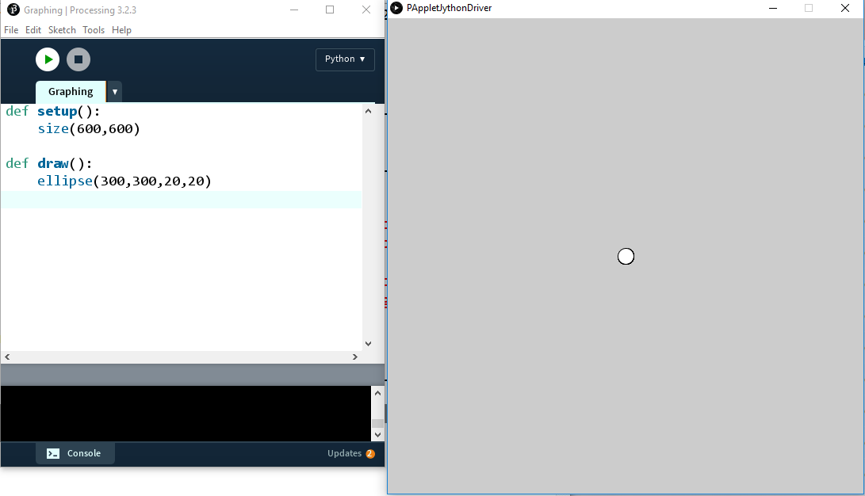
Figure 4.2
Surprisingly, computer graphics usually have their “origin” in the top left corner of the screen and the y-coordinates get larger as they go down the screen, not up, like in Figure 4.3:
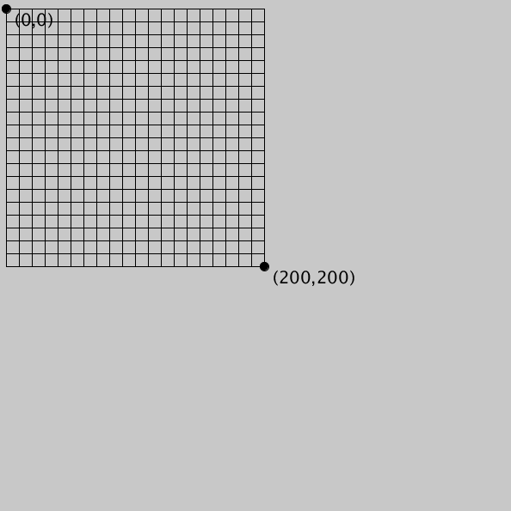
Figure 4.3
To move the origin to the center of the screen, we use the “translate” function:
translate(width/2, height/2)
Now the origin will be in the middle of the screen. Figure 4.4 gives you the idea:
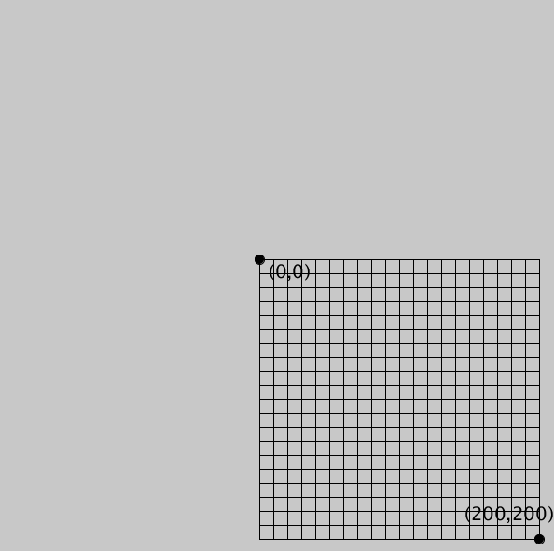
Figure 4.4
Our screen is still 600 pixels by 600 pixels but we'll probably only need x- and y- values from -10 to 10. Let's declare a range of x- and y-values we're interested in displaying. If we really only need to see the values between -10 and 10, that's 21 integers (including zero). We can create two variables for the x-range and y-range this way:
rangex = 21
rangey = 21
We'll scale the coordinates down (or up) by simply multiplying the x- or y-coordinates by these factors. The “x-scale” factor would be 1 if our x-range were the same as the width, right? And it would be 2 if our range was between -300 and 300, so we're dividing the width by the x-range. Same for the y-scale. When graphing we'll have to remember to multiply all our x-coordinates and y-coordinates by these scale factors or they won't show up correctly on the screen.
xscl = width/rangex
yscl = height/rangey
Now we'll draw lines for the grid, in blue, like graph paper. The lines will go from (x, -10) to (x, 10) for each x value and from (-10, y) to (10, y) for each y-value.
#cyan lines
stroke(0,255,255)
for i in range(-10,11):
line(i*xscl,-10*yscl,i*xscl,10*yscl)
line(-10*xscl,i*yscl, 10*xscl,i*yscl)
Now we'll create the axes, a line between (0,-10) and (0,10) and another between (-10,0) and (10,0).
Exercise 4.4: Crossing the Lines
Draw two black lines for the x- and y-axes.
Solution:
stroke(0) #black axes
line(0,-10*yscl,0,10*yscl)
line(-10*xscl,0, 10*xscl,0)
Add “background(255)” to the beginning of the draw function to set the background white. That gives us a nice grid, like in Figure 4.5:

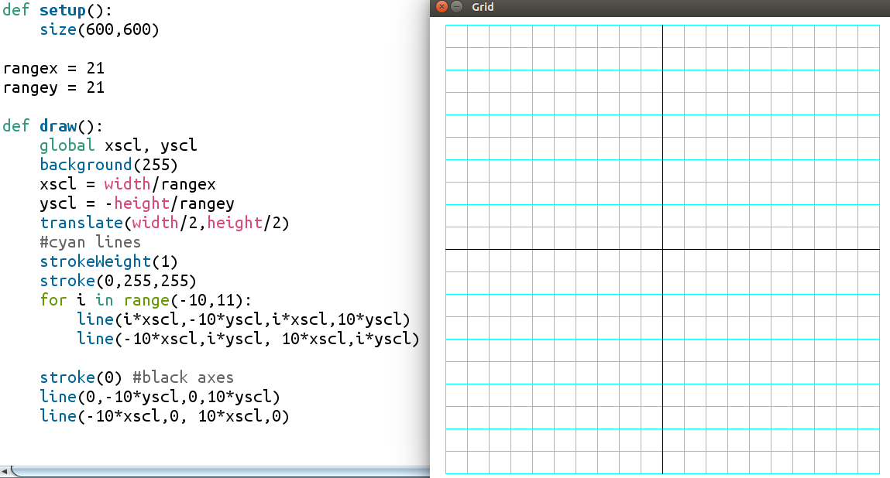
Figure 4.5: Creating a grid for graphing. You only have to do it once!
This looks done, but if we try to put a point (an ellipse, actually) at (3,6), we see a problem:
#test with a circle
fill(0)
ellipse(3*xscl, 6*yscl,10,10)
You'll see what's in Figure 4.6:
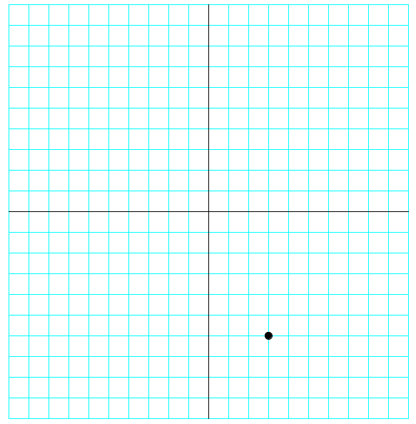
Figure 4.6: Checking our graphing program. Almost there!
The y-coordinates go up as we go down the screen, so our graph is “upside-down.” We can add a negative sign to the y-scale factor in the draw function to flip that over:
yscl = -height/rangey
This flips the output to how we want it, like in Figure 4.7:
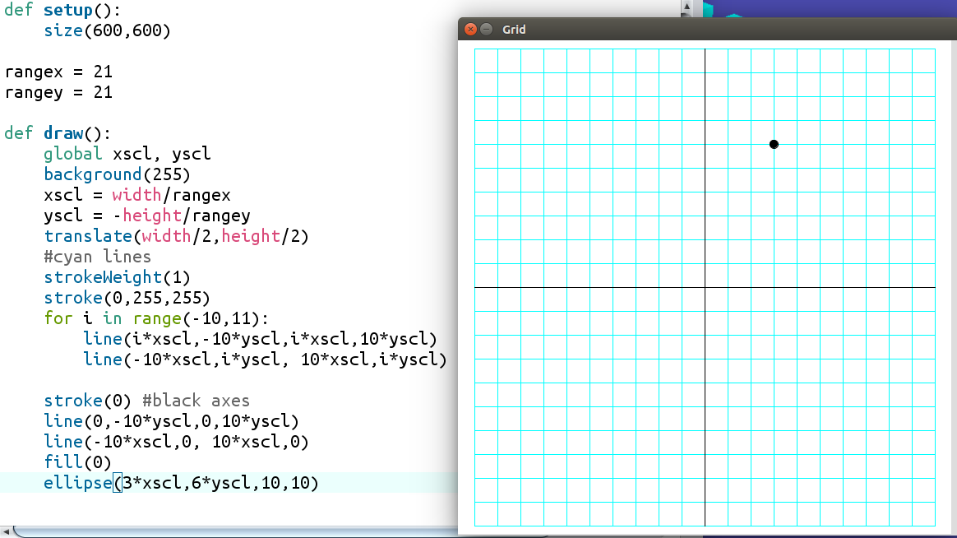
Figure 4.7: The grapher is working!
The grid function
To keep our code organized, we'll separate all the code that makes the grid into its own function and call it “grid.” Then we'll call the “grid” function in the draw function. It should look like this:
def draw():
background(255)
grid() #draw the grid

def grid():
global xscl, yscl
xscl = width/rangex
yscl = -height/rangey
translate(width/2,height/2)
#blue lines
strokeWeight(1) #thin lines
stroke(0,255,255) #cyan
for i in range(-10,11):
line(i*xscl,-10*yscl,i*xscl,10*yscl)
line(-10*xscl,i*yscl, 10*xscl,i*yscl)

stroke(0) #black axes
line(0,-10*yscl,0,10*yscl) #y-axis
line(-10*xscl,0, 10*xscl,0) #x-axis
Now we're ready to solve our equation:
6x³ + 31x² + 3x – 10 = 0
We'll add this function
def f(x):
return 6*x**3 + 31*x**2 + 3*x – 10
to our program and draw lines from every point to every “next” point, going up a tenth of a unit at a time:
def graphFunction():
x = -10
while x <= 10:
stroke(255,0,0) #red function
line(x*xscl,f(x)*yscl,(x+0.1)*xscl,f(x+0.1)*yscl)
x += 0.1
Finally, call “graphFunction” in draw function and you'll see the output in Figure 4.8:
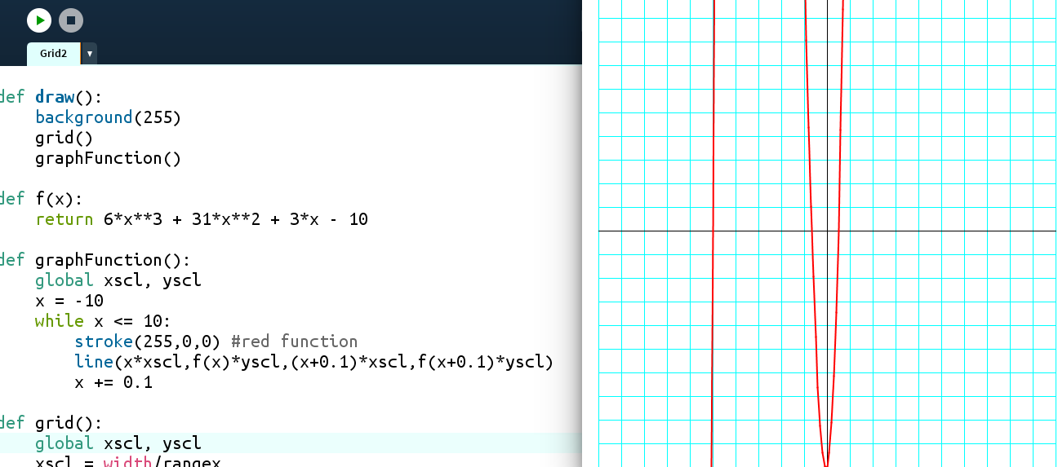
Figure 4.8: Graphing a polynomial function
The solutions to the equation (called the “roots”) are where the graph crosses the x-axis. We can see three places: where x = -5, where x is between -1 and 0, and where x is between 0 and 1.
The Halving Method
We already saw how effective our “Halving Method” was in the last chapter. Now we can use that method to approximate the roots. Let's start with the root between 0 and 1. Is it 0.5? We can easily plug in 0.5 and see. We'll move to IDLE for this.
def f(x):
return 6*x**3 + 31*x**2 + 3*x – 10

>>> f(0.5)
0.0
Another solution to our equation is 0.5. Finally, we'll try the root between -1 and 0.
>>> f(-0.5)
-4.5
Looking at the graph, now we can tell we guessed too high: the root is somewhere between -1 and -0.5. We'll average those endpoints and try again:
>>> f(-0.75)
2.65625
That's positive, so we guessed too low: the solution is between -0.75 and -0.5.
>>> f(-0.625)
-1.23046875
Too high. Do you see how we might use Python to do these steps for us?
Exercise 4.5 Halving Your Roots Done
Create a function that will use the “halving method” to check for roots to the polynomial between a lower and upper value and adjust its “guesses” accordingly.
Solution:
'''The halving method'''
def f(x):
return 6*x**3 + 31*x**2 + 3*x - 10

def average(a,b):
return (a + b)/2.0

def halving():
lower = -1
upper = 0
for i in range(20):
midpt = average(lower,upper)
if f(midpt) == 0:
return midpt
elif f(midpt) < 0:
upper = midpt
else:
lower = midpt
return midpt

x = halving()

print(x, f(x))

The output is
-0.6666669845581055 9.642708896251406e-06
x looks like it's around -2/3 and f(x) is close to 0. The “e-06” at the end means scientific notation. In decimal terms, that number is 0.00000964. If we increase the number of iterations from 20 to 40, we'll get a number even closer to 0:
-0.6666666666669698 9.196199357575097e-12
Let's check f(-2/3):
>>> f(-2/3)
0.0
The three solutions to the equation
6x³ + 31x² + 3x – 10 = 0
are x = -5, -2/3 and ½.
Algebra Has Been Transformed!
All we have to do to solve an equation, no matter how complicated, is graph it and approximate where it crosses the x-axis. By iterating and “halving” the range of values that work, we can get as accurate as we want. When we learn a Calculus trick called the derivative, we'll have another method to solve equations like this. And when we learn to use lists of lists, called arrays or matrices, we'll learn how to solve systems of equations, too!
Linear Functions
In math we often need to be able to deal with functions like y = 2x + 5, which are called “linear functions,” because when you graph them, they make a straight line. The slope, or direction, from one point to the next is always the same in a line. The formula is
slope = rise / run
which means we calculate the slope of a line by dividing the vertical change between two points by the horizontal change between the same two points. The slope is usually represented by the letter m.
Exercise 4.6: Rising and Running
Write a program to find the slope of the line between two points. You should be able to enter any two points and it should return the slope as a number, like this:
>>> slope((1,2),(5,6))
1.0
>>> pt1 = (-2,5)
>>> pt2 = (10,-4)
>>> slope(pt1,pt2)
-0.75
Solution:
def slope(a,b):
'''Returns the slope of the line
between points a and b'''
#find the difference between the
#y-values:
rise = a[1] - b[1]
#the difference between the
#x-values:
run = a[0] - b[0]
return rise/run
The other half of the linear function is the y-intercept, where the graphed line crosses the vertical y-axis. Remember the equation of the line is y = mx + b, where m is the slope and b is the y-intercept. It's not so hard to solve this equation for b:
b = y – mx
Exercise 4.7: A Tale of Two Points
Write a function (you can use your slope function!) that will return the slope and y-intercept of a line between two given points. It should return values like this:
>>> line2pts((1,2),(5,6))
(1.0, 1.0)
>>> pt1 = (-2,5)
>>> pt2 = (10,-4)
>>> line2pts(pt1,pt2)
(-0.75, 3.5)
Solution:
def line2pts(a,b):
'''Returns the slope and y-intercept
of the line between points a and b'''
#find the slope:
rise = a[1] - b[1]
run = a[0] - b[0]
slope = rise/run
#y-intercept: b = y - mx
yint = a[1] - slope*a[0]
return slope, yint
The equation of a line is y = mx + b, meaning all the x- and y-values of every point in the line are connected by the same formula. In y = 2x + 5, you multiply the x-value by 2 and add 5, and you get the y-value of that point. For example, for x = 3, the y-value of the point on the line y = 2x + 5 where the x-value is 3 is 2(3) + 5 = 11. The point on that line whose x-value is 3 is (3, 11). Let's graph it and see.
Lists of Points
Remember when we learned about variables? They were the way to save one value:
x = 5
playing = True
name = “Peter”
Then we wanted to save more than one number, so we learned to make lists:
myList = [2,4,6,8]
What shapes really do is store a bunch of values, usually points. When those points are put on a screen, it looks like an ellipse or a rectangle. Even the equation of a line or curve is a way to link the x-values and y-values of all the points that make up that shape.
y = 2x + 5
Obviously we can think of a bunch of points that work in this equation: (0,5), (1,7) and so on. If we were to use our graphing tool and put those points on the grid, we'd see the shape that equation represents, as in Figure 4.9:
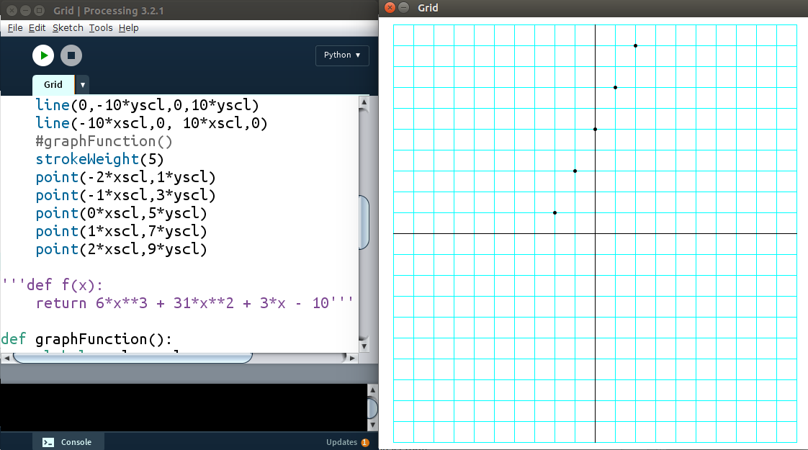
Figure 4.9: Plotting points one by one.
That's very time consuming and there is an easier way. We just need a list of points and we can put them in the code automatically. Here's a function to make a list full of points from that function:
a = list() #or a = []
for i in range(-10,11):
a.append([i*xscl,(2*i+5)*yscl])
The list looks like this:
[[-10, -15], [-9, -13], [-8, -11], [-7, -9], [-6, -7], [-5, -5], [-4, -3],
[-3, -1], [-2, 1], [-1, 3], [0, 5], [1, 7], [2, 9], [3, 11], [4, 13], [5, 15],
[6, 17], [7, 19], [8, 21], [9, 23], [10, 25]]
List Comprehensions
Python has a way to create lists in a compact form. Instead of the three lines above, you can do it all in one line:
a = [[i,2*i+5] for i in range(-10,11)]
Here's the function for graphing points, given a list:
def graphPoints(pointList):
'''Graphs the points in a list'''
for p in pointList:
point(p[0]*xscl,p[1]*yscl)
However, you might remember “range” only contains integers. That means when we graph the points in list a, we'll see what's in Figure 4.10:
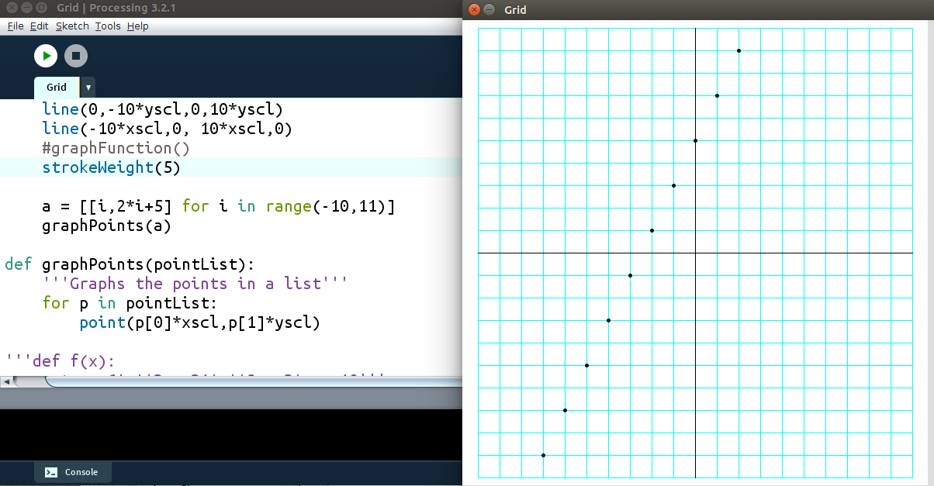
Figure 4.10: The points generated by the list comprehension.
Python has a terrific numerical package called Numpy which contains “arange,” which can go up by decimals. However, you can't import Numpy into Processing yet. Let's create our own “arange” function:
Exercise 4.8: Home on arange
Create a function called “arange” that creates a list. It should start at a given “start” value, go up by a given “step” value and put all the values into the list until it reaches a “stop” number, like this, which means “all the numbers from 1 to 3, going up by 0.25.” Like “range,” it doesn't contain the “stop” value.
>>> print(arange(1,3,0.25))
[1, 1.25, 1.5, 1.75, 2.0, 2.25, 2.5, 2.75]
Solution:
def arange(start,stop,step):
output = []
x = start
while x < stop:
output.append(x)
x += step
return output
Once we put that in our Processing sketch, we can generate a list of points using arange:
b = [[i,2*i+5] for i in arange(-10,11,0.1)]
and graph the points in that list. The output looks like figure 4.11:
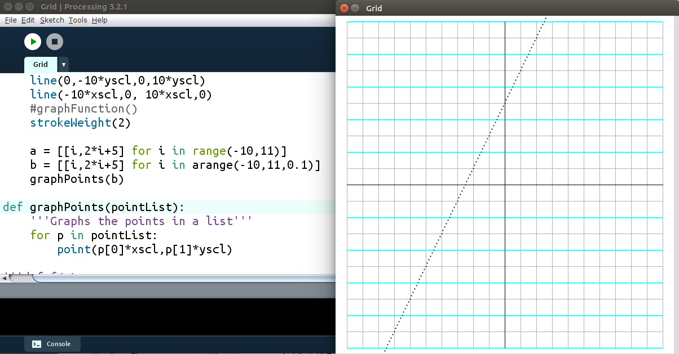
Figure 4.11: Graphing a function by generating the points
We could get a better looking graph by connecting the dots with lines:
def graphPoints2(pointList):
'''Graphs the points in a list using segments'''
for i,p in enumerate(pointList):
if i<len(pointList)-1:
line(p[0]*xscl,p[1]*yscl,
pointList[i+1][0]*xscl,pointList[i+1][1]*yscl)
This gets us the output in Figure 4.12:
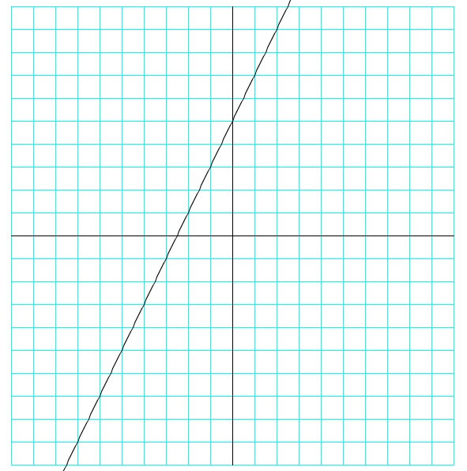
Figure 4.12
Exercise 4.9: Making connections
Write a program that will find the intersection point of two lines, given their slope and y-intercept. For example, if I want the intersection of the lines y = 2x + 5 and y = -3x – 10, I can just enter the numbers like this:
>>> intersection([2,5],[-3,-10])
(-3.0, -1.0)
Solution
If the y-value of the intersection point has to work in both equations y = 2x + 5 and y = -3x – 10, then the right sides must be equal:
2x + 5 = -3x – 10
But we can easily solve that with our “equation” function from earlier in this chapter! Use thtat to solve for the x-value of the intersection, then plug x into either line to find the y-value:
def intersection(line1, line2):
'''returns the intersection point of two
lines, given their slopes and y-intercepts'''
#find the x-value of the intersection
x = equation(line1[0],line1[1],line2[0],line2[1])
#find the y-value by plugging it in to either line
y = line1[0]*x + line1[1]
return x,y
To check, the graph of the lines and their intersection is in Figure 4.13:
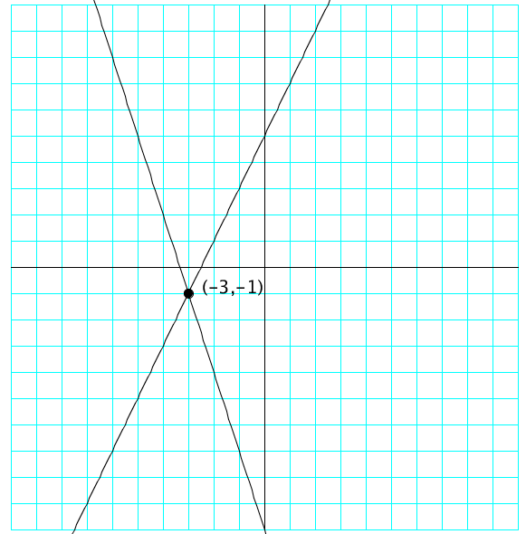
Figure 4.13: The intersection of two lines.
In Conclusion…
We've created a lot of tools in this chapter:
Plug and Check
Equation Solver
Quadratic Formula
Grid for Graphing
Graphing a Function
Find Roots by Halving
List Comprehensions
arange
PointList
Graphing from a Point List
Find Line Through Two Points
Intersection of Two Lines

Now we're going to use these to build even more powerful tools!

