4 [ChapterStart]
Mathematics may be defined as the subject in which we never know what we are talking about, nor whether what we are saying is true. - Bertrand Russell
Algebra: Transforming and Storing Numbers
Algebra is introduced in school as the idea of replacing numbers with letters. Instead of 2·3 you have 2x or 2y, for example, meaning “2 times some unknown number.” We've already used variables to replace numbers, and it's a vital tool in programming.

Unfortunately, in traditional math class variables are often used to represent a “mystery number” that a student is required to find. Not “find” as in Figure 4.1:
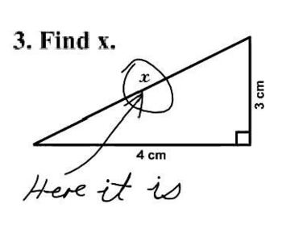
Figure 4.1: Math questions are subject to interpretation.
Every day in Algebra students are given an equation with an unknown (or two or three…) and they have to find what number or numbers make the equation true, like:
1. Solve 2x + 5 = 13.
“Solve” means “find out which number, when you replace x with that number, makes both sides of the equation equal.” Equations of this form don't take too much effort to solve, but even at this level we can use Python and “brute force” to plug in random numbers.
Exercise 4.1:
Write a program that will plug all the integers between -100 and 100 into the above equation and if one works, print out the number.
Solution:
def plug():
x = -100 #start at -100
while x < 100: #go up to 100
if 2*x + 5 == 13: #if it makes the equation true
print("x =",x) #print it out
x += 1 #make x go up by 1

plug() #run the plug function
The output is
x = 4
This is a valid way to solve a problem! It's too laborious for a human to do by hand, but using a computer it's a cinch. If the solution isn't an integer, you might have to increment by smaller numbers.
All “first-degree” equations, meaning those in which the highest exponent is one, fall into this pattern:
ax + b = cx + d
where a, b, c and d are numbers. Like these ones:
3x - 5 = 22
4x - 12 = 2x - 9

Sometimes there's no x term on one side, so the coefficient is zero. Using a little Algebra, you can solve the general form of the equation and that will help you solve all equations of that form.
ax + b = cx + d
Get all the x's on one side of the equals sign:
ax - cx = d - b
Now factor out an x:
x(a - c) = d - b
Divide both sides by a – c and you have the value of x:

Exercise 4.2:
Write a program that will take the four coefficients of the general equation above and print out the solution, like this:
>>> equation(2,5,0,13)
4.0
Solution:
def equation(a,b,c,d):
'''solves equations of the
form ax + b = cx + d'''
return (d - b)/(a - c)
Let's test it with an equation we've solved already:
>>> equation(2,5,0,13)
4.0
Check. Now for a more complicated one:
12x + 18 = -34x + 67
>>> equation(12,18,-34,67)
1.065217391304348
Using Return instead of Print
How do we check it? We plug that solution in for x. But why type all those digits? Notice we didn't use “print” in the program, but we used “return” instead. This means we can assign the result to a variable:
>>> x = equation(12,18,-34,67)
>>> x
1.065217391304348
We “stored” that result in the variable x. Now find out what the left side of the equation becomes with that number for x:
>>> 12*x + 18
30.782608695652176
Is it the same as the right side of the equation?
>>> -34*x + 67
30.782608695652172
Except for some rounding error at the end, yes!
Higher Degree Equations
Things get more complicated when there's an x² term, like x² + 3x – 10 = 0. This is called a polynomial (it means “many terms”). If you're faced with an equation with a squared term in it, like ax² + bx + c = 0, you should use the Quadratic Formula:

Exercise 4.3:
Write a program that will take a, b and c above and return the two solutions to the quadratic formula. Use it to solve x² + 3x – 10 = 0.
Solution:
Add this line to the top of your Python file to import the square root function:
from math import sqrt
Here's the function:
def quad(a,b,c):
'''Returns the solutions of an equation
of the form a*x**2 + b*x + c = 0'''
x1 = (-b + sqrt(b**2 - 4*a*c))/(2*a)
x2 = (-b - sqrt(b**2 - 4*a*c))/(2*a)
return x1,x2

>>> quad(1,3,-10)
(2.0, -5.0)
Here's how we check the answers:
>>> 2**2 + 3*2 - 10
0
>>> (-5)**2 + 3*(-5) - 10
0
Factoring
Many problems require students to solve those quadratic equations (with an x² term) by factoring. Factoring means reducing one number into the product of two or more numbers, like 30 = (5)(6). That means ax² + bx + c (if it's factorable) can be split into the form
(dx + e)(fx + g)
d and f are factors of a, and e and g are factors of c. All you have to do is go through all the factors of a and all the factors of c, and see if d*g + e*f equals b. It would be annoying for a human to go through every possible combination, but computers were made for such repetition. Remember the program you wrote that factored an integer? We need to adapt it to include the negative factors, too.

Exercise 4.4:
Write a program that will factor an integer and put all its factors (including negative ones!) into a list, like this:
>>> factor(6)
[1, -1, 2, -2, 3, -3, 6, -6]
Solution:
def factor(num):
factors = [] #factor list
num = abs(num) #use the absolute value
for i in range(1,num+1):
if num % i == 0:
factors.append(i)
factors.append(-i)
return factors
Now all you have to do is go through all the factors, add up d*g + e*f and see which combination adds up to b.
Exercise 4.5:
Write a program that will take a, b and c and print out the factored form of the polynomial, if it is factorable.
Solution:
def factorPoly(a,b,c):
afactors = factor(a) #get the factors of a
cfactors = factor(c) #get the factors of c
for afactor in afactors: #try all the factors of a
for cfactor in cfactors: #and c
#see which combination adds up to b
if afactor * c/cfactor + a/afactor * cfactor == b:
print("(",afactor,"x +",cfactor,")(",
int(a/afactor),"x +",int(c/cfactor),")")
return

>>> factorPoly(6,-1,-15)
( 2 x + 3 )( 3 x + -5 )
Unfortunately, not all polynomials are factorable. But using the Quadratic Formula will always work, even if the solutions aren't integers, rational numbers or even real numbers!
Solving Higher Degree Equations
In Algebra class students are often asked to solve a higher degree equation, like
6x³ + 31x² + 3x – 10 = 0
You can use the “plug” function and look for solutions manually:
def g(x):
return 6*x**3 + 31*x**2 + 3*x – 10

def plug():
x = -100
while x < 100:
if g(x) == 0:
print("x =",x)
x += 1
print("done.")

>>> plug()
x = -5
done.
That gives you one of the solutions. What if there were a way to see all the possible inputs and corresponding outputs to a function? Well, there is, and it's called graphing.
Creating Your Own Graphing Tool
We're going to use Processing to create a graphing tool that will allow us to see how many solutions our equation has. The basic setup of a Processing sketch in Python mode is shown in Figure 4.1:
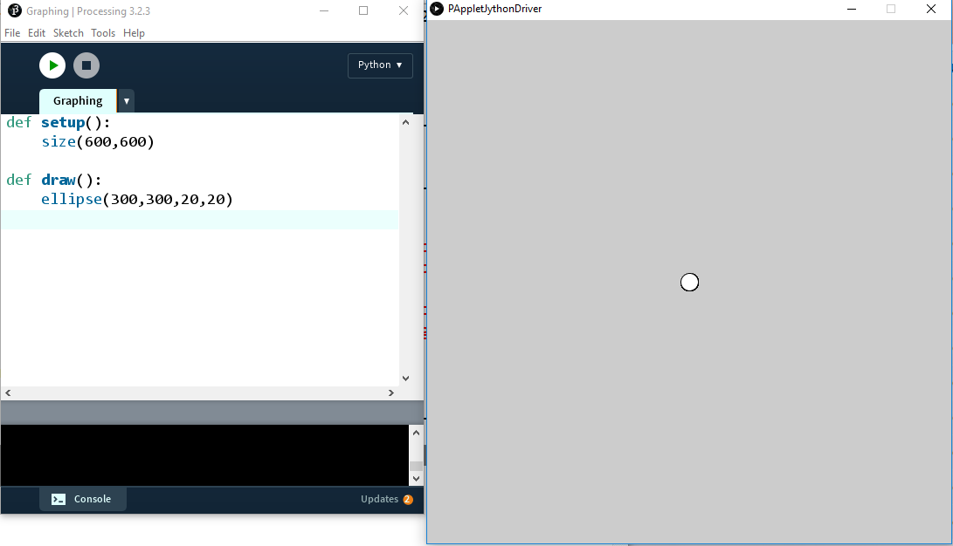
Unfortunately for us, computer graphics usually have their “origin” in the top left corner of the screen and the y-coordinates get larger as they go down the screen, not up, like in Figure 4.2:

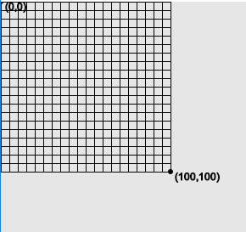

To move the origin to the center of the screen, we use the “translate” function:

translate(width/2, height/2)
So the origin will be in the middle of the screen. Figure 4.3 gives you the idea:
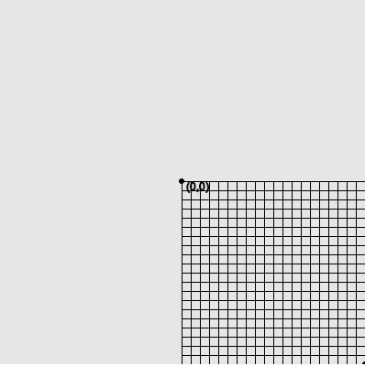
Our screen is still 600 pixels by 600 pixels but we probably will only need x- and y- values from -10 to 10. Let's declare a range of x- and y-values we're interested in displaying. If we really only need to see the values between -10 and 10, that's 21 integers (including zero). We can create two variables for the x-range and y-range this way:
rangex = 21
rangey = 21
We'll scale the coordinates down (or up) by simply multiplying the x- or y-coordinates by these factors. The “x-scale” factor would be 1 if our x-range were the same as the width, right? And it would be 2 if our range was between -300 and 300, so we're dividing the width by the x-range. Same for the y-scale. When graphing we'll have to remember to multiply all our x-coordinates and y-coordinates by these scale factors or they won't show up correctly on the screen.
xscl = width/rangex
yscl = height/rangey
Now we'll draw lines for the grid, in blue, like graph paper. The lines will go from (x, -10) to (x, 10) for each x value and from (-10, y) to (10, y) for each y-value.
#cyan lines
stroke(0,255,255)
for i in range(-10,11):
line(i*xscl,-10*yscl,i*xscl,10*yscl)
line(-10*xscl,i*yscl, 10*xscl,i*yscl)
Now we'll create the axes, a line between (0,-10) and (0,10) and another between (-10,0) and (10,0).
Exercise 4.6
Draw two black lines for the x- and y-axes.
Solution:
stroke(0) #black axes
line(0,-10*yscl,0,10*yscl)
line(-10*xscl,0, 10*xscl,0)
Add “background(255)” to the beginning of the draw function to set the background white. That gives us a nice grid, like in Figure 4.4:
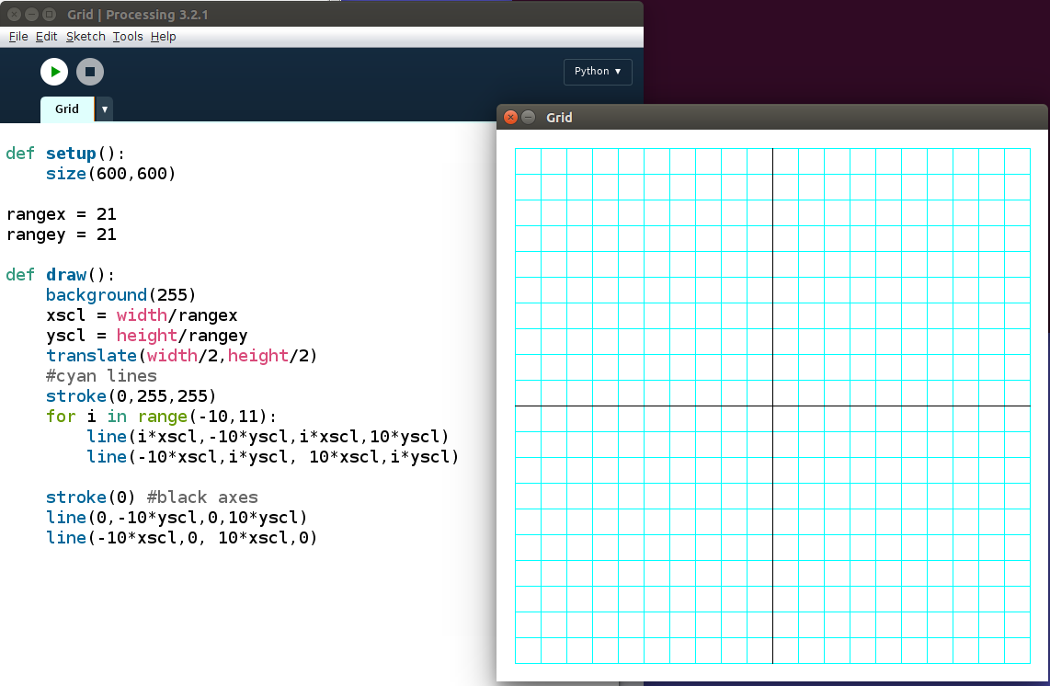
Figure 4.4: Creating a grid for graphing. You only have to do it once!
This looks done, but if we try to put a point (an ellipse, actually) at (3,6), we see a problem:
#test with a circle
fill(0)
ellipse(3*xscl, 6*yscl,10,10)
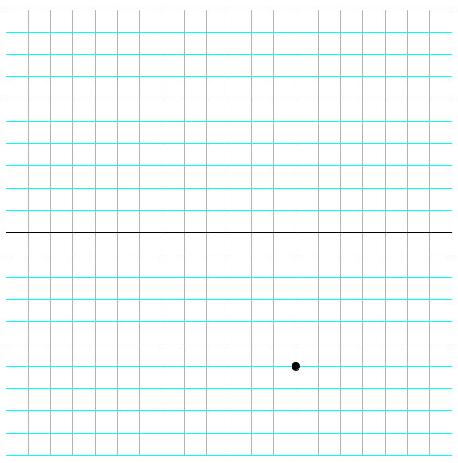
You'll see what's in Figure 4.5:
Figure 4.5: Checking our graphing program. Almost there!
The y-coordinates go up as we go down the screen, so our graph is “upside-down.” We can add a negative sign to the y-scale factor in the draw function to flip that over:
yscl = -height/rangey
This flips the output to how we want it, like in Figure 4.7:
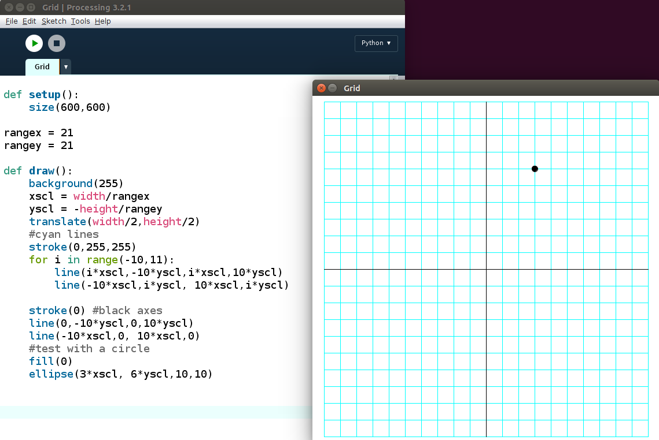
Figure 4.7: The grapher is working!
The grid function
To keep our code organized, we'll separate all the code that makes the grid into its own function and call it “grid.” Then we'll call the “grid” function in the draw function. It should look like this:
def draw():
background(255)
grid() #draw the grid

def grid():
global xscl, yscl
xscl = width/rangex
yscl = -height/rangey
translate(width/2,height/2)
#blue lines
strokeWeight(1) #thin lines
stroke(0,255,255) #cyan
for i in range(-10,11):
line(i*xscl,-10*yscl,i*xscl,10*yscl)
line(-10*xscl,i*yscl, 10*xscl,i*yscl)

stroke(0) #black axes
line(0,-10*yscl,0,10*yscl) #y-axis
line(-10*xscl,0, 10*xscl,0) #x-axis

Now we're ready to solve our equation:

6x³ + 31x² + 3x – 10 = 0

We'll add the function
def f(x):
return 6*x**3 + 31*x**2 + 3*x – 10
to our program and draw lines from every point to every “next” point, going up a tenth of a unit at a time:
def graphFunction():
x = -10
while x <= 10:
stroke(255,0,0) #red function
line(x*xscl,f(x)*yscl,(x+0.1)*xscl,f(x+0.1)*yscl)
x += 0.1
Finally, call “graphFunction” in draw function and you'll see the output in Figure 4.8:
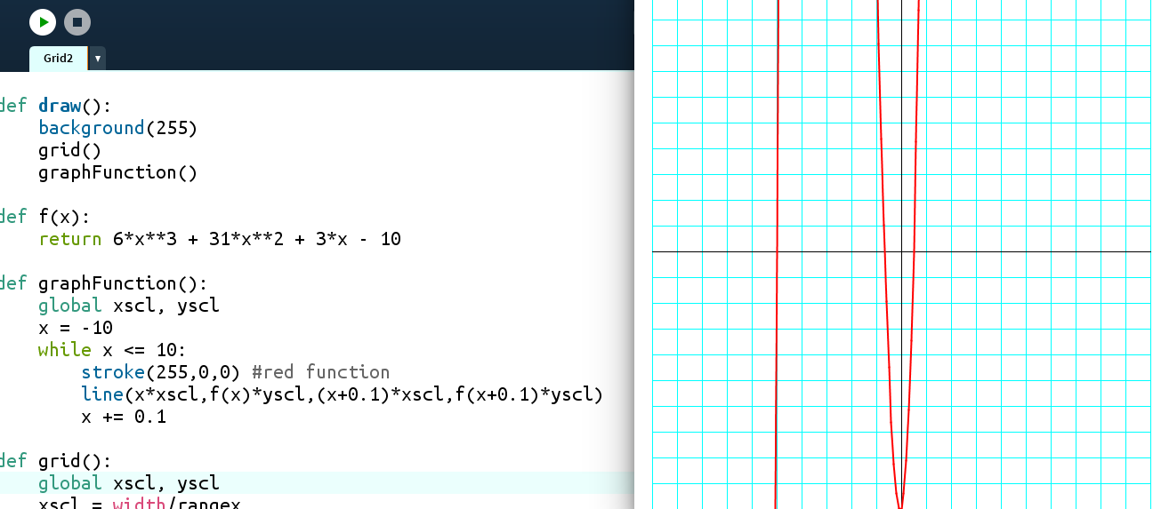
Figure 4.8: Graphing a polynomial function
The solutions to the equation (called the “roots”) are where the graph crosses the x-axis. We can see three places: where x = -5, where x is between -1 and 0, and where x is between 0 and 1.
The Halving Method
We already saw how effective our “Halving Method” was in the last chapter. Now we can use that method to approximate the roots. Let's start with the root between 0 and 1. Is it 0.5? We can easily plug in 0.5 and see. We'll move to IDLE for this.
def f(x):
return 6*x**3 + 31*x**2 + 3*x – 10

>>> f(0.5)
0.0
Another solution to our equation is 0.5. Finally, we'll try the root between -1 and 0.
>>> f(-0.5)
-4.5
Looking at the graph, now we can tell we guessed too high: the root is somewhere between -1 and -0.5. We'll average those endpoints and try again:
>>> f(-0.75)
2.65625
That's positive, so we guessed too low: the solution is between -0.75 and -0.5.
>>> f(-0.625)
-1.23046875
Too high. Do you see how we might use Python to do these steps for us?
Exercise 4.7
Create a function that will use the “halving method” to check for roots to the polynomial between a lower and upper value and adjust its “guesses” accordingly.
Solution:

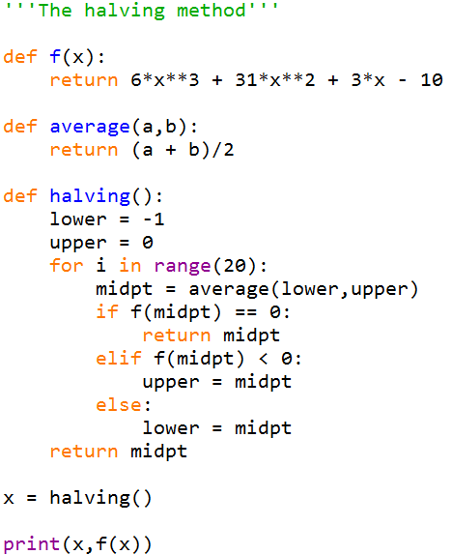
The output is
-0.6666669845581055 9.642708896251406e-06
x looks like it's around -2/3 and f(x) is close to 0. The “e-06” at the end means scientific notation. In decimal terms, that number is 0.00000964. If we increase the number of iterations from 20 to 40, we'll get a number even closer to 0:
-0.6666666666669698 9.196199357575097e-12
Let's check f(-2/3):
>>> f(-2/3)
0.0
The three solutions to the equation
6x³ + 31x² + 3x – 10 = 0
are x = -5, -2/3 and ½.
So now all we have to do to solve an equation, no matter how complicated, is graph it and approximate where it crosses the x-axis. By iterating and “halving” the range of values that work, we can get as accurate as we want.
When we learn a Calculus trick called the derivative, we'll have another method to solve equations like this. And when we really learn to use matrices, we'll learn how to solve systems of equations, too.
Variables are Supposed to Vary
People familiar with x's and y's in Algebra class might think variables represent a specific (and secret) number that people have to figure out. But that's not how variables are used in the real world. As you might suspect from their name, “variables” are letters that represent values that will vary, or change. We've already seen “i” used in this way in loops:
>>> for i in range(5):
print(i)
0
1
2
3
4
The variable i starts off as 0 and changes (or “varies”) every loop. This is incredibly useful, since it allows us to easily deal with situations when numbers change. We also saw how easy variables make things when a number pops up repeatedly, and changing a number once is easier than changing it throughout the code. A simple example is the polygon function we created for our turtles:
def polygon(num):
for i in range(num):
fd(100)
rt(360/num)
Whenever you want to change the number of sides in the polygon, the variable called “num” changes the value automatically throughout the function.
Algebraic Geometry
All this transforming using functions will come in handy when we're doing Geometry. For example, what is the midpoint of the points (1,2) and (-4,5)? The x-value of the midpoint is the average of the two x-values and the y-value of the midpoint is the average of the two y-values.
Exercise 4.8
Write a “midpoint” function that will take two points and return the midpoint, like this:
>>> midpoint((2,3),(-1,4))
(0.5, 3.5)
Solution:
def midpoint(a,b):
'''returns the midpoint of points a and b'''
x = average(a[0],b[0])
y = average(a[1],b[1])
return x,y
We can graph this midpoint by adding this to our “grid” program.
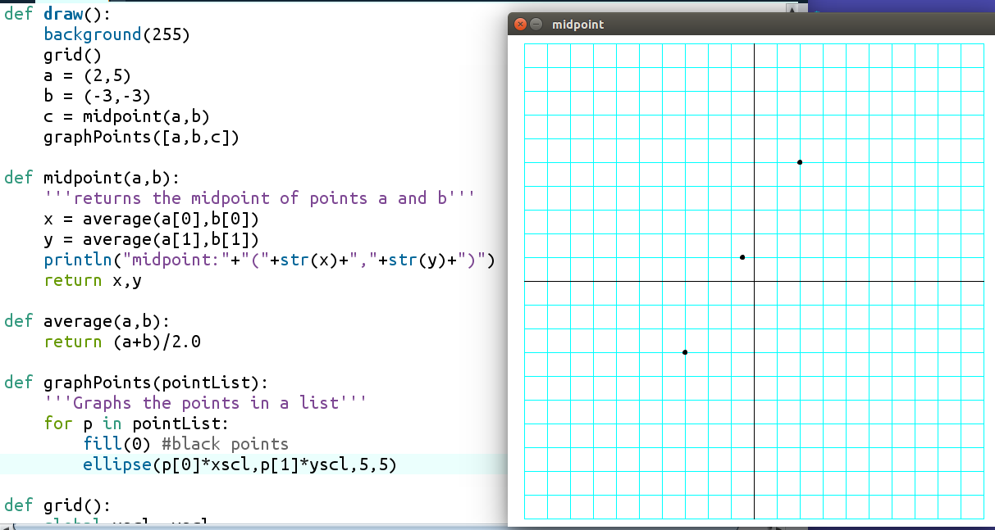
Figure 4.9: Graphing a midpoint

