6 [ChapterStart]
I've got an oscillating fan at my house. The fan goes back and forth. It looks like the fan is saying "No". So I like to ask it questions that a fan would say "no" to. "Do you keep my hair in place? Do you keep my documents in order? Do you have 3 settings? Liar!" My fan lied to me. - Mitch Hedberg
Trigonometry
Trigonometry means “the study of triangles.” It starts with right triangles and the three ratios between the sides: sine, cosine and tangent, given in Figure 5-1:
sin A = opposite / hypotenuse  cos A = adjacent / hypotenuse  tan A = opposite / adjacent | 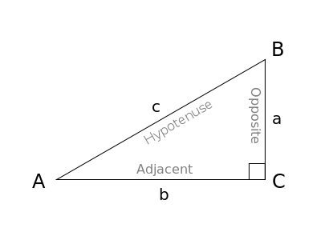
Figure 5-1 : The ratios of the sides of a right triangle
Students in Trigonometry class (or “Pre-calculus”) are assigned innumerable problems concerned with finding missing sides or angles in triangles. But this is seldom how trig functions are used in reality. In this chapter you'll see sine and cosine applied to oscillating motion, and you'll make some interesting, dynamic, interactive sketches. You'll apply the tangent function (and its inverse) to a problem of making a field of objects orient themselves to the location of your mouse.
Rotations
First of all, sines and cosines make rotations a cinch. In Figure 6-2, you can imagine r, the hypotenuse of the triangle, rotating around (0,0), becoming the radius of a circle.
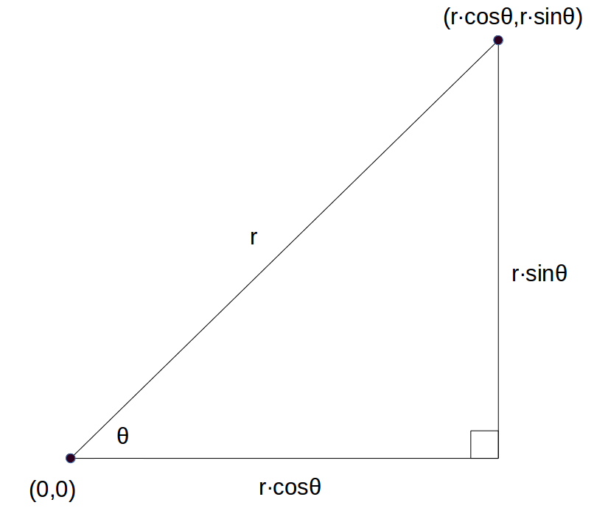
Figure 5-2 “Polar” form of coordinates of a point
Polygons
This makes creating polygons very easy. Remember how much geometry we needed to know to draw an equilateral triangle in the Geometry chapter? With trigonometry functions helping us with rotations, all we have to do is use Figure 6-2 to create a “polygon” function. The Processing functions “beginShape” and “endShape” define any shape we want using the “vertex” function to say where the points of the shape go. We can use as many vertices as we want. Here’s a simple example of making a shape using those tools:
def setup():  size(600,600)  def draw():  beginShape()  vertex(100,100)  vertex(100,200)  vertex(200,200)  vertex(200,100)  vertex(150,50)  endShape(CLOSE) | 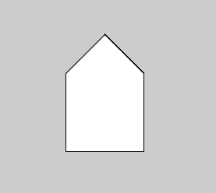
Figure 5-3 A shape made from vertices
But it’s laborious to enter more than 4 or 5 points. It would be great if you could just use a loop and just rotate the point, but if you run this code you get a blank screen!
def draw():
translate(width/2,height/2)
beginShape()
for i in range(6):
vertex(100,100)
rotate(radians(60))
endShape(CLOSE)
We can’t use “rotate” inside a shape because, remember, “rotate” spins the entire coordinate system. So we’ll use the sine and cosine notation from Figure 5-2 to rotate the vertices manually, and get what you see in Figure 5-4:
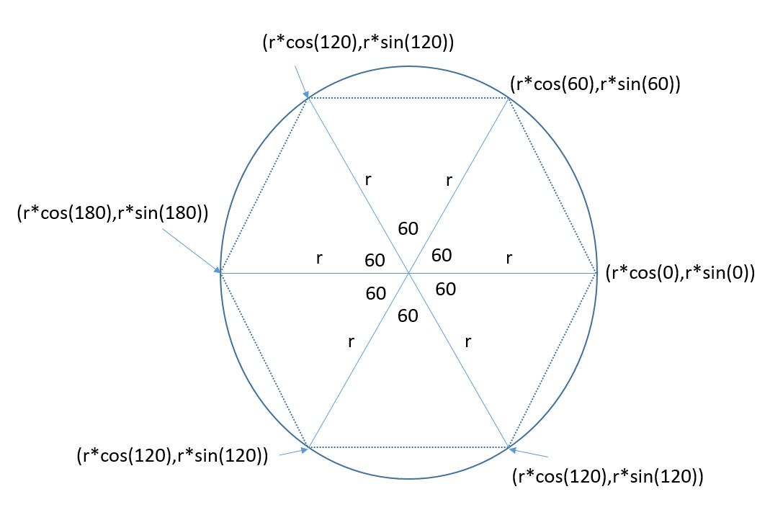
Figure 5-4 Using sines and cosines to rotate a point around the center.
So we have to use a number for the distance from the center of rotation. That won’t change. But the number of degrees changes. They’re all multiples of 60. Generally it’s
for i in range(6):
vertex(r*cos(60*i), r*sin(60*i))
In the code below, I’ve set r equal to 100 and I’ve converted the degrees to radians. Now we can get a hexagon, as in Figure 5-5:
def setup():  size(600,600)  def draw():  translate(width/2,height/2)  beginShape()  for i in range(6):  vertex(100*cos(radians(60*i)),  100*sin(radians(60*i)))  endShape(CLOSE) | 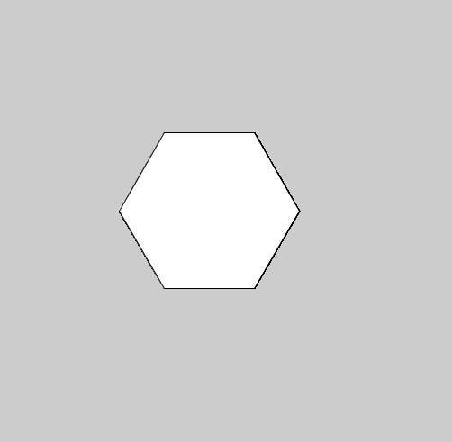
Figure 5-5: A hexagon built with a vertex and a loop.
We could create a function to make any polygon this way! The central angle is just 360 divided by the number of sides. Here's a simpler way to make an equilateral triangle:
def setup():
size(600,600)

def draw():
translate(width/2,height/2)
polygon(3,100) #3 sides, vertices 100 units from the center

def polygon(sides,sz):
'''draws a polygon given the number
of sides and length from the center'''
beginShape()
for i in range(sides):
vertex(sz*cos(radians(i*360/sides)),
sz*sin(radians(i*360/sides)))
endShape(CLOSE)
In the above code we created a “polygon” function that needs the number of sides and the size of the polygon. The rotation for each vertex is 360 divided by the number of sides. For our 6-sided hexagon above, we rotated 360/6 = 60 degrees. The line polygon(3,100) calls the polygon function and passes two inputs: 3 for the number of sides and 100 for the distance from the center to the vertices. Run it and you get what's in Figure 5-6:
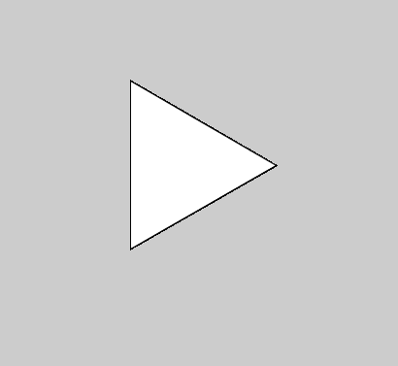
Figure 5-6: A much simpler Triangle!
Now making polygons of any number of sides (“n-gons”) a breeze. No square roots necessary!
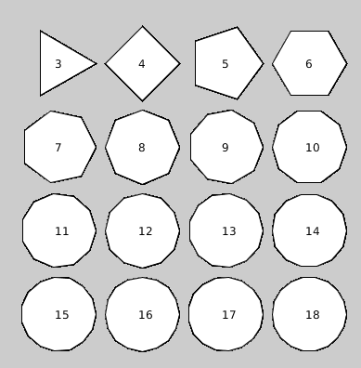
Figure 5-7 : All the Polygons you want!
Stars
Why stop with Polygons? Copy the “polygon” function and change a few lines so it looks like this:
def star(x,y,sides,sz):
'''draws a star given the number
of prongs and size at location (x,y)'''
turns = int(sides/2) #number of turns
beginShape()
for i in range(sides):
vertex(x+sz*cos(i*TWO_PI*turns/sides),y+sz*sin(i*TWO_PI*turns/sides))
endShape(CLOSE)
It'll allow you to make stars of any (odd) number of prongs. Figure 6.? contains a sample. To get rid of the lines you need to add “noStroke()” to the code above.
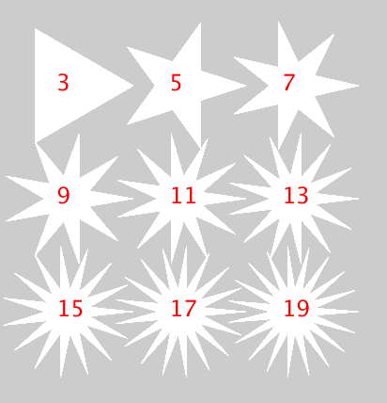
Figure 5-8: Stars made from vertices
Saving Points
In the polygon function we needed to save the x- and y-coordinate of the vertex so we could use it to draw a shape. Here’s an interesting design, a number of points evenly spaced around a circle. All the points are connected to all the other points. It looks like a mandala:
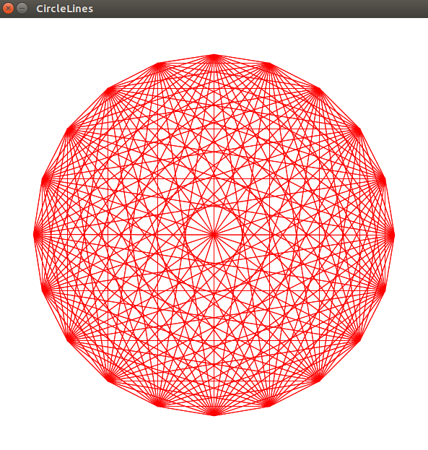
Figure 5-9: Mandala
Just like with polygons and stars, putting points around a circle is easy using rotations and translations. But we used sines and cosines to help us save the coordinates of the points. We only needed to create a simple function to draw a shape, but for this design we need to save all the points so we can draw lines between them. What do we use to save a bunch of values? Lists.
Create a list called “points” and then use the good old sine/cosine values for the locations around the circle. We’ll start off with 12 points:
‘’’circleLines.pyde’’’

def setup():
size(600,600)

def draw():
translate(width/2,height/2)
points = [] #empty points list
for i in range(12):
x = 250*cos(radians(360.0*i/12))
y = 250*sin(radians(360.0*i/12))
#put point in a list
points.append([x,y])
And then go through the list again and draw a line between every point and every other point.
for p in points: #from every point
for other in points: #to every "other" point
stroke(255,0,0) #red
line(p[0],p[1],other[0],other[1])
That gives us a nice Mandala as in Figure 5-10:
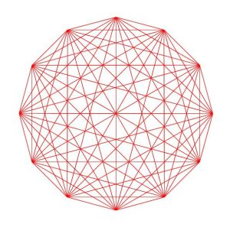
Figure 5-10: A 12-pointed Mandala
If we want to create more points, we can change the 12 to “num” so we can just change one “num:”
num = 24
for i in range(num):
x = 250*cos(radians(360.0*i/num))
y = 250*sin(radians(360.0*i/num))
#put point in a list
points.append([x,y])

for p in points: #from every point
for other in points: #to every "other" point
stroke(255,0,0) #red
line(p[0],p[1],other[0],other[1])
Trigonometry's True Purpose: Oscillation
Like Mitch Hedberg's fan at the beginning of the chapter, Sines and Cosines are for rotating and oscillating. Sines and cosines make waves when the height of a point on a circle is measured over time. Let's make a circle. Then we'll put a smaller circle on the circumference and as it travels around the circle, its height will draw out a sine wave.
Start a new Processing sketch and create a big circle on the left side of the screen like in Figure 5-11. Try it yourself before looking at the code below:
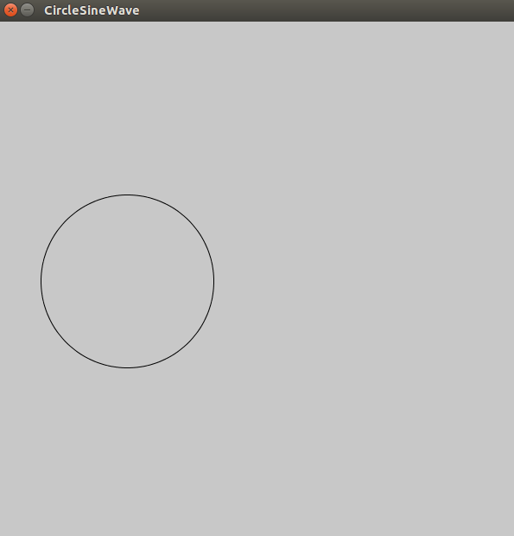
Figure 5-11: The start of the Sine Wave sketch
Here's the code:
#CircleSineWave.pyde
r1 = 100 #radius of big circle
r2 = 10 #radius of small circle
t = 0 #time variable

def setup():
size(600,600)

def draw():
background(200)
#move to left-center of screen
translate(width/4,height/2)
noFill() #don't color in the circle
stroke(0) #black outline
ellipse(0,0,2*r1,2*r1)
Now how do we make another circle spin around the big circle? Finding out the x- and y-coordinates of every spot on the circle isn't obvious, but it is obvious what the radius of the circle is, and all we have to do is rotate around the center. Using r as the radius of the circle and the Greek letter theta as the measure of the angle and using trig ratios, we can define a point on the circle as seen in Figure 6.2.
It might look more complicated than (x,y) but we only have to code it once and it'll work perfectly! Here's how to use sine and cosine to define the position of the ellipse that will rotate around the first circle.
#circling ellipse:
fill(255,0,0) #red
y = r1*sin(t)
x = r1*cos(t)
ellipse(x,y,r2,r2)
At the end of the draw function, make the time variable go up by a little bit:
t += 0.05
If you try to run this right now, you'll get an error message about “local variable 't' referenced before assignment.” Python functions have local variables but we want the draw function to use the global time variable t. So we have to add this line to the beginning of the draw function:
global t
Now you'll see a red ellipse traveling along the circumference of the big circle, as in Figure 6-3:
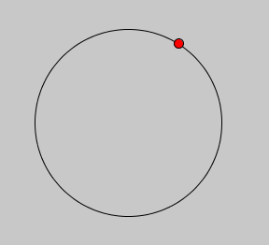
Figure 5-12: The red circle travels along the circumference of the big circle.
Now we'll chose a place over to the right of the screen to start drawing the wave. We'll extend a green line from the red circle to, say, x = 200. Add these lines to your draw function right before “t += 0.05.”
#CircleSineWave.pyde
r1 = 100 #radius of big circle
r2 = 10 #radius of small circle
t = 0 #time variable

def setup():
size(600,600)

def draw():
background(200)
global t
#move to left-center of screen
translate(width/4,height/2)
noFill() #don't color in the circle
stroke(0) #black outline
ellipse(0,0,2*r1,2*r1)
#circling ellipse:
fill(255,0,0) #red
y = r1*sin(t)
x = r1*cos(t)
ellipse(x,y,r2,r2)
stroke(0,255,0) #green for the line
line(x,y,200,y)
fill(0,255,0) #green for the ellipse
ellipse(200,y,10,10)
t += 0.05
Run your program and you'll see we've added a green circle that only measures the height of the red circle, as in Figure 6-13:
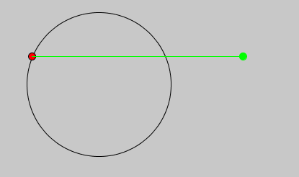
Figure 5-13 Getting ready to draw the wave!
Now we want the green ellipse to leave a trail to show its height over time. Leaving a trail really means we save all the heights and display them all, every loop. How do we save a bunch of things? We need a list. Add this line to the variables we declared at the beginning of the program, before the setup function:
circleList = []
And add it to the “global” line in the draw function:
global t, circleList
After we calculate x and y in the draw function, save the y-coordinate to the circleList:
#add to list:
circleList.insert(0,y)
At the end of the draw function (before incrementing t) we'll put in a loop. It will loop through all the elements of the circleList and draw a new ellipse, to look like the green ellipse is leaving a trail.
#loop over circleList to leave a trail:
for i in range(len(circleList)):
#small circle for trail:
ellipse(200+i,circleList[i],5,5)
A more “Pythonic” way of doing that is to use Python's built-in “enumerate” function. It’s a handy way of keeping track of the index and value of the items in a list. You’ll notice there are two variables (“index” and “value”) instead of just one (“i”), like this:
>>> myList = ["I","love","using","Python"]
>>> for index, value in enumerate(myList):
print(index,value)

0 I
1 love
2 using
3 Python
When you do this for your circle list, you can keep track of the iterator “i” and the circle “c.”
#loop over circleList to leave a trail:
for i,c in enumerate(circleList):
#small circle for trail:
ellipse(200+i,c,5,5)
This is the start of your Trigonometry class of the future! You made a sine wave, as you see in Figure 5-14:
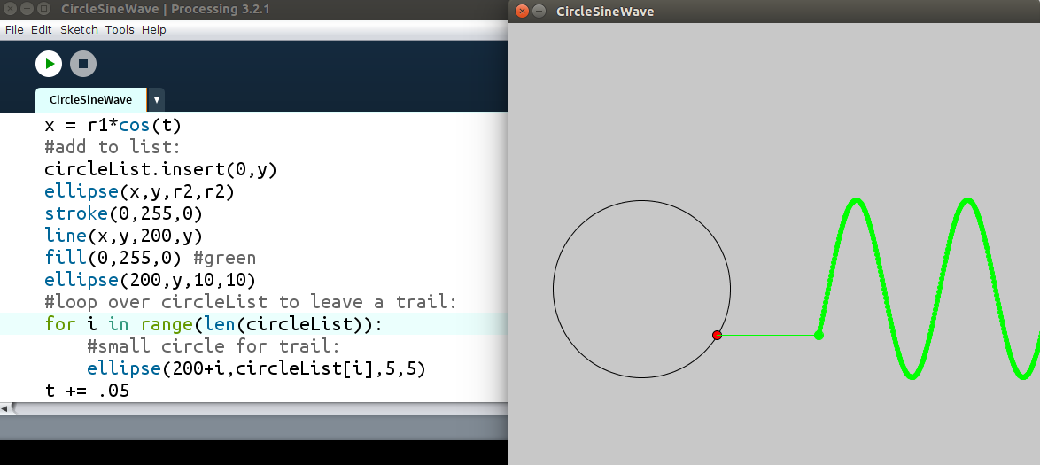
Figure 5-14: A sine wave
If you leave the program going for a while, you'll notice it starts to slow down. That's because the list of points is getting long, into the tens of thousands long! We can put a few lines of code in the draw function (right before the loop) to delete the first points if the list gets long enough:
if len(circleList)>300:
circleList.remove(circleList[-1])
Spirograph
Now that we can rotate circles and leave trails, it's time to make a Spirograph model!
First we'll start our sketch, put a big circle in the middle and create variables for the big circle and the small one:
from __future__ import division
'''Spirograph Model'''

r1 = 300 #radius of big circle
r2 = 175 #radius of circle 2
r3 = 5 #radius of drawing “dot”
#location of big circle:
x1 = 0
y1 = 0
t = 0 #time variable
points = [] #empty list to put points in
The first line is necessary so Python won't round off when it divides integers.
Now we can put the big circle on the screen and put a smaller circle on its circumference. But where to put the smaller circle?
Exercise 6-1: Our Ellipses Are so Close
Place the smaller circle on the circumference of the big circle, as in Figure 5-15:
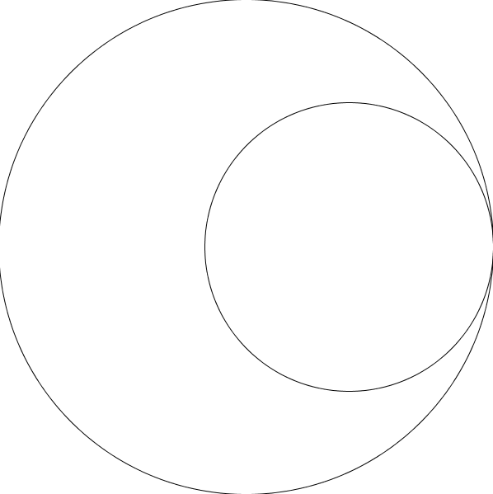
Figure 5-15
Solution:
def setup():
size(600,600)

def draw():
global r1,r2,x1,y1,t
translate(width/2,height/2)
background(255)
noFill()
#big circle
stroke(0)
ellipse(x1,y1,2*r1,2*r1)
#circle 2
x2 = (r1 - r2)
y2 = 0
ellipse(x2,y2,2*r2,2*r2)
Exercise 6-2: I Can See Your Ellipse Moving
Make the smaller circle rotate around “inside” the bigger circle, as if it's a Spirograph gear.
Solution
We'll need to declare our global variable t at the beginning of the draw function, and add the “sin” and “cos” parts to the location of circle 2:
x2 = (r1 - r2)*cos(t)
y2 = (r1 – r2)*sin(t)
Finally at the very end of the draw function, we have to increment our time variable:
t += 0.05
Now it should spin nicely! But how about that hole on the gear where the pen sits and draws the trail? We'll create a third ellipse to represent that point. Its location will be the second circle's center plus the difference of r
#drawing dot
x3 = x2+(r2 - r3)*cos(t)
y3 = y2+(r2 – r3)*sin(t)
fill(255,0,0)
ellipse(x3,y3,2*r3,2*r3)
Run this and you'll see the drawing dot right on the edge of circle 2, rotating as if circle 2 were sliding along circle 1's circumference. Circle 3 has to be a certain proportion between the center of circle 2 and its circumference so we'll introduce a “prop” variable:
prop = 0.9
…
global r1,r2,x1,y1,t,prop
…
x3 = x2+prop*(r2 - r3)*cos(t)
y3 = y2+prop*(r2 – r3)*sin(t)
Now we have to figure out how fast it rotates. It only takes a little Algebra (or common sense?) to prove its angular velocity (how fast it spins around) is the ratio of the size of the big circle to the little circle. And the negative sign means it spins in the opposite direction:
x3 = x2+prop*(r2 - r3)*cos(-((r1-r2)/r2)*t)
y3 = y2+prop*(r2 - r3)*sin(-((r1-r2)/r2)*t)
All that's left is to save the point (x3,y3) to a “points” list and draw lines between the points, just like we did in the wave sketch. Create a points list and put that with the variables before the setup function:
points = []
Then add the points list to the global line:
global r1,r2,r3,x1,y1,t,prop,points
After drawing the third ellipse, put the points into a list. Finally go through the list and draw lines between the points:
points.append([x3,y3])
if len(points) > 2000: #if the list gets too long
points.pop() #remove the first point
for i,p in enumerate(points): #go through the points list
if i < len(points)-1: #up to the next to last point
stroke(255,0,0)# draw red lines between the points
line(p[0],p[1],points[i+1][0],points[i+1][1])
Run this and watch the program draw a Spirograph!
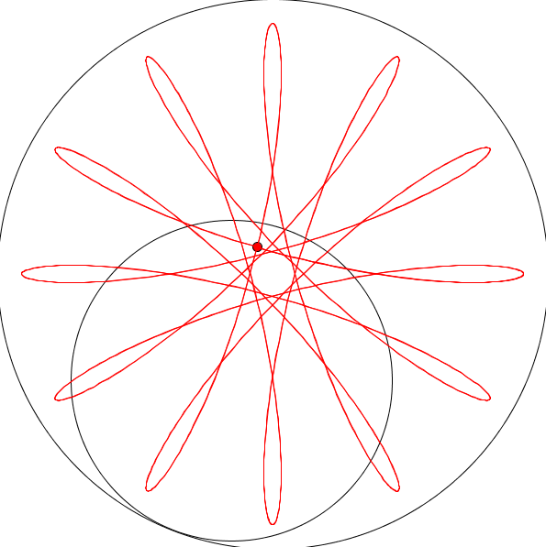
Figure 5-16 Drawing the Spirograph
Oscillating with Trigonometry
Another sketch that uses trig functions to oscillate back and forth is one by Dave “Bees and Bombs” Whyte. The interesting thing about this oscillation is that unlike our up-and-down sine wave in Figure 6.5, the wave oscillates in and out from the center. Start with the circle of circles template from the Geometry chapter in Figure 5-17. Here’s the code:
#Dots.pyde
def setup():
size(600,600)

def draw():
background(0)
translate(width/2, height/2)
for i in range(12):
ellipse(200,20,15,15)
rotate(radians(360/12))
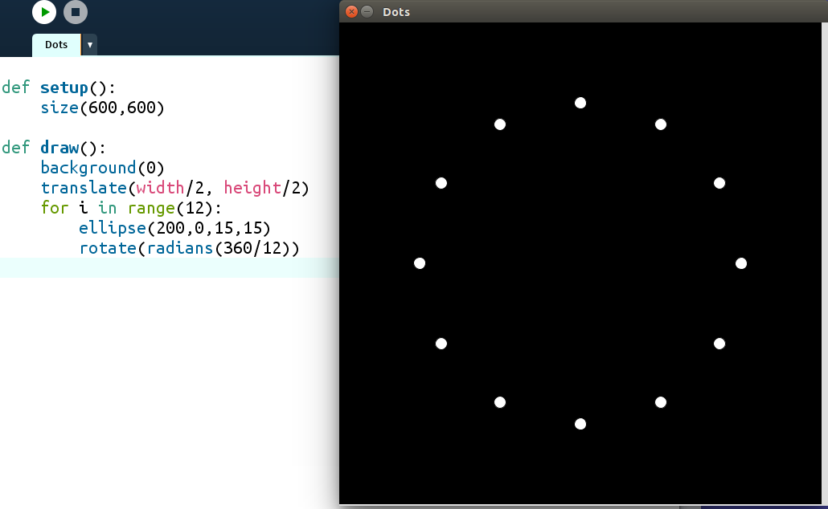
Figure 5-17
Now to oscillate the dots. Create a global time variable, use “sin(t)” in the ellipse location and increment time at the end of the draw function. The code now looks like this:
t = 0

def setup():
size(600,600)

def draw():
global t
background(0)
translate(width/2, height/2)
for i in range(12):
ellipse(120 + 90*sin(t),0,15,15)
rotate(radians(360/12))
t += 0.1
The dots are now oscillating in and out from the center. But they're moving in exactly the same way. Let's make them vary by their “i” value. Change the ellipse line to this:
ellipse(120 + 90*sin(t + i),0,15,15)
This makes each dot oscillate differently from its neighbors. You can change the look of the design by multiplying the “i” by a number. Play around with different numbers. To copy the sketch I saw, I used 0.75, and I changed the number of dots to 24:
for i in range(24):
ellipse(120 + 90*sin(t+.75*i),0,15,15)
rotate(radians(360/24))
To make some pretty rainbow colors, we’ll use the “Hue, Saturation, Brightness” color mode instead of “Red, Green, Blue.” Add this to your setup function:
colorMode(HSB) #hue, saturation, brightness
and just before drawing the ellipses in your draw function, add this:
#here’s the color; Vary the hue for rainbow
fill((15*i) % 255, 300, 300)
Surprisingly, each dot only moves in and out from the center. The wave is an optical illusion!
Harmonographs
Oscillating in one direction is one thing, but what about two directions? In the 1800s there was an invention called the harmonograph which was a table connected to two pendulums. When the pendulums swung the attached pen would draw on a piece of paper. As the pendulums swung back and forth and died down (“decayed”), the patterns would change in interesting ways, as in Figure 5-18:
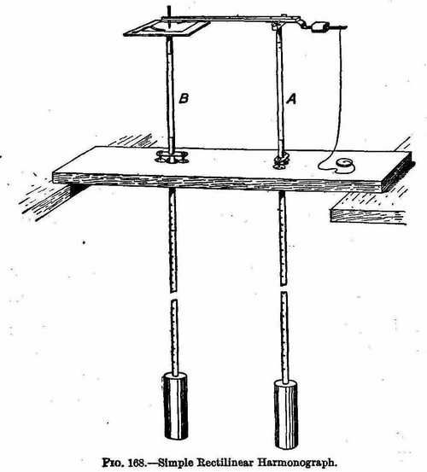
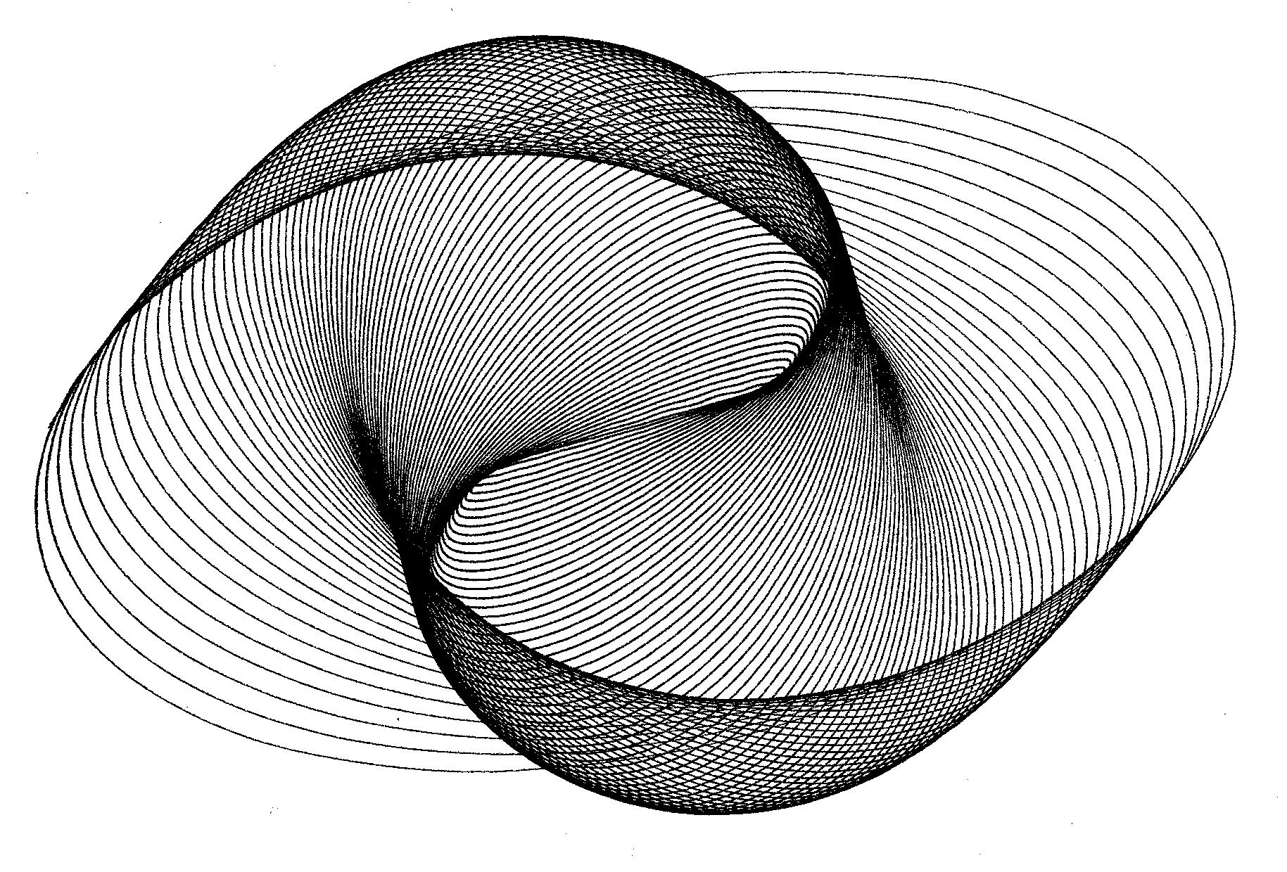
Figure 5-18 Harmonograph machine and design
Using programming and a few equations, we can model how a harmonograph drew its patterns. The equations to model the oscillation of one pendulum are
x = a*cos(ft + p)e-dt
y = a*sin(ft + p)e-dt
where x and y are the horizontal and vertical displacement (left/right and up/down distance), a is the amplitude (size) of the motion, f is the frequency of the pendulum, t is the elapsed time, p is the phase shift, e is the base of the natural logarithms (it’s a constant, around 2.7), and d is a decay factor (how fast the pendulum slows down). The time variable t will of course be the same in both of the above equations, but all the other variables can be different: the left/right frequency can be different from the up/down frequency for example.
Exercise : Model a pendulum
Create a Python-Processing sketch that models the movement of a pendulum with a time variable t and values for the amplitude (a1,a2), frequency(f1,f2), phase shift (p1,p2), and decay constants (d1,d2).
Solution:
We can model this using Python and Processing by creating a standard program with setup and draw and a time variable, as we’ve done before:
t = 0
def setup():
size(600,600)
noStroke()

def draw():
global t
background(255)
translate(width/2,height/2)
fill(0) #black
ellipse(0,0,5,5)
t += .1
This will give you a black dot in the center of the screen. Now we can add in the variables and equations. Here’s the new draw() function:
def draw():
global t
a1,a2 = 100,200
f1,f2 = 1,2
p1,p2 = 0,PI/2
d1,d2 = 0.02,0.02
background(255)
translate(width/2,height/2)
fill(0) #black
x = a1*cos(f1*t + p1)*exp(-d1*t)
y = a2*cos(f2*t + p2)*exp(-d2*t)
ellipse(x,y,5,5)
t += .1
You see the circle moving, but what is it drawing out? We need to put the points in a list and then graph all the points in the list. Right after declaring the t variable, create a list called “points.”
t = 0
points = []
...
def draw():
global t,points
a1,a2 = 100,200
f1,f2 = 1,2
p1,p2 = 0,PI/2
d1,d2 = 0.02,0.02
background(255)
translate(width/2,height/2)
x = a1*cos(f1*t + p1)*exp(-d1*t)
y = a2*cos(f2*t + p2)*exp(-d2*t)
points.append([x,y])

for p in points:
fill(0) #black
ellipse(p[0],p[1],5,5)
t += .1
Now when we run it we see the dot leave a trail of points behind it:
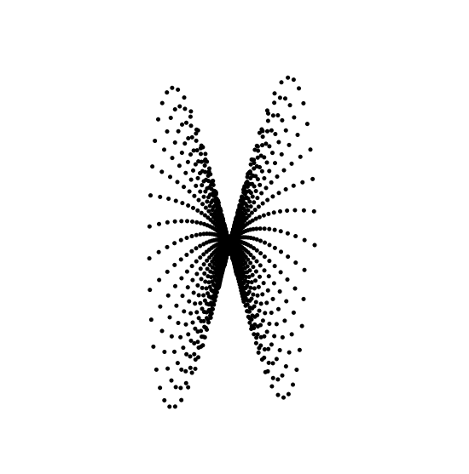
Figure 5-19 A harmonograph of dots
Change the “t += 0.1” line to “t += 0.01” and the dots will get closer together, looking more like a trail:
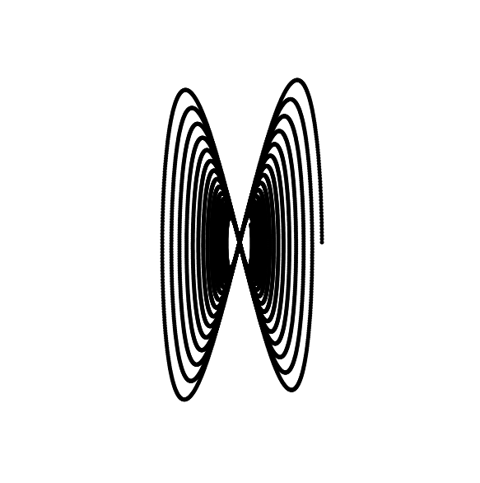
Figure 5-20 The dots are closer together
The first few times it’s cool to watch it draw the design. But this takes a while. What if we could fill the points list all at once? We’re drawing the whole list every frame, so there must be a way to fill the list instantly.
I cut the whole harmonograph code out of the draw function and pasted it into its own function like this:
def harmonograph(t):
a1,a2 = 100,200
f1,f2 = 1,2
p1,p2 = PI/6,PI/2
d1,d2 = 0.02,0.02
x = a1*cos(f1*t + p1)*exp(-d1*t)
y = a2*cos(f2*t + p2)*exp(-d2*t)
return [x,y]
Now in the draw function you just have to have a loop where you add a bunch of points for values of t:
def draw():
background(255)
translate(width/2,height/2)
points = []
t = 0
while t < 100:
points.append(harmonograph(t))
t += 0.01
for p in points:
fill(0) #black
ellipse(p[0],p[1],2,2)
Run this code! I changed the size of the ellipses and the phase shifts, so it looks different. Change each of the values yourself and see how it changes the design!
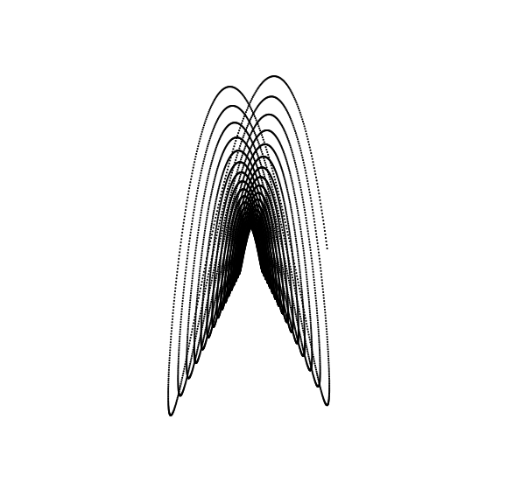
Figure 5-21 A different formula
Two Pendulums are Better Than One
We can add another pendulum to make more complicated designs by adding another term to each formula, like this:
x = a1*cos(f1*t + p1)*exp(-d1*t) + a3*cos(f3*t + p3)*exp(-d3*t)
y = a2*cos(f2*t + p2)*exp(-d2*t) + a4*cos(f4*t + p4)*exp(-d4*t)
Of course you have to make more variables, and give them values. Here are my suggestions for copying one of the designs I found on http://www.walkingrandomly.com/?p=151
def harmonograph(t):
a1=a2=a3=a4 = 100
f1,f2,f3,f4 = 2.01,3,3,2
p1,p2,p3,p4 = -PI/2,0,-PI/16,0
d1,d2,d3,d4 = 0.0085,0.065,0,0
x = a1*cos(f1*t + p1)*exp(-d1*t) + a3*cos(f3*t + p3)*exp(-d3*t)
y = a2*sin(f2*t + p2)*exp(-d2*t) + a4*sin(f4*t + p4)*exp(-d4*t)
return [x,y]
Exercise 6: Forgot My Lines
The final step is to replace the dots with lines. We did this already in the Spirograph project. All you have to do is copy and paste the code for going through the points list and drawing lines between all the points! Change the t < 100 line to “t < 1000.” Then you’ll get a nice design like this:
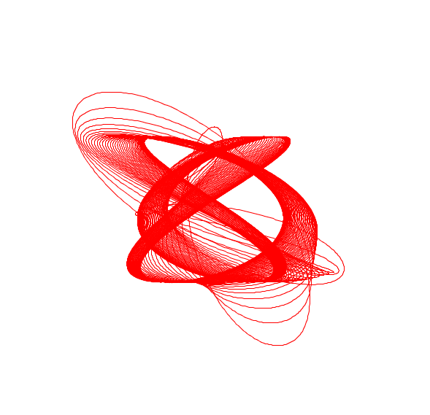
Figure 5-22 A complete harmonograph!
Solution:
#harmonograph.pyde
t = 0

def setup():
size(600,600)

def draw():
background(255)
translate(width/2,height/2)
points = []
t = 0
while t < 1000:
points.append(harmonograph(t))
t += 0.01
if len(points) > 2000: #if the list gets too long
points.pop() #remove the first point
for i,p in enumerate(points): #go through the points list
if i < len(points)-1: #up to the next to last point
stroke(255,0,0)# draw red lines between the points
line(p[0],p[1],points[i+1][0],points[i+1][1])

def harmonograph(t):
a1=a2=a3=a4 = 100
f1,f2,f3,f4 = 2.01,3,3,2
p1,p2,p3,p4 = -PI/2,0,-PI/16,0
d1,d2,d3,d4 = 0.0085,0.065,0,0
x = a1*cos(f1*t + p1)*exp(-d1*t) + a3*cos(f3*t + p3)*exp(-d3*t)
y = a2*sin(f2*t + p2)*exp(-d2*t) + a4*sin(f4*t + p4)*exp(-d4*t)
return [x,y]
Trigonometry is for Transforming!
While students in Trigonometry class are being asked to solve for unknown side lengths or angle measurements in triangles, the real use of sines and cosines is to rotate and transform points and shapes to make spirograph and harmonograph designs and much, much more!

