7 [ChapterStart]
Matrices
Matrices are rectangular arrays (lists) of numbers. Math students are usually taught how to add, subtract and multiply them without ever teaching them how they’re really used. Matrices are useful in machine learning and are absolutely crucial to 2D and 3D graphics.
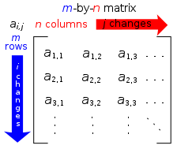
You’ve already seen things like (x,y), in which numbers can be arranged without being operated on. The point (2,3) doesn’t mean you add or multiply 2 and 3; they just sit next to each other. Matrices are like that, too. They have a number of rows and columns:

Matrices have m rows and n columns

Adding Matrices
You can only add and subtract matrices of the same dimensions (size and shape). It’s just a matter of adding or subtracting the corresponding elements:

That’s easy enough to put into a Python function, since you can save a matrix to a variable:
#matrices.py

A = [[2,3],[5,-8]]
B = [[1,-4],[8,-6]]

def addMatrices(a,b):
'''adds two 2x2 matrices together'''
C = [[a[0][0]+b[0][0],a[0][1]+b[0][1]],
[a[1][0]+b[1][0],a[1][1]+b[1][1]]]
return C

C = addMatrices(A,B)
print(C)
I declared a couple of 2x2 matrices, A and B, using Python’s list syntax. A, for example, is a list of 2 lists, both of which have 2 elements. I decalared a function called addMatrices, which takes two matrices as arguments. I created another matrix, C, which adds each element in the first matrix to the corresponding element in the second.

The output is
[[3, -1], [13, -14]]
Multiplying Matrices
Multiplying matrices is harder. You don’t simply multiply the corresponding elements. You multiply the elements in each row of the first matrix by the corresponding elements in each column of the second matrix. This means the number of columns in the first matrix has to equal the number of rows in the second or they can’t be multiplied.
Matrices as Lists of Points
Let's put a bunch of points into a list that make a special shape. I'll use the letter F because it's my initial:
fmatrix = [[0,0],[1,0],[1,2],[2,2],[2,3],[1,3],[1,4],
[3,4],[3,5],[0,5],[0,0]]
graphPoint2(fmatrix)
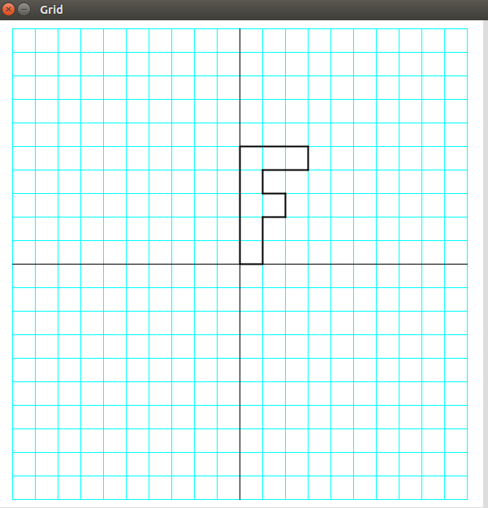
The output looks like figure 5.11:
Figure 5.11: The output of graphing the points in the matrix called “fmatrix.”
Let's change the “rangex” and “rangey” variables to something smaller so we can get a better look at the graph.
rangex = 15
rangey = 15
Now the output is what you see in Figure 5.12:
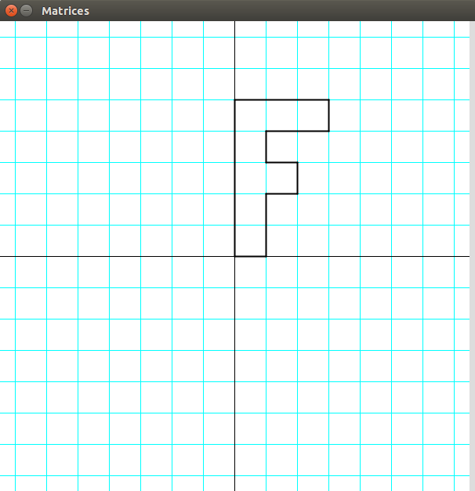
Figure 5.12: We changed the range of x and y to zoom in on the graph.
When we learn about matrices in school, we learn to add and multiply them, but we never learn why. It's only when you graph them that you learn that multiplying matrices is transforming them. You have to multiply every row in the first matrix by everything in every column in the second.
Exercise 5.3: Enter the Matrix
Create a function that will take two matrices, a and b and multiply them. Matrix a is a list of points in [x,y] form so for now b will be a 2x2 matrix.
Solution:
def multMatrix(a,b):
'''Multiplies two matrices.
b is a 2x2 matrix'''
newmatrix = []
for i in range(len(a)): # repeat for every row in matrix a
newmatrix.append([])
for j in range(2): #because b only has two columns
newmatrix[i].append(a[i][0]*b[0][j]+a[i][1]*b[1][j])
return newmatrix
Now that the hard part is done, let's transform the F using matrix multiplication. First we'll create a transformation matrix:
transformation_matrix = [[0,-1],[1,1]]
Next, we'll multiply the f-matrix by the transformation matrix and save the result to a new matrix. We'll graph the f-matrix in black and change the stroke color to red for the new matrix:
newmatrix = multMatrix(fmatrix,transformation_matrix)
graphPoints2(fmatrix)
stroke(255,0,0) #red resultant matrix
graphPoints2(newmatrix)
The result is what you see in Figure 5.13:
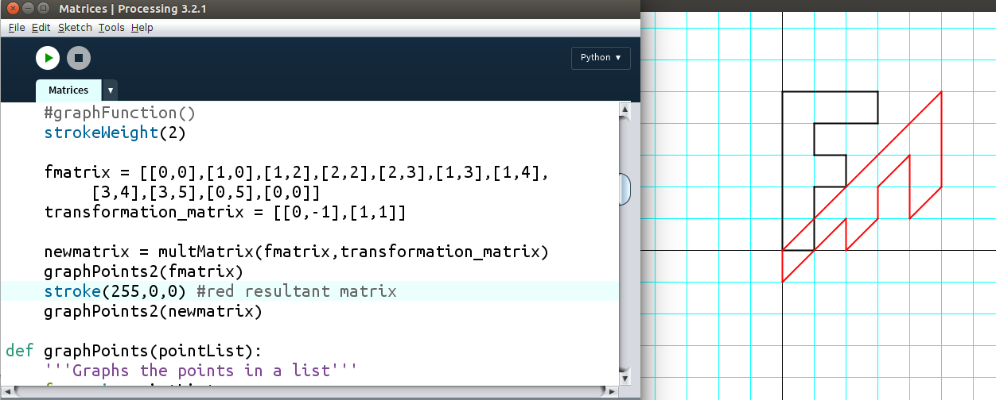
Figure 5.13
Exercise 5.4:
See what happens when your transformation matrix is one of these matrices:

Rotation Matrix – Interactive!
So we've just learned how matrices can transform points. This can happen in real time, and interactively, too. Change your code to this (we'll discuss “sin” and “cos” in the Trigonometry chapter):
ang = map(mouseX,0,width,0,TWO_PI)
rot_matrix = [[cos(ang),-sin(ang)],
[sin(ang),cos(ang)]]

newmatrix = multMatrix(fmatrix,rot_matrix)
Now the red F will rotate around the origin as you move your mouse left and right, as in Figure 5.14:
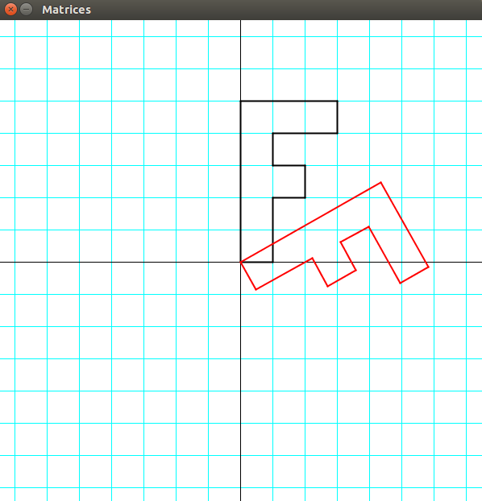
Figure 5.14: Transforming points using matrices in real time!
This is the kind of transformation that's happening on all the time when you see any animation on a computer screen. This is perhaps the most common application of matrices: computer graphics.
What About 3D?
You might be curious as to how we mathematicians crunch the numbers to represent a 3-dimensional object on a 2-dimensional surface, the computer screen. Luckily, all the math that's necessary is a few similar triangles, as in Figure 5.15:
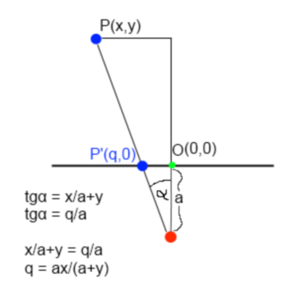
Figure 5.15: Collapsing the 3D point P to the point P' on the screen using ratios only
Here we go. It only requires that we add another dimension to our matrix of points:
fmatrix = [[0,0,0],[1,0,0],[1,2,0],[2,2,0],[2,3,0],[1,3,0],[1,4,0],
[3,4,0],[3,5,0],[0,5,0],
[0,0,1],[1,0,1],[1,2,1],[2,2,1],[2,3,1],[1,3,1],[1,4,1],
[3,4,1],[3,5,1],[0,5,1]]
And we'll extend our matrix multiplication function to any size:
def multmatrix(a,b):
'''Returns the product of
matrix a and matrix b'''
newmatrix = []
for i in range(len(a)):
row = []
#for every column in b
for j in range(len(b[0])):
sum1 = 0
#for every element in the column
for k in range(len(b)):
sum1 += a[i][k]*b[k][j]
row.append(sum1)
newmatrix.append(row)
return newmatrix
We'll make our mouse represent the angle of rotation again:
rot = map(mouseX,0,width,0,TWO_PI)
tilt = map(mouseY,0,height,0,TWO_PI)
And we'll multiply the rotation matrices together:
def rottilt(rot,tilt):
'''returns the matrix for rotating a number of degrees.'''
rotmatrix_Y = [[cos(tilt),0.0,sin(tilt)],
[0.0,1.0,0.0],
[-sin(tilt),0.0,cos(tilt)]]
rotmatrix_X = [[1.0,0.0,0.0],
[0.0,cos(rot),sin(rot)],
[0.0,-sin(rot),cos(rot)]]
return multmatrix(rotmatrix_Y,rotmatrix_X)
But first, we need to collapse the points from 3D to 2D:
#Camera position
Xc = 0
Yc = 3.0
Zc = 6.0
zoom = 10

def collapse(point):
'''Collapses 3D point to 2D'''
x = ((point[0] - Xc) / (point[2] + Zc) * zoom) + Xc
y = ((point[1] - Yc) / (point[2] + Zc) * zoom) + Yc
return [x, y]
Now we'll add an “edges” list so we can simply tell the program which points to link with segments:
#list of points to connect:
edges = [[0,1],[1,2],[2,3],[3,4],[4,5],[5,6],[6,7],
[7,8],[8,9],[9,0],
[10,11],[11,12],[12,13],[13,14],[14,15],[15,16],[16,17],
[17,18],[18,19],[19,10],
[0,10],[1,11],[2,12],[3,13],[4,14],[5,15],[6,16],[7.17],
[8,18],[9,19]]
Here's the new graphing function that will graph the edges between the points in the list:
def graphPoints2(pointList,edges):
'''Graphs the points in a list using segments'''
for e in edges:
line(pointList[e[0]][0]*xscl,pointList[e[0]][1]*yscl,
pointList[e[1]][0]*xscl,pointList[e[1]][1]*yscl)
You'll get what's in Figure 5.16:
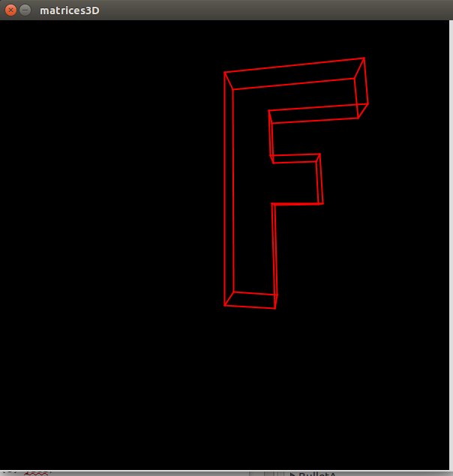
Figure 5.16: moving your mouse around will transform the F!

Solving Problems with Matrices
Matrices are of great use in solving systems of equations, like this one:

2x + 5y = -1
3x – 4y = -13
There’s a way to express this multiplication using matrices:

If only you could transform the 2x2 matrix on the left into the “identity matrix,” like this:

The numbers on the right would be the solutions for x and y.
You can arrange the coefficients and constants into one matrix like this:

There’s a method called Gaussian Elimination where you do operations on entire rows in order to get to the identity matrix. You can multiply or divide a row by a constant, and you can add or subtract a row from another row. It’s a laborious process, so we’re going to find a pattern and automate it with Python. Then we’ll be able to solve systems that are as big as we want!
1. Divide the row by the number where we want the “1.”
First, we’ll divide all the terms in the first row by 2, since we want a 1 where the 2 is:

2. Add the other row to the first row multiplied by the “additive inverse” of the term where you want a zero.
In row 2, we want a zero where the 3 is. So we’ll add the first row multiplied by -3 to the second row:

Now repeat where we want the 1 to be in the second row. We’ll multiply everything in row 2 by -2/23:

And add everything in the first row by the second row multiplied by the additive inverse of the term where we want the zero to be in the first row, in this case 5/2. We’ll add every term in the first row to the corresponding term in the second row multiplied by -5/2. Notice this doesn’t affect the 1, which we want to keep:

The solution to the system of equations is in the right column: x = -3, y = 1. We check it by plugging those numbers into the original system:
2(-3) + 5(1) = -6 + 5 = -1 Check!
3(-3) – 4(1) = -9 – 4 = -13 Check!
Doing it in Python
It might seem complicated, but there are really only 2 steps that we need to code:
1. Divide all the elements in a row by the term in the diagonal.
2. Add each term in one row to the corresponding term in another row.
Exercise: Divide and conquer
Given a row, divide all the terms by a number. For example, divide this row by 2.
row = [1,2,3,4,5]
Solution:
divisor = 2
row = [1,2,3,4,5]
for i, term in enumerate(row):
row[i] = term / divisor
print(row)
The output is:
[0.5, 1.0, 1.5, 2.0, 2.5]
Exercise: Add and conquer
Given two rows, add each element of one row to the corresponding element in the other row.
For example, add all the elements in row 0 below to the elements in row 1 and replace the elements in row 1 with the sum.
my_matrix = [[3,4,5,6,7],
[10,11,12,13,14]]
Solution:
for i,term in enumerate(my_matrix[1]):
my_matrix[1][i] += my_matrix[0][i]
print(my_matrix)
The output is
[[3, 4, 5, 6, 7], [13, 15, 17, 19, 21]]
We successfully added the terms in the first row to those in the second row.
Now we just have to put those steps together to do that for all the rows in a matrix. We’ll call the matrix A. Once we’ve put the x,y,z’s and the constant terms in order, we put only the coefficients and the constants into the matrix:
2x + y – z = 8
-3x – y + 2z = -1
-2x + y + 2z = -3

First, we divide every term by the term in the diagonal so the diagonal term will be 1. Notice the diagonal terms are where the row number is the same as the column number.
for j,row in enumerate(A):
#diagonal term to be 1
#by dividing row by diagonal term
if row[j] != 0: #diagonal term can’t be 0
divisor = row[j]
for i, term in enumerate(row):
row[i] = term / divisor
Now we go through every other row in the matrix and do the second step. So we’ll need a list of row numbers, and take out the current row (j):
rowList = [x for x in range(len(A))]
#don't do it to row j
rowList.remove(j)
Now, for each of the rows in the rowlist, calculate the additive inverse of the jth term, multiply each term in row j by that inverse and add those terms to their corresponding terms in the ith row. So each term in the first row of A is going to be multiplied by 3 and added to the corresponding term in the second row. And then every term in the first row is going to be multiplied by 2 and added to the corresponding term in the third row.

for i in rowList:
#calculate the additive inverse
addinv = -1*A[i][j]
#for every term in the ith row
for ind,value in enumerate(A[i]):
#add the corresponding term in the jth row
#multiplied by the additive inverse
#to the term in the ith row
A[i][ind] += addinv*A[j][ind]
Put all that code together into a “gauss” function and print out the results:
def gauss(A):
'''Converts a matrix into the identity
matrix by Gaussian elimination, with
the last column containing the solutions
for the variables'''
for j,row in enumerate(A):
#diagonal term to be 1
#by dividing row by diagonal term
if row[j] != 0:
divisor = row[j]
for i, term in enumerate(row):
row[i] = term / divisor

#add the other rows to the additive inverse
#this list will contain the row numbers
rowList = [x for x in range(len(A))]
#don't do it to row j
rowList.remove(j)
#for every other row
for i in rowList:
#calculate the additive inverse
addinv = -1*A[i][j]
#for every term in the ith row
for ind,value in enumerate(A[i]):
#add the corresponding term in the jth row
#multiplied by the additive inverse
#to the term in the ith row
A[i][ind] += addinv*A[j][ind]

return A

#example:
B = [[2,1,-1,8],
[-3,-1,2,-11],
[-2,1,2,-3]]

print(gauss(B))
The output is
[[1.0, 0.0, 0.0, 2.0], [0.0, 1.0, 0.0, 3.0], [-0.0, -0.0, 1.0, -1.0]]
We look at the last numbers in each row, so x = 2, y = 3 and z = -1.
This is a major achievement! Not only can we solve systems of 2 or 3 unknowns but any number of unknowns! Solving a system of 4 unknowns is a heart-breaking task if the student doesn’t know Python. But we do.
Exercise:
Solve this system of equations for w, x, y and z:
2w – x + 5y + z = -3
3w + 2x + 2y – 6z = -32
w + 3x + 3y – z = -47
5w – 2x – 3y + 3z = 49
Solution:
The only “problem” for us is typing all the coefficients and constants into a matrix:
>>> A = [[2,-1,5,1,-3],[3,2,2,-6,-32],[1,3,3,-1,-47],[5,-2,-3,3,49]]
>>> print(gauss(A))
The output is
[[1.0, 0.0, 0.0, 0.0, 2.000000000000001], [0.0, 1.0, 0.0, 0.0, -12.0], [0.0, 0.0, 1.0, 0.0, -4.0], [0.0, 0.0, 0.0, 1.0, 1.0000000000000004]]
Remember, our solutions are the last terms in each row, so, rounding off, w = 2, x = -12, y = -4 and z = 1. Check them by plugging into the original system.

