8 [ChapterStart]

Complex Numbers
Complex doesn't mean complicated. It means a number has a real and an imaginary part. The imaginary part is the square root of -1, called i or j. Some math books tell you imaginary numbers were discovered when somebody needed to solve an equation like this:
x² + 1 = 0
But we have a grapher and we can easily graph f(x) = x² + 1 and look at the graph for where f(x) is 0:

Figure 8.
It's never 0. There's no reason to pursue this any further, much less invent a whole new type of number to try to solve it.
Cubics
Fast forward to the 1500s, when Italian mathematicians were challenging each other to public competitions to see who could stump the other with increasingly abstract equations. The type of equation that was still unsolved was the cubic, like this one:
x³ + 6x² – 5x – 1 = 0
In this excellent book Journey Through Genius, William Dunham recounts the exciting race to the solution of the cubic and to the general cubic formula. It's like the quadratic formula but uglier. Don't believe me? The solution of ax3 + bx2 + cx + d = 0 is
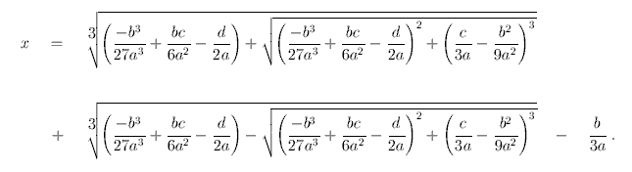

The mathematician Cardano published a similar formula in 1545! A problem arose when the formula was used to solve the equation x3 - 15x – 4 = 0. The square roots in the formula came out with a negative number in them!
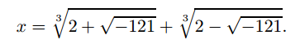
Just like the quadratic, we're tempted to throw the problem out as being impossible or meaningless, but let's look at the graph of f(x) = x3 - 15x – 4:
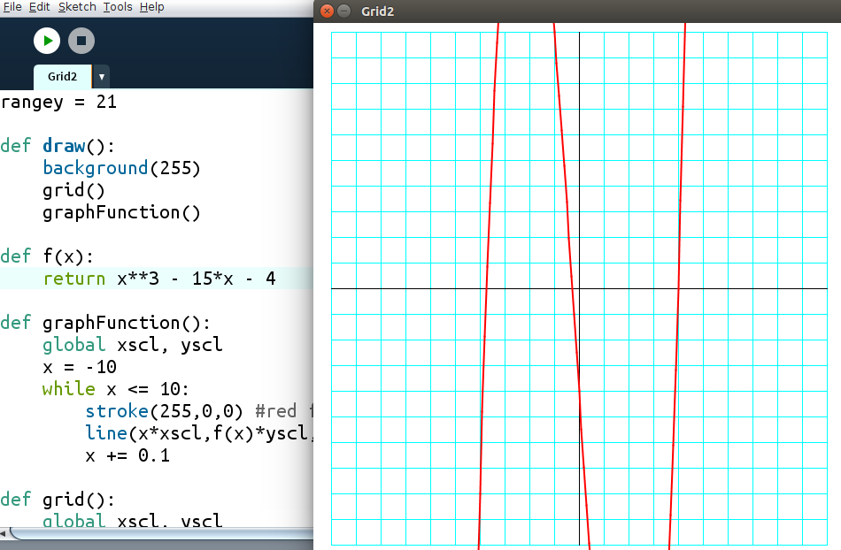
Figure 8.3
There are 3 real (and visible) roots to the equation! Mathematicians had to face this square root of a negative number problem and figure out a way to treat them like any other number. It wasn't for another few hundred years that they were named i, but √-121 = 11 * √-1 or 11i. Not long after Cardano, Bombelli solved this, possibly using logic but more realistically using trial and error.
Complex Numbers
So complex numbers have a real part and an imaginary part. We can use a list to represent a + bi as [a,b]. Multiplying two complex numbers will only require FOIL:
(a + bi)(c + di) = ac + adi + bci + bdi2 = ac – bd + (ad + bc)i or [ac – bd, ad + bc]
Exercise 8.1 FOILed again
Write a Python function that will take two complex numbers (as lists) and return their product, as outlined above.
Solution
def cMult(a,b):
'''returns the product of two
complex numbers a and b'''
return [a[0]*b[0] - a[1]*b[1], a[0]*b[1]+a[1]*b[0]]
Does this work? Let's check it with complex numbers we know, like those with no imaginary part:
>>> cMult([3,0],[4,0])
[12, 0]
Or let's square i:
>>> cMult([0,1],[0,1])
[-1, 0]
You can FOIL the product of another couple of complex numbers to check your function:
>>> cMult([1,-2],[-3,4])
[5, 10]
Now let's go back to Bombelli, who was looking for the complex number which, when cubed, equals 2 + 11i.
Exercise 8.2
Write a function that will take a complex number and return its cube. You'll use the cMult function.
Solution:
def cubeMult(a):
'''returns the cube of the
complex number a'''
return cMult(a,cMult(a,a))
Now let's find out if there's a combination of integers anywhere between -20 and 20 for the real and imaginary parts of the cube root. This is probably the way Bombelli solved this problem in the 1500s.
for real in range(-20,20):
for imag in range(-20,20):
a = [real,imag]
if cubeMult(a) == [2,11]:
print(a)
and the output:
[2, 1]
Sure enough, when you cube 2 + i, you get 2 + 11i.
Exercise 8.3:
Find the cube root of 2 – 11i
Solution:
for real in range(-20,20):
for imag in range(-20,20):
a = [real,imag]
if cubeMult(a) == [2,-11]:
print(a)
>>>
[2, -1]
But in the Algebra chapter we learned a way to closely approximate the roots of equations of any degree. x3 - 15x – 4 = 0 is a cinch. It looks like the largest root is 4, and sure enough 4³ – 15(4) – 4 = 64 – 60 – 4 = 0. The other two will require our halving method. The lowest root is between -4 and -3 and the function is increasing:
def f(x):
return x**3 - 15*x - 4

def average(a,b):
return (a + b)/2.0

def halving():
'''for finding roots of a polynomial.
works for increasing range.'''
lower = -4
upper = -3
for i in range(20):
midpt = average(lower,upper)
if f(midpt) == 0:
return midpt
elif f(midpt) > 0:
upper = midpt
else:
lower = midpt
return midpt

x = halving()

print(x, f(x))
And the output:
-3.732050895690918 -2.3603145535844305e-06
For the other root, between -1 and 0, is on a decreasing interval, so change the line “elif f(midpt) > 0” line to “elif f(midpt) < 0” and you'll get the third root, x = -0.26794910430908203.
Complex numbers are for Rotating
Complex numbers are easy to visualize and graph, because the graph of a + bi is really just the graph of the point (a,b) in the Cartesian coordinate system. For example, this is the graph of 2 + 3i:
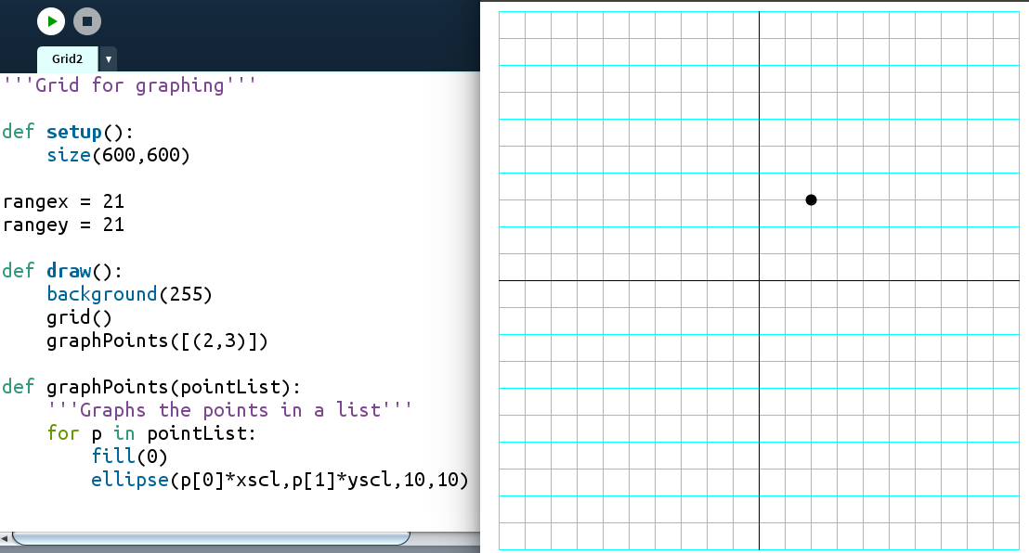
Figure 8.5
If we copy and paste the cMult function into our Processing sketch we can keep multiplying that complex number and see what happens to it.
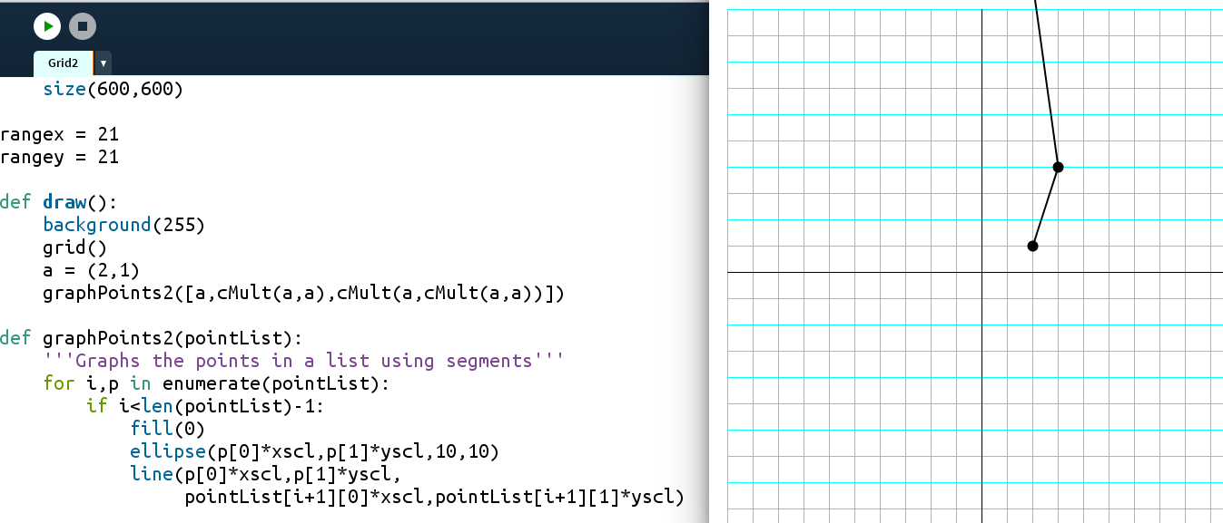
Figure 8.6
When we keep multiplying by 2 + 3i, the number keeps getting bigger and bigger until it's off our grid. We say it “diverges.” The number 0.5 + 0.75i doesn't diverge. It gets smaller until it's pretty much 0.

