9
Fractals
“Are fractals merely creatures of math and fantasy? Are fractals mere figments of a computer’s imagination? Or do they capture something at work in the real world?” - Howard Bloom, The God Problem
For centuries math class has been focused on the easy-to-create graphics like lines and the conic sections – parabolas, ellipses and so on. These were fine for modeling projectile and planetary motion but in the 20th Century mathematicians started to investigate shapes made with more complicated algorithms. These algorithms included recursion

Tree Fractal
The tree fractal is made up of a bunch of Y’s. If we can make a Y and return to our starting point, then we can replace the “branches” with Y’s and keep doing that. First, set up a Processing sketch:
#fractals.pyde

def setup():
size(600,600)

def draw():
background(255)
Now we create a “tree” function with a “length” parameter for the trunk. The length of the branches should be a percentage of the length of the trunk.
def draw():
background(255)
#translate to bottom of canvas:
translate(width/2,height-10)
tree(100)

def tree(length):
line(0,0,0,-length)
Remember “up” in the Processing coordinate system is the negative y-direction. This should draw a trunk:

Figure : The trunk of the tree
In order to create a tree, we don’t have to draw every branch and twig, but we have to translate up the trunk, draw the branches and translate back down again:
def tree(length):
line(0,0,0,-length)
translate(0,-length) u
rotate(radians(-30))
line(0,0,0,-0.8*length)
rotate(radians(50))
line(0,0,0,-0.9*length)
rotate(radians(-20))
translate(0,length)

In u we move up the trunk of the tree, then we rotate a certain number of degrees (I picked 30) in order to draw a branch. We have to convert the degrees into radians first, with radians(-30). The angle is measured clockwise, so the negative sign means it’s rotating counter-clockwise. The next line draws the branch 80% of the length of the trunk. After that we rotate clockwise 50 degrees and we draw the right branch 90% of the length of the trunk. We have to rotate back to the center 20 degrees and translate back down the trunk. Now we have a Y, the beginnings of a tree:
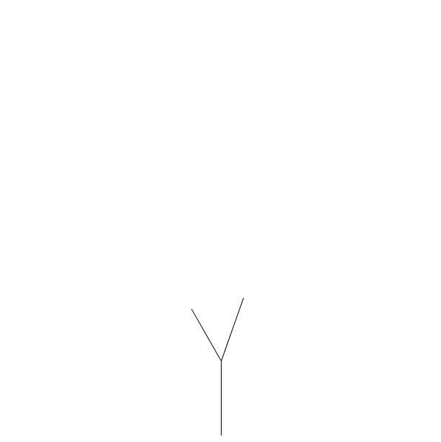
Figure 9: A tree with two branches
Here comes the interesting part: we want to replace the branches with smaller Y’s. So we change the “line” code for the branches to a “tree.”
def tree(length):
line(0,0,0,-length) u
translate(0,-length)
rotate(radians(-30))
tree(-0.8*length)
rotate(radians(50))
tree(-0.9*length)
rotate(radians(-20))
translate(0,length)
When we run this, unfortunately, we get an error message saying “maximum recursion depth exceeded.” We’re trying to draw a tree inside the definition of the tree function! It’s like the recipe for a loaf of bread including the line “Bake a loaf of bread.” We haven’t told the program how to make a tree yet. The solution is surprising.
Each “tree” will have its own “level,” and for the branches, the level will go down 1 and stop when the level is 0. So we add a parameter like this:
def tree(length,level):
Each call to the tree function will need a level, but it will be “level – 1,” and we’ll include a conditional so the whole process will only execute if the level is greater than 0.
if level > 0:
line(0,0,0,-length) u
translate(0,-length)
rotate(radians(-30))
tree(0.8*length, level - 1)
rotate(radians(50))
tree(0.9*length, level - 1)
rotate(radians(-20))
translate(0,length)
Notice the “length” of each branch has gone from negative to positive. The length variable in the line of code at u is negative and will make sure the tree grows up instead of down.
To draw the tree, call “tree(100,3)” in the draw function to get three Y’s:
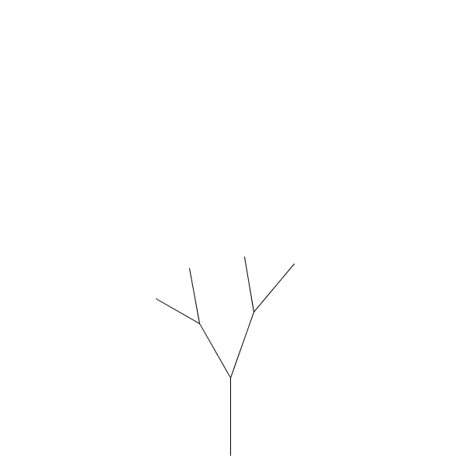
Figure : A level-3 tree
If you haven’t already done so, draw a tree with a much higher level, like 15:
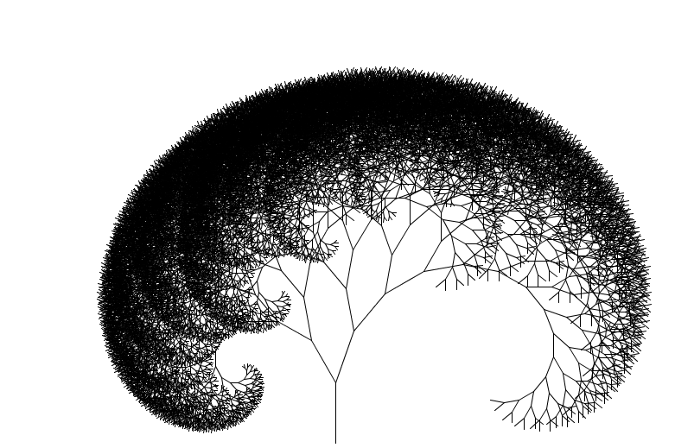
Figure : A level-15 tree!
The great thing about using a graphics library like Processing is you can change a parameter like the first angle you drew, the -30 degrees, to a variable so you can change it dynamically with the mouse. Create an angle1 variable and map the mouse’s x-value to it. Angle1 should go between -100 and 100 degrees:
line(0,0,0,-length)
translate(0,-length)
angle1 = map(mouseX,0,width,-100,100)
rotate(radians(angle1))
tree(0.8*length, level – 1)
rotate(radians(50))
tree(0.9*length, level - 1)
rotate(radians(-50 – angle1)) u
translate(0,length)
You can make the lower branches thicker by putting this line just before the “line” code:
strokeWeight(level)
You’ll see a more realistic tree:


1st Para (large font paragraph at start of chapter; do not use for NXT books)
BodyFirst (standard paragraph following heading; no indent)
Body (standard paragraph; indented)
Basic: For manga speech bubble text (manga template only)
Italic: For italic manga speech bubble text (manga template only)
HeadA (first level heading)
HeadB (second level heading)
HeadC (third level heading)
CodeA (first line of code listings -- 78 characters available in layout)
CodeB (middle lines of code listings)
CodeC (last line of code listings)
CodeSingle (code listing of only one line)
CodeA Wide (listings set wide into the margin -- 95 characters available in layout)
CodeB Wide
CodeC Wide
CodeSingle Wide
CodeA Indent (listings indented in lists -- 74 characters available in layout)
CodeB Indent
CodeC Indent
CodeSingle Indent
◆ CodeA Wingding (for putting wingdings in the margin)
❖ CodeB Wingding (leave a default font space after the margin wingding)
⬥ CodeC Wingding
 CodeSingle Wingding
Note (for short asides)
List Plain A (first item; shorter “term/description” lists -- begin with EmphasisBold + em space)
List Plain B (middle items)
List Plain C (final item)
ListHead
ListBody (use ListHead/ListBody for longer “term/description” lists)
NumListA (first item, numbered list)
NumListB (middle items)
NumListC (final item)
SubNumberA (first item, numbered sublist)
SubNumberB (second items)
BulletA (first item, bulleted list)
BulletB (middle items)
BulletC (final item)
SubBullet (bulleted sublist)
ListSimple (second paragraph for any kind of list item)
Block Quote (for longer quotations)
Epigraph
Caption (for images – numbered: Figure 1-1, etc.)
Listing (caption for code listings that need references – numbered: Listing 1-1, etc.)
Table Title (title for tables – numbered: Table 1-1, etc.)
Table Header (for header row paragraphs in tables)
Table Body (for body row paragraphs in tables)
Footnote
Author Query (use this for conversation between authors/editors – do not use Comments)
Production Directive (use this for directions to production folks)
EmphasisBold (regular bold text – for menu paths, buttons, terms in plain lists)
EmphasisBoldBox (regular bold text in text boxes)
EmphasisItalic (regular italic text – for introduced vocab terms, etc.)
EmphasisItalicBox (regular italic in text boxes)
EmphasisItalicFoot (regular italic in footnotes)
EmphasisBoldItal (for bold text in italic paragraphs, italic text in bold phrases, etc.)
EmphasisNote (for italic in Notes; allows for different Note styles in different templates)
EmphasisRevItal (for text that would be italic in italic paragraphs or phrases)
EmphasisRevCaption (for text that would be italic in captions)
Keycap (for keyboard key names – underlying text should be lowercase)
Literal (for code text in regular paragraphs)
LiteralBox (for code text in text boxes)
LiteralFootnote (for code text in footnotes)
Literal1st (for code text in 1st Para)
LiteralCaption (for code text in captions)
LiteralBold (for highlighting user input in code listings, etc.)
LiteralItal (for placeholder words in code listings, etc.)
LiteralBoldItal (for italic in bold phrases or bold in italic phrases in code)
 (MenuArrow) (numeral 4 arrow character for menu paths)
 (Wingdings,  for code annotation references in regular text paragraphs)
 (Wingdings Small,  for code paragraphs)

HeadANum (first level numbered head: 1.1, etc.)
HeadBNum (second level numbered head: 1.1.1, etc.)
HeadCNum (third level numbered head: 1.1.1.1, etc.)
Note Warning (for asides with “Warning” flag rather than “Note”)
styles for text boxes:
HeadBox
BodyFirstBox.*
BodyBox.
List Plain A Box Text text text.
List Plain B Box Text text text.
List Plain C Box Text text text.
ListHeadBox
ListBodyBox.
BulletA Box
BulletB Box
BulletC Box
NumListA Box.
NumListB Box.
NumListC Box.
CaptionBox.
* FootnoteBox.

