5 [ChapterStart]
Geometry
In the teahouse one day Nasrudin announced he was selling his house. When the other patrons asked him to describe it, he brought out a brick. “It's just a collection of these.” - Idries Shah
In traditional Geometry class, everything is about dimension, so we study lines (1-dimensional), circles, squares or triangles (2D), or spheres and cubes (3D). In the new Geometry class, creating a shape with modern (free) software is a trivial task. It’s manipulating and transforming the shapes that’s the challenge, and those are the explorations you’ll do here. It’ll still be about circles and triangles for a while, but soon you’ll see new shapes: fractals and cellular automata, that extend the old patterns into the future.
Processing
Using the Processing graphics package, it’s trivial to put a circle on the screen, as shown in Figure 5.1:
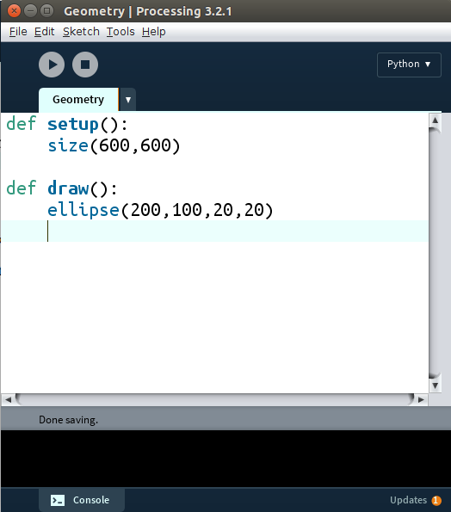
Figure 5.1: All the code required to draw a circle on the screen
When you click the Run button (it looks like the “Play” symbol), you’ll see what’s in Figure 5.2:
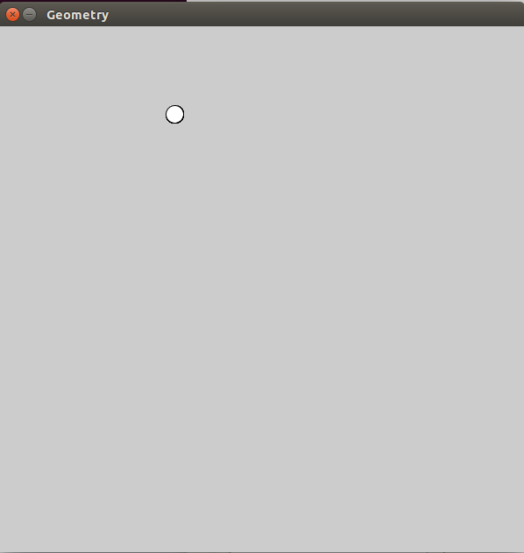
Figure 5.2: The output of the above code.
Processing has functions that make it easy to draw shapes. Look at the reference pages and you'll see ellipses, triangles, rectangles, arcs and more, as in Figure 5.3:
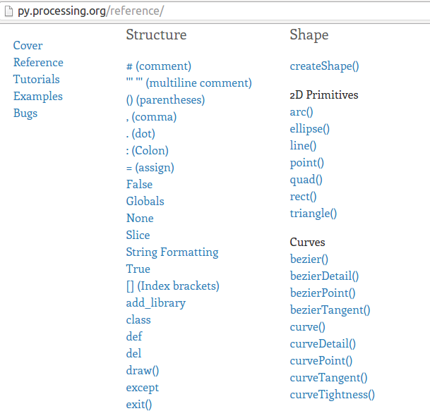
Figure 5-3: Part of the reference page of the Python mode of Processing.
Drawing a circle is no longer the challenge. The challenge in the Math Class of the Future will be using circles and other shapes to create dynamic, interactive graphics, and in doing that you’ll learn about location and transformations.
Location
In traditional math graphs, the center of the page is the “origin,” where x = 0 and y = 0, as in Figure 5.4:

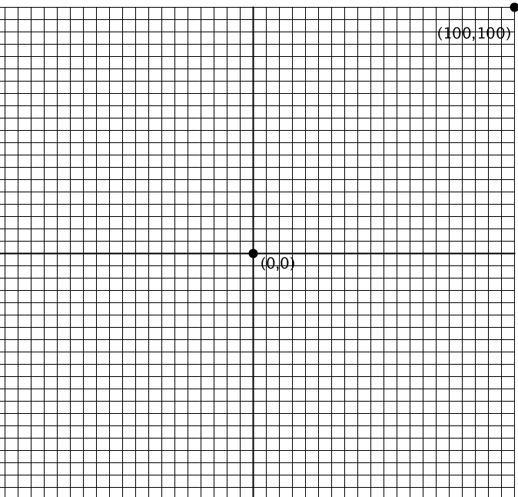
Figure 5.4 The traditional math graph setup. Notice the origin in the center.
In many computer graphics, however, the case is a little different. The x- and y-coordinates start in the top-left corner of the screen and go to the right (x) and down the screen (y), as in Figure 5.5:
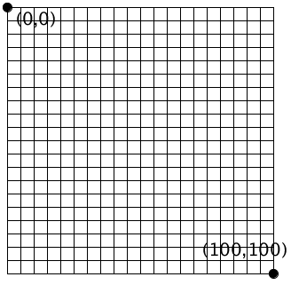
Figure 5.5 The coordinate system for computer graphics.
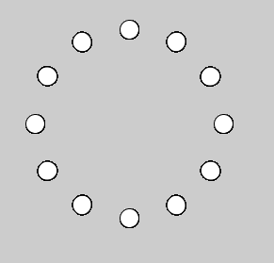
The good news is you don’t have to deal with negative numbers unless you really want to. But drawing things can get complicated pretty quickly. For example, the design in Figure 5.6:
Figure 5.6: A circle of circles. Do you need to know the coordinates of each circle?
In a case like this, you don’t really need to know the absolute x- and y-coordinates of a figure. If only there were an easy way of placing objects where you want them. Well, there is a way.
Transformations
Transformations are an important part of the traditional Geometry class, and they’re an absolutely vital part of the Geometry class of the future.
When you tell Processing to translate, it moves the entire grid, as in Figure 5.7:
translate(50,80);
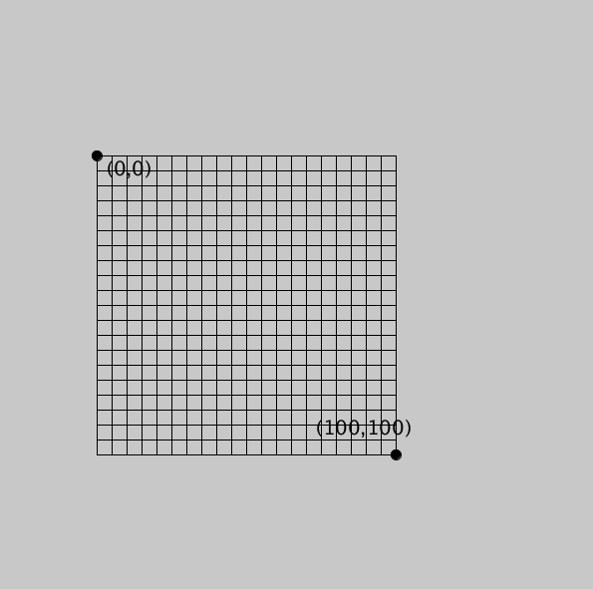
This is helpful for moving the “origin” (0,0) to the center of the canvas when you want to. This will look like Figure 5.8:
translate(width/2, height/2);
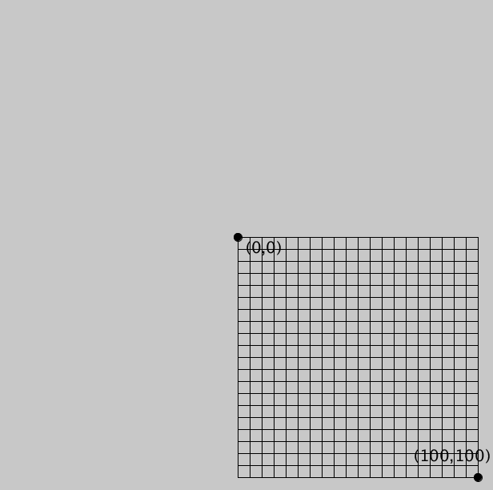
Figure 5.8 The grid is translated to the center of the screen
Rotate
Another useful function is “rotate,” which rotates the grid about (0,0), as in Figure 5.9:

rotate(radians(20)); | translate(width/2,height/2);  rotate(radians(20));
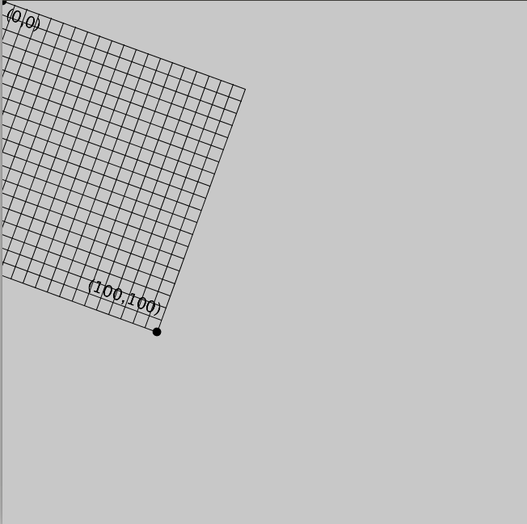 | 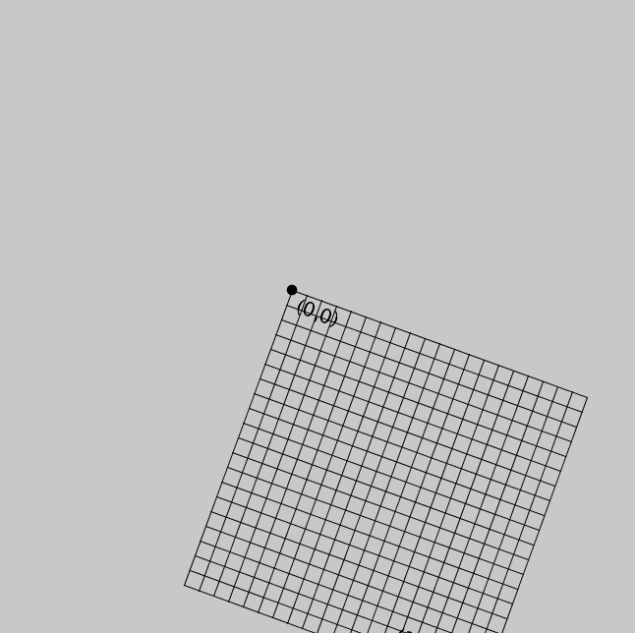
Figure 5.9: Rotating the grid always happens about (0,0)
As you can see in the code above, rotation is done in radians. If you think in degrees (like I do), just convert to radians using the “radians()” function first.
In the figure above on the left, the grid is rotated 20 degrees around (0,0), which is at the top left corner of the screen. In the figure on the right, the origin has been translated to the center of the canvas and then the grid has been rotated.
Making circles of objects is easy with rotate. Here are the steps:
- Translate to where you want the center of the circle to be.
- Rotate the grid and put the objects on the circumference of the circle.
Exercise 5.1
Create a program that will generate what is in Figure 5.7 using the steps above.
Solution:
First we have to translate to the center of the screen:
translate(width/2,height/2)
Then we have to start a loop that will place an ellipse at some point and rotate after each one.
for i in range(12):
ellipse(200,0,50,50)
rotate(radians(360/12))
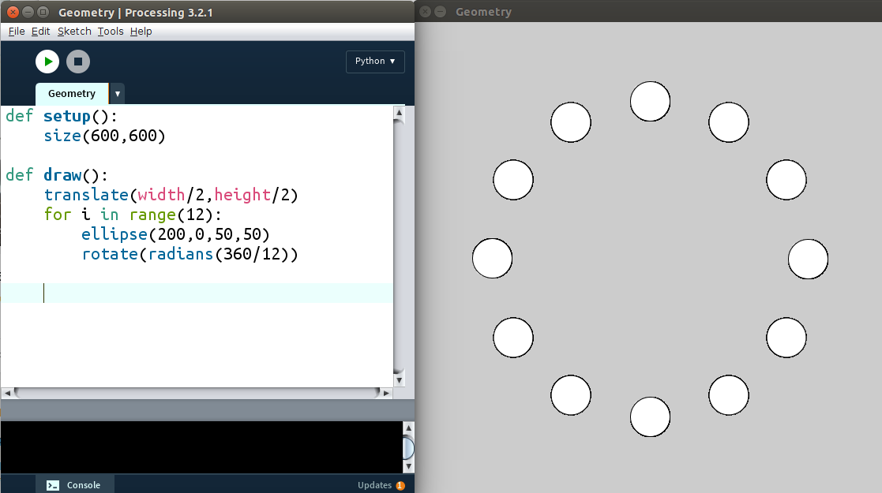
You'll get what's in Figure 5.10:
Figure 5.10: The code and output for translating, rotating and repeating.
If you add another step to that sequence, you can rotate the objects in the circle. Obviously we can't tell if the circles are rotating, so we'll replace them with squares for now.
Exercise 5.2: Squaring the Circle
Change the program from drawing circles to squares.
Solution:
Change the “ellipse” line to this:
rect(200,0,50,50)
As you can tell from the output when you run this, rotate is done instantly, so in order to see a rotation, we have to introduce a time variable. You can use Processing's built-in “frameCount” variable or create your own t. We're going to create t. You can add “t = 0” before the setup function and the line
rotate(radians(t))
before the loop, you'll get the error message:
UnboundLocalError: local variable 't' referenced before assignment
This is because Python doesn't know whether you're creating a whole new “local variable” t inside the function that doesn't have anything to do with the “global variable” t outside the function. All you have to do is add “global t” at the beginning of your draw function and it will know you mean the same t. Now the whole circle of squares should rotate, as in Figure 5.11:
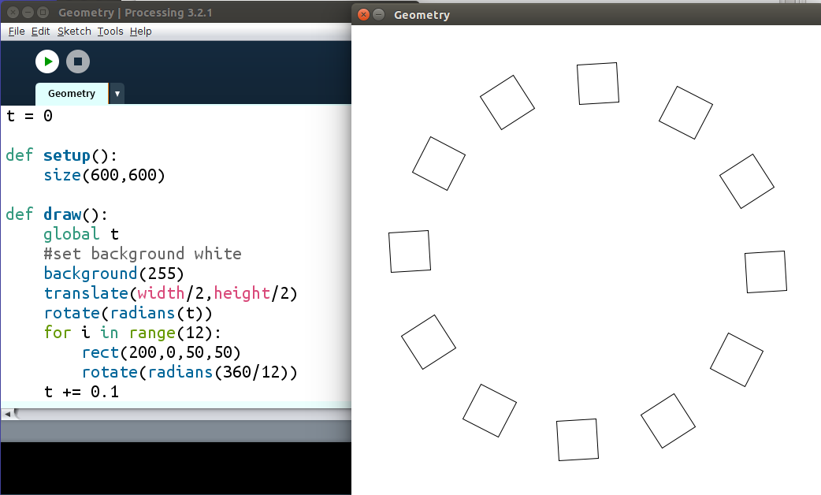
Figure 5.11
That's how you rotate the whole circle. What we want is to rotate each square, too. However, rotating is done around (0,0) in Processing, so inside the loop we have to translate to where we want each square to be, rotate, and draw the square. The code will look like this:
for i in range(12):
translate(200,0)
rotate(radians(t))
rect(0,0,50,50)
rotate(radians(360/12))
But when you run it (please run it!) you'll find that creates some strange behavior. That's because of changing the center, and changing the orientation of the grid so much. Processing has an easy way to save the orientation at a certain point, then returning to that orientation. It's “pushMatrix” and “popMatrix.” We want to save the orientation when we're in the center of the screen. So the loop should look like this:
for i in range(12):
pushMatrix() #save this orientation
translate(200,0)
rotate(radians(t))
rect(0,0,50,50)
popMatrix() #return to the saved orientation
rotate(radians(360/12))
That works perfectly, but if the rotation looks strange to you, it's because Processing locates a rectangle at its top left corner. If you want rectangles to be located at (and rotated around) their center, add this line to your setup function:
rectMode(CENTER)
Yes, the capitalization matters. Now the rectangles will rotate around their centers, too. If you want them to spin more quickly, change their rotate line to this:
rotate(radians(5*t))
The 5 is the frequency of the rotation. Change it and see what happens!
Grid of Objects
Making a grid of a hundred objects seems like a time-consuming task but in fact, using a loop or two makes it easy. We want to vary x and y by regular intervals.
Exercise 5.3: On the Grid
Create a 12 x 12 grid of squares.
Solution:
With very little code, Figure 5.12 is almost there:
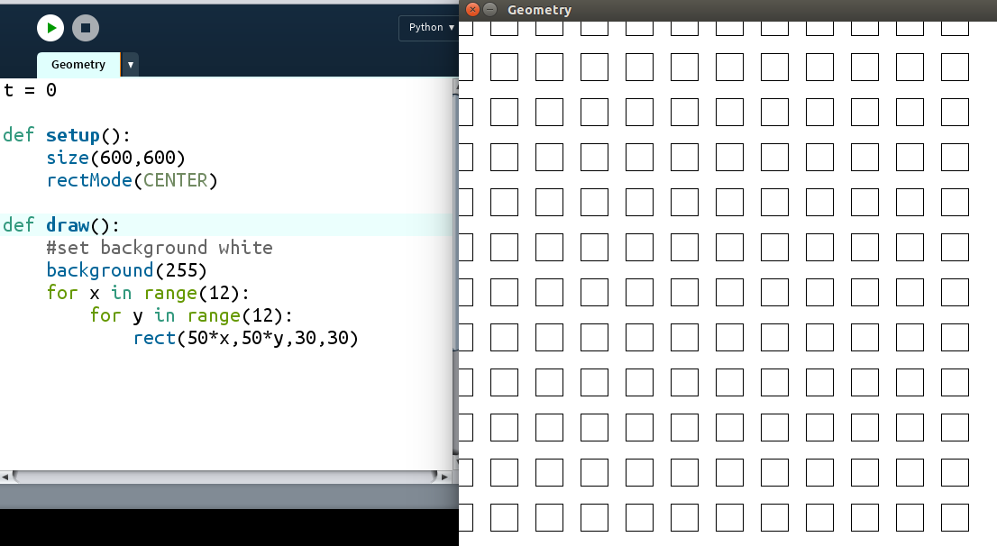
Figure 5.12
We just want the grid to be a little more centered, so we'll translate first. Add this line after “background(255)”:
translate(20,20)
This makes Figure 5.13
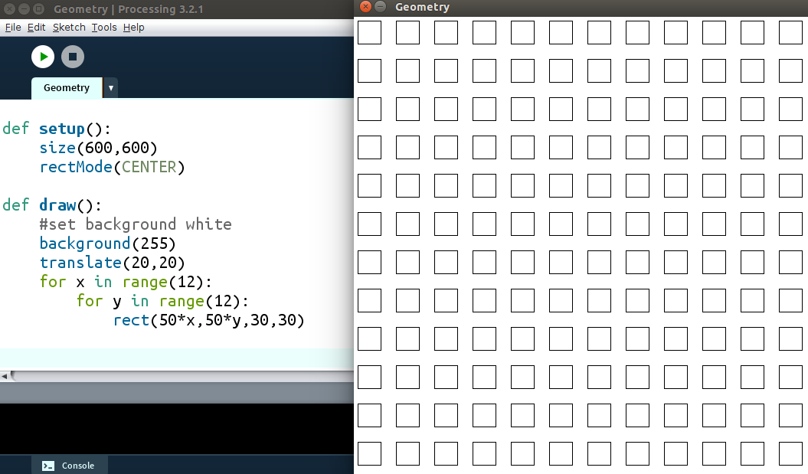
Figure 5.13
Exercise 5.4 Rocking the Grid
Make each square in the grid spin using the rotate function.
Solution:
Adding a time variable and a couple of rotate functions like the previous example will make each square rotate:
t = 0

def setup():
size(600,600)
rectMode(CENTER)

def draw():
global t
#set background white
background(255)
translate(20,20)
for x in range(12):
for y in range(12):
pushMatrix()
translate(50*x,50*y)
rotate(5*radians(t))
rect(0,0,30,30)
popMatrix()
t += 0.1
Why stop at 144 squares? And let's add a little color. The “colorMode” is usually RGB, a mixture of Red, Green and Blue. This one is HSB, which stands for “Hue, Saturation and Brightness.” The Hue is the only one we'll change, according to the distance the rectangle is from the mouse. Change the code to
def setup():
size(600,600)
rectMode(CENTER)
colorMode(HSB)

def draw():
#set background black
background(0)
translate(10,10)
for x in range(30):
for y in range(30):
d = dist(20*x,20*y,mouseX,mouseY)
t = 100/(d+0.01) #to prevent zero division
fill(400*t,360,360)
rect(20*x,20*y,15,15)
You'll see a very colorful design which will follow your mouse around, as in Figure 5.14:
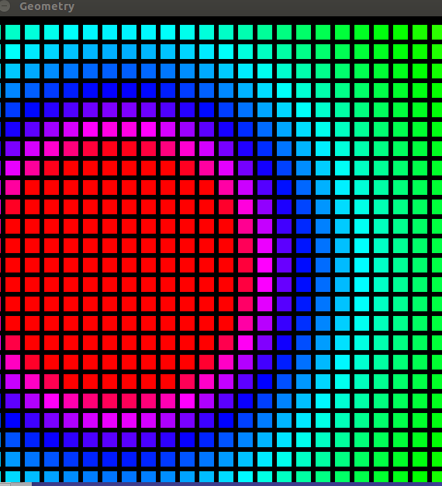
Figure 5.14
The Rotating Triangles Sketch
I was blown away by this sketch posted by the University of Oslo's Roger Antonsen (Figure 5.15):
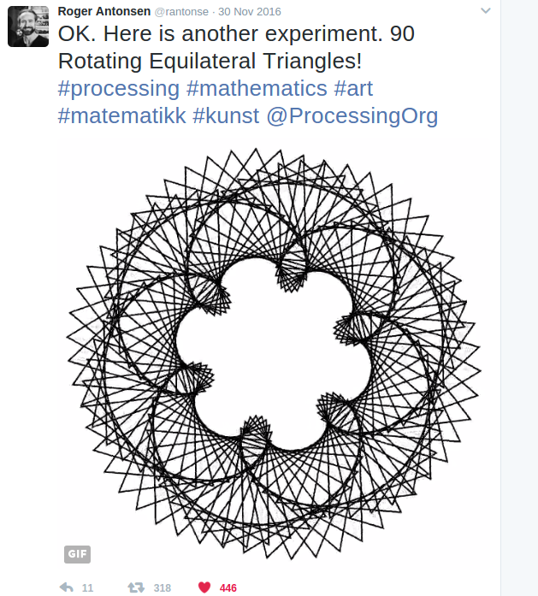
Figure 5.15: 90 Rotating Equilateral Triangles
The great thing about math and programming is you have to figure out the simplest component of a figure, like the bricks making up Nasrudin's house. Antonsen gave away the secret when he called the sketch “90 Rotating Equilateral Triangles.” Easy! All we have to do is figure out how to draw an equilateral triangle and how to rotate it, then repeat that for 90 of them.
Exercise 5-5: Spin Cycle
Create a triangle in a Processing sketch and rotate it using the rotate function.
Solution:
Here's one way to create a rotating triangle but as you can see in Figure 5.16, it rotates around one of its vertices:
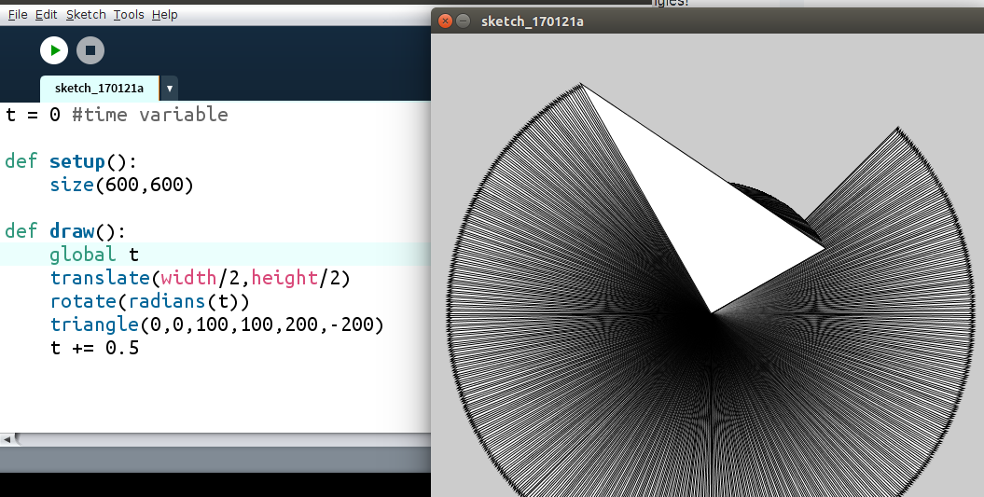
Figure 5.16: A rotating triangle, but…
To copy Roger's sketch we need an equilateral triangle for one, and we need to find the center of the triangle to rotate it properly. Let's look at an equilateral triangle in Figure 5.17:
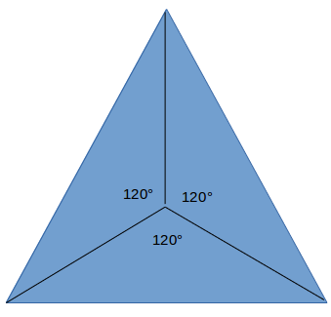
Figure 5.17: An equilateral triangle dissected into 3 equal parts
The point in the middle is the center of the triangle. Now let's cut the bottom triangle in half again, as in Figure 5.18:
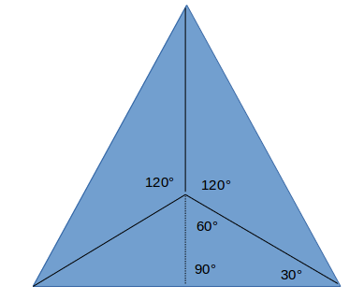
Figure 5.18 Dividing up the equilateral triangle into special triangles
The right triangle on the bottom of the figure is a classic 30-60-90 triangle, a “special triangle” that is studied in geometry and trigonometry classes and which shows up on every SAT test. It's worth knowing the ratios of the sides in that triangle, because it'll help us find the three vertices with respect to the center. Let's zoom in, as in Figure 5.19:
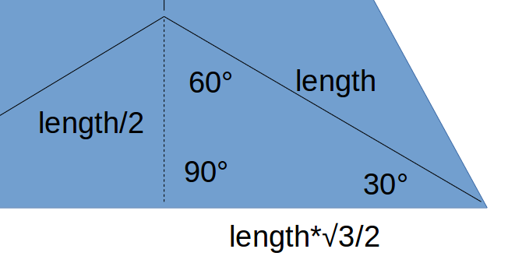
Figure 5.19
If we declare the distance from the center of the equilateral triangle to the vertex to be the “length,” we can find the other sides with reference to the “length” variable. It's the hypotenuse of the special triangle, so the shorter leg is half the “length.” And the longer leg is the length of the shorter leg times the square root of 3. So if we use the center point for drawing the triangle, the coordinates of the three points are shown in Figure 5.20:
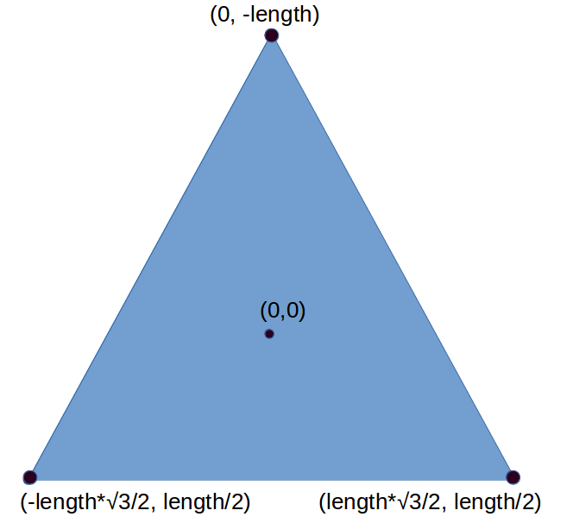
Figure 5.20: The points of the triangle
Exercise 5-6: Triangulation
Write a function called “tri” that will take a variable “length” and draw an equilateral triangle using the above points.
Solution
The code to make the triangle is shown in Figure 5.21 and the rotation still works.
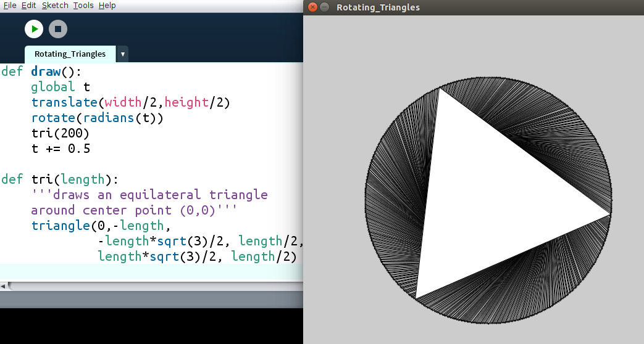
Figure 5.21
Now we can cover up all the old triangles by adding this line to the beginning of the draw function:
background(255) #white
Now we have a rotating triangle. All we have to do is put 90 of them in a circle, just like we did in the Geometry chapter, using “rotate.”
Exercise 5.7: Whole Lot of Rotating Going On
Create a sketch of 90 rotating triangles in a circle.
Solution
This is basically the same sketch as the rotating squares exploration, but using our “tri” function:
def draw():
global t
background(255)#white
translate(width/2,height/2)
for i in range(90):
#space the triangles evenly
#around the circle
rotate(radians(360/90))
pushMatrix() #save this orientation
#go to circumference of circle
translate(200,0)
#spin each triangle
rotate(radians(t))
#draw the triangle
tri(100)
#return to saved orientation
popMatrix()
t += 0.5
However, if you run this, you'll notice the triangles aren't transparent, like in Aronsen's sketch. We need to add this line to our tri function:
noFill()
Now we have 90 rotating triangles but they're all rotating in the same way. We need to make each one rotate a little differently from their next-door neighbors. We do that with a phase shift. Each triangle was assigned a number in the loop: i. We only need to add that to t in the “rotate(radians(t))” line, like this:
rotate(radians(t + i))
We'll see what's in Figure 5.22:
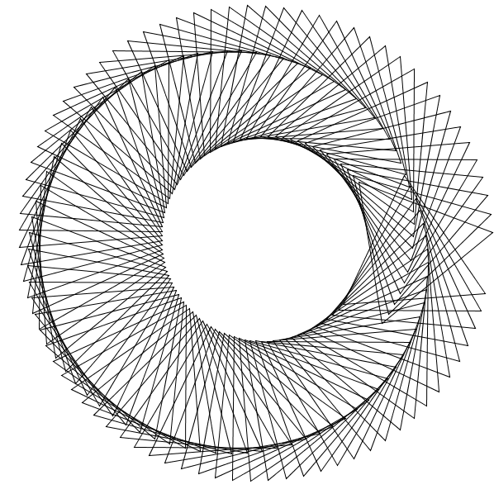
Figure 5.22: Rotating Triangles with Phase Shift
You'll notice there's a break in the pattern on the right side of the screen. If we want a nice, seamless pattern, we have to make the phase shifts add up to a multiple of 360 degrees. Since there are 90 triangles, we'll divide 360 by 90 and multiply that by i:
rotate(radians(t + i*360/90))
I know 360/90 is 4 but there's a reason I'm leaving it in. For now we're able to see the nice seamless pattern in Figure 5.23:
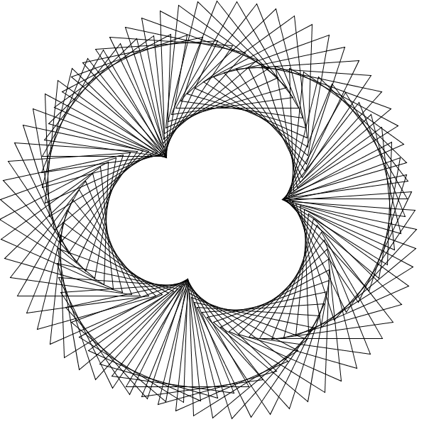
Figure 5.23 Getting Closer!
It's easy to change the look of the sketch by simply changing the phase shift. Try multiplying i by a number:
rotate(radians(t + 2*i*360/90))
This looks very close to the sketch we were trying to copy! See Figure 5.24:
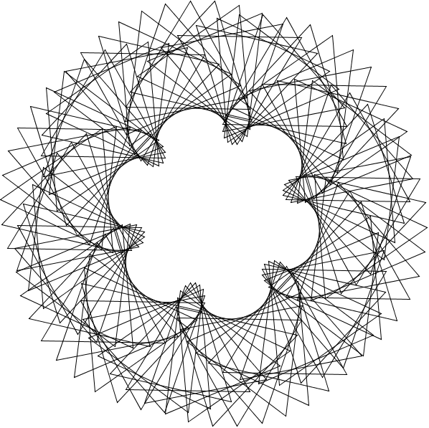
Figure 5.24 They Still Spinnin'!
In this chapter we've learned how to break down some complicated-looking designs into their simple components, like Nasrudin's house described as a collection of bricks. In the next chapter we'll learn some new functions that will make even more complicated behavior possible, like leaving a trail and creating any shape from a bunch of vertices.

