7
Classes and Objects
Old teachers never die, they just lose their class. - Anonymous
After you’ve built up some skills creating cool graphics using functions and other code, you can supercharge your creativity using Classes. There are times we want to draw things using Python, but drawing lots of them can become too much work. Classes make drawing lots of objects with the same properties easy, but there’s a bit of syntax to remember. On the Python.org website they show how to create a “Dog” object using a class:
class Dog:
def __init__(self, name):
self.name = name
Then you create a dog with a name
d = Dog(‘Fido’)
Now “d” is a Dog and its name is Fido:
>>> d.name
'Fido'
It might not be clear why you’d need a Dog class from the above, but it’s good to know you can do literally anything you want with code and be as creative as you want. We’ll make some useful objects in this chapter. Here’s one example of how using Classes will let us do something really cool and save us a lot of work.
The bouncing ball
It’s easy to put one circle on the screen, right? That’s your first challenge.
Exercise 1: Ball Game
Start a Processing sketch and draw a single circle on the screen, which we’ll turn into a “ball,” bouncing around.
Solution:
Here’s the code for one circle:
‘’’bouncingball.pyde’’’
def setup():
size(600,600)

def draw():
background(0) #black
ellipse(300,300, 20,20)

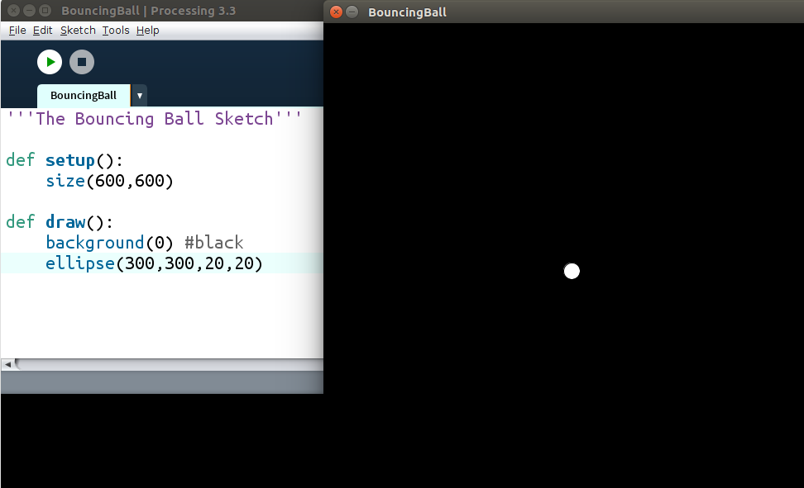
Figure7-1: One Circle
Now we’ll make the ball move. That involves changing, or varying, its position. We can create a variable for the x-value and a variable for the y-value and set them to 300 (the middle of the screen), like this:
‘’’bouncingball.pyde’’’
xcor = 300
ycor = 300

def setup():
size(600,600)

def draw():
background(0) #black
ellipse(300,300, 20,20)
Now we’ll change the x-value and y-value by a certain number and make sure we draw our ellipse at the location (xcor, ycor):
‘’’bouncingball.pyde’’’
xcor = 300
ycor = 300

def setup():
size(600,600)

def draw():
global xcor, ycor
background(0) #black
xcor += 1
ycor += 1
ellipse(xcor, ycor, 20,20)
Remember, we need to tell Python we’re using the same “xcor” and “ycor” we’ve already created and not new ones just for the draw function. Then we increment them by 1 and draw the ellipse at the location (xcor, ycor).
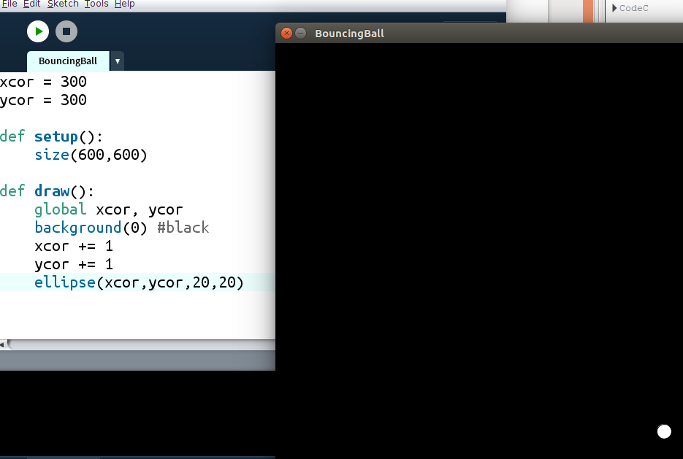
Figure 7-2: The ball moves!
Now the ball moves, but it moves off the screen and we never see it again! We want it to “bounce” off the walls. How?
We’re changing the x-value and the y-value by 1. What’s a change in position called? Velocity. So let’s create some x-velocity and y-velocity variables.
‘’’bouncingball.pyde’’’
xcor = 300
ycor = 300
xvel = 1
yvel = 2

def setup():
size(600,600)

def draw():
global xcor, ycor,xvel,yvel
background(0) #black
xcor += xvel
ycor += yvel
#if the ball reaches a wall, switch direction.
if xcor > width or xcor < 0:
xvel = -xvel
if ycor > height or ycor < 0:
yvel = -yvel
ellipse(xcor, ycor, 20,20)
In the draw function we have to tell Python xvel and yvel are global variables, and make the x- and y-coordinates vary by the velocity variables. The “if” statements tell the program that if the ball’s position goes outside the boundaries of the screen to change velocity to its negative. This should look like it’s “bouncing” off the walls.
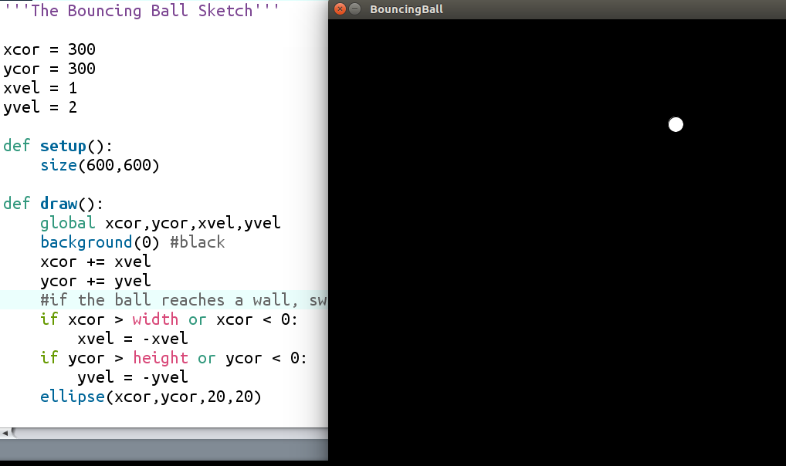
Figure 7-3: One Bouncing Ball!
Now we want to make another ball, or many other balls. How do we start? We’d need to make a new variable for the second ball’s x-value, another variable for the second ball’s y-value, another for its x-velocity and a fourth for its y-velocity. Then we’d have to increment its position by its velocity, check if it needs to bounce off a wall, and finally draw it. We’re doubling all our code! A third ball would triple our code! Twenty balls would be out of the question. You don’t want to have to keep track of all these variables for position and velocity. This is what it would look like:
#ball1:
ball1x = random(width)
ball1y = random(height)
ball1xvel = random(-2,2)
ball1tvel = random(-2,2)

#ball2:
ball2x = random(width)
ball2y = random(height)
ball2xvel = random(-2,2)
ball2tvel = random(-2,2)

#ball3:
ball3x = random(width)
ball3y = random(height)
ball3xvel = random(-2,2)
ball3tvel = random(-2,2)

#update ball1:
ball1x += ball1xvel
ball1y += ball1yvel
ellipse(ball1x,ball1y,20,20)

#update ball2:
ball2x += ball2xvel
ball2y += ball2yvel
ellipse(ball2x,ball2y,20,20)

#update ball3:
ball3x += ball3xvel
ball3y += ball3yvel
ellipse(ball3x,ball3y,20,20)
That’s the code for only 3 balls. And this isn’t even including the bouncing part!

Classes to the Rescue
A class is like a recipe: a way to create an object with its own properties. We tell Python how to make a “ball” once. Then all we have to do is create a bunch of balls with a loop and put them in a list. Aren’t lists great? Here’s how we’ll put the code we’ve already written into a class. This goes at the beginning of the program:
‘’’bouncingball.pyde’’’
ballList=[] #empty list to put the balls in

class Ball:
def __init__(self,x,y):
‘’’How to initialize a Ball’’’
self.xcor = x
self.ycor = y
self.xvel = random(-2,2)
self.yvel = random(-2,2)
What this does is create the empty list we’ll use to save the balls in, then we start the recipe. The name of an object is always capitalized. The “init” method is a requirement in Python: it contains all the properties the object gets when it’s initialized. There are 2 underscores before and 2 after “init.” “Self” simply means every object has its own methods and properties, which are functions and variables that can’t be used except by a Ball. So each Ball will have its own xcor, its own ycor, and so on. Since we may have to create a Ball at a specific location sometime, I made x and y parameters of the init method. We’ll have to tell Python the location of a Ball when we create it.
Now we need to tell Python how to update the ball every time the draw function loops. We’ll call that the update method, and it’s indented inside the Ball class, just as init is. You can simply cut and paste all the ball code there. Add “self.” to the object’s properties and you have a Ball class:
‘’’bouncingball.pyde’’’
ballList=[] #empty list to put the balls in

class Ball:
def __init__(self,x,y):
‘’’How to initialize a Ball’’’
self.xcor = x
self.ycor = y
self.xvel = random(-2,2)
self.yvel = random(-2,2)

def update(self):
self.xcor += self.xvel
self.ycor += self.yvel
#if the ball reaches a wall, switch direction
if self.xcor > width or self.xcor < 0:
self.xvel = -self.xvel
if self.ycor > height or self.ycor < 0:
self.yvel = -self.yvel
ellipse(self.xcor,self.ycor,20,20)
Now the program knows how to create and update a ball. In the setup function, we’re going to create 3 balls and put them into the ball list:
def setup():
size(600,600)
for i in range(3):
ballList.append(Ball(random(width),
random(height)))
Now there are 3 balls in the ball list. We want to update them (which includes drawing them) every loop, so we add this code to the draw function:
def draw():
background(0) #black
for ball in ballList:
ball.update()
It loops over the ball list and for every ball in the list it runs its update method. Run this sketch and you should see three balls moving around the screen and bouncing off the walls! The great thing is it’s super easy to change the number of balls. All you have to do is change the number you put in “for i in range(number):” in the setup function to 20 or 50 to see more balls.
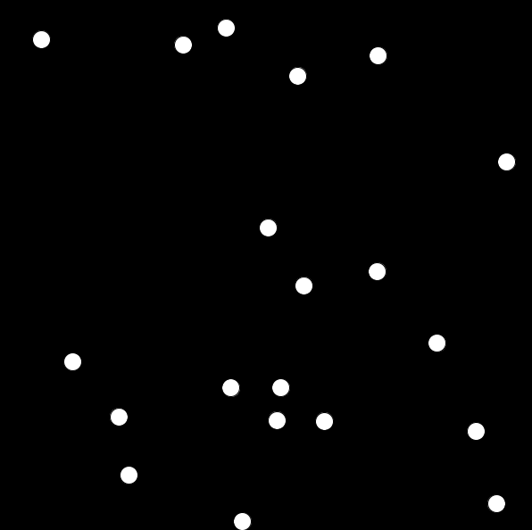
Figure 7-4: As many balls as you want!
So there are three steps to using classes to create objects:
1. Write the class. It’s like a recipe for how to make balls or planets or rockets.
2. Instantiate the object or objects by calling them in the setup function, like we did with
Ball(random(width),random(height))
3. Update the object or objects in the draw function (the display loop)

What’s cool about Classes is you can give an object any properties or methods you want. We don’t have to make our balls all the same color. Add this code to your Ball class:
class Ball:
def __init__(self,x,y):
‘’’How to initialize a Ball’’’
self.xcor = x
self.ycor = y
self.xvel = random(-2,2)
self.yvel = random(-2,2)
self.col = color(random(255),
random(255),
random(255))
That gives every ball its own color. Processing’s color function needs 3 numbers: red, green and blue. RGB values go from 0 to 255. By using “random(255)” we let the program choose the numbers randomly. But the “init” method only runs once, so once the ball has a color, it keeps it.
Next, in the update method, add this line so the ellipse gets filled with the ball’s own color:
fill(self.col)
ellipse(self.xcor,self.ycor,20,20)
Now when you run the program all the balls will have a random color!
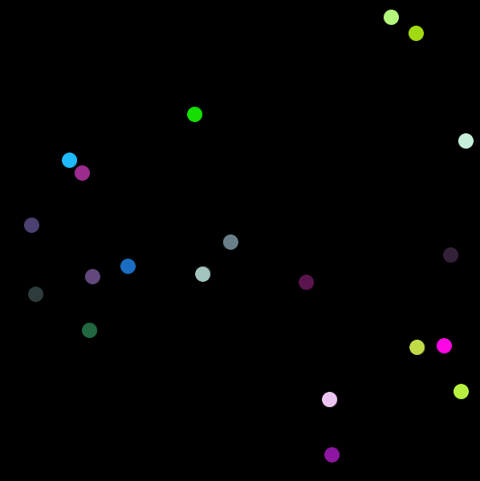
Figure 7-5: After giving the balls their own color
Exercise:
Give each ball its own size, between 5 and 50 units.
Solution:
Add the “sz” property to the “init” method. There’s already a keyword in Processing called “size” so I use “sz.”
self.col = color(random(255),
random(255),
random(255))
self.sz = random(5,50)
This code makes Processing choose a random number between 5 and 50 and save it as the ball’s size. Change the “ellipse” line so each ellipse will be drawn using its own size like this:
ellipse(self.xcor,self.ycor,self.sz,self.sz)
Now each ball gets its own color and size!
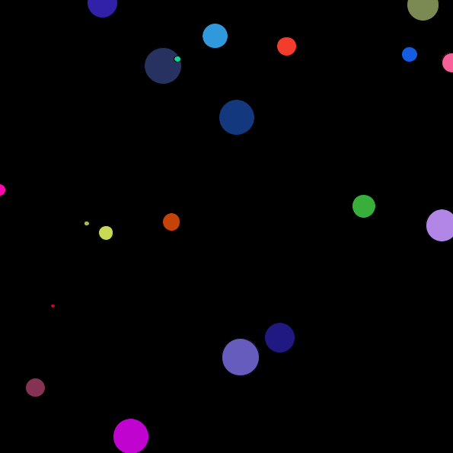
Figure 7-6: Random location, color and size!
The Sheep Sketch
Now that we can create classes, let’s make something useful. We’ll code a Processing sketch of an ecosystem of sheep that walk around eating grass. Why do they eat grass? For energy, of course. If they get enough energy, they’ll reproduce. If they don’t get enough energy, they’ll die. We could learn a lot about biology, ecology and evolution through creating and tweaking this model.
Sheep are kind of like Balls; they’ll each have their own x- and y-position and size, and they’ll be represented by a circle.
Exercise 1: Enter the Sheep
Create a class that will create a Sheep object with its own x- and y-position and its own size. Create an update method that will draw an ellipse of the sheep’s size at the sheep’s location.
Solution:
The class code is nearly identical to the Ball class:
'''SheepAndGrass.pyde'''

class Sheep:
def __init__(self,x,y):
self.x = x #x-position
self.y = y #y-position
self.sz = 10 #size

def update(self):
ellipse(self.x,self.y,self.sz,self.sz)
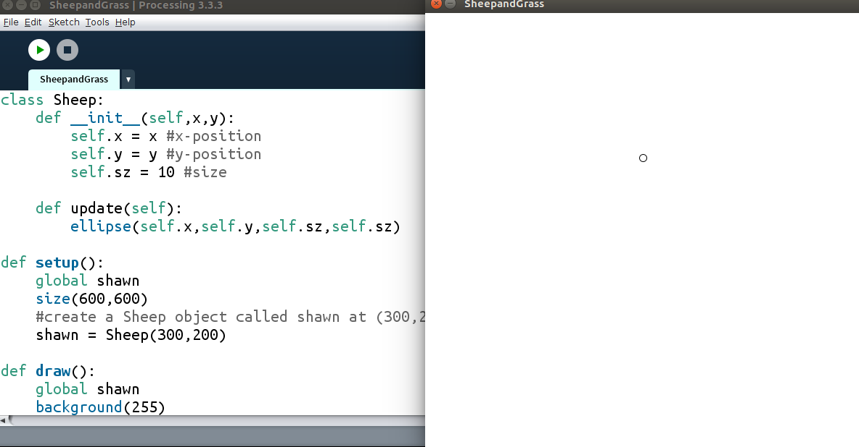
Figure 7-7: One Sheep
Here’s the code to get started with a Processing sketch containing one Sheep, which I’ve called shawn:
def setup():
global shawn
size(600,600)
#create a Sheep object called shawn at (300,200)
shawn = Sheep(300,200)

def draw():
global shawn
background(255)
shawn.update()
We create shawn, an instance of a Sheep object, in the setup function and update it in the draw function. But Python doesn’t know you mean the same “shawn” unless you tell it “shawn” is a global variable. When you run this you should get a white screen with a little circular sheep at the coordinate (300,200), as in Figure 7-7.
Move That Sheep
Now let’s teach a Sheep how to move around. We’ll just make the Sheep move around randomly. We can always program it to move differently in the future if we want to. We’ll change its x- and y-coordinates by a random number between -10 and 10:
def update(self):
#make sheep walk randomly
move = 10 #the maximum it can move in any direction
self.x += random(-move, move)
self.y += random(-move, move)
fill(255) #white
ellipse(self.x,self.y,self.sz,self.sz)
This code creates a variable “move” for the maximum value the sheep will be able to move, and (since we set move to 10) it updates the sheep’s x- and y-coordinates by a random number between -10 and 10. Finally the sheep’s color will be white for now.
When you run this you’ll see the sheep wandering around randomly, and it might wander off the screen. Let’s give the sheep some company. If we want to create and update more than one object, it’s a good idea to put them in a list. Then in the draw function, we’ll go through the list and update each Sheep:
sheepList = [] #list to store sheep

def setup():
size(600,600)
for i in range(3):
sheepList.append(Sheep(random(width),
random(height)))

def draw():
background(255)
for sheep in sheepList:
sheep.update()
This code is exactly what we did with the Balls: we create a for loop and put a Sheep in the sheep list. Then in the draw function we go through the sheep list and update each one. When you run this you should get 3 Sheep walking around. Change the number in the “for i in range” line and see the different numbers of sheep you can make.
Walking takes energy! Let’s give the sheep a certain level of energy when they’re born and take away their energy when they walk. We do this by creating an energy property in the init method and set it to 20. Then in the update method we lower the energy by 1 when it walks.
class Sheep:
def __init__(self,x,y):
self.x = x #x-position
self.y = y #y-position
self.sz = 10 #size
self.energy = 20 #energy level

def update(self):
#make sheep walk randomly
move = 10
self.energy -= 1 #walking costs energy
In the draw function, we’ll check if the sheep is out of energy, and if it is, remove it from the list. Of course we’ll need a conditional to check if sheep.energy < 0 and if so, remove that sheep from the sheeplist using the remove function:
def draw():
background(255)
for sheep in sheepList:
sheep.update()
if sheep.energy <= 0:
sheepList.remove(sheep)
When you run this, you’ll see the Sheep move around for a second and then disappear. What we need to do is to give them grass to eat. Let’s call each patch of grass “Grass.” We’ll make a new class for it. Grass will have an x- and y-value, a size and an energy content. We’ll make it change color when it’s eaten. In fact we’ll be using a bunch of different colors in this sketch, for our Sheep and our Grass, so let’s add this code so we can just use their names. Feel free to add other colors, too. This goes at the very beginning of the program:
WHITE = color(255)
BROWN = color(102,51,0)
RED = color(255,0,0)
GREEN = color(0,102,0)
YELLOW = color(255,255,0)
PURPLE = color(102,0,204)
The all-caps indicates they’re constants and won’t change values, but that’s just for the programmer. There’s nothing magical about capital letters and you can change the values if you want. Now we can just type the names of the colors, like for the green Grass. This goes right after the Sheep class:
class Grass:
def __init__(self,x,y,sz):
self.x = x
self.y = y
self.energy = 5 #energy from eating this patch
self.eaten = False #hasn't been eaten yet
self.sz = sz

def update(self):
fill(GREEN)
rect(self.x, self.y, self.sz,self.sz)
You’re probably starting to get used to the structure of the class notation. It always starts with the init method. You create its properties. In this case, Grass will have an x- and y-location, an energy level, a boolean (True/False) variable that will keep track of whether the Grass has been eaten or not, and a size. To update a patch of Grass, we just create a green rectangle on the Grass’ location.
Now we have to initialize and update our Grass, the same way we did for our Sheep. Since there will be a lot of grass, let’s create a list for it: Before the setup function, add this code:
sheepList = [] #list to store sheep
grassList = [] #list to store grass
patchSize = 10 #size of each patch of grass
We might want to vary the size of the patch of grass in the future, so it’s good to create a variable (I called it “patchSize”) so you’ll only have to change it in one place. In the setup function, after creating the sheep, create the grass:
def setup():
global patchsize
size(600,600)
#create the sheep
for i in range(3):
sheepList.append(Sheep(random(width),
random(height)))
#create the grass:
for x in range(0,width,patchSize):
for y in range(0,height,patchSize):
grassList.append(Grass(x,y,patchSize))
We have to tell Python we’re using the same patchSize variable everywhere, and then we go through two for loops (one for x and the other for y), appending Grass to the grass list so we can create a square grid of Grass. Then we update everything in the draw function, just like we did for the sheep. Whatever is drawn first will be drawn over by what’s drawn after, so we’ll update the grass first:
def draw():
background(255)
#update the grass first
for grass in grassList:
grass.update()
#then the sheep
for sheep in sheepList:
sheep.update()
if sheep.energy <= 0:
sheepList.remove(sheep)
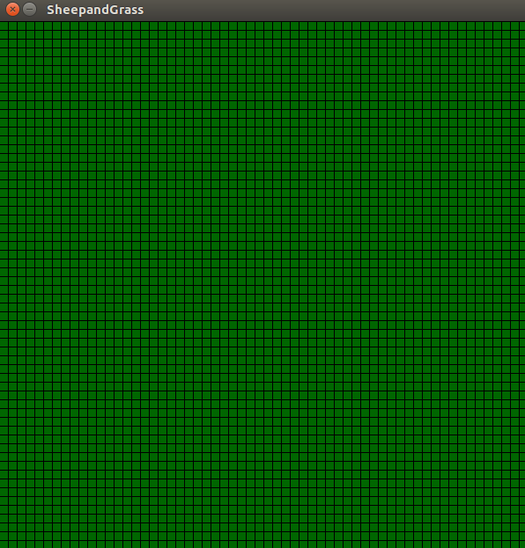
Figure 7-8: Grass with lines?
When you run this code you should see a grid of green squares, like in Figure 7-8. Let’s shut off the black outline so it’ll look like a smooth field of grass. Add this code to the setup function:
def setup():
global patchsize
size(600,600)
noStroke()
Now we have our Grass. How do we make it so if a Sheep is on a patch of Grass, the Sheep gets the Grass’s energy and the patch of Grass turns brown? Change the update method for Grass to this:
def update(self):
if self.eaten:
fill(BROWN)
else:
fill(GREEN)
rect(self.x, self.y, self.sz,self.sz)
Change your draw function to this:
def draw():
background(WHITE)
#update the grass first
for grass in grassList:
for sheep in sheepList:
#check if there's a sheep on this patch
if not grass.eaten and dist(grass.x,grass.y, sheep.x, sheep.y)<10:
grass.eaten = True
sheep.energy += grass.energy
grass.update()

for sheep in sheepList:
if sheep.energy <= 0:
sheepList.remove(sheep)
sheep.update()
This means if the Grass is not eaten and the Sheep is within a certain distance of the patch of Grass, we’ll assume the Sheep is eating the Grass. The Grass turns brown and the Sheep gets the energy. Now we can create more Sheep. Let’s change the “for i in range line to 20.”
#create the sheep
for i in range(20):
sheepList.append(Sheep(random(width),
random(height)))
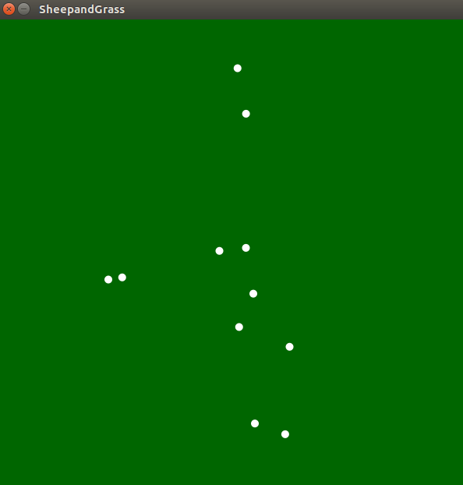
Figure 7-9: A herd of sheep!
Now 20 Sheep walk around, as in Figure 7-9. Let’s have them choose a color when they’re “born.” After defining the colors, let’s put them into a color list and choose like this:
YELLOW = color(255,255,0)
PURPLE = color(102,0,204)
colorList = [WHITE,RED,YELLOW,PURPLE]
Make the changes below to the Sheep class to use different colors. First you need to give them a color property, and since “color” is a keyword in Processing I used “col.” Then in the update function, before drawing the Sheep (the ellipse), tell Processing to fill the ellipse with the Sheep’s own color.
class Sheep:
def __init__(self,x,y,col):
self.x = x #x-position
self.y = y #y-position
self.sz = 10 #size
self.energy = 20
self.col = col

def update(self):
#make sheep walk randomly
move = 10 #the maximum it can move in any direction
self.energy -= 1
self.x += random(-move, move)
self.y += random(-move, move)
fill(self.col) #its own color
ellipse(self.x,self.y,self.sz,self.sz)
When the Sheep are instantiated (born) in the setup function, you need to give them a random color. That means at the top of the program you have to import the choice function from the random module at the beginning of the program:
from random import choice
Finally, when you’re creating the Sheep, add the random choice of colors from the color list to the arguments we pass to the Sheep constructor:
def setup():
size(600,600)
noStroke()
#create the sheep
for i in range(20):
sheepList.append(Sheep(random(width),
random(height),
choice(colorList)))
Now you should have a bunch of randomly-colored Sheep walking around the screen, eating Grass:
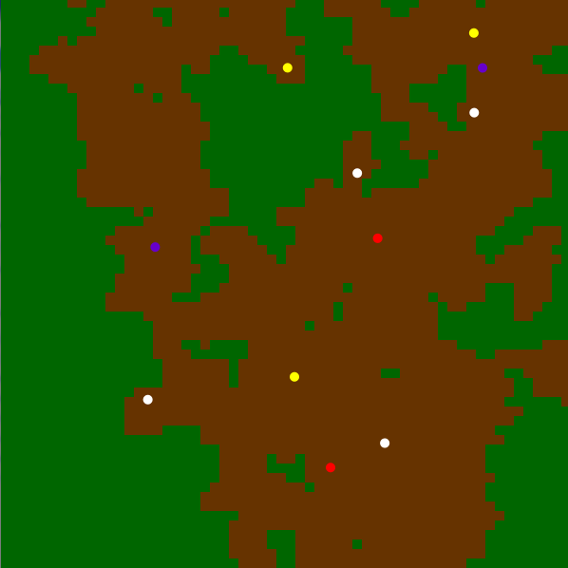
Figure 7-10: Multi-colored sheep
Unfortunately, they eat the Grass until they have eaten so much they wander too far away from the Grass and run out of energy and die. Let’s say if the Sheep’s energy gets up to 50 they can reproduce. That means adding a conditional to check if the Sheep’s energy is greater than or equal to 50. If it is, take away some energy for birthing and add another Sheep to the Sheep list. Notice the new Sheep is on the same location and is the same color as its “parent:”
for sheep in sheepList:
if sheep.energy <= 0:
sheepList.remove(sheep)
if sheep.energy >= 50:
sheep.energy -= 30 #giving birth takes energy!
#add another Sheep to the list
sheepList.append(Sheep(sheep.x,sheep.y,sheep.col))
sheep.update()
Now you’ll see them reproduce and it’ll look like “tribes” of similarly-colored Sheep:
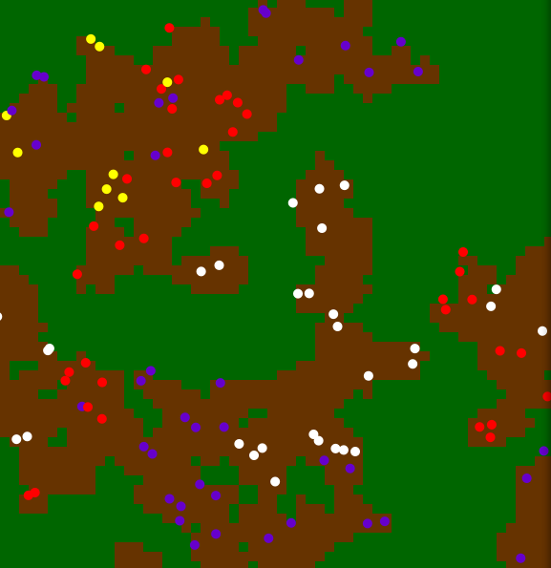
Figure 7-11: Sheep eating Grass
However, they soon eat up all the Grass in their area and die. (Is there a lesson in that?) We clearly need to allow our Grass to regrow. Change the Grass’s update method to this:
def update(self):
if self.eaten:
if random(100)<5:
self.eaten = False
else:
fill(BROWN)
else:
fill(GREEN)
rect(self.x, self.y, self.sz,self.sz)
This generates a random number between 0 and 100. If it’s less than 5, we’ll regrow a patch of Grass by setting its “eaten” property to False. Otherwise, it’s brown. Run it and now you get so many Sheep the program might slow down!
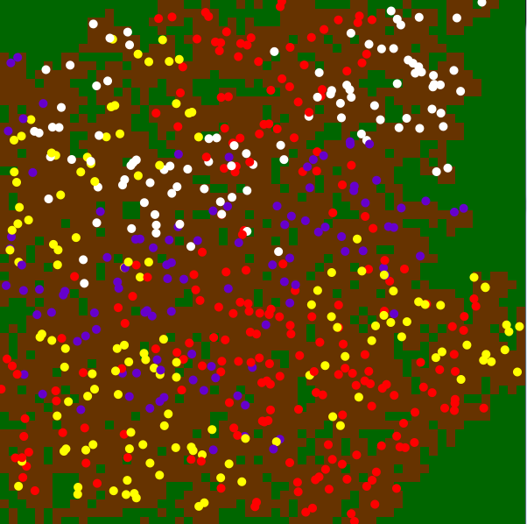
Figure 7-12: Overpopulation!
Change the amount of energy each patch of Grass contains:
class Patch:
def __init__(self,x,y,sz):
self.x = x
self.y = y
self.energy = 2 #energy from eating this patch
self.eaten = False #hasn't been eaten yet
self.sz = sz
That seems to be a good balance. Play around with the numbers all you want, it’s your world!
Evolutionary Advantage
Let’s give one of the colors of Sheep an advantage. You can choose any advantage you can think of (getting more energy from grass or having more offspring at once for example) but I’m going to let the purple Sheep walk a little further than the others. Will that make any difference? Change this line in the Sheep’s update method:
def update(self):
#make sheep walk randomly
move = 10 #the maximum it can move in any direction
if self.col == PURPLE:
move = 12
self.energy -= 1
What this does is check if the Sheep’s color is purple, and if so it sets its move value to 12. Otherwise it leaves it at 10. Let’s run it and check the outcome:
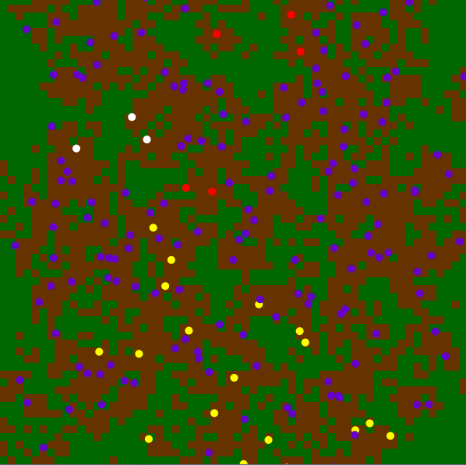
Figure 7-13: Lots of Purple Sheep!
After a little while it sure looks like that tiny advantage paid off for the purple sheep. They’re dominating the environment and pushing out all the other sheep just by competing for their grass. I left my model going and eventually it was all purple sheep. This could really spark a discussion about ecology, invasive species, biodiversity and evolution.
The more you use Classes, the more creative you can get with “autonomous” objects walking, flying or bouncing around, doing their thing without you having to code every step!

