Rotating Colorful Triangles

1. Make a function to draw an equilateral triangle at a location with sidelength x:

def tri(x):
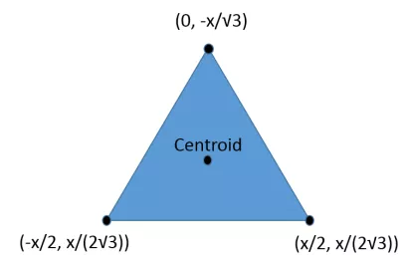
…

2. Make a circle of triangles using a loop, and translate and rotate:

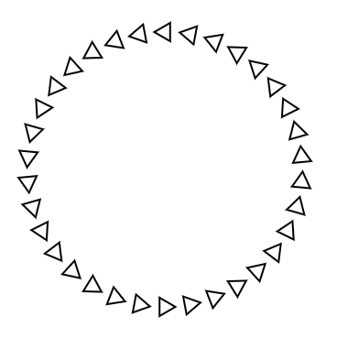

3. Create a time variable.
4. Rotate each triangle before calling the “tri” function, and increment the time variable

5. Make each triangle rotate just a little more than the previous one by using the variable in the loop. This is called an “offset” and it can be added to the time variable. Here's a hint:

rotate(t * frequency + i / offset)

6. Change the size and color of each triangle like in this picture:

