Appendix 1 [ChapterStart]
Sliders
Sliders are important tools for allowing users to change variables dynamically, adding interactivity to your sketches. You'll get to see what happens to a variable as you change it in real time!
1. With your Processing sketch open, click the tab next to the title of your sketch and select “New Tab.”
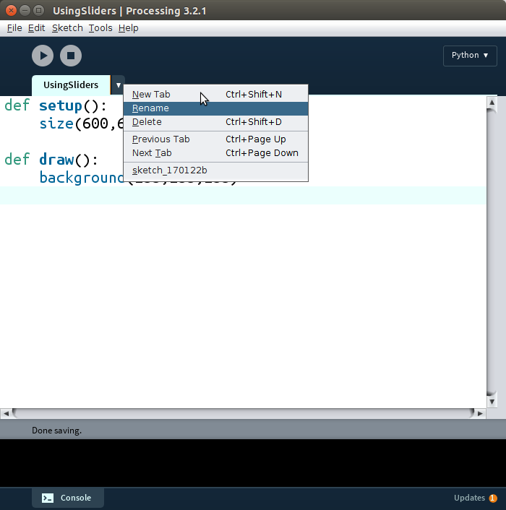
It'll ask you for the “New name for file.” Call it “slider.py.”
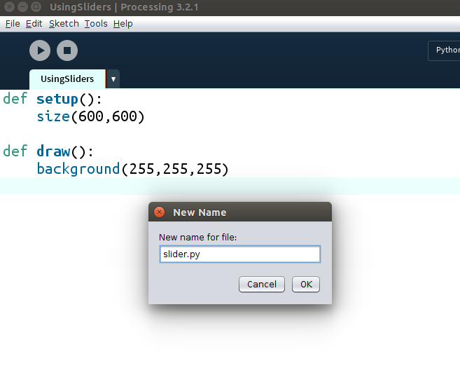

You'll get an empty file:
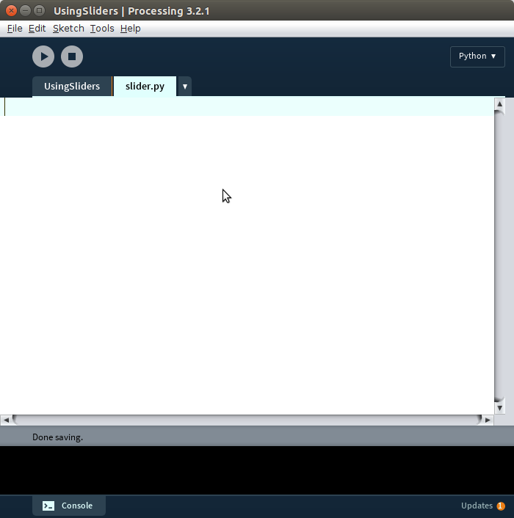
Go to https://github.com/hackingmath/python-sliders and click “slider.py.” Copy the code, paste it into the slider.py file and save it.
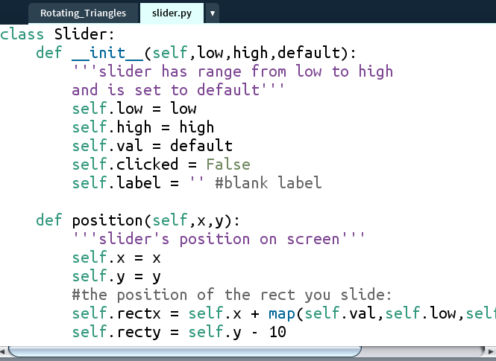
To use the Slider object, there are 4 steps, each of which require only 1 line of code:
1. Import the Slider
2. Create the Slider object
3. Give the Slider a position (inside setup)
4. Assign the value of the Slider to a variable (inside draw)

At the top of the sketch, before the setup function, type this line:
from slider import Slider
This means “From the slider.py file, import all the functionality of the Slider class.” Step 1 completed! Next, before the setup function, create an instance of the Slider object. Of course, you can create more than one by giving them different names:
slider1 = Slider(0,255,100)
This means “Create a slider with a range of values from 0 to 255, and set it initially to 100. Call this 'slider1.'” Step 2 completed!
Inside the setup function, set the slider position to an x-y coordinate, in this case (20,20):
slider1.position(20,20)
Step 3 completed! The last thing is to assign the value of the slider to a variable and keep updating the value in the draw function. For example, I'm going to create a variable called “red” which will be the amount of red color I put in the background to this sketch. Every loop, the red value will be set to whatever value the slider shows. Add this line to the draw function.
red = int(slider1.value())
The “int” part makes sure the value assigned to “red” is an integer.
You have the option of adding a label to your slider, to let your user know what they're changing. After the “position” line, add this line:
slider1.label = “red”
We'll draw an ellipse in the middle of the screen and change the red value:
def draw():
background(255)
red = slider1.value()
translate(width/2,height/2)
fill(red,0,0)
ellipse(0,0,200,200)
Run this and you'll see the ellipse, but the red value is pretty low (100):
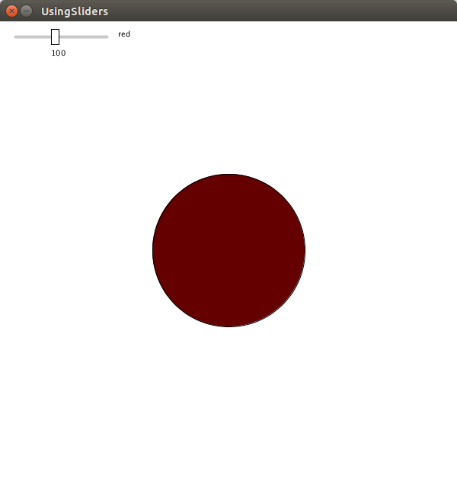
When you move the slider, you'll see the red value increase and decrease in real time:
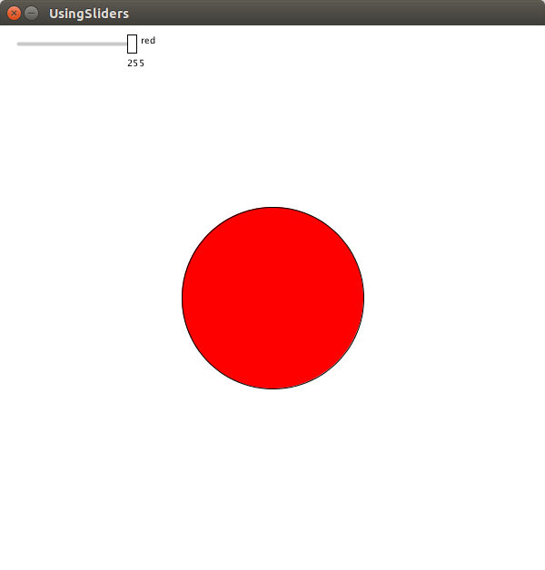
You can use sliders to change lengths, angles of rotation, and the number of objects on the screen!

