Virtual Magnetic Resonance Scanner

User Manual

Thomas Hackländer

Version 3.2.3, April 12, 2006
Author’s address

Priv.-Doz. Dr. med. Dipl.-Phys. Thomas Hackländer
IFTM Institut für Telematik in der Medizin GmbH
Höhscheider Weg 13
42269 Solingen
Germany

E-Mail: hacklaender@iftm.de

English version

Dr. Heinrich Mertens

E-Mail: hmertens@ wuppertal.helios-kliniken.de

© 2006 Dr. Thomas Hackländer

Preface

The idea of this project is based on the wish to give future medical students a good access to the complexity of the magnetic resonance imaging. As not every medical student gets access to a clinical magnetic resonance scanner during his/her studies, the aim of this project was to simulate features and functions of such an scanner by a computer system.

In order to open the simulation to a large number of users, the project has been put under the control of the GPL license.

After a planning phase of more than one year the first concrete realization was made within the thesis of Christian Schalla and Andreas Trümper. Without the support of Professor Reusch, head of the institute of computer science I at the University of Dortmund, the project, certainly, would not have been realized.

The current version is a further development of the above mentioned thesis. Didactic aspects as well as a reduction and reorganization of the source code have played a central role so that other developers can also collaborate on the project later on.

Solingen, in November 2002

Contents

1 Installation 5
1.1 Hardware and software requirements 5
1.2 Windows 5
1.3 Macintosh OS X 6
1.4 Macintosh OS 9 6
1.5 Linux 6
2 Generating the first image 7
3 Operating the virtual magnetic resonance scanner 10
3.1 General functions 11
3.2 Viewer Tab 13
3.3 Window Tab 16
3.4 Artifacts Tab 18
3.5 Tools Tab 19
3.6 Selection of the pulse sequence and setting the measuring parameters 20
3.7 Image calculations 22
3.8 Menus 22
Appendix A: Mathematics of the simulation 24
Appendix B: Using the Jar bundler under Macintosh OS X 26
Appendix C: GPL License 27

Installation

Hardware and software requirements
The Virtual Magnetic Resonance Scanner is programmed in pure Java. Therefore, the program runs on every computer a Java virtual machine or Java Runtime Environment (JRE), version 1.2 or higher, are installed on.
To perform the extensive calculations of the simulation within an acceptable time a Pentium II processor with a processor clock speed of 400 MHz and a random access memory (RAM) of 128 MB has to be available under Windows and Linux i386 at least. The system excellently runs on a Pentium II processor with 500 MHz and 256 MB. For a better performance a large amount of RAM is more important than a faster processor.
For the hard disk space is 1 MB sufficient.
If you want to install the virtual MR from a CD you have to connect the CD-ROM drive to the computer. If you want directly to start the program from the CD the CD-ROM drive has to be able to read the CD with speed 20X at least.

Windows
First make sure, that Java 1.4 or higher is installed on your PC. To test type in the Command-Window:
java –version
If Java is installed, a message stating the version is displayed. If Java is not installed you can download the current version from:
http://java.sun.com/j2se
Next download the Virtual MR Scanner from Sourceforge
http://sourceforge.net/projects/vmri
To run the simulation the “bin” Version is sufficient. The “full” version includes the “bin” version as well as the source files and the complete Netbeans project folder to compile the source files.
After decompressing the ZIP archive a folder containing all necessary files is available. By double clicking the file
vmrt_xx.bat
the Virtual MR Scanner is started using the current language settings defined in Windows. By clicking
vmrt_de.bat
vmrt_en.bat
vmrt_ee.bat
the simulation is started with the German, English or Estonian language settings.

Macintosh OS X
Download the Virtual MR Scanner from Sourceforge
http://sourceforge.net/projects/vmri
To run the simulation the “bin” Version is sufficient. The “full” version includes the “bin” version as well as the source files and the complete Netbeans project folder to compile the source files.
After decompressing the ZIP archive a folder containing all necessary files is available. By double clicking the file
vmrt_xx_mac
the Virtual MR Scanner is started using the current language settings.

Macintosh OS 9
Not tested. Could be problematic because Java 1.4.x was not available for OS 9 as a standard option.

Linux
Not tested. Should be done similar to the Windows installation. The downloadable files of the Virtual MR are pure Java and not operating system specific.

Generating the first image
In this chapter the functional principle of the virtual magnetic resonance scanner (virtual MR) will be illustrated with a simple example:
The installed data set of a reference phantom is to be measured with an inversion recovery pulse sequence. The inversion time has to be set in this way that either the cystic fluid or the fat give no signal.
On a Windows system the program is started with a double click on the batch-file vmrt.bat. First a splash screen is displayed with references to the version number and to the GLP license.

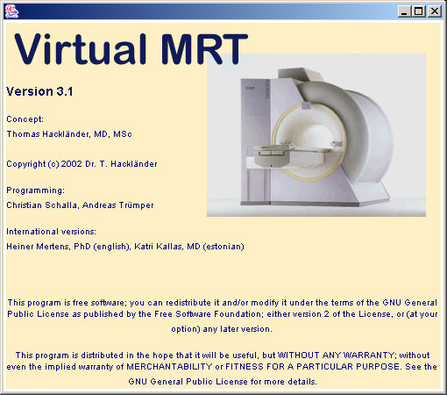

Then, the main window of the virtual MR is opened. It is divided into an image area on the left and a control area on the right.

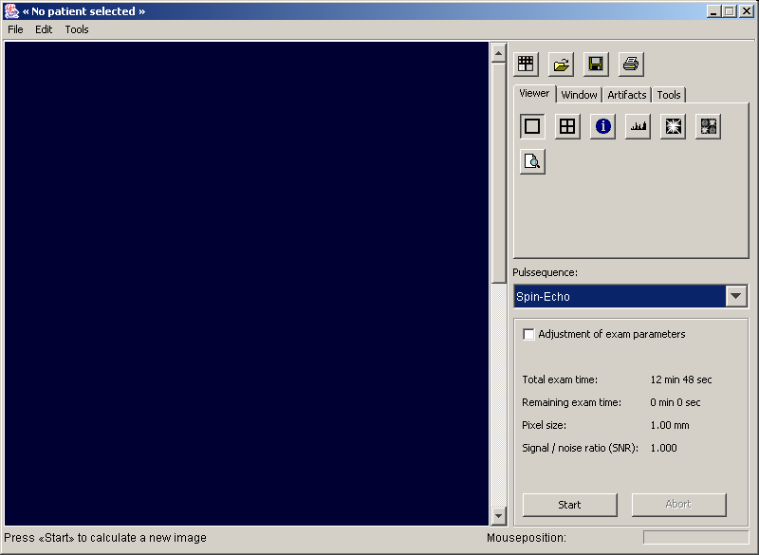

The title bar No patient selected indicates that there is still no object on the scanner for measuring.
By clicking on the left icon in the uppermost part of the control panel the data set of a reference phantom is loaded. The title bar is changed to Information about the patient: Reference Phantom and a window with the description of the data set is opened.

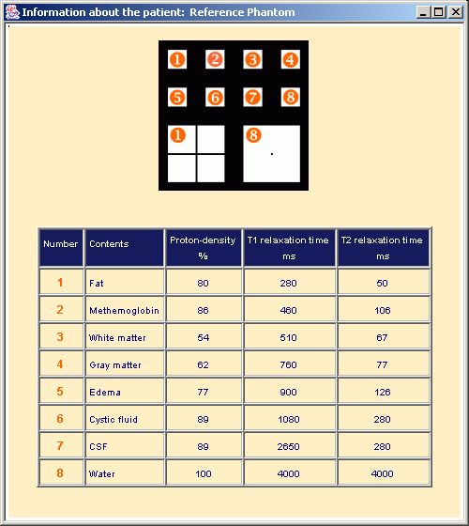

The window shows the arrangement of objects in the phantom in the upper part and a table of values in the lower part. In the phantom 8 smaller objects of the same size and 2 larger objects of the same size are arranged. The objects are composed of different substances. The substances are numbered and listed in the table. In the table the proton density as well as T1- and T2 relaxation time are given for each substance. In the phantom the cystic fluid is in the second row in the second column, the fat in the first row in the first column.
For imaging the phantom the pop-up menu pulse sequence in the middle of the control area has to be opened and Inversion-Recovery has to be selected.

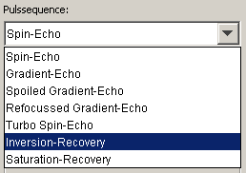

By selecting the check box Adjustment of exam parameters on the lowest panel of the control area a panel is opened in the lower half of the image area. The activation is indicated by a check mark. Via this panel the parameters of the pulse sequence can be determined:

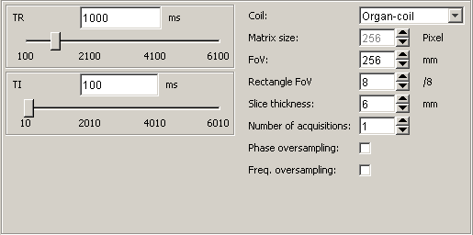

First the value of 5000 is entered for the TR (repetition time). For the TI (inversion time) the value of 749 is entered. After entering all values the panel has to have the following appearance:

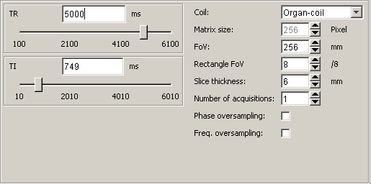

Now the parameter panel has to be deactivated by deselecting Adjustment of exam parameters.
By clicking on the Start button the calculation of the image is started. A few seconds later the result is shown in the image area of the virtual MR. As expected the image of the cystic fluid (in the second row in the second column) is black because the signal intensity is zero.

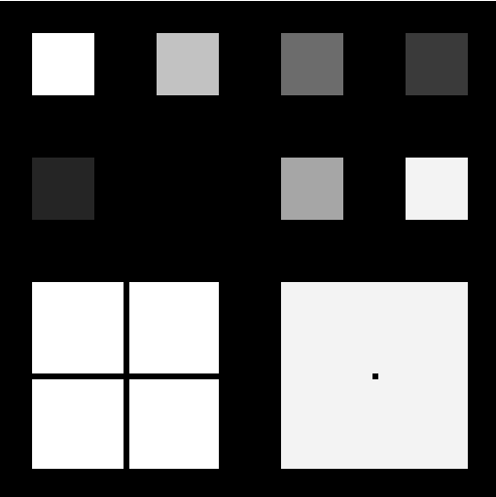

Now a value of 194 is entered for TI as described above. Subsequently, the calculation of the image is started again. The image of the fat is black i.e. no signal intensity (in the first row in the first column). Using this parameter setting the image of the cystic fluid has an intermediate signal intensity.

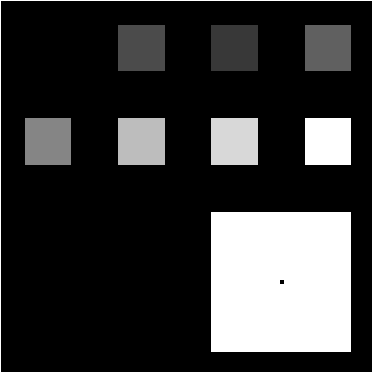

Operating the virtual magnetic resonance scanner
Essentially the main window of the virtual magnetic resonance scanner (virtual MR) is divided into an image area ❶ on the left and a control area on the right.
The control area is subdivided into three control panels numbered ❷, ❸ and ❹:
The uppermost part ❷ contains the commands Load reference phantom, Select a new patient, Save the currently selected image and Print the currently selected image.
On the tabbed pane ❸ functions are thematically grouped. The functions refer to the currently selected image.
From the control panel ❹ the pulse sequences can be selected and the parameters of the selected pulse sequence can be determined. Additionally, informations about the examination are displayed. Furthermore, this part contains the buttons to start or to abort the pulse sequence.
At the bottom the main window there is an information bar ❺ divided into status bar and mouse position. On the status bar informations about the processing are given to the user. The mouse position displays the current position of the mouse pointer on an image.
On the top of the main window there is the menu bar. Most of the entries can be also activated with the buttons of the control area. Only the command Exit as well as informations about the author and the version of the program are available by means of the menus.

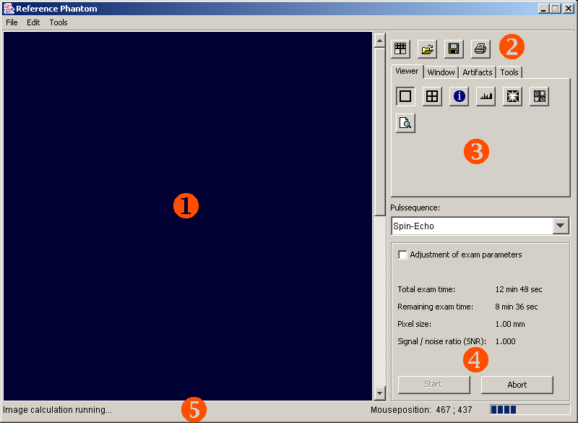

General functions
General functions of the virtual magnetic resonance scanner (virtual MR) can be selected by means of the operating elements of the control panel ❷.

Load reference phantom
With this button the installed data set of a reference phantom is loaded. This data set can be also applied if there are no parameter images available. The arrangement of the objects in the phantom is displayed in the upper part of the figure shown below. These objects are composed of different physiological substances: fat ❶, methemoglobin ❷, white matter ❸, grey matter ❹, edema ❺, cystic fluid ❻ and CSF ❼ as well as water ❽. For each substance the proton density as well as the T1 and T2 relaxation time are shown in the table of the figure. Please note that these values depend on the magnetic field strength. The listed values are for 1.5T. The percentage of the proton density is referred to pure water and the T1 and T2 relaxation time are given in milliseconds. The larger fat object ❶ in the phantom contains a proton free cross. The larger water object ❽ in the phantom has a small proton free square in the middle.

Load sample case
As a sample case a brain examination without pathology is loaded.

Select a new patient
Before the virtual MR can be used to simulate a magnetic resonance scanner it is necessary to load a data set of parameter images. These raw data sets are composed of 5 DICOM formatted parameter files. They optionally have a HTML page with in formations about the particular case. All these files are integrated in an index file with the extension .idx.
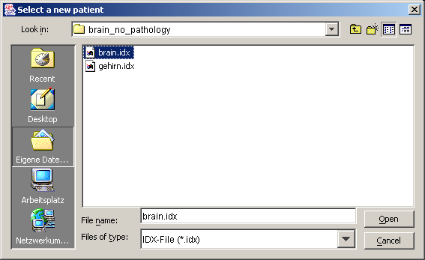
For loading a data set of parameter images the button is to be clicked on. Thereafter, an operating system specific dialog box for the file selection is opened. By means of this dialog the user can navigate through the directory structure of the file system. Furthermore, the raw data set that is be loaded can be selected by the index file. If a HTML page with informations about this case exists this page will be automatically displayed.

Save the currently selected image
As soon as an image is generated and displayed on the screen this image can be selected. Subsequently, the image can be saved. After clicking on the button dialog window for the file selection appears to save the image. The target directory can be selected and the target file or the name of the file that is to be created can be entered. After clicking on the button the generated image is saved as a DICOM-Secondary Capture image. It can be loaded with any program that is DICOM compliant.

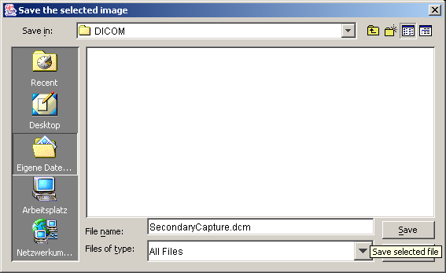

Print the currently selected image
The currently selected image can be printed as a hard copy on a printer installed on the system. For this purpose the button has to be clicked on. The figure shows the dialog window for Windows operating system. Now the printer can be selected. After selecting the printer the print job is started by clicking on the OK button.

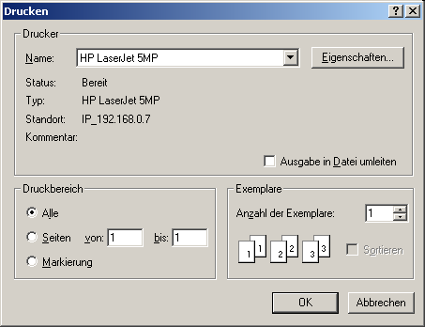

Navigating through the image stack and selecting an image
If more than one image has been generated it can be navigated through the image stack by means of the vertical scroll bar slider on the right margin of the image area. An image can be selected by a simple click on the image. This status is shown to the user by a red frame. Functions as Save the currently selected image and Print the currently selected image always refer to the currently selected image.

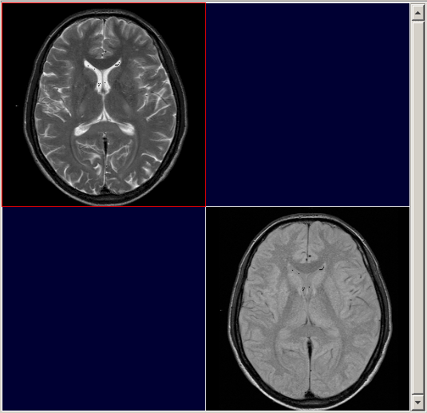

Viewer Tab
The functions under the tab Viewer enable the switching between the display of a single image and the display of 4 images, the display of the image labels, histograms and the display of k-space.

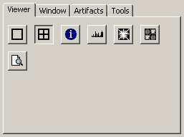

Show 1 image
Show 4 images
As standard one image is displayed with a spatial resolution of 512*512 pixels. The images generated by the virtual magnetic resonance scanner (virtual MR) always have a spatial resolution of 256*256 pixels. Therefore, the images are displayed with a magnification of 2. By clicking on the button four images can be displayed simultaneously. Then, every image is displayed at its original size that is a spatial resolution of 256*256 pixels. The frequency encoding axis is oriented horizontally, the phase encoding axis vertically.

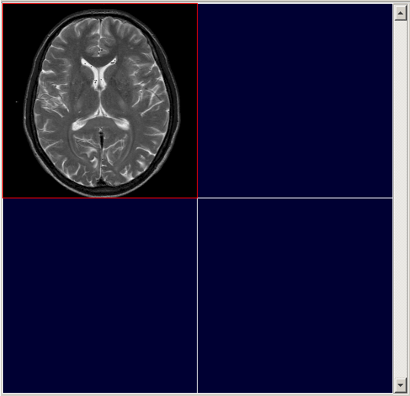

Show/Hide image labels
The image labels beside an image can be faded in or faded out with this function. In the top left-hand corner parameters that specify the pulse sequence are shown: type of the pulse sequence (Sequence), repetition time (TR), echo time (TE), flip angle (FA) and echo train length (ETL). In the top right-hand corner the examination date (Examdate), the patient name (Name), birth date (Birthdate) and sex (Sex) are shown. In the bottom left-hand corner the slide position (SP) which is irrelevant to the virtual MR and the current value of the center (C) and window (W) are shown.

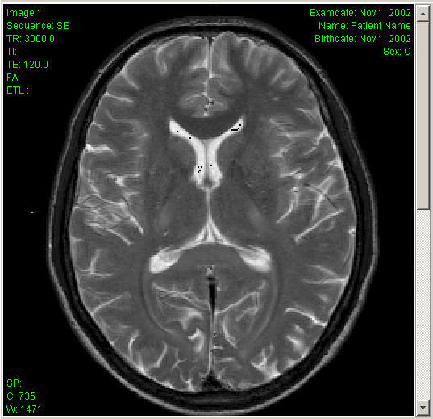

Display information about the patient
With this function a dialog window is displayed with textural and/or graphical informations about the current raw data set. Please note that such an information does not need to be available for each row data set.

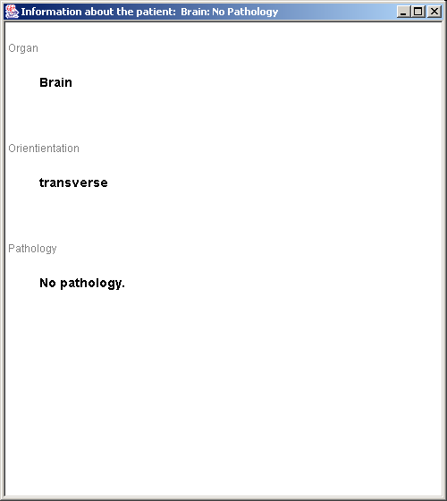

Histogram of the currently selected image
By clicking on this button a histogram is displayed in a new window. This histogram shows the signal intensity of all voxels of the currently selected image. The shades of grey range from 0 to 255. The height of each bar represents the number of the voxels with the same shade of grey.

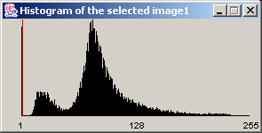

For a better graduation of the histogram the shades of grey that are very numerous are shown by red bars. These red bars do not have their full height because otherwise the other bars are hardly perceptible.
It is possible to open as many histogram windows as you like. The images have to be closed manually by clicking on the Exit button of the window frame.

k-space transform of the currently selected image
The k-space of the currently selected image is displayed in an own window. Here, the frequency encoding axis is oriented horizontally, the phase encoding axis vertically. By clicking on the buttons at the bottom of the window it can be switched between the magnitude and the phase image as well as between the real and imaginary part of the Fourier transform.
Please note that the shades of grey of the magnitude image correspond to logarithmic signal values. It is possible to open as many k-space windows as you like. The images have to be closed manually by clicking on the Exit button of the window frame.

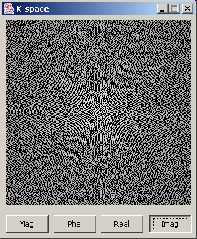

k-space manipulator for the currently selected image
The k-space manipulator offers the possibilities to alter the data in k-space and to assess the effects in the image space. In the top left-hand corner of the image area the image that was selected while opening of k-space manipulator is displayed. In the top right-hand corner the magnitude image of the Fourier transformed original image is shown. This magnitude image corresponds to k-space. In the bottom left-hand corner the original k-space is displayed initially. This original k-space can be manipulated with the operating elements of the control area.
In the bottom right-hand corner that image that was reverse transformed is displayed. Because the reverse transform requires time this reverse transform is not performed parallel to the manipulation of k-space but it has to be started by clicking on the Reverse transform button. As soon as a reverse transform is completed the window width and center of the reverse transformed image can be adjusted by the mouse as described under the Window Tab. Besides, the image can be transferred on the virtual MR by clicking on the Transfer to Viewer button. The image is stored as a new image on the virtual MR corresponding to the settings of the Tools Tab.

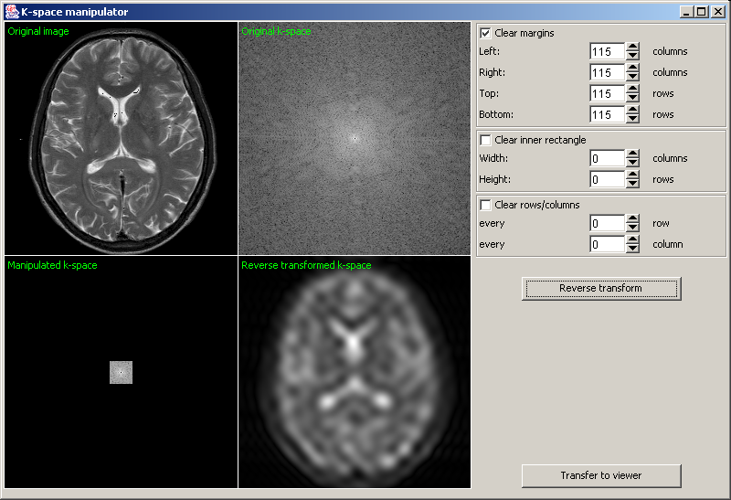

At the moment there are three operators of manipulation: Clear margins, Clear inner rectangle, Clear row/column. The operators are displayed in the control area of the main window. The operating elements of each operator are grouped into frames. An operator can be turned on/off. Its activation is indicated by a check mark next to the feature. As soon as the operator is turned on the settings of the operating elements of this operator have their effects on the manipulated k-space.
The manipulator Clear margins allows to clear the data from some rows or columns of the left-hand, right-hand, upper or lower margin separately i.e. the signal intensity of these rows or columns is set to zero. This manipulation has the effect that the detail-information in the image space get smaller.
The manipulator Clear inner rectangle allows to clear the data of the rectangle that is located in the centre of k-space. The height and the width of the rectangle can be determined before clearing the rectangle. If this rectangle becomes larger the contrast in image space will be lower and the edges of the image will be sharper.
The manipulator Clear row/column allows to clear the data from every nth rows or every nth columns. This manipulation has the effect that the higher order images get closer to the central image and are made visible in the reverse transformed (central) image. This can be seen as a wraparound artifact by the user.

Window Tab
The signal intensities of each voxel can be from 0 (pure black) to 4096 (pure white). But only 256 shades of grey can be visually distinguished. Therefore, the user has to determine the intensity range that is to be presented in these shades of grey. This operation is designated as windowing.
For that the width and the center of the window have to be determined for the signal intensities. Example: The width is 100 and the center is 200. Then, all signal intensities between 150 and 250 are converted to 256 shades of grey. All intensities from 0 to 149 are black, from 251 to 4096 are white.
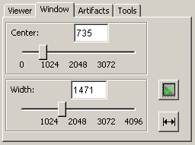

Manual windowing
The control panel has a scroll bar for the window center and for the window width as well as a text box for center and width. The values of the center and width can be directly entered into the text box or can be set by moving the scroll bar slider with the mouse while keeping the left mouse button pressed. With these options the windowing of the selected image can be done manually.
For windowing the image on the canvas the windowing function is activated as follows: The mouse pointer is positioned on the canvas, and the left mouse button is kept pressed while dragging. The activated function is displayed by altered mouse pointer. The up/down movement of the mouse changes the window center, the left/right movement the window width.

Maximal window
With this function the windowing of the selected image is set to the maximum values, i.e. is set to the center 2048 and width 4096. With this setting all possible 12 bit values are presented in shades of grey. Usually, the image contrast is very poor.

Optimal window
With this function the optimal window of the selected image is obtained. First of all, the smallest shade of grey-scale min and the largest shade of grey max is determined. The width is set to max-min and the center is set to min+(max-min)/2. In this way the image contrast is optimized.

Example
In the figure shown below one and the same image is displayed with four different window settings: In the top row the optimal window and maximal window are displayed. In the bottom row two manually selected window settings are shown.

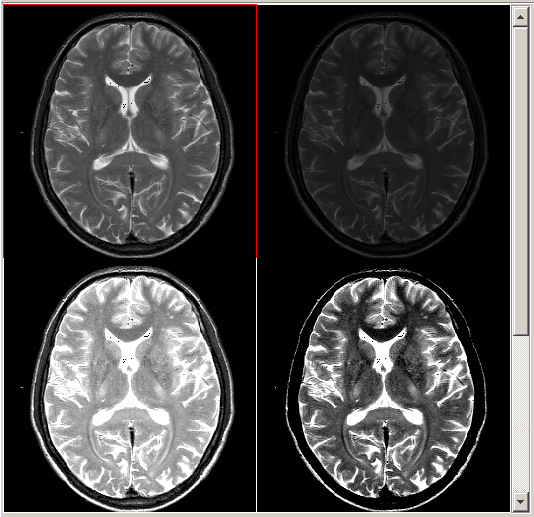

Artifacts Tab
Here the user can simulate the influence of different types of motion on the images. It is distinguished between a simple translational motion and a periodic motion.
Via a pop-up menu the user can select the types of artifact for the simulation. Depending on the selection additional setting options are visible on the panel.

Translational motion
Translational motion can be simulated along the x-axis and/or the y-axis. This corresponds to the situation when the body or part of the body move along the x-axis with constant velocity (horizontal velocity) and/or along the y-axis with constant velocity (vertical velocity). The x-axis corresponds to the frequency encoding axis, the y-axis to the phases encoding axis.

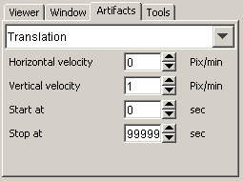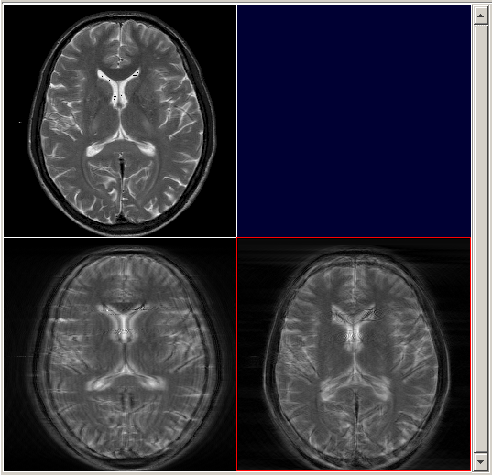

Via the panel the horizontal and/or vertical velocity can be determined. The velocity is given in pixel/minute. Furthermore, the start and the end time of the body movement can be determined. The start of the movement is delayed by 0 to 99999 seconds in comparison to the start of the examination.
Example: If the start is fixed at 30 seconds then more or less lines of k-space will be taken without artifacts depending on the pulse sequence selected.
In the top left-hand corner of the image area an image without artifacts is shown. In the bottom left-hand corner one artifact has been generated by superposition of a motion artifact along the frequency encoding axis (x-axis). In the bottom right-hand corner another one has been generated by superposition of a motion artifact along phase encoding axis (y-axis).

Periodic motion
Periodic motion e.g. respiratory motion can be simulated along the x-axis and/or along the y-axis. The x-axis corresponds to the frequency encoding axis, the y-axis to the phase encoding axis.
In addition to the maximum amplitude of the motion given in pixel the frequency of the motion given in 1/minute has to be also entered by means of the panel. Furthermore, the start and the end of the body movement can be determined. The start of the movement is delayed by 0 to 99999 seconds in comparison to the start of the examination.
Example: If the start is fixed at 30 seconds then more or less lines of k-space will be taken without artifacts depending on the pulse sequence selected.
In the top left-hand corner of the image area an image without artifact is shown. In the bottom left-hand corner one artifact has been generated by superposition of a motion artifact along the frequency encoding axis (x-axis). In the bottom right-hand corner another one has been generated by superposition of a motion artifact along phase encoding axis (y-axis).

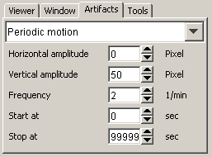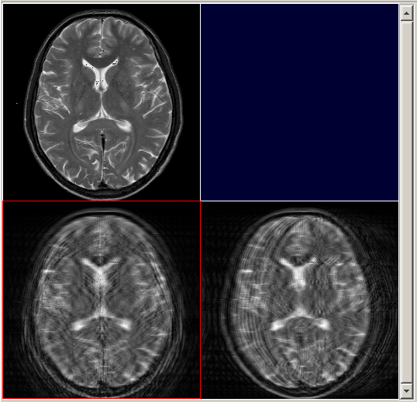

Tools Tab
Via this panel the next image can be positioned and the relative duration of the simulation can be determined.

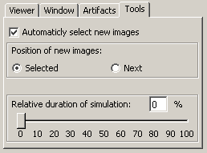

Position of a new image
With the function Position of a next image the user can determine the position the next calculated image is to be displayed on: The option Selected pastes the calculated image on the currently selected position. An image on this position will be overwritten. The option Next pastes a new image on the next free position within the image batch. The standard setting is the option Next.

Relative duration of simulation
The setting Relative duration of simulation gives the user an idea of the real examination time of a pulse sequence. The setting determines the duration of the simulation. The relative duration of the simulation refers to the percentage of the real examination time.
Example: If the relative duration is fixed at 50% the simulation will take 50% of the real examination time. If the relative duration is fixed at 0% the image will calculated as fast as possible. The image generation only needs the pure calculation time.
Especially for the fast pulse sequences the simulation time can be longer than the real examination time. Particularly the simulation of the Turbo-Spin-Echo may takes longer than the real examination time. This is because of several Fourier transforms which have to be done for the simulation.
The optional simulation of artifacts needs extra calculation time.

Activating a new image
If the check-box is selected a new calculated image is automatically selected.

Selection of the pulse sequence and setting the measuring parameters
From the pop-up menu Pulse sequence the type of pulse sequence can be determined.

By selecting the check-box Adjustment of exam parameters a new control panel is opened in which the settings regarding the pulse sequence can be done. If all settings has been done the control panel can be deactivated by deselecting the check-box Adjustment of exam parameters. The settings are kept fixed until another type of pulse sequence is selected.
The control panel is divided into two parts: the right part is the same for all types of pulse sequence, the left part depends on the type of pulse sequence.

General parameters of a pulse sequence
- Coil: Body coil or organ coil can be selected. If the body coil is selected the noise will be stronger as on a real magnetic resonance scanner.
- Image matrix: The simulation uses a fixed image size of 256*256 pixels. This value is only informative and can not be changed.
- FoV: The field of view is given in millimeter (mm). The FoV determines the dimensions of the part of the body that is to be examined. The FoV is divided into 256 rows and 256 columns. In this way the pixel size is determined indirectly.
- Rectangle: The number of the phase encoding steps oriented along y-axis can be reduced.
Example: The rectangle is 6/8. Then, for a single image the phase encoding step is repeated 192 times ([6/8]*256) instead of 256 times ([8/8]*256).
- Slice thickness: The slice thickness can be determined. A thinner thickness results in a lower signal-to-noise ratio and thus the image quality is reduced.
- Number of acquisitions: The number of acquisitions or excitations (NEX) determines how often a measurement is performed. An increase in the number of acquisitions prolongs the examination time by a factor of NEX.
- Phase-OS: With phase oversampling performed along the y axis the number of phase encoding steps are doubled resulting in doubling the examination time. Turning off the phase oversampling can lead to wraparound artifacts.
- Frequency-OS: With frequency oversampling performed along the x axis the sampling rate is doubled. There is no effect on examination time but turning off the frequency oversampling can lead to wraparound artifacts.
The values can be directly enter into the text box or can be determined by clicking on the button or the button.
Please note that the settings carried out for the general parameters of a pulse sequence can have an effect on the examination time, the pixel size and the signal to noise ratio.

Specific parameters of a pulse sequence
The specific parameters of a pulse sequence can be determined with the operating elements in the left part of the panel. For the inversion recovery pulse sequence shown in the above figure these are the repetition time TR and the inversion time TI. These value can be changed by moving the scroll bar slider with the mouse or these values can be directly entered into the text box.
The following specific parameters of a pulse sequence can be determined for each pulse sequence:
- Spin echo pulse sequence: repetition time (TR), echo time (TE)
- Gradient echo pulse sequence: repetition time (TR), echo time (TE), flip angle
- Spoiled gradient echo pulse sequence: repetition time (TR), echo time (TE), flip angle
- Refocussed gradient echo pulse sequence: repetition time (TR), echo time (TE), flip angle
- Turbo spin echo: repetition time (TR), echo spacing (ESP), effective echo time (TEeff), echo train length (ETL)
- Inversion recovery pulse sequence: repetition time (TR), inversion time (TI)
- Saturation recovery pulse sequence: repetition time (TR)

Image calculations
Informations about the examination are shown on the bottom panel of the control area. The simulation can be started by activating the Start button. As long as the calculation is carried out the Abort button can be selected. The calculation can be stopped with the Abort button at any time.

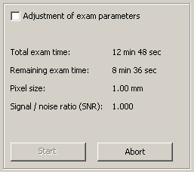

Furthermore, the following informations about the pulse sequence and the progression of the calculation are shown here:
- Total exam time: the time needed to perform the examination on a real magnetic resonance scanner using the selected pulse sequence
- Remaining exam time: the remaining time needed for a real examination
- Pixel size: the size of each pixel in the image
- Signal / noise ration (SNR): the signal to noise ratio
- The progression of the calculation is graphically shown by a horizontal progress bar.

Menus
In the current version of the virtual magnetic resonance scanner (virtual MR) there are functions that are not yet available via menus. The following entries have a function so far:

Menu File

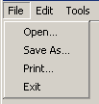

Open…
A new data set of parameter images is loaded. This entry corresponds to the button.

Save as…
The currently selected image is saved as DICOM file. This entry corresponds to the button.

Print…
The currently selected image is printed. This entry corresponds to the button.

Exit
The program is terminated.

Menu Edit

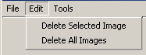

Delete selected image
The currently selected (red framed) image of the image area is deleted. Deleting the image has to be confirmed in a dialogue box. But it is still possible to abort the process.

Delete all image
All images of the image area are deleted. Deleting all images has to be confirmed in a dialog box. But it is still possible to abort the process.

Menu Tools

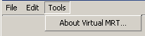

About Virtual MRT
The splash screen is displayed with references to the version of the program and to the GLP license.

Appendix A: Mathematics of the simulation

Abbreviation

α | Flip angle
ΔB | Magnetic field inhomogeneity
etl | Echo train length
ESP | Echo Spacing
γ | Gyromagnetic ratio of the proton = 42,6 MHz/T
k | Dimensionless constant varying for each measurement (current scanner setting)
PD | Proton density referred to pure water [%]
T1 | T1 relaxation time [ms]
T2 | T2 relaxation time [ms]
T2* | Effective T2 relaxation time [ms]
TE | Echo time [ms]
TE_{eff} | Effective Echo time [ms]
TI | Inversion time [ms]
TR | Repetition time [ms]

Spin echo pulse sequence
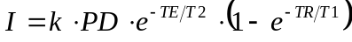

Inversion recovery pulse sequence
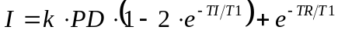

Saturation recovery pulse sequence
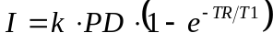

Turbo spin echo pulse sequence
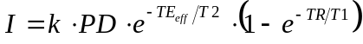
The rows of k-space are filled with echos of different echo times.
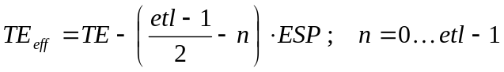
The effective echo time (TE_{eff}) is the echo time of those echos that are selected for the central portion of k-space.

Gradient echo pulse sequence
Instead of the T2 relaxation time the effective T2 relaxation time (T2*) has to be used. T2* depends on the T2 relaxation as well as on the relaxation caused by the magnetic field inhomogenity (ΔB). T2* is defined by the formula:
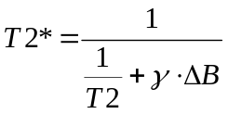
In case of the magnetic field inhomogenity the virtual magnetic resonance scanner (virtual MR) simulates a 1.0 T scanner. This scanner has a magnetic field inhomogenity of 5 ppm applying a field of view (FoV) which is 50 cm in diameter. Using a FoV of 50 cm and a spatial resolution of 256*256 pixels (picture elements) the magnetic field inhomogenity over each pixel (ΔB) is equal to 19.5 * 10⁻⁹ T.
With the following substitutions
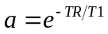
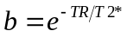
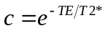
the signal intensity of the different gradient echo pulse sequences is given by the following equations:

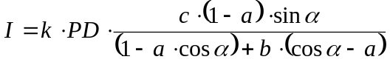

Spoiled gradient echo pulse sequence
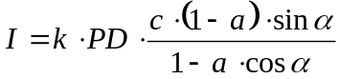

Refocused gradient echo pulse sequence
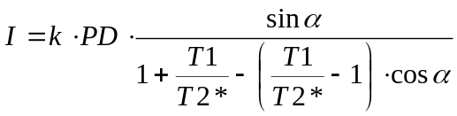

Appendix B: Using the Jar bundler under Macintosh OS X
First download the developer tools from the Apple Support site.
Run the Jar bundler
Developer/Applications/Java Tools/Jar Bundler
Use the following information to fill the dialog box:
Card: Build Information
Choose…
Select dist/vmri.jar File
Select virtual.mrt.VMRT as “Main Class”
Anti-alias Text
Anti-alias Graphics
JVM Version: 1.4*
Card: Classpath and Files
Add…
Select dist/lib/dcmlib.jar
Select dist/lib/dicomie.jar
Select dist/lib/jai_imagei.jar.jar
Card: Build Information
Create Application…
vmrt_xx_mac

Appendix C: GPL License
<!DOCTYPE HTML PUBLIC "-//W3C//DTD HTML 4.0 Transitional//EN"><!-- saved from url=(0036)http://www.gnu.org/copyleft/gpl.html -->
<!DOCTYPE HTML PUBLIC "-//W3C//DTD HTML 4.0 Transitional//EN"><!-- saved from url=(0036)http://www.gnu.org/copyleft/gpl.html -->GNU General Public License

Version 2, June 1991
Copyright (C) 1989, 1991 Free Software Foundation, Inc.
59 Temple Place - Suite 330, Boston, MA 02111-1307, USA

Everyone is permitted to copy and distribute verbatim copies of this license document, but changing it is not allowed.

Preamble
The licenses for most software are designed to take away your freedom to share and change it. By contrast, the GNU General Public License is intended to guarantee your freedom to share and change free software--to make sure the software is free for all its users. This General Public License applies to most of the Free Software Foundation's software and to any other program whose authors commit to using it. (Some other Free Software Foundation software is covered by the GNU Library General Public License instead.) You can apply it to your programs, too.
When we speak of free software, we are referring to freedom, not price. Our General Public Licenses are designed to make sure that you have the freedom to distribute copies of free software (and charge for this service if you wish), that you receive source code or can get it if you want it, that you can change the software or use pieces of it in new free programs; and that you know you can do these things.
To protect your rights, we need to make restrictions that forbid anyone to deny you these rights or to ask you to surrender the rights. These restrictions translate to certain responsibilities for you if you distribute copies of the software, or if you modify it.
For example, if you distribute copies of such a program, whether gratis or for a fee, you must give the recipients all the rights that you have. You must make sure that they, too, receive or can get the source code. And you must show them these terms so they know their rights.
We protect your rights with two steps: (1) copyright the software, and (2) offer you this license which gives you legal permission to copy, distribute and/or modify the software.
Also, for each author's protection and ours, we want to make certain that everyone understands that there is no warranty for this free software. If the software is modified by someone else and passed on, we want its recipients to know that what they have is not the original, so that any problems introduced by others will not reflect on the original authors' reputations.
Finally, any free program is threatened constantly by software patents. We wish to avoid the danger that redistributors of a free program will individually obtain patent licenses, in effect making the program proprietary. To prevent this, we have made it clear that any patent must be licensed for everyone's free use or not licensed at all.
The precise terms and conditions for copying, distribution and modification follow.

TERMS AND CONDITIONS FOR COPYING, DISTRIBUTION AND MODIFICATION

0. This License applies to any program or other work which contains a notice placed by the copyright holder saying it may be distributed under the terms of this General Public License. The "Program", below, refers to any such program or work, and a "work based on the Program" means either the Program or any derivative work under copyright law: that is to say, a work containing the Program or a portion of it, either verbatim or with modifications and/or translated into another language. (Hereinafter, translation is included without limitation in the term "modification".) Each licensee is addressed as "you".
Activities other than copying, distribution and modification are not covered by this License; they are outside its scope. The act of running the Program is not restricted, and the output from the Program is covered only if its contents constitute a work based on the Program (independent of having been made by running the Program). Whether that is true depends on what the Program does.
1. You may copy and distribute verbatim copies of the Program's source code as you receive it, in any medium, provided that you conspicuously and appropriately publish on each copy an appropriate copyright notice and disclaimer of warranty; keep intact all the notices that refer to this License and to the absence of any warranty; and give any other recipients of the Program a copy of this License along with the Program.
You may charge a fee for the physical act of transferring a copy, and you may at your option offer warranty protection in exchange for a fee.
2. You may modify your copy or copies of the Program or any portion of it, thus forming a work based on the Program, and copy and distribute such modifications or work under the terms of Section 1 above, provided that you also meet all of these conditions:
a) You must cause the modified files to carry prominent notices stating that you changed the files and the date of any change.
b) You must cause any work that you distribute or publish, that in whole or in part contains or is derived from the Program or any part thereof, to be licensed as a whole at no charge to all third parties under the terms of this License.
c) If the modified program normally reads commands interactively when run, you must cause it, when started running for such interactive use in the most ordinary way, to print or display an announcement including an appropriate copyright notice and a notice that there is no warranty (or else, saying that you provide a warranty) and that users may redistribute the program under these conditions, and telling the user how to view a copy of this License. (Exception: if the Program itself is interactive but does not normally print such an announcement, your work based on the Program is not required to print an announcement.)
These requirements apply to the modified work as a whole. If identifiable sections of that work are not derived from the Program, and can be reasonably considered independent and separate works in themselves, then this License, and its terms, do not apply to those sections when you distribute them as separate works. But when you distribute the same sections as part of a whole which is a work based on the Program, the distribution of the whole must be on the terms of this License, whose permissions for other licensees extend to the entire whole, and thus to each and every part regardless of who wrote it.
Thus, it is not the intent of this section to claim rights or contest your rights to work written entirely by you; rather, the intent is to exercise the right to control the distribution of derivative or collective works based on the Program.
In addition, mere aggregation of another work not based on the Program with the Program (or with a work based on the Program) on a volume of a storage or distribution medium does not bring the other work under the scope of this License.
3. You may copy and distribute the Program (or a work based on it, under Section 2) in object code or executable form under the terms of Sections 1 and 2 above provided that you also do one of the following: <!-- we use this doubled UL to get the sub-sections indented, --><!-- while making the bullets as unobvious as possible. -->
a) Accompany it with the complete corresponding machine-readable source code, which must be distributed under the terms of Sections 1 and 2 above on a medium customarily used for software interchange; or,
b) Accompany it with a written offer, valid for at least three years, to give any third party, for a charge no more than your cost of physically performing source distribution, a complete machine-readable copy of the corresponding source code, to be distributed under the terms of Sections 1 and 2 above on a medium customarily used for software interchange; or,
c) Accompany it with the information you received as to the offer to distribute corresponding source code. (This alternative is allowed only for noncommercial distribution and only if you received the program in object code or executable form with such an offer, in accord with Subsection b above.)
The source code for a work means the preferred form of the work for making modifications to it. For an executable work, complete source code means all the source code for all modules it contains, plus any associated interface definition files, plus the scripts used to control compilation and installation of the executable. However, as a special exception, the source code distributed need not include anything that is normally distributed (in either source or binary form) with the major components (compiler, kernel, and so on) of the operating system on which the executable runs, unless that component itself accompanies the executable.
If distribution of executable or object code is made by offering access to copy from a designated place, then offering equivalent access to copy the source code from the same place counts as distribution of the source code, even though third parties are not compelled to copy the source along with the object code.
4. You may not copy, modify, sublicense, or distribute the Program except as expressly provided under this License. Any attempt otherwise to copy, modify, sublicense or distribute the Program is void, and will automatically terminate your rights under this License. However, parties who have received copies, or rights, from you under this License will not have their licenses terminated so long as such parties remain in full compliance.
5. You are not required to accept this License, since you have not signed it. However, nothing else grants you permission to modify or distribute the Program or its derivative works. These actions are prohibited by law if you do not accept this License. Therefore, by modifying or distributing the Program (or any work based on the Program), you indicate your acceptance of this License to do so, and all its terms and conditions for copying, distributing or modifying the Program or works based on it.
6. Each time you redistribute the Program (or any work based on the Program), the recipient automatically receives a license from the original licensor to copy, distribute or modify the Program subject to these terms and conditions. You may not impose any further restrictions on the recipients' exercise of the rights granted herein. You are not responsible for enforcing compliance by third parties to this License.
7. If, as a consequence of a court judgment or allegation of patent infringement or for any other reason (not limited to patent issues), conditions are imposed on you (whether by court order, agreement or otherwise) that contradict the conditions of this License, they do not excuse you from the conditions of this License. If you cannot distribute so as to satisfy simultaneously your obligations under this License and any other pertinent obligations, then as a consequence you may not distribute the Program at all. For example, if a patent license would not permit royalty-free redistribution of the Program by all those who receive copies directly or indirectly through you, then the only way you could satisfy both it and this License would be to refrain entirely from distribution of the Program.
If any portion of this section is held invalid or unenforceable under any particular circumstance, the balance of the section is intended to apply and the section as a whole is intended to apply in other circumstances.
It is not the purpose of this section to induce you to infringe any patents or other property right claims or to contest validity of any such claims; this section has the sole purpose of protecting the integrity of the free software distribution system, which is implemented by public license practices. Many people have made generous contributions to the wide range of software distributed through that system in reliance on consistent application of that system; it is up to the author/donor to decide if he or she is willing to distribute software through any other system and a licensee cannot impose that choice.
This section is intended to make thoroughly clear what is believed to be a consequence of the rest of this License.
8. If the distribution and/or use of the Program is restricted in certain countries either by patents or by copyrighted interfaces, the original copyright holder who places the Program under this License may add an explicit geographical distribution limitation excluding those countries, so that distribution is permitted only in or among countries not thus excluded. In such case, this License incorporates the limitation as if written in the body of this License.
9. The Free Software Foundation may publish revised and/or new versions of the General Public License from time to time. Such new versions will be similar in spirit to the present version, but may differ in detail to address new problems or concerns.
Each version is given a distinguishing version number. If the Program specifies a version number of this License which applies to it and "any later version", you have the option of following the terms and conditions either of that version or of any later version published by the Free Software Foundation. If the Program does not specify a version number of this License, you may choose any version ever published by the Free Software Foundation.
10. If you wish to incorporate parts of the Program into other free programs whose distribution conditions are different, write to the author to ask for permission. For software which is copyrighted by the Free Software Foundation, write to the Free Software Foundation; we sometimes make exceptions for this. Our decision will be guided by the two goals of preserving the free status of all derivatives of our free software and of promoting the sharing and reuse of software generally.

NO WARRANTY
11. BECAUSE THE PROGRAM IS LICENSED FREE OF CHARGE, THERE IS NO WARRANTY FOR THE PROGRAM, TO THE EXTENT PERMITTED BY APPLICABLE LAW. EXCEPT WHEN OTHERWISE STATED IN WRITING THE COPYRIGHT HOLDERS AND/OR OTHER PARTIES PROVIDE THE PROGRAM "AS IS" WITHOUT WARRANTY OF ANY KIND, EITHER EXPRESSED OR IMPLIED, INCLUDING, BUT NOT LIMITED TO, THE IMPLIED WARRANTIES OF MERCHANTABILITY AND FITNESS FOR A PARTICULAR PURPOSE. THE ENTIRE RISK AS TO THE QUALITY AND PERFORMANCE OF THE PROGRAM IS WITH YOU. SHOULD THE PROGRAM PROVE DEFECTIVE, YOU ASSUME THE COST OF ALL NECESSARY SERVICING, REPAIR OR CORRECTION.
12. IN NO EVENT UNLESS REQUIRED BY APPLICABLE LAW OR AGREED TO IN WRITING WILL ANY COPYRIGHT HOLDER, OR ANY OTHER PARTY WHO MAY MODIFY AND/OR REDISTRIBUTE THE PROGRAM AS PERMITTED ABOVE, BE LIABLE TO YOU FOR DAMAGES, INCLUDING ANY GENERAL, SPECIAL, INCIDENTAL OR CONSEQUENTIAL DAMAGES ARISING OUT OF THE USE OR INABILITY TO USE THE PROGRAM (INCLUDING BUT NOT LIMITED TO LOSS OF DATA OR DATA BEING RENDERED INACCURATE OR LOSSES SUSTAINED BY YOU OR THIRD PARTIES OR A FAILURE OF THE PROGRAM TO OPERATE WITH ANY OTHER PROGRAMS), EVEN IF SUCH HOLDER OR OTHER PARTY HAS BEEN ADVISED OF THE POSSIBILITY OF SUCH DAMAGES.
END OF TERMS AND CONDITIONS

http://www.gnu.org/home.html
FSF & GNU inquiries & questions to gnu@gnu.org. Other ways to contact the FSF.
Comments on these web pages to webmasters@www.gnu.org, send other questions to gnu@gnu.org.
Copyright notice above.
Free Software Foundation, Inc., 59 Temple Place - Suite 330, Boston, MA 02111, USA
Updated: <!-- hhmts start -->3 Jan 2000 rms <!-- hhmts end -->

Calculation of the inversion time: The signal intensity I of the inversion recovery pulse sequence is defined by the formula: I = k * PD (1 – 2 *e-TI/T1). In case of a given T1 value of a substance the equation can be solved for TI; that is the point the signal intensity is zero: TI = -T1 * ln(1/2). For the cystic fluid with a T1 = 1080 ms TI is equal to 749 ms. For fat with a T1 = 280 ms TI is equal to 194 ms.
Hashemi R: MRI the basics. Williams, Baltimore, 1997. Page 48.

