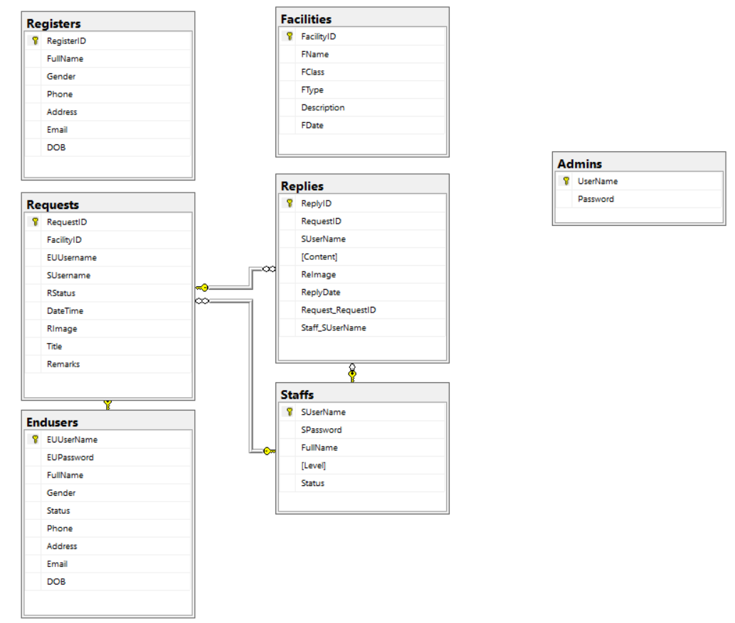

*Table Admin

|  |  |  |  |  |  |  |
| --- | --- | --- | --- | --- | --- | --- |
| Admin | | | | | | |
| No. | **Field Name** | **Data Type** | **Null** | **Key** | **Reference Table** | **Description** |
| 1 | UserName | String | No | P |  | Unique |
| 2 | Password | Varchar(50) | No |  |  | Store password of Admin |

|  |  |  |  |  |  |  |
| --- | --- | --- | --- | --- | --- | --- |
| Staff | | | | | | |
| No. | **Field Name** | **Data Type** | **Null** | **Key** | **Reference Table** | **Description** |
| 1 | SUserName | String | No | P |  | Unique |
| 2 | SPassword | Varchar(50) | No |  |  | Store password of Staff |
| 3 | FullName | Varchar(50) | No |  |  | Store full name of Staff |
| 4 | Level | int | No |  |  | Store level of Staff |
| 5 | Status | Bool | No |  |  | Store status of Staff |

*Table Staff

|  |  |  |  |  |  |  |
| --- | --- | --- | --- | --- | --- | --- |
| End-User | | | | | | |
| No. | **Field Name** | **Data Type** | **Null** | **Key** | **Reference Table** | **Description** |
| 1 | EUUserName | String | No | P |  | Unique |
| 2 | EUPassword | Varchar(50) | No |  |  | Store password of End-User |
| 3 | FullName | Varchar(50) | No |  |  | Store full name of End-User |
| 4 | Gender | Varchar(10) | Yes |  |  | Store gender of End-User |
| 5 | Status | Bool | No |  |  | Store status of End-User |
| 6 | Phone | Varchar(20) | Yes |  |  | Store phone of End-User |
| 7 | Address | Varchar(50) | Yes |  |  | Store address of End-User |
| 8 | Email | Varchar(50) | No |  |  | Store email of End-User |
| 9 | DOB | String | Yes |  |  | Store birth day of End-User |

*Table

|  |  |  |  |  |  |  |
| --- | --- | --- | --- | --- | --- | --- |
| Facility | | | | | | |
| No. | **Field Name** | **Data Type** | **Null** | **Key** | **Reference Table** | **Description** |
| 1 | FacilityID | String | No | P |  | Unique |
| 2 | FName | Varchar(50) | No |  |  | Store name of Facility |
| 3 | FClass | Varchar(50) | No |  |  | Store class of Facility |
| 4 | FType | Varchar(50) | No |  |  | Store type of Facility |
| 5 | Description | Varchar(200) | Yes |  |  | Store description of Facility |
| 6 | FDate | DateTime | Yes |  |  | Store date of Facility |

*Table Facility

*Table Request

|  |  |  |  |  |  |  |
| --- | --- | --- | --- | --- | --- | --- |
| Request | | | | | | |
| No. | **Field Name** | **Data Type** | **Null** | **Key** | **Reference Table** | **Description** |
| 1 | RequestID | String | No | P |  | Unique |
| 2 | FacilityID | String | Yes | F |  | Unique |
| 3 | EUUserName | String | No | F |  | Unique |
| 4 | SUserName | String | Yes | F |  | Unique |
| 5 | RStatus | int | No |  |  | Store status of Request |
| 6 | DateTime | DateTime | No |  |  | Store date of Request |
| 7 | RImage | String | Yes |  |  | Store image of Request |
| 8 | Title | Varchar(50) | No |  |  | Store tile of Request |
| 9 | Remark | Varchar(200) | Yes |  |  | Store remark of Request |

*Table Reply

|  |  |  |  |  |  |  |
| --- | --- | --- | --- | --- | --- | --- |
| Reply | | | | | | |
| No. | **Field Name** | **Data Type** | **Null** | **Key** | **Reference Table** | **Description** |
| 1 | ReplyID | String | No | P |  | Unique |
| 2 | RequestID | String | No | F |  | Unique |
| 3 | SUserName | String | No | F |  | Unique |
| 4 | Content | String | No |  |  | Store content of Reply |
| 5 | ReImage | int | Yes |  |  | Store image of Reply |
| 6 | ReplyDate | DateTime | No |  |  | Store date of Reply |

*Table Register

|  |  |  |  |  |  |  |
| --- | --- | --- | --- | --- | --- | --- |
| Register | | | | | | |
| No. | **Field Name** | **Data Type** | **Null** | **Key** | **Reference Table** | **Description** |
| 1 | RegisterID | String | No | P |  | Unique |
| 2 | FullName | Varchar(50) | No |  |  | Store full name of Register |
| 3 | Gender | Varchar(10) | No |  |  | Store gender of Register |
| 4 | Phone | Varchar(20) | No |  |  | Store phone of Register |
| 5 | Address | Varchar(50) | No |  |  | Store address of Register |
| 6 | Email | Varchar(50) | No |  |  | Store email of Register |
| 7 | DOB | DateTime | No |  |  | Store birth day of Register |