Failover LB
The complete guide to installing and running it

Version 1.0 | For Failover LB 1.0

NGINX® is a registered trademark of F5, Inc. NGINX Plus is a trademark of F5, Inc. Failover LB is an independent project and is not affiliated with, endorsed by, or sponsored by F5, Inc.

Contents
Contents 2
1. About this guide 12
What this software is 12
How to read this 12
How the pictures work 12
Names 12
A word about what this cannot do 13
2. The ideas you need first 14
A site 14
A backend pool 14
Applying 14
Active and standby 14
The agent 14
3. Before you start 16
What you need 16
Ports that need to be open 16
Getting a terminal 16
4. Installing the first server 18
Step 1: get the software 18
Step 2: install Docker 18
Step 3: install the manager 18
Step 4: install nginx 19
5. Adding the second server 20
Step 1: get a token from the first server 20
Step 2: run it on the second server 20
Step 3: check they can see each other 21
6. Signing in for the first time 22
Setting up your authenticator 22
Your recovery codes 24
7. A tour of the screens 25
The menu 26
The bar along the top 26
The pages you will use most 26
8. Backend pools 27
Making a pool 28
What the settings mean 28
Health checks 29
Servers that use https 29
9. Sites 30
Making a site 31
The three modes 31
www and the bare domain 31
Secure traffic 31
10. Sending different paths to different places 32
Adding a path 32
How paths are chosen 32
Taking the path off before passing it on 32
11. Certificates 33
Which one do I want? 34
Getting one from Lets Encrypt 35
Renewal 36
Uploading one you already have 36
Making a signing request 36
Self signed certificates 36
Deleting a certificate 36
12. Error pages 37
Making a template 38
Errors from your application 38
What to write 38
13. Limits, caches and access lists 39
Why they live on their own page 39
Rate limits 39
Connection limits 41
Caches 42
Access lists 43
Using one 44
14. Maps 45
What it is for 45
Making one 46
15. TCP and UDP 47
How it differs from a site 48
Making one 48
Passing on the visitor's address 48
16. Applying changes 49
What happens when you press Apply 49
The Changes page 49
Warnings before applying 50
If something goes wrong anyway 50
17. Utilization 51
What is on it 51
Backend numbers 52
18. Running the two servers as a pair 53
Active and standby 53
How they keep in step 54
What happens when the active server fails 54
Failing over on purpose 54
Taking a server out for a while 54
Adding a third server 54
If a server says it needs to rejoin 54
19. DNS failover 56
The problem 56
What this is called elsewhere 56
Being honest about the limits 56
What you need before you start 56
Step 1: make a zone 57
Step 2: add a name 58
Step 3: point your domain at these servers 59
Doing this in Amazon Route 53 60
Step 4: check it works 61
A note about port 53 61
What failover actually looks like 62
20. The nginx build 63
Why nginx is built rather than installed 63
Rebuilding 63
Checking the two match 63
21. Reaching the management screen by name 64
How it works 64
Step 1: a pool for it 64
Step 2: tell the screen it lives under a path 64
Step 3: a site in front of it 64
Step 4: a real certificate 64
22. Upgrades 66
Doing it 66
Do every server 66
Checking it worked 66
23. Users, roles and the audit log 67
The three roles 67
Adding somebody 68
When somebody leaves 68
The audit log 68
Recovery outside the screen 69
24. Backup and going back 71
Undoing a change you just made 71
What is already backed up for you 71
Backing up properly 71
Losing one server 72
Losing both 72
25. When something is wrong 73
A button is greyed out 73
The second server does not appear after joining 73
A site returns 502 73
A page loads but has no styling 74
A certificate will not renew 74
A name in DNS Failover does not resolve 74
nginx will not start after an upgrade 74
Where to look for more 74
26. Worked example: putting a site live 76
The example 76
Step 1: a pool for the web servers 76
Step 2: a pool for the API servers 77
Step 3: the site 77
Step 4: apply, and check the plain address 77
Step 5: the certificate 77
Step 6: turn on https 78
Step 7: send /api somewhere else 79
Step 8: prove the failover works 79
What you have 79
27. Worked example: DNS failover end to end 80
The example 80
Step 1: the zone 80
Step 2: the name 80
Step 3: the delegation 81
Step 4: check the servers answer 82
Step 5: check the delegation took 82
Step 6: test the failover 82
Step 7: bring it back 83
What to check afterwards 83
28. Worked example: taking a server out for maintenance 84
Before you touch anything 84
Take it out of the DNS answer 84
Hand over being in charge 84
Stop it from coming back too early 84
Do the work 84
Putting it back 84
A checklist you can print 85
29. The site screen, control by control 86
Naming and turning it on 87
Listening 87
The www setting 88
The mode, and what each one adds 88
Security 88
Error pages 88
Paths 89
Raw configuration 89
Deleting a site 89
30. The pool screen, control by control 90
The servers 90
How traffic is shared 91
Health checks 92
Talking to backends over https 92
Connection reuse 93
Slow start 93
Where the numbers for the charts come from 93
Deleting a pool 93
31. Importing an existing nginx config 94
Nothing happens until you say so 94
Which file to paste 94
Reading the preview 95
What the notes under a site mean 96
Certificates are never brought across 96
Warnings you may see 97
What is deliberately not imported 97
Doing the import 97
A worked example 98
32. Settings 99
Where a setting comes from 101
Certificates 101
When you would use dns-01 102
DNS 102
Management networks 102
Monitoring 103
Set in the environment 103
33. Your own account 104
Changing your password 104
Your authenticator 104
Recovery codes 105
Your sessions 105
34. The NGINX® Build screen, control by control 106
Why nginx is built rather than installed from Ubuntu 106
What is installed now 107
Checking before you build 107
Rebuilding 107
Do one server at a time 108
If a rebuild fails 108
35. Open source parity 109
Why this page exists 109
What is on the list 110
A note about reloads 110
Should you buy NGINX Plus? 111
36. Every dialog, field by field 112
New site 112
New pool 113
Adding a server to a pool 115
Getting a certificate from Lets Encrypt 117
Uploading a certificate 118
Making a signing request 119
Making a self signed certificate 120
Adding a path to a site 121
New error page template 122
New map 123
New TCP or UDP service 124
New rate limit zone 126
New cache zone 127
New access list 128
New user 129
37. The tunnel 131
When to use it 131
How to get to it 131
What the words mean 132
Turning it on 133
If the load balancers do not have what they need 133
Adding a workload 133
What the command does 134
If you closed the window before copying the command 134
Putting the workload behind a site 134
Removing a workload 135
When it does not work 135
The workload says it enrolled, but the backend is down 135
Nothing happens at all 136
It works through one load balancer and not the other 136
Getting a fresh command 136
38. Certificates from a paid authority 136
Two ways to use a paid certificate 136
What you need from the supplier 137
Setting up an authority 137
Checking it before you rely on it 138
Getting a certificate from it 139
Renewal 139
When it does not work 140
The test fails 140
The test passes but issuing fails 140
Renewal stopped working 140
39. Backup and restore 140
How it is protected 140
Taking a backup 141
What goes in it 142
How often 142
Where to keep it 142
Restoring 142
What restoring does 143
After a restore 143
Restoring onto different servers 143
One setting is deliberately not restored 144
Tunnel workloads 144
When it does not work 144
That password does not open this backup 144
This zip has no backup in it 144
The restore finished but something is missing 144
40. How DNS failover works 145
Step by step 145
What this does well 146
What it cannot do, and why 146
41. How big the servers need to be 146
The rule of thumb 146
Recommended sizes 147
What changes these numbers 147
Where these numbers come from 148
The honest caveat 148
Appendix A: Ports 149
Appendix B: Files and folders 150
Appendix C: Glossary 151

1. About this guide
This guide explains how to install and run Failover LB. It is written for somebody who has been handed a pair of servers and asked to put a load balancer on them. You do not need to have run one before. Where a word is unavoidable jargon, it is explained in plain language the first time it appears, and again in the glossary at the back.

What this software is
Failover LB is a web page that runs your nginx servers for you. nginx is the program that actually takes requests from the internet and passes them to your applications. It is controlled by text files that are easy to get wrong and unforgiving when you do. This software puts a screen in front of those files, checks your changes before they go live, and pushes them to every server at once so the two never drift apart.

How to read this
Part 1 takes you from two empty servers to a working pair with the screen open in front of you. Read it in order and type the commands as they appear. Part 2 covers the everyday work of adding sites and certificates. Part 3 is about running two servers as a pair, including what happens when one of them fails. Part 4 is for keeping the thing safe and healthy over time.
You can read Part 2 onward in any order. Each chapter says what it assumes you have already done.

How the pictures work
Screenshots in this guide are of the real software. Anything drawn on top in red was added for this guide and is not on your screen. Red arrows point at the thing being described.
Worth knowing Throughout this guide the example domain is example.net and the two servers are called lb-01 and lb-02. Wherever you see those, use your own domain and your own server names instead.

Names
This software is called Failover LB. NGINX is the web server it drives, and it is named on nearly every page of this guide for that reason and no other.
NGINX® is a registered trademark of F5, Inc. NGINX Plus is a trademark of F5, Inc. Failover LB is an independent project and is not affiliated with, endorsed by, or sponsored by F5, Inc.

A word about what this cannot do
No load balancer can send traffic to a server that is switched off, and none of them can make a broken application work. What this does is notice quickly, stop sending people to something that is not answering, and let you fix it without a maintenance window. Chapter 19 is honest about the limits of the failover in particular, because those limits are set by how the internet works and not by this software.

2. The ideas you need first
There are five words used constantly in this guide. Learning them now will save you time later. Nothing here needs to be memorised, and the glossary repeats all of it.

A site
A site is one name that people type into a browser, such as www.example.net, and the rules for what happens when they do. If you run three different web addresses, you have three sites.

A backend pool
A pool is the list of servers that actually run your application. The load balancer takes a request and hands it to one of the servers in the pool. If a pool has four servers in it and one stops answering, the other three carry on and nobody outside notices.
Sites and pools are kept separate on purpose. Several sites can share one pool, and you can swap the pool a site uses without touching anything else.

Applying
Changes you make on the screen are saved right away, but they are not live until you apply them. Applying is one button. It checks the whole configuration first, sends it to every server, and only then tells nginx to start using it. If any server refuses the new configuration, the change is rolled back everywhere and nothing goes live.
Worth knowing This is the single most important habit to build. Save as often as you like, because saving changes nothing for your visitors. Apply when you are ready for the change to be real.

Active and standby
You run two servers. At any moment one is active and the other is standby. Both hold exactly the same configuration and both are capable of serving traffic. The active one is simply the one in charge of making changes. If it fails, the standby takes over on its own, without anybody being woken up.

The agent
The web screen runs with very few privileges, which is deliberate: it faces your staff and it is the part most likely to be attacked. Anything that genuinely needs administrator rights, such as writing nginx configuration or restarting a service, is done by a separate small program called the agent. The agent will only carry out a short fixed list of jobs and will refuse anything else.
You do not have to do anything with the agent. It is installed for you and it looks after itself. It is mentioned here because you will see the word in a few places, and because it is the reason this software can be run without giving the web page administrator rights over your servers.

3. Before you start

What you need
You need | Why
Two servers running Ubuntu | One is enough to start, but a pair is what gives you failover.
Administrator access to both | The installer has to add software and start services.
A domain name you control | For certificates, and for the DNS failover in Part 3.
The ability to add DNS records | At whoever runs your domain, such as Route 53 or GoDaddy.

The servers do not need to be large. Two processors and two gigabytes of memory is a sensible starting point for most workloads, and nginx itself is famously light. What matters far more is that both servers can be reached from the internet on their own addresses.

Ports that need to be open
Port | Used for | Who needs to reach it
80 | Ordinary web traffic, and certificate checks | Everyone
443 | Secure web traffic | Everyone
7443 | The management screen | Your staff only
7444 | The two servers talking to each other | The other server only
53 | DNS failover, if you use it (Part 3) | Everyone

Take care Port 7443 is the management screen and should not be open to the whole internet. The installer asks which networks may reach it, and Chapter 4 shows where to put your office address.

Getting a terminal
Everything in the next two chapters is typed into a terminal on your own computer, connected to the server. On a Mac or on Linux, open the Terminal application. On Windows, open PowerShell. Then connect to the first server:
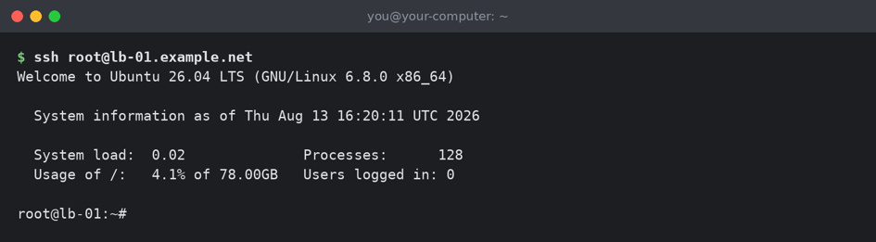
Connecting to the first server. The last line, ending in a hash, is the server waiting for you.
From here on, a line starting with a dollar sign is something you type. Everything else is what the server prints back. You do not type the dollar sign.

4. Installing the first server
This chapter sets up the first of your two servers. At the end of it you will have the management screen running and be able to sign in. It takes about fifteen minutes, most of which is the server downloading things.

Step 1: get the software
Copy the software onto the server. The folder it goes in does not matter, and the one used here is a sensible default.
$ sudo git clone https://git.example.net/nginx-gui-mgmt.git \
/data/docker/nginx-gui-mgmt

Step 2: install Docker
The management screen runs inside Docker, which is a way of packaging a program with everything it needs so it behaves the same everywhere. There is a script that installs and configures it for you.
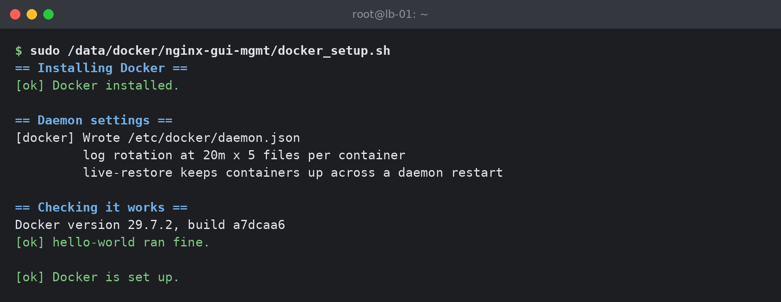
Installing Docker. This takes a couple of minutes.

Step 3: install the manager
Now install the management software itself. The allowlist is the list of networks allowed to open the management screen. Put your office address here. If you are not sure what it is, visit any website that reports your public address and use that, followed by /32.
$ sudo /data/docker/nginx-gui-mgmt/nginx-gui-mgmt_setup.sh \
--allowlist 198.51.100.25/32 \
--acme-email you@example.net
The installer prints what it is doing as it goes. The important lines are near the end.
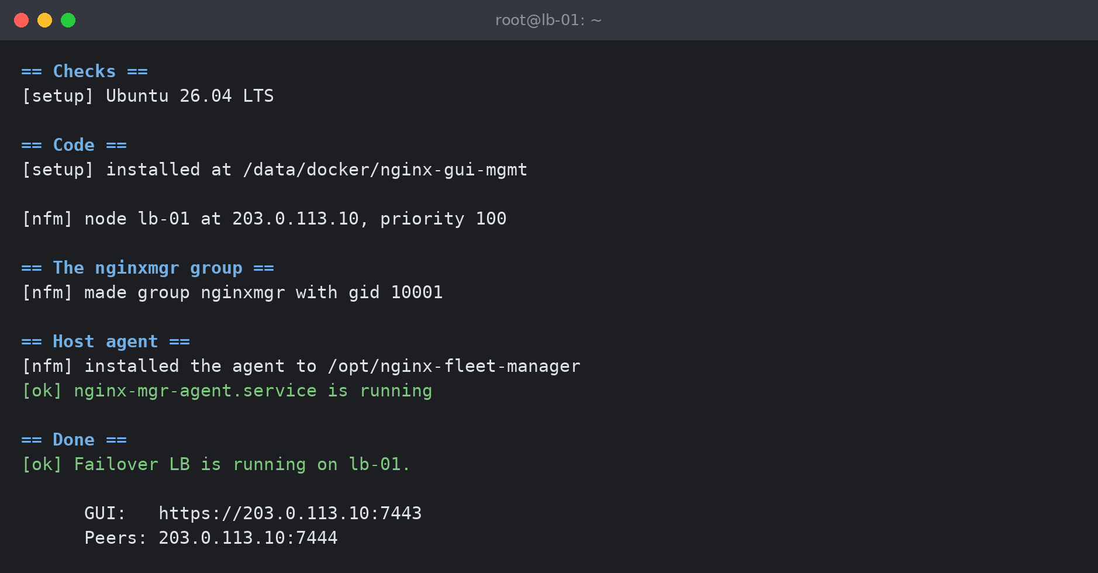
The end of a successful install. Write down the GUI address on the second to last line.
Worth knowing The installer is safe to run again. If something goes wrong, fix it and run the same command a second time. It leaves alone anything it has already done.

Step 4: install nginx
The manager manages nginx, but it does not bring its own copy. Install it now. This one takes the longest, because it builds nginx from source with every module this software knows how to configure.
$ sudo /data/docker/nginx-gui-mgmt/nginx-installer.sh install
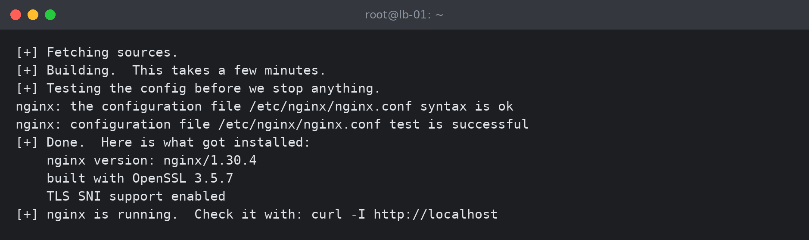
nginx built and running. Yours may show a slightly newer version.
That is the first server finished. You can sign in now if you like, and Chapter 6 shows you how, but it is easier to add the second server first while you still have the terminal open.

5. Adding the second server
The second server joins the first one. Joining means the two share one configuration from then on: anything you change on either is sent to both. To join, the second server needs a token from the first, which is a short lived password that lets it in once.
Take care Do not copy the folder from the first server to the second to save a download. It contains a settings file with that server's identity and its secret key, and the second server will come up believing it is the first one. Install it fresh, as below. The installer now refuses to join if it spots this, but it is easier not to do it.

Step 1: get a token from the first server
Sign in to the management screen on the first server, go to Cluster, and press Add a node. It gives you a command with a token already in it. Copy the whole thing.
The token can be used once and expires after two hours. If you take longer than that, come back and press the button again for a fresh one.

Step 2: run it on the second server
Connect to the second server and run the three steps from Chapter 4 again: get the software, install Docker, then install the manager. The only difference is the last command, which now carries the join details.
$ sudo /data/docker/nginx-gui-mgmt/nginx-gui-mgmt_setup.sh \
--join 203.0.113.10:7444 \
--token <the token you copied> \
--allowlist 198.51.100.25/32
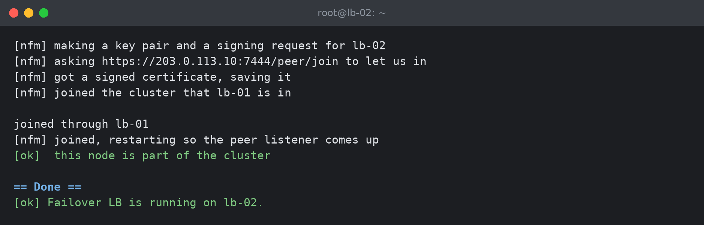
The second server joining the first.
Then install nginx on this server too, exactly as before.
$ sudo /data/docker/nginx-gui-mgmt/nginx-installer.sh install

Step 3: check they can see each other
Open the management screen and go to Cluster. Both servers should be listed, one marked active and the other standby, and both should say online. If the second one is missing or shows an error, Chapter 25 has the usual causes.
Worth knowing It does not matter which server ends up active. They are equal, and which one is in charge will change over time as they are restarted.

6. Signing in for the first time
Open a browser and go to the address the installer printed, which looks like https://203.0.113.10:7443. Chapter 21 shows how to put this behind a proper name and certificate so it is easier to remember.
Worth knowing The first time you visit, your browser will warn you that the connection is not private. That is expected. The server made its own certificate during installation and no browser has been told to trust it. Continue past the warning. Chapter 21 replaces it with a real certificate.

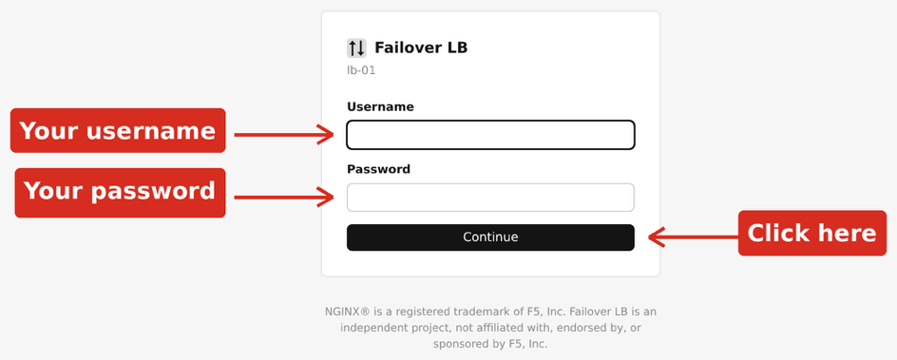
The sign in page. Type your username and password, then press Continue.
Your username and first password are the ones set during installation, or given to you by whoever installed it.

Setting up your authenticator
After your password, you are asked for a six digit code from an authenticator app. Everybody with a local account has to set one up. A password on its own is not enough to reach a screen that can change where all of your traffic goes.
If you have never used one, install any authenticator app on your phone. Google Authenticator, Microsoft Authenticator and 1Password all work, and so does anything else that scans this kind of code.
- Open your authenticator app and choose to add an account.
- Point your phone at the square code on the screen.
- The app starts showing a six digit number that changes every thirty seconds. Type the current one into the box and press Continue.
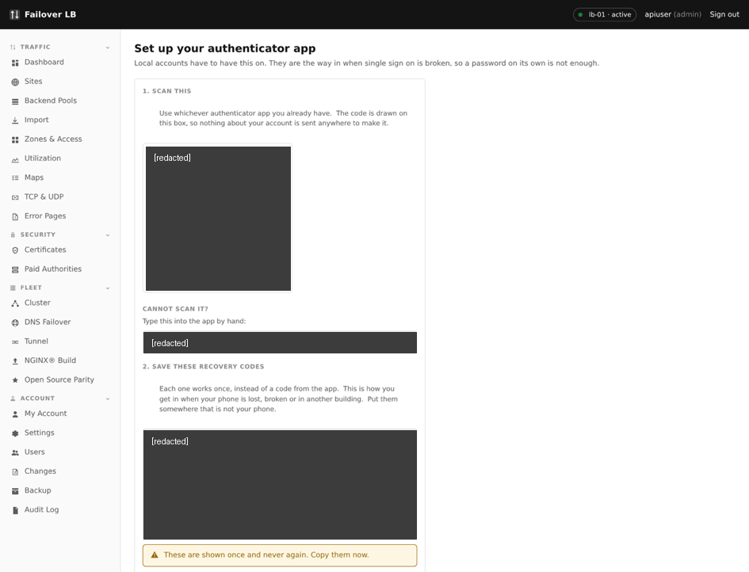
The setup screen. Scan the square code with your phone, then type the six digit number it shows.
Worth knowing If your phone cannot scan the code, there is a line of letters and numbers underneath it. Type that into the app by hand instead. It is the same thing in a different form.

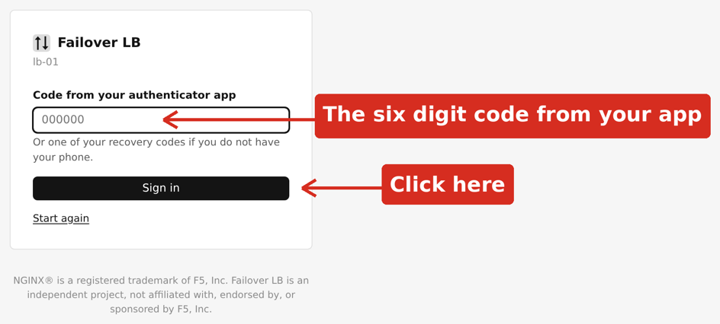
Entering the six digit code from your authenticator app.

Your recovery codes
Take care You are shown a list of recovery codes once, and never again. Each one works a single time in place of a code from your app. They are how you get back in if your phone is lost, broken, or in another building. Save them somewhere that is not your phone.

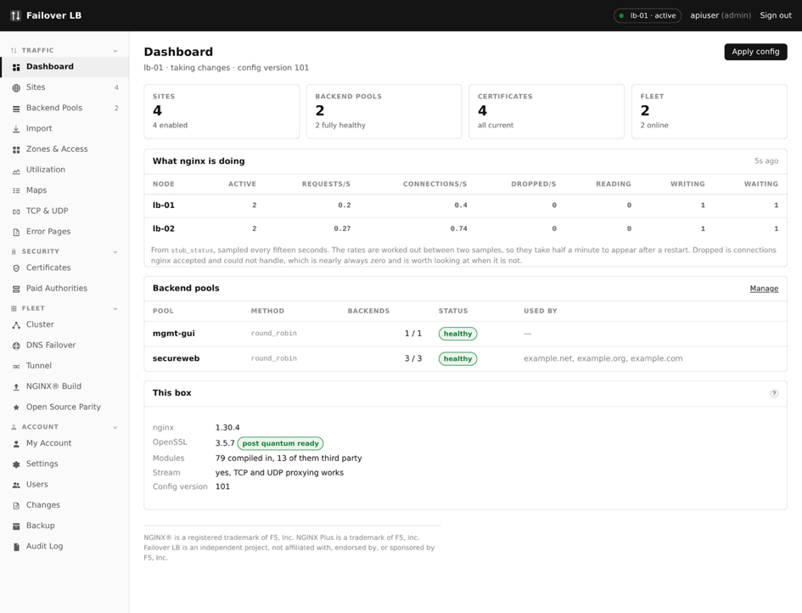
The recovery codes. This screen is shown once and never again.
A password manager is a good place. Printed and put in a drawer is also fine. What matters is that they are not only on the device you might lose.
Each code works once. When you use one, it is gone, and the count on the My Account page goes down by one. Chapter 33 shows how to make a fresh set when you are running low.

7. A tour of the screens
You are now looking at the dashboard. This chapter is a quick walk through what is where. You do not need to do anything yet.
In the sidebar, under TRAFFIC, click Dashboard.
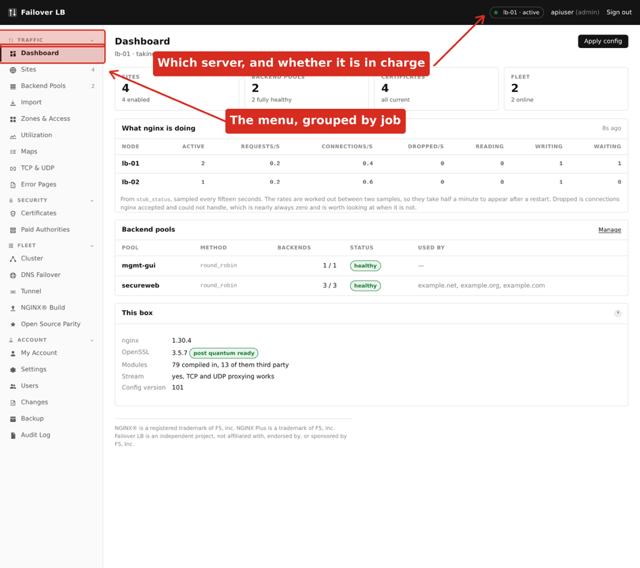
The dashboard, with the menu down the left.

The menu
The menu is grouped into four sections, and the grouping is worth learning because it tells you where to look for things.
Group | What lives there
Traffic | Everything about handling requests: sites, pools, error pages and the rest. This is where you will spend most of your time.
Security | Certificates, and the authorities you buy them from.
Fleet | The two servers as a pair: cluster status, DNS failover, the tunnel, upgrades and the NGINX® Build page.
Account | Your own login, users, settings, and the record of who changed what.

Each group heading can be clicked to fold that part of the menu away, and the screen remembers how you left it. If a page named in this guide is not in the menu, its group is folded rather than missing: click the heading to open it again.

The bar along the top
On the right of the top bar is the name of the server you are looking at and whether it is active or standby. This matters more than it looks. Both servers show the same screens, but changes are made on the active one. If you find a button greyed out, check this first.

The pages you will use most
Page | What it is for | Chapter
Sites | The web addresses you serve | 9
Backend Pools | The servers behind them | 8
Certificates | Making traffic secure | 11
Changes | What is saved but not yet live | 16
Cluster | The two servers as a pair | 18
DNS Failover | Sending people to a server that is up | 19

The next part of this guide works through the everyday jobs in the order you are most likely to need them. If you are setting this up for the first time, start with Chapter 8 and work forward, because a site needs a pool to point at and a certificate to be secure.

8. Backend pools
A pool is the list of servers that run your application. This chapter comes first because a site needs a pool to point at, so making the pool is the first real job.
In the sidebar, under TRAFFIC, click Backend Pools.
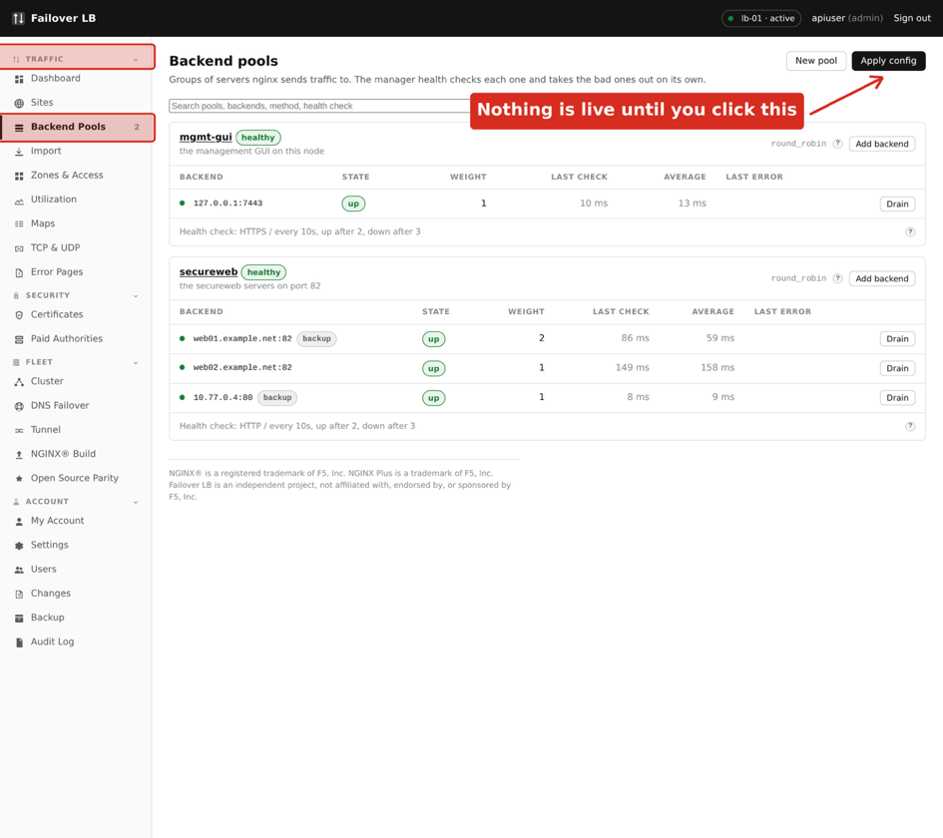
The Backend Pools page.

Making a pool
- Go to Backend Pools and press New pool.
- Give it a name. Use something that says what is in it, such as shop-web or billing-api. You will pick it from a list later and the name is all you will see.
- Add each server, one row per server. You need its address and the port your application listens on.
- Press Save.
Worth knowing Saving a pool changes nothing for your visitors yet. Nothing is live until you apply, which is Chapter 16.

What the settings mean
Setting | What it does
Balancing method | How requests are spread across the servers. Round robin sends them out in turn and is the right answer for almost everybody. Least connections favours whichever server is least busy, which helps when some requests take much longer than others.
Weight | How much of the traffic a server takes compared to the others. Leave it at 1 unless one machine is genuinely bigger, then give it 2 to send it twice as much.
Backup | A server that is used only when every other server in the pool is down. Useful for a holding page, and a common mistake otherwise, because a backup server sits idle and untested until the worst possible moment.
Max fails and fail timeout | How many failures in a row before the server is taken out, and for how long. Three failures and ten seconds suits most people.
Keep alive | How many connections to hold open ready for the next request. This makes a real difference to speed and the default is sensible.

Health checks
The load balancer checks each server regularly and stops sending traffic to any that stop answering. This is what makes a pool worth having. By default it checks that the server accepts a connection.
A better check asks for a page and looks at the answer. If your application has a health page, point the check at it. A server whose web process is running but whose database has gone will still accept a connection, so a connection check calls it healthy while every visitor gets an error.
Take care Point the health check at something that genuinely tests the application. A page that returns OK without touching anything is only telling you the web server is running, which you already knew.

Servers that use https
If your application speaks https rather than plain http, turn on the TLS setting for the pool. There are two further settings and they matter.
Setting | When to change it
Check the certificate | On by default, and right for a backend with a real certificate. Turn it off only for a backend using a self signed certificate, for example something on the same machine.
Certificate authority file | If your company issues its own certificates, point this at your company's authority file. Then checking stays on and still works.

Worth knowing If a pool with TLS turned on gives errors straight away, this is usually why. The backend's certificate cannot be checked, so the connection is refused. The page for the pool says so.

9. Sites
A site is one web address and the rules for what happens when somebody visits it. Now that you have a pool, you can put a site in front of it.
In the sidebar, under TRAFFIC, click Sites.
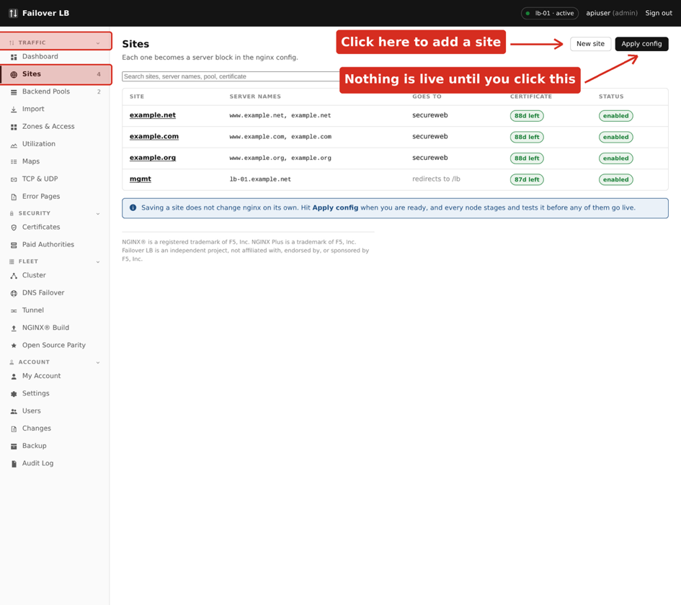
The Sites page.

Making a site
- Go to Sites and press New site.
- Give it a name. This is for your use only and visitors never see it.
- Under Server names, put the web address people will type, such as www.example.net. You can add more than one.
- Choose Proxy as the mode, and pick the pool you made in Chapter 8.
- Press Create site.

The three modes
Mode | What it does
Proxy | Passes requests to a pool. This is what you want for an application.
Static | Serves files straight from a folder on the server. Good for a holding page or a set of downloads.
Redirect | Sends visitors somewhere else. Used for old addresses you want to keep working.

www and the bare domain
Most people want both example.net and www.example.net to work, and want one of them to be the real address so the other simply forwards to it. Put both names on the site and turn on the setting to send everything to the first name. Visitors who type either one end up in the same place, and search engines are not confused by the same pages appearing at two addresses.
Worth knowing The forward is written so it does not interfere with certificate renewal. This is worth knowing because doing it by hand in nginx usually does interfere, and the certificate then quietly fails to renew two months later.

Secure traffic
Turn on Listen on https and pick a certificate. Chapter 11 covers getting one. Leave Force https on, which sends anybody arriving on the plain address over to the secure one.
Take care Do not turn off Listen on http. Certificate renewal needs port 80 to answer. Force https already means no real visitor stays on it.

10. Sending different paths to different places
So far a site sends everything to one pool. Often you want part of a site handled differently: /api to one set of servers and everything else to another, or /downloads served as files. That is what paths are for.

Adding a path
- Open the site and find the Paths section.
- Press Add a path.
- Type the path, such as /api.
- Choose what it does. The choices are the same three as a site: send it to a pool, serve files, or redirect.
- Press Save.

How paths are chosen
When a request arrives, the most specific matching path wins. A request for /api/users matches a path of /api rather than the site's general rule, because /api is more specific. You do not have to put them in any particular order.

Taking the path off before passing it on
There is a setting called Take this path off before sending it on. It is worth understanding because getting it wrong produces a confusing failure.
With it off, a request for /api/users reaches your application as /api/users. With it on, the same request reaches it as /users.
Which you want depends on the application. If it was written knowing it lives under /api, leave the setting off. If it expects to be at the top level and you are mounting it under a prefix it has never heard of, turn it on.
Worth knowing The giveaway for getting this wrong is a page that loads but has no styling, because the page itself was found and the stylesheet was not. It looks like a problem with the appearance and it is really the path.

11. Certificates
A certificate is what makes the padlock appear in the browser and what stops anybody between your visitor and your server reading the traffic. This chapter covers the four ways to get one.
In the sidebar, under SECURITY, click Certificates.
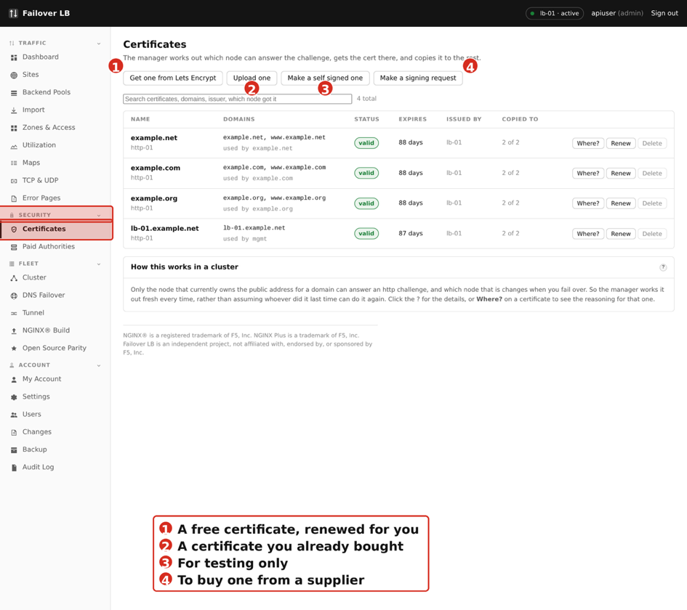
The Certificates page.

Which one do I want?
If you want | Use
A certificate that costs nothing and renews itself | Lets Encrypt. This is the right answer for nearly everybody.
To use a certificate your company already bought | Upload one.
Something for testing that browsers will warn about | Make a self signed one.
To buy from a particular supplier | Make a signing request.

Getting one from Lets Encrypt
Lets Encrypt gives out certificates free, and this software renews them for you before they run out. For it to work, the name you are asking for has to already point at one of your servers, and port 80 has to be reachable from the internet.
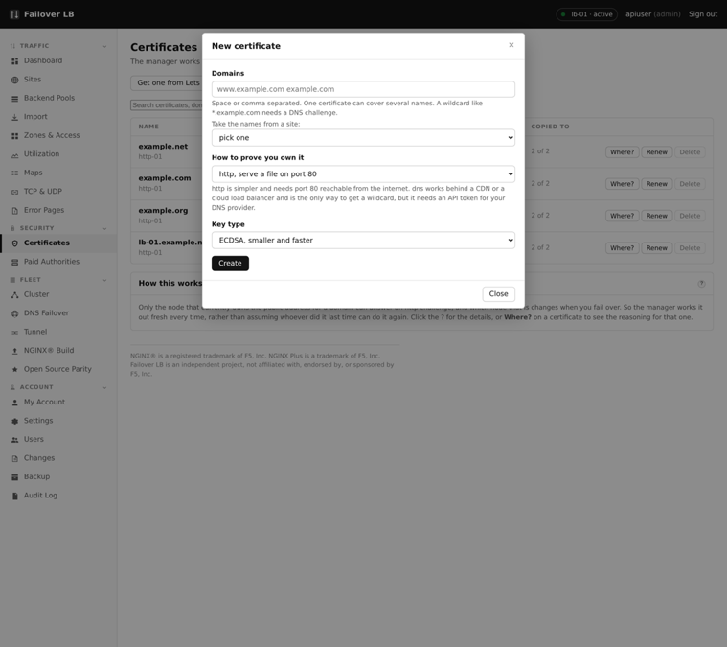
Asking Lets Encrypt for a certificate.
- Press Get one from Lets Encrypt.
- Type the domain name, such as www.example.net. You can add more names to one certificate.
- Press Request. It takes about thirty seconds.
The certificate appears in the list marked valid, with the number of days until it expires and which servers have a copy.
Worth knowing Only the server that currently owns the public address can answer the check, and which server that is changes when you fail over. The software works out which one can do it every time rather than assuming whoever did it last still can. The Where? button explains its reasoning for any certificate.

Renewal
Renewal happens on its own, thirty days before expiry by default. You do not need to do anything and you do not need a calendar reminder. If a renewal fails, the certificate list says so, and it keeps trying, so a single bad night does not become an outage a month later.

Uploading one you already have
If your company buys certificates, press Upload one and paste in the certificate and its private key. The software checks that the key actually matches the certificate before it saves anything, which catches the most common mistake, and it puts any intermediate certificates in the right order for you.

Making a signing request
If your supplier needs a signing request, press Make a signing request. Choose a key length of 2048 or 4096. Both are fine; 2048 is faster and 4096 is what some auditors ask for.
You get a block of text to send to your supplier. The private key stays here and is never sent anywhere, which is the point of doing it this way. When your supplier sends the certificate back, find the request in the list, press Paste Certificate, and paste in what they sent. It is then a normal certificate and can be used on a site.

Self signed certificates
Take care A self signed certificate makes every browser show a warning, because nothing has vouched for it. It is fine for testing and for something only your own systems talk to. Never use one on a site the public visits.

Deleting a certificate
A certificate that is not being used by any site can be deleted. One that is in use cannot, and the page tells you which site is using it. That is deliberate: deleting a certificate a site depends on would stop that site working the moment you next applied.

12. Error pages
When something goes wrong, visitors see a bare page from nginx that says 502 Bad Gateway and nothing else. Error page templates replace that with something of your own.
In the sidebar, under TRAFFIC, click Error Pages.
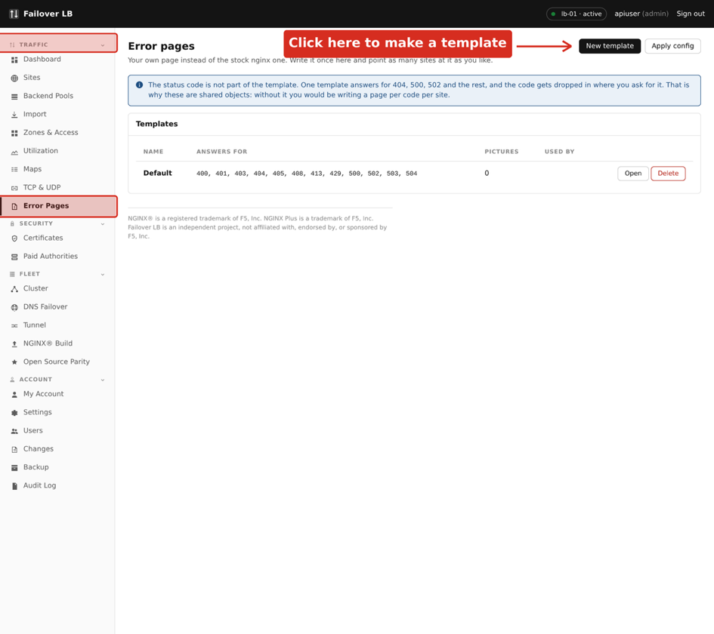
The Error Pages page.

Making a template
- Go to Error Pages and press New template.
- Give it a name.
- Write the page for each error you care about. 404 for a page that does not exist and 502 for the application being down are the two worth doing first.
- Press Save.
Then open a site and choose the template. You can also set a different template on a single path, which is useful when part of a site is an API that should return something machine readable rather than a friendly page.

Errors from your application
Worth knowing By default your error pages are also used for errors your application returns, not just errors nginx generates itself. If your application already returns its own nicely designed error pages, turn that setting off for the site so its pages are passed through untouched.

What to write
Keep it short and say what the visitor should do. A page that says the site is having a problem and to try again in a few minutes is worth more than a clever design. Avoid technical detail: it does not help the visitor and it tells anybody probing your site more than they need to know.

13. Limits, caches and access lists
The Zones and Access page holds the shared pieces your sites point at. There are four kinds, on four tabs: rate limits, connection limits, caches, and access lists. You make one here, then choose it on a site or on a single path.

Why they live on their own page
nginx wants these declared once near the top of its configuration and then used further down. That is the reason they are not settings on a site. It also turns out to be what you want, because several sites can share one: a single login limit protecting every sign in page you run is easier to reason about than six separate ones.
Worth knowing Each list has a Used by column. A zone that says it is not used yet is doing nothing. Making one is only half the job, and choosing it on a site is the other half.

Rate limits
A rate limit caps how many requests one visitor may make in a period. It is the simplest protection against somebody hammering a login page guessing passwords, and against one badly written script using all of your capacity.
In the sidebar, under TRAFFIC, click Zones & Access, then the Rate limits tab.
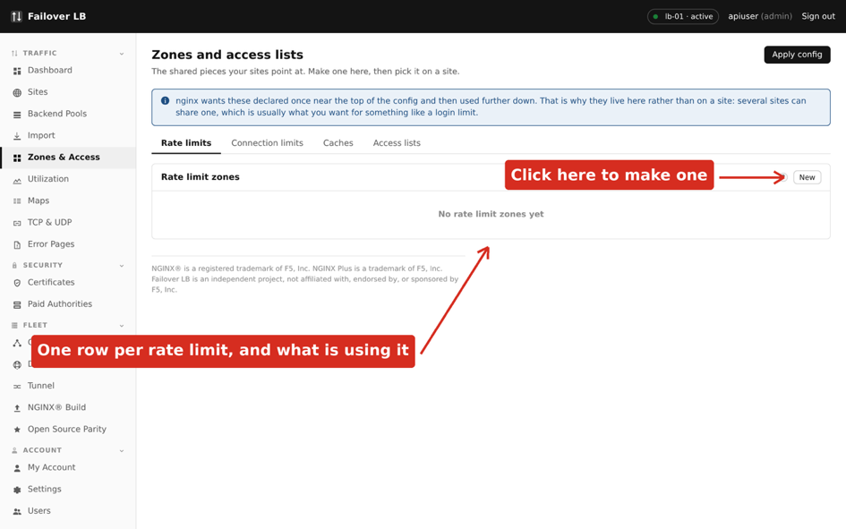
The rate limits tab.
Setting | What it does | Usual value
Name | What you will pick it by on a site | login-limit
Counts by | What makes two requests count as the same visitor. The visitor's address is the normal answer | $binary_remote_addr
Rate | How many requests are allowed, per second or per minute | 10r/s
Memory | How much to set aside for remembering visitors. 10m holds roughly 160,000 addresses, which is plenty for most sites | 10m

Take care Set the rate well above what a real person does. Somebody reading a site makes a handful of requests a second while a page loads, so ten a second stops abuse without anybody noticing. Set it too low and real visitors get errors, which is a worse outage than the one you were protecting against, and harder to spot because most people just leave.

Test it before you rely on it. Ask for a page faster than the limit and confirm you get refused, then confirm normal use does not.

Connection limits
A connection limit caps how many conversations one visitor may have open at once, rather than how fast they ask. The two are different and protect against different things. A rate limit stops rapid requests; a connection limit stops one visitor holding open hundreds of slow ones, which is how a small number of machines can tie up a server without ever looking busy.
In the sidebar, under TRAFFIC, click Zones & Access, then the Connection limits tab.
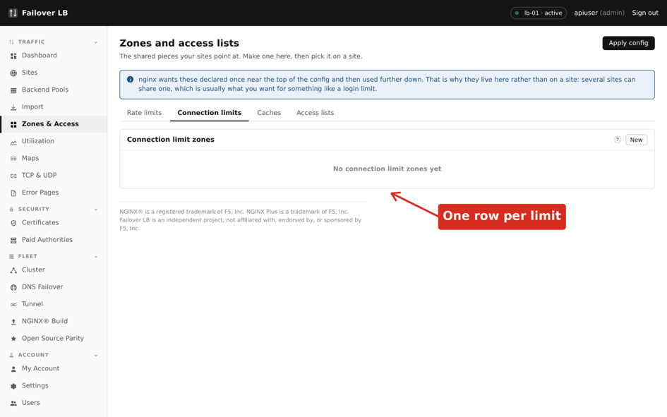
The connection limits tab.
Setting | What it does | Usual value
Name | What you pick it by | per-visitor
Counts by | What counts as one visitor | $binary_remote_addr
Memory | Space for remembering them | 10m

Worth knowing Be careful with a low connection limit on a normal website. A browser opens several connections at once on purpose, so a limit of one or two will break ordinary visitors. Ten is a gentle starting point.

Caches
A cache lets the load balancer keep a copy of things that do not change often, so your application is not asked for the same image a thousand times. Done well it is the cheapest speed improvement available.
In the sidebar, under TRAFFIC, click Zones & Access, then the Caches tab.
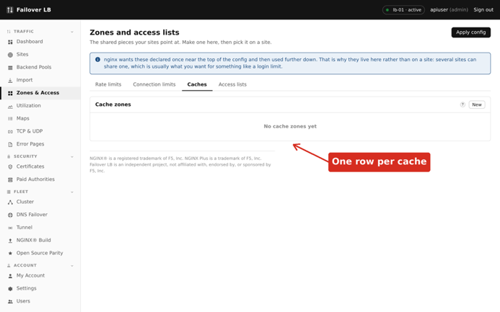
The caches tab.
Setting | What it does | Usual value
Name | What you pick it by | static-files
Folder | Where on disk the copies are kept | /var/cache/nginx/static
Memory for the index | Space for the list of what is cached, not the copies themselves | 10m
Maximum size | How much disk the copies may use before the oldest are thrown away | 1g
Inactive | Throw something away if nobody has asked for it in this long, even if there is room | 60m

Take care Cache static things: images, stylesheets, downloads. Be careful with anything that differs per visitor. A cached page belonging to one signed in user being served to another is the classic caching accident, and it is a data breach rather than a glitch.

Access lists
An access list decides who may reach a site or a path, by address. The common use is putting an admin area behind your office network while the rest of the site stays public.
In the sidebar, under TRAFFIC, click Zones & Access, then the Access lists tab.
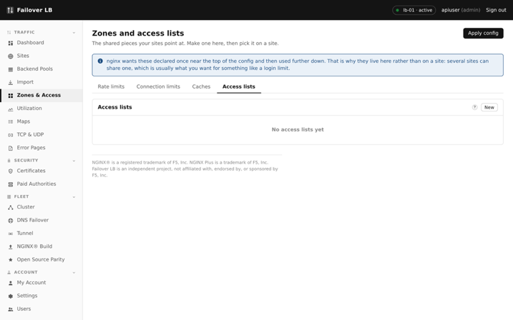
The access lists tab.
Setting | What it does
Allowed | Addresses or networks that may reach it. One per line. A single address or a range such as 198.51.100.0/24.
Blocked | Addresses that may not. Used with a default of allow, for shutting out a specific nuisance.
When nothing matches | Allow or deny. Deny with a list of allowed addresses is a private area. Allow with a list of blocked ones is a public area with exceptions.
Include the management networks | Adds the networks allowed to reach the management screen, so you do not lock yourself out of your own admin area.
Ask for a username and password | A second lock on top of the address check. Reasonable as a second layer, thin on its own.
Trust the address from a header | Turn on only if something else sits in front of these load balancers, such as a CDN. Without it you would be filtering on the address of that service rather than the real visitor.

Take care Trust the address from a header is the one to think about. If you turn it on when nothing trustworthy is in front, anybody can set that header themselves and walk straight through your access list. Turn it on only when you know what is in front and you have named it as trusted.

Using one
- Make the zone or list on this page.
- Open the site, or a single path on the site.
- Choose it from the list of that kind.
- Apply.
Choosing it on a path rather than the whole site is what lets you rate limit only the login page, or lock down only the admin area, and leave everything else alone. That is nearly always what you want.

14. Maps
A map is a lookup table. It reads one thing about a request, works down a list of rules, and sets a value you can then use elsewhere. This is the most technical chapter in Part 2 and you can skip it until you need it.
In the sidebar, under TRAFFIC, click Maps.
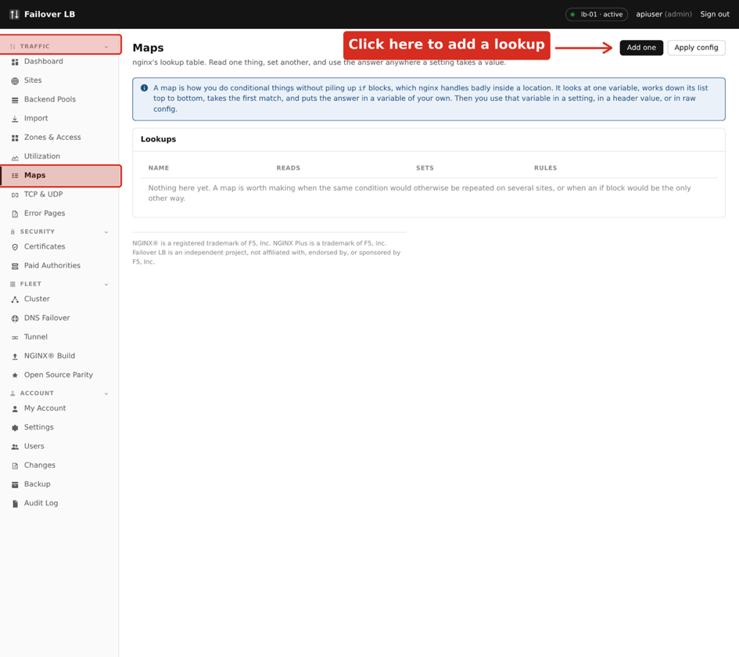
The Maps page.

What it is for
The usual reason is doing something conditionally without repeating yourself. If three sites all need to treat requests from mobile phones differently, one map does the deciding and all three sites use the answer.

Making one
- Press Add one.
- Choose what it reads. The browser type and the requested host are the common choices.
- Say what variable it sets. This is a name you invent.
- Add the rules, most specific first. The first match wins.
- Say what to use when nothing matches.
A plain word matches exactly. Starting a rule with a squiggle means it is a pattern rather than a fixed word, and a squiggle followed by a star means the pattern ignores capital letters.
Worth knowing The value a map sets is checked before it is saved. A name nginx does not recognise would stop nginx starting on every server at once, so it is refused here instead.

15. TCP and UDP
Everything so far has been about web traffic. This page balances things that are not web traffic: a database, a mail server, a game server, anything that speaks its own protocol.
In the sidebar, under TRAFFIC, click TCP & UDP.
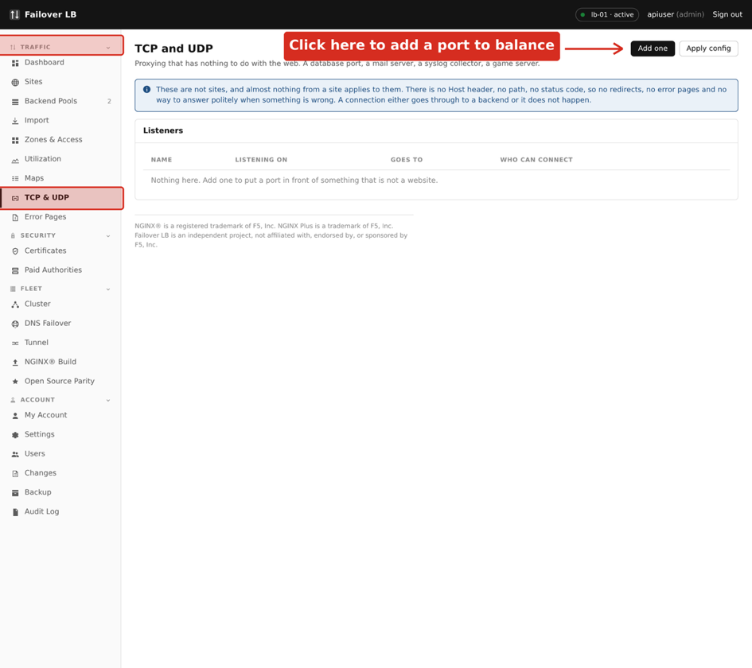
The TCP and UDP page.

How it differs from a site
There are no paths, no error pages and no redirects, because those are web ideas and this is not the web. What you get is a port to listen on and a pool to send connections to.

Making one
- Press Add one.
- Choose TCP or UDP. If you are not sure, it is TCP.
- Say which port to listen on.
- Choose the pool.
- Press Save, then apply.
Take care Pools used here are kept separate from the pools used by sites, even when the servers in them are the same. This is a rule in nginx itself, not a choice made here. You will see the same servers listed twice and that is correct.

Passing on the visitor's address
By default your backend sees the connection as coming from the load balancer, because it is. If your application needs the real visitor address, turn on the proxy protocol setting, but only if the application understands it. A backend that does not will fail to read the connection at all.

16. Applying changes
This chapter is short and it is the most important one in Part 2. Everything you have saved so far is written down and none of it is live. Applying is what makes it real.
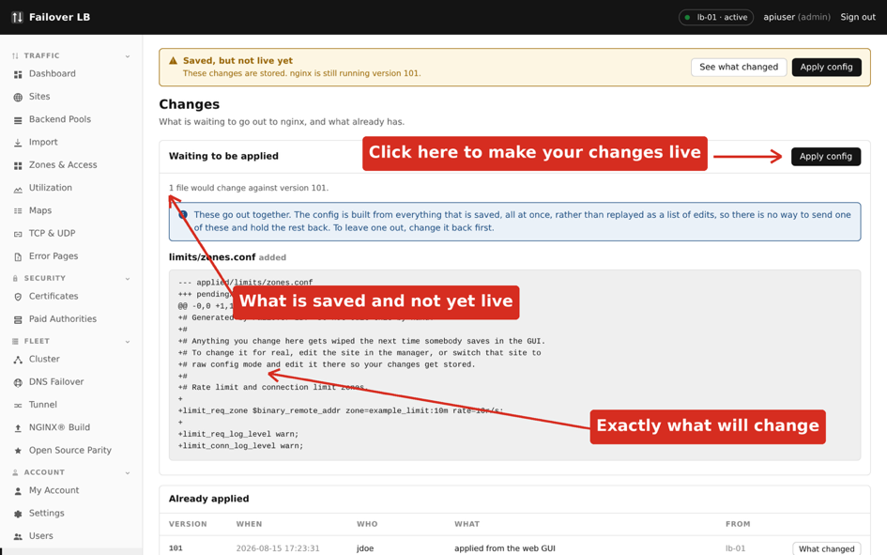
The Changes page, showing what is saved but not live.

What happens when you press Apply
- The whole configuration is built from what you have saved.
- It is checked for problems before anything is sent.
- It is sent to every server and each one tests it without using it.
- Only if every server accepts it does each one switch over.
- If any server refuses, every server keeps what it had and you are told what was wrong.
This is why applying is safe. A configuration that would stop nginx starting cannot get halfway across your servers. Either the change happens everywhere or it happens nowhere.

The Changes page
The Changes page shows what is saved and not yet live, and what changed. Read it before applying, particularly if somebody else has been working on the same thing. You are about to make their changes live along with your own.

Warnings before applying
Some changes get a warning first. The most common is a pool with no healthy servers in it, which means the site would serve errors. A warning is not a refusal. Sometimes serving an error page from a pool you are about to fill is exactly what you meant to do.

If something goes wrong anyway
Every apply is kept, so you can look at what changed and put it back. Chapter 24 covers going back to an earlier configuration.
Worth knowing Get into the habit of applying in small steps. One change applied and checked is easy to understand. Nine changes applied together, one of which broke something, is an afternoon.

17. Utilization
The Utilization page shows how busy things are over time. It answers the two questions people actually ask, which are whether the thing is coping now and whether it has been getting worse.
In the sidebar, under TRAFFIC, click Utilization.
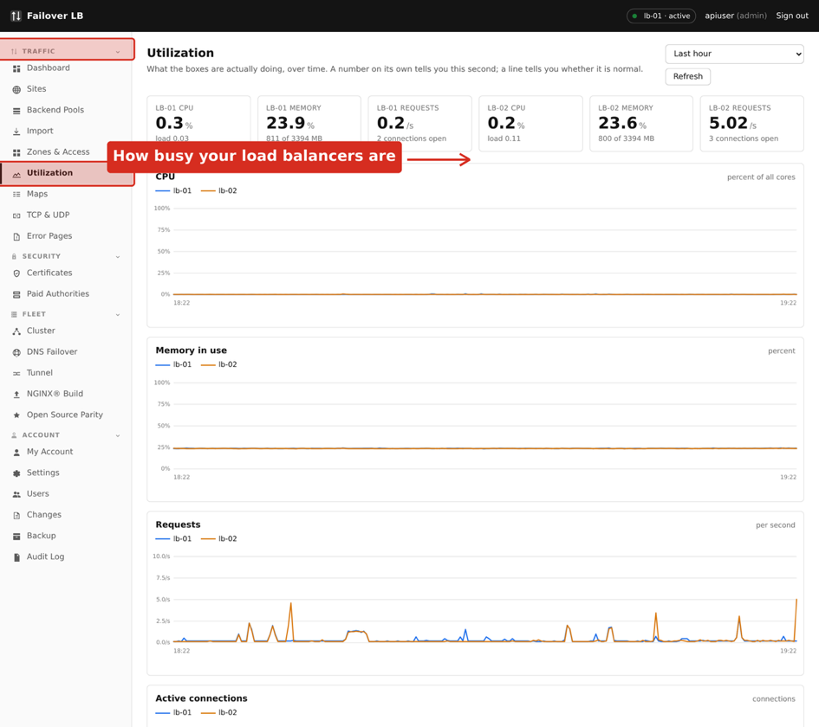
The Utilization page.

What is on it
Chart | What it tells you
Requests | How much traffic is arriving. A sudden change here explains most other charts.
Connections | How many conversations are open at once. Climbing while requests stay flat usually means something is answering slowly.
Processor and memory | How hard each of your load balancer servers is working.
Backend servers | The same for the servers in your pools, when they publish it. This section is hidden when there is nothing to show.

Backend numbers
The load balancer has no login on your application servers and does not want one. Holding a password for every machine in the estate would make this the most valuable box on your network, which is a much bigger risk than a chart is worth.
Instead it reads numbers your servers already publish, if they publish any. Many do without anybody setting it up. Put the address in the pool settings and the charts appear. If a server publishes nothing, it is simply not measured and the page says so rather than guessing.
Worth knowing A chart with a gap in it means no measurement was taken then, usually because something was restarting. A gap is drawn as a gap and not as zero, because zero would read as the server being idle when it was actually being restarted.

18. Running the two servers as a pair
Your two servers are a pair. They hold the same configuration, they both serve traffic, and one of them is in charge at any moment. This chapter explains what that means day to day and what happens when one of them fails.
In the sidebar, under FLEET, click Cluster.
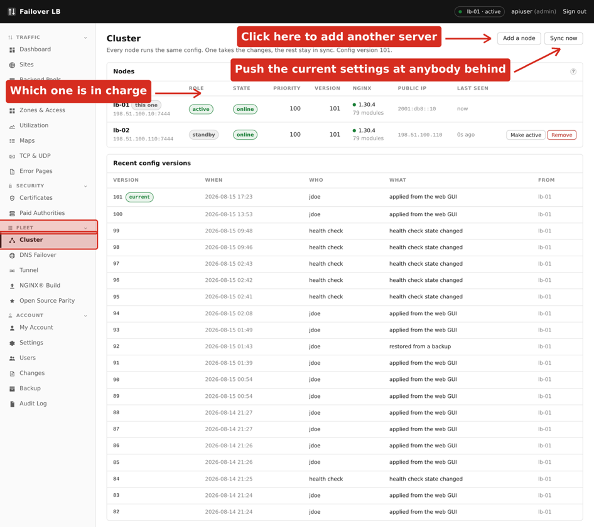
The Cluster page, showing both servers.

Active and standby
The active server is the one that accepts changes. The standby holds an identical copy of everything and is ready to take over. Both are serving traffic the whole time. Standby does not mean idle, and this catches people out: the standby is not a spare sitting in a cupboard, it is a working server that happens not to be the one you make changes on.
Which server is active will change over time, usually because one was restarted. That is normal and needs no action. If you find a button greyed out, check the top right of the screen to see whether you are looking at the standby, and open the other server instead.

How they keep in step
The two servers send each other a heartbeat every few seconds. A heartbeat is a short message that says I am here and this is the version of the configuration I am running. If one stops hearing from the other for long enough, it decides the other has gone.
When you apply a change, it is sent to both servers before either starts using it, which is what Chapter 16 described. So the two cannot drift apart through normal use.

What happens when the active server fails
The standby notices the heartbeats have stopped, promotes itself to active, and carries on. Nobody has to be woken up and nothing has to be typed. Traffic already going to the surviving server is unaffected throughout, because it was already serving.
What is not solved by this is traffic that was going to the server that died. Nothing on this page can help with that, because the decision about where to send a visitor was made before the connection was even attempted. That is what Chapter 19 is for, and it is the reason that chapter exists.

Failing over on purpose
There is a button to hand over to the other server. Use it before planned work, such as rebooting a machine. Handing over deliberately is calmer than pulling the plug and letting the software work it out, and it lets you confirm the other server is healthy first.

Taking a server out for a while
Forced standby stops a server from becoming active without removing it from the pair. Use it on a machine you are working on. Remember to turn it off afterwards, because a fleet where one server can never take over is a fleet with no failover, and nothing will remind you.

Adding a third server
The steps are exactly those in Chapter 5. Get a token from any server that is already in the cluster, then run the installer on the new machine with the join details. There is nothing special about having two.

If a server says it needs to rejoin
Worth knowing A server complaining that its credentials were refused is nearly always a name problem rather than a certificate problem. The usual cause is the settings file having been copied from another machine, so the server believes it is that machine. Chapter 25 covers how to tell and how to fix it.

19. DNS failover
This chapter solves the problem Chapter 18 could not. It is the longest chapter in the guide because it is the one that involves your domain provider as well as this software, and because it is worth being honest about what it can and cannot do.

The problem
A load balancer can only move traffic that reaches it. If a whole server is gone, nothing reaches it, so nothing it might have done matters. Visitors are still being sent there because their computer looked up your address before it tried to connect, and it was given the address of a server that has since died.
The only thing that can send them somewhere else is the lookup itself. So these servers answer that lookup, and they leave out any server that is not healthy.

What this is called elsewhere
If you have used other products, you may know this as GSLB, or global server load balancing. F5 call it GTM or BIG-IP DNS, Infoblox call it DTC, and Amazon Route 53 does the same thing with its health checks. It is all the same idea.

Being honest about the limits
Take care DNS failover is not instant and cannot be made instant. How long a computer remembers an answer is a request from you, not a rule. Some providers refuse very short values, browsers keep their own copy, and some programs remember an address for as long as they are running. Expect most visitors to move within a minute or two and expect a small number to take much longer.

Anybody who has promised you instant failover through DNS has promised something DNS cannot do. What it is genuinely good at is the case where nothing else works at all: two servers in different buildings, on different networks, with different addresses. Two servers on one network can share a floating address and move it in a second. Two servers in different places cannot, and then this is the answer.

What you need before you start
You need | Why
Each server on its own public address | The whole point is handing out different addresses.
A part of your domain you can delegate | Such as gslb.example.net. Not the whole domain.
Access to your domain provider | To point that part at these servers.

Worth knowing Use a piece of your domain rather than the whole thing. Delegating example.net itself moves every other record you have, including mail, onto these servers. Delegating gslb.example.net moves nothing except what you put there.

Step 1: make a zone
Go to DNS Failover and press Add a zone.
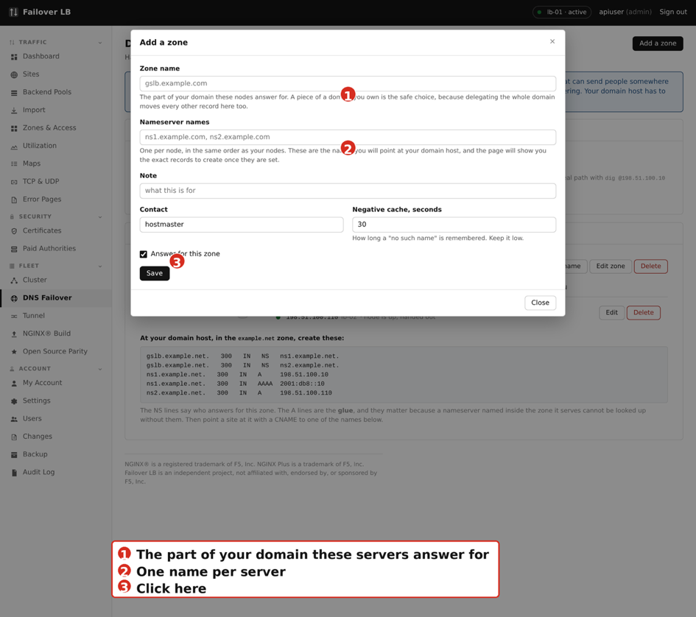
Adding a zone.
- For the zone name, use the piece of your domain you are delegating, such as gslb.example.net.
- For nameserver names, give one name per server, in the same order as your servers. Something like ns1.example.net and ns2.example.net. You are inventing these now and creating them at your provider in step 3.
- Press Save.

Step 2: add a name
A zone on its own answers nothing. Add the name people will actually use. Press Add a name on the zone.
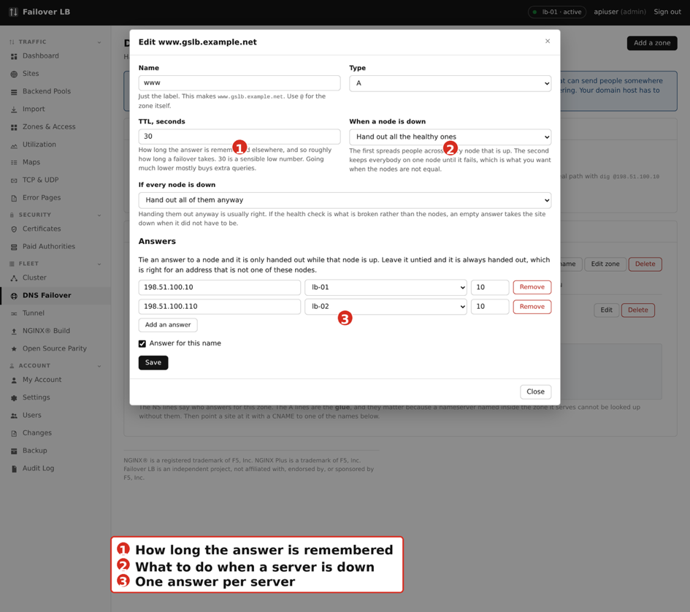
Adding or editing a name in the zone.
Setting | What to put
Name | The label, such as www. This makes www.gslb.example.net.
Type | A, unless you are giving out IPv6 addresses.
TTL | How long the answer is remembered. 30 seconds is a sensible low number. Going much lower mostly buys extra lookups without moving anybody faster.
When a server is down | Hand out all the healthy ones spreads visitors across everything that is up. Hand out the best one only keeps everybody on one server until it fails, which is what you want when the servers are not equal.
If every server is down | Hand them out anyway is usually right. If the health check itself is what broke, an empty answer takes the site down when it did not have to be.

Then add one answer per server. Pick the server from the list and its address is filled in for you. An answer tied to a server is only given out while that server is healthy. An answer left untied is always given out, which is what you want for an address that is not one of these servers.

Step 3: point your domain at these servers
This is the step people miss, and missing it looks exactly like the feature being broken. Everything on the page reads correctly and the name still does not work, because nothing has told the internet to ask your servers.
The page prints the exact records to create, with your addresses already filled in. Copy them to your domain provider.
In the sidebar, under FLEET, click DNS Failover.
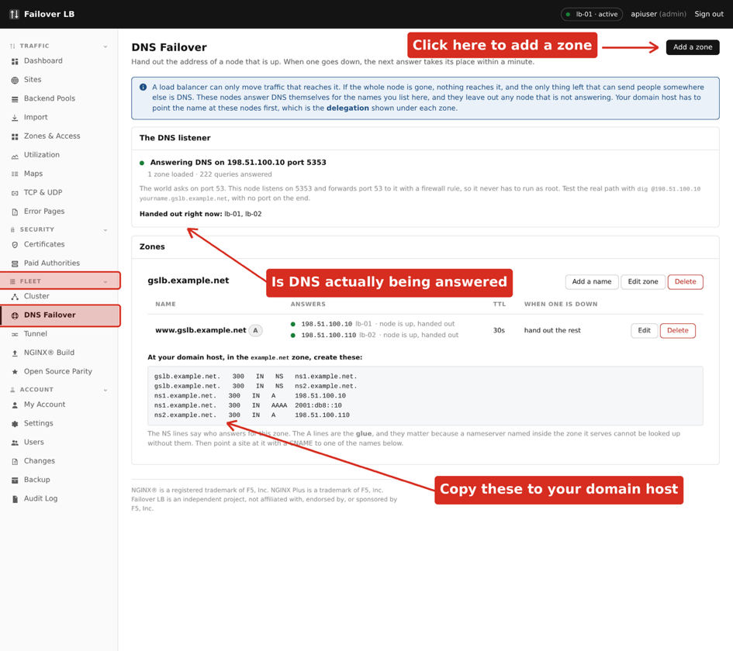
The DNS Failover page. The records to create at your provider are printed under the zone.
There are two kinds and you need both.
Record | What it does
NS | Says who answers for this part of your domain. One per server.
A, called glue | Gives the address of each nameserver. Needed because a nameserver named inside the part of the domain it answers for cannot be looked up without it, which is a loop.

Doing this in Amazon Route 53
In Route 53, open the hosted zone for example.net, which is the parent of the part you are delegating. Create these records there, not in a new hosted zone.
- Create a record named gslb, of type NS, with your two nameserver names as the value, one per line. Set the TTL to 300.
- Create a record named ns1, of type A, with the address of your first server.
- Create a record named ns2, of type A, with the address of your second server.
If you are pointing an existing address at this, add one more record: a CNAME from the name people use, such as shop.example.net, to the name in your new zone, www.gslb.example.net.
Worth knowing Do not create a hosted zone in Route 53 for gslb.example.net. Your servers are the nameservers for it now. A hosted zone there as well gives two different sets of servers claiming the same name.

Step 4: check it works
Ask each of your servers directly. On any computer with the dig command, which Macs and Linux have built in:
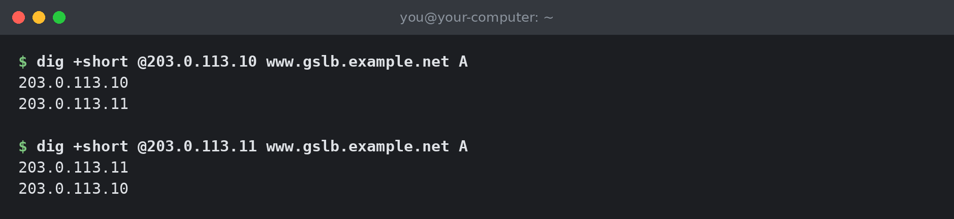
Both servers answering, each listing both addresses.
Both servers should answer, and both should list every healthy server. If one answers and the other does not, look at the DNS listener panel on the quiet one. That panel reports what the server is actually doing rather than what was typed in, and the gap between those two is where nearly all confusion here lives.

A note about port 53
Lookups arrive on port 53. The part of this software that answers them runs without administrator rights on purpose, and a program without those rights is not allowed to use port 53. So it listens on a higher port and a firewall rule sends port 53 to it.
You do not have to set any of this up and it is mentioned for one reason: if you test using the high port you will get an answer whether or not the public path works. Always test with no port on the end, as above, because that is the path your visitors use.

What failover actually looks like
The table below is from a real test on a pair of servers. The active server was stopped, and the surviving server was asked for the address every five seconds.
What happened | How long it took
Dead server removed from the answer | About 30 seconds
Server restored, back in the answer | About 5 seconds
A visitor whose computer had already asked | Up to the TTL on top of the above, so about a minute

Removal is deliberately slower than restoring. A server is only taken out after it has failed for a while, so a brief hiccup does not move everybody, and it is put back as soon as it is well.

20. The nginx build
The NGINX® Build page shows which version of nginx each server is running and what it was built with, and lets you rebuild it without opening a terminal.

Why nginx is built rather than installed
The version of nginx that comes with Ubuntu is built with a small set of features. Several things this software can configure need features that are not in it. So nginx is built from source with everything included, which is what the installer did in Chapter 4.

Rebuilding
Press Rebuild and the server fetches the current source and builds it. It takes several minutes. The new build is tested before anything is stopped, and your existing configuration is checked against it. If the test fails, the old nginx keeps running.
Take care Do one server at a time and check the site still works before starting the second. Rebuilding both at once removes the point of having two.

Checking the two match
The page shows the version and module count for each server side by side. They should match. Two servers running different builds is a fleet where a configuration can work on one and fail on the other, and that is a confusing morning.

21. Reaching the management screen by name
So far you have been opening the management screen by address and port, and clicking past a browser warning every time. This chapter puts it behind a proper name with a real certificate. It is optional, and it is a good exercise because it uses the things Part 2 taught.
By the end, https://lb-01.example.net/lb opens the screen with no warning.

How it works
You are going to point a site at the management screen, the same way you would point one at any other application. The management screen just happens to be running on the same machine.

Step 1: a pool for it
- Make a pool with one server in it: address 127.0.0.1, port 7443. That address means this machine.
- Turn on TLS for the pool, because the management screen speaks https.
- Turn off checking the certificate. The screen uses the self signed certificate it made at installation, and there is nothing to check it against. The traffic never leaves the machine.

Step 2: tell the screen it lives under a path
The management screen needs to know it is being served under /lb, so that every link it writes includes that. Add a line to the settings file on the server and restart it.
$ echo 'NFM_ROOT_PATH=/lb' | sudo tee -a \
/data/docker/nginx-gui-mgmt/.env
$ sudo docker compose \
--project-directory /data/docker/nginx-gui-mgmt up -d

Step 3: a site in front of it
- Make a site with the server name lb-01.example.net.
- Add a path of /lb, set to send requests to the pool you just made.
- Leave Take this path off before sending it on turned off. The screen now knows it lives under /lb and expects to be given the whole path.
- Apply.

Step 4: a real certificate
- Go to Certificates and get one from Lets Encrypt for lb-01.example.net, as in Chapter 11.
- Open the site, choose that certificate, turn on Listen on https and Force https.
- Apply.
Open https://lb-01.example.net/lb. You should get the sign in page with a padlock and no warning.
Worth knowing If the page appears but looks plain and unstyled, the setting in step 2 has not taken effect, or the path setting in step 3 is stripping the prefix. Both produce the same symptom: the page is found and the styling is not.

Take care Putting the management screen on a public name makes it easier for your staff to reach and easier for everybody else to find. Keep the allowlist from Chapter 4 set to your office networks. The name being public and the screen being reachable are two different things.

22. Upgrades
Upgrading gets the newest version of this software onto your servers. It does not touch your configuration and it does not change your settings file.

Doing it
On each server in turn, fetch the new version and run the installer with the upgrade option.
$ cd /data/docker/nginx-gui-mgmt && sudo git pull
$ sudo /data/docker/nginx-gui-mgmt/install.sh --upgrade
This rebuilds the management screen, updates the agent if it has changed, and starts everything again. It takes a couple of minutes. nginx keeps running throughout, so your sites stay up.

Do every server
Take care Upgrade every server, not just one. A pair where the two are running different versions is a pair that can disagree about what it is able to do. Do them one after the other, not at the same time, and check the Cluster page in between.

The gap between upgrading the first and the second should be minutes, not days. While they differ, a new setting that only one of them understands is being shared between them.

Checking it worked
Open the Cluster page. Both servers should be online and showing the same version. Then apply your configuration once, even though nothing has changed, to confirm both servers still accept it.

23. Users, roles and the audit log
Anybody who can sign in here can change where all of your traffic goes. That is worth a few minutes of thought about who has an account and what each of them is allowed to do.
In the sidebar, under ACCOUNT, click Users.
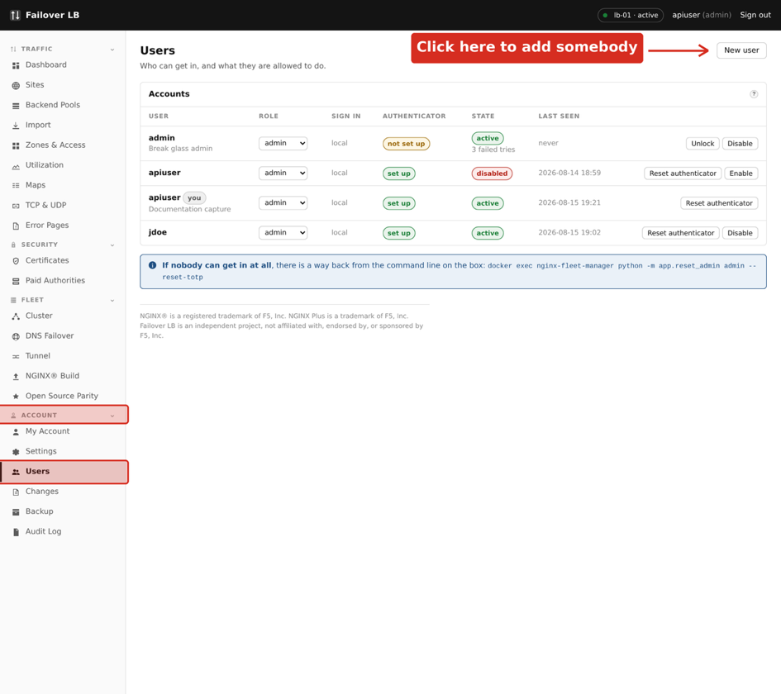
The Users page.

The three roles
Role | Can do
Viewer | Look at everything and change nothing. The right role for most people, including anybody who only needs to check whether something is up.
Operator | Change sites, pools and certificates, and apply. The role for the people who run the service day to day.
Admin | Everything, including managing users, the cluster and failover.

Give people the smallest role that lets them do their job. It is easy to raise somebody later and awkward to explain an outage caused by an account that did not need the rights it had.

Adding somebody
- Go to Users and press Add a user.
- Give them a username and pick a role.
- Set a first password and tell them to change it.
- They set up their own authenticator app the first time they sign in, as in Chapter 6.
Worth knowing Accounts are shared across both servers, so you add somebody once. Things that belong to one machine, such as how many times a password has been typed wrongly, stay on the machine that saw it.

When somebody leaves
Turn the account off rather than deleting it. Turning it off ends their sessions immediately, so a browser they left open somewhere stops working. Keeping the account means the audit log still makes sense, because entries against a deleted user are harder to follow later.

The audit log
Every change is recorded: who did it, when, and what changed. So is every sign in, and every failed one.
In the sidebar, under ACCOUNT, click Audit Log.
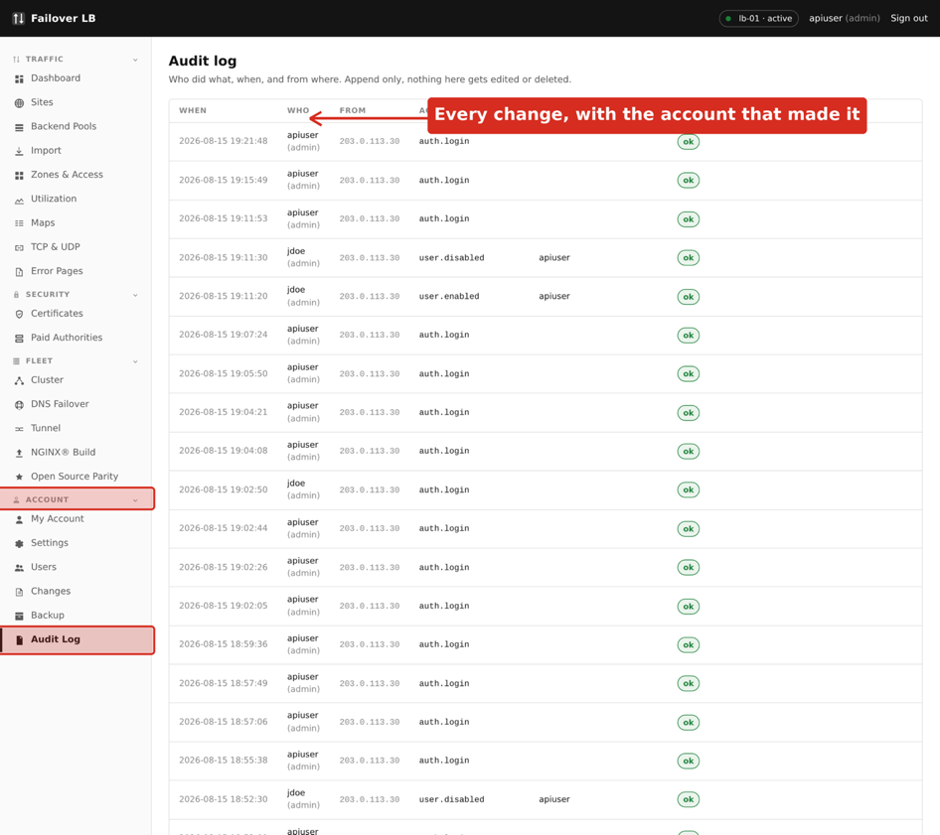
The Audit Log.
The audit log is written on the server where the thing happened and stays there. When you are looking for something and cannot find it, check the other server. This is deliberate. A log that travelled between machines could claim something was done on a server that never did it, which would make it useless as a record.

Recovery outside the screen
There is one job the screen cannot do for you, which is getting an administrator back in when they have lost their phone and used all their recovery codes. There is nobody inside the tool who can help, because the tool is the thing they cannot reach.
For that case there is a command on the server. It needs administrator access to the machine, which anybody who has it could read the database anyway, so it hands out nothing new.
$ sudo docker exec nginx-fleet-manager \
python -m app.reset_admin --list
$ sudo docker exec nginx-fleet-manager \
python -m app.reset_admin alice --reset-totp
Worth knowing Every use of this is written to the audit log as coming from the console. An account recovery done outside the screen is exactly the sort of thing that should stand out when somebody reads the log later.

24. Backup and going back
There are two different questions here and they have different answers. One is undoing a change you just made. The other is getting everything back after losing a machine.

Undoing a change you just made
Every apply is kept, with what changed and who did it. Open the Changes page and look at the history. You can see any earlier version and put it back, which applies it the same way any other change is applied: checked first, sent to every server, and only then used.
This is the answer nearly every time. It is quick, it needs no files, and it works while you are standing there wondering what you just did.

What is already backed up for you
Before every apply, the previous configuration is saved on each server in a folder of its own. That is what makes an apply safe to roll back even if the management screen is not running.
What | Where
Previous nginx configurations | /var/backups/nginx-fleet-manager
The configuration database | Inside the Docker volume nfm-data
Certificates and keys | /etc/nginx/nginxmgr/certs
Your settings and secret key | The .env file in the install folder

Backing up properly
Take care The one file worth guarding is .env, because it holds the secret key that unlocks stored passwords and authenticator seeds. Without it a restored database cannot read its own encrypted values. Keep a copy somewhere safe and separate.

Beyond that, take a copy of the Docker volume on a schedule that suits you. If your servers are virtual machines, a snapshot of the machine covers everything in the table above at once, and is the simplest thing that works.

Losing one server
If one of the pair is lost, the other carries on serving. Build a replacement, install it as in Chapter 4, and join it to the survivor as in Chapter 5. It gets the configuration from the survivor as part of joining. There is nothing to restore by hand.
Give the replacement the same name as the machine it replaces if you can, then anything that referred to that server by name still means what it meant before. If you cannot, check the DNS Failover page afterwards, because an answer tied to a server that no longer exists will not be handed out.

Losing both
Build one server as in Chapter 4, restore the database volume and the .env file from your backup, and start it. Then join a second server to it as in Chapter 5. Check the certificates page, because a certificate that expired while everything was down will need renewing.

25. When something is wrong
This chapter is a list of things that go wrong, what they look like, and what to do. They are in rough order of how often they happen.

A button is greyed out
You are almost certainly looking at the standby. Changes are made on the active server. Check the top right of the screen for which server you are on, and open the other one.

The second server does not appear after joining
Look at the Cluster page on the first server. If the second is missing entirely, the join did not finish and the installer output will say why. The usual cause is port 7444 being blocked between the two machines.
If it appears but keeps saying its credentials were refused and it may need to rejoin, the problem is nearly always its name rather than its certificate. Check what the second server thinks it is called:
$ grep NFM_NODE_NAME /data/docker/nginx-gui-mgmt/.env
If that says the name of your first server, the settings file was copied from it. Delete the .env file on the second server and install it again, so it makes its own. Newer versions refuse to join in this state and tell you, but a machine set up before that will sit there failing quietly.
Take care A copied .env also means both machines are sharing one secret key, which they should not. Treat that key as needing to be changed.

A site returns 502
502 means the load balancer could not get an answer from your application. Work through these in order.
- Open the pool and look at the servers in it. If they are marked down, the health check is failing and the problem is behind the load balancer, not in it.
- If the pool uses https to reach the backend, try turning off checking the certificate. If that fixes it, the backend's certificate cannot be verified, and the proper fix is to point the pool at the right certificate authority file rather than to leave checking off.
- Check the port. A pool pointing at the wrong port fails exactly like an application being down.

A page loads but has no styling
The page was found and its stylesheet was not. When the application is served under a path, this is the prefix setting described in Chapter 10. Either the application has not been told which prefix it lives under, or the path is being taken off when the application expects it, or it is not being taken off when the application does not expect it.
It looks like a problem with the appearance, and it is a problem with the path.

A certificate will not renew
Renewal needs the name to point at one of your servers and port 80 to be reachable from the internet. The two common causes are a firewall closing port 80, and somebody turning off Listen on http for the site because everything is on https anyway. Turn it back on. Force https already means no real visitor stays on the plain address.

A name in DNS Failover does not resolve
Check these in order, because the first two are where nearly all of these end.
- Ask the server directly, with no port on the end. If that answers, the software is working and the problem is the delegation.
- Check the records at your domain provider against the ones printed on the zone. The glue records are the ones people miss.
- Look at the DNS listener panel on each server. It reports what that server is really doing, which is not always what the page shows.
- Remember that a name only starts working once the old answer has been forgotten everywhere, which can take longer than the TTL suggests.

nginx will not start after an upgrade
It should not be possible to apply a configuration nginx will not accept, because it is tested on every server before any of them use it. If it happens anyway, the previous configuration is on the server in /var/backups/nginx-fleet-manager and can be put back by hand. Then open the Changes page and go back to the last version that worked.

Where to look for more
What | Command
The management screen's log | sudo docker logs nginx-fleet-manager
The agent's log | sudo journalctl -u nginx-mgr-agent -n 50
nginx's error log | sudo tail -50 /var/log/nginx/error.log
Whether nginx is happy | sudo nginx -t

Worth knowing When you report a problem, the first of those three logs and what you were doing at the time is nearly always enough for somebody to work out what happened.

26. Worked example: putting a site live
This chapter takes one site from nothing to working, with a certificate, and then adds a second set of servers for part of it. Follow it with your own names in place of the example ones and you will have done most of the jobs in Part 2 once.

The example
A company runs a shop. The application runs on two servers inside their network, and there is a separate pair running the part of it that the mobile app talks to.
Thing | Value
The address people type | shop.example.net
Web servers | 10.0.0.11 and 10.0.0.12, both on port 8080
API servers | 10.0.0.21 and 10.0.0.22, both on port 9000
Everything under /api | Should go to the API servers

Step 1: a pool for the web servers
- Go to Backend Pools and press New pool.
- Name it shop-web.
- Add 10.0.0.11 port 8080, then add 10.0.0.12 port 8080.
- Leave the balancing method as round robin.
- Set the health check to ask for a page rather than just open a connection. If the application has a health page, use it. If not, use / for now and come back to it.
- Press Save.
Wait a few seconds and look at the pool. Both servers should turn green. If they do not, stop here and fix it. Everything after this assumes the load balancer can reach your application, and a site in front of a pool that cannot answer will only produce a more confusing version of the same problem.
Worth knowing Nothing you have done so far affects anybody. The pool exists in the screen and nginx has not been told about it.

Step 2: a pool for the API servers
Do the same again. Name it shop-api, add 10.0.0.21 and 10.0.0.22 on port 9000, and check both go green.

Step 3: the site
- Go to Sites and press New site.
- Name it shop.
- Under server names, put shop.example.net.
- Set the mode to Proxy and choose the pool shop-web.
- Leave Listen on http turned on. Leave Listen on https turned on. Leave the certificate empty for now.
- Press Create site.

Step 4: apply, and check the plain address
Press Apply config. It takes a few seconds and tells you which servers took the change.
Now check it. Ask for the site over plain http, since there is no certificate yet.
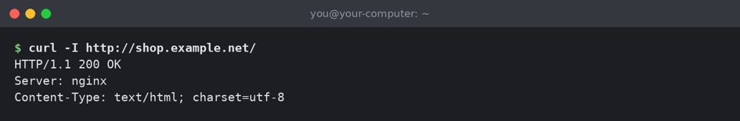
The site answering over plain http.
If you get 502, the load balancer reached nginx but could not get an answer from your application. Go back to the pool and look at the servers. If you get no answer at all, the name does not point at your load balancer yet, which is a DNS job rather than anything here.

Step 5: the certificate
- Go to Certificates and press Get one from Lets Encrypt.
- Type shop.example.net.
- Press Request and wait.
The certificate appears in the list marked valid, with the days remaining and how many servers have a copy. It should say it reached all of them.
In the sidebar, under SECURITY, click Certificates.
The certificate, issued and copied to both servers.

Step 6: turn on https
- Open the site.
- Choose the certificate you just got.
- Turn on Force https.
- Press Apply config.
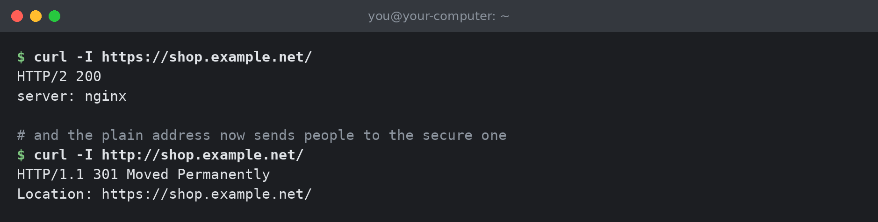
The secure address working, and the plain one forwarding to it.
Open it in a browser. You should get a padlock and no warning.

Step 7: send /api somewhere else
- Open the site and find the Paths section.
- Press Add a path.
- Type /api for the path.
- Set it to send requests to a pool, and choose shop-api.
- Leave Take this path off before sending it on turned off, because the API application was written knowing it lives under /api.
- Press Save, then Apply config.
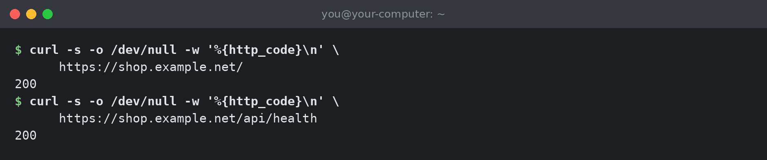
Both parts of the site answering, from two different sets of servers.

Step 8: prove the failover works
This is the step people skip and it is the one worth doing. Stop the application on 10.0.0.11, or take it off the network. Within a few seconds the pool should show that server red and the other green. The site should keep working throughout.
Start it again and watch it come back. You now know the health check works, which is not something to find out during a real failure.
Take care If the site kept working but the pool never went red, your health check is not testing anything useful. Point it at a page that genuinely exercises the application and try again.

What you have
A site on a real certificate that renews itself, spread across two servers, with part of it going to a different pair, and you have seen it survive one of them failing. That is the common shape of most of the work you will do here.

27. Worked example: DNS failover end to end
Chapter 19 explained the idea and the settings. This chapter does it once, all the way through, including the test that proves it works.

The example
The same company as Chapter 26. Their two load balancers are in different buildings on different networks, so they cannot share a floating address. They want shop.example.net to keep working when one building goes dark.
Thing | Value
First load balancer | lb-01, public address 203.0.113.10
Second load balancer | lb-02, public address 203.0.113.11
Part of the domain to delegate | gslb.example.net
Nameserver names to invent | ns1.example.net and ns2.example.net

Step 1: the zone
- Go to DNS Failover and press Add a zone.
- Zone name: gslb.example.net.
- Nameserver names: ns1.example.net, ns2.example.net.
- Press Save.

Step 2: the name
- Press Add a name on the zone.
- Name: www. Type: A. TTL: 30.
- When a server is down: hand out all the healthy ones.
- If every server is down: hand them out anyway.
- Add an answer and pick lb-01 from the list. Its address fills in.
- Add a second answer and pick lb-02.
- Press Save.
The page now shows the name with two answers, each with a green dot and the words node is up, handed out.
In the sidebar, under FLEET, click DNS Failover.
The zone with both servers handed out.

Step 3: the delegation
The zone prints the records to create. In Route 53, open the hosted zone for example.net and create them there.
Name | Type | Value | TTL
gslb | NS | ns1.example.net. and ns2.example.net. | 300
ns1 | A | 203.0.113.10 | 300
ns2 | A | 203.0.113.11 | 300
shop | CNAME | www.gslb.example.net. | 60

The last row is what points the address people actually use at the new zone. Until you add it, everything works and nobody is using it.

Step 4: check the servers answer
Ask each server directly, with no port on the end.
Both servers answering, and both listing both addresses.

Step 5: check the delegation took
Now ask the internet rather than the servers, so you are testing the whole path. Leave it a few minutes after making the records.
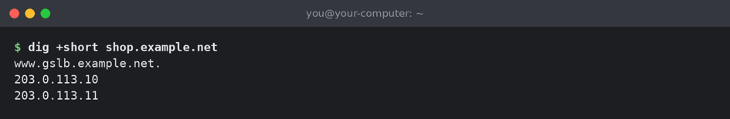
The address people use, followed through to both load balancers.
If this returns nothing, the delegation is the problem and not the software. Check the NS records and the two address records for the nameservers. Those address records are the ones people forget.

Step 6: test the failover
Stop the manager on lb-01, or shut the machine down entirely. Then ask the surviving server for the address every few seconds and watch what happens.
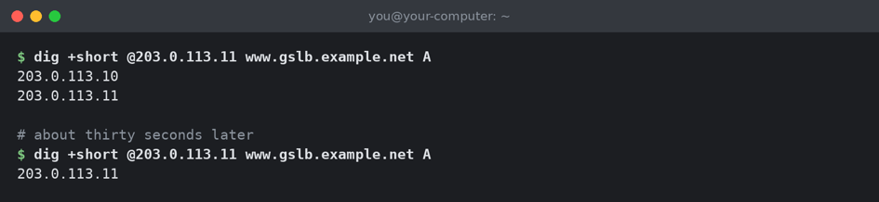
The failed server removed from the answer.
The dead server drops out of the answer in about thirty seconds. New visitors are sent only to the survivor. Visitors whose computers already had the old answer move once it is forgotten, which is the TTL on top, so about a minute in total.

Step 7: bring it back
Start lb-01 again. It rejoins and is back in the answer within about five seconds. Removal is slower than restoring on purpose, so a brief hiccup does not move everybody.

What to check afterwards
- The DNS Failover page on both servers says it is answering, not just one of them.
- Both answers show a green dot.
- The address people use still resolves through to both load balancers.
Take care Do this test on purpose, in daylight, before you need it. A failover that has never been tried is a plan, not a capability, and the two look identical right up until the moment they do not.

28. Worked example: taking a server out for maintenance
You need to reboot one of the load balancers, patch it, or move it. This is how to do that without anybody noticing. It is short, and doing it in this order is the whole point.

Before you touch anything
- Open the Cluster page and check both servers are online. If the other one is not healthy, stop. You are about to be running on one server and it needs to be a good one.
- Open the Changes page and check nothing is saved but not applied. Applying somebody else's half finished work in the middle of maintenance is a bad afternoon.

Take it out of the DNS answer
If you use DNS failover, do this first and give it time. Open DNS Failover, edit the name, and turn off the answer for the server you are about to work on. Save.
Wait at least twice the TTL before going further. With a TTL of 30 seconds, wait two minutes. That is not the software being slow, it is the time for computers elsewhere to forget the old answer. Skipping this is the difference between nobody noticing and a few people getting errors.

Hand over being in charge
If the server you are working on is the active one, use the failover button on the Cluster page to hand over to the other. Doing it yourself is calmer than pulling the plug and letting the software work it out, and you can confirm the other server took over before you go any further.

Stop it from coming back too early
Turn on forced standby for the server you are working on. That stops it becoming active again halfway through your work, for example after a reboot you did not expect to change anything.

Do the work
Reboot it, patch it, whatever you came to do. The other server is carrying all of the traffic. Nothing about this is urgent, which is the point of doing it in this order.

Putting it back
- Wait for it to come back and check the Cluster page shows it online.
- Turn off forced standby.
- Turn the DNS answer back on. It returns to the answer within a few seconds.
- Watch it for a few minutes before you go home.
Worth knowing The order going back in is the reverse of the order coming out. Health first, then being allowed to be in charge, then traffic. Turning the DNS answer back on before the server is actually well sends people to something that is not ready.

A checklist you can print
Order | Coming out | Going back in
1 | Check both servers healthy | Check it is online again
2 | Check nothing unapplied | Turn off forced standby
3 | Turn off its DNS answer, wait | Turn its DNS answer on
4 | Hand over if it is active | Watch for a few minutes
5 | Turn on forced standby
6 | Do the work

29. The site screen, control by control
Opening a site from the Sites list gives you this screen. It is the longest one in the product because a site has the most to say about it. This chapter goes through every part of it.
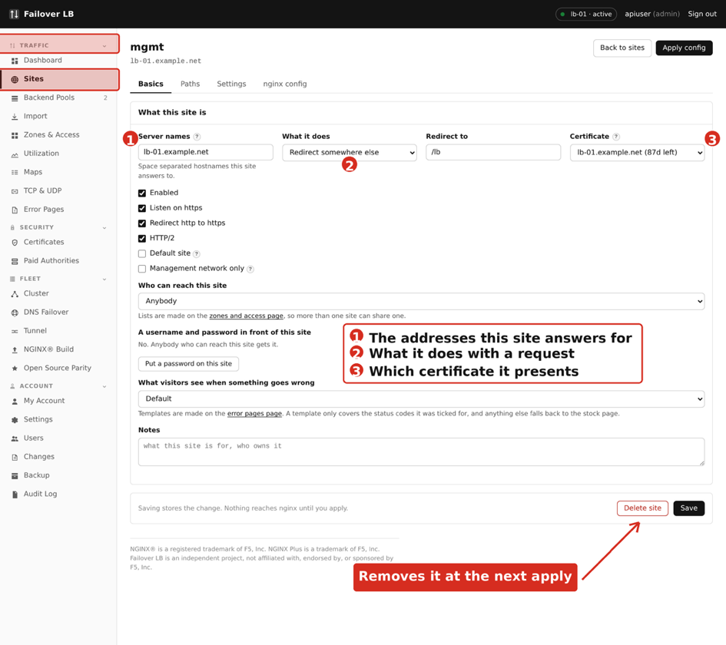
The site screen.
Worth knowing Some controls only appear when they are relevant. The pool chooser is only shown when the mode is Proxy, and the folder box only when it is Static. If something in this chapter is not on your screen, check the mode first.

Naming and turning it on
Control | What it does
Name | For finding it in the list. Visitors never see this and it can be changed at any time.
Server names | The web addresses this site answers for. One per line. This is the setting that decides which requests reach this site, so it is the one to check first when a site is not being used.
Enabled | Turn a site off without deleting it. A disabled site is left out of the configuration entirely at the next apply.
Default site | Answers anything that does not match another site's names. Only one site can be the default. Useful for showing a holding page to somebody who reaches your address by its IP.

Listening
Control | What it does | Usual setting
Listen on http | Answer on the plain port | On
Listen on https | Answer on the secure port | On
http port | Which plain port | 80
https port | Which secure port | 443
HTTP/2 | A faster newer way of speaking https | On
Force https | Send anybody arriving on the plain address to the secure one | On

Take care Leave Listen on http on even when everything is secure. Certificate renewal needs port 80 to answer. Force https already means no real visitor stays there, so the only thing you gain by turning it off is a certificate that quietly stops renewing.

The www setting
Send everything to the first name takes any request arriving on one of the other names and forwards it to the first one in the list. Put both example.net and www.example.net in the names, decide which you want to be the real one, and put that first.
The forward is written so it does not interfere with certificate renewal, which is the usual trap when this is done by hand.

The mode, and what each one adds
Mode | Extra controls | What it does
Proxy | Pool | Passes requests to the servers in that pool.
Static | Folder | Serves files straight from a folder on the load balancer.
Redirect | Target, and permanent or temporary | Sends visitors to another address. Permanent tells browsers and search engines to remember the change; temporary does not.

Security
Control | What it does
Access list | Restrict who may reach the site by address. Made on the Zones and Access page and chosen here.
Username and password | Ask for a username and password before anything is served. A reasonable second lock on something already limited by address, and a thin one on its own.
Certificate | Which certificate to present. Needed if Listen on https is on.

Error pages
Choose a template made on the Error Pages page. There is also a setting for whether your own error pages are used for errors your application returns, as well as errors nginx makes itself. Turn it off if your application already returns error pages you are happy with.

Paths
The Paths section is where a site sends different parts of itself to different places. Chapter 10 covers this and Chapter 26 works through an example. Each path has its own mode, its own pool or folder, and can have its own access list and error pages.

Raw configuration
At the bottom there is a box for nginx configuration typed by hand, for the occasional thing the screen does not offer. What you put here is stored with the site and survives every apply, which is why this exists and editing the generated files does not.
Next to it is a Check it button. It builds the whole configuration including your raw block and tests it, without applying anything. Use it every time you touch this box.
Take care Raw configuration is not checked for sense, only for syntax. A directive that is valid but wrong will apply cleanly and behave strangely. Keep what goes in here small, and write a note next to it saying why it is there.

Deleting a site
Delete removes the site at the next apply. The pools it used are left alone, because other sites may be using them. If you only want it off for a while, turn Enabled off instead: it keeps everything and can be put back with one click.

30. The pool screen, control by control
Opening a pool gives you this screen. It has fewer sections than a site but more detail in them, because this is where you decide how traffic is shared out and how a broken server is noticed.
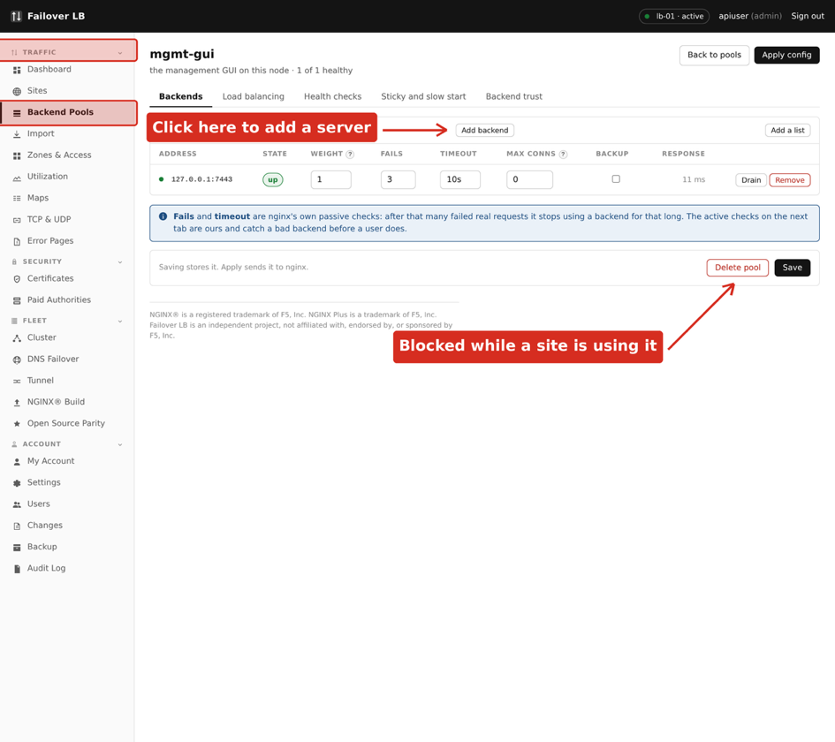
The pool screen.

The servers
Each row is one server. Add as many as you have.
Control | What it does | Usual setting
Address and port | Where the server is | Your app server
Weight | How much traffic this one takes compared to the others. 2 sends it twice as much as a 1 | 1
Backup | Only used when every non backup server is down | Off
Max fails | How many failures in a row before it is taken out | 3
Fail timeout | How long it stays out before being tried again | 10s
Max connections | A cap on how many at once this server will be given. 0 means no cap | 0
State | Up, down, or draining. Draining finishes what it is doing and takes nothing new, which is how you retire a server without dropping anybody | Up

Worth knowing Draining is the setting worth remembering. Turning a server off outright drops whatever it was in the middle of. Draining lets it finish, and you watch the connection count fall to zero before you touch the machine.

How traffic is shared
Method | When to use it
Round robin | In turn, one after another. The right answer for almost everybody and the default.
Least connections | Whichever server is least busy right now. Better when some requests take much longer than others.
By address | The same visitor always reaches the same server. Use only when the application keeps things in memory per visitor and cannot be changed.
By something you choose | The same value always reaches the same server, using a variable you name. For caches and shards.

The consistent option, offered with the last two, changes what happens when a server is added or removed. Without it, nearly every visitor moves to a different server. With it, only the share belonging to the changed server moves. Turn it on if you are hashing at all.

Health checks
This is what makes a pool worth having. Without a working check, a dead server keeps being sent traffic.
Control | What it does | Usual setting
Type | Open a connection, or ask for a page and read the answer | Ask for a page
Path | Which page to ask for | A health page
Interval | How often to check | 5s to 10s
Timeout | How long to wait for an answer | 2s to 5s
Rise | How many good checks before it is used again | 2
Fall | How many bad checks before it is taken out | 3
Expected status | What counts as a good answer | 200
Host header | The name to ask for, when the server hosts several | Your site
Expected text | Words that must appear in the answer. Catches a page that returns 200 while saying it is broken | Optional

Take care A check that asks for the front page tells you the web server is running. A check that asks for a page which talks to the database tells you the application works. The difference only shows up during an outage, when the first kind reports everything healthy.

Talking to backends over https
Control | What it does
Use TLS | Speak https to the servers rather than http.
Check the certificate | On by default and correct for a real certificate. Turn it off only for something self signed, such as a service on the same machine.
Authority file | Point at your company's certificate authority file if your servers use certificates you issue yourselves. Then checking stays on and works.
Server name | The name to ask for in the handshake, when it differs from the address.

Worth knowing A pool that starts failing the moment you turn on TLS is nearly always the certificate check. Prove it by turning the check off, then put it back on and fix it properly with the authority file. Leaving the check off works and gives up the point of using https.

Connection reuse
Keep alive holds connections open ready for the next request instead of making a new one each time. It makes a real difference to speed and the defaults are sensible. The number is how many idle connections to hold per server, not a limit on traffic.

Slow start
A server coming back after being down can be given a small share at first, growing to its full weight over a period you set. This stops a cold server with empty caches being hit with its full load the instant it says it is well, which is a good way to knock it straight back down.

Where the numbers for the charts come from
If your servers publish their own measurements, put the address pattern here and the Utilization page grows charts for them. Use {host} where the server address goes, so one pattern covers every member. Chapter 17 explains what is collected and why it is done this way.

Deleting a pool
A pool being used by a site cannot be deleted, and the screen says which site is using it. Point that site somewhere else first. This is deliberate, since deleting a pool a site depends on would take that site down at the next apply.

31. Importing an existing nginx config
If you already run nginx, you do not have to type all of it in again. The Import page reads your existing configuration and turns it into sites and pools here. This is usually the first thing somebody does, so it is worth doing carefully.

Nothing happens until you say so
The important thing about this page is how safe it is. Pasting a configuration in and pressing the preview button writes nothing at all. It reads your text, works out what it would make, and shows you. You can point it at your live configuration purely to see what this software makes of it, and walk away.
Even after you import, nothing is live. Everything arrives switched off and unapplied, so you can look it over, fix anything that came across oddly, and only then turn it on.
In the sidebar, under TRAFFIC, click Import.
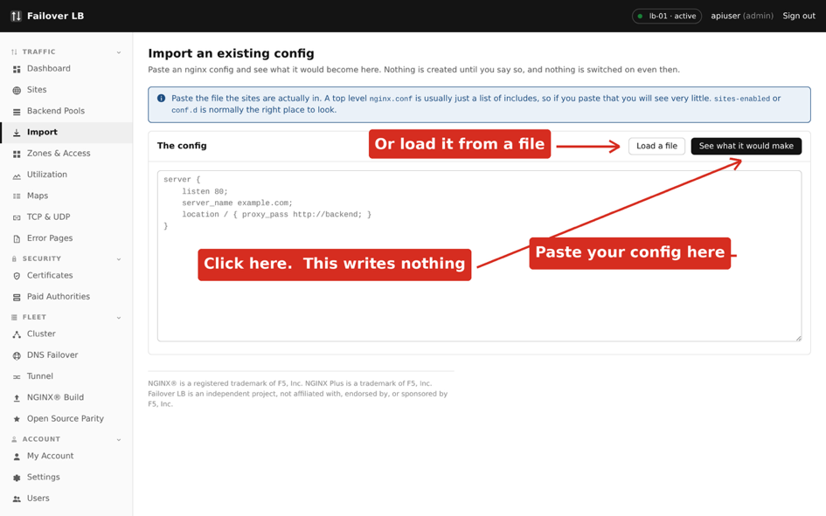
The Import page, waiting for a config.

Which file to paste
Take care Paste the file your sites are actually in. A top level nginx.conf is usually just a list of includes, so pasting that shows you almost nothing and looks like the import is broken. On most systems the sites live in sites-enabled or conf.d.

If your configuration is split across several files, paste them one after another into the same box, or import them one at a time. Order does not matter.
$ cat /etc/nginx/sites-enabled/*
One way to get everything on screen at once, ready to copy.

Reading the preview
Press See what it would make. The page splits what it found into three parts.
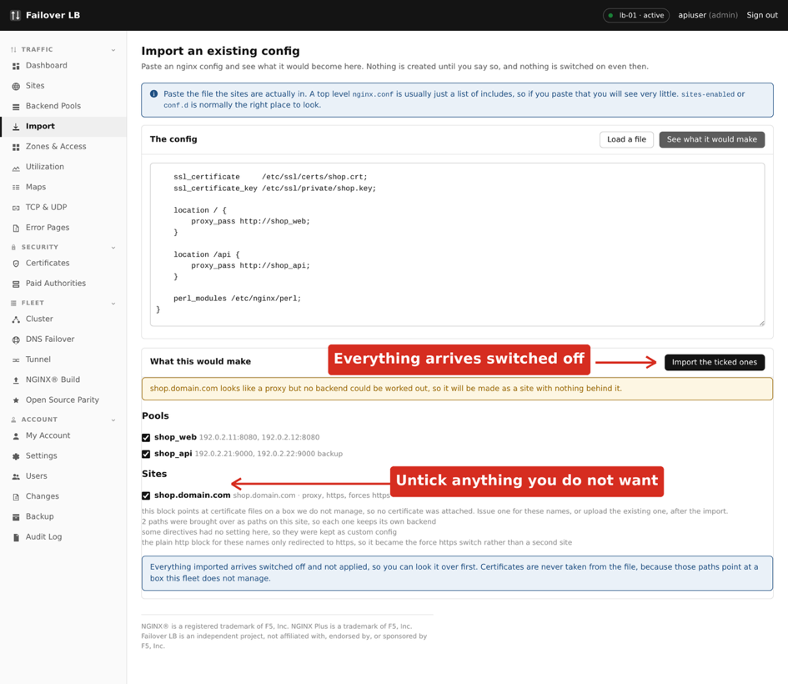
A preview. Everything shown here would be created, and nothing has been yet.
Section | What it holds
Pools | Every upstream block, with its servers. Settings such as backup and weight come across with them.
Sites | Every server block, with its names, ports, whether it uses https, and its paths. Under each one is a plain list of what was done and why.
Left alone | Anything that could not be turned into a setting on these screens. This section is the one to read properly.

Each entry has a tick box. Untick anything you do not want. A common reason is an old site you have been meaning to retire, and the import is a good moment to not bring it with you.

What the notes under a site mean
The lines under each site say what the importer decided. They are worth reading because they explain things you would otherwise notice later and find confusing.
A note like this | Means
The plain http block only redirected to https, so it became the force https switch | You had two server blocks for one name, one of which only forwarded to the other. That is one site here with a switch turned on, not two sites.
Paths were brought over, so each keeps its own backend | Your location blocks became paths on the site, as in Chapter 10.
Some directives had no setting here, so they were kept as custom config | Anything without a box on the screen is preserved as raw configuration on the site rather than dropped.
No certificate was attached | See the next section. This one always happens and it is not an error.

Certificates are never brought across
Your configuration names certificate files by path. Those paths point at files on the machine the configuration came from, which is not necessarily a machine this software manages, and the private keys are not in the text you pasted anyway.
So a site comes across knowing it uses https and with no certificate chosen. After importing, go to Certificates and either get a new one from Lets Encrypt, which is usually easiest, or upload the existing certificate and key. Then open the site, choose it, and apply. Chapter 11 covers both.

Warnings you may see
Warning | What to do
Looks like a proxy but no backend could be worked out | The site is created with nothing behind it. This happens when the proxying is inside the paths rather than on the server itself, which is fine: check the paths have their pools, and leave the site's own backend empty.
A name is already used by an existing site | Two sites answering for the same name is a problem, so the import will not quietly make one. Rename or untick.
An upstream was referred to but never defined | Your configuration pointed at a pool that was declared in a file you did not paste. Paste that file too and preview again.

What is deliberately not imported
Some things are left behind on purpose rather than because they could not be read.
- Anything to do with how nginx itself is built or started, since this software manages that separately through the NGINX® Build page.
- Log formats and file paths, because logs are handled per node here.
- Certificate and key files, as above.
Worth knowing Anything genuinely not understood is listed in Left alone with the reason. Nothing is dropped silently. That is the point of that section, and it is why it is worth reading rather than skipping to the import button.

Doing the import
- Untick anything you do not want.
- Press Import the ticked ones.
- Go to Backend Pools and check the servers are right. Give the pools better names now if the originals were cryptic, because renaming later means updating whatever points at them.
- Go to Sites and open each one. Check the names, the mode, and the paths.
- Sort out certificates, as above.
- Turn each site on when you are happy with it.
- Press Apply config.
Take care Do not import and apply in one go on a busy day. The import brings everything across switched off precisely so you can read it first. Applying immediately gives up that safety for no gain.

A worked example
The preview above came from this configuration, which is a small but realistic one: two pools, a plain http block that only forwards to https, and a secure block with two paths going to different places.
upstream shop_web {
server 192.0.2.11:8080;
server 192.0.2.12:8080;
}
server {
listen 80;
server_name shop.example.net;
return 301 https://$host$request_uri;
}
server {
listen 443 ssl http2;
server_name shop.example.net;
ssl_certificate /etc/ssl/certs/shop.crt;
location / {
proxy_pass http://shop_web;
}
location /api {
proxy_pass http://shop_api;
}
}
The preview turned that into two pools and one site. Notice what it did with the two server blocks: they became a single site with force https turned on, rather than two sites, because the first one existed only to send people to the second. The two locations became two paths, each keeping its own pool. No certificate was attached, and the note says so.
That is the shape of nearly every import. Read the notes, fix the certificate, check the pools, then turn it on.

32. Settings
The Settings page holds the choices that apply to the whole fleet rather than to one site. Most people set these once during installation and never come back. This chapter goes through every one of them so you know what you have.
In the sidebar, under ACCOUNT, click Settings.
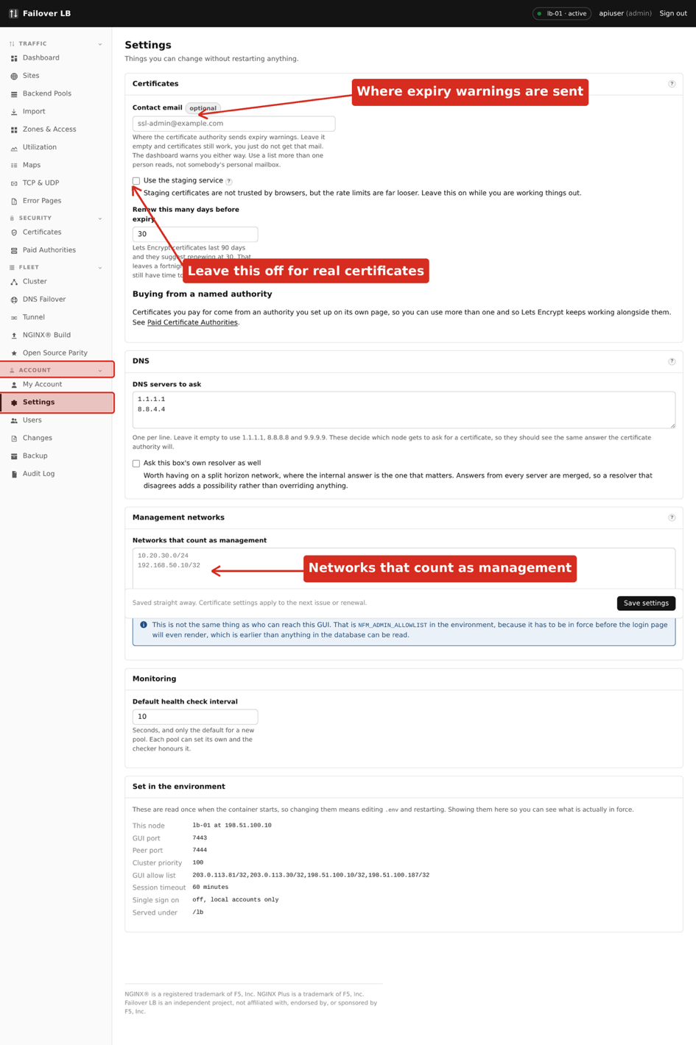
The Settings page.

Where a setting comes from
A setting can be set in two places: here on this screen, or in the settings file on each server. When both have a value, the file wins.
That is why there is a section at the bottom of the page called Set in the environment. Anything listed there is being controlled by the file and cannot be changed from this screen. If a box will not save, or saves and then goes back to its old value, look at that list first.
Worth knowing This arrangement exists so that somebody building servers automatically can set everything in the file and know the screen cannot quietly change it later. If you are not doing that, use the screen and ignore the file.

Certificates
Setting | What it does | Usual value
Contact email | Where Lets Encrypt sends warnings, such as a certificate about to expire that has not renewed. Use an address somebody reads | A team address
Use the staging service | Ask a practice version of Lets Encrypt instead of the real one. Certificates from it are not trusted by browsers. For testing the process without using up your allowance | Off
Renew this many days before expiry | How early to renew. Thirty days leaves plenty of room for a few failed attempts before anything is urgent | 30
DNS provider | For the dns-01 method, used when a name cannot be checked over the web. Needed for a wildcard certificate | Blank
DNS credentials | The login for that provider. Stored encrypted and never shown again once saved | Blank

Take care Turn the staging service off before you rely on any certificate. A staging certificate looks completely normal on this screen and every browser refuses it. There is a check that warns if one is in use, and it is easier not to get there.

When you would use dns-01
The usual way Lets Encrypt checks you own a name is by asking for a file over the web, which needs port 80 open. The other way is asking you to put a special record in your DNS, which this software can do for you if you give it credentials for your DNS provider.
You need this in two situations: a wildcard certificate covering anything.example.net, which cannot be done any other way, and a name that is not reachable from the internet at all.

DNS
Setting | What it does
DNS servers to ask | Which servers to use when this software has to look a name up, for example checking that a name points here before asking for a certificate. Leave blank to use the box's own settings.
Ask this box's own resolver as well | Check both, and treat a name as good if either answers. Useful when some names are only in your internal DNS.

Worth knowing This does not affect the DNS failover feature in Chapter 19, which answers questions rather than asking them. These settings are about lookups this software makes on your behalf.

Management networks
The networks that count as management for the whole fleet. Two things use this list.
- Access lists that have Include the management networks turned on, so you do not lock yourself out of your own admin areas.
- Warnings on the Cluster page when a node appears to be reachable from somewhere it should not be.
One network per line, written as a range such as 198.51.100.0/24 or a single address such as 203.0.113.25.
Take care This is not the same as the allowlist that controls who may open the management screen. That one lives in the settings file on each server, is applied before anybody signs in, and is the one that actually keeps strangers out. Chapter 4 covers it.

Monitoring
Setting | What it does | Usual value
Default health check interval | How often to check a backend, for pools that have not been given their own value. Lower notices a failure sooner and asks your servers more often | 5s to 10s

A pool can override this, and Chapter 30 covers the per pool health check settings in full. This is only the starting point for pools that have not been told otherwise.

Set in the environment
A read only list of everything currently being controlled by the settings file rather than by this screen. It is worth a look after any installation or upgrade, because it tells you exactly which of these boxes will do nothing if you change them.

33. Your own account
My Account is where you look after your own sign in. Everything here affects only you. Managing other people is Chapter 23.
In the sidebar, under ACCOUNT, click My Account.
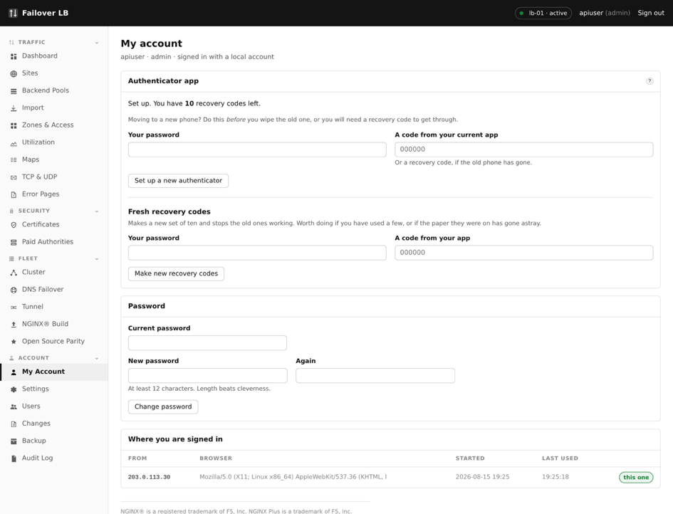
The My Account page.

Changing your password
You need your current password as well as the new one. Changing it ends your other sessions, so a browser you left signed in somewhere else stops working. That is deliberate, and it is the quickest thing to do if you think somebody else has your password.

Your authenticator
This is the app that gives you a six digit code when you sign in. There are two reasons to come here.
Situation | What to do
New phone, old one still working | Set up the new one from this page before you wipe the old. You are shown a fresh code to scan and the old phone stops working once you confirm.
Phone lost or broken | Sign in with one of your recovery codes instead of a six digit code, then come here and set up the new phone.
Phone gone and no recovery codes left | Nobody can help you from inside the software. Somebody with administrator access to the server has to run the recovery command in Chapter 23.

Recovery codes
Recovery codes each work once, in place of a code from your app. You were shown a list when you first set up your account and told to save them. This page tells you how many you have left and lets you make a fresh set.
Take care Making a fresh set cancels every old code immediately, including any you have written down. Do it when you are down to one or two, and save the new list before you close the page. It is shown once and cannot be shown again.

Worth knowing Save them somewhere that is not your phone. A password manager or a printed copy in a drawer are both fine. Codes stored only on the device you might lose are not doing the job they exist for.

Your sessions
The page lists where you are currently signed in. If you see something you do not recognise, change your password, which ends all of them at once, and tell whoever looks after security where you work.

34. The NGINX® Build screen, control by control
The NGINX® Build page shows exactly which nginx each of your servers is running, and rebuilds it when you need a newer one. Chapter 20 introduced it briefly. This chapter covers the whole screen.
In the sidebar, under FLEET, click NGINX® Build.
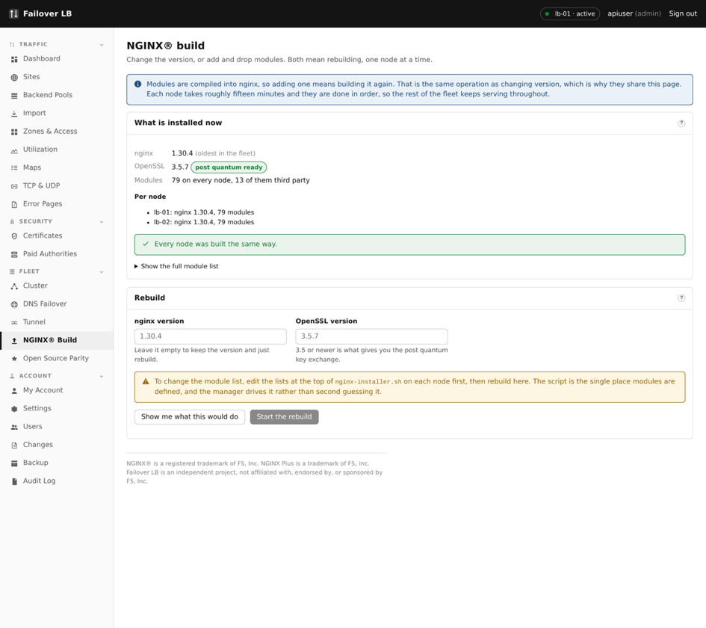
The NGINX® Build page.

Why nginx is built rather than installed from Ubuntu
The nginx that comes with Ubuntu is built with a small set of features. Several of the things this software can configure for you need features that are not in it, so nginx is compiled from source with all of them included. That is what the installer did in Chapter 4 and it is why that step took the longest.
The cost of this is that you cannot update nginx with the usual system update command. This page is where that happens instead.

What is installed now
The bottom section reports what each server is actually running.
Shown | What it means
nginx version | The version currently serving your traffic.
OpenSSL version | The library that does the encryption. Worth knowing when a security notice goes round, because that is usually what it is about.
Module count | How many extra features were compiled in. Two servers showing different counts is the thing to notice on this page.

Take care Both servers should show the same versions and the same module count. A fleet where they differ is one where a configuration can work on one server and be refused by the other, and the apply will fail with an error that points at your configuration rather than at the real cause.

Checking before you build
There is a check button that works out what a rebuild would do without doing it. It reports the versions that would be installed and whether your current configuration would still be accepted by them. Run it first, every time.

Rebuilding
Rebuild fetches the sources, compiles nginx, and installs it. It takes several minutes and the progress is shown on screen as it goes.
The order it works in is what makes this safe.
- The new nginx is built, while the old one carries on serving.
- Your existing configuration is tested against the new build.
- Only if that passes is the running nginx replaced.
- If it fails, the old nginx is left exactly as it was and you are told what was wrong.
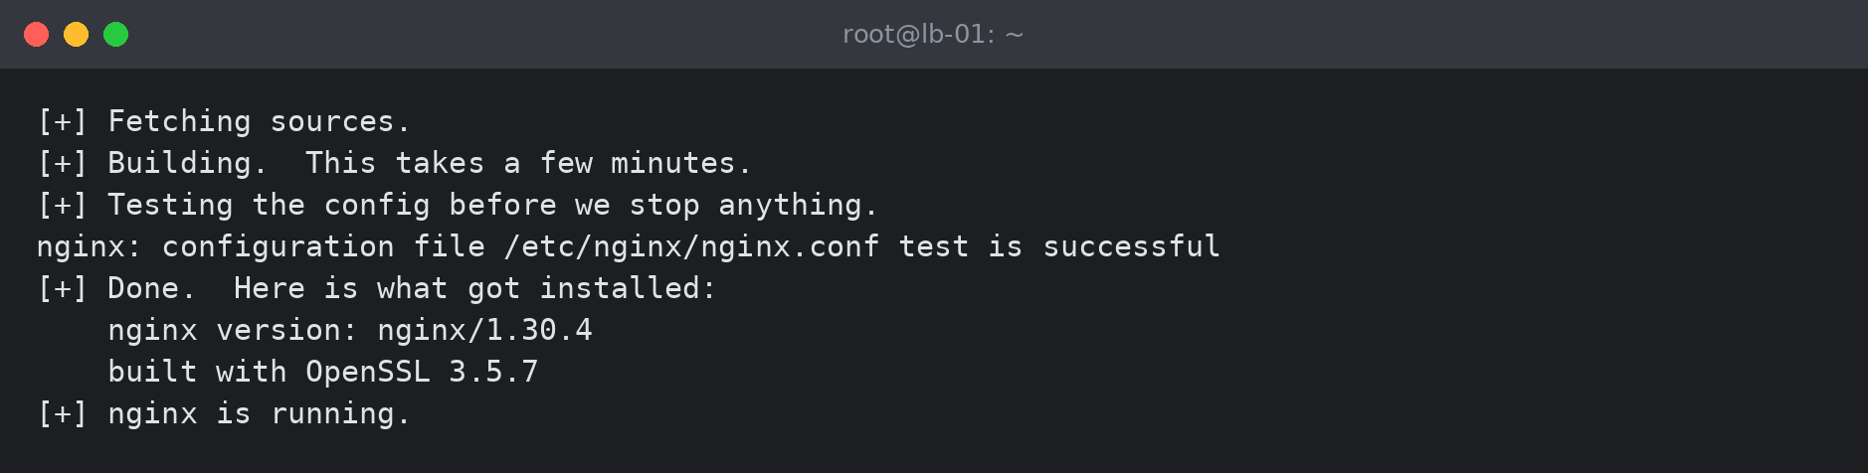
A rebuild finishing. The same output appears on the page as it happens.

Do one server at a time
Take care Rebuild one server, check your sites still work, and only then do the second. Rebuilding both at once removes the whole point of having two. If you use DNS failover, take the server out of the answer first as described in Chapter 28.

If a rebuild fails
The old nginx keeps running, so nothing is down. Read the output on the page: a build failure is nearly always a missing system package or a source that could not be downloaded, and both say so plainly. Fix it and press the button again.
Worth knowing A rebuild does not change your configuration and cannot lose it. Your sites, pools and certificates live in the database and are written out again on the next apply.

35. Open source parity
There are two nginx products. The free one, which is what this software runs, and a paid subscription called NGINX Plus. A handful of features exist only in the paid one.
In the sidebar, under FLEET, click Open Source Parity.
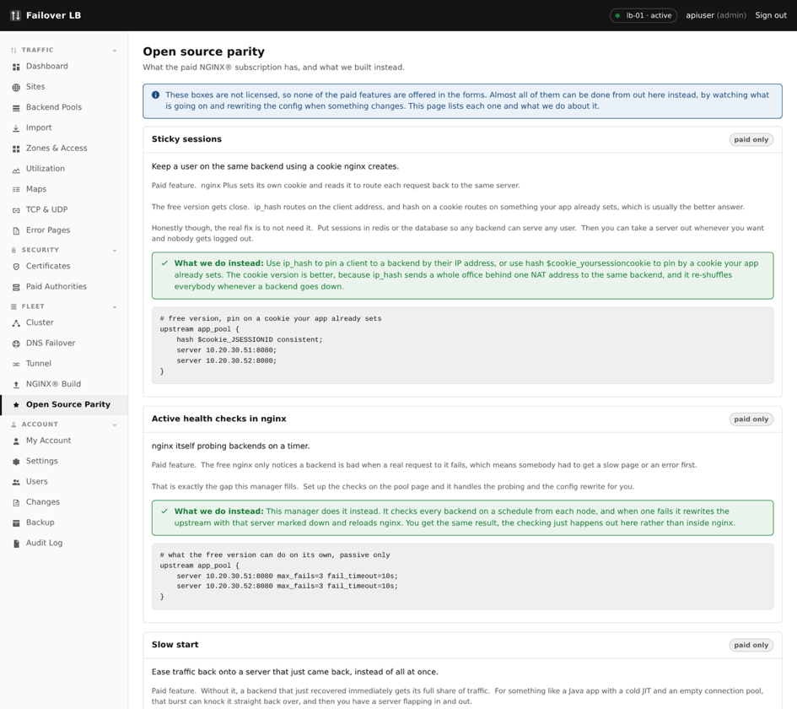
The Open source parity page.

Why this page exists
You will read about a feature somewhere, go looking for it, and not find it. Without this page you would spend an hour hunting before discovering it needs a subscription. This page lists each one, says so plainly, and tells you what to use instead.
In most cases there is a perfectly good free answer, and this software has already built it. Sticky sessions are the clearest example: the paid nginx has a directive for it, and this software gets the same result another way, so you have the feature without the subscription.

What is on the list
Feature | What it is | What you have instead
Sticky sessions | Sending the same visitor back to the same backend every time | Built here a different way, and it works the same
Active health checks | nginx testing backends by itself on a timer | This software runs the checks and updates the config, which is what Chapter 8 sets up
Slow start | Easing traffic onto a server that has just come back | Built here, on the pool screen
Least time balancing | Choosing the backend answering fastest right now | Least connections, which is close in practice
Runtime API and dashboard | Changing backends without reloading, and a live status page | The Utilization page, and applying a change is quick
JWT validation | nginx checking signed tokens itself | Have your application check them
Request queueing | Holding requests when every backend is busy rather than failing | Nothing directly. Add capacity, or use a connection limit so the failure is predictable

A note about reloads
The page has a section about this and it is worth understanding. The paid nginx can change its list of backends without reloading. The free one reloads to pick up a change.
A reload sounds alarming and is not. nginx starts new workers with the new configuration, hands new connections to them, and lets the old ones finish what they were doing before they stop. Nobody is disconnected and no request is dropped.
Worth knowing This matters in one situation: a health check taking a backend out causes a reload, so a flapping backend causes repeated reloads. That is worth avoiding for its own sake, and the fix is the same either way, which is to work out why the backend keeps failing.

Should you buy NGINX Plus?
This software does not use it and cannot configure it. If you need something on the list above that has no free answer, the honest position is that this is not the tool for that job. For everything else, the free nginx with this in front of it does what most people need.

36. Every dialog, field by field
This chapter is the reference half of the guide. Earlier chapters explain when to use something and why. This one lists what is in each box, so that somebody sitting in front of the screen with a field they do not recognise can look it up.
Nothing here needs reading front to back. Find the dialog you are looking at and read that section.
Worth knowing Every dialog in this chapter saves without applying. You can fill one in, save it, and nothing changes for your visitors until you press Apply config, as Chapter 16 describes.

New site
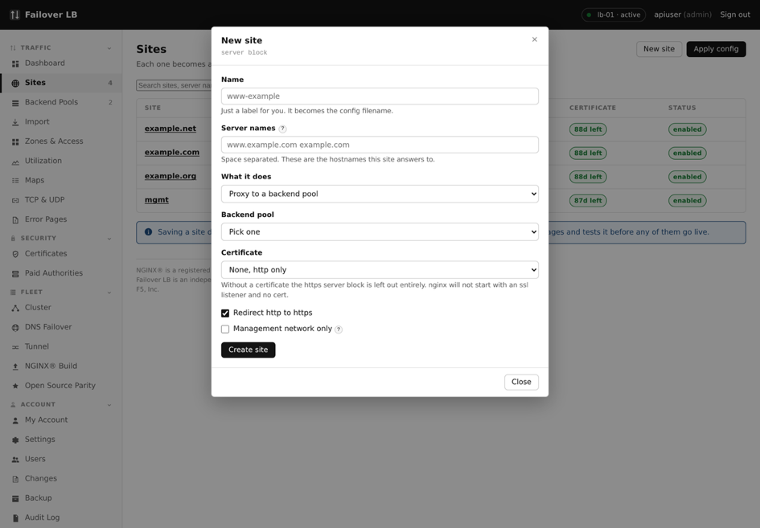
Making a site.
Field | What to put | If unsure
Name | A label for your own use, never seen by visitors | The main address
Server names | The web addresses this site answers for, one per line | Just the one to start
Mode | Proxy, static or redirect | Proxy
Pool | Which backend servers, when the mode is proxy | The one you made first
Listen on http | Answer on the plain port | On
Listen on https | Answer on the secure port | On
Certificate | Which certificate to present | Leave empty and add one later

Everything else about a site is on the site's own screen once it exists, which Chapter 29 covers in full. This dialog only asks for enough to create it.

New pool
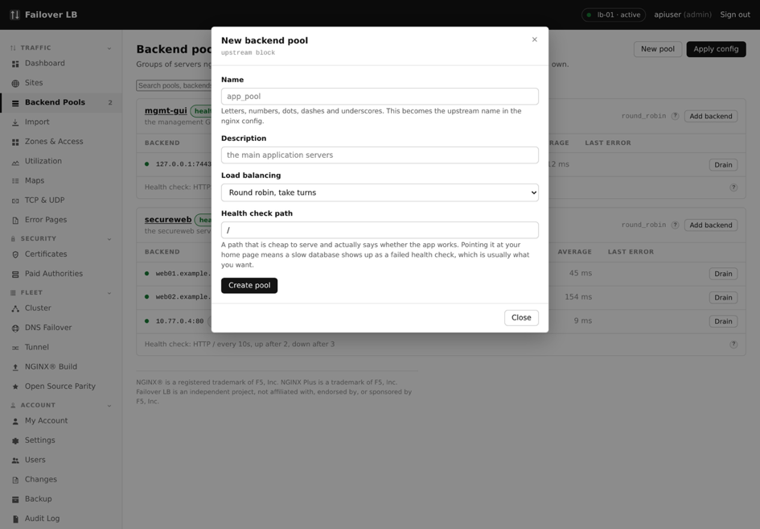
Making a pool.
Field | What to put | If unsure
Name | A label you will pick from a list later | Say what is in it, such as shop-web
Description | A note for whoever reads this next | Optional
Balancing method | How requests are shared out | Round robin
Servers | One row per backend, with address and port | Add them all now

The rest of a pool's settings, including health checks and backend TLS, are on the pool's own screen. Chapter 30 covers them.

Adding a server to a pool
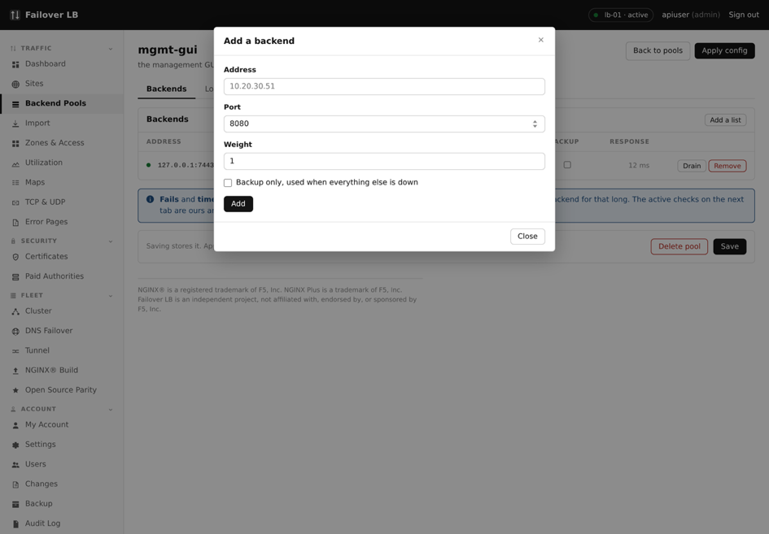
Adding one backend server.
Field | What it does | Usual value
Address | Where the server is. An address or a name | 10.0.0.11
Port | Which port your application listens on | 8080
Weight | Its share compared to the others | 1
Backup | Only used when everything else is down | Off
Max fails | Failures in a row before it is taken out | 3
Fail timeout | How long it stays out | 10s
Max connections | A cap on connections at once. 0 is no cap | 0
State | Up, down, or draining | Up

Worth knowing Draining is the one to remember. It lets the server finish what it is doing while taking nothing new, so you can retire a machine without dropping anybody mid request.

Getting a certificate from Lets Encrypt
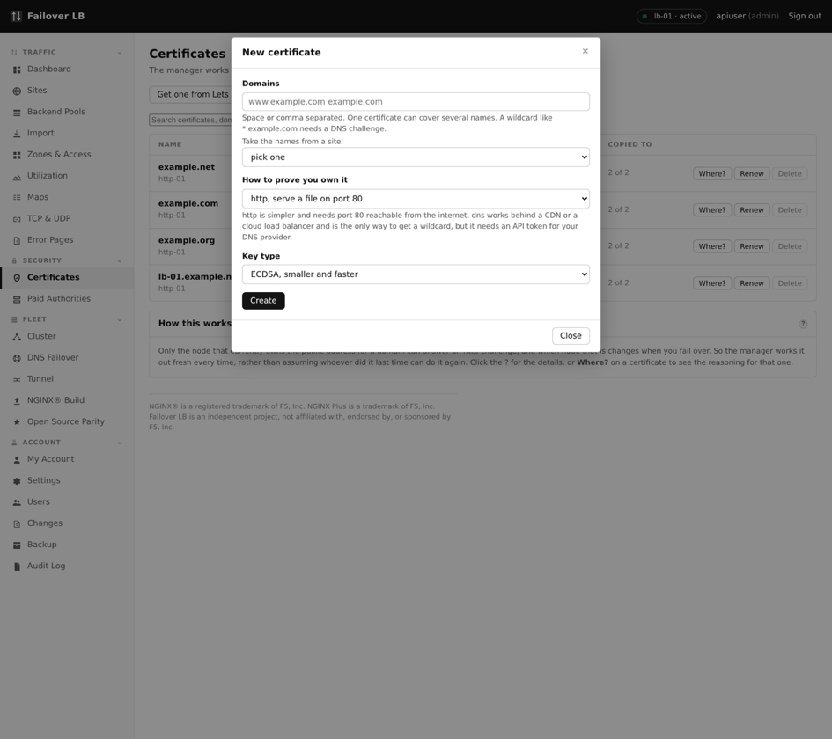
Asking for a free certificate.
Field | What to put | If unsure
Name | A label, usually the domain | The main domain
Domains | Every name this certificate should cover, one per line. All of them must already point at your load balancers | Just the site address
Renew automatically | Renew before it runs out, without anybody doing anything | On
Days before expiry to renew | How early. Leaves room for a few failed attempts | 30

Worth knowing This is the option most people want. It costs nothing, it renews itself, and the only requirement is that the names already point here and port 80 is open. Chapter 11 covers what happens if a renewal fails.

Uploading a certificate
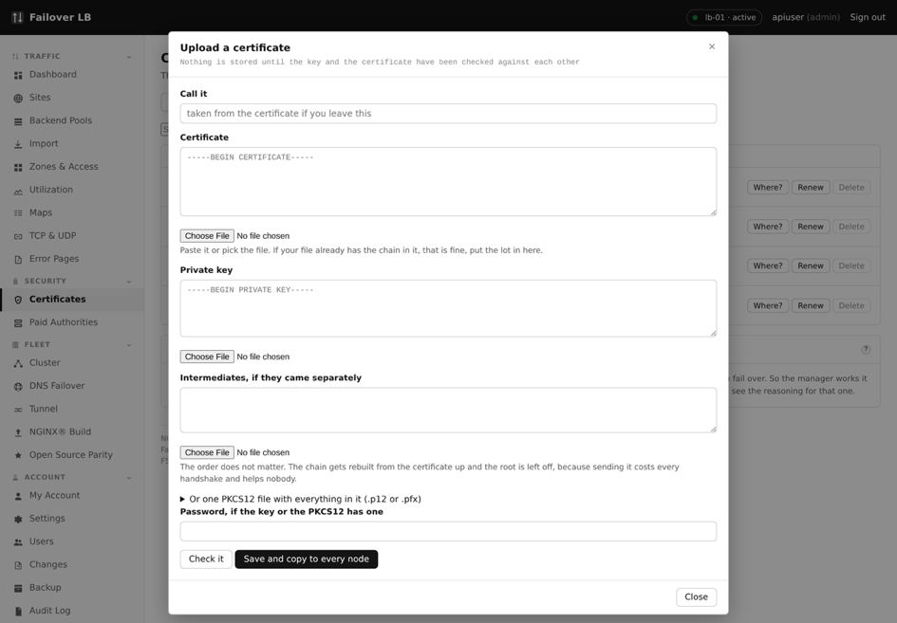
Uploading a certificate you already have.
Field | What to paste
Name | A label, usually the domain it covers
Certificate | The certificate itself, starting BEGIN CERTIFICATE. Paste the intermediates below it as well if your supplier gave you any
Private key | The matching key, starting BEGIN PRIVATE KEY. This never leaves your fleet

Worth knowing The key is checked against the certificate before anything is saved, so a mismatched pair is refused here rather than discovered when a site stops working. Intermediates are put in the right order for you, which is the other common upload mistake.

Making a signing request
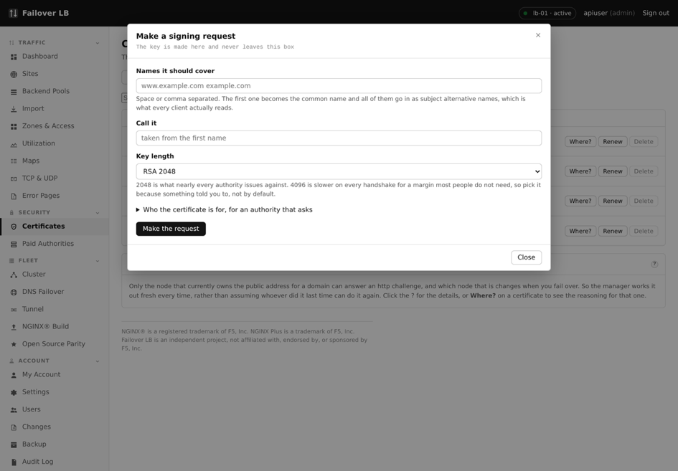
Making a request to send to a supplier.
Field | What to put | If unsure
Name | A label | The main domain
Domains | Every name the certificate should cover | The site address
Key length | 2048 or 4096 bits | 2048, unless told otherwise
Organisation and country | Your company details, if your supplier asks for them | Ask your supplier

You get a block of text to send to your supplier. The private key is made here and stays here, which is the point of doing it this way rather than letting somebody else generate it for you.
When the certificate comes back, find the request in the list, press Paste Certificate, and paste in what they sent. It becomes a normal certificate you can choose on a site.

Making a self signed certificate
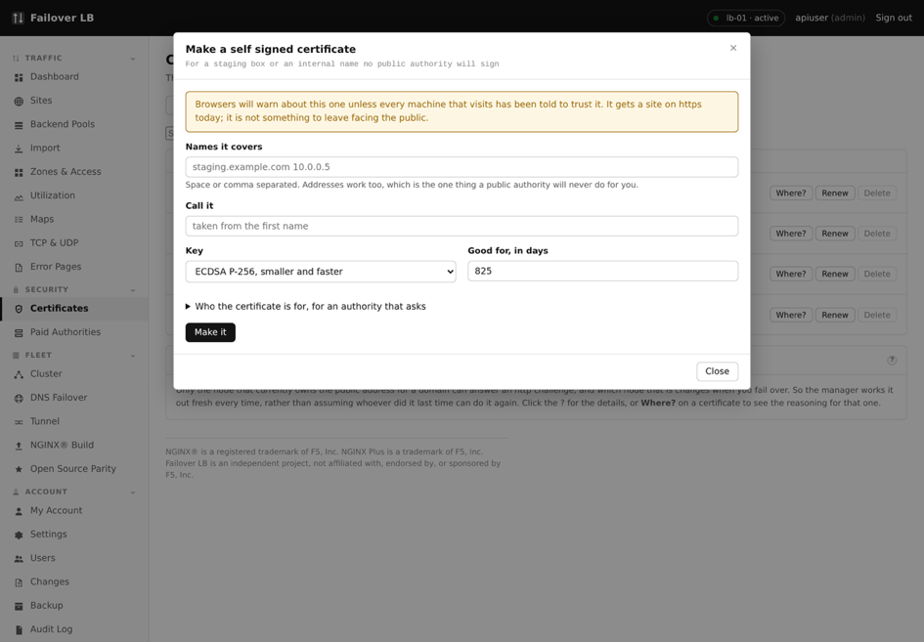
Making one yourself, for testing.
Take care Every browser shows a warning for these, because nothing has vouched for them. Fine for testing and for something only your own systems talk to. Never on a site the public visits.

Adding a path to a site
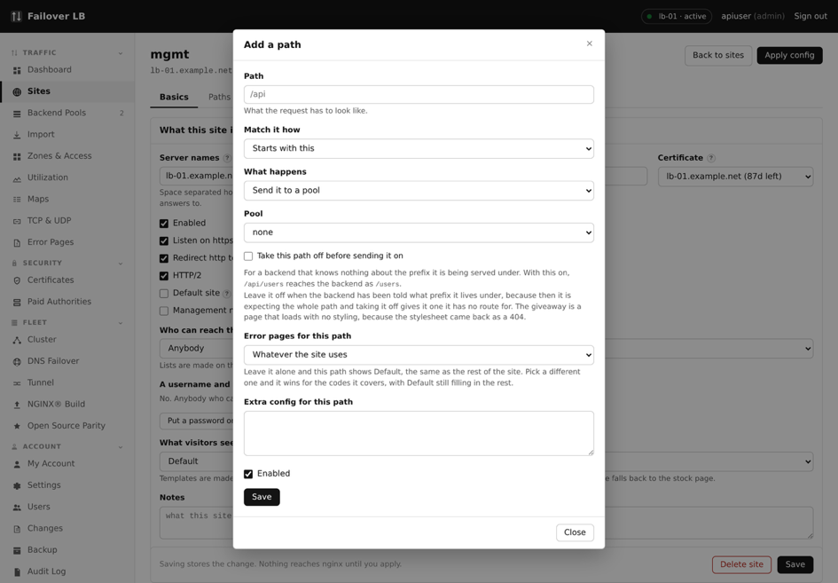
Adding a path.
Field | What to put | If unsure
Path | The part of the address, such as /api | /api
Match type | Prefix matches anything starting with it and is what you want almost always. Exact matches only that one address. Regular expression is for patterns | Prefix
Mode | Send it to a pool, serve files, or redirect | Proxy
Pool | Which backend servers handle this path | The pool for that part
Take this path off before sending it on | On when the backend knows nothing about the prefix. Off when it has been told which prefix it lives under | Off
Access list and error pages | Optional, and override whatever the site sets | Leave empty

Take care The prefix setting is the one worth getting right first time. Wrong either way gives a page that loads with no styling, which reads as an appearance problem and is really the path. Chapter 10 explains it.

New error page template
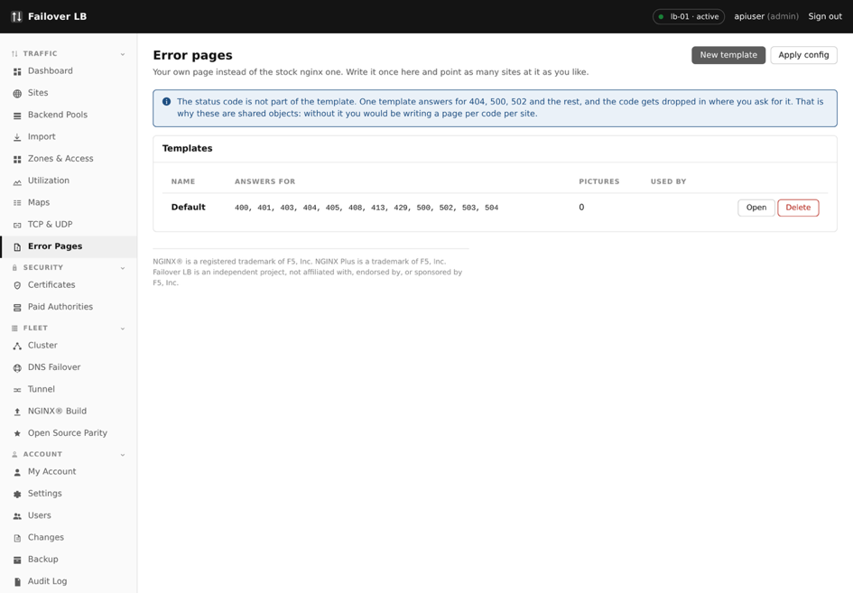
Making an error page template.
Give the template a name, then write a page for each error code you care about. 404 for a page that does not exist and 502 for the application being down are the two worth doing first. Chapter 12 covers what to write.

New map
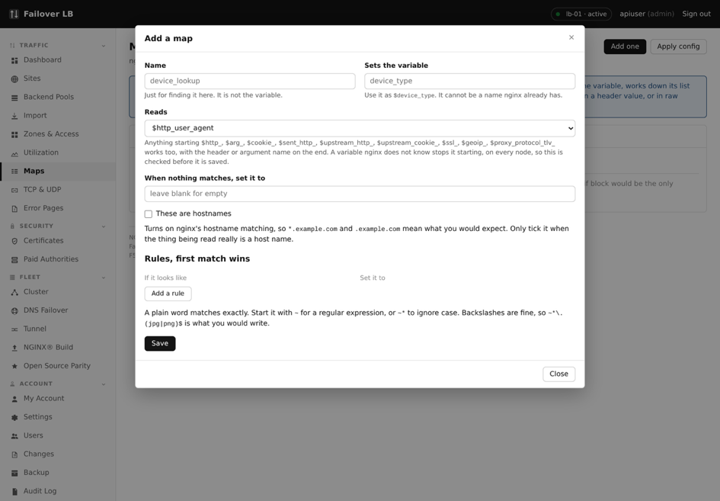
Making a lookup.
Field | What to put
Name | A label for the list
Reads | What it looks at, such as the browser type
Sets the variable | A name you invent. You then use it elsewhere as a setting value
Rules | What to look for and what to set, most specific first. The first match wins
When nothing matches | The value to use as a fallback

A plain word matches exactly. Start a rule with a squiggle for a pattern, or a squiggle and a star to ignore capital letters. Chapter 14 explains when a map is the right tool.

New TCP or UDP service
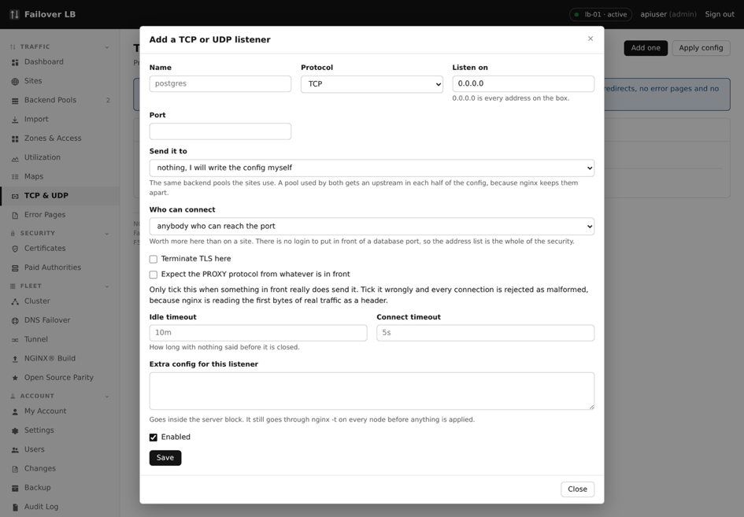
Balancing something that is not web traffic.
Field | What to put | If unsure
Name | A label | What it is for
Protocol | TCP or UDP | TCP
Listen port | The port to accept connections on | The port clients already use
Pool | Which backends to send them to | A pool made for this
Proxy protocol | Pass the real client address to the backend. Only if the backend understands it | Off

Take care Pools used here are separate from the pools used by sites, even when the servers are the same. That is a rule in nginx, not a choice made here, so you will see the same machines listed twice.

New rate limit zone
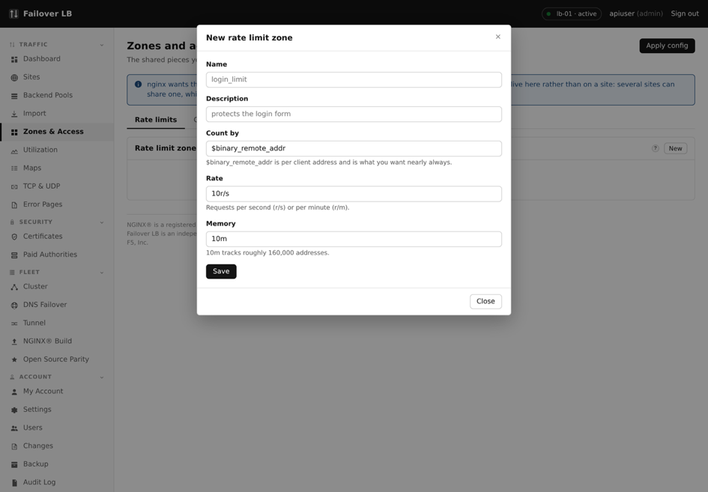
Making a rate limit.
Field | What to put | Usual value
Name | A label | login-limit
Counts by | What makes two requests the same visitor | $binary_remote_addr
Rate | How many allowed, per second or minute | 10r/s
Memory | Space for remembering visitors | 10m

New cache zone
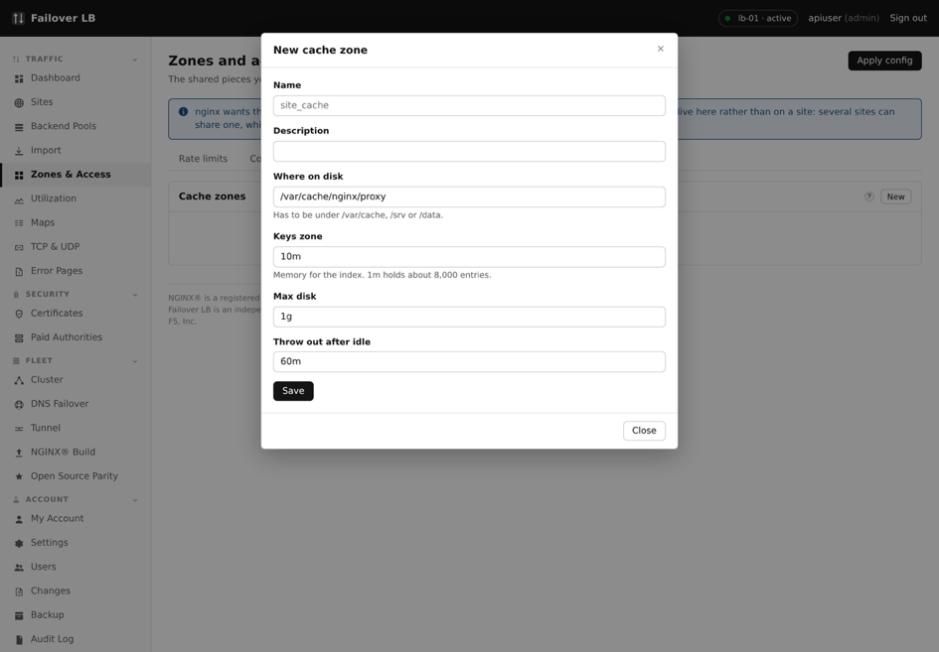
Making a cache.
Field | What to put | Usual value
Name | A label | static-files
Folder | Where the copies are kept on disk | /var/cache/nginx/static
Memory for the index | Space for the list of what is cached, not the copies | 10m
Maximum size | How much disk the copies may use | 1g
Inactive | Throw something out if nobody asks for it in this long | 60m

New access list
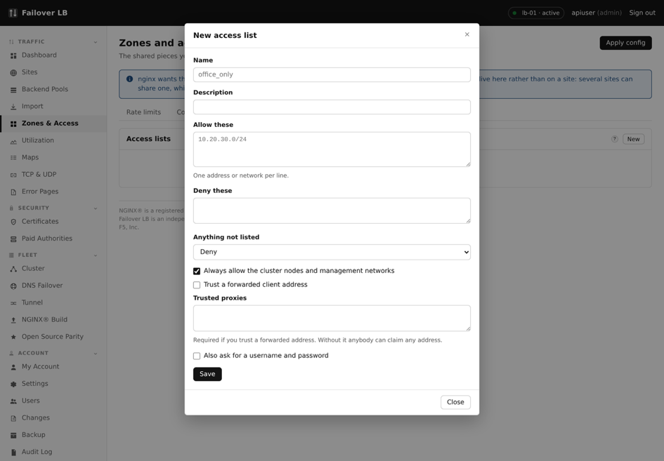
Making an access list.
Field | What to put
Name | A label
Allowed | Addresses or ranges that may reach it, one per line
Blocked | Addresses that may not
When nothing matches | Allow or deny
Include the management networks | Adds the networks from Settings, so you cannot lock yourself out
Ask for a username and password | A second lock on top of the address check
Trust the address from a header | Only when something trustworthy sits in front, such as a CDN

Take care Trust the address from a header with nothing trustworthy in front means anybody can set that header themselves and walk straight through the list. Chapter 13 explains this in full.

New user
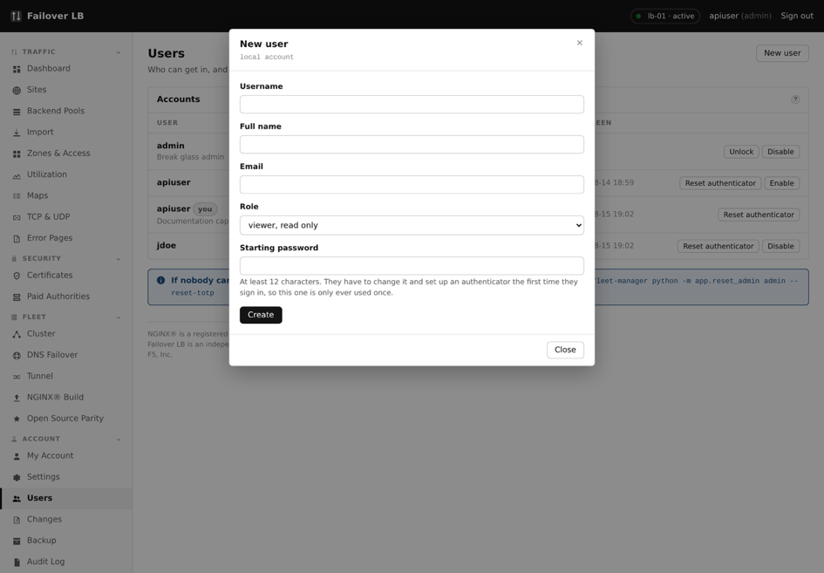
Adding somebody.
Field | What to put | If unsure
Username | What they will sign in with | Their work username
Full name and email | For the audit log and for contacting them | Optional
Role | Viewer, operator or admin | Viewer
First password | Something to give them once. They change it on first sign in | A generated password

They set up their own authenticator app the first time they sign in. Chapter 23 covers the roles and what each can do.

37. The tunnel
To put a server behind these load balancers, the load balancers have to be able to reach it. That normally means the server needs a public address and a hole in the firewall in front of it, and getting both of those arranged is often the longest part of the job. For a machine in an office, or in a data centre that does not hand out public addresses, it may not be possible at all.
The tunnel removes that requirement. The machine you want to reach opens a connection outward to the load balancers, and they reach it back down the same connection. Nothing inbound has to be allowed, and the machine needs no public address of its own.
Worth knowing It is not a VPN, and the difference matters. The machine gets a route to these load balancers and to nothing else. It does not change where that machine's own traffic goes, and it gives it no way out to the internet. A tunnel that did those things would be a much bigger decision than this one.

When to use it
- A web server in an office, with no public address.
- A data centre that will not give you public addresses for every machine, or charges for them.
- A backend you would rather was not reachable from the internet at all, even through a firewall rule.
- Somewhere you want to move a service between networks without changing anything on the load balancers.
If a backend already has a public address that the load balancers can reach, you do not need this. Add it to a pool in the ordinary way and skip this chapter.

How to get to it
In the sidebar, under FLEET, click Tunnel. The page is shown below with the entry marked, so you can find it on your own screen.
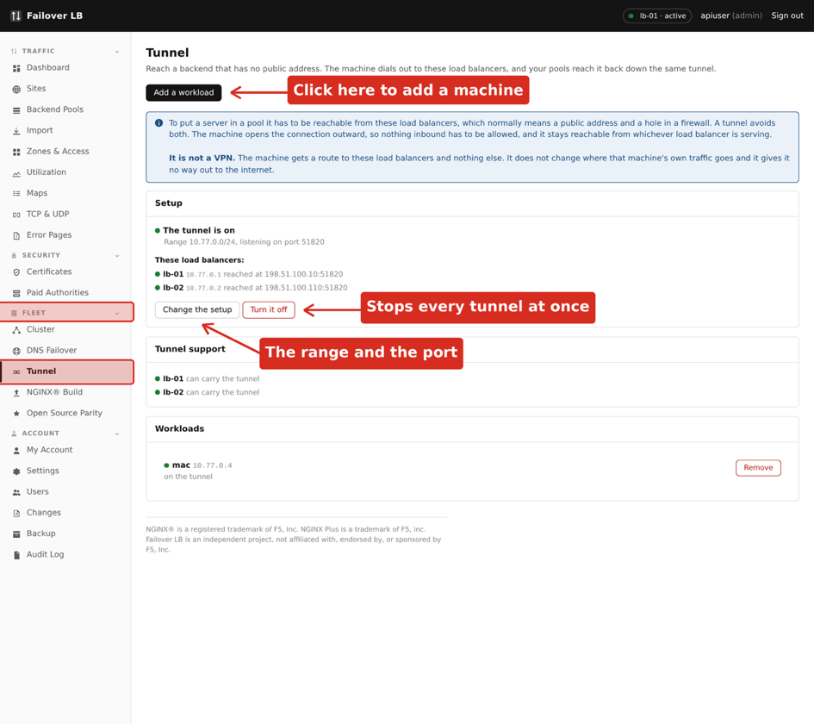
The Tunnel page, reached from FLEET in the sidebar.
The page has three parts. The panel at the top says whether the tunnel is switched on and, when it is, which load balancers are on it and how a workload reaches each of them. Below that is the list of workloads. Above both is a short explanation, kept on the page because the difference between a tunnel and a VPN is worth having in front of you while you decide.

What the words mean
Word | What it means here
Workload | A machine you want to reach that has no public address. One workload is one machine.
Range | The private addresses the tunnel hands out. Each load balancer takes one, and each workload takes one.
Enrolment | The one time step that joins a machine to the tunnel. It is a single command, run on that machine.

Turning it on
- Under FLEET in the sidebar, click Tunnel.
- Click Turn the tunnel on.
- Choose an address range. The suggestion is 10.77.0.0/24, which is fine unless something on your network already uses it.
- Leave the listening port at 51820 unless you have a reason to change it. Whatever you choose has to be reachable from wherever your workloads are, outbound.
- Tick Turn the tunnel on, and save.
You choose the range rather than the system choosing it, because you are the only one who knows what is already in use on your network. A range that clashes with something else does not fail loudly. It quietly makes one of the two unreachable.
Take care The range cannot be changed once workloads are enrolled on it. Changing it would strand them, so the page refuses. Remove the workloads first if you really need a different range.

If the load balancers do not have what they need
The tunnel needs a piece of software on each load balancer, and it is not installed until you switch the tunnel on. Installing a network package on somebody's production load balancers because a page was open is not a decision this system makes on its own.
If any node is missing it, a panel appears on the Tunnel page saying which one, with a button to install it on all of them. Click Install tunnel support and wait. It takes as long as fetching a package takes, and the page keeps up with it.
Worth knowing It installs on every load balancer, not only the one you are looking at. A workload connects to all of them so that it survives one going away, and a node that cannot carry the tunnel is a failover that will not work when you need it.

Adding a workload
Adding a workload reserves an address for a machine and gives you one command to run on it. Nothing happens on the machine until you run that command.
- Under FLEET in the sidebar, click Tunnel.
- Click Add a workload.
- Give it a name. This is only for you, and only appears in this list.
- Add a note if it helps, such as what it runs or who owns it.
- Click Add it.
A command appears. Copy it, and run it on the machine you want to reach. It looks like this:
curl -sSL https://lb-01.example.net/lb/tunnel/enrol/7f3c1a9e2b8d4c6f | sudo bash
The command works once and expires after two hours. Treat it like a password while it is alive: anybody who has it can put a machine on your tunnel. Only a hash of it is kept, so the exact command cannot be shown to you again, but you can always get a fresh one from the workload list.

What the command does
It is worth knowing what you are about to pipe into a shell. The script is short and deliberately readable, and you can look at it first by leaving off the last part of the command.
- Installs wireguard if the machine does not have it.
- Makes a key pair on the machine, and sends only the public half back.
- Writes one network interface, called nfm0.
- Adds a route to the load balancers, and to nothing else.
- Leaves behind a small helper command for checking and undoing it.
What it does not do is as important:
- It does not change the machine's default route.
- It does not send the machine's own traffic anywhere.
- It does not open any inbound port.
When it finishes, it waits for the tunnel to come up and tells you whether it did. An interface that exists and a tunnel that works are not the same thing, and the difference is usually a firewall that drops outbound traffic on the tunnel port. Better to find that out here than from a backend marked down later.

If you closed the window before copying the command
The workload will be sitting in the list saying it is waiting for the command to be run. Click Show the command next to it for a fresh one. Asking for a new command retires the old one, so a link that went astray stops working the moment you ask for another.

Putting the workload behind a site
Once a workload is on the tunnel it has an address, shown next to its name in the list. From here on it behaves like any other backend.
- Note the workload's tunnel address from the Tunnel page, for example 10.77.0.4.
- Under TRAFFIC in the sidebar, click Backend Pools.
- Open the pool you want it in, or make a new one.
- Add a server, using the tunnel address and the port the service listens on.
- Apply config.
The health checks run over the tunnel like any other check, so the pool page will show it as up or down in the usual way. If it shows down, the Troubleshooting section at the end of this chapter is the place to start.
Worth knowing Use the port the service actually listens on, which is not always the port the rest of the pool uses. A pool whose other members are on port 82 does not oblige a tunnelled member to be on port 82.

Removing a workload
Removing has two halves, and only one of them happens in the GUI. Taking the workload out here stops the load balancers talking to it straight away. The machine itself keeps its interface, its config and its key until somebody clears them.
- Take the address out of any pool that uses it, and apply. Otherwise the pool is left pointing at something that has gone.
- Under FLEET in the sidebar, click Tunnel.
- Click Remove next to the workload.
- Copy the command shown, and run it on the machine.
- Click Remove it here.
The command stays on screen after the removal, so you can go and run it afterwards. It looks like this:
sudo bash -c 'systemctl disable --now wg-quick@nfm0 2>/dev/null || \
wg-quick down nfm0 2>/dev/null; \
rm -f /etc/wireguard/nfm0.conf /etc/wireguard/nfm0.key \
/usr/local/bin/nfm-tunnel'
Worth knowing It leaves the wireguard package installed. That machine may be using it for something else, and removing a package on somebody's server is not something to do from a copied line.

When it does not work

The workload says it enrolled, but the backend is down
Check the Tunnel page first. A workload that has joined shows as on the tunnel. One that is still waiting for the command has not run it, or the command failed part way.
If it shows as on the tunnel and the backend is still down, the tunnel is up and the service behind it is not. Check that the service is listening, and on the port you used in the pool.

Nothing happens at all
On the machine, check the tunnel is up:
sudo nfm-tunnel status
If that reports the tunnel is not up, the interface was never created. The usual reason is a container whose kernel has no wireguard of its own, and the enrolment script says so when it happens. The other common reason is a firewall that allows outbound traffic generally but drops the tunnel port, which is UDP.

It works through one load balancer and not the other
A workload connects to every load balancer, and each connection is separate. One working and one not usually means the workload cannot reach one of them: a firewall on the way, or an address family problem, such as a load balancer published on IPv6 only while the workload has IPv4 only.
The Tunnel page shows how each load balancer is reached. If one of those addresses is not one your workload can get to, use Change the setup to put in a name or address that it can. A name that has both an A and an AAAA record is the most flexible, because each workload then resolves whichever it is able to use.

Getting a fresh command
Enrolment commands expire after two hours. If one has expired, or went astray, click Show the command next to the workload for a new one. The old one stops working immediately.

38. Certificates from a paid authority
Most sites are best served by Lets Encrypt. It is free, it is trusted everywhere that matters, and this system renews it for you without being asked. Chapter 12 covers that, and if nobody has told you otherwise it is the chapter you want.
Sometimes that is not an option. An organisation may have bought a certificate already, or have an agreement with a supplier, or a policy that names one. Some suppliers offer warranties or extended validation that Lets Encrypt does not. This chapter is for those cases.

Two ways to use a paid certificate
There is an important difference between them, and it decides how much work you do every year.
Way | What happens | Renewal
Upload one | Somebody buys a certificate, and you paste it in. | By hand, every time it expires.
Set up an authority | The supplier is registered here once, and certificates are issued and renewed automatically, exactly like Lets Encrypt. | Automatic.

Uploading is covered in Chapter 12 and needs nothing set up. This chapter is about the second way, which takes a few minutes once and then behaves like the free certificates do.
Worth knowing This only works with suppliers that offer ACME, which is the protocol Lets Encrypt uses. Most large certificate authorities now do. If yours does not, upload the certificate by hand instead, and there is nothing to set up here.

What you need from the supplier
Before starting, get three things from whoever sells you certificates. They are usually together on one page of the supplier's control panel, often called ACME or automation.
- The directory URL. This is the address of the supplier's ACME service, and it usually ends in /directory.
- A key identifier, sometimes written as EAB KID.
- An HMAC key, sometimes written as EAB HMAC key.
The last two are how the supplier knows the request is from your account, and therefore who to bill. They are credentials. Treat them the way you would treat a password.

Setting up an authority
In the sidebar, under SECURITY, click Paid Authorities. This page lists the suppliers this system knows how to ask for certificates. It is shown below with the entry marked, so you can find it on your own screen.
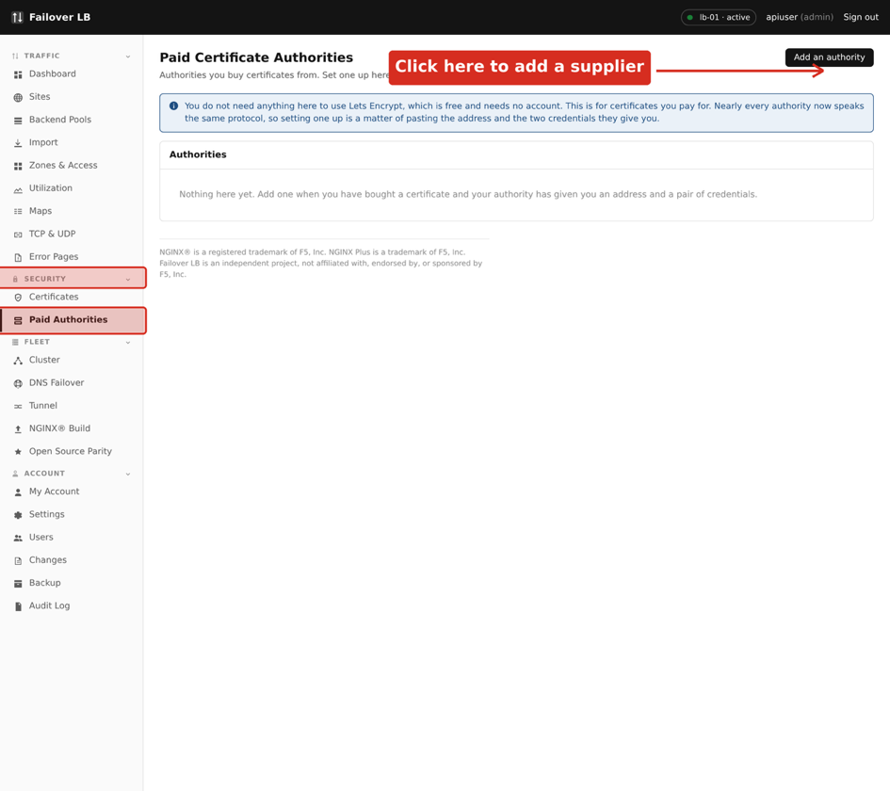
Paid Authorities, reached from SECURITY in the sidebar.
- Under SECURITY in the sidebar, click Paid Authorities.
- Click Add an authority.
- Give it a name you will recognise later, such as the supplier's name.
- Paste in the directory URL.
- Paste in the key identifier and the HMAC key.
- Save.
Saving stores the credentials encrypted, and they are never shown again. You can replace them later, but you cannot read them back out. That is on purpose.

Checking it before you rely on it
Use Test after saving. This registers with the supplier and asks nothing else of them, so it is safe to run and it does not cost anything or use up an allowance.
Testing first is worth the extra minute. Credentials that are wrong produce a failure at the moment you actually need a certificate, which is usually the moment a site is going live.
Take care Certificates from a paid authority are usually charged for, and some agreements limit how many you may have. Unlike Lets Encrypt, asking for one may cost money. Know what your agreement says before pointing sites at it.

Getting a certificate from it
Once an authority is set up, asking it for a certificate is the same as asking Lets Encrypt. The only difference is choosing who to ask.
- Under SECURITY in the sidebar, click Certificates.
- Click Get certificate from Paid CA.
- Choose the authority from the list.
- Enter the domains, exactly as in Chapter 12.
- Choose how the domain will be proved, http or dns.
- Save, and wait for it to be issued.
From there it behaves like any other certificate here. It is copied to every load balancer, it appears on the Certificates page with its expiry, and you pick it on a site in the ordinary way.
Worth knowing The choice of authority is per certificate, not per system. You can have Lets Encrypt for most sites and a paid supplier for the two that need it, and neither knows about the other.

Renewal
Renewal is automatic and works the same way as it does for the free certificates. The system renews well before expiry, and the renewed certificate is copied to every load balancer.
Two things are worth knowing. Paid certificates often last a year rather than ninety days, so a renewal problem can sit unnoticed for a long time. And a renewal may be chargeable. The expiry column on the Certificates page is the thing to keep an eye on either way.
Take care If the agreement with your supplier lapses, renewal stops working and the first sign of it is a certificate that did not renew. A paid authority ties your certificates to a commercial relationship in a way that a free one does not.

When it does not work

The test fails
Almost always the credentials. Check the key identifier and the HMAC key have been pasted whole, with no space at either end, and that the directory URL is the one the supplier gave you rather than their website. A directory URL nearly always ends in /directory.

The test passes but issuing fails
Then the credentials are right and something about the request is not. The usual reasons are a domain the agreement does not cover, an allowance that has been used up, or a validation method the supplier does not accept. The error from the supplier is shown on the certificate, and it is usually specific.

Renewal stopped working
Check the agreement is still current, and then run Test on the authority again. Suppliers do sometimes reissue credentials, and a set that worked last year may not work now.

39. Backup and restore
A backup here is one file containing everything this fleet is configured to do. Sites, backend pools, zones and access lists, TCP and UDP, error pages, certificates, paid authorities, settings and accounts. It is enough to rebuild the fleet somewhere else from nothing.
It is deliberately not a copy of the machines. Node names, cluster membership and the identity of each server are left out, because those belong to the machines rather than to the configuration. A backup restored onto new servers should let those servers do the job, not make them pretend to be the old ones.
Take care A backup contains every private key this fleet holds. That is enough on its own to serve every site you serve, to anybody who has the file and the password. Keep it where you would keep the keys themselves.

How it is protected
The file is a zip encrypted with AES-256, which any current zip tool can open. The password is your own login password, which is why you are asked for it when taking a backup and again when restoring one. Only a hash of your password is stored here, so it cannot be filled in for you.
Worth knowing Being asked for your password twice is not ceremony. It is what encrypts the file, and it also proves that whoever is at the keyboard is the account they are signed in as, which is worth doing for an operation that hands out every key you have.

Two honest limits are worth stating. The encryption in the zip format derives its key with fewer rounds than a modern password vault, so the file is only as strong as the password against somebody who has it and time to spend. And the password cannot be changed without changing your login. For a backup that will sit somewhere you do not control, put it inside something that does its own key derivation properly, and treat this file as sensitive in its own right.

Taking a backup
In the sidebar, under ACCOUNT, click Backup. The page is shown below with the entry marked.
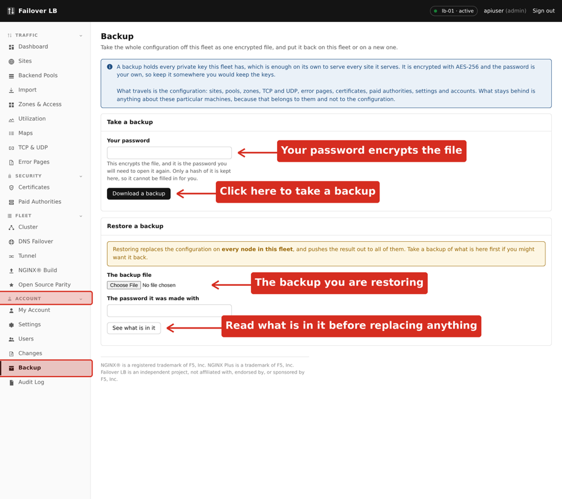
The Backup page, reached from ACCOUNT in the sidebar.
- Under ACCOUNT in the sidebar, click Backup.
- Type your password in the Take a backup panel.
- Click Download a backup.
- Save the file somewhere safe.
The file is named with the date and time it was taken, so several of them sit together without overwriting each other.

What goes in it
Everything listed at the start of this chapter, plus the certificate files themselves where this system holds them. That last part matters: it means a restored fleet can serve traffic immediately, rather than waiting to be issued new certificates it cannot get until it is already serving traffic.
If any certificate has no files on the node taking the backup, the page says so by name. Those will need issuing again after a restore.

How often
Before any change you are unsure about, and on a schedule that matches how often your configuration changes. A backup taken before a change is the cheapest way to undo it.

Where to keep it
- Not only on the load balancers. A backup that lives on the machine it protects is no help when that machine is what failed.
- Somewhere access is controlled, because the file is equivalent to your private keys.
- Somewhere you will still have access if you are locked out of this system, since restoring is how you get back in.
It is worth deleting old copies rather than letting them accumulate. Every one of them stays valid for as long as the keys inside it do.

Restoring
Take care Restoring replaces the configuration on every load balancer in the fleet, and pushes the result to all of them. Take a backup of what is there now first, if there is any chance you will want it back.

- Under ACCOUNT in the sidebar, click Backup.
- In the Restore a backup panel, choose the file.
- Type the password the backup was made with.
- Click See what is in it.
- Read what it reports, especially the addresses it came from.
- Type restore in the confirmation box.
- Click Restore this onto the whole fleet.
See what is in it opens the archive and reports what it holds without changing anything. Use it. It is where you find out that you have the wrong file, or the wrong password, at a point where nothing has been replaced yet.
The confirmation is typed rather than clicked for the same reason. This replaces the running configuration of every load balancer, and a dialog that can be dismissed by reflex is not the right amount of friction in front of that.

What restoring does
- Puts the configuration into the database.
- Writes the certificate files onto this node.
- Copies the certificates out to every other load balancer.
- Sends the settings to every other load balancer.
- Pushes the rendered configuration to the whole fleet, through the same two phase apply an ordinary save uses.
- Rebuilds the tunnel, if the backup had one switched on.
Worth knowing It finishes the job across the fleet rather than only on the node you are signed in to. A restore that landed on one load balancer would leave the fleet split, which is the one state the two phase apply exists to prevent.

After a restore
The accounts in the backup replace the accounts here, so sign in again if your own account came from the backup. Check the Sites page and the Certificates page, and look at the report the restore printed for anything it could not do.

Restoring onto different servers
This is the case a backup exists for, and it is the one with a trap in it.
Almost everything in a backup is names and settings, which mean the same thing wherever they are restored. DNS failover answers are the exception. An answer is a literal address, and its whole job is to be handed out to the internet. Carried across unchanged onto new servers, those answers would still name the old ones: the new load balancers would come up, report themselves healthy, and send every visitor to machines that are not theirs. Both ends would look correct.
So a restore repoints them. An answer tied to a load balancer by name is rewritten to that load balancer's own address on the fleet you are restoring onto, matching the kind of address: an A record gets IPv4 and an AAAA record gets IPv6.
Anything it cannot match is left exactly as it was and reported to you by name. If the new fleet has different node names, or a node has no address of the right kind, you will see it listed after the restore. Those need fixing by hand on the DNS Failover page.
Worth knowing Guessing which new machine replaces which old one is not something to do quietly with a DNS record, which is why anything uncertain is reported rather than assumed.

One setting is deliberately not restored
The list of networks allowed to reach the management interface stays as it is on the fleet being restored onto. You are rebuilding from wherever you happen to be, which need not be anywhere on the old fleet's list, and restoring it is a good way to be locked out of the system you are in the middle of recovering. Set it afterwards, on the Settings page.

Tunnel workloads
Enrolled workloads come back as configuration, but each machine still points at the old load balancers. Run the enrolment command again on each one, from the Tunnel page of the new fleet, as Chapter 37 describes.

When it does not work

That password does not open this backup
The password is the one that was typed when the backup was taken, which is that person's login password at that time. If they have changed it since, the backup still wants the old one. A backup taken by somebody else needs their password, not yours.

This zip has no backup in it
The file opened but does not contain what a backup contains. Usually this is an ordinary zip that happens to be in the same folder.

The restore finished but something is missing
Read the report on the page. Certificates that had no files are listed, DNS answers that could not be repointed are listed, and any load balancer that could not be reached is listed. A node that was unreachable during the restore has not been updated and needs the restore running again once it is back.

40. How DNS failover works
Chapter 19 covers setting DNS failover up. This chapter is about what it actually does, which is worth understanding before you rely on it, because it is the part of the system that keeps working when something else has stopped.
The problem it solves is simple to state. Two load balancers are no use if visitors keep being sent to the one that has failed. Somebody has to notice and stop handing out its address, and that somebody is the fleet itself.
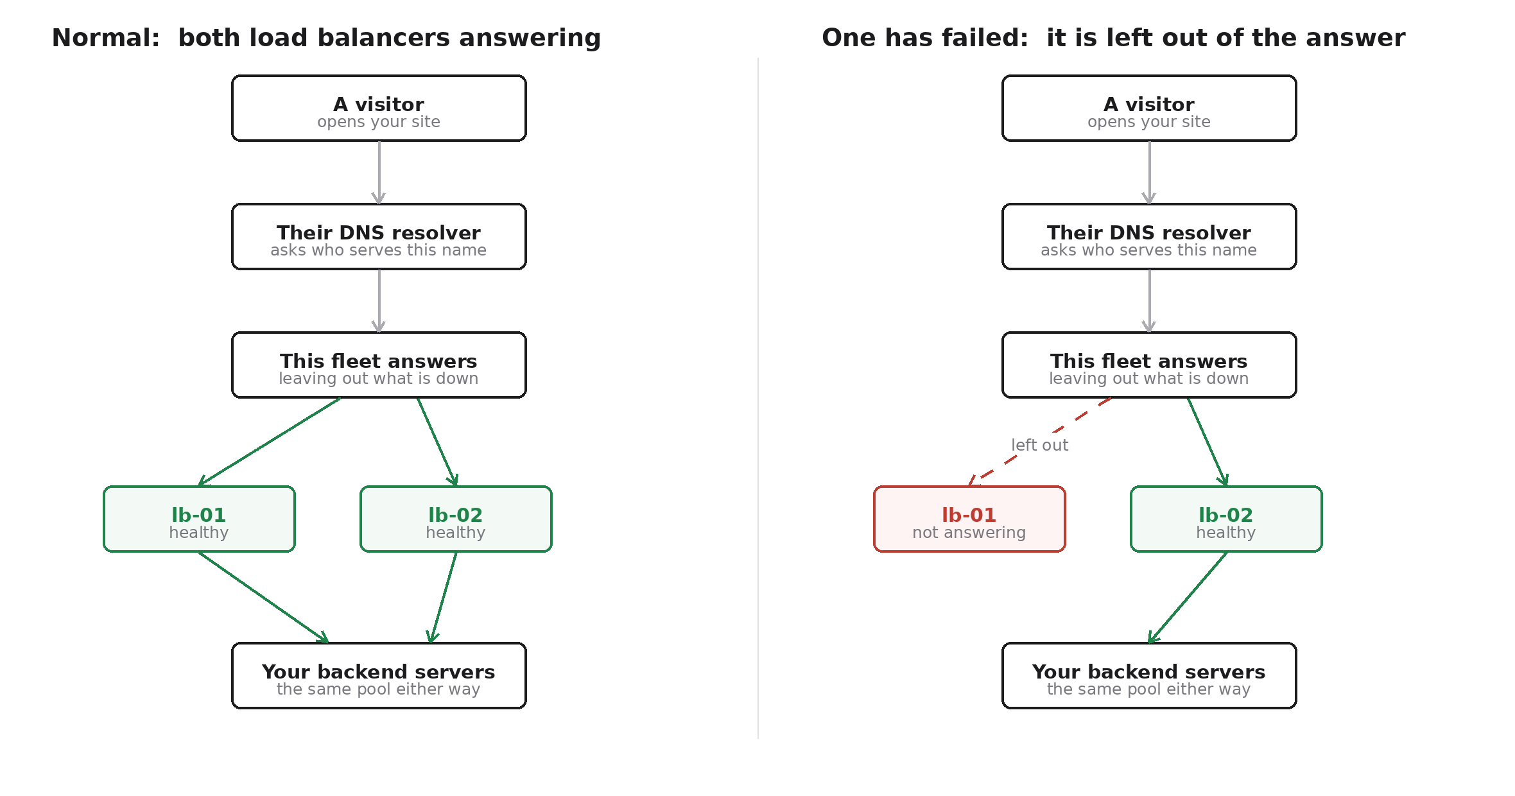
The same request, with both load balancers healthy and with one of them failed.

Step by step
- A visitor opens your site, so their computer needs an address for the name.
- Their DNS resolver asks whoever is responsible for that name. For a name you have delegated here, that is this fleet.
- The fleet answers with the addresses of the load balancers it believes are healthy, and leaves out any it believes are not.
- The visitor connects to one of the addresses it was given.
- That load balancer passes the request to your backend pool, which is the same pool whichever load balancer answered.
The health of each load balancer is something this system already tracks continuously for its own purposes, so failover uses what it already knows rather than a separate check that could disagree.

What this does well
- A failed load balancer stops being handed out, without anybody being woken up.
- It works across data centres and providers, which a shared address cannot.
- The backends do not change, so nothing behind the load balancers has to know a failover happened.

What it cannot do, and why
Take care DNS answers are remembered. A resolver that asked a minute ago will use the answer it already has until that answer expires, so some visitors keep trying a load balancer that has already failed. This is how DNS works everywhere and no system can avoid it.

The time to live setting decides how long an answer is remembered. A short one means failover takes effect quickly, and means more questions to answer. Thirty seconds is a reasonable starting point and is what this system suggests.
Two other things are worth knowing. Some resolvers ignore very short times to live and keep answers longer than they were told to. And the name at the very top of a domain cannot be a CNAME, which is why an apex name needs addresses rather than an alias, and why some providers offer their own failover feature for that case.
Worth knowing Measured on a real fleet, a failed load balancer was noticed in about thirty seconds, and visitors had moved across within about a minute of the failure. Traffic on a name that was already using both addresses did not stop at all.

41. How big the servers need to be
The short answer is smaller than most people expect, and the thing to size is the network rather than the processor. The rest of this chapter explains why, and gives figures you can work from.

The rule of thumb
Work out the peak number of requests per second the fleet has to serve. Multiply by the average size of a response. That is your bandwidth, and it is the number that will run out first.
Requests per second | At 28 KB per response | In bits
1,000 | 28 MB/s | 224 Mbit/s
2,000 | 56 MB/s | 448 Mbit/s
5,000 | 140 MB/s | 1.1 Gbit/s
10,000 | 280 MB/s | 2.2 Gbit/s

Add something for headroom, and provision the link for that. Then pick a processor and memory from the table below, which are comfortable rather than tight.

Recommended sizes
These assume a pair of load balancers where either one has to be able to carry everything on its own. That is the point of having two, so size each for the full peak rather than half of it.
Peak load | vCPU | Memory | Network | Disk
Up to 2,000 req/s | 4 | 4 GB | 1 Gbit/s | 40 GB SSD
Up to 5,000 req/s | 8 | 8 GB | 2.5 Gbit/s | 80 GB SSD
Up to 10,000 req/s | 16 | 16 GB | 10 Gbit/s | 160 GB SSD

Do not go below four processors even for a quiet site. An average hides bursts, and the two things that burst here are TLS handshakes when a lot of visitors arrive at once, and certificate renewal.

What changes these numbers
- Smaller responses move the limit from the network to the processor. A site serving small API replies rather than pages will need more processor and less bandwidth than the table suggests.
- Visitors who connect once and leave are much more expensive than visitors who stay, because each new connection pays for a TLS handshake. A site with heavy connection churn needs more processor.
- Caching on the load balancers trades memory and disk for backend load, which changes where the pressure sits.
Take care Keep both load balancers the same size. A pair where one is smaller has the capacity of the smaller one, and you find that out at the moment the larger one fails.

Where these numbers come from
An hour of continuous traffic against a real two node fleet, serving a real site through its real backends. The figures below are what was measured, not what was expected.
What | Result
Requests served | 7,541,340 in one hour
Sustained rate | 2,095 requests per second
Data transferred | 204.88 GB
Timeouts | none
Failed connections | none
Response time, 90th percentile | 131 ms and 81 ms
Processor at peak | 8% of 16 cores
Memory at peak | 771 MB of 3,393 MB

Nothing degraded across the hour. Response times at the end matched the beginning, memory moved by about twenty megabytes and did not trend upward, and connection counts held steady. The tunnel carried backend traffic throughout without interruption, and the other sites on the same fleet were unaffected.

The honest caveat
The test could not find the fleet's limit. Throughput stopped rising at about 3,000 requests per second, and at that moment the load balancers were running at roughly 6% of their processors. What ran out was bandwidth on the machine generating the traffic, not anything belonging to the fleet.
Take care So the real capacity of these servers is not known, and is higher than the numbers above, possibly much higher. Treat the recommendations as safe rather than precise. To find the true figure, generate load from several machines on separate connections and raise it until the load balancers themselves are busy.

What the hour does establish is the thing an endurance test is for. Under sustained heavy traffic this system does not leak, does not slow down, and does not need attention.

Appendix A: Ports
Port | Protocol | What it is | Who should reach it
80 | TCP | Web traffic and certificate checks | Everyone
443 | TCP | Secure web traffic | Everyone
7443 | TCP | The management screen | Your office networks
7444 | TCP | The servers talking to each other | The other servers
53 | TCP and UDP | DNS failover answers | Everyone
5353 | TCP and UDP | Where the DNS part really listens | Nobody directly

Port 5353 is in the table for completeness. Port 53 is sent to it by a firewall rule the software manages, so you never open 5353 and you never test against it.

Appendix B: Files and folders
Path | What it is
/data/docker/nginx-gui-mgmt | The software, and the .env settings file
/opt/nginx-fleet-manager | The agent
/etc/nginx | nginx's configuration, written by this software
/etc/nginx/nginxmgr | The parts this software generates
/etc/nginx/nginxmgr/certs | Certificates and keys
/var/backups/nginx-fleet-manager | The configuration before each apply
/var/log/nginx | nginx's own logs
/run/nginxmgr/agent.sock | How the screen talks to the agent

Take care Do not edit anything under /etc/nginx/nginxmgr by hand. It is written again from scratch on every apply, so your change will disappear without warning at the least convenient moment. Use raw configuration mode on a site if you need something the screen does not offer, because that is stored and survives.

Appendix C: Glossary
Term | What it means
Active | The server currently in charge of making changes. Both servers serve traffic.
Agent | The small program that does the few jobs needing administrator rights, so the web screen does not need them.
Apply | Making your saved changes live on every server at once.
Backend | One of your application servers, behind the load balancer.
Certificate | The file that makes the padlock appear and encrypts traffic.
Delegation | Telling the internet that your servers answer for part of your domain.
Failover | Traffic moving to a working server when one fails.
Glue | An address record that lets a nameserver inside a zone be found at all.
GSLB | Sending people to a healthy server using DNS. What Chapter 19 sets up.
Health check | A regular test of whether a backend is answering properly.
Lets Encrypt | A service giving out free certificates that renew automatically.
Location, or path | A rule for part of a site, such as everything under /api.
nginx | The program that actually handles the traffic. This software configures it.
Node | One of your load balancer servers.
Pool | A named list of backends that a site sends requests to.
Proxy | Passing a request on to another server and returning its answer.
Rate limit | A cap on how many requests one visitor may make.
Site | One web address and the rules for it.
Standby | The server not currently in charge. It still serves traffic.
TTL | How long a DNS answer is remembered before being looked up again.
Upstream | Another word for a pool, used inside nginx itself.

