Git Code Review
  - User guide
Finding leaked credentials, weak code and vulnerable dependencies across every repository you own, and keeping the record of who decided what about each one.

Version 1.0.1
August 2026
MIT licensed

Contents
(update this field to fill it in)
This list fills in when the document is opened in Word: select it and press F9, or use References then Update Table.

1. About this guide
What is in it, who it is for, and how to read it without reading all of it.

What this software is
Git Code Review reads every repository your organization owns and tells you three things: which credentials have been committed into them, which of the code in them has a weakness somebody could use, and which of the software you depend on has a known hole in it. It runs on a machine you control, it never sends your code anywhere, and it is free.
It is not the first tool to do any of that. The engines that do the actual reading are well known open source projects, and several companies sell products built on the same ones. What this adds is everything that turns tens of thousands of raw findings into a list a person can work through: judging what is real, ranking what matters, knowing what each repository is worth, and remembering who decided what about every finding that was set aside.
That last part is the difference between a scanner and something an auditor will accept. A scanner produces a number. This produces a number, the reasoning behind it, and a record of every human decision that changed it.

Who this guide is for
Somebody who has been made responsible for the security of code they did not all write. You might be a security engineer, an infrastructure engineer who inherited the problem, a development manager, or the one person at a smaller company who does all three. This guide assumes you can use a terminal and that somebody can give you a machine with Docker on it. It does not assume you have run a security scanner before.
It also assumes you have more repositories than you can look at by hand. Below about twenty, the honest answer is that a person reading the code carefully will do better than any tool. Above that, nobody reads them all, and this exists for that case.

How to read this
You do not need to read it in order and you certainly do not need to read all of it. There are three ways in.
- If you want it running today, read chapters 3 to 8. That is what you need and no more.
- If somebody has already installed it and handed you a list of nine thousand findings, start at chapter 10. The chapters on triage, exceptions and tuning are the ones that turn that list into a morning of work rather than a reason to give up.
- If you are deciding whether to use this at all, read chapter 2 and then chapter 52, which is the honest list of what it cannot do.
The reference chapters at the back are meant to be looked things up in rather than read. Every setting, every report file, every command line flag and every exit code is there.

How the pictures work
Every screenshot in this guide came from a real installation that had just scanned twenty public repositories. The findings, the counts and the rankings in them are what the product actually produced from that scan, not a mockup.
What has been changed is the names. Every organization, person and repository shown is invented, because publishing the real ones would be publishing somebody's estate. Every credential is shown through the product's own masking, which is all it stores anyway. You will see organizations called Acme Corp, Contoso and Globex, and people called things like a.whitfield and j.okafor. None of them exist.

A word about what this cannot do
Every chapter that describes a feature ends with a short section saying what that feature does not do, and chapter 52 collects all of them in one place. This is deliberate. A tool that only tells you what it is good at is one you will trust in exactly the situation where it is wrong.
The short version: it reads, it never writes. It will not fix anything, revoke anything, or open a pull request. Its judgements about what is real are good enough to be useful and not good enough to be automatic. And its vulnerability data is the public data, which is sometimes later than what a commercial feed would give you.

2. What problem this solves
Why an estate of repositories is different from a repository, and why credentials are the part to fix first.

The three questions nobody can answer
Every organization above a certain size has the same three questions about its own code, and almost none of them can answer any of them without a project.
1. What credentials are sitting in our repositories right now, including in history?
2. What are we shipping that has a known hole in it, and does any of it matter?
3. Who can reach any of this, and what would it cost us if they did?
Each question is answerable for one repository by a person with an afternoon. None of them is answerable for four hundred repositories by any number of people with any number of afternoons, because by the time you finish the first hundred the first ten have changed.

Why credentials come first
Of the three, leaked credentials are the one with the shortest fuse and the one the market covers worst.
A vulnerability in a library is a possibility: somebody would have to find a path to it, build something that reaches it, and get that to your running system. A credential in a repository is not a possibility. It is a working key, sitting in a place that is often more widely readable than anybody intended, and using it requires no skill at all. It also does not get better on its own. A library gets patched; a key committed in 2019 is still in the history in 2026 and still works if nobody rotated it.
The commercial tools in this market grew out of dependency scanning and static analysis, and credentials came later for most of them. This project started from the other end.
What the history means
Deleting a secret from a file does not remove it. The commit that added it is still in the repository, and anybody who can clone the repository can read it with one command. This is why the scanner walks the whole history of every branch rather than looking at the current state, and it is why the first scan of an old estate finds so much more than anybody expects.

Why the count is not the problem
The first scan of a real estate comes back with a number that looks like a catastrophe. Nine thousand findings is normal. Twenty thousand is not unusual. Almost all of it is noise, and the tool that hands you that number without doing anything about it has moved the problem rather than solved it.
On the twenty repository corpus used for the screenshots in this guide, three quarters of the dependency findings turned out to be in packages the application never calls. Sixty two per cent of the high and critical code findings came from rules the engine itself marks as low confidence. Two thousand of the credential findings were examples, test fixtures and documentation. Nine were real, live keys that the issuing provider confirmed still worked.
Nine is a number somebody can act on before lunch. Nine thousand is a number somebody closes the tab on. Everything in the middle of this product exists to get from one to the other without throwing away anything that mattered.

What this does that running the engines yourself does not
What you get from the engines alone | What this adds
A list of matches per repository | One list across every host, organization and repository you own
A severity from the rule that fired | A ranking that puts a verified live credential above a critical nobody can reach
Every string that looks like a secret | A judgement about which are examples, with the reasoning attached
A package name and a CVE | Whether your code can reach it, and whether anybody is exploiting it
A fresh list every time you run it | Memory: what is new since last time, and what somebody already decided about the rest
Nothing about who decided anything | An audit trail of every exception, regrade and mute, with a name, a reason and an expiry
No idea what any repository is worth | What each one holds and who can reach it, feeding into how its findings are ranked

3. The ideas you need first
Eight words this guide uses constantly. Five minutes here saves an hour later.

A connection
One place your code lives, and a credential that can read it. A connection is a host address, a token, and a scope saying which organizations inside it you care about. Most organizations need more than one: an estate that grew by acquisition usually has code on three or four different hosts, and each of those is its own connection with its own credential.
A connection also carries labels about what the systems behind it hold. That sounds like paperwork and it is the single most useful thing you can tell the product, because it is what lets the same finding be a medium in one place and a critical in another.

A scan
One run across one or more connections. A scan clones every repository in scope, runs the engines over all of them, works out what is worth reporting, and writes the result into the database and into a set of files. Scans are usually scheduled rather than started by hand, and more than one can run at once if you tell it to.

A finding
One thing worth telling you about, in one place. A leaked credential in a file, a weakness on a line of code, a vulnerable package in a dependency tree, a container image with a four year old base. Every finding has a repository, usually a file and a line, a severity, and a fingerprint that identifies it across scans so that "this is the same one as last week" is answerable.

An engine
One of the ten open source programs that do the reading. gitleaks and TruffleHog look for credentials. semgrep, gosec and bandit read code. syft builds a bill of materials, and grype and osv-scanner check it against the vulnerability databases. trivy reads infrastructure files, and zizmor reads pipelines. You never talk to any of them directly.

Triage
The step between what an engine reported and what you see. Triage decides whether a string that looks like a credential is a credential or an example, whether a code finding survives being read back in context, and whether a dependency is one your code can actually reach. Every triage verdict carries the sentence that justifies it.

An exception, an exclusion and a mute
Three different ways to set something aside, and the difference between them matters.
- An exception covers one finding. Somebody looked at that specific thing and signed a decision with a reason and an expiry date.
- An exclusion is a rule. It covers whatever matches it, now and in future scans: a path, a rule name, or the fingerprint of a particular credential value.
- A rule mute sets aside everything one rule will ever produce, across the whole estate. It is the widest instrument in the product and it needs a second administrator to agree.
None of the three delete anything. An excluded finding still appears in the report files, marked as excluded, with the reason and the reviewer attached.

Sensitivity
What a repository holds: cardholder data, personal data, health records, credentials, nothing much. You tell the product this, either per repository or for a whole connection, and it changes how findings in that repository are ranked and which exceptions apply to them. It is the highest value fifteen minutes of data entry available in the product.

Blast radius
Who can reach a repository and what would be reachable through it. Access counts, outside collaborators, whether the default branch is protected, which application it belongs to and who owns it. A leaked key in a repository forty people can push to is a different problem from the same key in one that two people can read.

4. Before you start
What you need, what to ask for, and the two decisions worth making before you install.

What you need
Thing | What is needed | Notes
A machine | Linux, with git and docker including the compose plugin | A virtual machine is fine. It does not need to be reachable from the internet and should not be.
Cores | Four is comfortable | The scan is mostly cloning and waiting on network, so more cores helps less than you would expect.
Memory | Eight gigabytes | Plus a gigabyte of shared memory so the scan can keep credentials out of the disk. This matters, see below.
Disk | Fifty gigabytes to start | Clones are temporary, but a large repository needs room while it is being read.
A credential | One per host, read only | On GitHub: repo and read:org. Nothing that can write.
A name | A hostname and a certificate | It speaks plain HTTP and expects a reverse proxy in front of it.

Shared memory, and why it is on this list
While a scan is running, the cleartext of every credential it finds passes through temporary files on its way to becoming a hash and a mask. If those files are on a disk, the cleartext of your organization's leaked keys has been written to that disk, and deleting a file does not necessarily remove what was in it.
The scanner therefore puts its temporary files in shared memory when there is enough of it, so that nothing is ever written down and a power cut takes it all with it. A container ships with 64 megabytes of shared memory by default, which is not enough for a large repository, so the scan falls back to disk and says so in the log rather than doing it quietly.
Do this once and forget it
Give the container a gigabyte of shared memory in the compose file. It costs nothing, and it is the difference between the cleartext of every leaked key in your organization existing only in volatile memory and existing on a disk somebody might one day image.

Decision one: which credential
On GitHub there are two reasonable answers and one of them is better for a schedule.
- A classic personal access token is the fastest way to get going. It belongs to a person, which means it stops working when that person leaves, and behind single sign on it has to be authorized for each organization separately.
- A GitHub App is the right answer for anything permanent. Its tokens skip the single sign on authorization step that catches out personal tokens, and it does not belong to anybody. Today the scanner works with one installation at a time, so an App across many organizations means one run each, which is on the roadmap to fix.
Whichever you choose, it should be able to read and nothing else. The product never writes to a repository and will not use permission you give it by mistake.

Decision two: how people sign in
Local accounts with a second factor, or single sign on against your identity provider, or both at once. Both is the usual answer: single sign on for people, and one local administrator account for the case where the identity provider is the thing that is broken.
You can change this later, so do not spend long on it now. What is worth deciding now is who gets an account at all, because access to this product is close to read access to every repository it scans.

Ports
Port | Direction | What for
443 outbound | To your git hosts | Cloning, and the host APIs
443 outbound | To the vulnerability databases | OSV, the advisory databases and the exploitation feeds
443 outbound | To credential issuers | Only when live verification is on; one flag turns it off
8080 inbound | From your reverse proxy only | The web interface. Loopback by default.
25 or 587 outbound | To your mail relay | Only if you want mail notifications by SMTP

5. Installing it
One command, six questions, and a running system.

The one command
On the machine you have chosen, as a user who can talk to the docker daemon:
curl -fsSL https://git.failoverlb.net/github-code-review/-/raw/master/get-gcr.sh | bash
If piping a script into a shell makes you uncomfortable, and it reasonably might, download it and read it first. It is short, and it does exactly what the next section says it does.

What it asks
Six questions, every one of them with a default you can accept by pressing enter.
1. Where it listens. Loopback and port 8080 unless you say otherwise. Leave this alone and put a reverse proxy in front.
2. How people sign in: local accounts with a second factor, your identity provider, or both.
3. Identity provider details, only if you picked one of those. The issuer address, a client id and a client secret.
4. Access to your code. A token, or a GitHub App if you are behind single sign on. You can skip this and add connections in the web interface later, which is what most people do.
5. Where the report files go. A directory on the host, so that other things can read them.
6. Whether to build now.
Then it builds the image, starts the container, waits for the health check to pass, and prints the sign in details.

The first password
The first administrator password is generated on first boot, printed once, and written to a single file inside the database volume with mode 600. The application deletes that file once the account has changed its password and set up a second factor.
If you miss it:
docker compose exec github-code-review \
cat /data/docker/github-code-review/db/first-admin.txt
Running the installer again is safe
It reads the .env file you already have and offers those answers back, so changing one thing does not mean retyping the rest. It will not reset your database and it will not reset your password.

Putting a proxy in front of it
The application speaks plain HTTP and listens on loopback, on the assumption that something in front of it is terminating TLS. Every organization already has an opinion about certificates and none of them want a tool to have its own.
Whatever proxy you use, three things have to be right or you will spend an afternoon on it:
- Forward the original host and scheme. If the application thinks it is on plain HTTP it will refuse to set a secure cookie, and sign in will loop forever with no error.
- Allow a generous body size. Some pages post a lot, and a CSV import of two hundred repositories is not small.
- Allow a long read timeout. A scan log is a long response and the default sixty seconds is not enough.

Checking it came up
docker compose ps
docker compose logs --tail 50 github-code-review
curl -sf http://127.0.0.1:8080/health && echo healthy
The health endpoint answers before anybody has signed in, which is what a load balancer or a monitoring system should be pointed at.

6. Signing in for the first time
Two factors, some recovery codes, and one thing to do before anybody else gets an account.
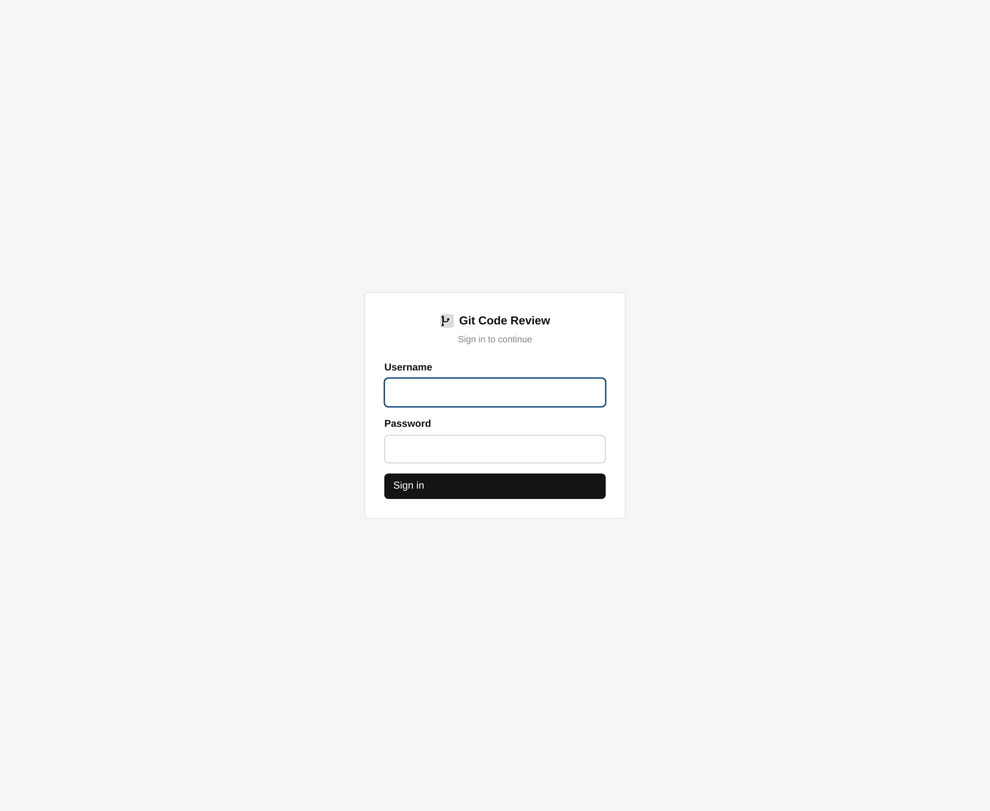
The sign-in page: username and password, then a one-time code.
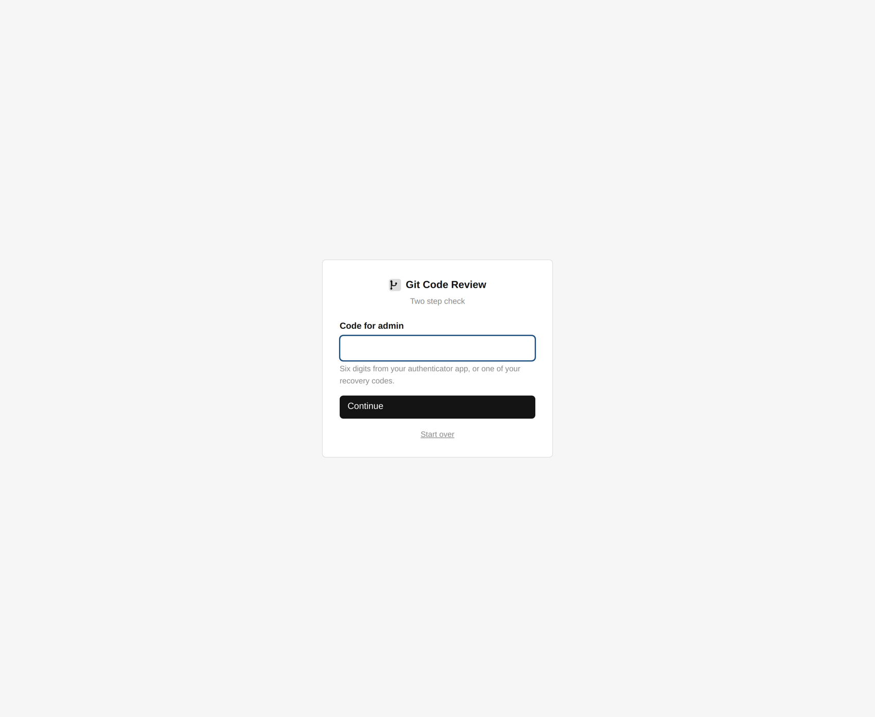
The second step asks for the six-digit code from your authenticator.
The sign in page. Local accounts and single sign on can both be on at once.

Changing the password
The first thing the product does with the account it just created for you is refuse to let you go anywhere until you have changed its password and set up a second factor. This is not configurable, on purpose: an administrator account on a system that knows where every credential in the organization has leaked is worth attacking.

Setting up your authenticator
Scan the code with whatever authenticator application you already use, and type the six digits back to prove it worked. Nothing about this is unusual. If the code will not scan, the secret is shown as text below it.

Your recovery codes
You are given a set of one use codes. Each one signs you in once, in place of the six digits, and then stops working.
Where not to put them
Not on the laptop you just set the authenticator up on, because losing that device is the exact situation the codes exist for. A password manager on a different device, or paper in a drawer somebody else can get to, are both better than the obvious answer.

Before you invite anybody else
Two things are worth doing while you are the only account.
1. Add your connections and run one scan, so that the first thing anybody else sees is real data rather than an empty screen.
2. Decide who gets which role. A reader can read and nothing else. A developer sees only the organizations and repositories assigned to them and can ask for an exception. An administrator can approve one, change severities, and read the audit log. New accounts should be readers until somebody decides otherwise.

7. A tour of the screens
Twenty pages, in three groups, and the six you will actually use.
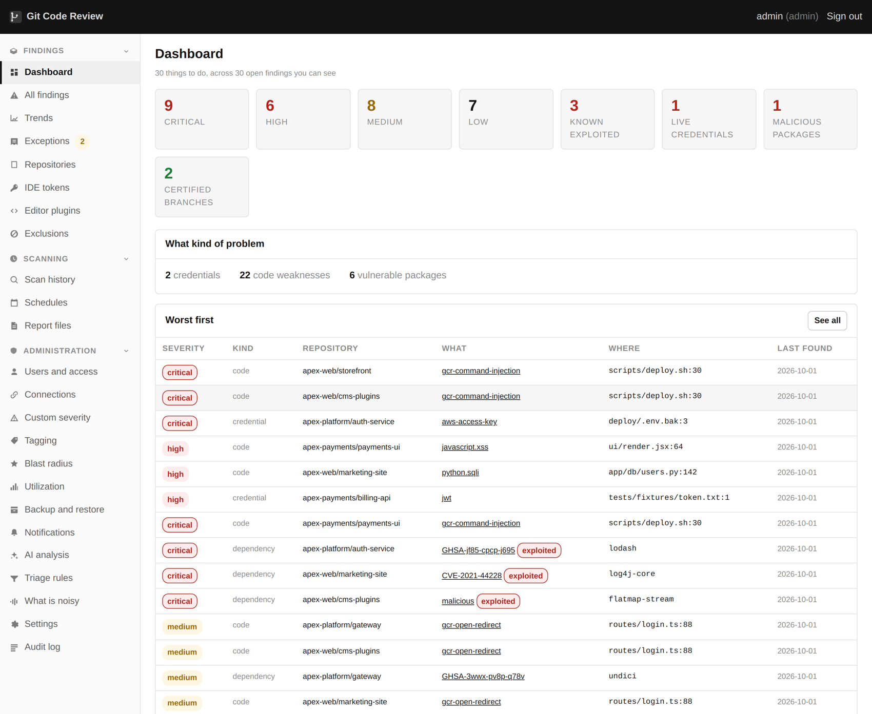
The dashboard: the counts that matter, worst findings first, and recent scans.

The shape of it
Everything is behind one navigation list down the left, in three groups. Findings is what you look at. Scanning is what produces it. Administration is what you set up once and then mostly leave alone.
Group | Page | What it is for
Findings | Dashboard | The estate at a glance, and what arrived since last time
Findings | All findings | The one list, filtered however you like
Findings | Exceptions | Decisions somebody signed, and requests waiting for approval
Findings | Repositories | What was scanned, when, and what came back
Findings | IDE tokens | Tokens for the editor API
Findings | Exclusions | Rules that set aside whatever matches them
Scanning | Scan history | Every run, what it covered, and what happened
Scanning | Schedules | When scans run, per organization
Scanning | Report files | Everything the scanner writes, ready to download
Administration | Users and access | Accounts, roles, scopes and view as
Administration | Connections | Where your code lives and how to read it
Administration | Custom severity | Grades as your organization means them
Administration | Tagging | What each repository is and what it holds
Administration | Blast radius | Who can reach what
Administration | Backup and restore | The database and the settings
Administration | Notifications | Slack, Teams, mail and webhooks
Administration | Triage rules | What counts as an example rather than a credential
Administration | Settings | Engines, thresholds, retention and limits
Administration | Audit log | Every decision anybody made

The dashboard
The dashboard. The counts are of findings nobody has set aside.
Three things are worth knowing about the numbers here. They count only findings nobody has set aside, so the number falls when work is done rather than when somebody changes a filter. They are across every connection at once. And the "new since the last scan" figure is the one to watch day to day, because the standing backlog is a project and the new arrivals are a habit.

The findings list
One list across every connection, organization and repository.
This is where the work happens. Every column filters, and the filters are in the web address, so a view can be sent to somebody else and it will be the same view when they open it. That sounds small and it is the difference between "have a look at the findings" and "have a look at these eleven".
The default order is not by severity. It is by what is worth doing first, which is not the same thing: a credential the issuing provider has just confirmed still works outranks a critical in a package nothing calls.

One finding
A credential finding, with everything about it on one page.
Clicking a finding opens everything known about it: the evidence, the reasoning behind every judgement the product made, the context of the repository it is in, and every decision available to you. There is no second click to find out why something was graded the way it was.

What you will actually use
Of the twenty pages, most people live in six: the dashboard, the findings list, one finding, exceptions, exclusions and triage rules. The rest are set up once. If you are short of time, learn those six well and come back to the others when you need them.

8. Connections
Ten kinds of host, one page, and the traps each one has.
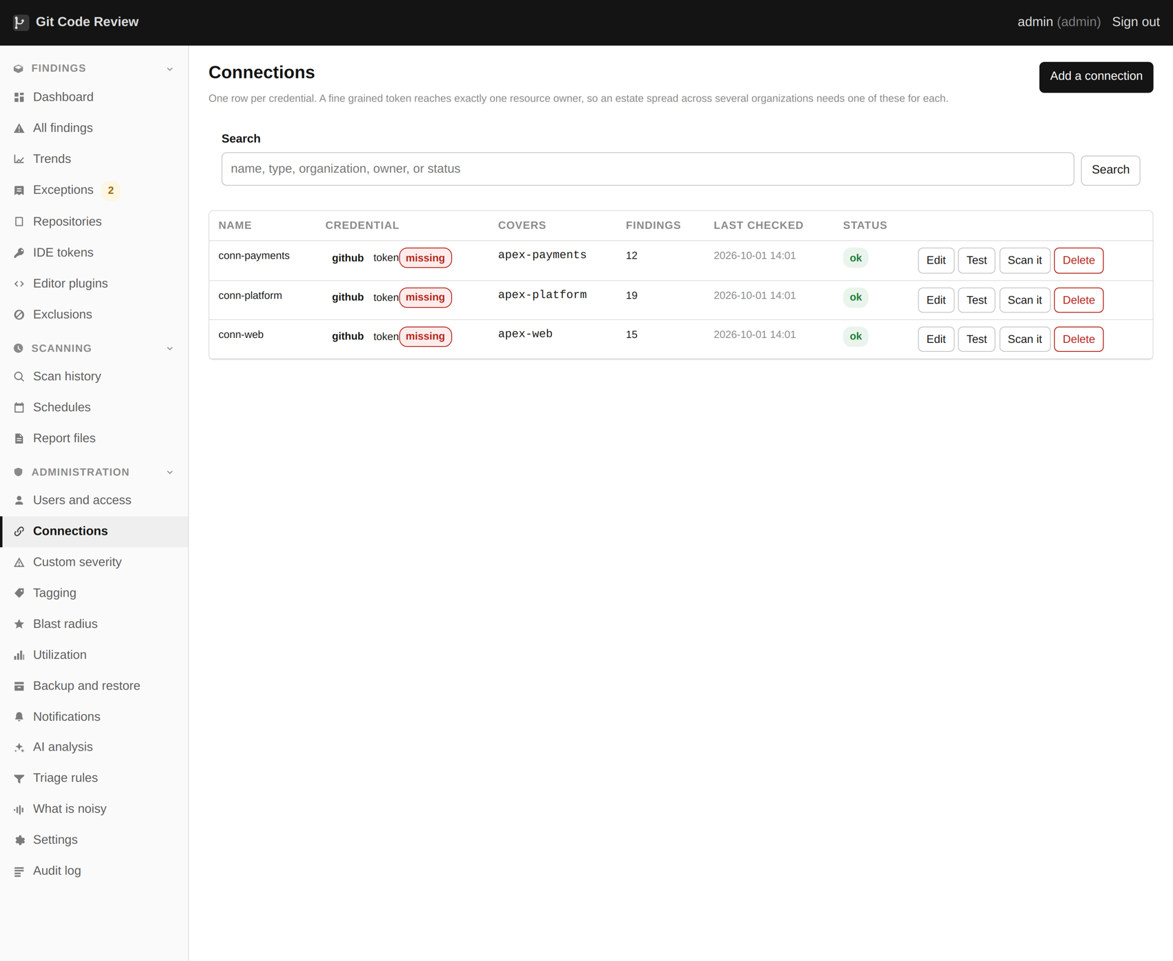
The Connections page, one row per account the scanner reaches.
Connections. Each carries its own credential, scope and labels.

What a connection is made of
Field | What it is
Name | What you call it. It appears on every scan event and every finding.
Provider | Which of the ten kinds of host this is
Address | The host, for anything self hosted. Left alone for the cloud ones.
Credential | Encrypted at rest, decrypted only in memory when a scan needs it
Scope | Which organizations, groups or projects inside the host to cover
Sensitivity | What the systems behind this connection hold, by default

The sensitivity labels on a connection are inherited by every repository under it unless that repository says otherwise. Setting them here is fifteen minutes that improves the ranking of every finding the connection ever produces.

GitHub
The most complete of the ten, because it is the one everything was built against first. A classic personal access token with repo and read:org is enough to start. Adding security_events folds in the host's own Dependabot, code scanning and secret scanning alerts alongside what the engines found.
The single sign on trap
If a token is authorized for some organizations under single sign on and not others, GitHub does not return an error. It returns a success with the unauthorized organization's repositories quietly missing, and marks the response with a header. The scanner watches for that header, warns loudly and records it in the report, because a truncated scan otherwise looks exactly like a clean one.
Fine grained tokens have a second trap. A fine grained token belongs to a resource owner, and one token can only cover repositories under one owner. On an estate with twenty six organizations that means twenty six tokens, which is the main reason connections exist as a first class thing in this product rather than there being one global credential.

GitLab
Self managed or gitlab.com. A project or group access token with read_api and read_repository. Groups nest, and the scope field takes the top group, so one entry covers everything under it.

Bitbucket
Cloud or Data Center. An app password on cloud, an HTTP access token on Data Center. Repository read and account read are the two permissions needed.

Azure Repos
A personal access token with Code read. The organization and project both go in the scope, because Azure nests one inside the other and a token is usually scoped to one organization.

AWS CodeCommit
Needs the AWS command line tools present, because cloning uses the credential helper they provide rather than a token in a URL. The connection refuses by name if they are missing rather than reporting an empty estate, which is the failure that wastes an afternoon.
Closed to new customers
AWS closed CodeCommit to new accounts in 2024. This is here for organizations that already have repositories in it, which is a real and reasonably large group, not for anybody starting today.

Google Cloud Source Repositories
Needs the gcloud tools present for the same reason. Also closed to new customers in 2024.

Assembla and Beanstalk
Both are token and address, both host git, and both work like the others. They are here because estates that grew by acquisition turn up in surprising places, and a scanner that covers eight of your nine hosts is a scanner nobody trusts the numbers from.

Subversion and Perforce
Neither is git. There is no commit graph to walk, so the credential history pass, which is where most leaked keys are found, does not apply. What does work is everything that reads files: the code analysis, the dependency tree, the licenses, the infrastructure files and the triage.
The connection form says this before you set one up rather than after. A tool that silently does half the job on a quarter of your estate is worse than one that says so.

Checking a connection before you trust it
Every connection has a Test button, which does three things: proves the credential works, reports which permissions it actually has rather than which you asked for, and lists the first few repositories it can see. If that list is shorter than you expected, stop and work out why before scheduling anything.

9. Your first scan
Start with one organization, watch it, and read the warnings.
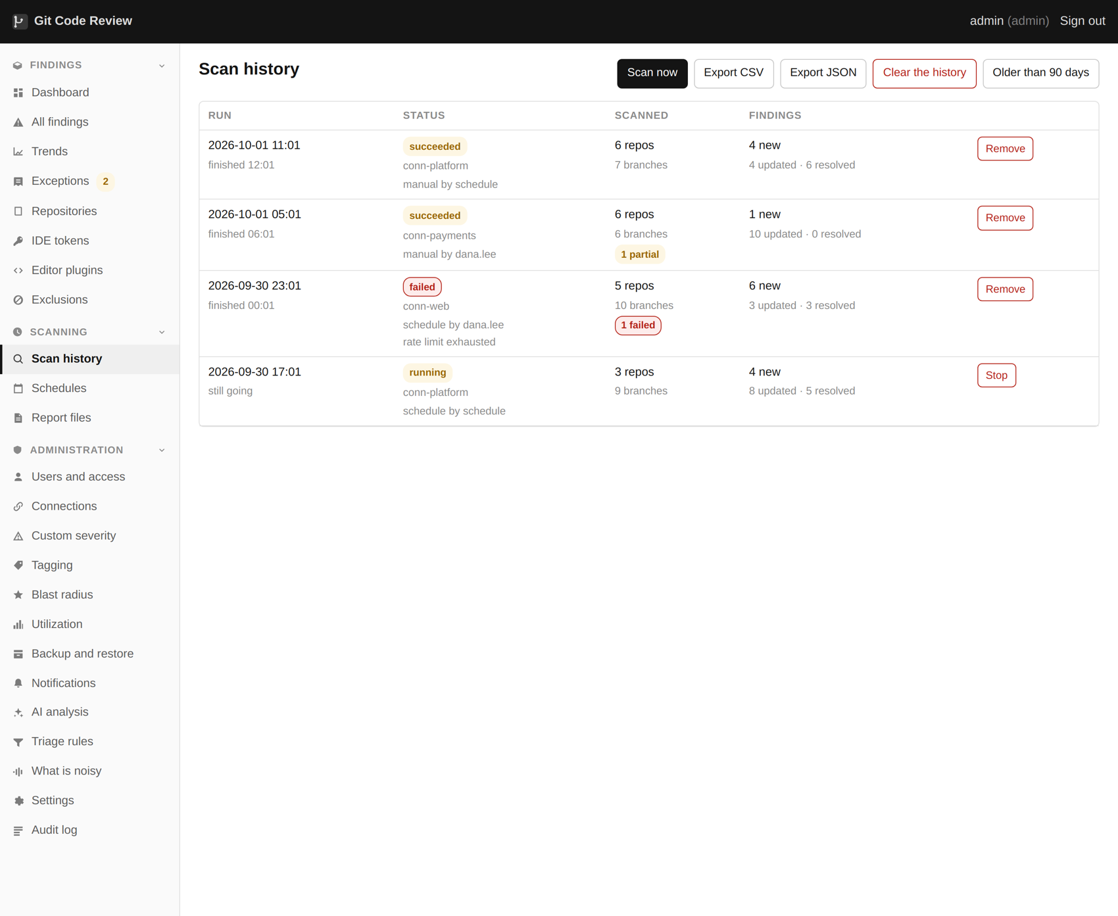
Scan history, with status, counts and what each run covered.

Start small
The temptation is to point it at everything and go home. Do not. The first scan of one organization tells you more about how long your estate takes to read than any estimate will, and it does it in twenty minutes rather than six hours.
1. Open Scan history and press New scan.
2. Choose one connection and one organization inside it.
3. Leave the engine selection alone. The defaults are the defaults because they are right for nearly everybody.
4. Start it, and stay on the page.

What you are watching
Scan history. Every run, what it covered, and what happened.
The log streams as it goes. What is worth reading, rather than watching scroll:
- The repository count it resolved at the start. If that is lower than you expected, the credential cannot see everything and the rest of the run is measuring the wrong estate.
- Any warning about truncated results, which means exactly that.
- Any warning about temporary files going to disk, which means the machine does not have enough shared memory and the cleartext of found credentials is being written down.
- Any engine that reported as missing. An engine that is absent finds nothing and exits successfully, which looks identical to an engine that found nothing.
Repositories in scope: what was scanned, when, and what came back.

How long it takes
It is dominated by cloning, so it depends on your estate and your network rather than on the machine. A rough shape: a few dozen small repositories is minutes. A hundred, some of them large with long histories, is under an hour. Four hundred across several hosts is a couple of hours, which is why it belongs on a schedule overnight.
Repositories are read several at a time, and how many is a setting. More is not always faster, because the limiting factor is usually the host's rate limit rather than your cores.

If it is interrupted
It keeps what it already finished. Repositories the scan had read are ingested and their findings appear; repositories it never reached are left exactly as they were, and nothing in them is counted as fixed. The run is marked interrupted rather than finished, so the history does not claim a clean result it did not get.
Check before you restart the container
A scan ninety minutes in represents ninety minutes of cloning and reading. The Scan history page tells you whether one is running. This is worth a habit, because a deploy during a scan is the single most common way to lose an evening of work.

10. Reading the first results
The number will be enormous. Here is the order to look at it in.
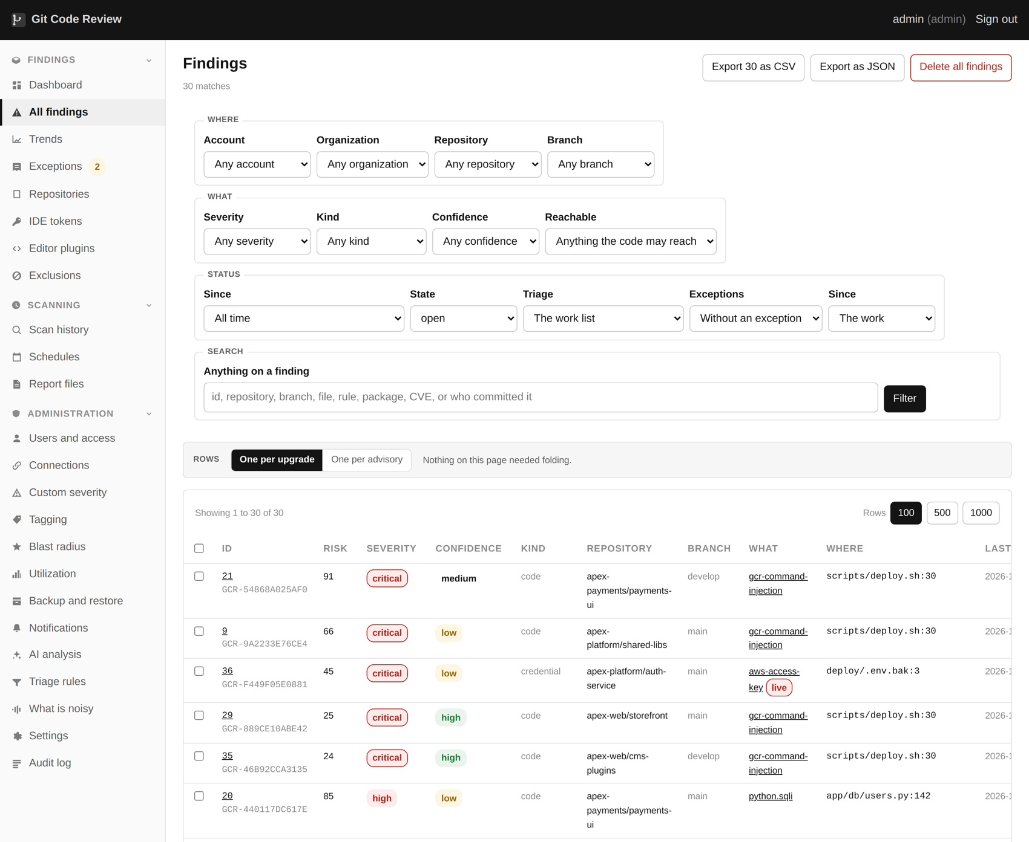
The findings list, filtered and sorted, with severity and kind.
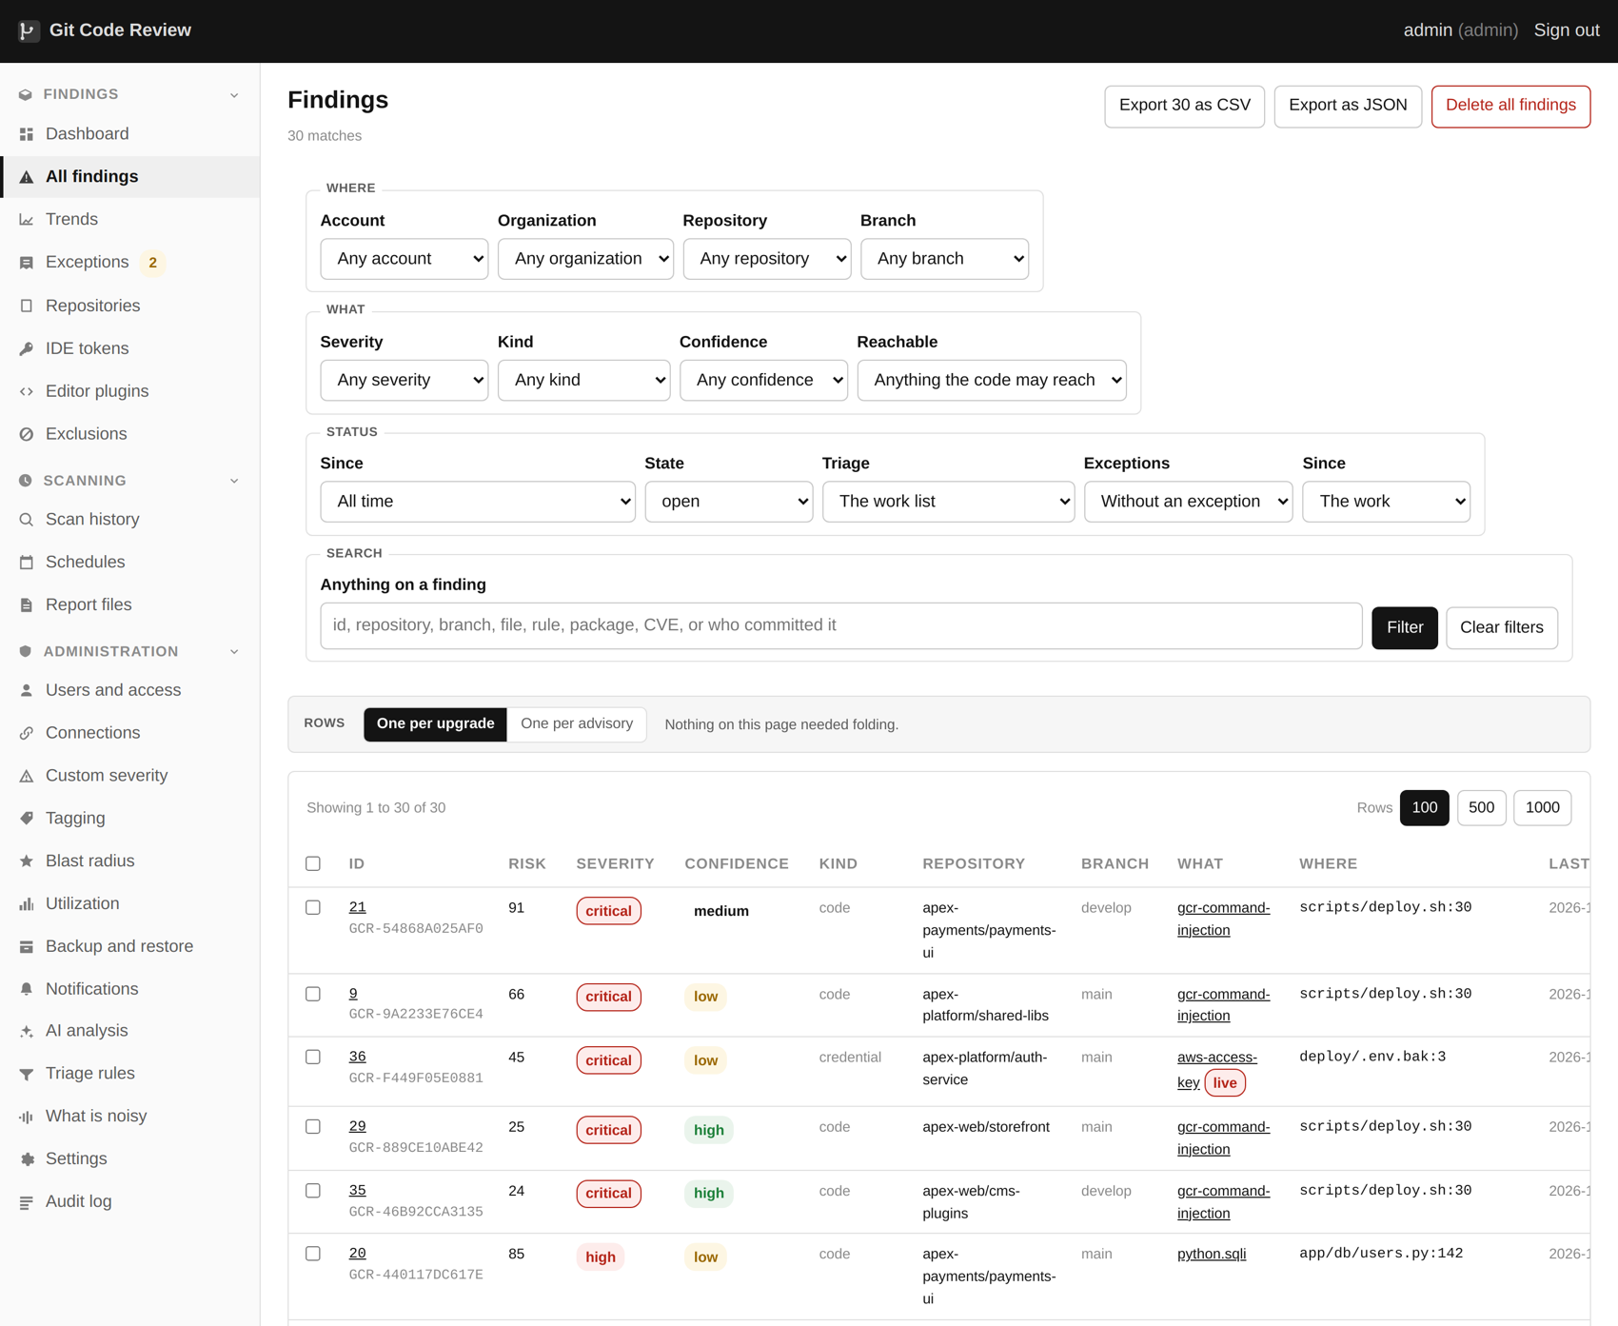
The same list narrowed to open critical and high findings.

Do not start at the top of the list
The list is already ranked, and the ranking is good, but the first thing to do with a first scan is not to work down it. It is to answer four questions in order, each of which takes about a minute and each of which changes what the list even means.

One: is anything live?
Filter to verified credentials. These are keys where the issuing provider itself was asked and said the key still works. There are usually very few, often single figures across a whole estate, and they are the only findings on the list that somebody could be using right now.
Deal with these today. Not this sprint, today. Everything else on the list can wait a week without the situation getting worse; these cannot.

Two: is anything being exploited?
Filtered to critical. Every column filters, and the filter is in the address.
Filter to findings on the published list of vulnerabilities being exploited in the wild. A medium that people are actively using outranks a critical that nobody has ever used, and this filter is the fastest way to see the difference.

Three: how much of this is historic?
Look at the first seen dates. If nearly everything predates the last year, you are looking at a backlog rather than a flow, and a backlog is a project with a plan rather than a list to work through. That is what baselines are for, and chapter 28 covers them.

Four: what is the shape of the noise?
Group the findings by rule and look at the top ten. On almost every estate those ten produce close to half of everything, and they are usually a small number of rules reporting a pattern rather than a defect. Deciding once what each of those ten is worth is the highest value hour available to you, and chapter 29 is entirely about it.
The most common mistake
Working the list from the top, one finding at a time, from day one. It feels like progress and it produces a long tail of exceptions with no reason written on them, a list nobody trusts, and a tool that gets switched off in the second month. Tune first, then work.

11. Credentials in code
Three engines, every branch, the whole history, and why the value never gets stored.
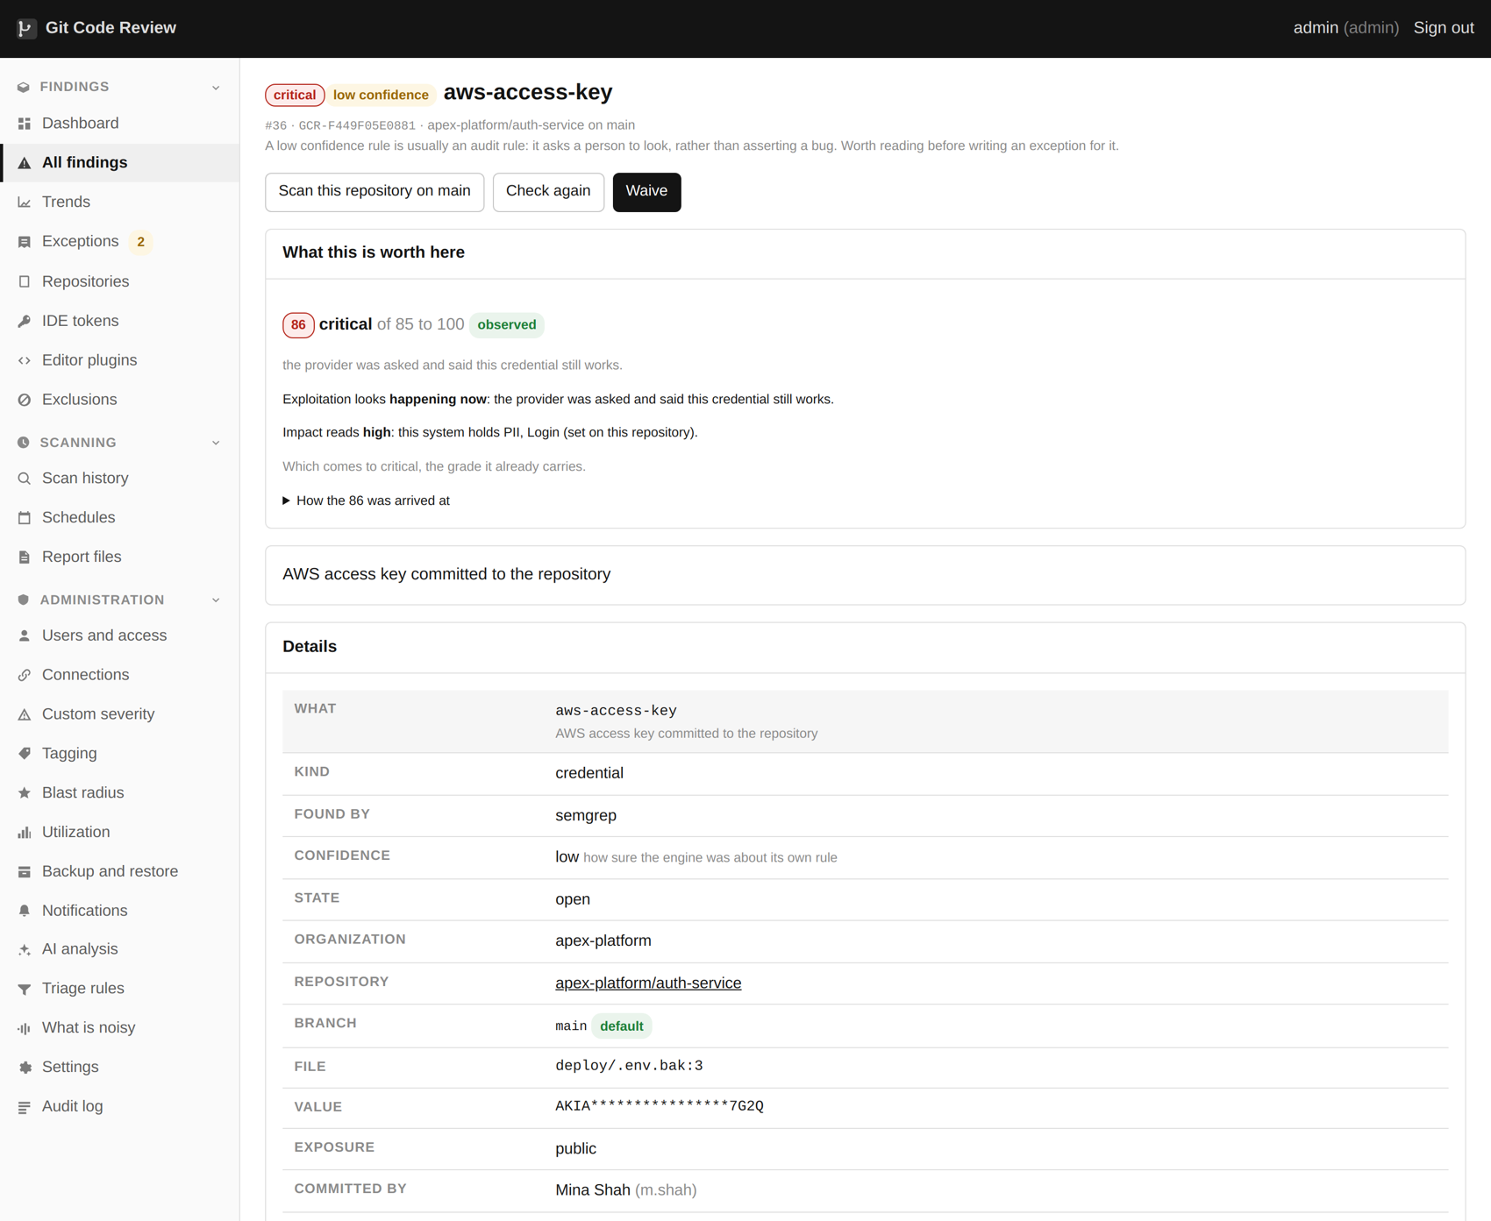
A credential finding, with the masked preview and whether it is live.

What it looks for
Anything that would let somebody act as you: API keys, cloud access keys, database connection strings with the password in them, private keys, tokens, webhook URLs that carry their own authentication, and plain usernames and passwords assigned in code.
Three engines look, and they deliberately disagree. gitleaks is fast and pattern based. TruffleHog is slower, finds different things, and can ask the issuing provider whether a key still works. The host's own secret scanning alerts are folded in where the host has them. When two engines find the same value it becomes one finding with both named, and that agreement raises its confidence.
A set of extra rules covers the material the upstream rulesets are thin on. The public rulesets are excellent at recognising a Stripe key or an AWS access key, because those have a distinctive shape. They are much weaker on a password in a connection string, an HTTP basic authentication header, or a variable called password with a string next to it, and on a real estate those are extremely common.

Every branch, and the history behind them
The default is every branch head and the full commit history behind them, which is the only setting that makes sense. A credential deleted from a file last March is still in the commit that added it, and anybody who can clone the repository can read it with one command. That is where the majority of what a first scan finds actually lives.
A finding says which branches it is live in and whether it exists only in history. Those need different responses. A key on the default branch is a key somebody is probably still using. A key that exists only in a commit from 2019 is a key to rotate and a history to have a conversation about, and the conversation is harder than the rotation.

What gets stored, and what does not
This is the most important paragraph in this chapter. The cleartext of a found credential exists only inside the running scan. Before anything is written down it becomes two things: a SHA-256 fingerprint of the value, and a mask showing the first four characters and the last three.
The fingerprint is what lets the product say "this is the same key as the one in that other repository", because the same value hashes the same way. The mask is what lets a person recognize it. Neither can be turned back into the key.
The consequence is worth being clear about: this product cannot show you a secret it found, to anybody, including somebody who owns the database. If you need the value, it is in the file at the line the finding names, in your own repository, which is where it always was.
What | Stored? | Why
The credential value | No | It exists in memory during the scan and nowhere else
A SHA-256 fingerprint | Yes | So the same key found twice is recognized as one thing
A mask, first four and last three | Yes | So a person can recognize which key it is
The file, line and branches | Yes | So somebody can go and look
The commit that introduced it | Yes | So the age of the exposure is known
A private key body | No, named instead | Masking a key body gives you nothing; the key type is useful

Telling a credential from an example
Raw output from three secret engines across a real estate is thousands of findings, and most of them are examples: documentation, test fixtures, the string "password" in a sample configuration file, a JWT from the official specification. Everything between the engine and the screen is the part that makes the list usable, and all of it is editable from a page in the product.
- Entropy. A real key is high entropy; the word "changeme" is not.
- Length and character diversity, which catch a surprising number of placeholders on their own.
- Patterns matched against the value: obvious placeholder forms, the well known example keys from provider documentation, strings that are clearly a template variable.
- Patterns matched against the path: documentation directories, test fixtures, vendored code, lock files.
- Live verification, where the provider offers it, which turns the whole question into a fact.

What this does not do
It reads. It cannot revoke a key and it will never try, because revoking is a write into somebody else's account and getting it wrong takes a production service down at an unpredictable moment. The finding tells you which key it is, where it is, whether it still works and who can reach it. Pressing the button is yours.
It also cannot tell you whether a key has been used by somebody who should not have it. That answer is in the provider's own access logs, and the finding page links to where to look for each provider it knows about.

12. Live verification
Not "this looks like a key", but "we asked, and it still works".
Live verification is shown on the finding itself.

What it does
When a candidate credential matches a provider the product recognizes, it is sent to that provider's own token introspection or identity endpoint, and the answer is recorded. AWS, Slack, Stripe, GitHub, Google, SendGrid, Twilio and a long list of others publish a way to ask exactly this question, because it is the same question their own client libraries ask at start up.
A verified finding outranks everything else on the list, whatever its severity would otherwise be. There is no argument to have about a key the issuer has just confirmed is live.

What it changes
On one corpus of two thousand two hundred credential findings, nine came back verified. That is not an argument that the other two thousand one hundred and ninety one are fake. Verification only works where the issuer offers a check, and most of the estate is keys for services that do not. It is an argument about where to start.
It also changes the conversation with the team who own the repository. "Your scanner thinks this might be a secret" starts an argument. "This key works, we asked Stripe" does not.

Turning it off
Verification is an outbound call to a third party carrying a candidate secret. Some environments will not allow that, and some will not allow it for particular providers. One flag disables it for the whole run, and everything else still works.
ghscan scan --no-verify
In the web interface it is a setting, and it is on by default because on almost every estate it is the single most useful signal available.

What this does not do
It only covers providers that publish a way to check. A verified finding is a fact; an unverified one is not evidence of anything in either direction, and the product does not treat it as such. A key for an internal service will never verify and may well be the most dangerous thing on the list.

13. Weaknesses in code
semgrep across thirteen rule packs, a second engine where a second engine sees more, and a pass that reads findings back in context.
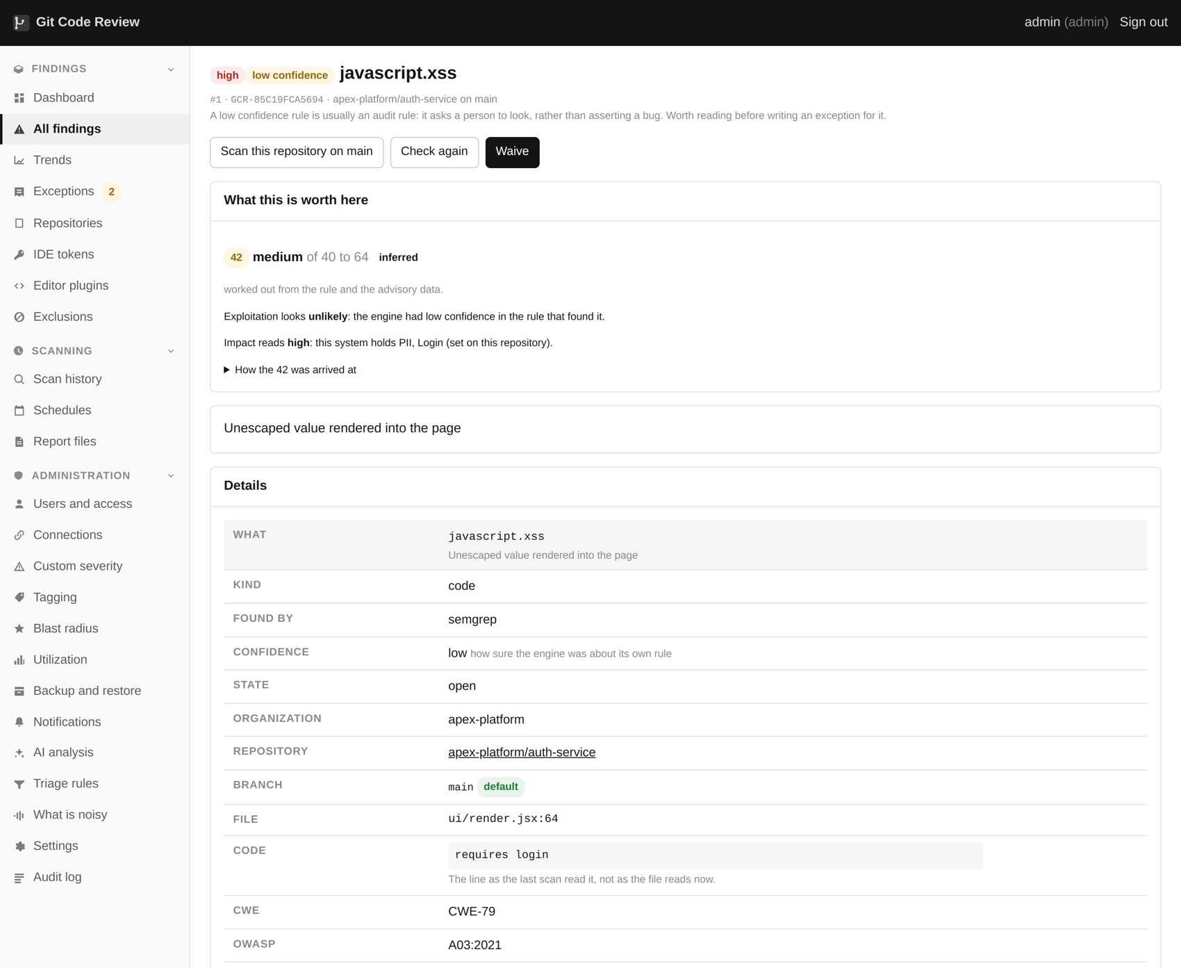
A code weakness, with the rule, the file and the line.

The engines
semgrep runs with the default, OWASP top ten, secrets, language specific and injection rule packs, on whichever languages are actually present in the checkout. It is fast, it is well maintained, and its free rules are genuinely good.
gosec is added for Go and bandit for Python. These are not there to find more of the same things; they are there because they work differently. gosec analyzes a whole package at once rather than a file at a time, which means it can follow a tainted value across a function boundary that semgrep cannot see past. Where two engines report the same line, the finding says so and its confidence rises. Where only the deeper engine saw it, the finding says that too.
An engine that is missing finds nothing, successfully
gosec needs a Go toolchain present to analyze Go. Without one it exits cleanly having found nothing at all, which looks exactly like a clean result. The scanner refuses rather than reporting that, because a silent zero is the worst possible output from a security tool.

The fidelity pass
Code findings are read back in their own context before anybody sees them. This is not a second engine; it is a set of checks that ask whether the thing the rule matched can actually be what the rule says it is.
- A value cast to an integer before it is printed cannot carry markup, so it is not a cross site scripting hole however it reaches the page.
- A header set earlier in the same function changes what a later call does.
- An input drawn from a fixed list of allowed values is not user input.
- A file path built from a constant is not path traversal.
Each verdict carries the sentence that justifies it, shown on the finding. That matters more than the verdict itself, because a person can disagree with a sentence. A bare "probably fine" is something you either trust completely or ignore completely, and neither is useful.

Rules that report a pattern
A large number of rules exist to say "somebody should look at this" rather than "this is a bug". Audit grade rules, in the vocabulary of the engines. They are worth having and they should not be graded the same way as a rule that found an actual injection.
These are marked as such, and can be set aside as a group rather than one exception at a time. On the corpus used for this guide, one hundred and ninety six of three hundred and fourteen high or critical code findings, sixty two per cent, came from rules the engine itself marks as low confidence.

What this does not do
Free semgrep reads one file at a time. A tainted value that crosses a function boundary into another file is invisible to it, and no amount of rule tuning changes that. gosec closes this for Go and bandit helps for Python. For Java, PHP and Ruby it is open, and it is the clearest single gap in the product against what a commercial tool will do.

14. Vulnerable dependencies
A real bill of materials first, then vulnerabilities against it, then the data that makes the ranking mean anything.
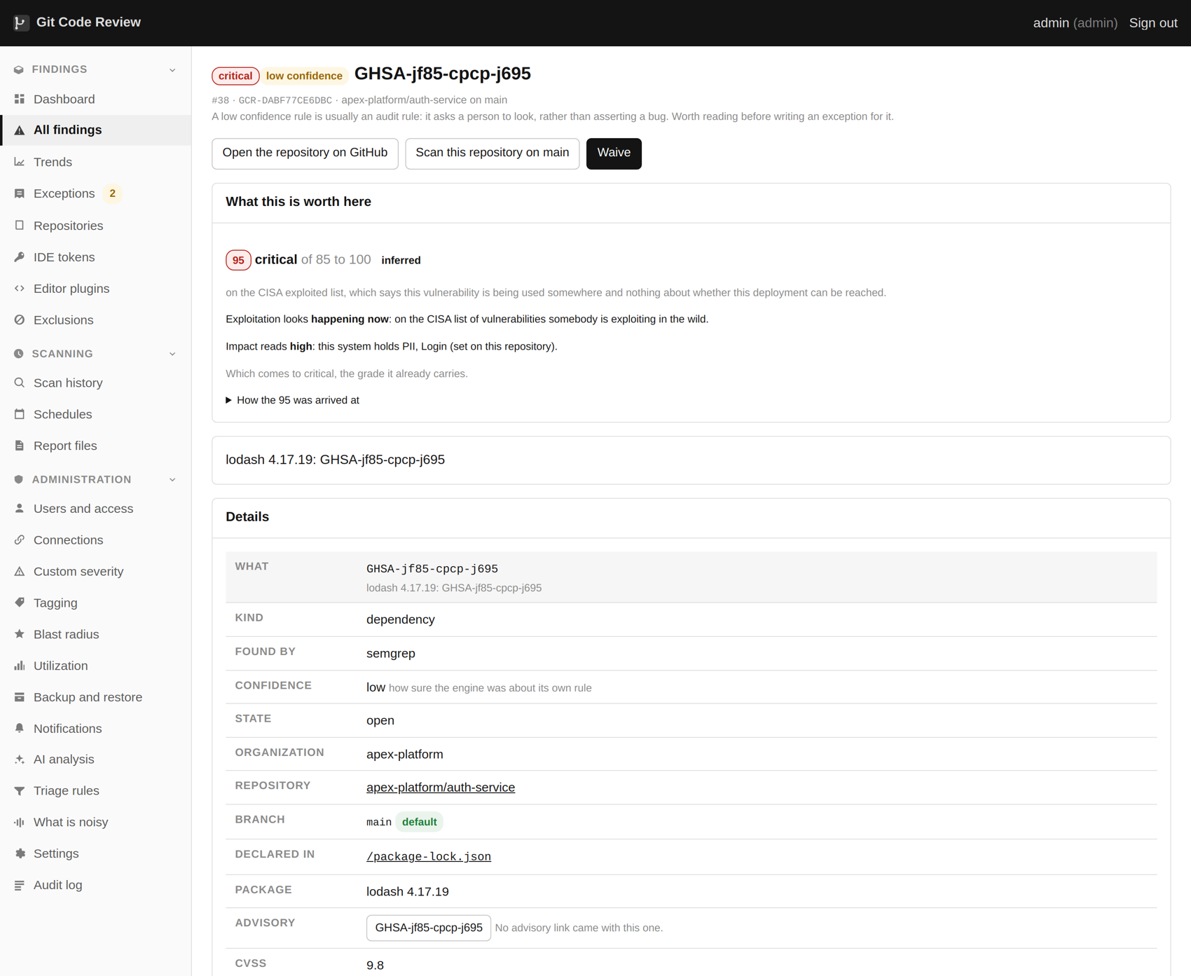
A dependency finding: the advisory, the fix, and the scores.

The bill of materials comes first
syft builds a bill of materials from what is actually in the checkout, rather than from what a manifest file claims. That distinction does real work: a lock file that disagrees with its manifest, a vendored directory nobody remembers, a jar checked in years ago. All of it is in the tree and all of it ships.
grype and osv-scanner then run against that bill of materials. Two of them, again because they disagree: they draw on overlapping but different databases, and the union is better than either.

Ranking that survives contact with reality
A list of vulnerabilities sorted by severity is close to useless on a real estate, because there are hundreds of criticals and nobody is going to do hundreds of things. Two pieces of public data change the picture completely, and both are on every finding.
Signal | What it means | Why it matters
On the exploited list | A published record that this is being used in attacks now | It moves a finding to the top regardless of its severity. Somebody is doing this today.
EPSS score | The published probability of exploitation in the next thirty days | Separates the criticals nobody will ever use from the handful that will be used.
Reachability | Whether your code can call the vulnerable package at all | Removes most of the list, with a reason on each one. See the next chapter.
Fix available | Whether there is a version to move to | A vulnerability with no fix is a different conversation from one with a patch release.

A medium on the exploited list matters more than a critical nobody has ever used. That sentence is the whole argument for putting this data on the finding rather than leaving it to a person to look up.

Container base images
Every Dockerfile in the checkout is read for the image it starts from, and each distinct image is pulled and read. On most applications the operating system layer is where the critical count actually lives, and it is the part nobody looks at. Chapter 20 covers this.

What this does not do
The vulnerability data is public: OSV, the GitHub advisory database and the national vulnerability database. Commercial products curate their own, employ people to write advisories, and are frequently earlier than the public feeds by days or weeks. That is a real difference and it is the main thing a license actually buys.

15. Reachability
Most vulnerable packages sit in code your application never calls. This says which, and says why on every one.
Reachability is shown on the dependency finding.

Three questions rather than a call graph
A full call graph is the right long term answer and the wrong first step. It is a large piece of work per language, it is slow, and it is wrong in ways that are hard to explain. Three much simpler questions get most of the way, and all three are facts about the dependency tree rather than inferences.
1. Is this package asked for directly, or is it eleven levels down inside something else?
2. Is it a development dependency that never ships, or is it in the running application?
3. Is the vulnerable module imported anywhere in the source at all?
Each verdict is one of three words. Reachable means the answers point at your code being able to call it. Unlikely means they point away. Unknown means it could not tell.
Dependencies the application never calls, each with a sentence saying why.

What it does to a list
On the corpus used for this guide, three hundred and sixty one dependency findings came back with two hundred and seventy eight marked as not reached. Each of those carries a sentence: a development dependency that does not ship, or nothing in the source imports it. The remaining eighty three are a list somebody can work through in an afternoon.
That is not the same as saying the two hundred and seventy eight do not matter. It says they do not matter today, in this application, for this reason, and here is the reason so you can disagree with it.

When it is unsure, it keeps the finding
Where it cannot tell, the verdict is unknown and the finding keeps its place in the list. The rule is deliberately asymmetric, because the two mistakes are not equal: a wrong "unlikely" is somebody not looking at the one that mattered, and a wrong "unknown" is somebody spending ten minutes on something that turned out to be fine.

The awkward cases it handles
- Scoped npm packages, where the package name and the import name are different.
- Python packages whose distribution name is not their module name, which is extremely common: PyYAML imports as yaml, Pillow imports as PIL, and there is a table of them.
- Go module paths, where a package is imported by a prefix of its module path.
- Indirect dependencies marked as such in a Go module file.
- Monorepos, where one repository holds several applications with different trees.

What this does not do
It is a heuristic and it says so on every finding. A commercial product with a call graph can tell you that the vulnerable function specifically is reached, which is a stronger claim than this makes and worth having. What this gives you is the same shape of answer for nothing, with the reasoning visible.

16. Malicious packages
A typosquat has no CVE. Neither does a compromised release, until well after it has run.
A malicious package is called out on the dashboard and never softened.

A different kind of problem
Everything in the previous two chapters is about a package that has a hole in it. This chapter is about a package that is the attack: published under a name one character away from something popular, or a real package whose maintainer account was taken over and a poisoned version released.
These do not have vulnerability identifiers, at least not until somebody has noticed, which is usually after they have been installed by a few thousand people. And they do not need your code to call them, because most of them run at install time.
Packages that are the attack, rather than packages with a hole.

The published feed
OpenSSF maintains a database of packages known to be malicious and publishes it into OSV, so those advisories arrive alongside everything else. The product recognizes them for what they are and presents them differently, because "this package is malware" and "this package has a bug" deserve different words.

What only the checkout can tell you
The published feed is always behind, so four signals are checked directly against your own dependency files.
Signal | What it means
An install hook that fetches and runs something | The most common way these execute at all. A package that curls a script during install is either malicious or badly behaved, and both are worth knowing.
A dependency that is not from a registry | A git URL or a tarball rather than a package name. Sometimes legitimate, always worth a look, and the usual shape of a dependency confusion attack.
A version that floats | A specifier with no upper bound takes whatever was published most recently, which means the next install could take a version published by somebody who just took over the account.
A name one edit away from a popular one | Checked by edit distance against the well known package names for each ecosystem.

Never softened
A malicious package is never recommended for a lower grade, whatever else is true about it. Reachability does not apply: it runs when it is installed, so "nothing calls it" is not a mitigation. This is enforced in the code, with a test, because it is exactly the kind of rule that a later change to the ranking logic would quietly break.

What this does not do
The four offline signals are suspicions and are graded as suspicions. There are products that do nothing but this, watch every publish on every registry in real time, and do it considerably better. If malicious packages are your main worry rather than one worry among several, look at those as well as this.

17. Infrastructure as code
The servers, buckets and clusters that are described in files.
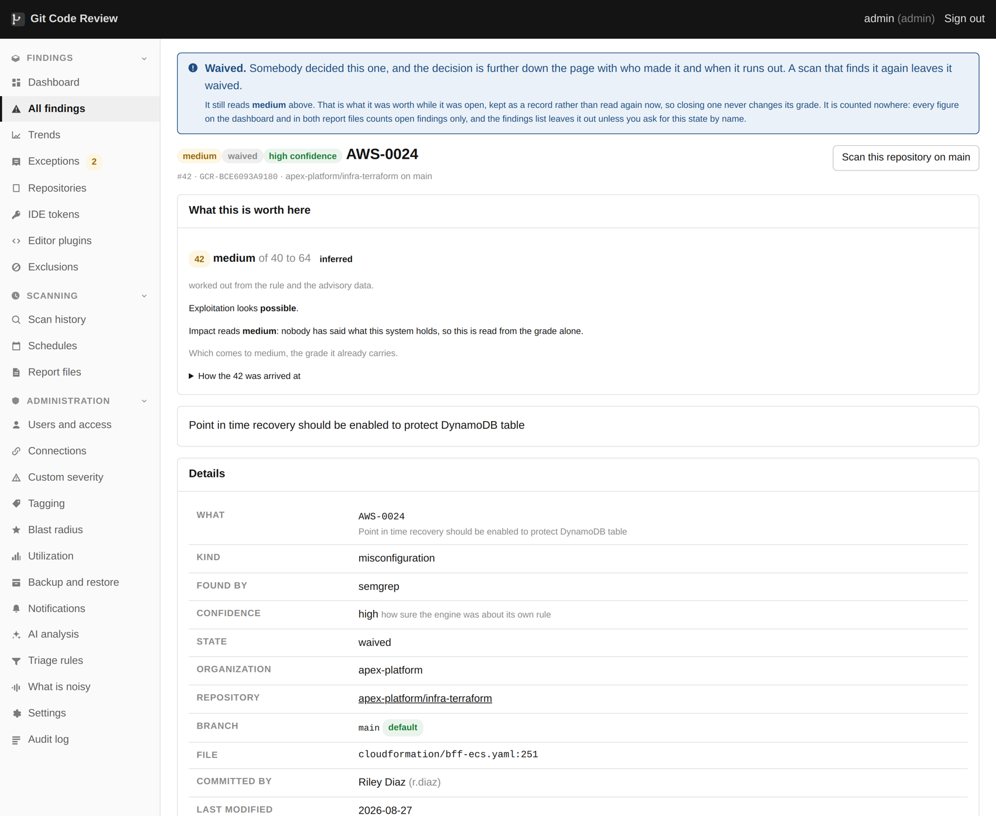
An infrastructure-as-code finding from the deployment templates.

What it reads
trivy runs over Terraform, CloudFormation, Kubernetes manifests, Helm charts and Dockerfiles. A storage bucket left open in a Terraform file is an open bucket in production, and it is very much cheaper to find in the file than in the news.
This is one of the highest yield parts of a first scan and one of the least contentious, because an infrastructure finding is usually unambiguous. A security group open to the whole internet is not a matter of opinion.

The most common findings
- Storage open to the public, or with no encryption configured.
- Security groups and firewall rules allowing the whole internet to a management port.
- Containers running as root, or with a writable root filesystem, or privileged.
- Secrets in environment variables in a manifest, which is also picked up by the credential engines from the other direction.
- No resource limits, which is a denial of service against yourself.
- Logging or audit trails switched off.

What this does not do
It reads the files. It has no idea what is actually running in your cloud account, so a resource created by hand three years ago and never described in any file is invisible to it. Cloud posture products do exactly that and this is not one.

18. The build pipeline
The least examined system in most organizations, and the one that holds every credential.
Pipeline findings read like code findings, tied to a workflow file.

Why the pipeline
Think about what a build pipeline can do. It can read every repository it builds. It holds the credentials to publish packages, push images and deploy to production. It runs arbitrary code from a file inside the repository, on a machine inside your network. And almost nobody reviews changes to it with anything like the care they review application code.
zizmor reads GitHub Actions workflows for exactly the things that make a pipeline a target.

What it finds
Finding | Why it matters
An action pinned to a mutable tag | The tag can be moved. Whoever owns that action can change what runs in your pipeline, retroactively, without you doing anything.
A workflow that checks out and runs pull request code | The dangerous variant runs code from a fork with access to your secrets. This is how several well known compromises worked.
A step with more permission than it needs | A workflow with write permission it does not use is a workflow that can be turned into something that does use it.
A secret passed where it need not be | Every step that can see a secret is a step that can leak it.
Untrusted input in a run block | A branch name or an issue title placed straight into a shell command is a shell injection with extra steps.

On the corpus used for this guide, mutable action tags alone accounted for two hundred and seventy one findings out of one thousand two hundred and ninety one, twenty one per cent of everything found. That is a single fix applied many times rather than two hundred and seventy one problems, which is exactly the sort of thing chapter 29 is about.

What this does not do
Only GitHub Actions today. Jenkins, GitLab CI, Azure Pipelines, CircleCI and the rest are not read, and they have the same problems. It is on the roadmap and it is honest to say that if your pipeline is Jenkins, this chapter does not apply to you yet.

19. Container images
A container starts from a frozen copy of an operating system. Somebody has to look at it.
A package from a base image, with the Dockerfile that asks for it.

What it does
Every Dockerfile in the checkout is read for the image it starts from. Build arguments with defaults are resolved, stage aliases and scratch are skipped, and a reference still carrying an unresolved variable is left alone rather than guessed at. Each distinct image is then pulled from its registry and read directly, with nothing built and no daemon involved.

Why this is worth the download
A base image is a frozen copy of an operating system and everything installed in it. Pin one in 2021 and you are shipping 2021's known holes today, every time, in every container built from it. It is extremely common, it is invisible in the application's own dependency list, and one line changes it.
On most applications, the operating system layer holds more critical vulnerabilities than everything the application itself depends on put together.

It is off by default
Because it downloads images, which costs bandwidth and time and may not be allowed from the machine the scanner runs on. Six images per repository is the cap, which covers almost everything and stops a repository with forty Dockerfiles from dominating a run.

What this does not do
It reads the base image your Dockerfile names, not the image you built and pushed. Those are different things: yours has your application in it. A dedicated container product does both, and also tells you which base image to move to. This tells you that the one you are on is four years old, which is usually the whole finding.

20. Bills of material and licenses
What is in it, in both standard formats, with a license policy that can fail a build.
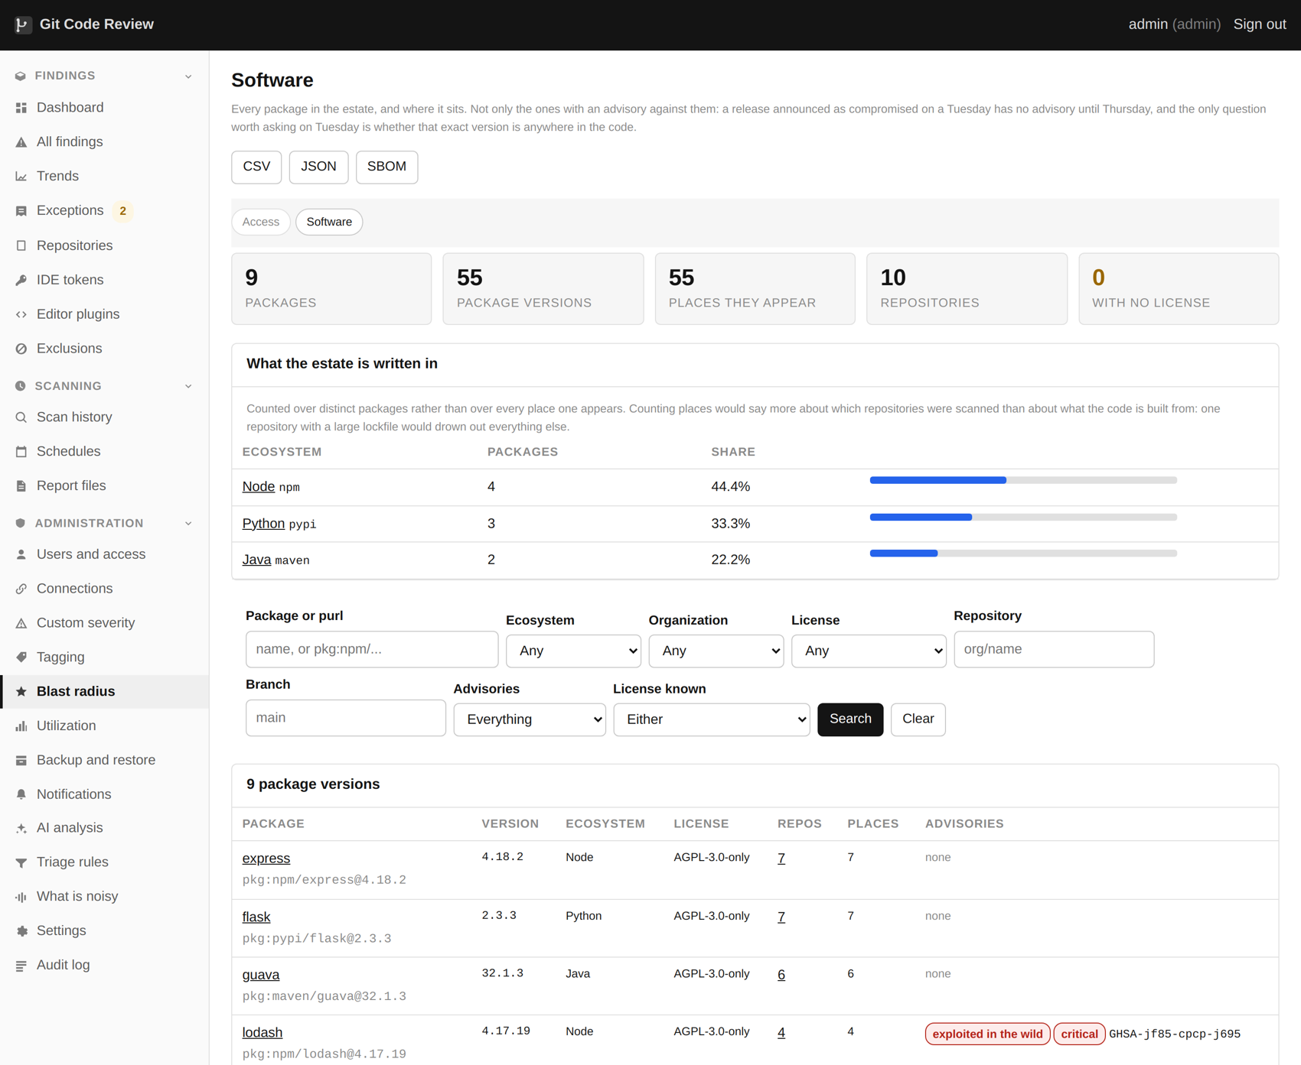
The software inventory: every package in the estate and where each one is.

Both formats, every scan
CycloneDX and SPDX are written for every repository, and optionally for every branch. Two formats because the world has not settled on one and the tool that reads yours will want a particular one. Per branch because a question about what shipped in a particular release needs an answer, and "here is what is on the default branch today" is not it.

Licenses
Every component in the bill of materials carries its license where the metadata declares one. Registry enrichment fills in a good number of the blanks by asking the registry the package came from, which knows things a manifest often does not.
Licenses can be denied or flagged, and a denied license can fail the scan with a non zero exit code. The default deny list is the strong copyleft and source available licenses most organizations already have an opinion about, and it is a setting rather than an opinion baked into the product.
Policy | What happens
Allowed | Nothing. It does not appear.
Flagged | A finding, so somebody sees it, but the scan succeeds.
Denied | A finding, and the scan exits non zero if the license gate is on.
Unknown | Reported as unknown rather than assumed to be fine.

What this does not do
License detection is only as good as the metadata. A package that declares nothing and ships a license file nobody parses comes back unknown, and unknown is not the same as permissive. It also does not do license compatibility analysis, which is the question of whether this combination of licenses is legal to distribute together, and that is a question for a lawyer rather than a scanner.

21. Triage rules
The rules that decide what counts as an example rather than a credential, on a page, with a box to test them in.
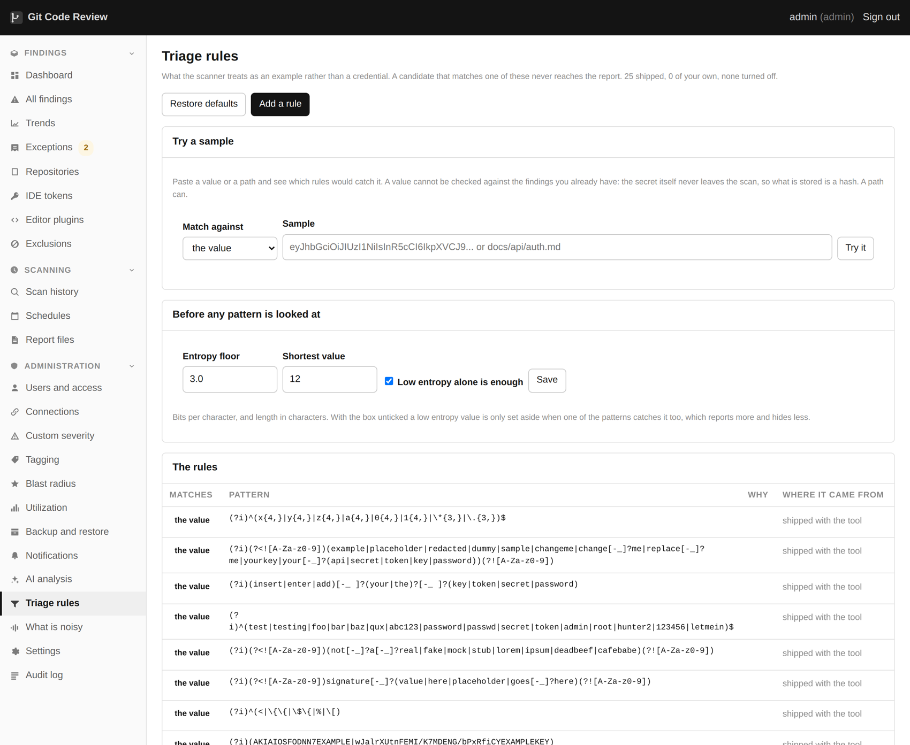
Triage rules: what counts as an example rather than a real credential.
Triage rules. Twenty ship, every one can be switched off, and an administrator can add more.

Two kinds of rule
A value rule matches the credential itself. A path rule matches the file it was found in. Twenty rules ship, covering the obvious placeholder forms, the well known example keys from provider documentation, documentation directories, vendored code, test fixtures and lock files.
Every rule that ships can be switched off, and an administrator can add their own. What makes this work as a page rather than a configuration file is the last part of this chapter.

Why the shipped rules are not in the database
A design detail worth explaining, because it is what makes "restore the defaults" a meaningful button. The rules that ship with the product are read from the product. A row exists in the database only where somebody made a decision: switched a shipped rule off, or added one of their own.
That means restoring the defaults is deleting rows rather than remembering what the defaults were, an upgrade that improves a shipped rule improves it for everybody who has not overridden it, and the page can always show you what the product thinks versus what you have said.

The test box
At the bottom of the page is a box. Paste a value or a path into it and it shows which rules would catch it, before you save anything. For value rules this is the only preview that is possible: the cleartext never leaves the scan, so there is nothing stored to run a new pattern against retroactively.
Patterns are checked by the thing that reads them
A new pattern is validated by handing it to jq, which is what actually applies it during a scan, rather than by a second regular expression engine that agrees most of the time. The two disagree at the edges, notably on Unicode escapes, and the failure mode of getting this wrong is a pattern that saves cleanly and breaks a scan at two in the morning.

Writing a good rule
- Prefer a path rule where you can. "Everything under docs/examples" is easy to reason about a year later. A clever value pattern is not.
- Anchor value patterns. An unanchored pattern that matches a substring will match things you did not think of.
- Test it against something you know is real as well as something you know is an example. A rule that catches every placeholder and also every real key is worse than no rule.
- Write the reason. The field is there and it is the only thing that will make sense of this in six months.

What this does not do
A triage rule hides findings estate wide with no expiry. It carries a reason and an author and it appears in the audit log, and it is still the sharpest instrument in the product. A badly written value rule can hide a real credential in a repository nobody has looked at, silently, forever. Prefer path rules, and review this page occasionally.

22. Recommended severity
When the evidence on a finding already contradicts its grade, the page says so.
The scanner's recommended severity sits on the finding until accepted.
A recommended grade, beside the engine grade, with the reasoning.

Where a recommendation comes from
It is derived entirely from what is already on the finding: the triage verdict and the sentence behind it, the engine's own confidence, the reachability verdict, whether anybody is exploiting it, and whether the rule is one that reports a pattern rather than a defect. There is no second opinion formed at display time and nothing is guessed.
It is expressed in words rather than a number. "Very likely not exploitable here, because this is a development dependency that does not ship" is something a person can agree or disagree with. A confidence of 0.83 is not.

A recommendation is not a decision
Nothing changes until an administrator accepts it. That is one click, it lands in the audit log with their name on it, and the engine's original grade stays visible beside the new one forever. You can always see both what the tool said and what your organization decided.

It usually says nothing
A recommendation on every finding is a recommendation on none of them. The logic returns nothing far more often than it returns something, which is deliberate: it should only speak when the evidence genuinely contradicts the grade.

What it will never soften
- A malicious package. It runs at install time, so no amount of reachability analysis is a mitigation.
- A credential the issuing provider has confirmed is live.
- Anything on the exploited list.
These are enforced with tests, because they are exactly the sort of rule that a later improvement to the ranking logic breaks by accident. One of them was in fact broken by accident during development, caught by review, and now has a regression test with its name on it.

23. Validating a finding with AI
A second reader for one finding at a time, when somebody asks for one.
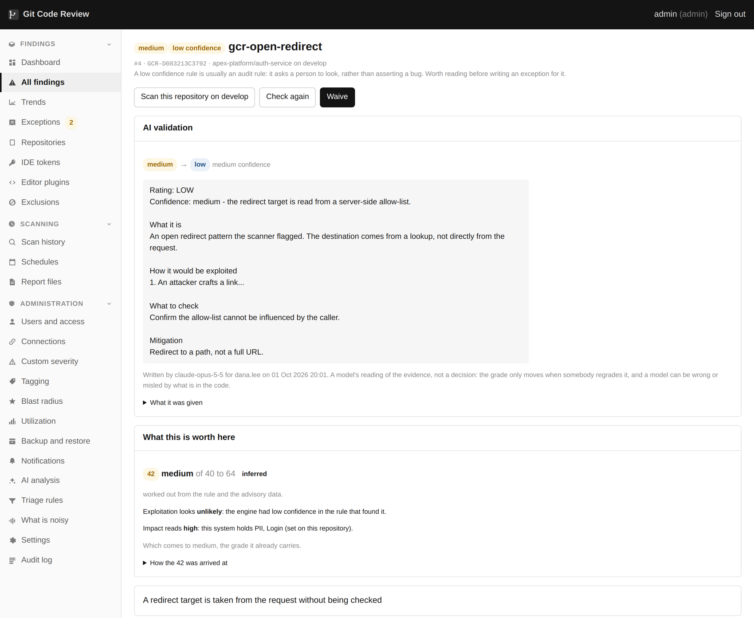
AI validation on a finding: a reading of whether it is really exploitable.
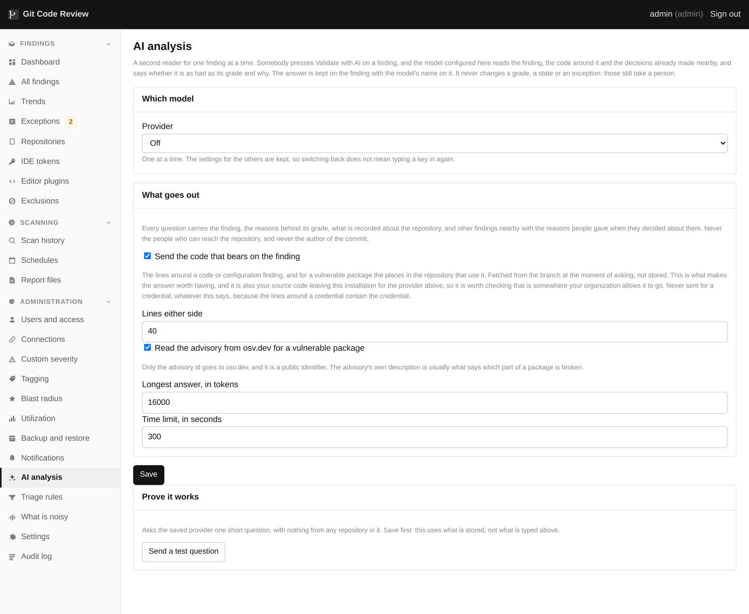
The AI analysis page, where a provider is connected.

What it is for
A scanner grades a finding from what its engine said and what this installation knows about the repository. It cannot read the code the way a reviewer does: notice that the redirect target came out of the server's own database, or that the broken half of a package is a client nothing in the repository ever constructs. That is the question somebody brings to a finding before they fix it or argue an exception from it, and Validate with AI asks it of a language model.
The model reads the evidence and answers in a fixed shape: a rating with its confidence, what the finding is in plain English, how it would be exploited, why it rates it as it does, what to check in the code, the fix, and the compensating controls if the fix has to wait.

Setting it up
Sign in as an administrator, expand Administration in the sidebar and choose AI analysis, between Notifications and Triage rules. The address is /ai on your installation. Only administrators see the menu entry or the page.
Pick one provider: a hosted provider's own API, anything that speaks the OpenAI chat API, or your organization's own inference service described the way curl would send it, as header lines and a body with the word SAMPLE where the question goes. Keys and the custom secret header are stored encrypted, the same as every other credential, and are never shown back. The documentation folder's ai-validation.md lists each provider and what it needs.
Save, then use Send a test question. It asks one short question with nothing from any repository in it, so the wiring is proven before a real question costs anything. List models asks the saved key which models it can use.

Using it
Once a provider is switched on and complete, each finding carries one button, Validate with AI. Until then the finding page carries no trace of the feature. Nothing runs on its own and there is no bulk version: every question is a person pressing the button, because every question is paid for. Two can run at once; a third is asked to wait, and the button locks while its own question is running.
The answer is kept on the finding with the model's name, the person who asked and when. Earlier answers stay readable beneath it, because a model that changed its mind is worth knowing about. What it was given lists every piece of evidence that went out with the question.

What goes out
Every question carries the finding and the reasons behind its grade, what is recorded about the repository, up to twelve findings nearby in the same file, package or rule with any exception or regrade reason somebody gave, and this tool's own definition of the rule when it is one of ours.
Two more things go only while their boxes are ticked. The code that bears on the finding: the lines around a code or configuration finding, or the places a vulnerable package is used, read from the branch at that moment and not stored. And the advisory text for a vulnerable package, from osv.dev, which is sent only the public advisory id.
Never sent: who can reach the repository, who wrote the commit, or a credential. The lines around a credential contain the credential, so no code goes with a credential finding whatever the box says.
Sending code means your source leaves this installation for the provider you picked. Check that is somewhere your organization allows it to go before ticking the box.

Who can use it
Administrators and developers can validate a finding. Readers see the answers but have no button. Only administrators can change the configuration. Every validation, every save and every test question is in the audit log.

What this does not do
It changes nothing. The grade moves when somebody regrades the finding, the state moves when a scan or a recheck says so, and an exception is still an argument a person makes. A model can be wrong, and it can be misled by text written into the code it was asked to read, which is one more reason its answer is advice rather than a decision.
It is not a scan. It looks at one finding, as it is on one branch, at the moment somebody asked.

24. Severity as your organization means it
A plain HTTP link on a brochure site and the same link carrying a session are the same rule and very different risks.
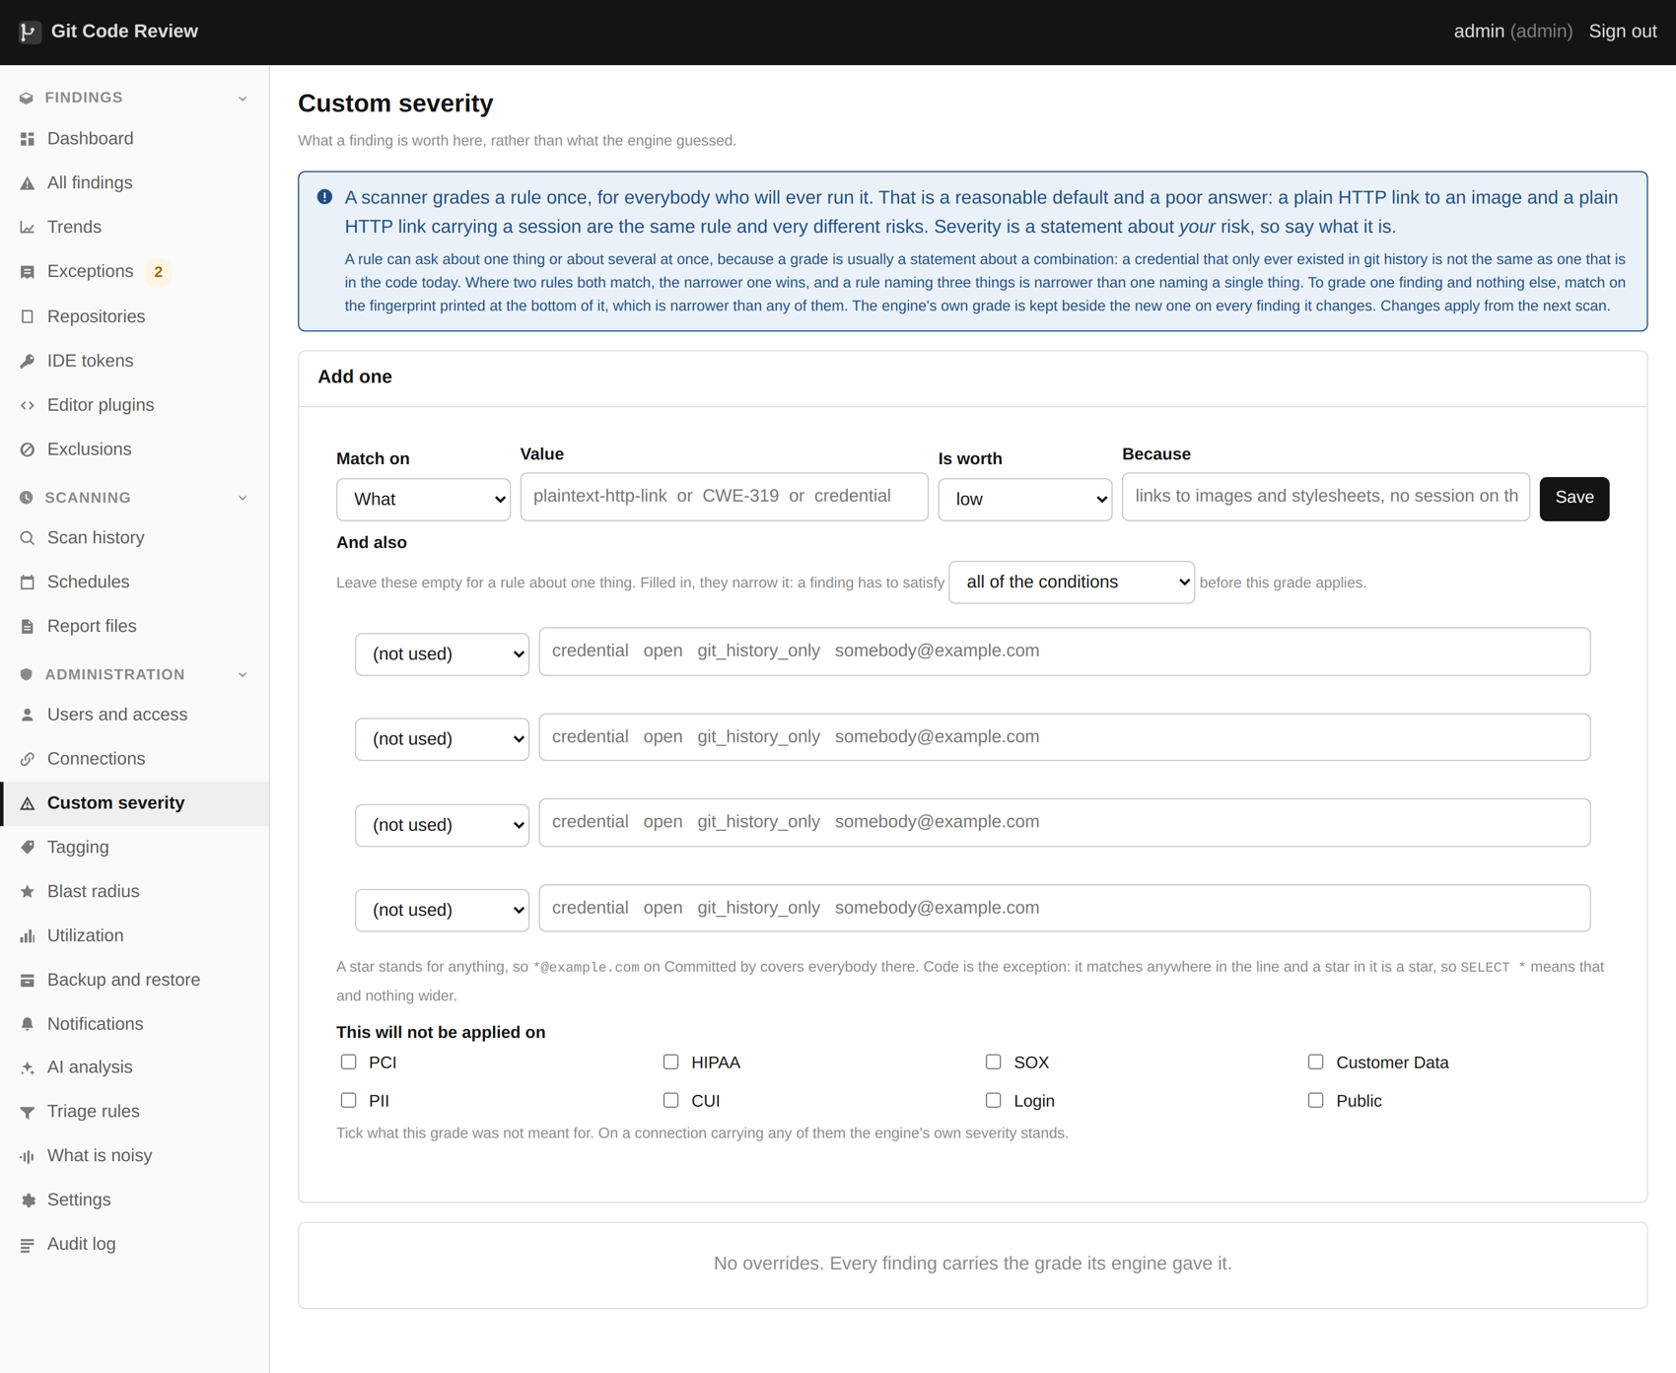
Custom severity rules, scoped by what a system holds.
Custom severity. The engine grade stays visible beside yours.

Two levels
A rule or a weakness class can be regraded across the whole estate. That is the right instrument when your organization has a settled view: perhaps you have decided that a missing security header is a low everywhere, because you terminate at a proxy that adds them all.
One finding can also be regraded on its own, which a rule level override cannot do and should not try to. Sometimes one instance is genuinely different.

Scoped by sensitivity
An override can be told not to apply where a system carries a particular label. "This is a low" becomes "this is a low, except where the repository holds cardholder data", which is almost always what somebody actually meant. Without this, one reasonable decision about a brochure site quietly becomes the same decision about a payment system.

What this does not do
A regrade is a judgement, and the product records who made it, when, and why. It cannot tell you whether the judgement was right. The engine's original grade stays beside it precisely so that somebody reviewing this in a year can see what was changed and by how much.

25. Exceptions
One finding, one decision, one name against it.
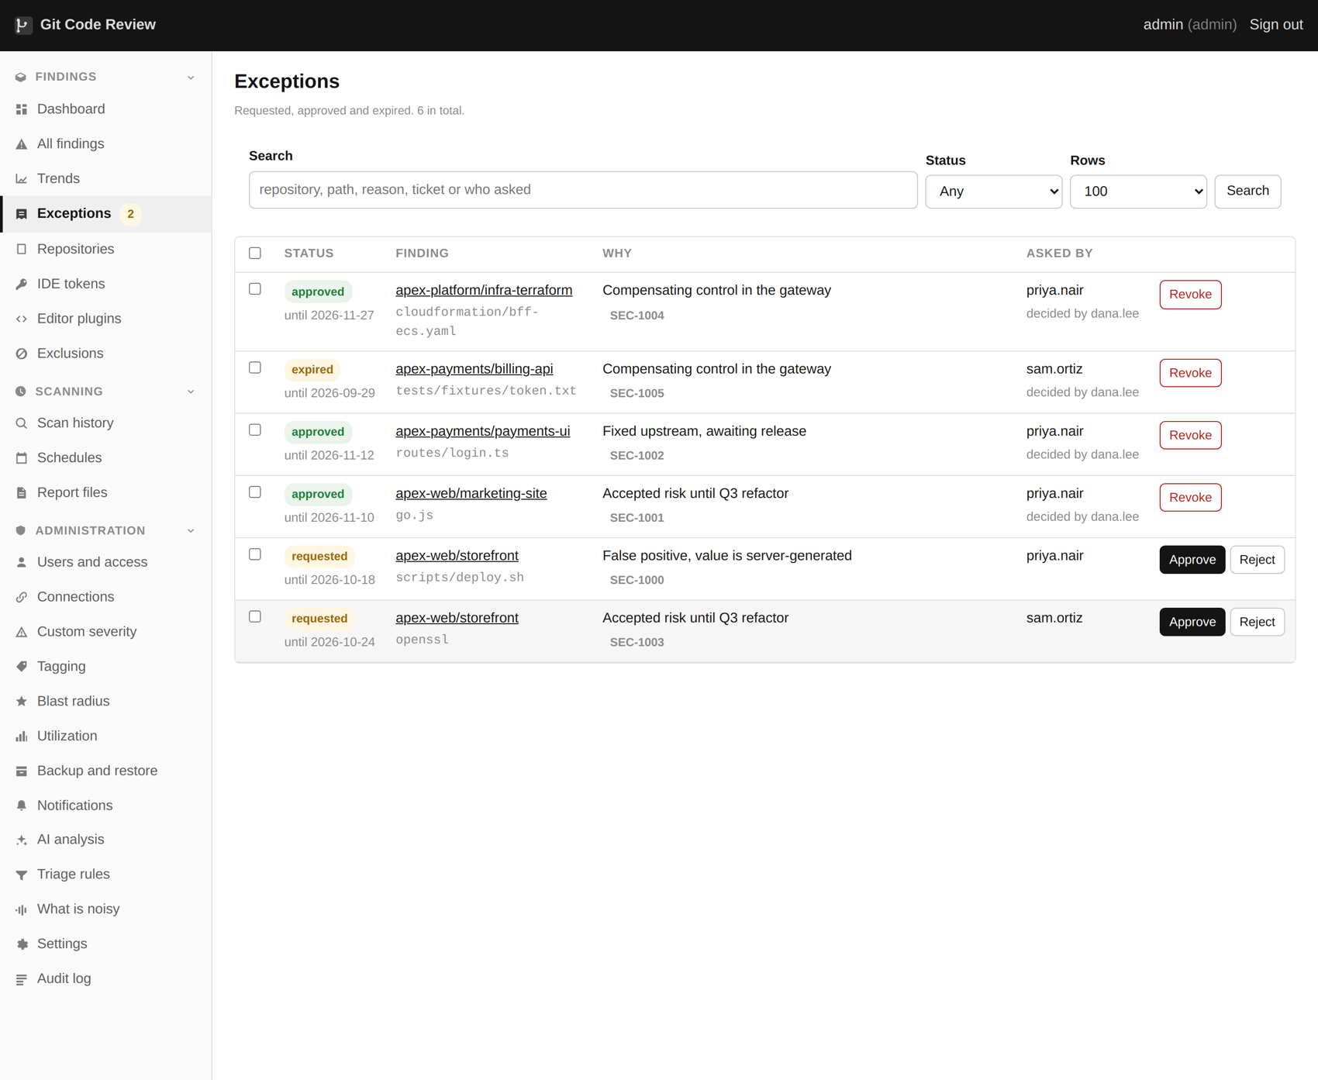
Exceptions: requested, approved, with the reason and the expiry.
Exceptions, and who signed them off.

What an exception is
Somebody looked at one specific finding and decided it does not need to be fixed, or does not need to be fixed yet. That decision carries four things: who made it, why, when, and when it lapses. All four are required, and the expiry can be at most a year out.

Two roles, on purpose
A developer can ask for an exception on anything they can see. Nothing changes until an administrator approves it, and until then the finding stays in the report files. An administrator asking for one approves it in the same step, and an administrator may approve an exception they asked for themselves, which is a deliberate decision: requiring a second administrator for every routine exception produces a queue nobody works and a workaround everybody uses.

Nothing is deleted
An excepted finding leaves the work list and stays in the record. It still appears in the report files with the reason and the reviewer attached, so an auditor reading the output sees both what was found and what was decided about it. That is the difference between a clean report and an honest one.

Expiry
When the date passes, the finding comes back into the work list and into the report files on the next write. This is the mechanism that stops exceptions becoming permanent by default, and it is why the field is required.
Review the expiring ones as a batch
A monthly look at what expires in the next thirty days takes ten minutes and is much easier than dealing with forty findings that all reappeared on the same morning.

26. Exclusions
A rule that covers whatever matches it, now and in every scan afterwards.
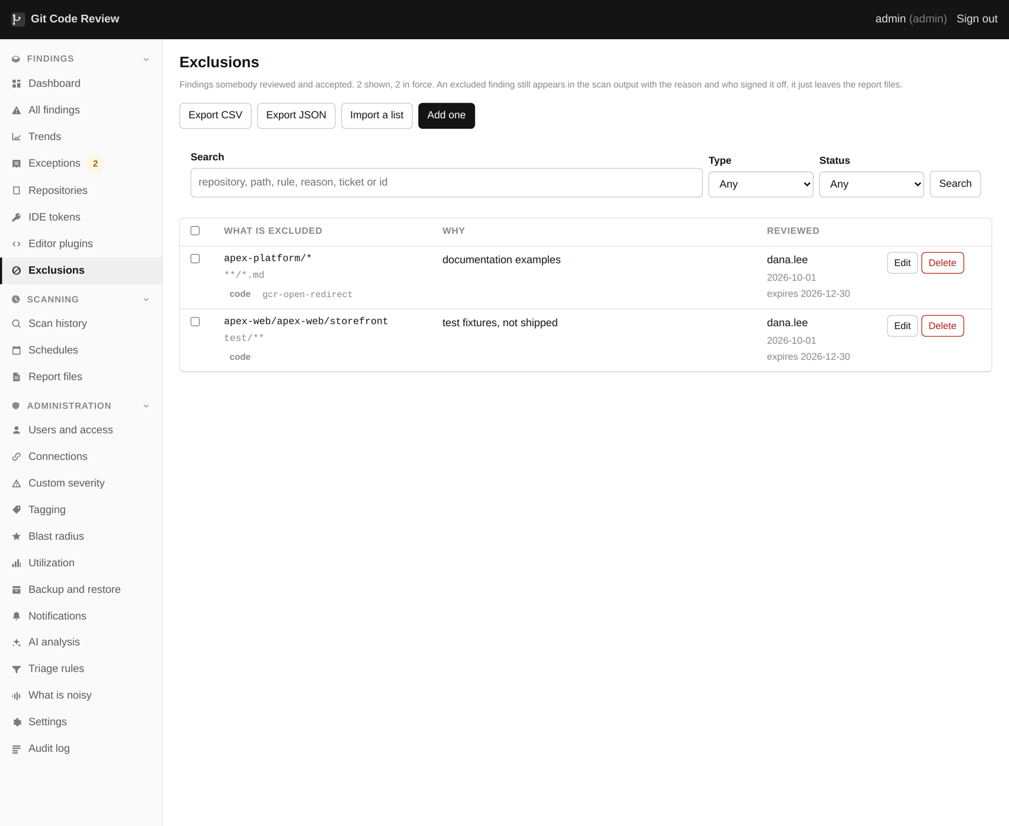
Exclusions: findings reviewed and accepted, with the reason each time.
Exclusions. A rule can match a path, a rule name, or the fingerprint of a credential value.

How a rule is matched
Field | How it matches | Notes
Organization | Exact, or * | Left as * unless you mean one organization specifically
Repository | Glob, or * | Matches the full name or the short name
Path | Glob, or * | The usual instrument: vendored code, fixtures, generated files
Rule | Glob, or * | The rule or detector name
Fingerprint | Exact, credentials only | The hash of the value. The cred: prefix is optional.
Type | credential, code, vulnerability, misconfiguration or any | Narrow this
Expires | A date | A past date stops the rule working

Excluding by value
The fingerprint field is the interesting one. A credential is identified by a hash of its own value, so two findings with the same fingerprint are the same secret wherever they are. One exclusion on a fingerprint therefore covers the same test key committed to nine different repositories, including the ones nobody has found yet.
This is the right instrument for a shared example key, a well known public test credential, or a value that is genuinely not a secret and keeps being found. It is the wrong instrument for a real key, which should be rotated rather than excluded.
The prefix does not matter
A rule written as f960f486dcc3fe6d and one written as cred:f960f486dcc3fe6d both match. Rules written by hand and rules carried over from an older installation disagree about the prefix, and neither should silently fail to match anything.

Scoped to what the system holds
An exclusion can say what it was not written for. "This is fine everywhere except where the repository holds cardholder data" is a sentence somebody can defend. On a connection carrying that label the finding comes back, with the reason it was let through elsewhere still on the record.

Expiry, and the pile of expired ones
An exclusion with no expiry is permanent until somebody notices. The page counts the ones that have lapsed and offers to clear them, and the scanner warns during a run when rules have expired. Neither of those can make anybody look at the page, which is the actual failure mode.

27. Rule mutes
The widest instrument in the product, and the only one that needs two people.
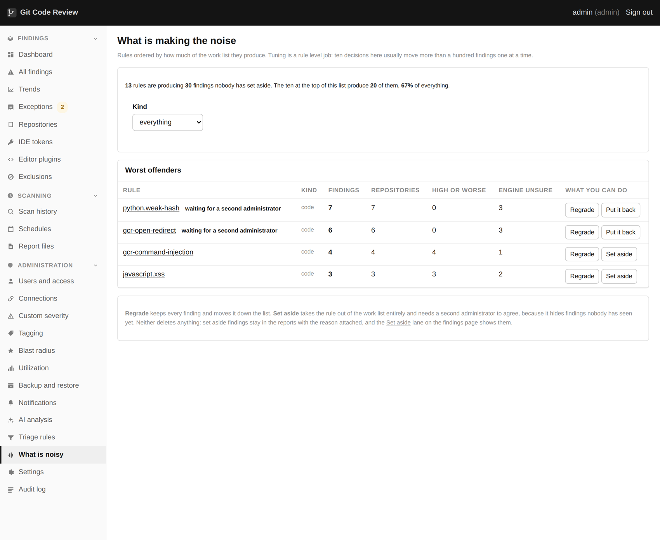
Rule mutes set a noisy rule aside while keeping it on the record.

What it does
A rule mute sets aside every finding a rule will ever produce, across the entire estate, including findings in repositories nobody has scanned yet and repositories that do not exist yet. It is the right answer for a rule that reports a pattern your organization has decided it does not care about, and it is a very large hammer.

Why it needs a second administrator
Because of that last sentence. Everything else in this product hides findings somebody has looked at. This hides findings nobody has seen, forever, and the person switching it on will not be the person who discovers what it hid. Two administrators is a small friction against a decision that is hard to reverse and hard to notice.

When it is the right answer
- A rule reporting a convention your organization has deliberately chosen not to follow.
- A rule that is genuinely wrong for your stack in a way that will not change.
- An audit grade rule that produces thousands of findings and no action, where you have already decided the underlying pattern is acceptable.
When it is not the right answer: any case where the honest description is "this is noisy and I do not have time". That is what a severity regrade and a baseline are for, and both of them keep the findings.

28. Baselines
Draw a line on a date, work forward from it, and keep the backlog one click away.
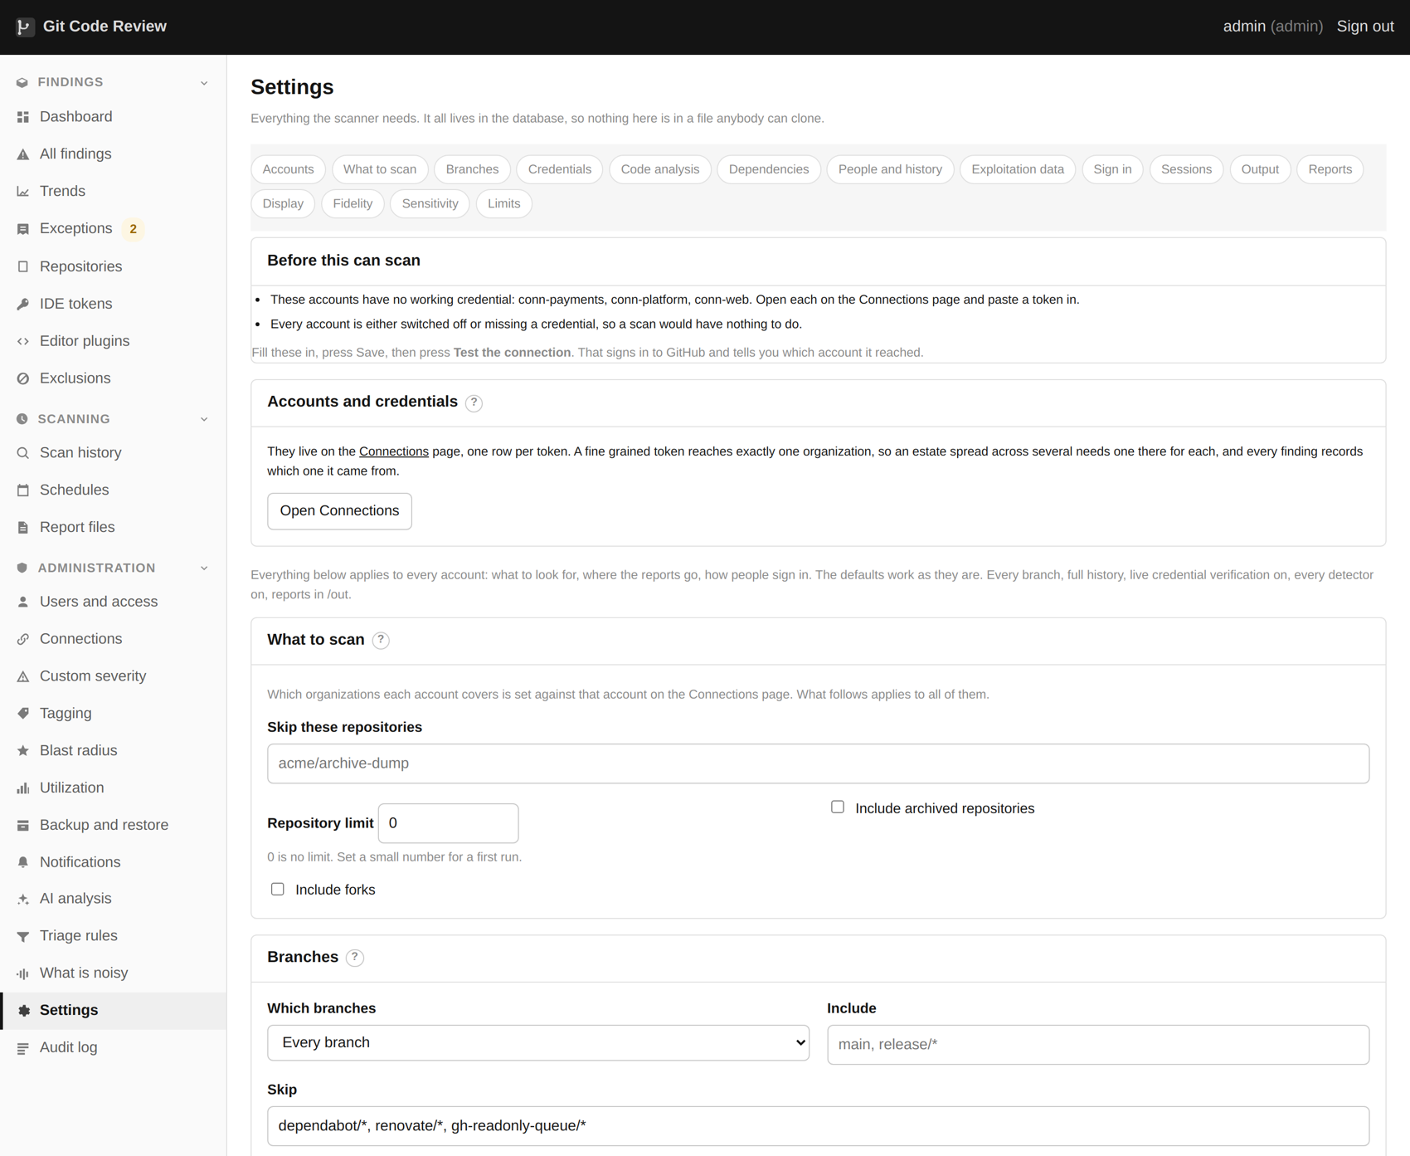
Baselines and the other scan settings live on the Settings page.

The problem it solves
A first scan of an old estate produces a backlog rather than a work list. Nine thousand findings, most of them from before anybody currently employed was there. A team looking at that does not work through it; a team looking at that closes the tab.
A baseline says: everything before this date is a project we will plan separately, and everything after it is work. The count of what is behind the line stays on the page, so nobody can pretend it went away.

Per organization
Because estates are acquired at different times and one line across everything is the wrong shape. An organization brought in last year has a different history from one that has been building since 2011.

What it does not do
A baseline is a way of managing attention, not a way of fixing anything. Everything behind the line is still there, still counted, still in the reports, and still just as exploitable as it was. Setting a baseline and never planning the backlog project is worse than not setting one, because it looks like progress.

29. The first hour of tuning
Do this once, properly, with somebody who knows the estate in the room.
The What-is-noisy page is where the first hour of tuning happens.

Why an hour, once
The alternative is tuning one finding at a time over three months, which produces a long tail of exceptions with no reason written on them, a list nobody trusts and a tool that gets switched off. The difference between a list people work and a list people close is almost always this hour.

The order
1. Deal with anything verified. Live keys are today's work, not this hour's.
2. Set a baseline if the backlog is historic, per organization.
3. Filter dependencies to reachable only, and see what is left. On most estates this removes three quarters of them.
4. Group code findings by rule and look at the top ten. Decide, once, what each is worth: a regrade, a mute, an exclusion scoped to some paths, or leave it.
5. Look at the rules the engine itself marks as low confidence. On the corpus for this guide those were sixty two per cent of the high and critical code findings.
6. Accept the recommended grades that look right. Each is one click and each lands in the audit log.
7. Set the sensitivity labels on your connections. Fifteen minutes, and it improves the ranking of every finding those connections ever produce.

A worked example
On the twenty repository corpus used throughout this guide, the tuning pass looked like this.
What | Before | After | How
Dependency findings | 361 | 83 | Filtered to reachable, each with a reason
High and critical code findings | 314 | 118 | Low confidence audit rules regraded as a group
Mutable action tag findings | 271 | 1 | One rule, one decision, one fix applied everywhere
Credential findings | 2,200 | 9 verified, 271 to review | Triage rules and live verification

None of that is deletion. Every one of those findings is still in the database, still in the report files, and still counted. What changed is what a person is being asked to look at first.

The rule of thumb
If a decision would be the same for a hundred findings, make it once
That is what the difference between an exception, an exclusion and a mute is for. An hour spent making ten decisions that each cover hundreds of findings beats three months spent making a thousand decisions that each cover one.

30. Tagging repositories
The highest value data entry available in this product.
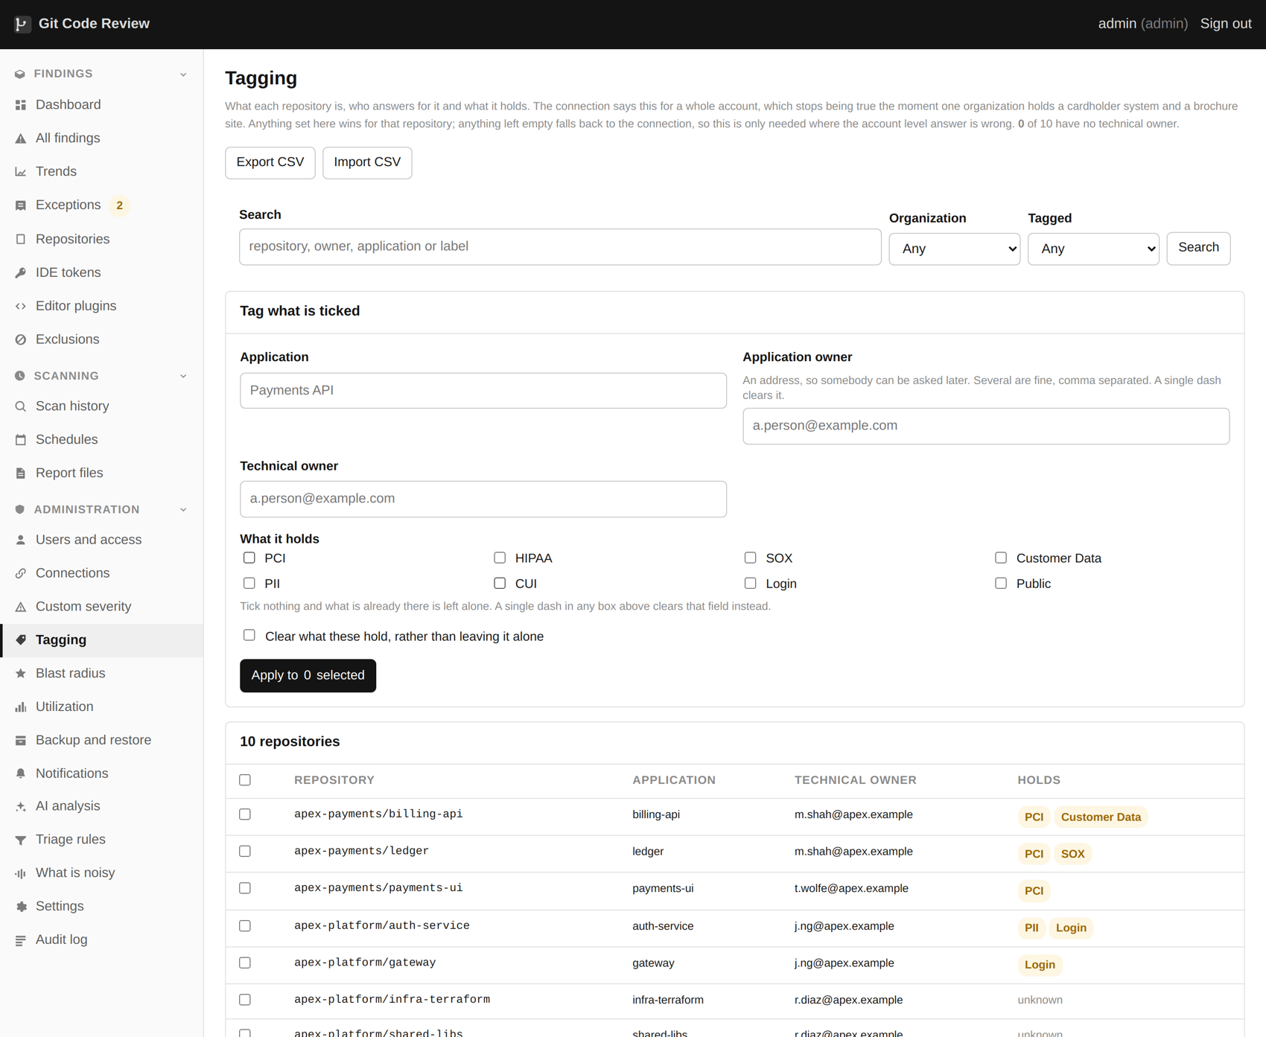
Tagging: what each repository is, who answers for it and what it holds.
Tagging. What each repository is, what it holds, and who answers for it.

What you are recording
Field | What it is for
Application | Which product or service this repository is part of. Several repositories usually make one application, and the answer to "what did we ship" is at the application level.
Business owner | Who decides whether a risk is acceptable. Not a team, a person.
Technical owner | Who will actually fix it.
Environment | Production, staging, internal, experiment, or abandoned. An abandoned repository with a live key in it is a different conversation from a production one.
What it holds | Cardholder data, personal data, health records, credentials, source only. Several at once, and this is the field that changes ranking.
Description | A sentence saying what this thing is, for the person who has never heard of it.

Why it changes the answers
The same credential in a payment system and in a brochure site are not the same problem, and no scanner can work that out from the code. Sensitivity labels are how you tell it. Once told, they feed into the ranking of every finding in that repository, into which exclusions apply, into which severity overrides apply, and into the information shown beside a finding when somebody is deciding what to do about it.

Inherited, or set here
A repository inherits from its connection unless it says otherwise, and the page always shows which of the two an answer came from. This matters more than it sounds: "nobody has said" and "somebody said, for the whole account" are different states, and showing them the same way asserts something nobody actually asserted.

31. Tagging in bulk
Because the answers are already in a spreadsheet somewhere.
The same page exports and re-imports tags in bulk.

Export, edit, import
The whole table exports to a comma separated file with the columns already filled in where something is known. Edit it in whatever you like, and import it back. This is the difference between tagging two hundred repositories and not tagging two hundred repositories.

The rules of the import
- It updates. It never creates. A repository in this product means one the scanner actually found, and inventing them from a spreadsheet would make the estate look bigger than it is.
- An empty cell leaves the existing value alone. A partial spreadsheet is therefore a safe thing to import.
- A single dash clears a value, which is how you say "no, really, remove this".
- Several values in one field are separated by a pipe: Cardholder data|Personal data.
- It does not stop at the first problem. Rows it cannot use are reported and the rest are processed, because a spreadsheet of two hundred rows with three bad ones should update a hundred and ninety seven.

What the report back tells you
After an import you get a count of rows updated, rows skipped because nothing changed, and rows that could not be used with the reason for each. The most common reason is a repository name that does not match anything, which is usually a renamed repository or a typo, and both are worth knowing about for their own sake.

32. Blast radius
Who can reach each repository, and what would be reachable through it.
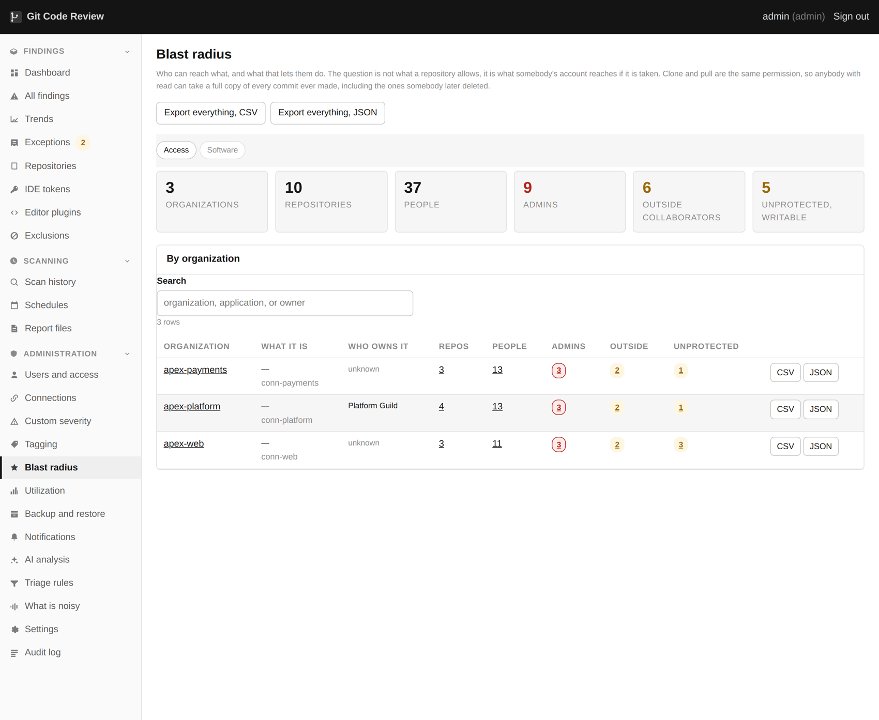
Blast radius by organization: who can reach what, worst first.
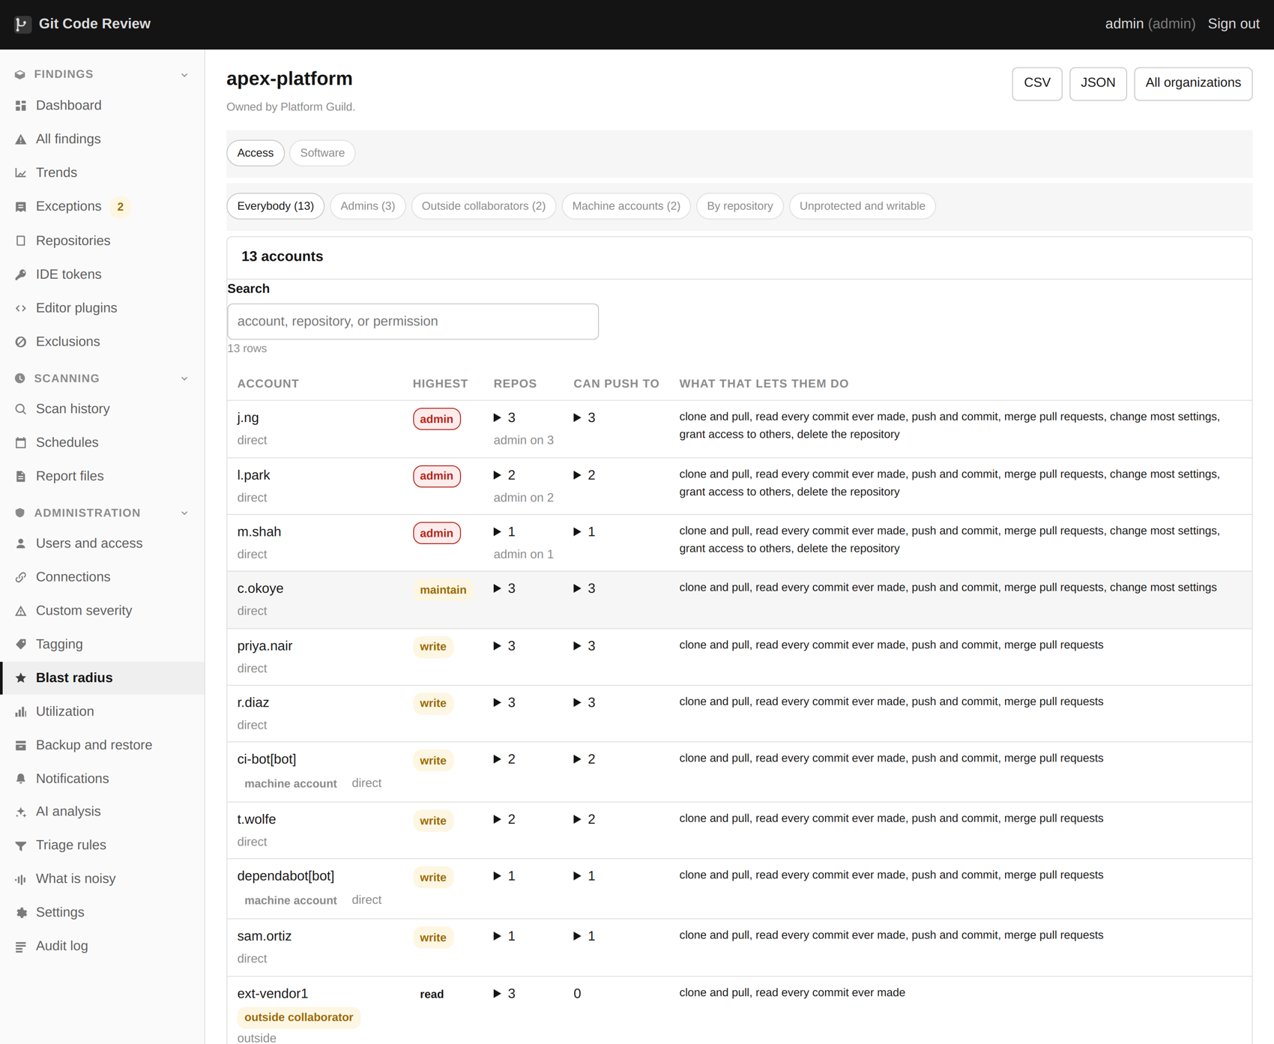
Opening an organization shows every account and its permission.
Access counted per organization, with outside collaborators separated.

What it shows
Per organization and per repository: how many people can read it, how many can write to it, how many of those are outside collaborators rather than members, whether the default branch is protected, and whether the repository is archived or a fork.
Outside collaborators are counted separately on purpose. Forty employees with write access is a governance question. Four contractors with write access to the payment service is a different question and it should not be hidden inside the same number.
By repository, with a row opened to show the description and what it holds.

Opening a row
A row expands to show the description, the sensitivity labels, both owners and where each answer came from. Only an administrator can write these; everybody who can see the repository can read them.

Why it sits next to findings
Because the two questions are the same question. A leaked credential in a repository forty people can push to, which is a fork, which is archived, and which holds nothing but a brochure site is not the same finding as the same credential in the payment service. Having to open a second page to find that out means nobody does.

What this does not do
The access inventory needs a credential that can read organization membership. Without one the page shows what it can and says clearly that it is incomplete rather than showing a confident zero. It also cannot see access granted outside the git host, which on some estates is most of it.

33. The information panel on a finding
Everything a person needs to decide, without opening another page.
The information panel sits on every finding.

What is on it
Beside the evidence and the reasoning, every finding carries an information section about the repository it is in: the description, what it holds, which application it belongs to, both owners, and who has access to it.
The purpose is narrow and specific. Somebody reviewing a finding has to answer "how bad is this here", and that question cannot be answered from the code. It is answered from what the system is and who can reach it, and that information was previously two pages away, which meant it was never used.

Who can see it
The same people who can see the finding. A developer scoped to their own repositories sees it for those repositories, because it is context about a thing they already have access to. Administrators write it; everybody reads it.

34. Scheduling
Nightly, per organization, staggered.
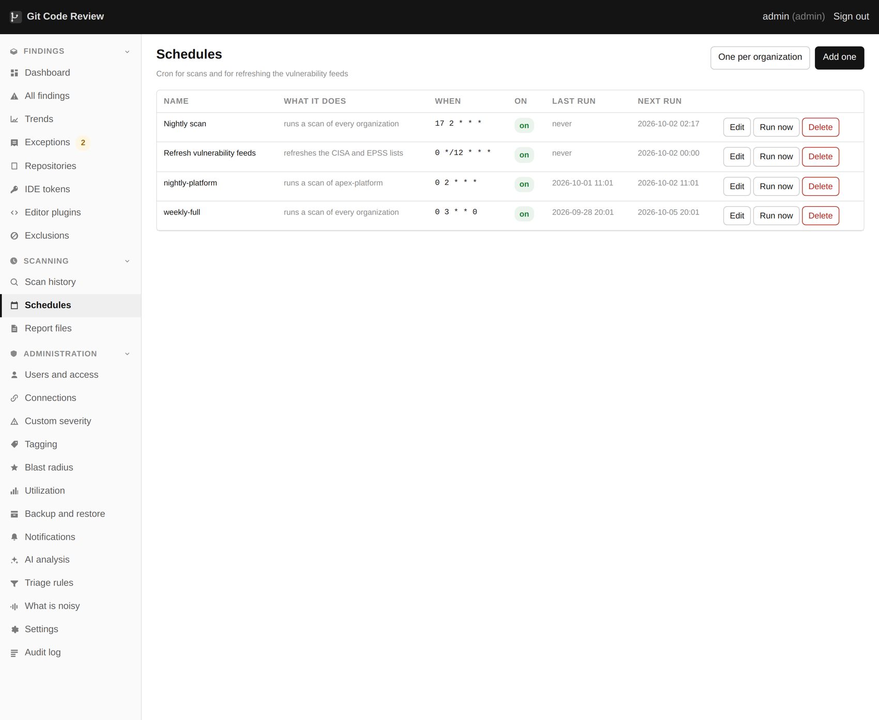
Schedules: the cron that drives overnight scans.

The usual shape
One schedule per organization, overnight, staggered by an hour or so, so that the whole estate is not being cloned at the same moment. This spreads the load on your network and on the host's rate limits, and it means one slow organization does not hold up the rest of the night.

How many at once
The limit on concurrent scans is a setting and it defaults to one, so nothing changes for anybody who does not want it. Raising it lets two small organizations run at once on a machine with the cores for it.
Two scans on one credential share one budget
The rate limit belongs to the credential, not to the scan. Two runs against the same connection share that budget rather than each assuming it has the whole thing, which is what stops them racing each other into a limit neither is watching.

Stopping one
Each running scan has its own stop button on its own row. That sounds obvious and it was not always true: when only one scan could run, the button lived on the page header and meant "whichever one is going", which is fine with one and wrong with three.

Retention
How long scan history, report files and log excerpts are kept is a setting. The findings themselves are not deleted by retention: they persist until they stop being found. What ages out is the per run detail, which is large and mostly interesting for a week.

35. Notifications
On what is new, not on the standing backlog.
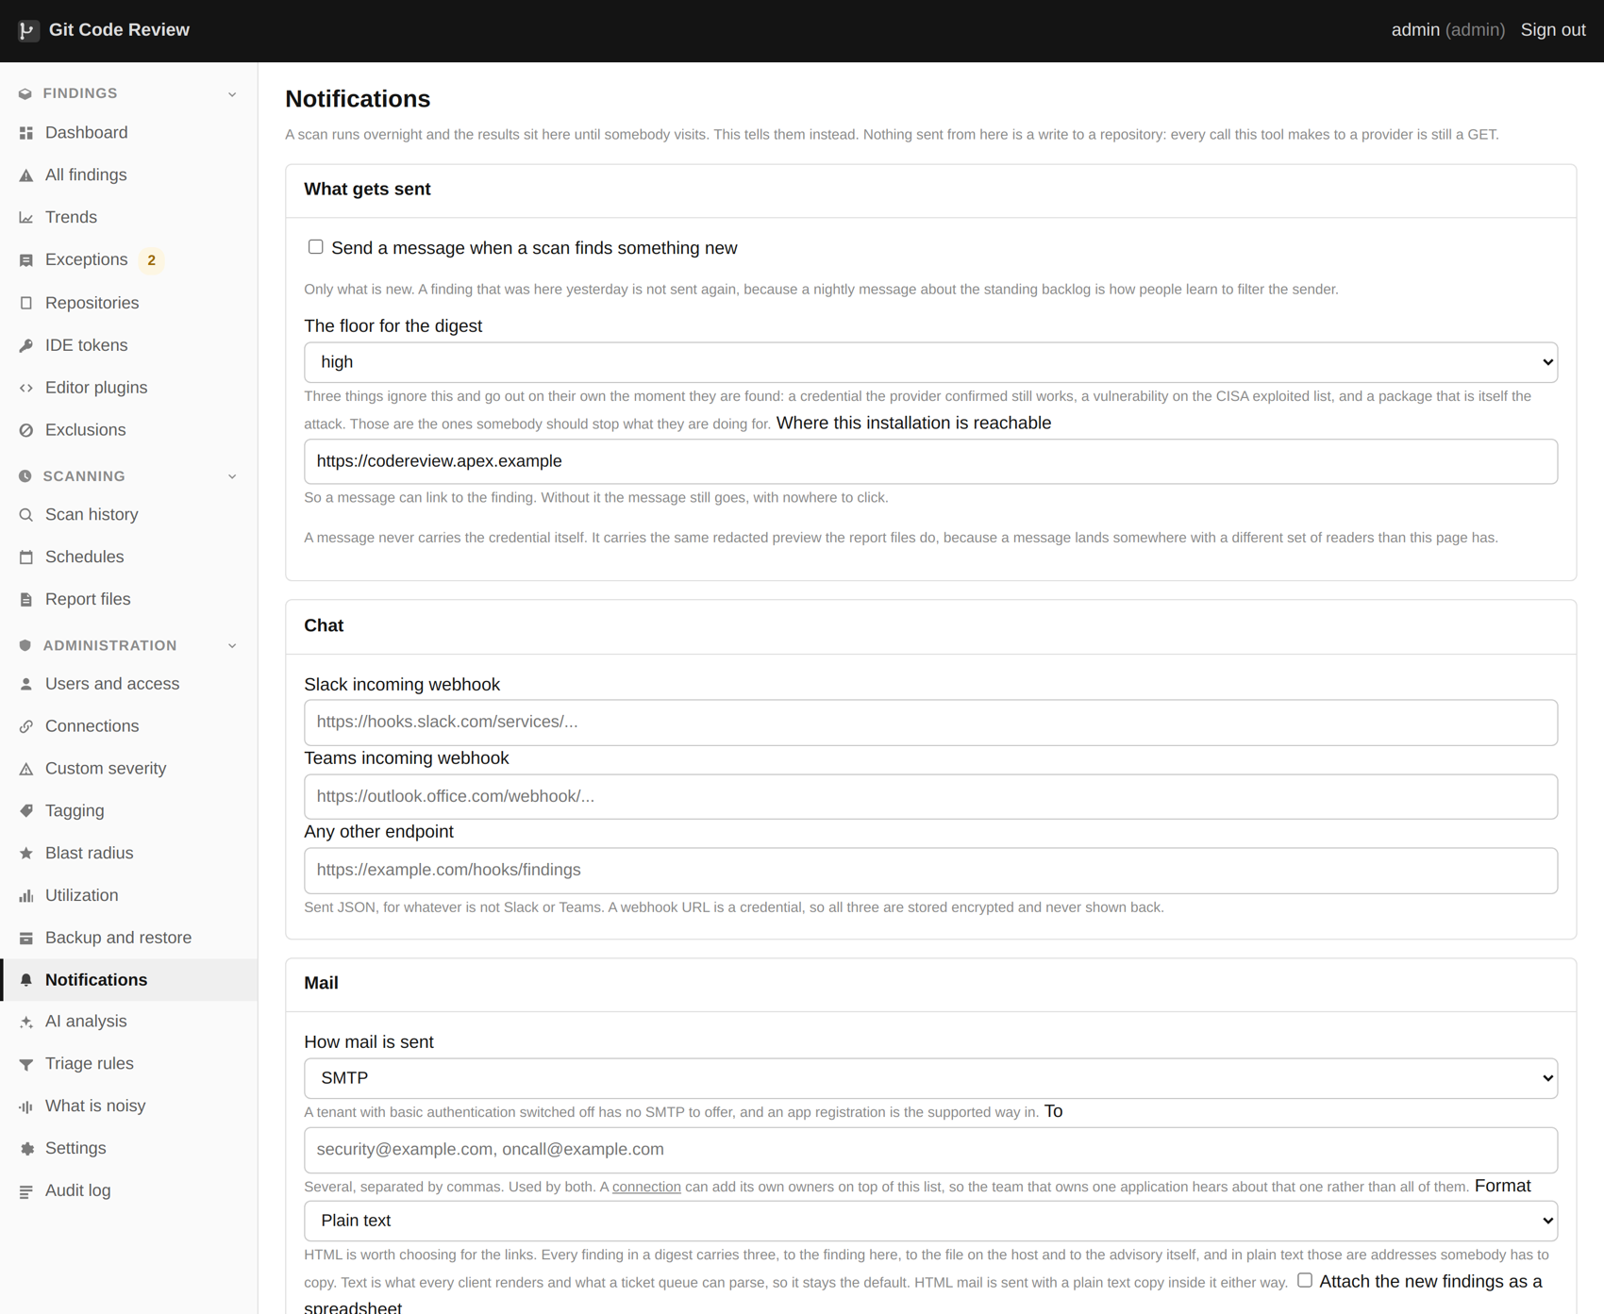
Notifications: where a message goes when a scan finds something new.
Slack, Teams, mail and a plain webhook, routed by severity.

The rule that makes them useful
A nightly message about the backlog teaches people to filter the sender, and once they have, the message that mattered goes into the same folder as the others. So the default is to notify on findings that are new since the last scan. Every finding carries when it was first seen, so this is already answerable without any extra bookkeeping.

What goes out immediately
Three things do not wait for the digest, because all three are situations where twenty minutes matters.
- A credential the issuing provider has just confirmed still works.
- A vulnerability on the published list of things being exploited in the wild.
- A malicious package.
Everything else above your chosen floor goes out as one digest at the end of the scan.

Where it can send
Channel | What is needed | Notes
Slack | An incoming webhook URL | The URL is a secret and is stored encrypted
Microsoft Teams | An incoming webhook URL | Sent as a message card so it renders properly
Mail by SMTP | A host and port | Username and password are both optional
Mail by Microsoft Graph | Tenant, client id, client secret, from address | For tenants with basic authentication off
A plain webhook | A URL | JSON, for anything that is not one of the above

Never the secret
A notification carries the same redacted preview the report files do. This is worth saying because a notification lands somewhere with a completely different set of readers than the web page has: a Slack channel is often much more widely visible than the security tool, and a mail thread gets forwarded.

The reachable address
Notifications carry links back into the product, and the product has no reliable way to know what address people reach it on from outside. There is a field for it, and if it is wrong every link in every message points at somewhere that does not work.

36. Mail, two ways
An internal relay that wants no password, or Microsoft 365 with SMTP switched off.
Mail is sent by SMTP or Microsoft 365, set on the same page.

SMTP, including without authentication
Plenty of organizations run an internal relay that accepts mail from known hosts by address and has no accounts at all. Both the username and the password fields are optional, and leaving them empty means no authentication is attempted rather than an empty one being sent.
If the relay refuses, it is almost always the source address rather than anything about the message. The host running the container is what needs to be on the allow list, and inside Docker that address may not be the one you expect.

Microsoft Graph
Microsoft has been switching SMTP authentication off across tenants, which leaves a self hosted tool with nothing to connect to. Sending through the Graph API as an application is the supported answer, and it needs three values from Azure.
1. In the Azure portal, open Microsoft Entra ID, then App registrations, and register a new single tenant application.
2. Copy the Application (client) ID and the Directory (tenant) ID from the overview page.
3. Under Certificates and secrets, create a client secret and copy the value immediately. It is shown once.
4. Under API permissions, add an application permission, not a delegated one, for Microsoft Graph: Mail.Send.
5. Press Grant admin consent. Without this step nothing works and the error does not say so clearly.
6. Decide which mailbox it sends as. A shared mailbox is the usual answer, because a person leaves and their mailbox goes with them.
7. Enter the tenant id, client id, client secret and from address in Notifications, and press Send a test.
Restrict that permission
Mail.Send as an application means every mailbox in the tenant unless you restrict it. An application access policy scoped to the one mailbox takes a couple of minutes in PowerShell and is the difference between a mail sender and a tenant wide capability.

The test button
Every channel has one, and the failure message says which part failed rather than reporting a generic error. For Graph that means it distinguishes between a bad tenant, a bad client, a bad secret and a permission that was never consented to, which are four different afternoons.

37. Users, roles and access
Three roles, and the gaps between them are deliberate.
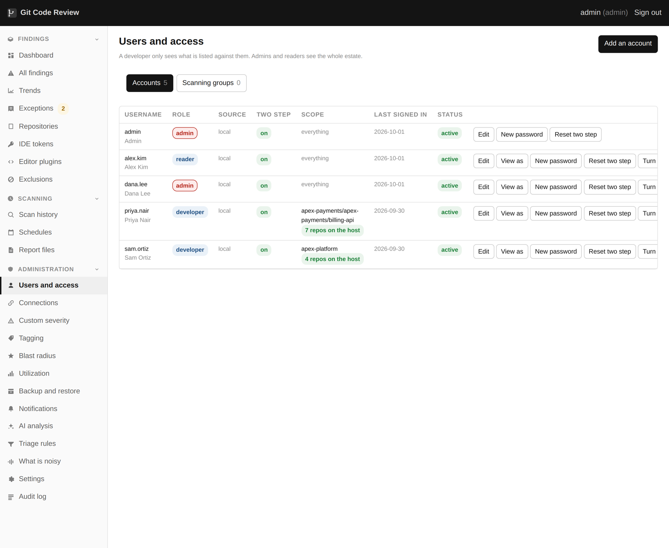
Users, roles and access, with the three roles and what each can do.
Users and access.

The three roles
 | Administrator | Developer | Reader
See findings | Everything | Assigned organizations and repositories only | Everything
Export reports | Yes | Yes | Yes
Ask for an exception | Yes | Yes | No
Approve an exception | Yes | No | No
Revoke an exception | Yes | No | No
Start a scan | Yes | Yes | No
Edit schedules | Yes | No | No
Validate a finding with AI | Yes | Yes | No
Configure AI validation | Yes | No | No
Manage users | Yes | No | No
Read the audit log | Yes | No | No

What a developer sees
Only the organizations and repositories assigned to them. A developer with nothing assigned sees an empty screen, which is deliberate: a new account should show nothing at all until somebody decides what it should show.
This is enforced in the database query rather than in the page. Every list starts from the same scoped query and every lookup by identifier goes through the same check. Guessing the identifier of a finding in another team's repository returns a not found rather than a forbidden, so the answer tells you nothing about whether it exists.

Single sign on
Any OpenID Connect provider. Groups from the provider map to roles here, so joining a group in your identity provider is how somebody gets an account, and leaving it is how they lose one. Keep one local administrator account with a second factor for the case where the identity provider is the thing that is broken.

38. Viewing as another user
Reproduce what somebody is seeing, without asking for their password.
An administrator can view the product as another user, read-only.

What it does
"I cannot see the findings page" is usually a role, sometimes a scope, occasionally a filter and rarely a bug, and all four look identical over a chat message. An administrator can press View as on a user and see exactly what that user sees.

It cannot write anything
Every write is refused while this is active. Not hidden in the page: refused at the middleware, before any route runs, so there is nothing to find and no way around it. The check is arranged so that only writes pay for the extra lookup, which keeps reading fast.

It is loud, and it is audited
A band across the top says whose session this is and does not go away. Both the start and the end are in the audit log with both names on them. Viewing the product as somebody else is a serious power and it should be impossible to do quietly.

39. The audit log
Every decision anybody made, searchable as you type.
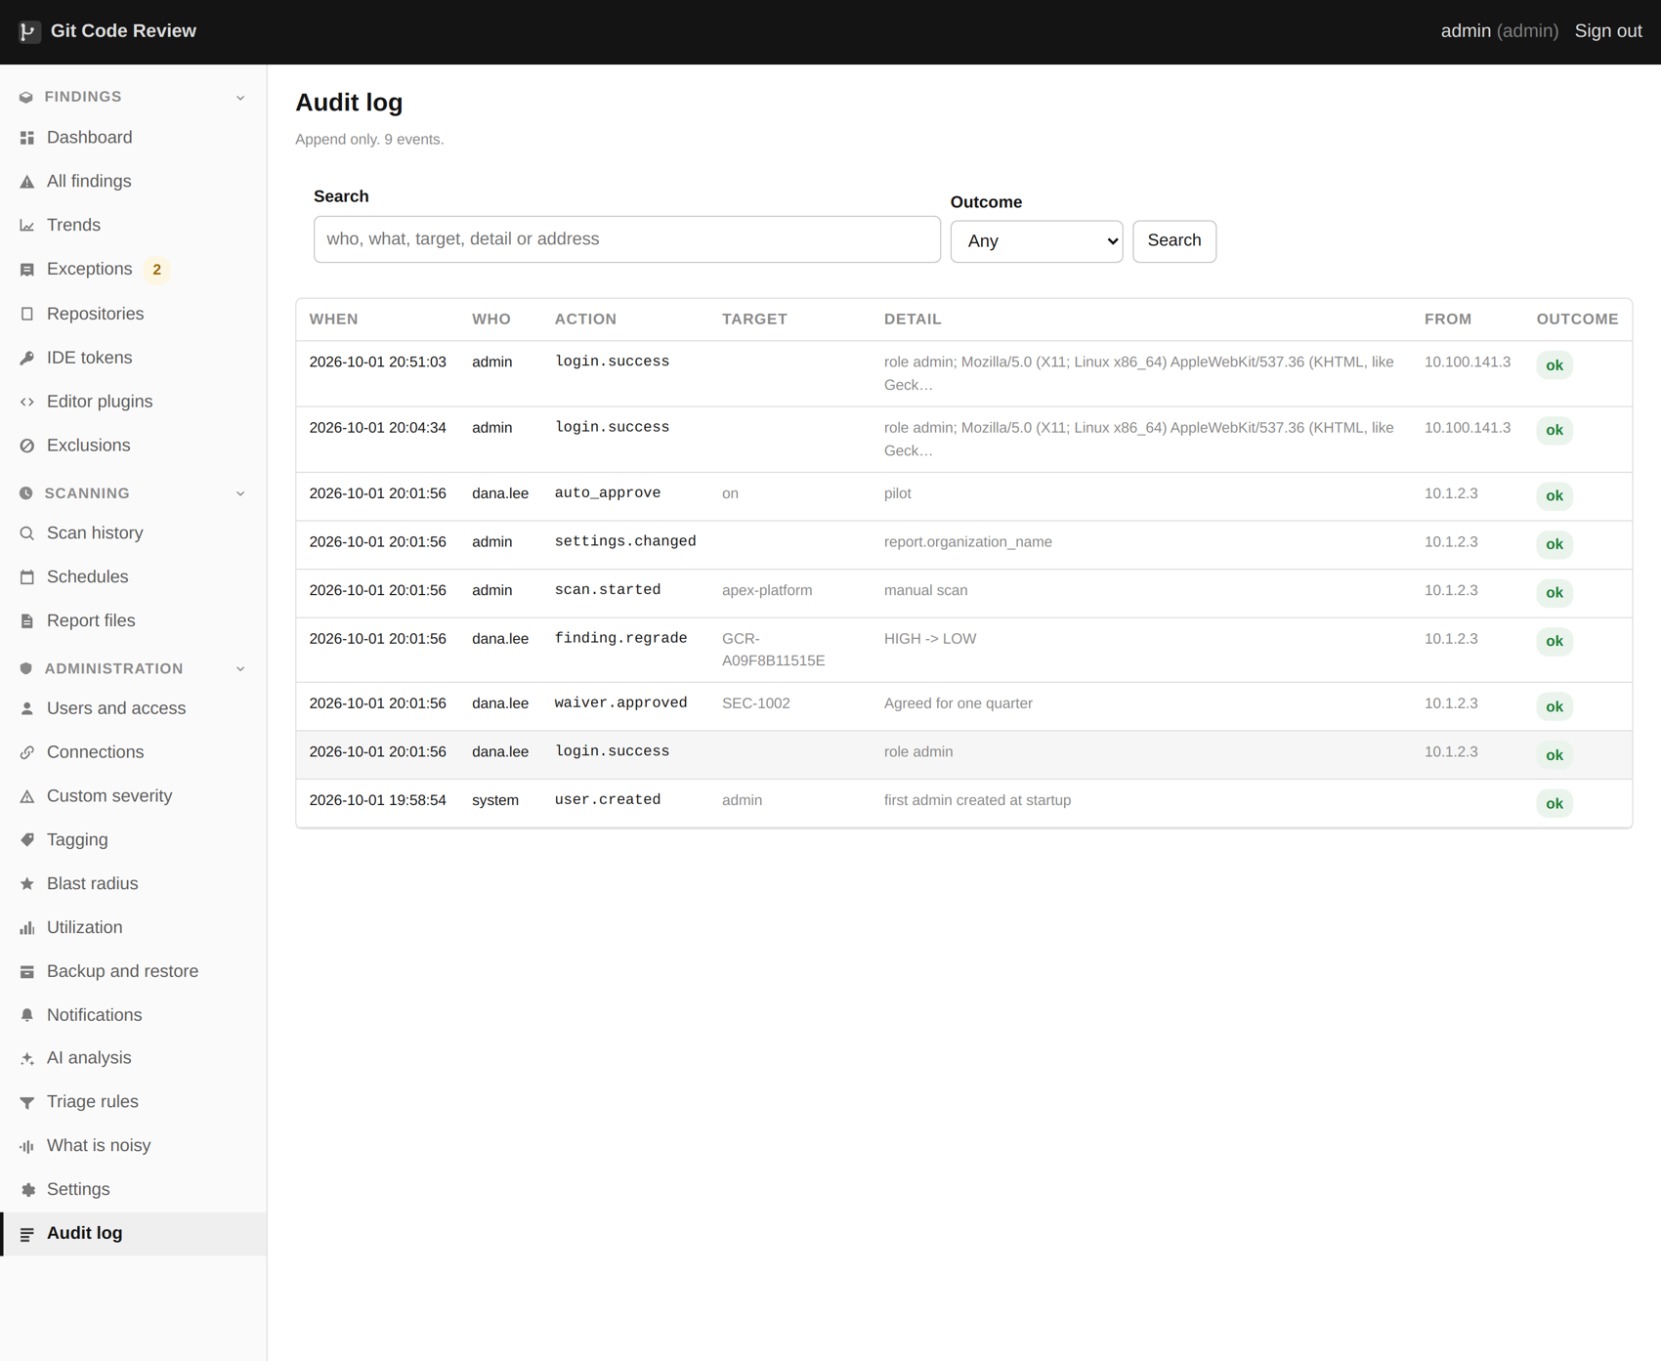
The audit log: who did what, append-only.
The audit log, filtered as you type.

What is in it
- Sign ins, sign outs, failures, and second factor enrolments.
- Every exception asked for, approved, revoked and expired.
- Every severity override and every accepted recommendation.
- Every exclusion and triage rule created, changed or removed.
- Every settings change, by name. Never by value, because some values are secrets.
- Scans started, stopped, finished and interrupted, each naming the connection.
- Impersonation, both ends.
- User accounts created, changed, disabled and their roles changed.

Search
The filter narrows as you type, across the actor, the action and the detail. It is a small thing that changes how the page is used: a log you have to page through is a log nobody reads, and a log you can type a repository name into is one people actually use to answer questions.
One event, opened.

Opening an event
Every event opens to show its whole detail, with a link to whatever it names. Enough to answer "who set this aside, and what did they say" without anybody opening a database. A scan event names the connection it was scanning, which sounds obvious and was added because without it "scan started" and "scan finished" tell you nothing at all on an estate with nine connections.

40. Reports and where they go
Everything the scanner writes, and why it is written that way.
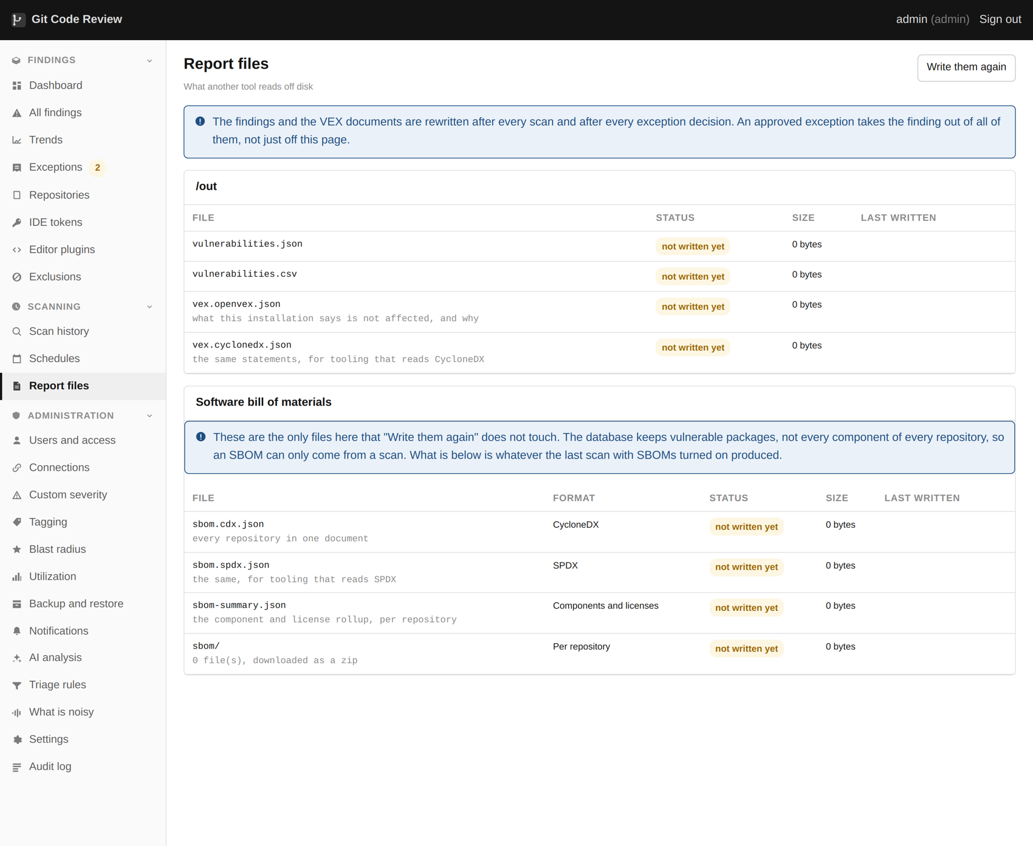
The report files a scan writes, and where they go.
The report files, including both VEX dialects.

The files
File | Format | What it is for
findings.json | JSON | Everything, with the full reasoning on each finding. The one to process with something else.
findings.csv | CSV | The same list, flattened, for a spreadsheet.
findings.sarif | SARIF | What a code host security tab and most vulnerability managers read.
sbom.cdx.json | CycloneDX | The bill of materials.
sbom.spdx.json | SPDX | The same, in the other standard.
vex.openvex.json | OpenVEX | Which of the vulnerabilities in the bill of materials matter.
vex.cdx.json | CycloneDX VEX | The same, in the other dialect.
excluded.json | JSON | What was set aside, with the reason and the reviewer.
summary.json | JSON | Counts, timings, engine versions and any warnings from the run.

Written on every scan, and rewritten on every decision
The files are rewritten whenever a decision changes what is reportable, not only when a scan runs. An exception approved at eleven in the morning is reflected in the files at eleven in the morning. Without that, the files and the screen disagree, and whichever one somebody is looking at is the one they will believe.
Both are written atomically, to a temporary name and then moved into place, so a reader never sees half a file. This matters more than it sounds when something else is picking them up on a timer.

The schema is published
The JSON report validates against a JSON Schema that ships with the product, and the scanner can validate a report against it on demand. If you are building something that reads these files, validate against the schema in your own tests, and a future version that changes shape will break your test rather than your production job.
ghscan validate --report ./out/findings.json

Retention
How long report files are kept is a setting, and they are per run, so a nightly scan of a large estate produces a lot of them. The findings themselves live in the database and are not affected by report retention.

41. VEX documents
Answering "your product contains a vulnerable library" with a file rather than a thread.
VEX documents are written alongside the reports.

What a VEX document is
A bill of materials says what is in your product. It does not say which of those things matter, and a customer running a scanner against what you shipped will find every vulnerability in every component whether or not any of them are reachable. A VEX document is the supplier's statement about which ones are actually exploitable.
Both dialects are written, OpenVEX and CycloneDX, beside the bill of materials every time the reports are written. Beside, and at the same moment, so that a document can never describe a set of decisions that has since changed.

Only decisions somebody made
A VEX statement is an assertion the supplier is standing behind, so only two things go into one.
- An exception, which has a reviewer, a reason and a date.
- A triage verdict of not applicable, which has the sentence explaining why.
"The scanner did not look" is not a statement anybody should make in this format, so nothing else is emitted at all.

An accepted risk is affected
This is the most important sentence in the chapter. A waiver that says "we will fix this next quarter" is emitted as affected, with the reason attached. It is never emitted as not affected.
The temptation to do otherwise is obvious: a document with no affected entries looks better. It also tells a customer they are safe when the decision your organization actually made was "later", in a format specifically designed to be trusted and processed automatically. That is the one thing this format must never do.

What this does not do
It is only as good as the decisions behind it. A VEX document generated from an empty exception table says nothing at all, correctly. If you want useful VEX output, the work is in triage, not in the export.

42. Pipelines and SARIF
Fail a build on what you choose, or hand findings to whatever already reads SARIF.

Exit codes that mean something
For most pipelines the whole integration is one command and an exit code.
--fail-on | Exits non zero when
none | Never. Report only.
secrets | Any credential was found.
verified-secrets | A credential the provider confirmed still works was found.
critical | Any critical finding.
high | Any high or critical finding.
license | A license on the deny list was found.

Exit code | Meaning
0 | Completed, nothing above the threshold
1 | Something went wrong
2 | Bad usage: an unknown flag or a missing argument
3 | Completed, and findings met the threshold

Start with credentials, not with critical
Failing a build on any critical, in a repository that already has forty of them, fails every build from the first minute and gets switched off by the end of the week. Almost nobody argues with a build that fails because somebody just committed a key.
ghscan review . --diff origin/main --fail-on secrets

Only what changed
The --diff flag limits a review to the files changed against a reference, so a pipeline reports what somebody wrote on this branch rather than the repository's whole backlog. This is the difference between a check people fix and a check people bypass.

Putting the scanner on your build server
Everything in this chapter runs on your build server, not on the Git Code Review server. Those are usually two different machines, and the build server has never heard of the other one. That is on purpose, and it is worth understanding before you start, because it is the part people find confusing.
Three things are true, and together they explain the whole setup.
- The build server does not contact Git Code Review. The check reads the code that is already sitting on the build server and runs the same engines against it. Nothing is sent anywhere, no password or token is needed, and it works even if the Git Code Review server is switched off.
- The build server does not download this product's source code. It downloads your application, which it already does in order to build it.
- What the build server does need is the checking tool itself. You put that on the build server once. After that, every build uses it without any further setup.
There are two sensible ways to do that. Pick whichever matches how your build servers already work. If you are not sure which, ask whoever looks after them which of the two sentences below is true, and that is your answer.

Way one: through your container registry
Choose this if your build servers already download container images from a company registry. Most do. A registry is a shared library of prepared software, and your build servers almost certainly take things from one already.
Step 1. On the Git Code Review server, give the image a name that points at your registry. Replace the address below with your own.
docker tag github-code-review:1.0.1 registry.example.com/security/ghscan:1.0.1
Step 2. Send it to the registry.
docker push registry.example.com/security/ghscan:1.0.1
Step 3. In your build, use that name. Here is the whole step for Jenkins. Everything in it is fixed text except the registry address and the name of your main branch.
docker run --rm -v "$WORKSPACE:/src:ro" \
--entrypoint /opt/gcr/bin/ghscan \
registry.example.com/security/ghscan:1.0.1 \
review /src --diff origin/main --fail-on secrets
That is the whole integration. The build stops if a credential is found, and carries on otherwise.
One rule worth following. Always name a version, as above, rather than writing latest. A build that follows latest changes what it enforces on a day nobody chose, and the first anyone hears of it is a build failing on code that did not change.

Way two: installed directly on the build server
Choose this if your build servers do not run containers, or if you would rather not run a container inside a build. Somebody with administrator access to the build server does this once per server.
Step 1. Install the six scanning engines. The product ships a script that does this and is safe to run more than once.
sudo contrib/install-deps.sh
Step 2. Copy the tool itself into place.
sudo mkdir -p /opt/ghscan
sudo cp -r bin lib /opt/ghscan/
Step 3. In your build, call it directly.
/opt/ghscan/bin/ghscan review "$WORKSPACE" --diff origin/main --fail-on secrets
The trade off is that you now keep the engine versions level across every build server yourself. Two build servers running different versions of the same engine will disagree about the same code, and that is a difficult argument to have with a developer who is looking at a passing build on one and a failing build on the other.

Two mistakes that waste an afternoon
Build servers usually download only the most recent commit of your code, to save time. If they do, the branch you are comparing against is not there, and the check quietly examines the entire repository instead of just your change. It then reports every finding your codebase has ever had, on every build, and people switch it off within a fortnight. Fetch the main branch first, or turn the shallow download off in your build settings.
Findings from a build do not appear on the Git Code Review dashboard. Nothing was sent there, so nothing can. The dashboard shows what the server's own scans found. They are two separate records of the same code, and that is deliberate: a build check is about stopping something today, and the dashboard is about what is already there.

SARIF out
SARIF is the standard format a security tab, a code host and most vulnerability managers already read. Writing it and letting the pipeline upload it means annotations appear on a pull request without this product ever needing write access to anything: the upload uses the pipeline's own token.
ghscan review . --format sarif > findings.sarif

What this does not do
It is a command and a schema rather than a polished integration. There is no marketplace action, no curated set of pipeline policies and no pull request comment written by this product. Commercial tools ship all three, and getting the same result here is more assembly than clicking install.

43. The editor API
Reviewing a file before it is committed.
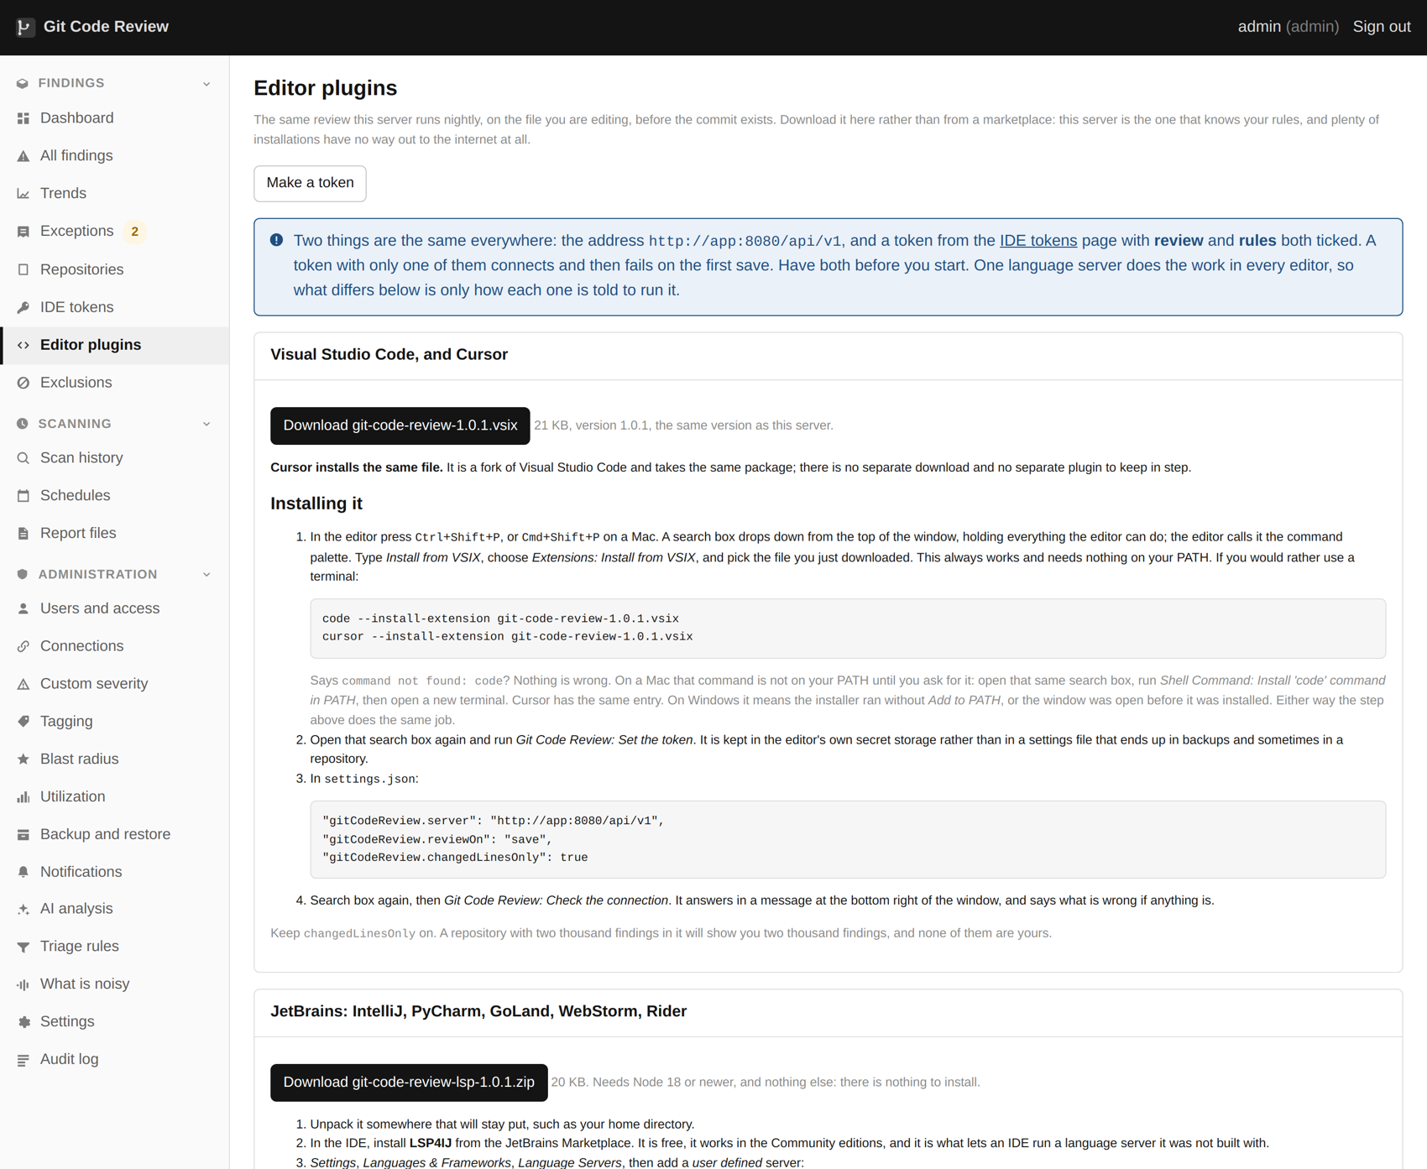
The editor plugins page hands out the IDE integration.
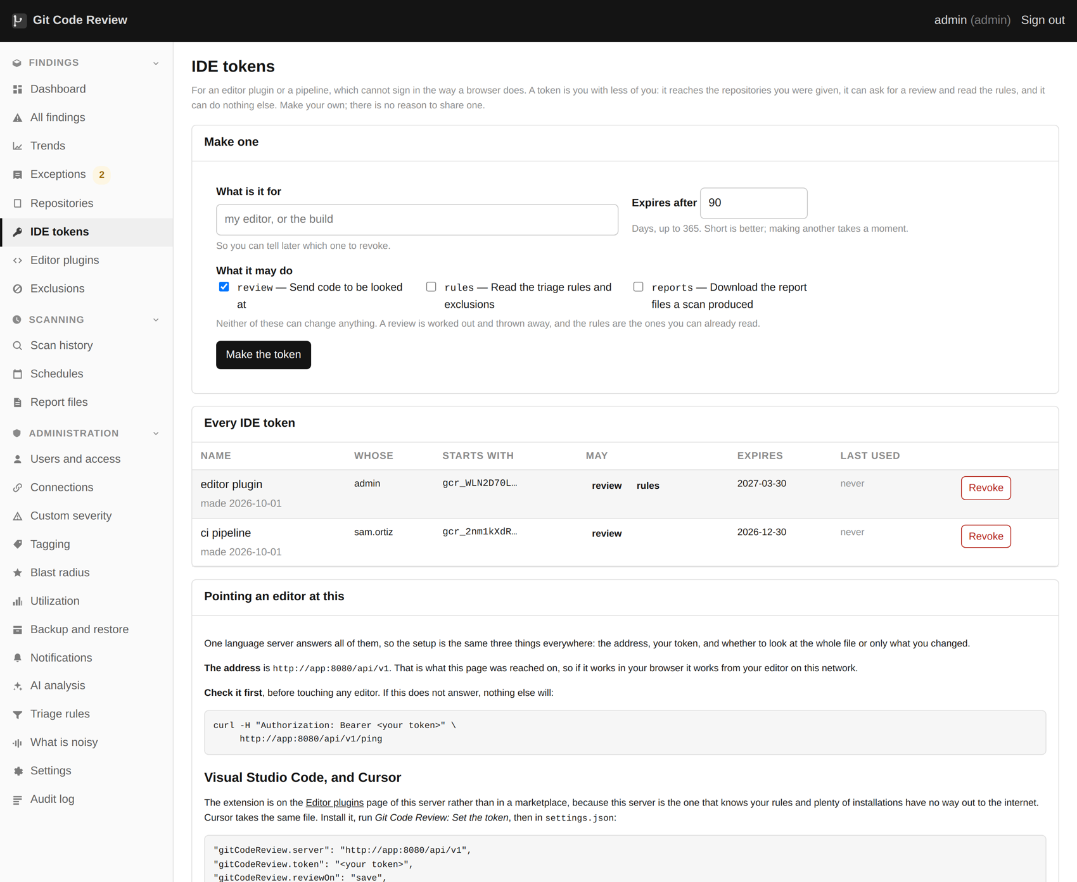
API tokens for editors and pipelines, shown once when created.

What it is
A small JSON API. You post a set of files as text and it returns credentials and code findings against them. Nothing is cloned, nothing is stored, and the tokens for it are scoped and expire. The IDE tokens page is where they are issued.

Why it exists
The cheapest possible finding is the one caught before the commit, because nothing has entered the history yet. A credential caught in an editor is a key that never leaked. The same credential caught by a nightly scan is a key that has to be rotated and a history to have a conversation about.

What this does not do
There is an API and there is no editor plugin. Somebody could write one in an afternoon and nobody has. Against every commercial product in this market, that is a real gap, and it is on the roadmap.

44. Backup and restore
What is in the database, why it is sensitive, and how to get it back.
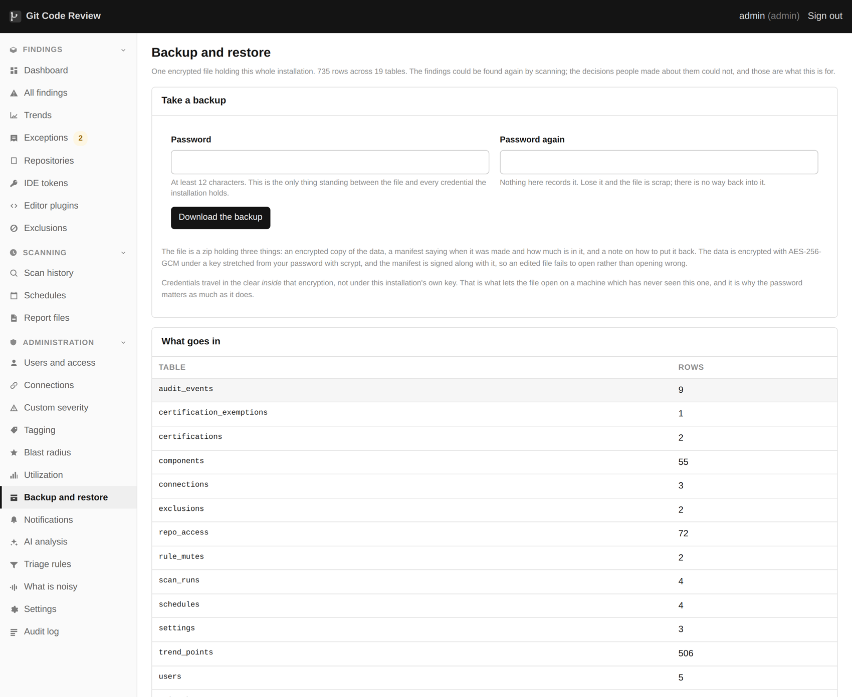
Backup and restore, encrypted with the app key.

What is worth backing up
Thing | Why
The database | Every finding, every decision, every user, and the encrypted connection credentials. This is the one that matters.
The installation secret | Without it the encrypted credentials in the database cannot be decrypted. Back it up separately from the database.
The .env file | How the installation is configured.
The report files | Only if you need the history. They are regenerated by a scan.

The database is sensitive
It holds the encrypted credentials for reading every repository you own, and a map of everywhere a secret has leaked. Treat a backup of it with the same care as a backup of a password vault, and do not put it somewhere with a wider audience than the product itself has.

Restoring
The Backup and restore page takes a backup and puts it back. What it will not do is put a backup from a newer version into an older one, because the schema moves. Restore into the same version or a newer one, and let it migrate.

What you lose if you lose the secret
The connection credentials, which are encrypted with a key derived from it. Everything else in the database is readable. Recovering from that is re-entering the tokens, which is annoying rather than fatal, but it is worth avoiding.

45. When a scan goes wrong
Interrupted, failed, or quietly finding nothing.
A scan that was interrupted or failed is shown with the reason.

Interrupted
A restart, a deploy, a stop button, or the machine running out of room. In all four cases the run keeps the repositories it had already finished, is marked interrupted rather than finished, and does not claim a clean result. Repositories it never reached are left exactly as they were, and nothing in them is counted as fixed.
The most common cause by a distance is a deploy during a scan. Checking the Scan history page before recreating the container is a habit worth building.

Failed
Where a scan fails rather than being stopped, the reason is stored with the run, including the traceback, rather than only in a container log that has since rotated. That is the difference between diagnosing a failure a week later and not.

Finding nothing, successfully
The worst failure in a security tool is the silent zero, and there are three ways to get one.
- An engine is missing. Several of them exit cleanly having done nothing when a toolchain they need is absent. The scanner refuses rather than reporting that, and names the engine.
- A credential cannot see as much as you think. The repository count at the start of a run is the number to check, and a test on the connection lists what it can actually see.
- A single sign on authorization is partial, which returns a success with repositories missing. The scanner watches for the header that says so and warns.

Reading the log
The log excerpt is on the run in the Scan history page. Full logs are in the container. What is worth grepping for first is the word warn, because the warnings are where the silent failures announce themselves.
docker compose logs --tail 500 github-code-review | grep -i warn

46. Settings
What is worth changing, and what to leave alone.
The Settings page: everything the scanner needs, in one place.
Settings. Engines, thresholds, retention and limits.

Worth changing
Setting | Why
Concurrent scans | Defaults to one. Raise it if the machine has the cores and you have several organizations.
Parallel repositories | How many repositories one scan reads at once. The limit is usually the host rate limit rather than your cores.
Container images | Off by default because it downloads. Turn it on if you build containers, which is most people.
Report retention | A nightly scan of a large estate produces a lot of files.
Notification floor | The severity below which a digest says nothing.
License policy | The deny and flag lists. The defaults are an opinion, and it should be your opinion.

Worth leaving alone
Setting | Why
History depth | Full history is the point. Shortening it is how you stop finding the things that matter most.
Branch coverage | All branches. A credential on a branch nobody merged is still a credential.
Live verification | On, unless your environment forbids the outbound call.
Engine selection | The defaults are the defaults because they are right for nearly everybody.

Secrets in settings
Every secret stored in settings is encrypted at rest with a key derived from the installation secret, is never returned by the API, is never shown back on the page once saved, and is never written to a log. A settings change appears in the audit log by name, never by value.

47. Troubleshooting
The eight things that actually go wrong.

Sign in loops forever with no error
The reverse proxy is not forwarding the original scheme, so the application believes it is on plain HTTP and refuses to set a secure cookie. Forward the scheme and the host.

The scan finds far fewer repositories than expected
The credential cannot see them. Test the connection, which reports what it can actually reach. Behind single sign on, check the token is authorized for every organization separately. With a fine grained token, remember it can only cover one resource owner.

A whole category of finding is missing
An engine is absent or a toolchain it needs is absent. The scan log names it. This is the silent zero and it is the one to check first when the numbers look too good.

The scan says temporary files are going to disk
The container does not have enough shared memory. Give it a gigabyte in the compose file. Until then, the cleartext of found credentials is being written to a disk during scans.

Mail will not send
For SMTP it is nearly always the source address rather than the message; the relay is refusing the host. For Graph it is nearly always the admin consent step, which is easy to skip and produces an unhelpful error. The test button distinguishes the four Graph failure modes.

Links in Slack or mail go nowhere
The reachable address field is empty or wrong. The product cannot know what address people use to reach it from outside.

A scan will not start
Either another is running and the concurrency limit is one, or the previous run was interrupted and has not been marked as such yet, which happens on the next boot. The Scan history page shows both states.

A finding that was fixed keeps coming back
It is in the history rather than in the current files, and deleting a secret from a file does not remove it from the commit that added it. The finding says whether it is live on a branch or exists only in history. If it is history only, the fix is a rotation plus a decision about the history, and an exception with a reason is a perfectly reasonable answer.

48. Every setting
All 91 of them, grouped, with what each is for. Generated from the product itself, so this list cannot drift from what is actually there.
Every setting has a box here, grouped by what it affects.
Secrets are marked. A setting marked as a secret is encrypted at rest, is never returned by the API, is never shown back on the page once saved, and appears in the audit log by name rather than by value.

Reaching GitHub
Setting | Default | What it does
github.api_url | https://api.github.com | Change this for GitHub Enterprise Server.
github.web_url | https://github.com | Where finding links point.
github.auth_method | pat | pat or app.
github.token (secret) | empty | A personal access token. Stored encrypted.
github.app_id | empty | GitHub App id.
github.app_installation | empty | Installation id. Leave empty to look it up.
github.app_key (secret) | empty | The App private key PEM. Stored encrypted.
github.parallel_repos | 4 | Repositories scanned at once.

What to scan
Setting | Default | What it does
scan.organizations | [] | Organizations to scan. Empty means every one the credential can see.
scan.repositories | [] | Specific repositories as owner/name. Overrides organizations when set.
scan.exclude_repos | [] | Repositories to skip.
scan.include_archived | off | Scan archived repositories too.
scan.include_forks | off | Scan forks too.
scan.max_repos | 0 | Stop after this many repositories. 0 means no limit.
scan.timeout_per_repo | 3600 | Give up on a repository after this many seconds.
scan.max_concurrent | 1 | How many scans may run at once. One keeps the old behavior. Raising it lets a slow organization stop holding up the rest of the night; scans on the same connection still share one rate limit budget.

Cloning
Setting | Default | What it does
clone.max_repo_size_mb | 4096 | Skip repositories bigger than this. 0 means no limit.

Branches and history
Setting | Default | What it does
branches.mode | all | all default or list.
branches.include | [] | Branch globs to include when the mode is list.
branches.exclude | ["dependabot/*", "renovate/*", "gh-readon... | Branch globs to skip.
branches.full_history | on | Walk every commit not just the branch heads.
branches.max_per_repo | 0 | Most branches to scan in one repository newest first. 0 is all of them.
branches.stale_days | 0 | Skip branches with no commit in this many days. 0 keeps every branch however old.

Credentials
Setting | Default | What it does
secrets.max_file_mb | 25 | Skip files bigger than this when looking for credentials. Different from the repository limit above: this one applies to each file inside a repository that is being scanned. 0 means no limit.
secrets.enabled | on | Look for credentials.
secrets.verify | on | Send candidate credentials to the provider that issued them to see if they are live.
secrets.min_entropy | 3.0 | Bits per character below which a value is treated as a placeholder.
secrets.min_length | 12 | Shorter than this and a value is treated as a placeholder.
secrets.drop_below_entropy | on | Whether low entropy on its own is enough to call something a placeholder or only counts alongside one of the patterns.
secrets.resolve_authors | on | Find the account behind each commit that introduced a credential.

Code analysis
Setting | Default | What it does
code.enabled | on | Run static analysis.
code.rulesets | ["p/default", "p/owasp-top-ten", "p/secre... | semgrep rulesets.
code.muted_rules | [] | Rules set aside as advisory. They still run and are still recorded with a reason; they just do not sit in the work list. Empty this to see everything.

Bills of material and licenses
Setting | Default | What it does
sbom.enabled | on | Build SBOMs and collect license data.
sbom.enrich | ["all"] | Look declared dependencies up on their registries to get real licenses.
sbom.scan_branches | default | default branch only or all for one SBOM per branch.
sbom.denied_licenses | ["AGPL-3.0-only", "AGPL-3.0-or-later", "S... | Licenses that fail the policy.
sbom.flagged_licenses | ["GPL-2.0-only", "GPL-3.0-only", "GPL-3.0... | Licenses that get flagged for review.

Container images
Setting | Default | What it does
images.enabled | off | Read the base image each Dockerfile names. Finds what the operating system layer carries which is where most of a critical count usually lives. Pulls images from their registries so it is off until you want it.

Vulnerabilities
Setting | Default | What it does
vulns.enabled | on | Match packages against vulnerability databases.
vulns.min_severity | all | Report at or above this. all keeps everything.

Access inventory
Setting | Default | What it does
access.enabled | on | Collect who can reach each repository.

Pull request history
Setting | Default | What it does
pulls.enabled | on | Collect pull request history.

Exclusions
Setting | Default | What it does
exclusions.enabled | on | Apply the exclusions from the Exclusions page.

Exploitation data
Setting | Default | What it does
intel.enabled | on | Rank findings with the CISA exploited list and EPSS scores. Both are free.
intel.kev_url | https://www.cisa.gov/sites/default/files/csv/"  "known_exploited_vulnerabilities.csv | The CISA known exploited vulnerabilities feed.
intel.epss_url | https://epss.empiricalsecurity.com/epss_scores-current.csv.gz | The daily EPSS scores feed.
intel.max_age_hours | 24 | Refetch the feeds when the copy on disk is older than this.

Output
Setting | Default | What it does
output.dir | /out | Where the report files are written. Mount this as a volume.
output.per_repo_files | on | Write a report per repository as well as the combined one.
output.include_clean | on | List repositories with nothing wrong in them.

Rate limits
Setting | Default | What it does
rate.min_remaining | 100 | Stop and wait when the hourly budget gets this low.
rate.adaptive_pacing | on | Slow down as the budget runs out instead of stalling at zero.
rate.max_sleep_sec | 3900 | Longest wait for the limit to reset. Has to be over 3600.
rate.retries | 5 | Retries per request.

Signing in
Setting | Default | What it does
auth.mode | empty | local oidc or both. Empty follows GCR_AUTH_MODE.

Single sign on
Setting | Default | What it does
oidc.issuer | empty | The provider's base address the one that serves the discovery document.
oidc.client_id | empty | The application id your provider issued.
oidc.client_secret (secret) | empty | The client secret. Stored encrypted.
oidc.redirect_url | empty | Where the provider sends people back to. Has to match the provider exactly.
oidc.scopes | openid profile email groups | Scopes asked for at sign in.
oidc.group_claim | groups | The claim the group names arrive in.
oidc.admin_groups | [] | Groups that get the admin role.
oidc.developer_groups | [] | Groups that get the developer role.
oidc.reader_groups | [] | Groups that get the reader role.

Sessions
Setting | Default | What it does
session.hours | 12 | How long a session lasts.
session.idle_minutes | 60 | Sign somebody out after this long doing nothing. 0 never does.

Sign in attempts
Setting | Default | What it does
login.attempt_limit | 5 | Wrong passwords before the account locks.
login.lockout_minutes | 15 | How long the lock lasts.

Transport security
Setting | Default | What it does
security.force_https | on | Mark cookies secure and send HSTS. Leave on behind TLS.
security.trusted_proxies | [] | Addresses the load balancer connects from. X-Forwarded-For is believed from these and nowhere else.

Sensitivity labels
Setting | Default | What it does
sensitivity.labels | ["PCI", "HIPAA", "SOX", "Customer Data", ... | The labels a connection can carry and the ones an exception can be told not to cover. Yours to choose: these are a starting point not a fixed list.

Notifications
Setting | Default | What it does
notify.enabled | off | Send a message when a scan finds something new.
notify.min_severity | high | The floor for the digest. A verified credential a vulnerability on the exploited list and a malicious package go out whatever this says.
notify.base_url | empty | Where this installation is reachable so a message can link to the finding. Without it a message has no link.
notify.slack_webhook (secret) | empty | A Slack incoming webhook. Stored encrypted.
notify.teams_webhook (secret) | empty | A Teams incoming webhook. Stored encrypted.
notify.webhook_url (secret) | empty | Any other endpoint sent JSON. Stored encrypted.
notify.mail_transport | smtp | smtp or graph for Microsoft 365 through the Graph API.
notify.email_to | empty | Where mail goes. Several separated by commas.
notify.graph_tenant | empty | The directory (tenant) id from the app registration.
notify.graph_client_id | empty | The application (client) id.
notify.graph_secret (secret) | empty | The client secret value. Stored encrypted.
notify.graph_sender | empty | The mailbox the message is sent as. The app registration needs Mail.Send for it.
notify.email_from | empty | The sender address.
notify.smtp_host | empty | The mail server.
notify.smtp_port | 587 | 587 for STARTTLS 465 for SSL 25 for neither.
notify.smtp_security | starttls | starttls ssl or none.
notify.smtp_user | empty | Leave empty for a server that does not ask.
notify.smtp_password (secret) | empty | Stored encrypted.

AI validation
Setting | Default | What it does
ai.provider | off | Which model answers a Validate with AI question: a hosted provider's API, an OpenAI compatible API, or a custom service. One at a time.
Provider keys and models | empty | Each provider's key, model and address. Keys are stored encrypted. ai-validation.md lists what each provider needs.
ai.custom_template | empty | For a custom service: header lines and a --data-raw body the way curl writes them. SAMPLE in the body is replaced with the question.
ai.custom_secret_header_value (secret) | empty | The custom service's secret header. Stored encrypted and added when the request goes.
ai.send_code | on | Send the lines around a finding, or the places a package is used. Never for a credential.
ai.context_lines | 40 | Lines either side of a finding to send.
ai.fetch_advisories | on | Read the advisory text from osv.dev for a vulnerable package. Only the public id is sent.
ai.max_tokens | 16000 | The longest answer to accept.
ai.timeout | 300 | Seconds to wait for an answer.

Interface
Setting | Default | What it does
ui.timezone | GMT | An IANA zone name such as America/New_York. Every time on screen is shown in it and a schedule's cron is read in it. GMT leaves everything on UTC.

49. The command line
The scanner underneath the web interface, for pipelines and for debugging.

Commands
Command | What it does
scan | The full run: credentials, bills of material, licenses and vulnerabilities. The default.
review PATH | Look at a directory already on this machine. No host, no clone, no token. Credentials and code, as JSON on standard output. This is the one a pre commit hook or an editor wants.
check | Validate the configuration, the credentials and the installed engines, then exit.
inventory | List the repositories in scope as JSON and exit.
orgs | List the organizations the credential can see, as JSON, and exit.
coverage | Count organizations, repositories and branches. Nothing is cloned.
validate FILE | Check a report against the published schema.
version | Print the version.

Options
Option | What it does
-c, --config PATH | The configuration file. Required, or set GHSCAN_CONFIG.
-o, --out DIR | Output directory, overriding the configured one.
--repo OWNER/NAME | Scan only this repository. Repeatable.
--org NAME | Scan only this organization. Repeatable.
--only WHAT | A comma separated list of: secrets, code, sbom, vulns, access, pulls.
--no-verify | Disable live credential verification. No outbound calls to issuers.
--verify | Force live credential verification on.
--fail-on WHAT | none, secrets, verified-secrets, critical, high or license.
-j, --jobs N | How many repositories to read at once.
--keep-clones | Do not delete the working clones. For debugging.
--dry-run | Resolve the scope and print the plan. Scan nothing.
--probe | With check: call every endpoint and report what the credential can reach and which permission each call needs.
--diff REF | With review: only the files changed against this reference.
--format WHAT | With review: json, the default, or sarif.
-v, --verbose | Log at debug level. Twice for trace.
-q, --quiet | Log at warning level only.
-h, --help | The usage text.

Examples
ghscan check -c /run/gcr/scanner-config.json
ghscan scan -c /run/gcr/scanner-config.json -o ./out
ghscan scan --repo acme/payments --only secrets --fail-on verified-secrets
ghscan inventory --org acme | jq -r '.[].full_name'
ghscan review .
ghscan review . --diff origin/main
ghscan review . --only secrets --fail-on secrets
ghscan review . --format sarif --repo acme/payments > review.sarif

Exit codes
Code | Meaning
0 | Completed, nothing above the --fail-on threshold
1 | Something went wrong
2 | Bad usage: an unknown flag or a missing argument
3 | Completed, and findings met the --fail-on threshold

50. What is in a finding
The fields on a finding in the JSON report, for anybody building something on top.
Everything that is in a finding, on one page.

Always present
Field | What it is
id | Stable across scans, so the same finding is recognisable over time
category | credential, code, dependency, misconfiguration, image or license
severity | The grade in force, after any override your organization has applied
engine_severity | What the engine originally said, kept so both are visible
organization, repository | Where it is
file, start_line | Where in it, where that makes sense
rule_id, rule_name, detector | What found it
first_seen, last_seen | When it appeared and when it was last confirmed
engines | Every engine that reported it, so agreement is visible

On a credential finding
Field | What it is
secret_fingerprint | A SHA-256 hash of the value. The same key found elsewhere hashes the same.
preview | The masked value: first four characters, then stars, then the last three
verified | Whether the issuing provider confirmed the key still works
branches | Which branches it is live in
history_only | True when it exists only in commit history, not in any current file
introduced_commit | The commit that added it, so the age of the exposure is known
triage | The verdict and the sentence that justifies it

On a dependency finding
Field | What it is
package, version, ecosystem | What it is and where it came from
advisory | The identifier, usually a CVE or a GHSA
kev | Whether it is on the published list of vulnerabilities being exploited
epss | The published probability of exploitation in the next thirty days
reachability | reachable, unlikely or unknown, with the sentence behind it
malicious | True when the package is the attack rather than a package with a hole
fixed_in | The version to move to, where there is one
direct | Whether you asked for this package or something else did

When somebody has decided something
Field | What it is
excluded_by | The reason, the reviewer, the date, the expiry and which rule matched
exception | The reason, who approved it and when it lapses
severity_override | What it was changed to, by whom, and why
recommended_severity | A lower grade the product is suggesting, with the reasoning

51. Glossary
Every term this guide uses that is not obvious.
Term | What it means here
Baseline | A date. Findings older than it are counted but kept out of the work list.
Blast radius | Who can reach a repository and what would be reachable through it.
CISA KEV | A published list of vulnerabilities known to be exploited in the wild.
Connection | One host, one credential, one scope. Where some of your code lives.
CycloneDX | A standard format for a bill of materials, and for VEX.
Detector | The specific pattern inside an engine that matched.
EPSS | A published score: the probability a vulnerability will be exploited in the next thirty days.
Engine | One of the ten open source programs that do the reading.
Exception | A decision about one finding, with a reviewer, a reason and an expiry.
Exclusion | A rule that sets aside whatever matches it, now and in future scans.
Fingerprint | A hash of a credential value. The same secret hashes the same wherever it is.
History only | A credential that is not in any current file but is in a commit.
IaC | Infrastructure as code: servers and clusters described in files.
Ingest | Reading a completed scan into the database.
KEV | See CISA KEV.
Live verification | Asking a credential's issuer whether it still works.
Malicious package | A package that is the attack, rather than a package with a hole in it.
Reachability | Whether your application can call a vulnerable package at all.
Rule mute | Setting aside everything one rule will ever produce. Needs two administrators.
SARIF | A standard format for static analysis results, read by most security tooling.
SBOM | A bill of materials: the list of everything in a piece of software.
Sensitivity | What a repository holds, which changes how its findings are ranked.
SPDX | The other standard format for a bill of materials.
Triage | Deciding what an engine's output actually means before anybody sees it.
Typosquat | A malicious package named one character away from a popular one.
VEX | A supplier's statement about which vulnerabilities in their product matter.

52. What this cannot do
Every limit in this guide, collected. Read this one before you decide.

It reads, and never writes
No fix pull requests, no key revocation, no changes to anybody's settings, no writes to any repository. This is a design decision rather than a missing feature and it is not going to change. Commercial products offer automatic fix pull requests and some people value them highly.

Static analysis depth
Free semgrep reads one file at a time. gosec closes this for Go and bandit helps for Python. For Java, PHP and Ruby, a tainted value crossing a file boundary is invisible, and that is the clearest gap in the product.

Reachability is a heuristic
Three facts about the dependency tree, not a call graph. It says so on every finding. A commercial product that builds a real call graph makes a stronger claim than this does.

The vulnerability data is public
OSV, the GitHub advisory database and the national vulnerability database. Curated commercial feeds are frequently earlier. That is the main thing a license buys.

Only GitHub Actions pipelines
Jenkins, GitLab CI, Azure Pipelines and the rest are not read, and they have the same problems.

Subversion and Perforce have no history pass
Neither is git. Everything that reads files works; the credential history walk, which is where most leaked keys are, does not.

There is no trend reporting
Everything on the screen is the state today. There is no chart of the last ninety days and nothing that answers "are we getting better". The data is there; the reporting is not.

There is an editor API and no editor plugin
Somebody could write one in an afternoon and nobody has.

It notifies, it does not open the ticket
No integration with an issue tracker. A webhook and somebody else's automation is the answer today.

It is one machine
The database would replicate today, unplanned: every table is InnoDB with a primary key. The application would not, because the scan lock is a lock in one process. At a thousand developers that matters.

There is no support to buy
Bugs and questions go to the repository. This is a tool somebody wrote because the commercial answer cost more than the problem was worth to their employer, and it is offered on exactly those terms.

53. Where to go next
The three things worth doing in the first month.

Week one: know what you have
One connection, one scan, one hour of tuning with somebody who knows the estate. Do not invite anybody else until the first list is honest, because the first impression of a security tool is the one that decides whether anybody opens it again.

Week two: make it a habit
Schedules per organization overnight. Notifications on what is new, into a channel the right people already read. A monthly ten minutes on the exceptions that are about to expire. None of these are hard and all of them are what turns a scan into a practice.

Week three: put the context in
Export the tagging spreadsheet, fill in what your asset list already knows, import it back. Set the sensitivity labels on your connections. This is the least glamorous hour in this guide and it improves the ranking of every finding the product will ever produce.

And then
Pick one pipeline and fail its build on new credentials only. Once that has been running for a month without anybody complaining, do the next one. Working backwards from the nightly scan towards the moment the code is written is the whole direction of travel, and it is much easier to do one repository at a time than all at once.

