

OPERATINGSYSTEMS  
FINALPROJECT

By

Thejus Rao – [th2833@nyu.edu](mailto:th2833@nyu.edu)

Stephanie Hou - [sh6403@nyu.edu](mailto:sh6403@nyu.edu)

**Table of Contents**

Working environment 3

Experiments 4

The Build Code 5

Part one - Basics 6

In write mode 6

In read mode 7

Code 8

Part two - Measurement 13

Code 14

Part three – Raw Performance 18

Testing Files 19

Observations 22

Part four - Caching 23

Trends 26

Observations 28

Part five – System Calls 29

Observations 30

Part six – Raw Performance 32

Approach taken to extract performance 33

Code 34

## Working environment

All tests in this document were performed on a 64-bit version of Ubuntu 22.10 in a virtual machine environment. The system has the following specifications – 4GB of RAM, disk capacity of 20GB, and a Ryzen 5900X x86 64-bit processor with 4 threads.

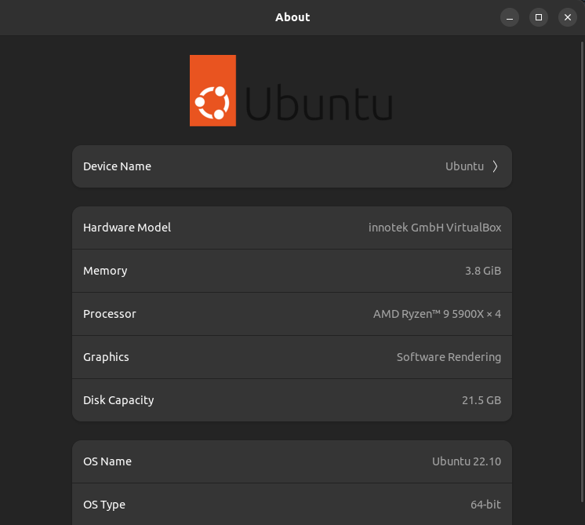

## Experiments

A bunch of randomly generated text files, in addition to

* ubuntu-21.04-desktop-amd64.iso (provided in the question statement),
* AMD-Ryzen-Master.exe,
* android-studio.zip

were used to check the performance of the program. The file sizes are given below   
( ls -lh lists the sizes in megabytes for reference, ls -l lists it in bytes):

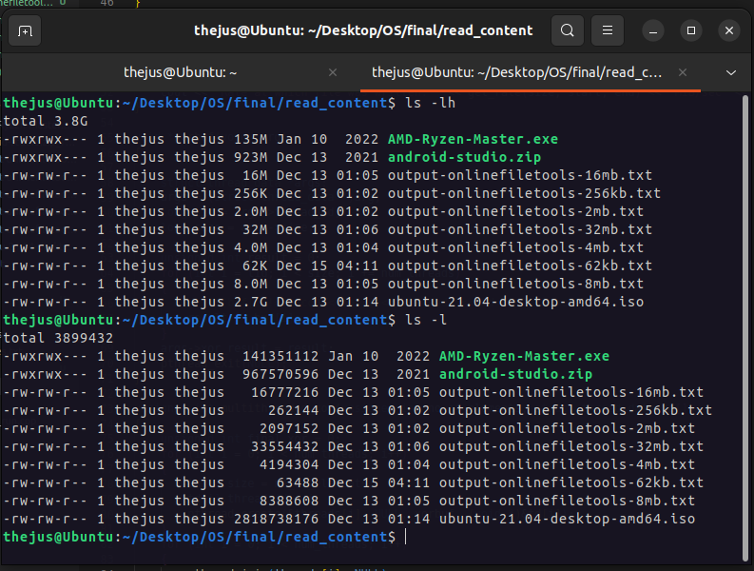

## The Build Code

Since the question statement quoted we could use either C/C++, and bash for the build script, we used C++ to code run, run2, and fast bash for the build.sh file.

The build.sh file:

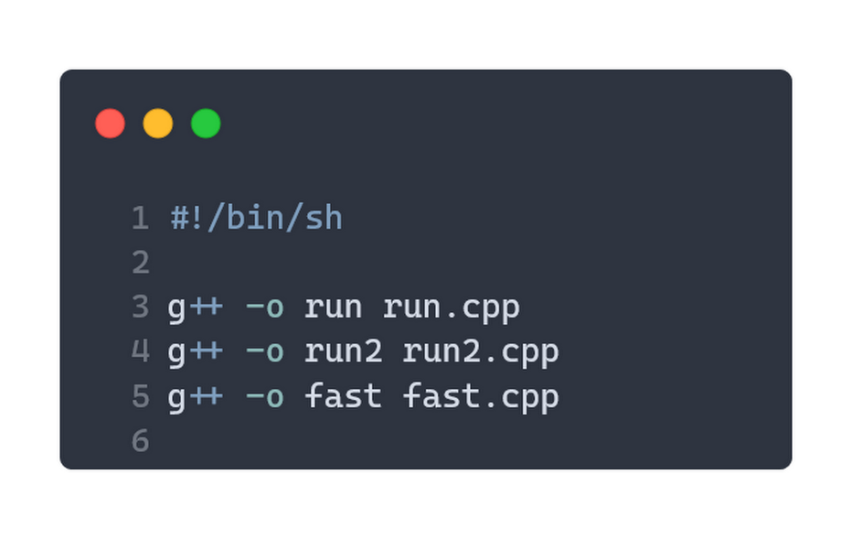

## Part one - Basics

The program is run according to the following parameters: ./run <filename> [-r|-w] <block_size> <block_count>. Upon running we get the following outputs:

### In write mode

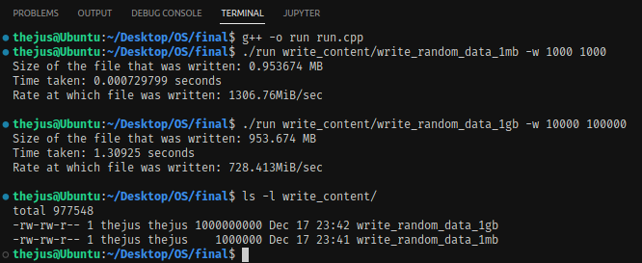

The contents of the file will be garbage values, i.e the contents inside memory. Here is a sample (binary data inside, so rendering is flawed):

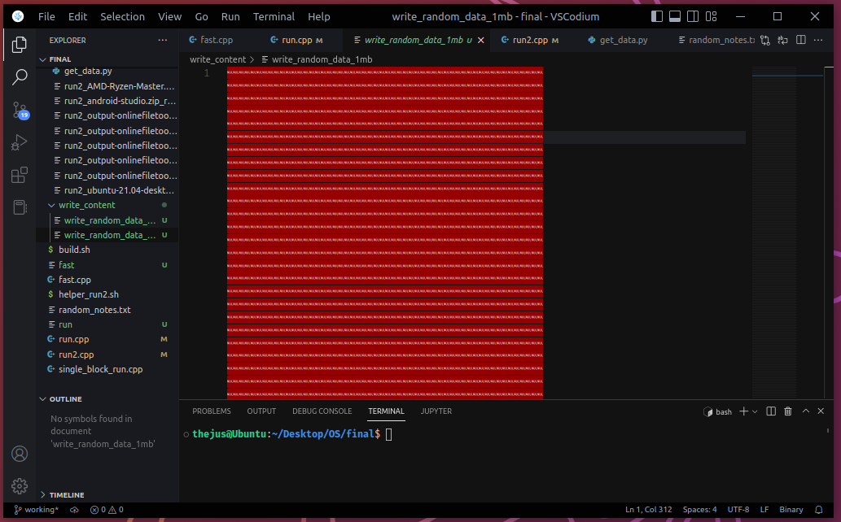

Note: In write mode, we are using a char array, unlike in read mode where we use an int array. This is because we would cast the int buffer into a char * anyway, as the fstream object write function takes only a char* type argument (along with bytes to write as the next argument)

### In read mode

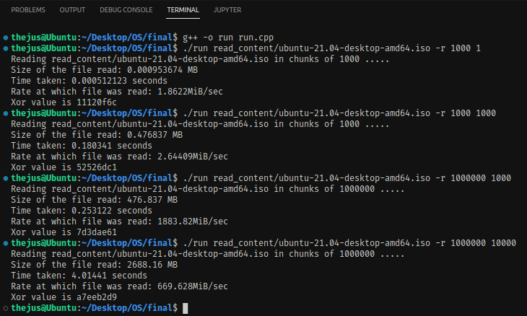

Here, we are varying different block counts and block sizes. We can see that **the xor values will be different depending on the number of bytes it reads from the file**. block_size*block_count will give the total number of bytes read. If block_size*block_count > size-of-file, then it will read size-of-file bytes. We can see above from the last execution of ./run that the xor value of a7eeb2d9 is the correct, despite block_size*block_count slightly exceeding the size of the file.

Note: If block_size is not divisible by four, then it will default to rounding upwards. The program works fine with no issues, this case is handled.

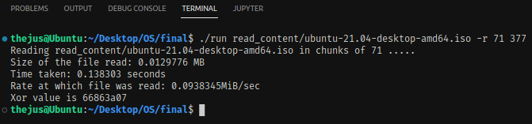

Code **– run.cpp**

#include <iostream>

#include <cstring>

#include <fstream>

#include <string>

#include <sys/time.h>

#include <pthread.h>

using namespace **std**;

int num_threads = 4;

char *buffer;

unsigned int *buf;

**pthread_t** *threads;

struct **thread_data**

{

    unsigned int thread_id;

    unsigned int size;

    unsigned int xor_result;

};

double **now**()

{

    struct **timeval** tv;

**gettimeofday**(&tv, 0);

    return tv.tv_sec + tv.tv_usec / 1000000.0;

}

double **get_rate**(double size, double start, double end)

{

    return size / ((end - start) * 1024 * 1024);

}

void **perror**(**string** s)

{

    cout **<<** "Error! " **<<** s **<<** **endl**;

**exit**(0);

}

void **print_performance**(double size, double start, double end, unsigned int block_count, unsigned int final_xor)

{

    cout **<<** "Number of blocks read: " **<<** block_count **<<** " blocks" **<<** **endl**;

    cout **<<** "Size of the file read: " **<<** (size / (1024 * 1024)) **<<** " MB" **<<** **endl**;

    cout **<<** "Time taken: " **<<** (end - start) **<<** " seconds" **<<** **endl**;

    cout **<<** "Rate at which file was read: " **<<** **get_rate**(size, start, end) **<<** "MiB/sec" **<<** **endl**;

**printf**("Xor value is %08x", final_xor);

}

void **print_performance_w**(double size, double start, double end)

{

    cout **<<** "Size of the file that was writte: " **<<** (size / (1024 * 1024)) **<<** " MB" **<<** **endl**;

    cout **<<** "Time taken: " **<<** (end - start) **<<** " seconds" **<<** **endl**;

    cout **<<** "Rate at which file was written: " **<<** **get_rate**(size, start, end) **<<** "MiB/sec" **<<** **endl**;

}

void \***xorbuf**(void *arg)

{

    struct **thread_data** *args;

    args = (struct **thread_data** *)arg;

    long tid = args->thread_id;

    long size = args->size;

    unsigned int result = 0;

    for (int i = tid; i < size; i += num_threads)

    {

*// if(buf[i]!=0) cout<<buf[i]<<" thread "<<tid<<" "<<i<<endl;*

        result ^= buf[i];

    }

    args->xor_result = result;

**pthread_exit**(**NULL**);

}

unsigned int **multithreaded_xor**(unsigned int no_of_elements, struct **thread_data** td[])

{

    unsigned int final_xor = 0;

    for (int i = 0; i < num_threads; i++)

    {

        td[i].size = no_of_elements;

        td[i].thread_id = i;

**pthread_create**(&threads[i], **NULL**, **xorbuf**, (void *)&td[i]);

    }

    for (int i = 0; i < num_threads; i++)

    {

**pthread_join**(threads[i], **NULL**);

    }

    for (int i = 0; i < num_threads; i++)

    {

        final_xor = final_xor ^ td[i].xor_result;

    }

    return final_xor;

}

int **main**(int argc, char *argv[])

{

    unsigned int block_size = 0, block_count = 0, size=0;

    bool read_mode = false, write_mode = false;

    double start, end;

**string** file_name = "";

    struct **thread_data** td[num_threads];

    if (argc != 5)

**perror**("Too few arguments!");

    else

    {

**string** s = argv[2];

        file_name **=** argv[1];

        read_mode = ("-r" **==** s || "-R" **==** s);

        write_mode = ("-w" **==** s || "-W" **==** s);

        block_size = (unsigned int)**stoi**(argv[3]);

        block_count = (unsigned int)**stoi**(argv[4]);

*// cout<<"---"<<block_size<<"--"<<block_count<<endl;*

    }

**srand**(**time**(**NULL**));

    size = block_count * block_size;

    if (read_mode)

    {

        unsigned int no_of_blocks_elapsed = 0, final_xor = 0, size_of_buf;

        unsigned int no_of_elements = (unsigned int)(block_size / sizeof(int) + block_size % sizeof(int));

        size_of_buf = no_of_elements * sizeof(int);

        buf = (unsigned int *)**malloc**(size_of_buf);

        start = **now**();

**ifstream** object;

        object.**open**(file_name, **ios**::binary);

        if (object.**fail**())

            cout **<<** "Can't read file " **<<** file_name;

        else

        {

            cout **<<** "Reading " **<<** file_name **<<** " in chunks of " **<<** block_size **<<** " ..... " **<<** **endl**;

            threads = (**pthread_t** *)**malloc**(sizeof(**pthread_t**) * num_threads);

            if (!threads)

**perror**("out of memory for threads!");

            while (object.**read**((char *)buf, size_of_buf))

            {

                final_xor ^= **multithreaded_xor**(no_of_elements, td);

                if (block_size * ++no_of_blocks_elapsed >= size)

                    break;

            }

            if (object.**gcount**() < block_size && object.**gcount**() > 0)

            {

                final_xor ^= **multithreaded_xor**(object.**gcount**() / sizeof(unsigned int), td);

            }

*// cout<<"----"<<object.gcount()<<endl;*

            end = **now**();

**print_performance**(size, start, end, block_count, final_xor);

        }

    }

    else if (write_mode)

    {

        start = **now**();

**ofstream** **object**(file_name);

        buffer = new char[size];

        for (unsigned int i = 0; i < block_count; i++)

        {

            object.**write**(buffer, size);

        }

        end = **now**();

**print_performance_w**(size, start, end);

    }

    else

    {

**perror**("Please check your arguments and specify if its -r/-w");

    }

    cout **<<** "\n";

    return 0;

}

## Part two - Measurement

The program is run according to the following parameters: ./run2 <filename> [-r|-w] <block_size> Upon running we get the following outputs:

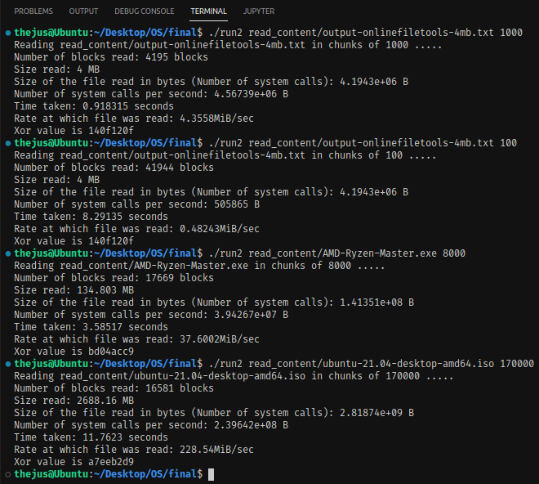

The program takes in a file and a given block_size, and reads accordingly. It reads the entire file, it finishes execution and gives us the output, as shown above.

Code **– run2.cpp**

#include <iostream>

#include <cstring>

#include <fstream>

#include <string>

#include <sys/time.h>

#include <pthread.h>

using namespace **std**;

int num_threads = 4;

char *buffer;

unsigned int *buf;

**pthread_t** *threads;

struct **thread_data**

{

unsigned int thread_id;

unsigned int size;

unsigned int xor_result;

};

double **now**()

{

struct **timeval** tv;

**gettimeofday**(&tv, 0);

return tv.tv_sec + tv.tv_usec / 1000000.0;

}

double **get_rate**(double size, double start, double end)

{

return size / ((end - start) * 1024 * 1024);

}

void **print_error**(**string** s)

{

cout **<<** "Error! " **<<** s **<<** **endl**;

**exit**(**EXIT_FAILURE**);

}

void **print_performance**(double size, double start, double end, unsigned int block_count, unsigned int final_xor, int flag)

{

cout **<<** "Number of blocks read: " **<<** block_count **<<** " blocks";

if (flag == 1)

{

cout **<<** " (file not fully read, program exceeded time limit of 15s and was terminated)";

}

cout **<<** **endl**;

cout **<<** "Size read: " **<<** (size / (1024 * 1024)) **<<** " MB" **<<** **endl**;

cout **<<** "Size of the file read in bytes (Number of system calls): " **<<** (size) **<<** " B" **<<** **endl**;

cout **<<** "Number of system calls per second: " **<<** (size/(end-start)) **<<** " B" **<<** **endl**;

cout **<<** "Time taken: " **<<** (end - start) **<<** " seconds" **<<** **endl**;

cout **<<** "Rate at which file was read: " **<<** **get_rate**(size, start, end) **<<** "MiB/sec" **<<** **endl**;

**printf**("Xor value is %08x", final_xor);

}

void \***xorbuf**(void *arg)

{

struct **thread_data** *args;

args = (struct **thread_data** *)arg;

long tid = args->thread_id;

long size = args->size;

unsigned int result = 0;

for (int i = tid; i < size; i += num_threads)

{

*// if(buf[i]!=0) cout<<buf[i]<<" thread "<<tid<<" "<<i<<endl;*

result ^= buf[i];

}

args->xor_result = result;

**pthread_exit**(**NULL**);

}

unsigned int **multithreaded_xor**(unsigned int no_of_elements, struct **thread_data** td[])

{

unsigned int final_xor = 0;

for (int i = 0; i < num_threads; i++)

{

td[i].size = no_of_elements;

td[i].thread_id = i;

**pthread_create**(&threads[i], **NULL**, **xorbuf**, (void *)&td[i]);

}

for (int i = 0; i < num_threads; i++)

{

**pthread_join**(threads[i], **NULL**);

}

for (int i = 0; i < num_threads; i++)

{

final_xor = final_xor ^ td[i].xor_result;

}

return final_xor;

}

int **main**(int argc, char *argv[])

{

unsigned int block_size = 0, block_count = 0, final_xor = 0, size = 0;

double start, end;

**string** file_name = "";

struct **thread_data** td[num_threads];

if (argc != 3)

**print_error**("Check arguments!");

else

{

file_name **=** argv[1];

block_size = (unsigned int)**stoi**(argv[2]);

}

**srandom**(**time**(**NULL**));

unsigned int no_of_elements = (unsigned int)((block_size + sizeof(int) - 1) / sizeof(int));

unsigned int size_of_buf = no_of_elements * sizeof(int);

int flag = 0;

buf = (unsigned int *)**malloc**(size_of_buf);

*// memset(buf,0,no_of_elements*sizeof(int));*

*// cout<<no_of_elements<<" ----- "<<size<<" ----- "<<sizeof(buf)<<"-----"<<(no_of_elements * sizeof( unsigned int))<<endl;*

start = **now**();

**ifstream** object;

object.**open**(file_name, **ios**::binary);

if (object.**fail**())

**print_error**("Cannot read file!");

else

{

cout **<<** "Reading " **<<** file_name **<<** " in chunks of " **<<** block_size **<<** " ..... " **<<** **endl**;

*// cout<<"buf4-----"<<buf[4]<<endl;*

threads = (**pthread_t** *)**malloc**(sizeof(**pthread_t**) * num_threads);

if (!threads)

**perror**("out of memory for threads!");

while (object.**read**((char *)buf, size_of_buf))

{

final_xor ^= **multithreaded_xor**(no_of_elements, td);

block_count++;

size += object.**gcount**();

*// if ((end = now()) - start > 15)*

*// {*

*// flag = 1;*

*// break;*

*// }*

}

size = block_count*block_size;

if (object.**gcount**() < block_size && object.**gcount**() > 0 && flag == 0)

{

final_xor ^= **multithreaded_xor**(object.**gcount**() / sizeof(unsigned int), td);

block_count++;

size += object.**gcount**();

}

*// cout<<"----"<<object.gcount()<<endl;*

end = **now**();

**print_performance**(size, start, end, block_count, final_xor, flag);

}

cout **<<** "\n";

return 0;

}

## Part three – Raw Performance

In order to avoid program biases and variations, and mostly in order to test out different scenarios, we used different files. The files we used are:

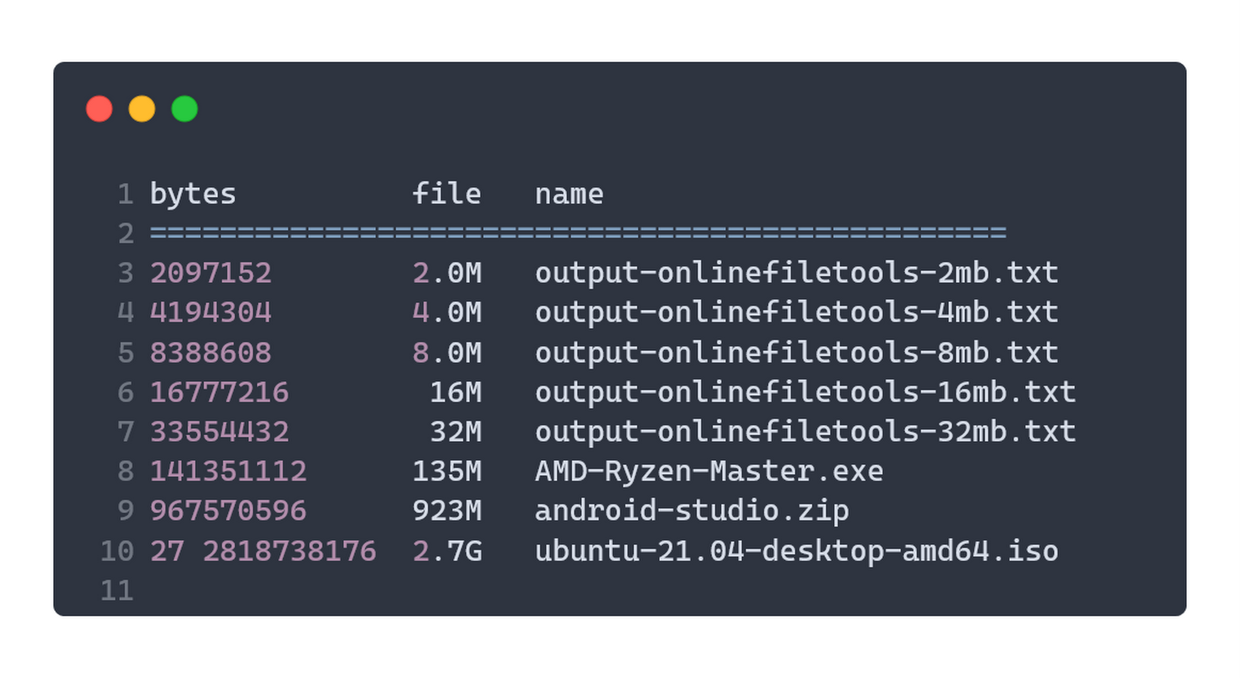

The graphs for performance (MB/sec) vs block_size (bytes) for each of the files are given below. X-axis corresponds to the block_size and Y-axis gives the performance.

For each of the above files, we have collected the following data:

* Block size in bytes
* Rate in MB/sec
* Time taken in seconds
* Size in Megabytes

For reference, 1 MB = 1024x1024 bytes.

Care has been taken to ensure other I/O tasks were not taking place at the same time, CPU was free the time of operation and all the available memory was not otherwise occupied in order to obtain accurate results.

Testing Files

**run2_output-onlinefiletools-2mb.txt**

|  |  |  |
| --- | --- | --- |
| **Block Size in Bytes** | **Rate in MB/sec** | **Time taken in sec** |
| 60 | 0.0980585 | 20.396 |
| 100 | 0.164238 | 12.1774 |
| 300 | 0.500106 | 3.99915 |
| 1000 | 1.7063 | 1.17212 |
| 2000 | 3.40903 | 0.586677 |
| 4000 | 6.78633 | 0.29471 |
| 8000 | 11.3935 | 0.175538 |

**run2_output-onlinefiletools-4mb.txt**

|  |  |  |
| --- | --- | --- |
| **Block Size in Bytes** | **Rate in MB/sec** | **Time taken in sec** |
| 60 | 0.101735 | 39.318 |
| 100 | 0.173402 | 23.0678 |
| 300 | 0.502205 | 7.96487 |
| 1000 | 1.69449 | 2.36059 |
| 2000 | 3.24666 | 1.23203 |
| 4000 | 6.27926 | 0.637018 |
| 8000 | 9.06908 | 0.441059 |
| 20000 | 6.66799 | 0.599881 |

**run2_output-onlinefiletools-8mb.txt**

|  |  |  |
| --- | --- | --- |
| **Block Size in Bytes** | **Rate in MB/sec** | **Time taken in sec** |
| 300 | 0.504379 | 15.8611 |
| 512 | 0.840117 | 9.52248 |
| 1000 | 1.68361 | 4.7517 |
| 2000 | 3.35301 | 2.38592 |
| 4096 | 7.01725 | 1.14005 |
| 8000 | 13.4298 | 0.595691 |
| 20000 | 32.9639 | 0.24269 |

**run2_output-onlinefiletools-16mb.txt**

|  |  |  |
| --- | --- | --- |
| **Block Size in Bytes** | **Rate in MB/sec** | **Time taken in sec** |
| 680 | 1.02944 | 15.5424 |
| 1000 | 1.51158 | 10.585 |
| 2000 | 2.5552 | 6.26175 |
| 4096 | 6.49084 | 2.46501 |
| 8000 | 12.9742 | 1.23321 |
| 20000 | 15.7881 | 1.01342 |

**run2_output-onlinefiletools-32mb.txt**

|  |  |  |
| --- | --- | --- |
| **Block Size in Bytes** | **Rate in MB/sec** | **Time taken in sec** |
| 1000 | 1.69476 | 18.8818 |
| 1500 | 2.50447 | 12.7772 |
| 2000 | 3.46356 | 9.23905 |
| 4096 | 6.66941 | 4.79802 |
| 8000 | 13.3097 | 2.40427 |
| 20000 | 33.3101 | 0.96067 |
| 40000 | 62.3464 | 0.513261 |

**AMD-Ryzen-Master.exe**

|  |  |  |
| --- | --- | --- |
| **Block Size in Bytes** | **Rate in MB/sec** | **Time taken in sec** |
| 2000 | 3.29764 | 40.8786 |
| 4096 | 7.03181 | 19.1704 |
| 8000 | 13.3513 | 10.0966 |
| 20000 | 32.188 | 4.18798 |
| 40000 | 64.9727 | 2.07476 |
| 80000 | 122.63 | 1.09926 |

**android-studio.zip**

|  |  |  |
| --- | --- | --- |
| **Block Size in Bytes** | **Rate in MB/sec** | **Time taken in sec** |
| 20000 | 24.531 | 37.6156 |
| 40000 | 60.504 | 15.251 |
| 80000 | 126.447 | 7.2975 |
| 120000 | 179.527 | 5.13987 |

**ubuntu-21.04-desktop-amd64.iso**

|  |  |  |
| --- | --- | --- |
| **Block Size in Bytes** | **Rate in MB/sec** | **Time taken in sec** |
| 20000 | 30.1109 | 89.2754 |
| 40000 | 54.8533 | 49.0063 |
| 80000 | 92.5068 | 29.059 |
| 120000 | 120.994 | 22.2174 |
| 200000 | 194.823 | 13.7979 |

### Observations

We can see from the above data that the **performance increases almost linearly with block size**. There were a couple of variations, such as:

* run2_output-onlinefiletools-4mb.txt - We can chalk this down to run-to-run variance, as the files bigger/smaller and block sizes bigger/smaller do not exhibit the same behaviour. Its quite likely that the system was performing that some other I/O task and as a result performance dipped.
* run2_output-onlinefiletools-16mb.txt - This is likely either the same case as above, or could be that performance plateau over time with increasing block sizes, or a combination of the two. Or perhaps the file was in cache at the block size of 8000, resulting in diminishing gains on increasing block size.

There are a couple of things to keep in mind, such as

* Higher and higher values of block sizes lead to the program using more memory than it should, and also causes memory fragmentation.
* At some point increasing the block size does not linearly improve performance, i.e. we get diminishing returns.

## Part four - Caching

First, we create a file of variable size (say, 1GB) using ./run . Then, since we are in a linux environment, instead of rebooting, we clear the cache using the given command and read the file.

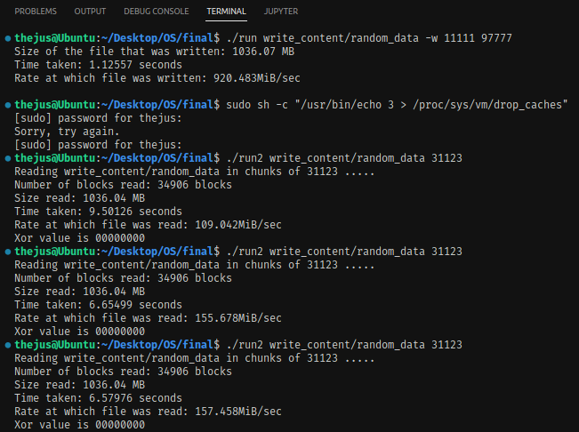

The first time it reads the file, it takes about 9.5 seconds to read the file. The second time, it takes about 6.65 seconds. If we were to increase the block size from **31,123 to 70,000**, then:

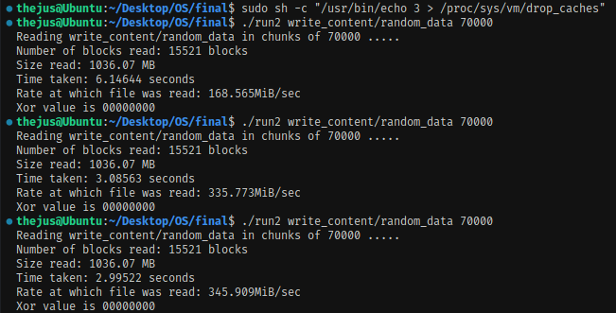

The first time it reads the file, it takes about 6.146 seconds to read the file. The second time, it takes about 3.08 seconds, and the third, 2.99 seconds. That’s an improvement of a factor of more than 2X. On increasing it from **70,000 to 311,232**, we get:

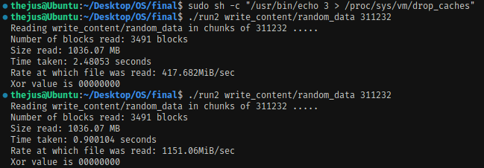

It takes 2.48 seconds on the first try, and on the second it takes 0.9 seconds. That’s an even bigger factor compared to 2X. Finally, on increasing it to **700,000 blocks,** we get:

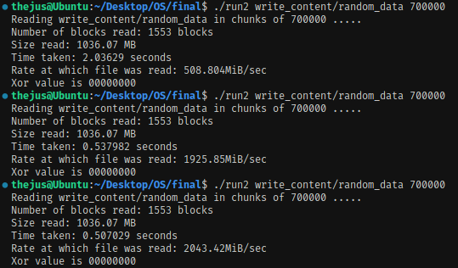

|  |  |  |  |  |
| --- | --- | --- | --- | --- |
|  | **Pre-cached** |  | **Cached** |  |
| **Block size** | **Performance in MB/sec** | **Time taken in sec** | **Performance in MB/sec2** | **Time taken in sec3** |
| 31123 | 109.0142 | 9.50126 | 157.458 | 6.57926 |
| 70000 | 168.565 | 6.14644 | 345.909 | 2.99522 |
| 311232 | 417.682 | 2.48053 | 1151.06 | 0.900104 |
| 700000 | 508.804 | 2.03628 | 2043.42 | 0.507029 |

On plotting a block size vs performance graph for the file tested, for cached vs pre-cached performance, we get the below graph:

### Trends

We can see from the above that the larger the block size is relative to the file, the greater the performance. However, while the benefits of larger block sizes slow down over time, the performance the file is cached increases linearly. We will attempt to replicate this with a file of smaller file size and see if the results hold true

**Note: Why the Xor value of the above file gives 0**

We are writing via a char array will be populated with the null char literal. The value of which is \u0000.

char is a primitive type. This means that it can never hold null, so like int, double and the rest, it needs some starting value. For int it's 0, for char it's \u0000, which **evaluates to 0**. And **0 XOR 0 = 0**

**write_content/10mb_file**

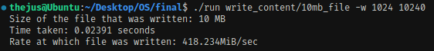

|  |  |  |  |  |
| --- | --- | --- | --- | --- |
|  | **Pre-cached** |  | **Cached** |  |
| **Block size** | **Performance in MB/sec** | **Time taken in sec** | **Performance in MB/sec2** | **Time taken in sec3** |
| 200 | 0.923859 | 10.6719 | 0.962077 | 10.3942 |
| 550 | 2.67721 | 3.83027 | 2.54597 | 3.91354 |
| 6000 | 20.9551 | 0.477211 | 24.2486 | 0.412395 |
| 15000 | 40.9621 | 0.244128 | 40.5319 | 0.246719 |

### Observations

Cache seems to come into play only at larger block sizes. At smaller sizes it seems to have minimal effect on the performance of I/O operations. To prove this, we ran it at an extremely large block size and got a reduction in running time.

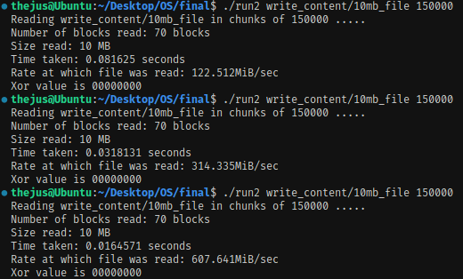

**Extra credit**

Why ‘3’ in sudo sh -c "/usr/bin/echo 3 > /proc/sys/vm/drop_caches"?

Because /proc/sys/vm/drop_caches is a sysctl file that has 3 modes.

* Mode “1” will free the page cache - buffered I/O, other OS data
* Mode “2” will free slab objects, dentries and inodes – dnodes are representations of folders, inodes represent files, both of which store cache.
* Mode “3” will essentially free up all of the above.

So, we use mode 3 to clear all cache. As for the rest of the command, the /usr/bin/echo 3 can be replaced simply with “echo 3” , and sh tells linux that we can execute drop_caches using the old unix command interpreter, even if the extension is not sh (my ubuntu recognizes it as a “plain text document”.

We went from 0.0816 seconds to 0.016457 seconds. That’s an improvement factor of 4.958.

## Part five – System Calls

We modified the ./run2 code in order to measure system call overhead. We also removed the XOR function call as that incurs a large performance penalty and hence not conducive to measuring system call performance. The logic for measuring system calls is given below.

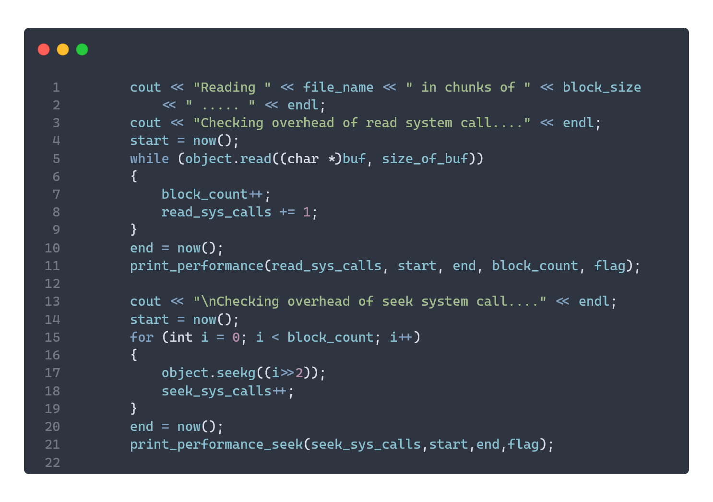

The above program seeks purely to measure the system call performance. On running certain tests, we can see that on average, the seekg system call is almost twice as fast as read, meaning it incurs less overhead.

**Output is given below**

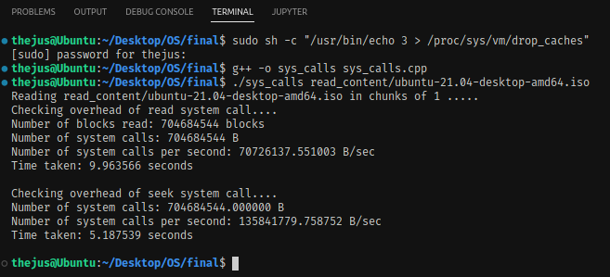

### Observations

For the Read and seek system call tests

|  |  |  |  |  |
| --- | --- | --- | --- | --- |
|  | **Read** |  | **Seekg** |  |
| **Number of system calls** | **System calls in B/sec** | **Time taken in sec** | **System calls in B/sec** | **Time taken in sec2** |
| 15872 | 83111102 | 0.000191 | 142858354 | 0.000111 |
| 35337778 | 67802360 | 0.521188 | 132346284 | 0.26701 |
| 241892649 | 60023284 | 4.02998 | 136776410 | 1.768526 |
| 704684544 | 72935218 | 9.661787 | 134659127 | 5.233099 |

On graphing it out, we get

Looking at the rate of **syscalls per second vs time**, we get:

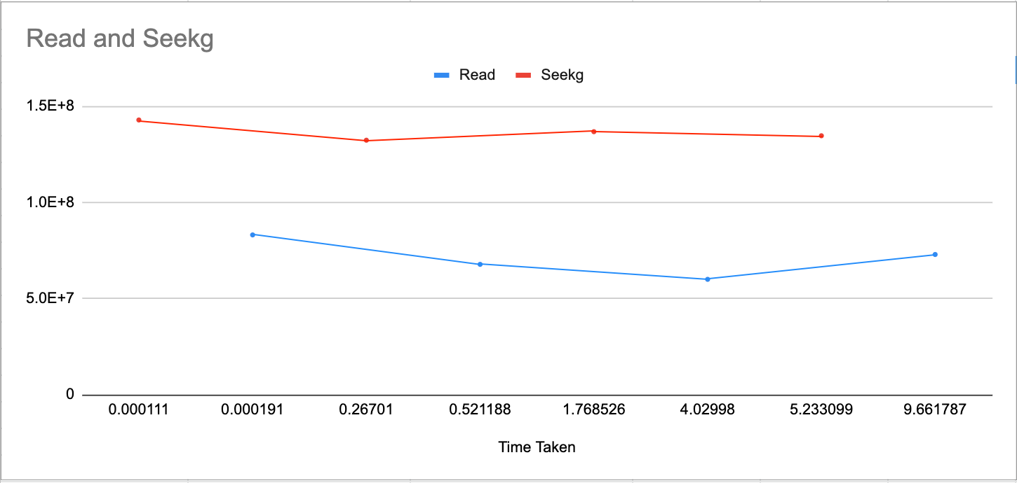

**Seekg has almost half the overhead as read.**

## Part six – Raw Performance

The program is run according to the following parameters: ./fast <filename>. Upon running we get the following output:

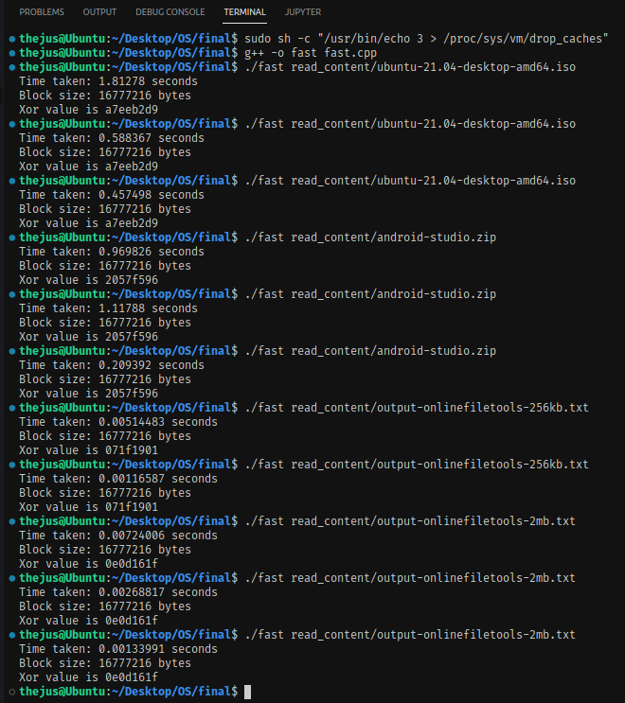

We can see from the above runs:

* ubuntu-21.04-desktop-amd64.iso
  + Pre-cached result: 1.81278 seconds
  + Cached result: 0.457498 seconds
* android-studio.zip
  + Pre-cached result: 0.969826 seconds
  + Cached result: 0.209392 seconds
* output-onlinefiletools-256kb.txt
  + Pre-cached result: 0.00514483 seconds
  + Cached result: 0.00116587 seconds
* output-onlinefiletools-2mb.txt
  + Pre-cached result: 0.00724006 seconds
  + Cached result: 0.00133991 seconds

Approach taken to extract performance **from fast.cpp**

* Consistent with our results from part 3, we used a big block size in order to extract the most performance that we could get. Our block_size = 16777216 (**16 megabytes**, to be exact). We found that increasing this has no performance gain, and actually makes it slightly less performant. Another reason not to go with a huge block size is that it can cause memory fragmentation, and that is not ideal.
* Since XOR is purely a deterministic function, we opted to use multi-threading to calculate XOR value, one block at a time. Our multi-threaded function to calculate the XOR value looks like this  
  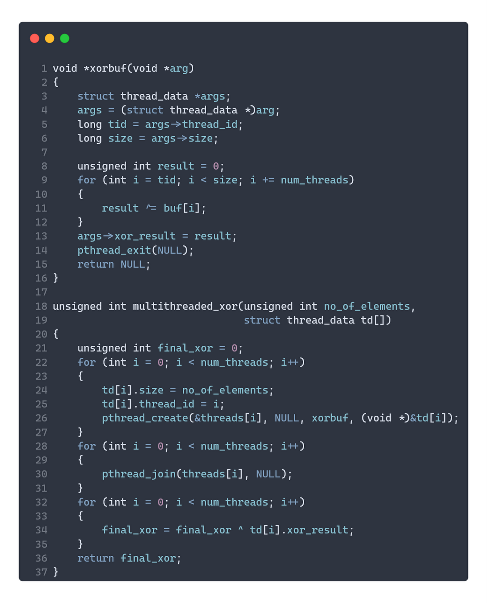  
  The program uses 4 threads in order to get the best performance. Any more threads and performance decreases (possibly due to the overhead of context switches and syncing of the threads), and any less does not give us the most performance out of our system.

Code **– fast.cpp**

#include <iostream>

#include <cstring>

#include <fstream>

#include <string>

#include <sys/time.h>

#include <pthread.h>

using namespace **std**;

int num_threads = 4;

unsigned int *buf;

**pthread_t** *threads;

struct **thread_data**

{

unsigned int thread_id;

unsigned int size;

unsigned int xor_result;

};

double **now**()

{

struct **timeval** tv;

**gettimeofday**(&tv, 0);

return tv.tv_sec + tv.tv_usec / 1000000.0;

}

double **get_rate**(double size, double start, double end)

{

return size / ((end - start) * 1024 * 1024);

}

void **print_error**(**string** s)

{

cout **<<** "Error! " **<<** s **<<** **endl**;

**exit**(**EXIT_FAILURE**);

}

void \***xorbuf**(void *arg)

{

struct **thread_data** *args;

args = (struct **thread_data** *)arg;

long tid = args->thread_id;

long size = args->size;

unsigned int result = args->xor_result;

for (int i = tid; i < size; i += num_threads)

{

*// if(buf[i]!=0) cout<<buf[i]<<" thread "<<tid<<" "<<i<<endl;*

result ^= buf[i];

}

args->xor_result = result;

**pthread_exit**(**NULL**);

return **NULL**;

}

void **multithreaded_xor**(unsigned int no_of_elements, struct **thread_data** td[])

{

unsigned int final_xor = 0;

for (int i = 0; i < num_threads; i++)

{

td[i].size = no_of_elements;

td[i].thread_id = i;

**pthread_create**(&threads[i], **NULL**, **xorbuf**, (void *)&td[i]);

}

for (int i = 0; i < num_threads; i++)

{

**pthread_join**(threads[i], **NULL**);

}

}

int **main**(int argc, char *argv[])

{

unsigned int block_size = 16777216, final_xor = 0; *//16MB of buffer*

double start, end;

**string** file_name = "";

struct **thread_data** td[num_threads];

for (int i = 0; i < num_threads; i++)

td[i].xor_result = 0;

if (argc != 2)

**print_error**("Check arguments!");

else

{

file_name **=** argv[1];

}

**srand**(**time**(**NULL**));

unsigned int no_of_elements = (unsigned int)(block_size / sizeof(int));

unsigned int size_of_buf = no_of_elements * sizeof(int);

buf = (unsigned int *)**malloc**(size_of_buf);

*// memset(buf,0,no_of_elements*sizeof(int));*

start = **now**();

**ifstream** object;

object.**open**(file_name, **ios**::binary);

if (object.**fail**())

**print_error**("Cannot read file!");

else

{

threads = (**pthread_t** *)**malloc**(sizeof(**pthread_t**) * num_threads);

if (!threads)

**perror**("out of memory for threads!");

while (object.**read**((char *)buf, size_of_buf))

**multithreaded_xor**(no_of_elements, td);

if (object.**gcount**() < block_size && object.**gcount**() > 0)

**multithreaded_xor**(object.**gcount**() / sizeof(unsigned int), td);

for (int i = 0; i < num_threads; i++)

final_xor = final_xor ^ td[i].xor_result;

end = **now**();

cout **<<** "Time taken: " **<<** (end - start) **<<** " seconds" **<<** **endl** **<<**

"Block size: " **<<** block_size **<<** " bytes" **<<** **endl**;

**printf**("Xor value is %08x", final_xor);

}

cout **<<** "\n";

return 0;

}