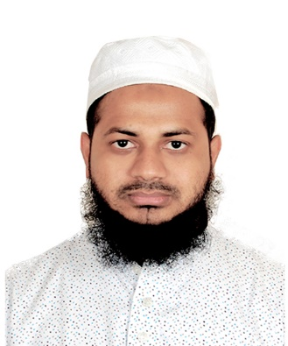Curriculum Vitae

Of

Shamim Ahamad

**Present Address**: 228/1, Shekhpara Road, South-Jatrabari, Dhaka-1204

**Phone: +880 1877651143**

**Email:** [shamimdewan343@gmail.com](mailto:shamimdewan343@gmail.com)

**Web-Site:** https://shamimdewan.xyz

**Skype: live:.cid.a0c9df7b141e9e7d**

**Career Objective:**

I am passionate about my work with dedication. I focus in my work with research, academics and developing skills. I consider myself as a self-motivated, responsible, punctual, quick learner and deadline oriented person who can work under pressure and able to solve problems analytically with latest technologies in minimal supervision. I worked as team leader as well as team player during my academic life.

**Educational Qualification:**

|  |  |  |  |  |
| --- | --- | --- | --- | --- |
| **Degree** | **Institution Name** | **Passing Year** | **Department / Group** | **CGPA/GPA** |
| Kamil (Masters) | Islamic Arabic University, Dhaka | 2019 | Fiqh (Kamil) | Pending… |
| Fazil (BSS) | Islamic University, Kushtia-Jhenaidah | 2018 | Bachelor Of Social Science | 3.09/5.00 |
| Alim (H.S.C) | Gawsia Islamia Fazil madrasah, Dhaka | 2013 | General | 4.92/5.00 |
| Dakhil (S.S.C) | Dhaka Mohammadia Dakhil Madrasah | 2011 | General | 4.31/5.00 |
| Hafij Al-Quran | Jamia Rahmanai Arabia, Dhaka | 2006 | Al-Quran | 76/100 |

**Training Backgraound:**

**1) Course Type** : Professional Web Development, Duration- 6 months, Year- 2018

**Institution :** Creative IT Institute of Bangladesh.

**2) Course Type** : Professional Web Design, Duration- 6 months, Year- 2018

**Institution** : SR Institute of Bangladesh.

**Programming Skills:**

* **Language :** PHP, javaScript, HTML5, CSS3 .
* **Framework :** Laravel, WordPress, Boostrap, Jquery, Ajax, vue js.
* **Database :** MySQL.
* **Operating System :** Windows OS. Linux (Ubuntu)
* **Version Control Management :** Git .

**Job** **Experience:**

**Company Name**  : SheBa Web Technology

**Company Address** : House-951, Road-14, Avenue-02, Mirpur DOHS

Mirpur-12, Dhaka-1216

**Duration** : From May 2020 to Running…

**Designation**  : IT Executive

**Responsibilities**  : Coding, web Application and Software Build,

Customize by Laravel/ WordPress

**Personal Details:**

**Father’s Name** : Late Monsur Shamad

**Mother’s name** : Nasima Begum

**Marital Status** : Single

**Blood Group** : B+

**Date of Birth** : 10 July, 1996

**Religion**  : Islam

**Nationality** : Bangladeshi

**Permanent Address** : Vill: Laxmipur, PO: Bhaberchar, PS: Gazaria, Dist: Munshiganj

**Language Proficiency:**

**English** : Conversational proficiency

**Bengali** : Native proficiency

**Reference:**

Shohan Hossain Din Islam Tahsan

Department Head (Web) Faculty Member(Web)

Creative IT Institute Creative IT Institute

Phone : 01990779750 Phone: 01990779785

Email: [Head.web.cit@gmail.com](mailto:Head.web.cit@gmail.com) Email: [tahsan.cit.bd@gmail.com](mailto:tahsan.cit.bd@gmail.com)

**Signature:**



Shamim Ahamad