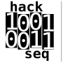

**Artem Babaian**

Organizer, hackseq18

[www.hackseq.com](http://www.hackseq.com) **|** [@hackseq](https://twitter.com/hackseq)