孙 晖

1513012班 | 15130120141

人工智能概论（张白一老师）

专家系统

目录

一、设计题目 2

1、大学选择系统中大学的特性 2

2、大学名称与特性表 2

二、专家系统的分类 3

三、程序 3

四、实验结果 6

五、实验总结 7

**题目：**

**按照张老师的要求，学生自己仿照狗专家系统设计一个专家系统，使用这个系统只需要根据窗口提供去回答“yes”或“no”，系统就会帮助我选择想要的东西。**

# 一、设计题目

我想设计的是一个大学选择系统，我规定大学的一些属性，用户依据自己的喜好选择各个属性，最终得出符合用户要求的大学。

## 1、大学选择系统中大学的特性

1. 是985或211
2. 不是985或211
3. 只有一个校区
4. 不只一个校区
5. 有博士后流动点
6. 就业率高
7. 上研率超过40%
8. 有国家级实验室

## 2、大学名称与特性表

每个特性应用到每个大学都有一个肯定的或者否定的回答，也就是说每个不同的大学具有或者不具有某一特性。各大学的特性如下：

|  |  |
| --- | --- |
| 大学名称 | 特性 |
| SiChuan University  ChongQing University  HaiNan University  HeNan University  XiaMen University  JiLin University  ShangHai University  LanZhou University | 1,3,5,8  1,3,5,8  1,3,5,7  2,3,5,6,7,8  1,4,5,6,8  1,4,5,7,8  1,3,5,6,8  1,4,5,7,8 |

# 二、专家系统的分类

该专家系统首先按照大学是否是985/211分类，分为是985/211和不是985/211；然后再按照大学的名称给出大学的特性，如下图所示；最后根据大学及特性编写规则。

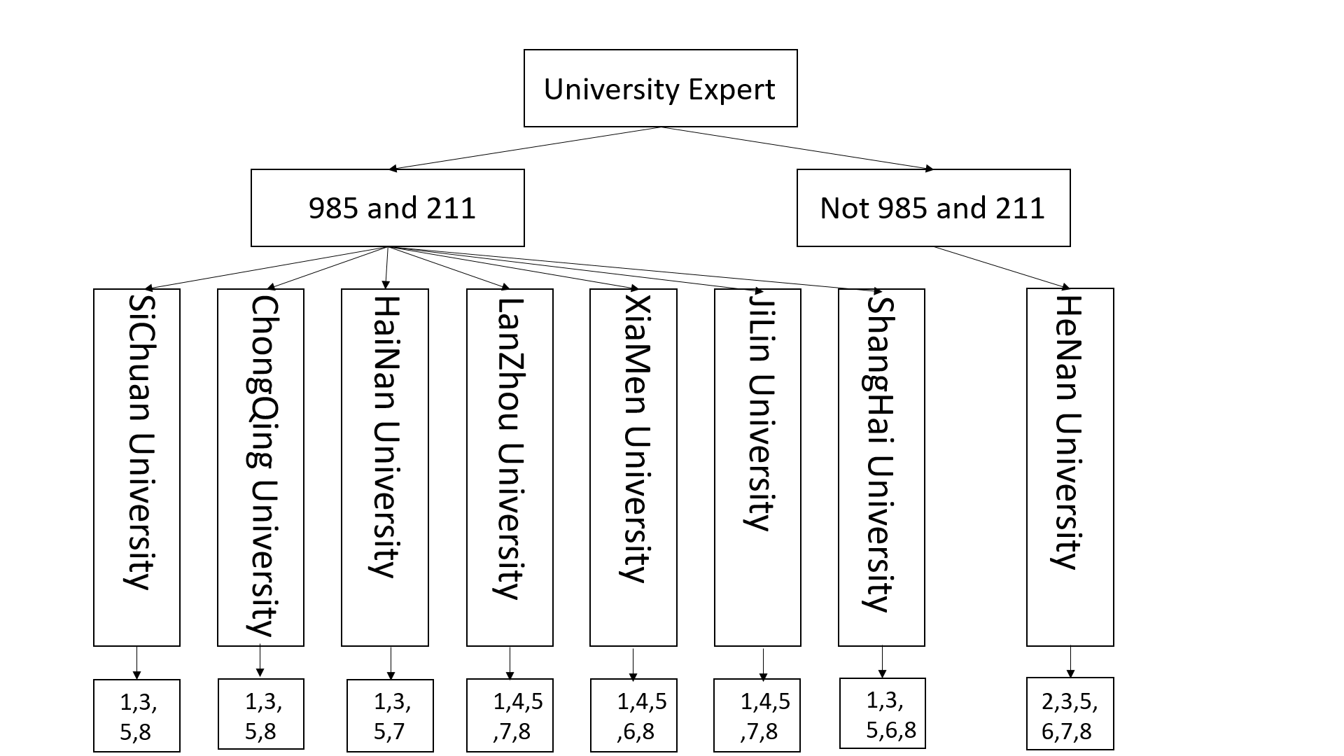

# 三、程序

/* wlO. pro */

/* Program: University Expert */

/* Purpose: To Show the working of an expert */

/* It is a production rule _based system */

/* Remark: This is a University classification expert system */

/* It uses a set of production rules for the*/

/* purpose of inferring. */

domains

database

xpositive(symbol,symbol)

xnegative(symbol,symbol)

predicates

do_expert_job

do_consulting

ask (symbol, symbol)

university_is (symbol)

it_is (symbol)

positive(symbol,symbol)

negative (symbol,symbol)

remember (symbol,symbol,symbol)

clear_facts

goal

do_expert_job.

clauses

/* USER INTERFACE SYSTEM */

do_expert_job:-

makewindow(1,7,7,"AN EXPERT SYSTEMS", 1, 16,15,58),

nl,write(" ******************************************"),

nl,write(" WELCOME TO UNIVERSITY EXPERT SYSTEM "),

nl,write(" This is a university identification system "),

nl,write(" Please respond by typing in "),

nl, write(" 'yes' or 'no'. Thank you "),

nl, write(" "),

nl,write(" ******************************************"),

nl, nl,

do_consulting,

write("Press space bar."),nl,

readchar(_),

clearwindow,

exit.

do_consulting:-

university_is(X),!,

nl,write("Your university may be a(n) ",X,"."),nl,

clear_facts.

do_consulting:-

nl,write("Sorry, unable to determine the university."),nl,

clear_facts.

ask(X,Y):-

write("Question:-",X," it ",Y,"?"),

readln(Reply),

remember(X,Y,Reply).

/* INFERENCE BIGING */

positive(X,Y):- xpositive(X,Y), !.

positive(X,Y):- not(negative(X,Y)),!,ask(X,Y).

negative(X,Y):- xnegative(X,Y), !.

remember(X,Y,yes):- asserta(xpositive(X,Y)).

remember(X,Y,no):- asserta(xnegative(X,Y)),fail.

clear_facts:- retract(xpositive(_,_)),fail.

clear_facts:- retract(xnegative(_,_)),fail.

/* Production rules */

university_is("SiChuan University"):-

it_is("985 or 211"),

positive(has,"only one compus"),

positive(has,"Postdoctoral flow point"),

positive(has,"have national laboratory"),!.

university_is("ChongQing University"):-

it_is("985 or 211"),

positive(has,"only one compus"),

positive(has," Postdoctoral flow point"),

positive(has,"have national laboratory"),!.

university_is("HaiNan University"):-

it_is("985 or 211"),

positive(has," only one compus"),

positive(has, " Postdoctoral flow point"),

positive(has,"more than forty percent of students go to graduate school"),!.

university_is("HeNan University"):-

it_is("not 985 or 211"),

positive(has,"only one compus"),

positive(has,"Postdoctoral flow point"),

positive(has,"more than forty percent of students go to graduate school"),

positive(has," high employment rate"),

positive(has,"have national laboratory"),!.

university_is("XiaMen University"):-

it_is("985 or 211"),

positive(has," more than one compus"),

positive(has," Postdoctoral flow point"),

positive(has," high employment rate"),

positive(has,"have national laboratory"),!.

university_is("JiLin University"):-

it_is("985 or 211"),

positive(has,"more than one compus"),

positive(has,"more than forty percent of students go to graduate school"),

positive(has," Postdoctoral flow point"),

positive(has,"have national laboratory"),!.

university_is("ShangHai University"):-

it_is("985 or 211"),

positive(has," only one compus"),

positive(has," Postdoctoral flow point"),

positive(has," high employment rate"),

positive(has,"have national laboratory"),!.

university_is("LanZhou University"):-

it_is("985 or 211"),

positive(has," more than one compus"),

positive(has," Postdoctoral flow point"),

positive(has,"have national laboratory"),

positive(has,"more than forty percent of students go to graduate school"),!.

it_is("985 or 211"):- positive(has," 985 or 211"),!.

it_is("not 985 or 211"):- positive(has," not 985 or 211"),!.

/* end */

# 四、实验结果

图1 程序显示编译成功

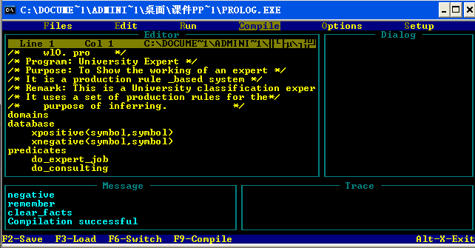

图2 在对问题进行“yes”和“no”的回答

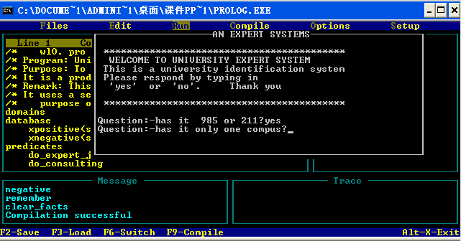

图3 显示用户条件得出的结果是厦门大学

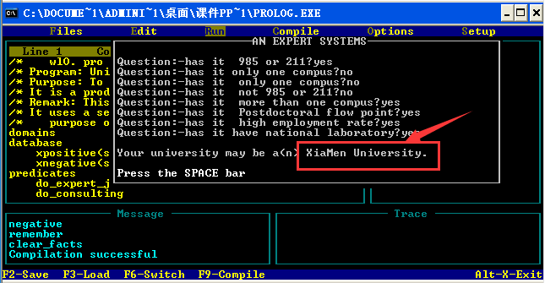

# 五、实验总结

1. 专家系统是一个很有趣的实验，通过回答yes和no就可以从大学中筛选出我想要的大学是一件很有趣的事情，结果出来的那一刻感觉很开心，很有成就感。
2. 在程序运行过程中出现了一些错误，我通过仔细的检查发现了错误，最终把错误解决。例如，我漏掉了“！”符号，在prolog编译器报错提醒下最终发现了错误。
3. 总的来说，专家系统是人工智能里的经典问题，能够在老师给的框架下完成这件事情，令人兴奋。希望在以后的学习过程中多动脑，勤动手。而且这样一个实验为我以后出来相似问题提供了思路，是一件很有意义的事情。