# 环境搭建（setup environment）

The first day is about how to setup environment, and considering that some of the readers might be zero foundation, I would use some screenshots to illustrate.

* Download the Python(Windows based)

1. <https://www.python.org/>
2. 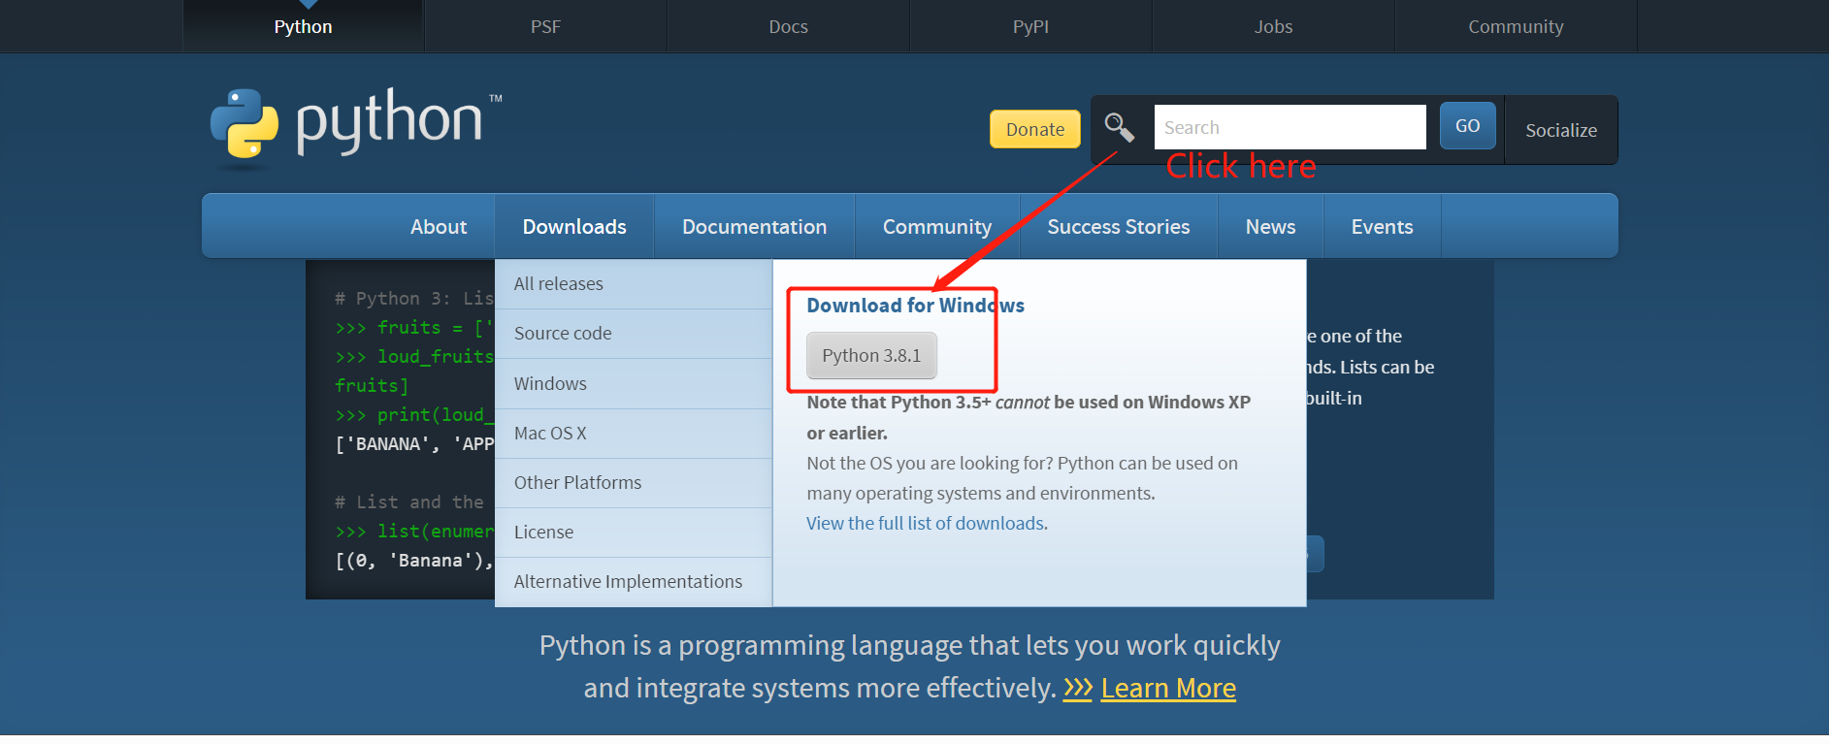
3. Open it！
4. 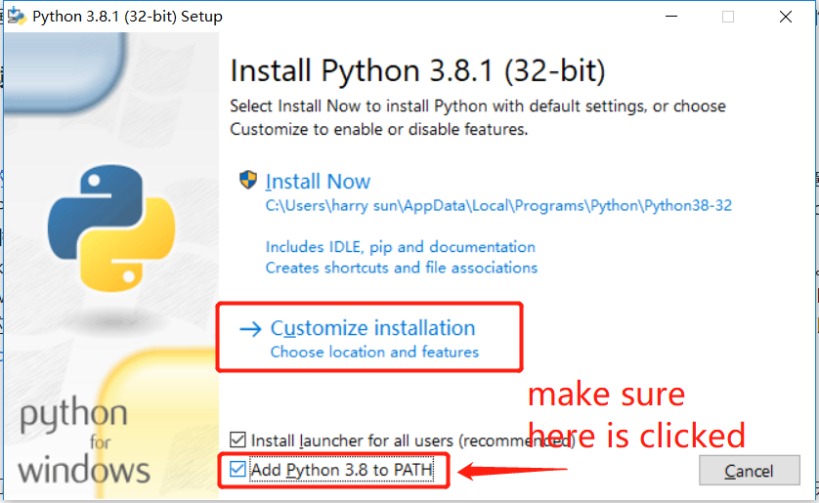

Choose “Add Python 3.8 to PATH” then click “Customize installation”

1. 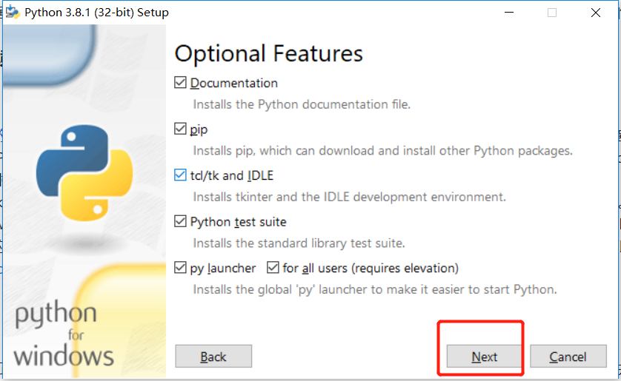click “Next”
2. 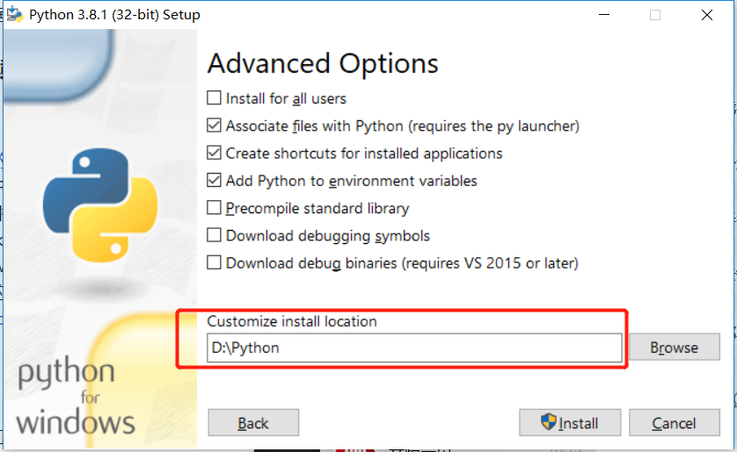

You can choose any Browse as location, here I choose “D:\Python”

1. 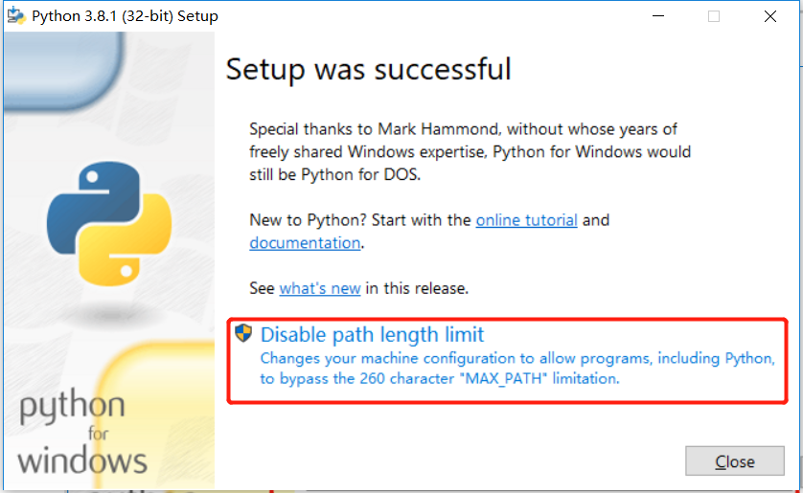

Notice: you need to click “Disable path length limit”

Here is a background knowledge which you can ignore or scan for a few seconds.

PATH Length Limit is set by windows defined as 260 #define MAX_PATH 260. If you are a Chinese, you can click here:

<https://blog.csdn.net/weixin_30687051/article/details/101185701>

for more info;

or, you can click here:

[*http://msdn.microsoft.com/en-us/library/windows/desktop/aa365247(v=vs.85).aspx*](http://msdn.microsoft.com/en-us/library/windows/desktop/aa365247(v=vs.85).aspx)

1. Then click “close” and finish.

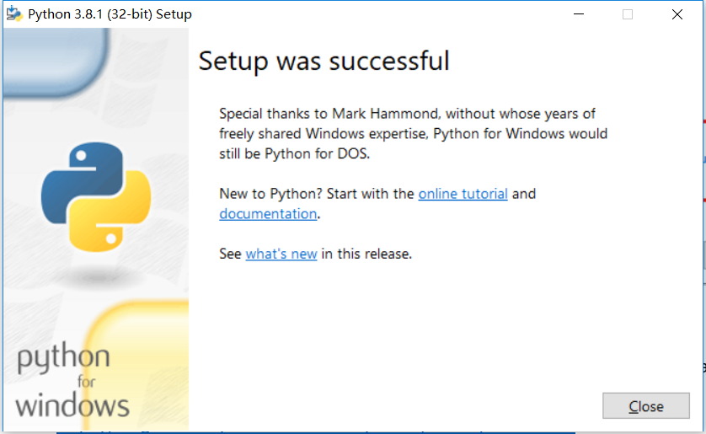

1. Finally:

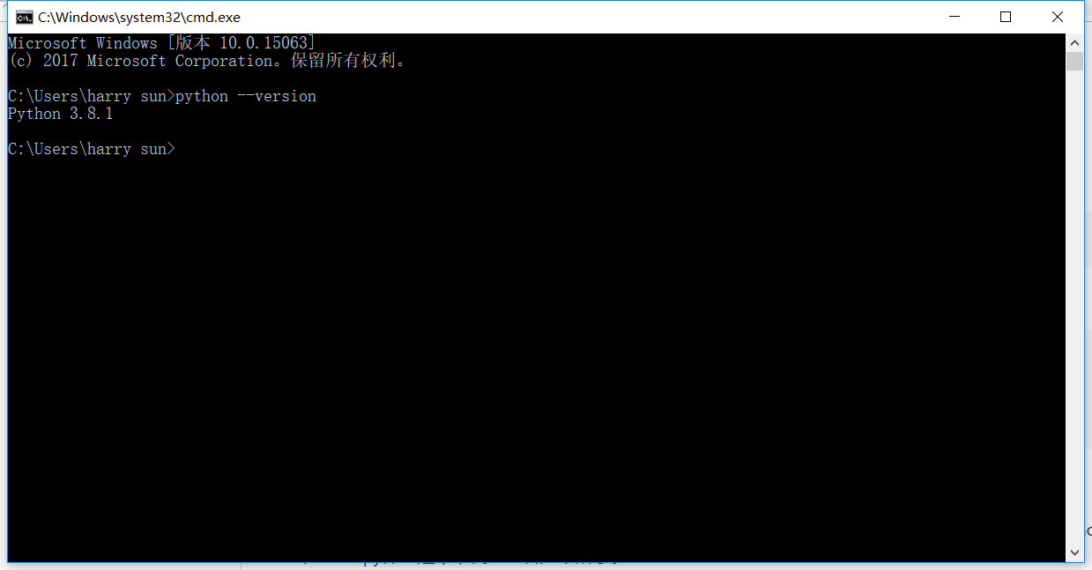

Input “python --version” to check it.

Now, I have to choose a Complier or to say IDLE for python, from my perspective, vscode->pycharm->jupyter, vscode first.

Here I would like to show you how to install vscode and use it to run the first python program.

1. Download from:

<https://code.visualstudio.com/>

Also windows based.

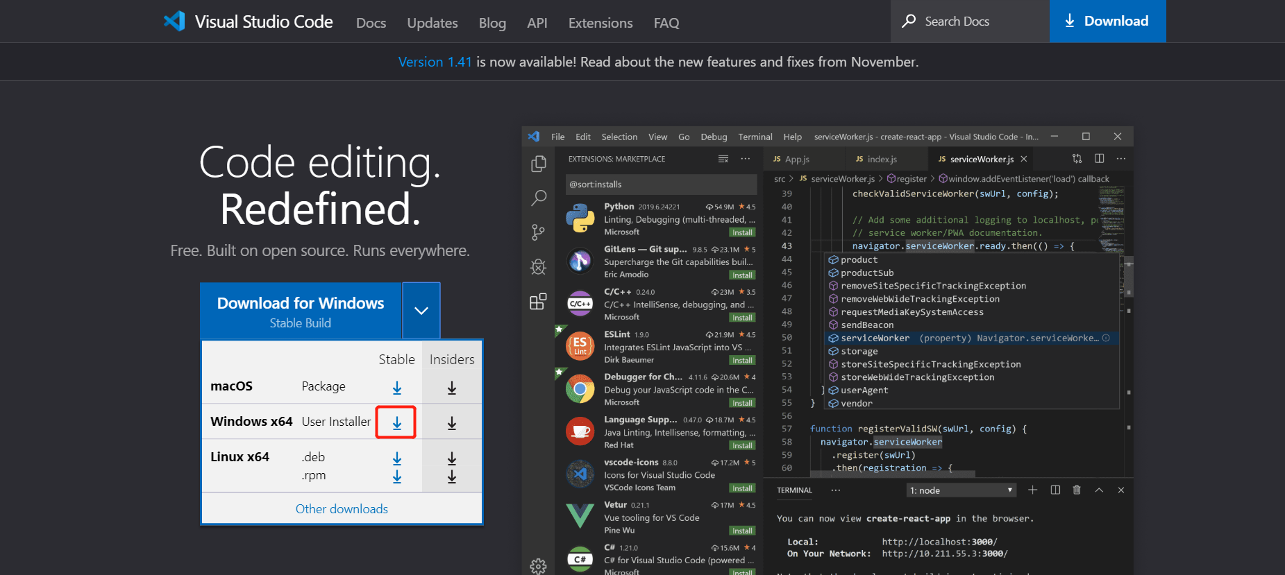

1. Install 
2. 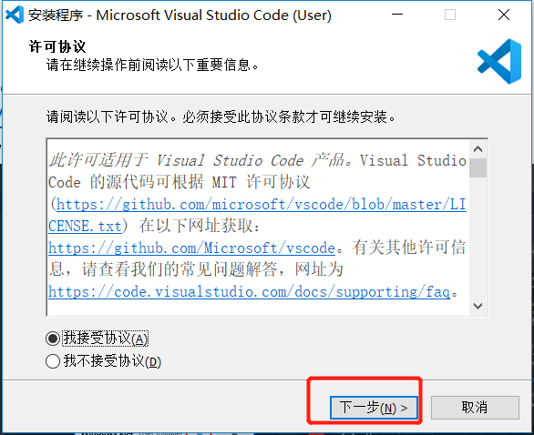

Click “next”

1. 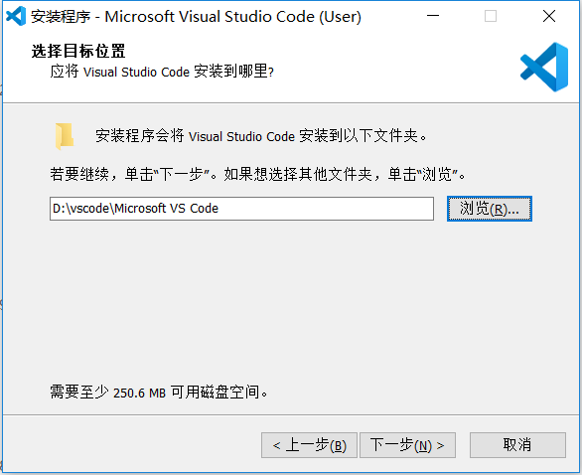

Next

1. 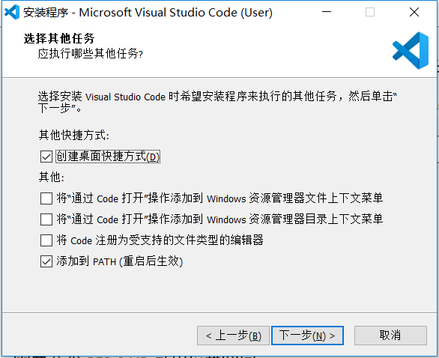

Next

1. Install

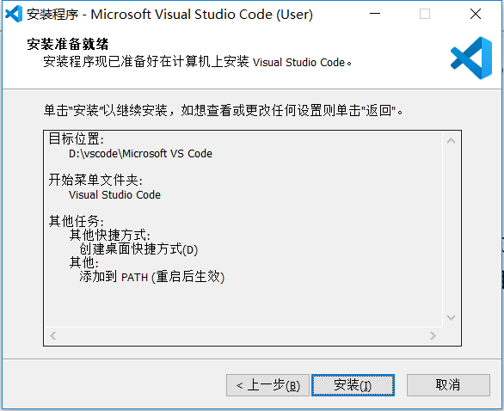

1. 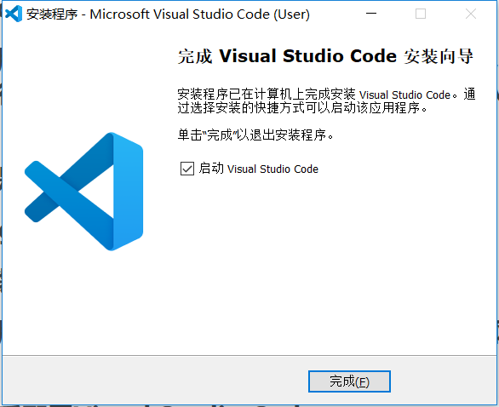

Finish

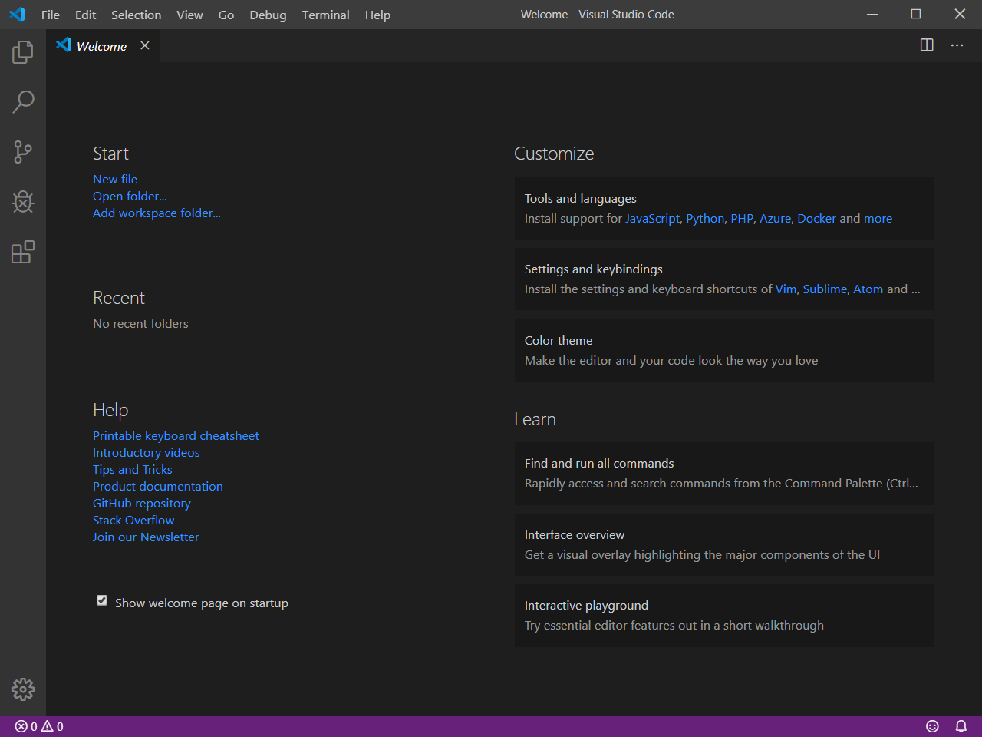

1. If you want to change the language, you can press “F1”

Input “configure language” then choose ”configure display language”

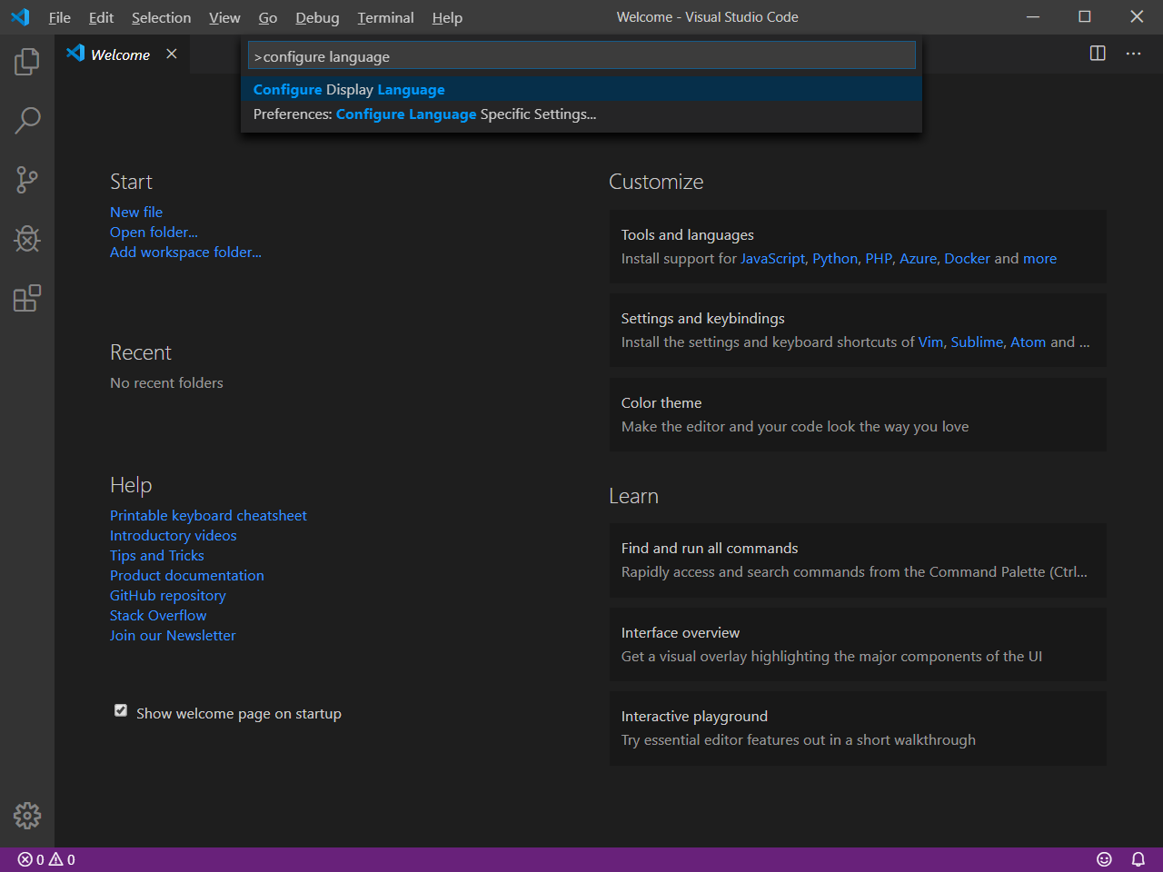

Choose this

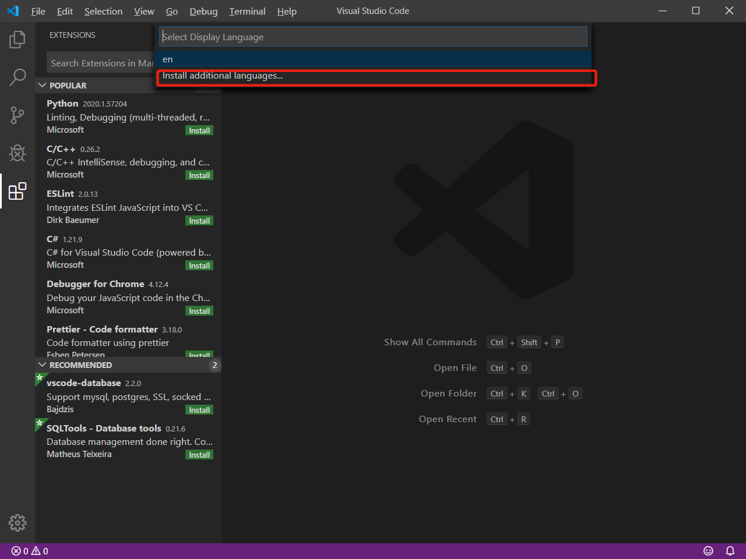

Here you get this

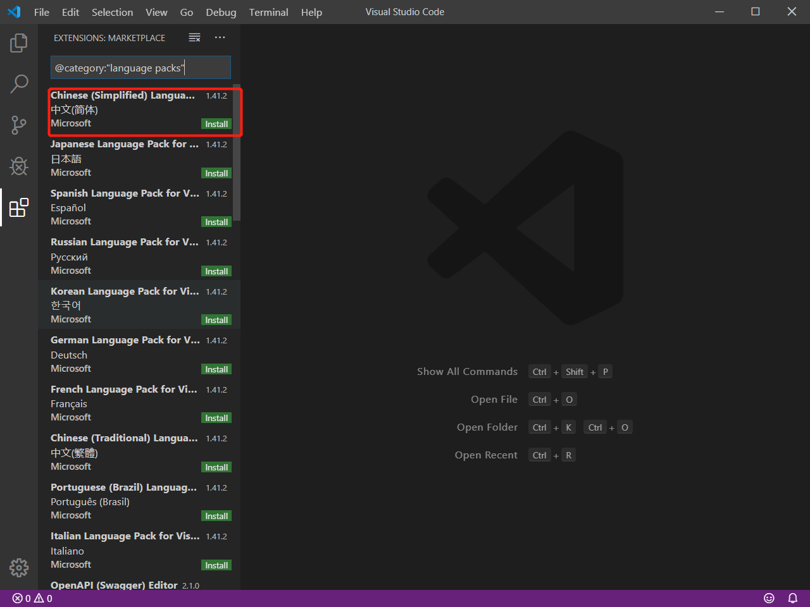

1. 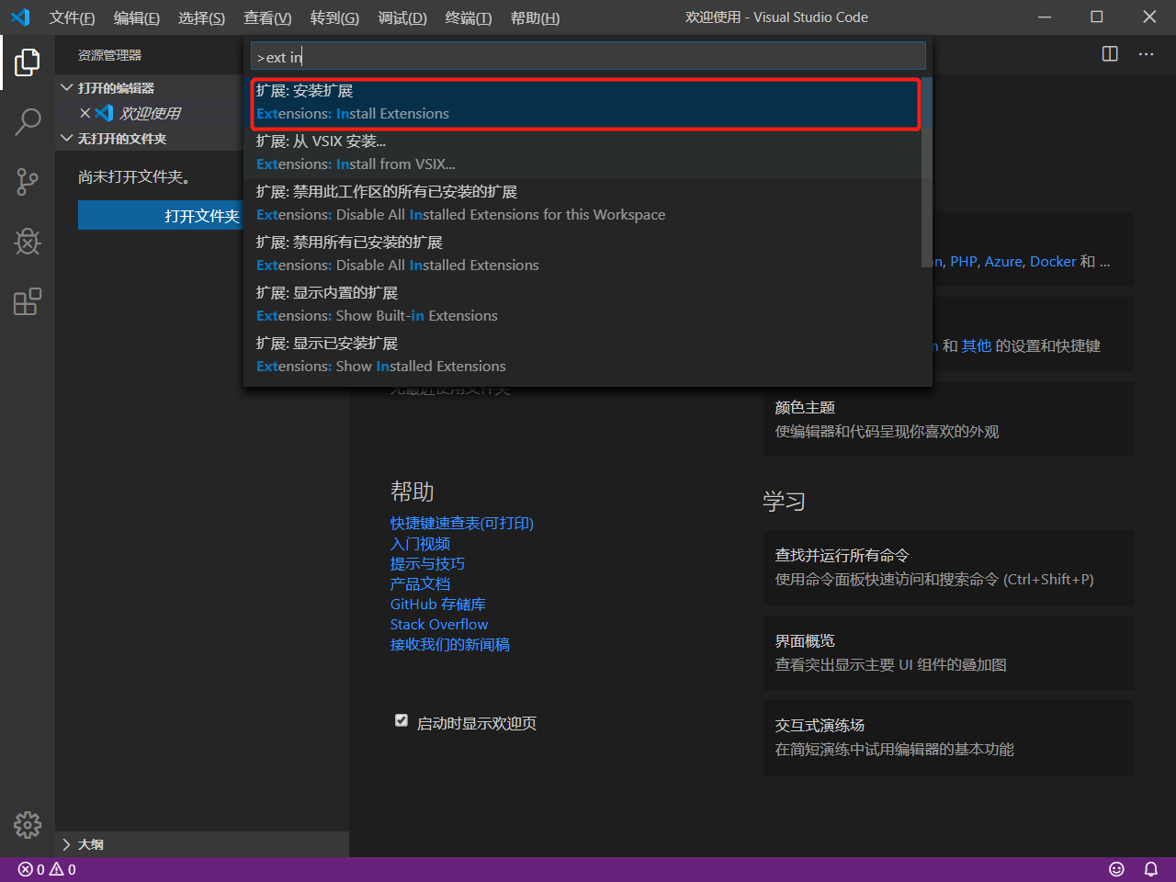

Click “extensions: Install Extensions”

1. 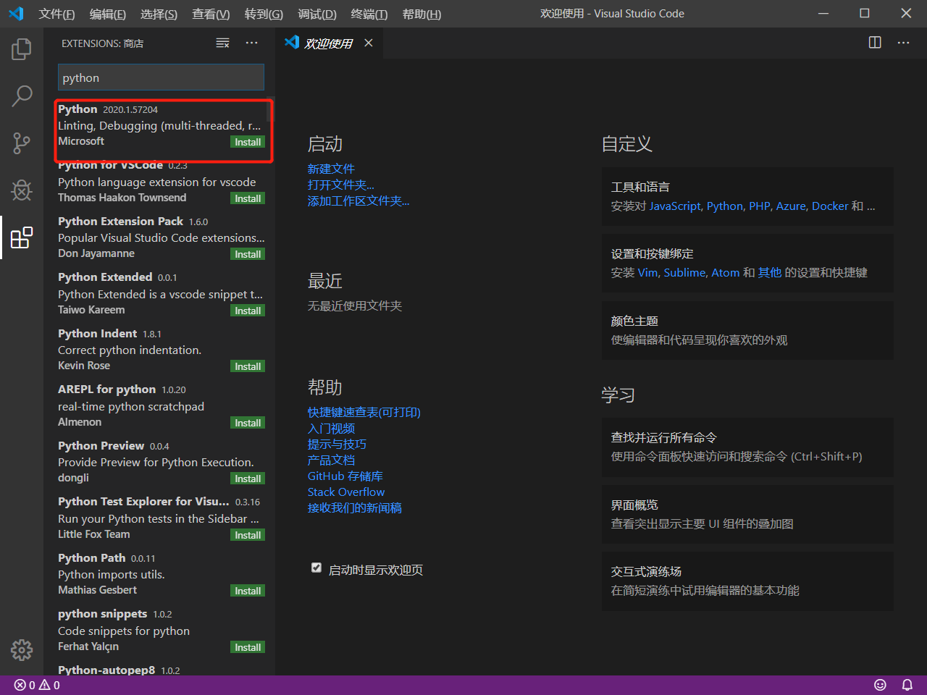
2. 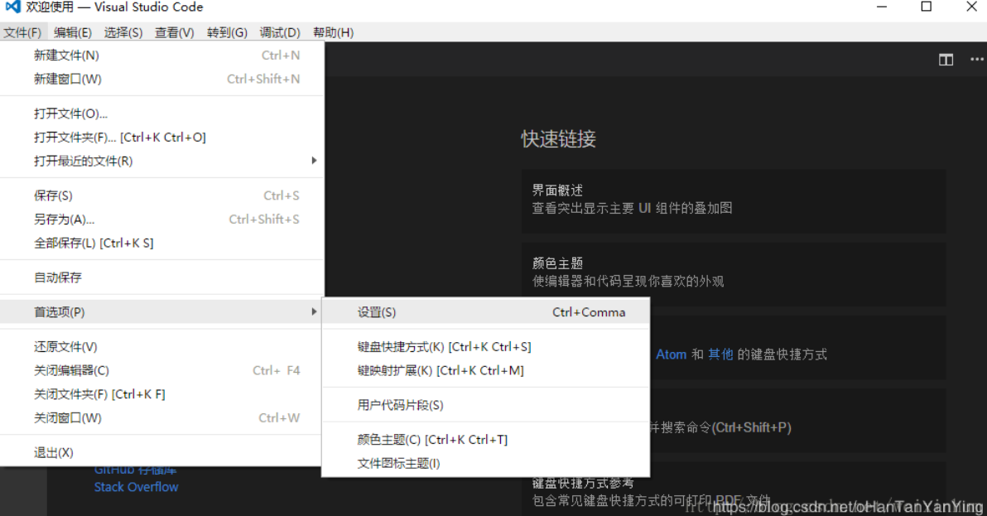
3. 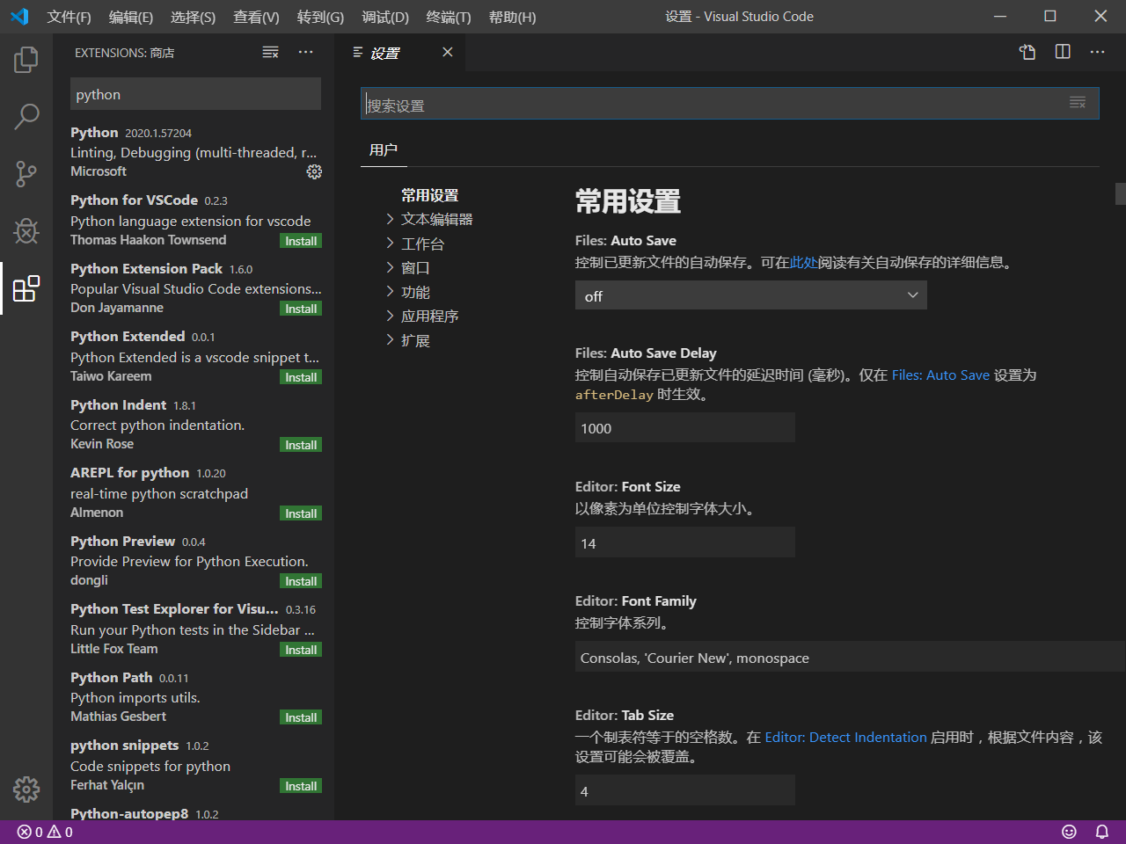
4. 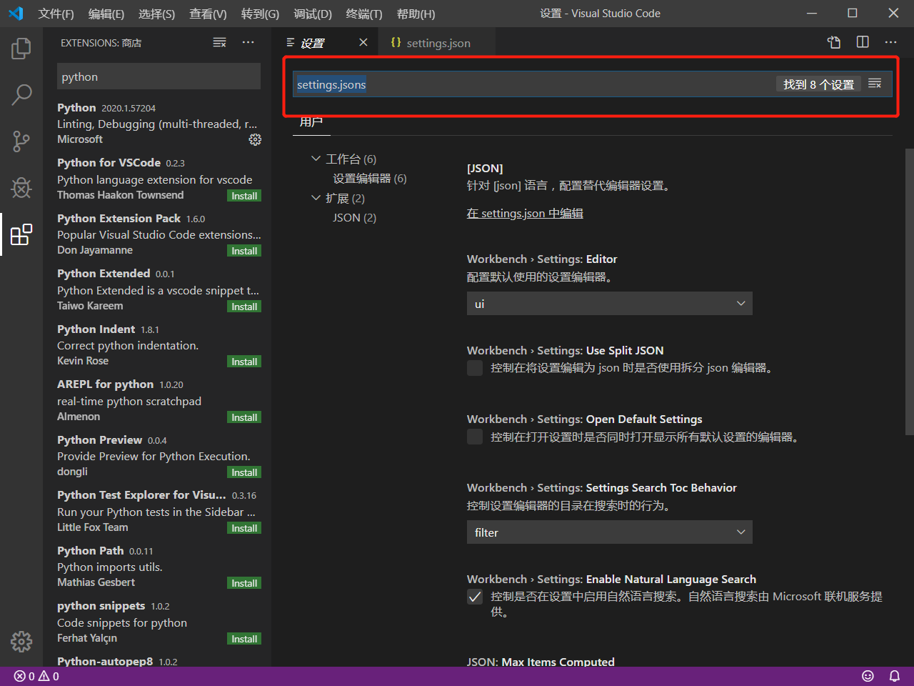
5. <https://blog.csdn.net/weixinhum/article/details/73038117> for more info, click here.