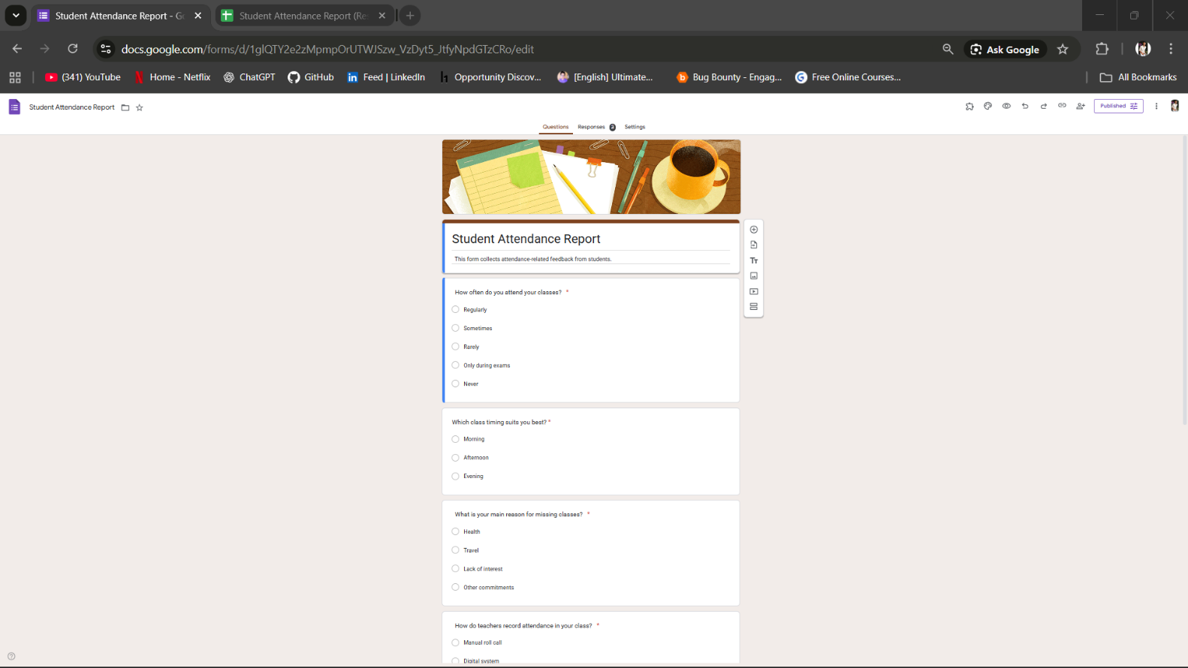
Student Attendance Report - https://docs.google.com/forms/d/e/1FAIpQLSf8eUVlzu-X1K2qyAAwHEXGfEkdLgTxoy9FsLuq3IUFuJuK3A/viewform?usp=header
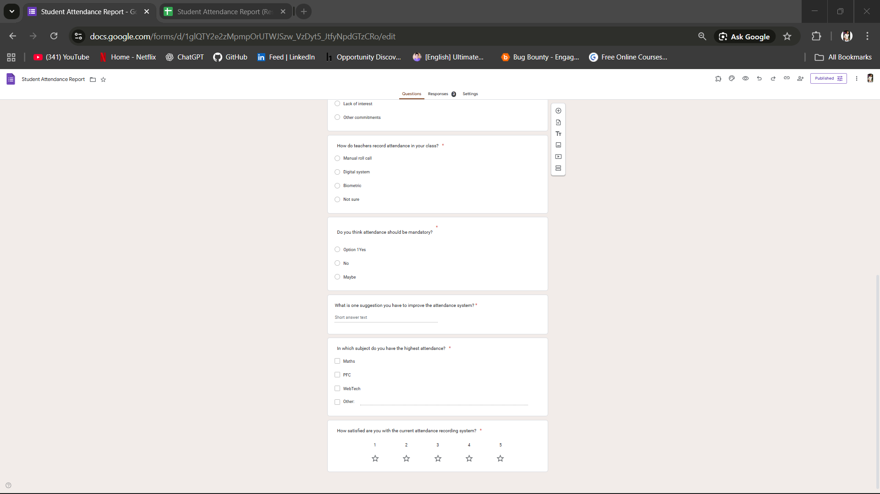

Student Attendance Report (Responses);- https://docs.google.com/spreadsheets/d/1-yDj258UKLP09YQqT0Lghv04BjUcMK3-DAL-LsX2JFw/edit?usp=sharing
