Google Form Link –
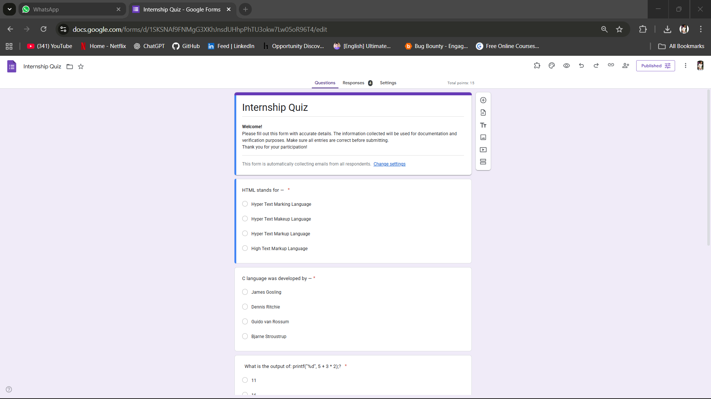
https://presenter.jivrus.com/p/1SKSNAf9FNMgG3XKhJnsdUHhpPhTU3okw7Lw05oR96T4
