10. a. How to run Nmap scan.

b. Operating System Detection using Nmap.

Nmap is a network scanning tool

- Nmap is a network scanner created by Gordon Lyon.
- Nmap is used to discover hosts and services on a computer network by sending packets and analyzing the responses.
- Nmap provides a number of features for probing computer networks, including host discovery and service and operating system detection.
- Nmap is now one of the core tools used by network administrators to map their networks. The program can be used to find live hosts on a network, perform port scanning, ping sweeps, OS detection, and version detection.
Nmap Installation:
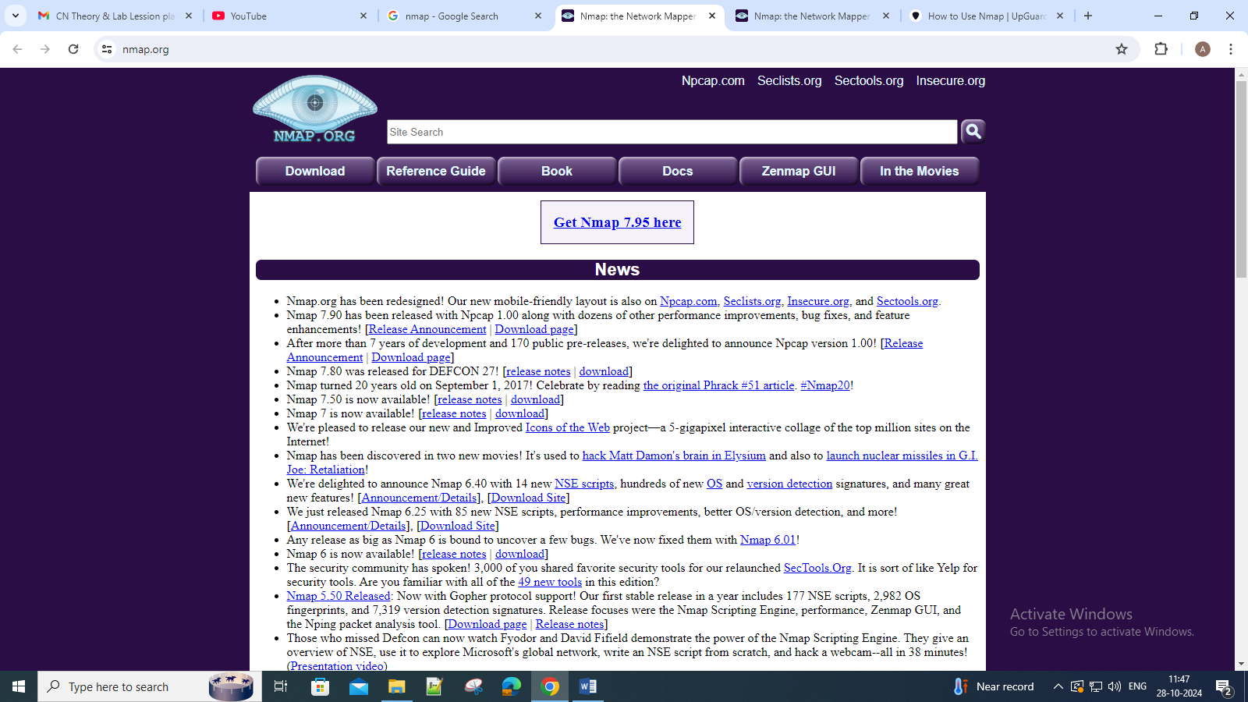

Latest stable release self-installer: nmap-7.95-setup.exe → download this
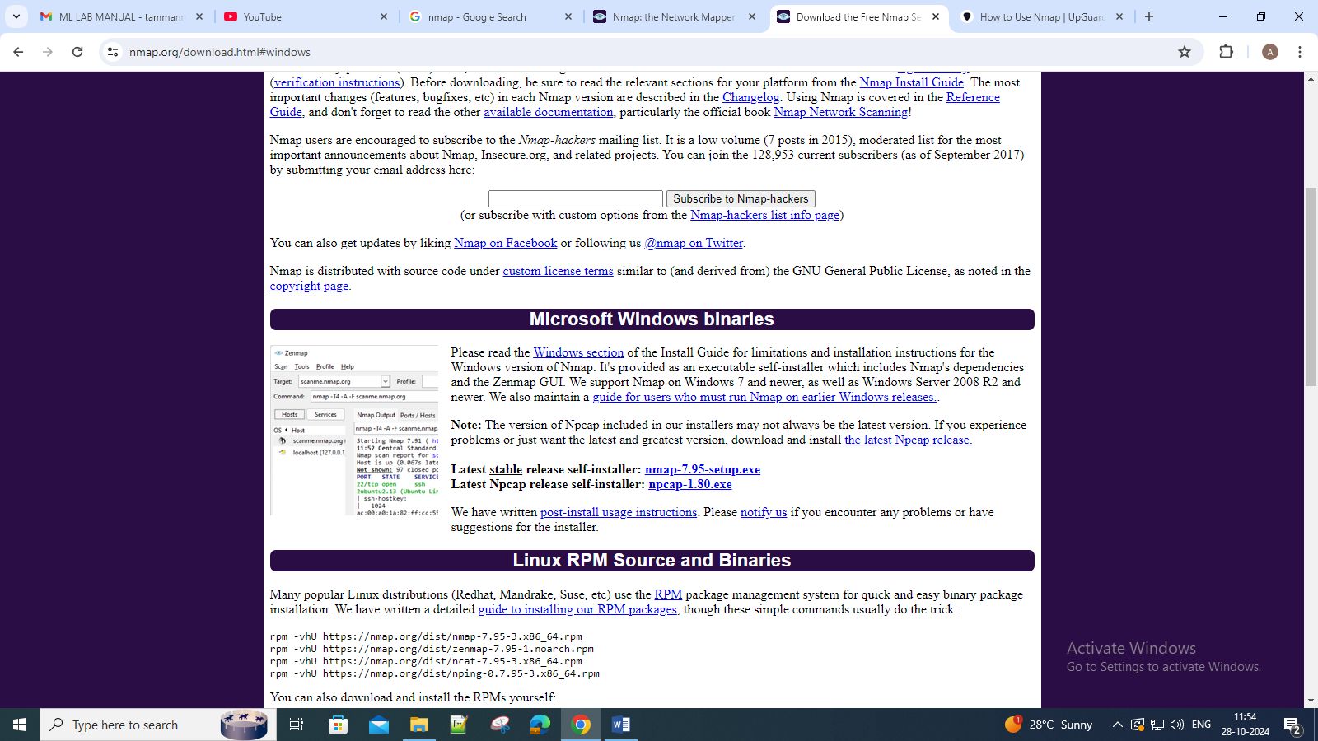

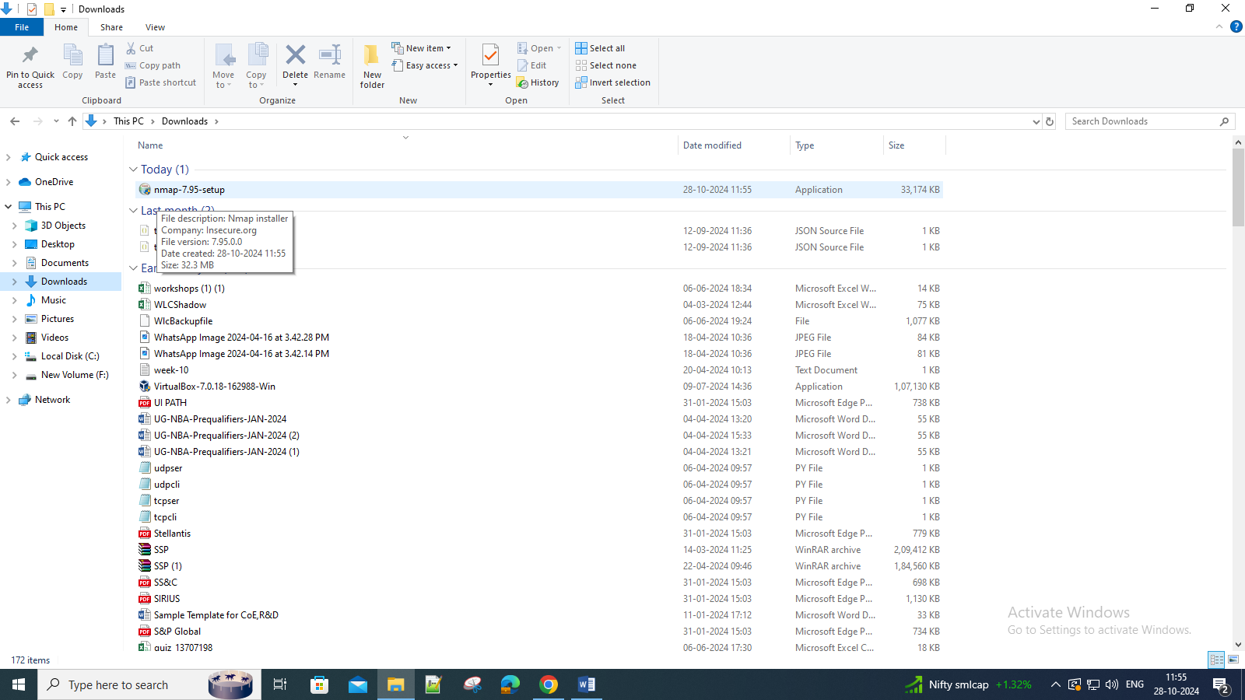

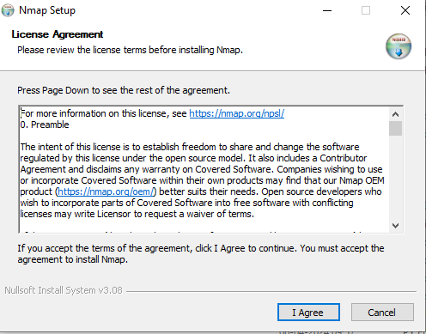
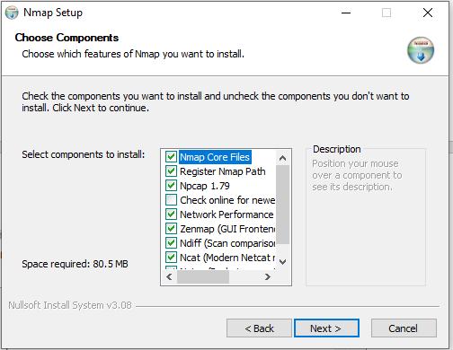
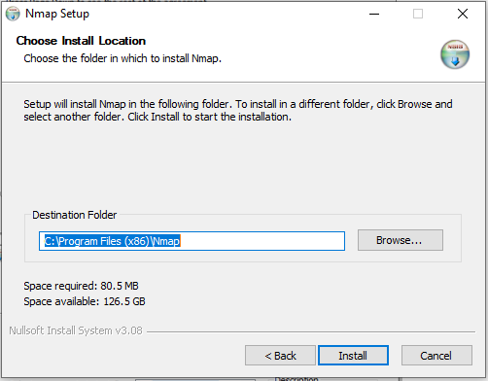
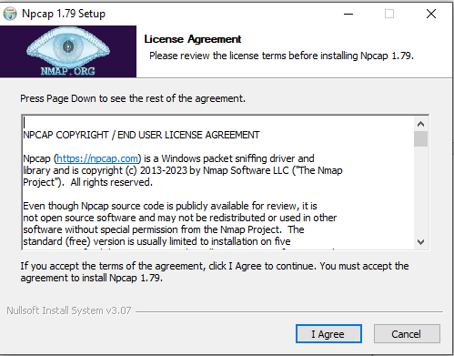
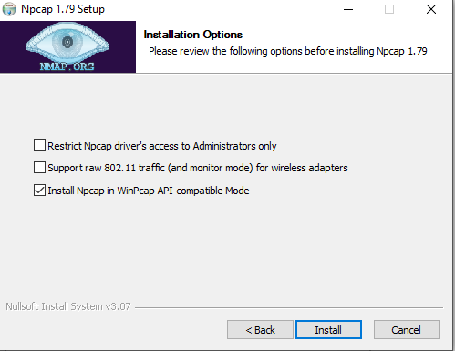
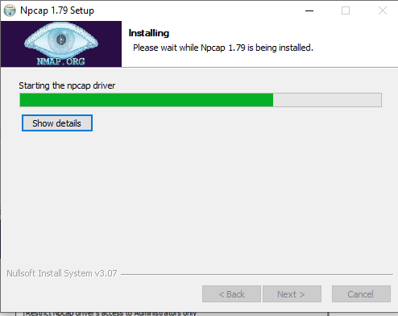
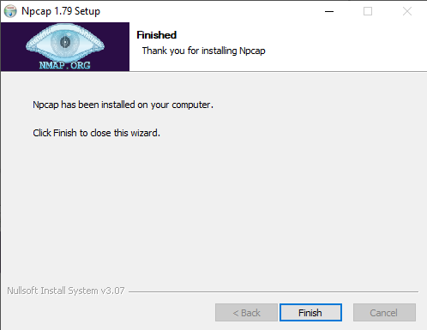
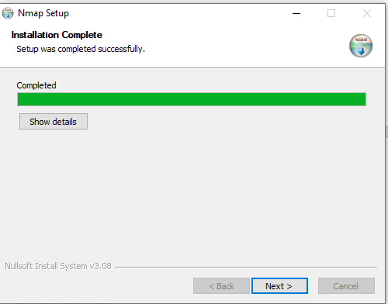
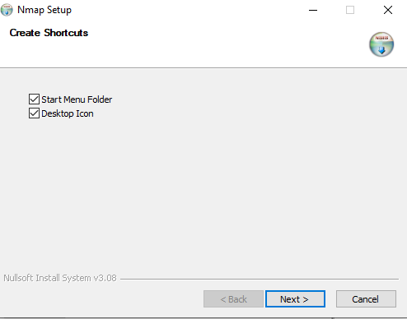
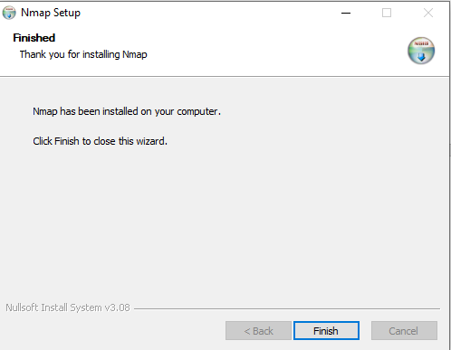

Open Nmap-ZenmapGUI
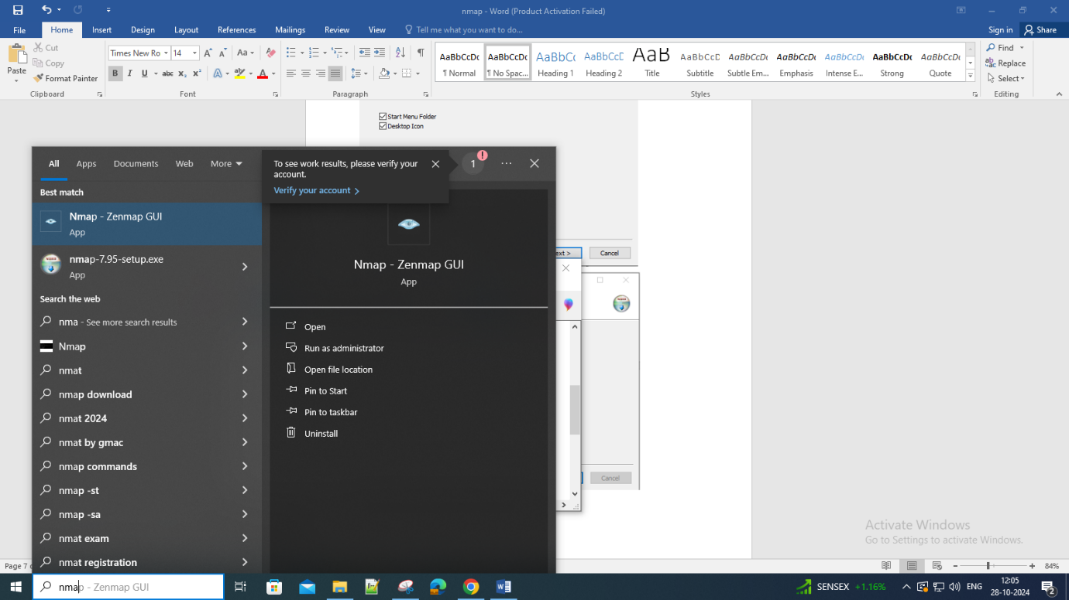
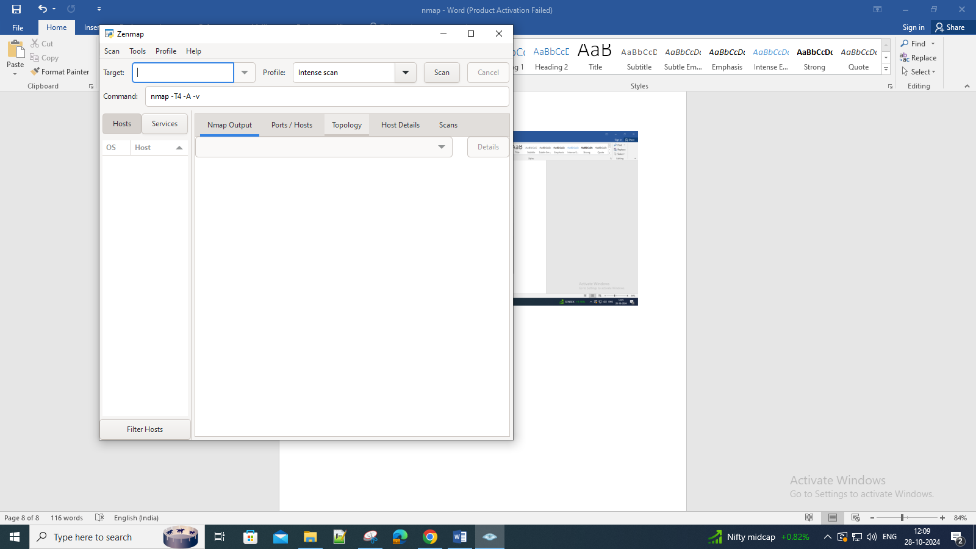

In ubuntu:
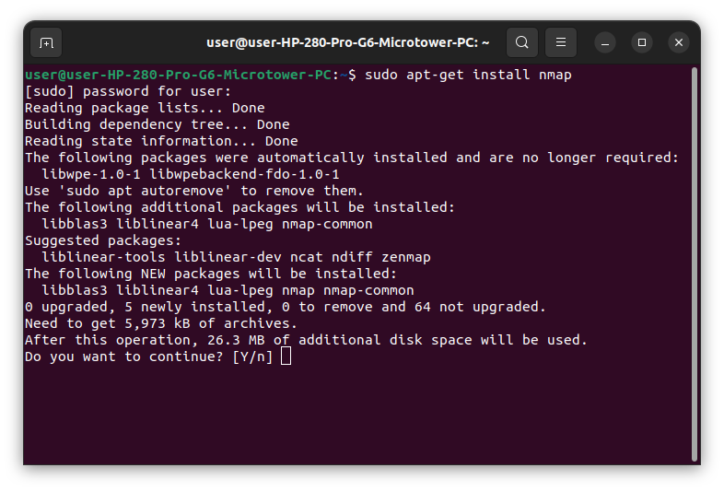
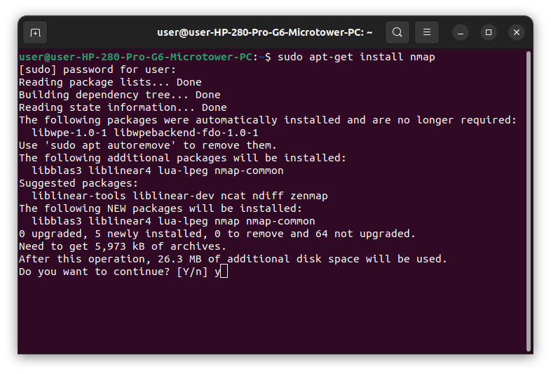

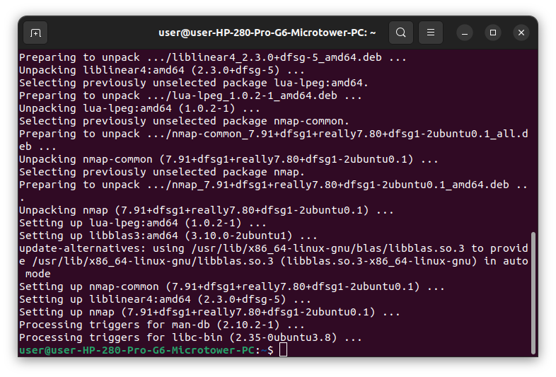
OS detection: nmap -sV scanme.nmap.org

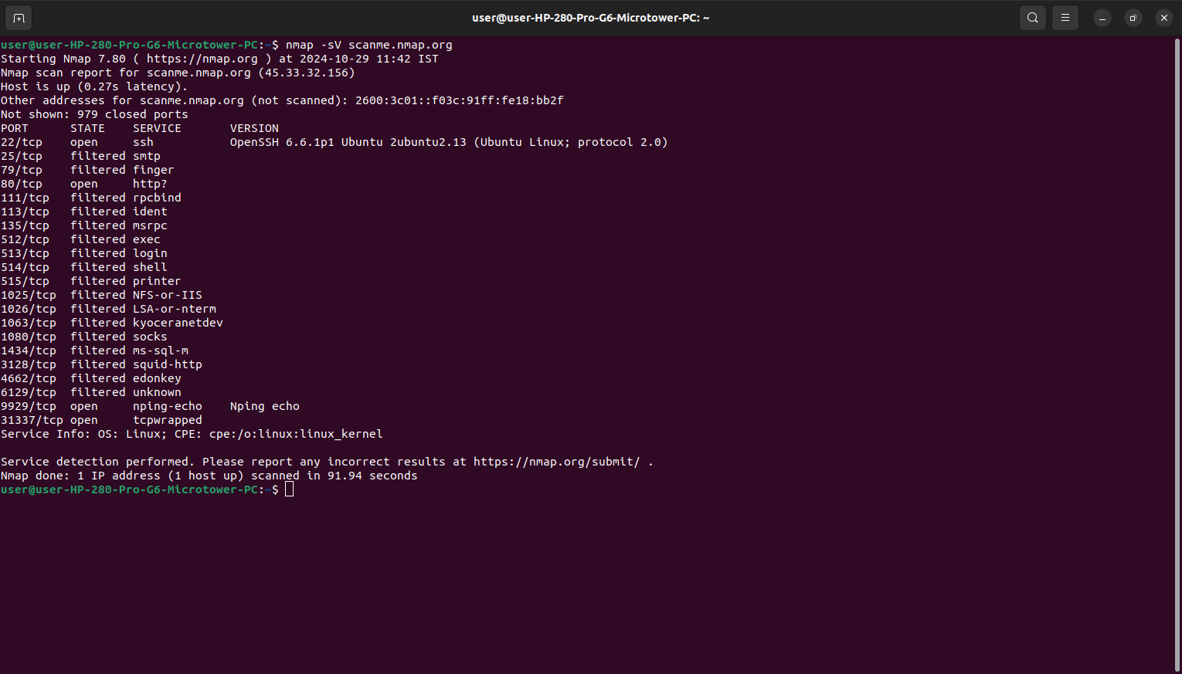

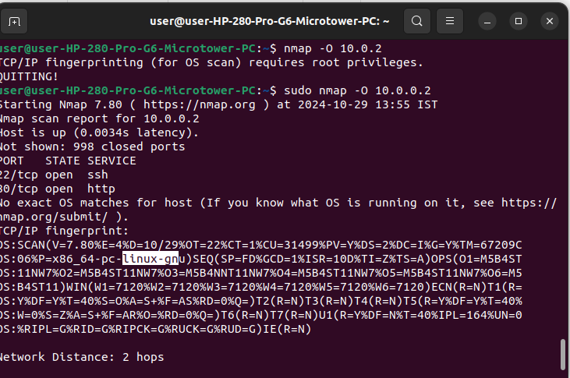
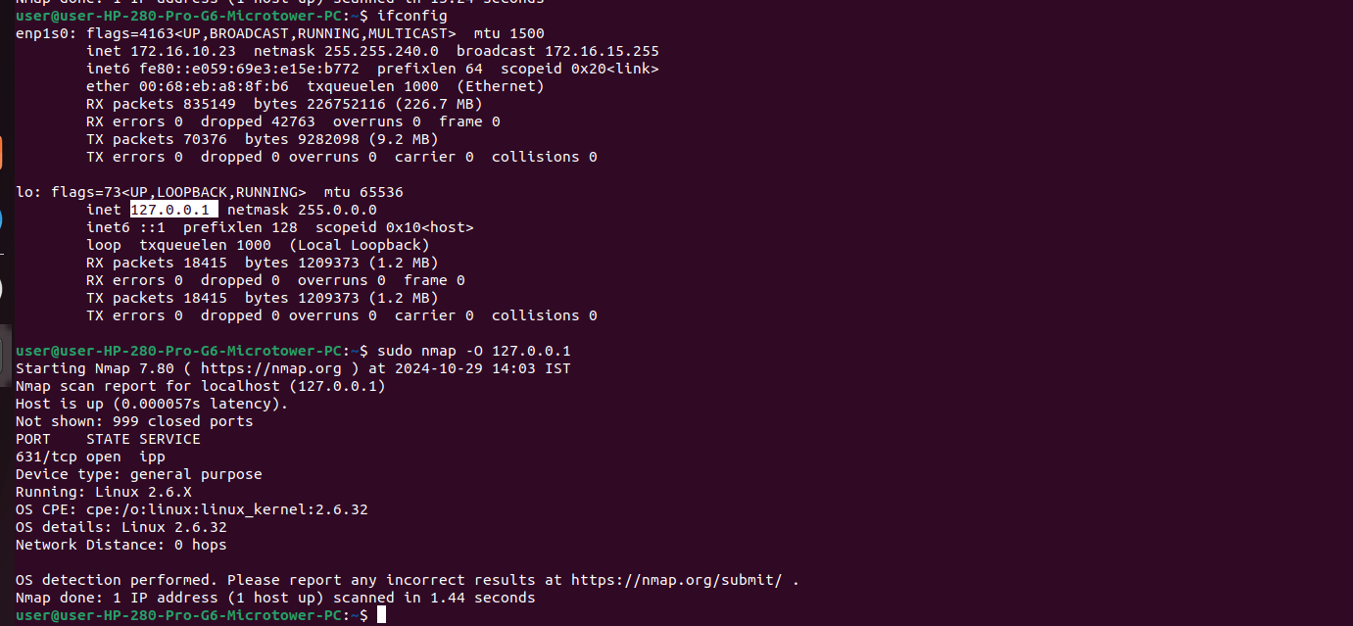

Nmap is now one of the core tools used by network administrators to map their networks. The program can be used to find live hosts on a network, perform port scanning, ping sweeps, OS detection, and version detection.
Nmap, short for Network Mapper, is a multi-purpose tool commonly used for penetration testing to give you a granular view of your network’s security.
In other words, you can use Nmap to scan IP addresses, search for security loopholes, and scan for open ports on your computer network by sending packets and analyzing the responses.
At its core, Nmap uses IP packets to give you detailed, real-time information on all your networks, as well as the devices (servers, routers, switches, mobile devices) connected to them.
primary use of Nmap:
- Scan every active IP address. You can get detailed information on every IP active on your network to determine whether an IP has been compromised. Nmap will tell you whether a legitimate service or an external hacker is using the IP.
- Perform entire network scanning. You can get information on your network as a whole, including a list of live hosts and open ports and the OS of every connected device. Due to this, Nmap does a great job at monitoring your ongoing system and helping perform pen-testing.
- Identify server vulnerabilities. You can use the tool to scan your web server for any security gaps to protect personal and business websites. Nmap helps simulate the process a malicious agent would typically use to attack your website.
- Develop visual mappings. Nmap has a graphical user interface known as Zenmap. You can use it to create visual mappings of your network to facilitate better usability and reporting.
- Automate system and vulnerability scans. Nmap has an incredible feature known as “Nmap Scripting Engine” (NSE). It's a scripting engine that lets you use a predefined set of scripts and automate networking features
To install nmap:
sudo apt-get install nmap

OS SCAN
nmap -O -sV 10.10.8.232

Host scan
nmap 10.10.8.232

