Install Wireshark and perform the following using
Wireshark.
I. Packet Capture Using Wire Shark.
II. Starting Wire shark.
III. Viewing Captured Traffic.
IV. Analysis and Statistics &amp; Filters.

Installation of Wireshark:
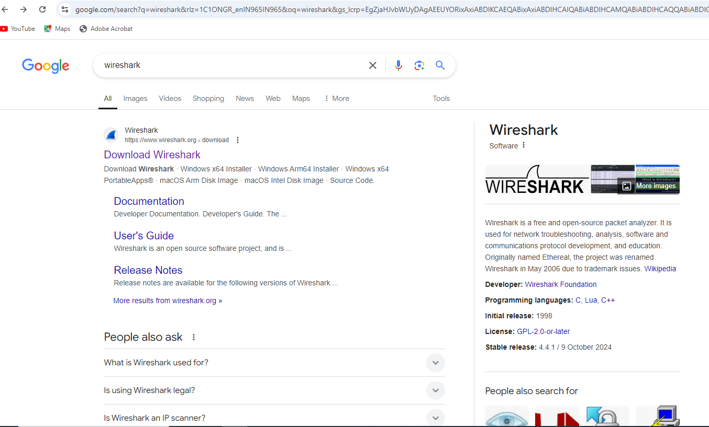

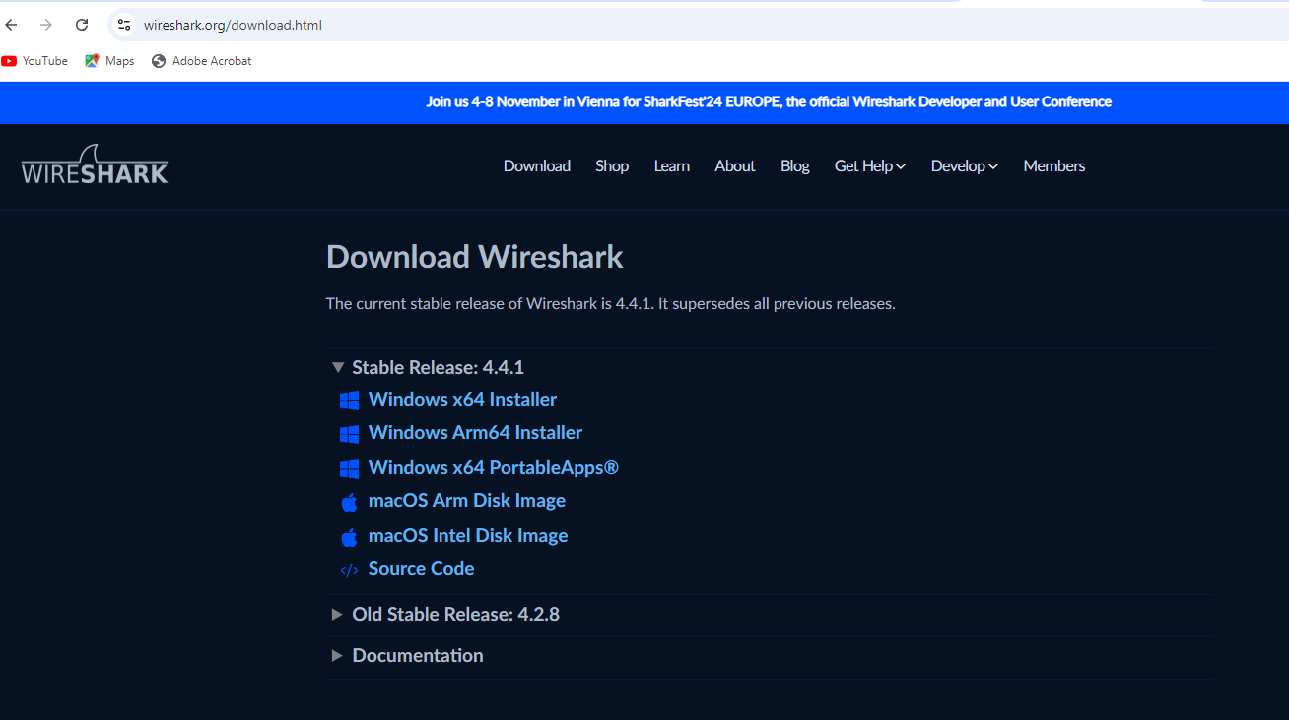

What is Wireshark?
- Open source network analyzer application.
- Can sniff and analyze network traffic.
- Network Traffic = Data packets sent over the network
What is Data Packet?
A data packet is a tiny unit of information that travels across a network.
Think of it as a letter in the mail. Just like a letter has an envelope with an address and content inside, a data packet has a header containing addressing information and the actual data payload.
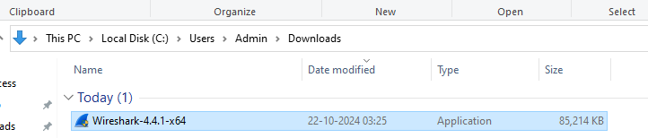
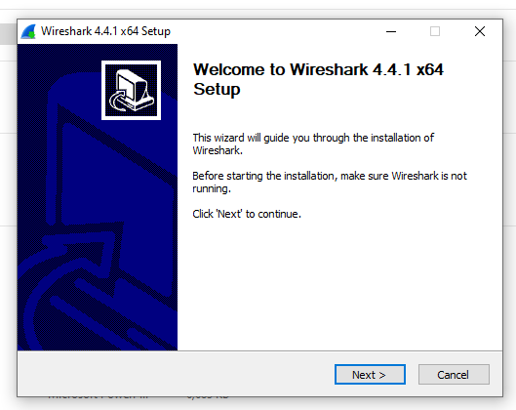
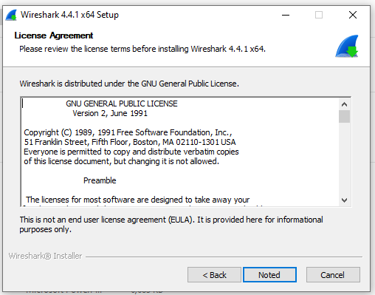
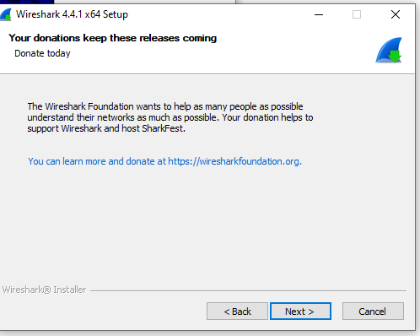

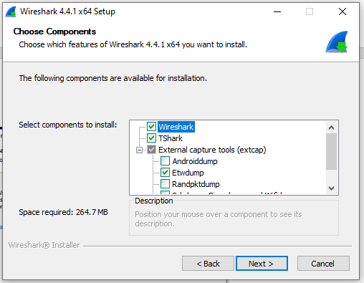

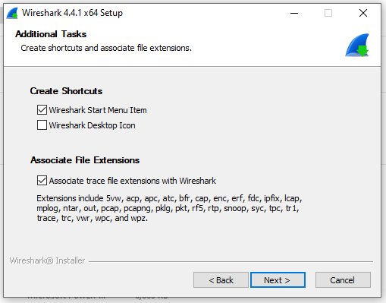
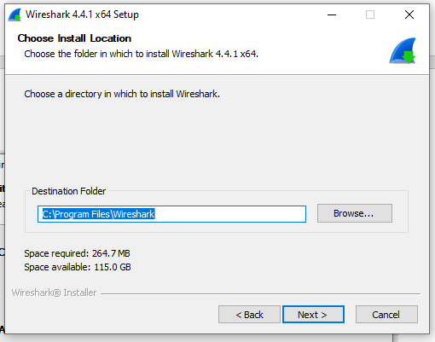

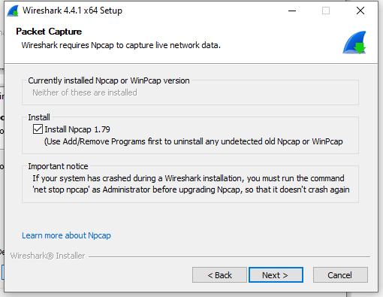
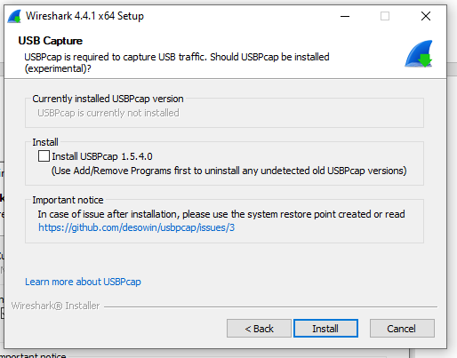
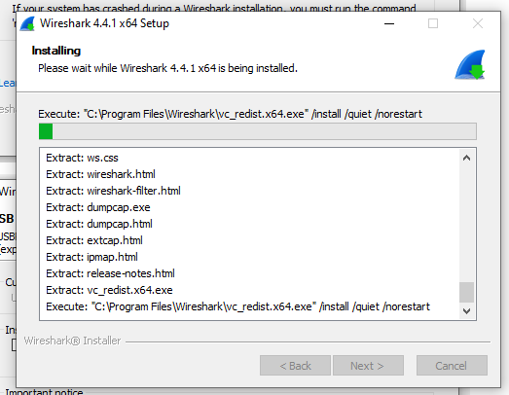
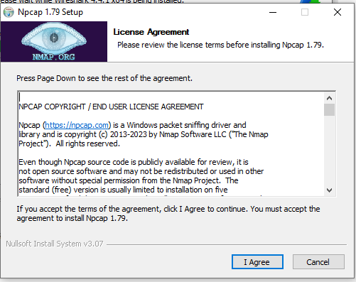
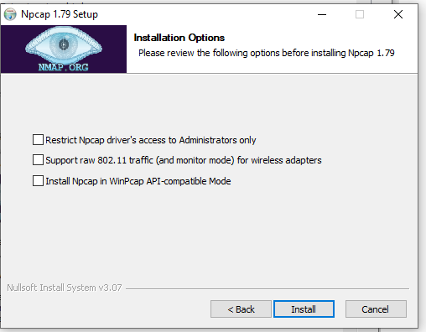
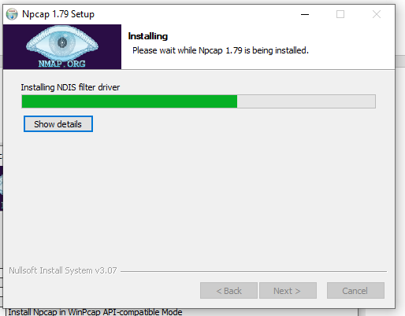
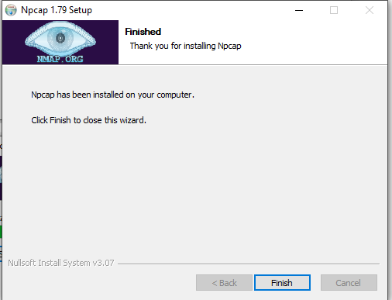
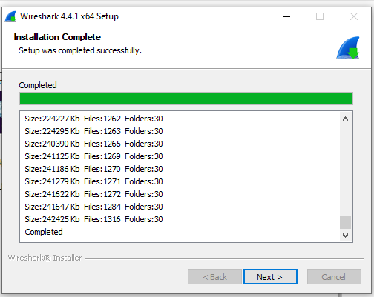
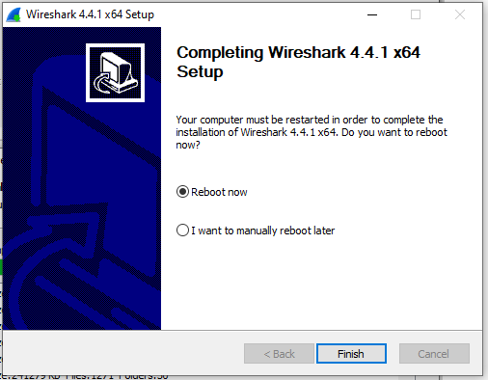

How Wireshark app will look like:
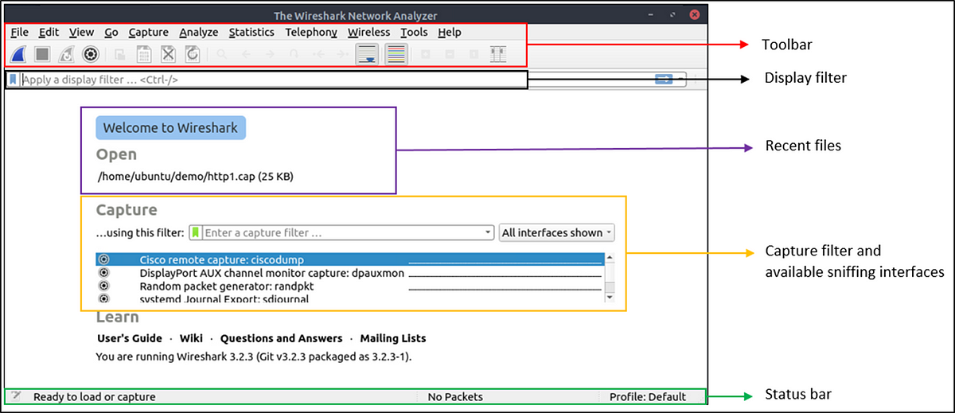

Open Wireshark app
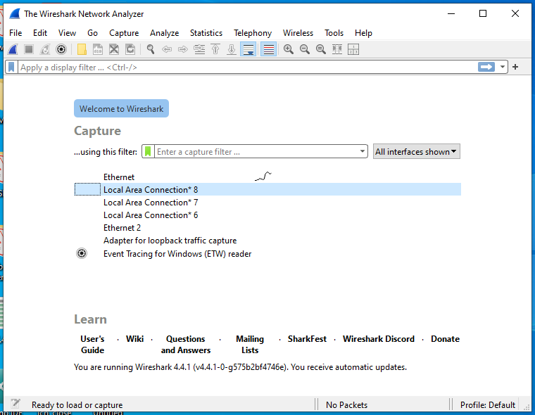
Traffic on ehternet
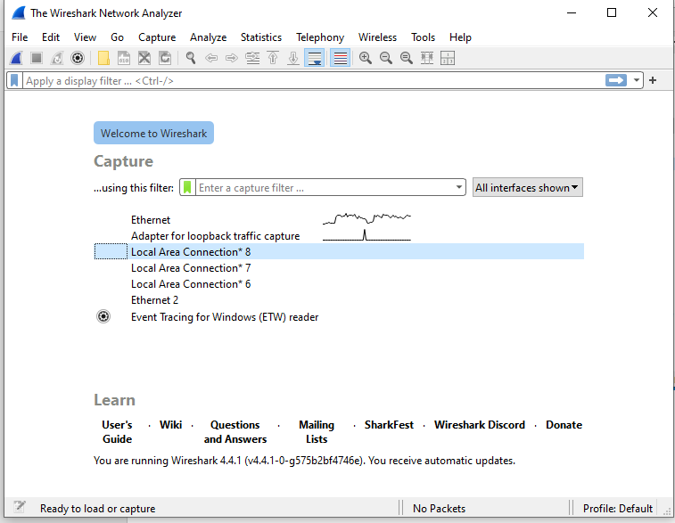

- Packet Capture Using Wire Shark

Click on Capture option in tool bar
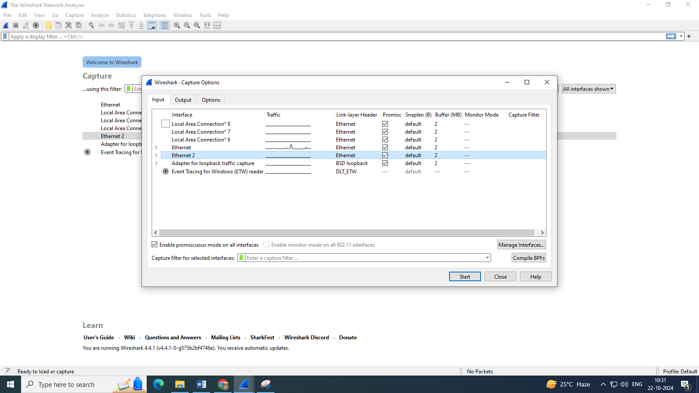

Click on Start to capture the packets
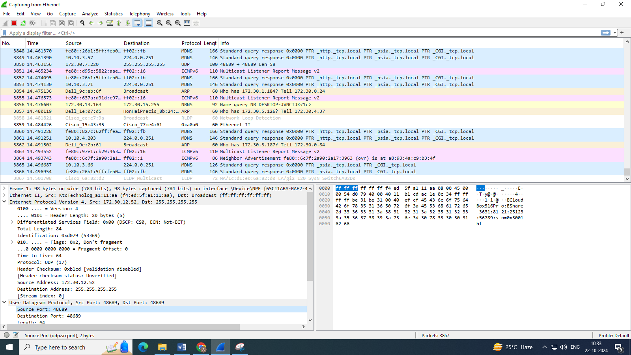
If you want to select a particular protocol like TCP, UDP then
In Apply filter bar, type tcp or udp etc…, those packets only will be captured
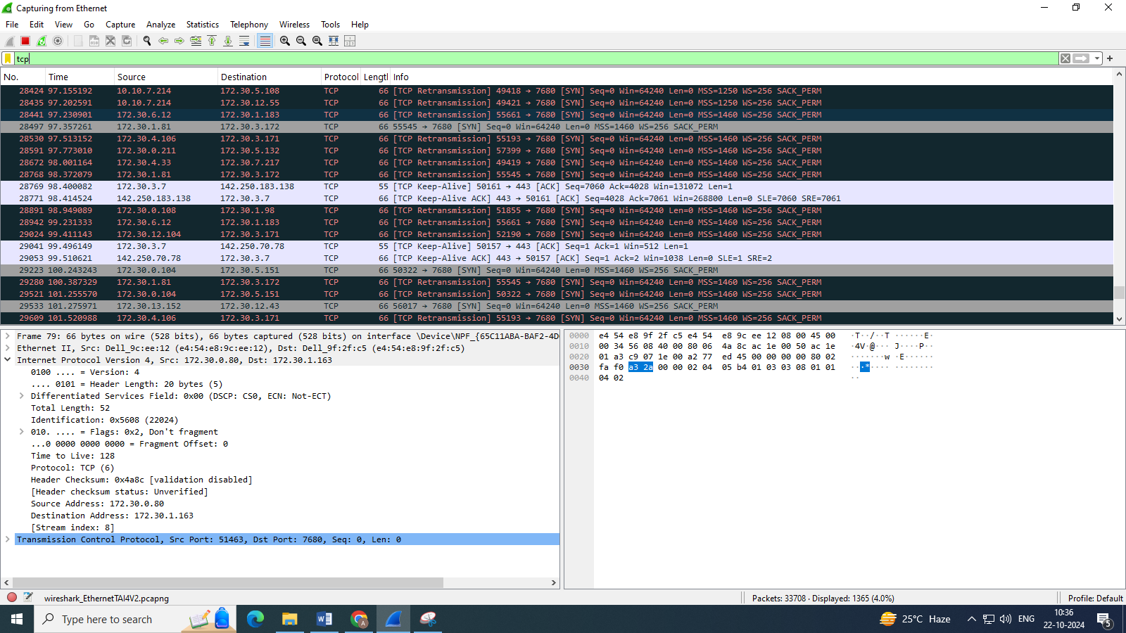
To stop capturing – click on stop button (red button) on tool bar
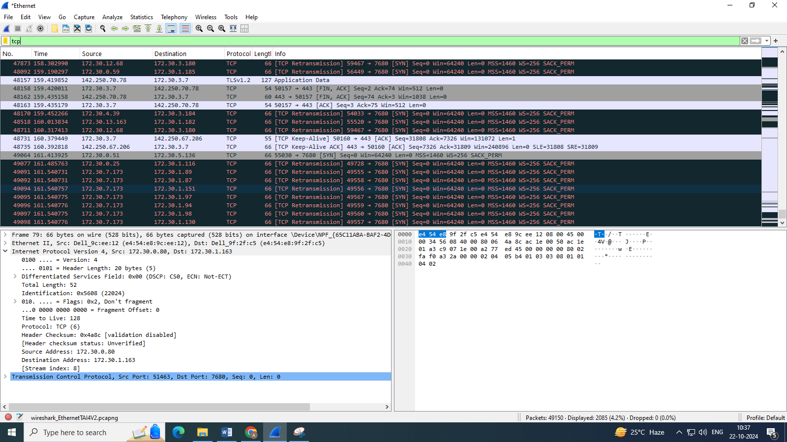

- Starting Wire shark.
Go to start menu – Open Wireshark app
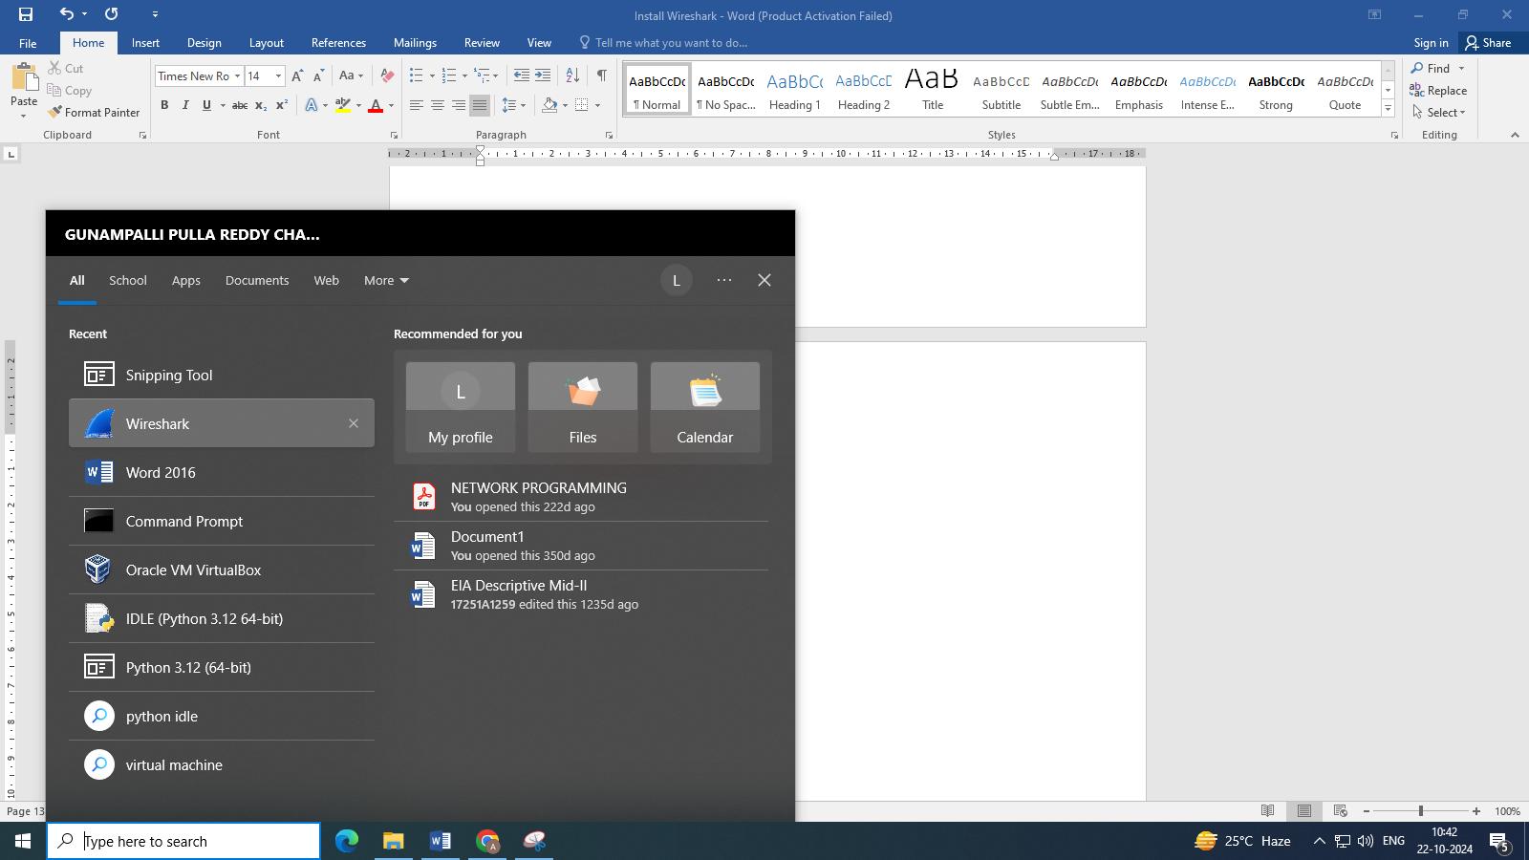

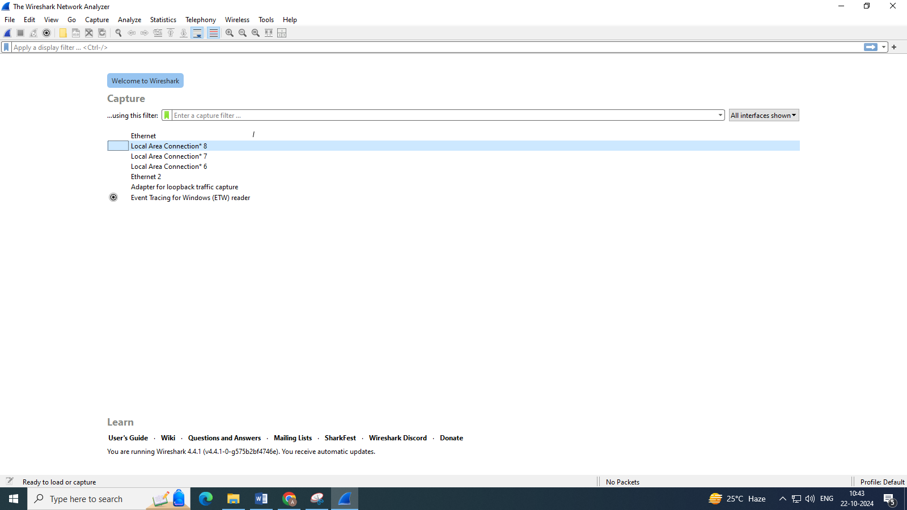

- Viewing Captured Traffic.
- The first window box is called the packet listing window which lists all the packets that are captured in the traffic.
- The second window box (bottom left) is packet header-detailed window. It contains detailed information about the components of packets.
- The bottom window (Bottom right) is calls packet contents window, which displays the content in ASCII and hexadecimal format.
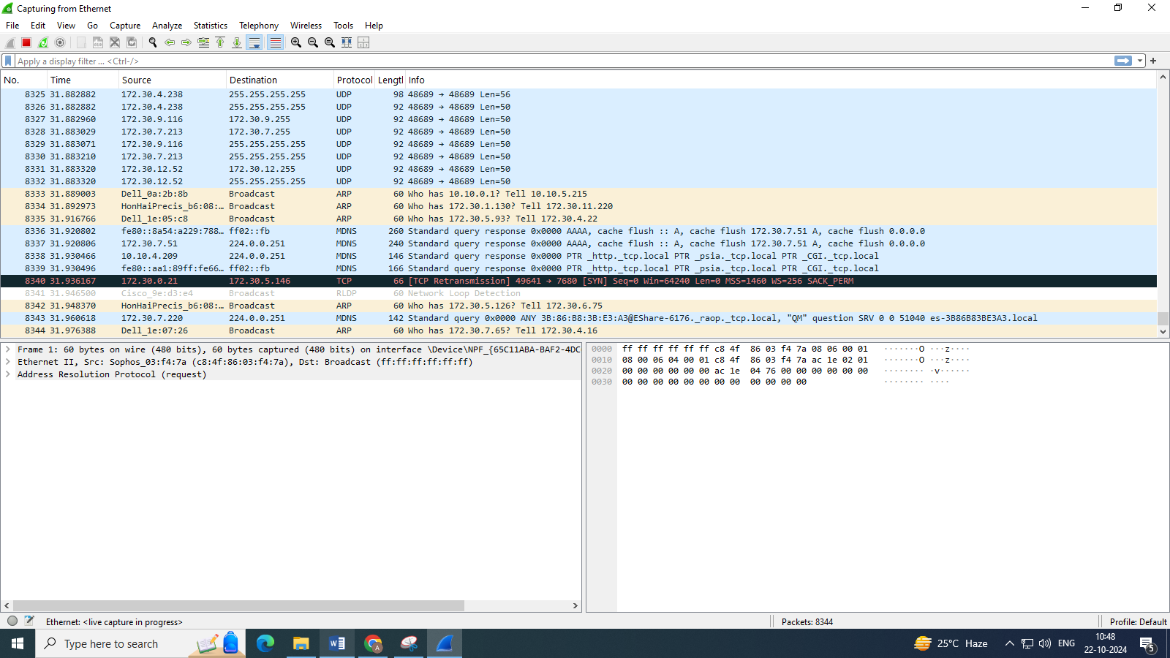

- Analysis and Statistics & Filters
Go to Analyze in menu bar – click on Display Filters
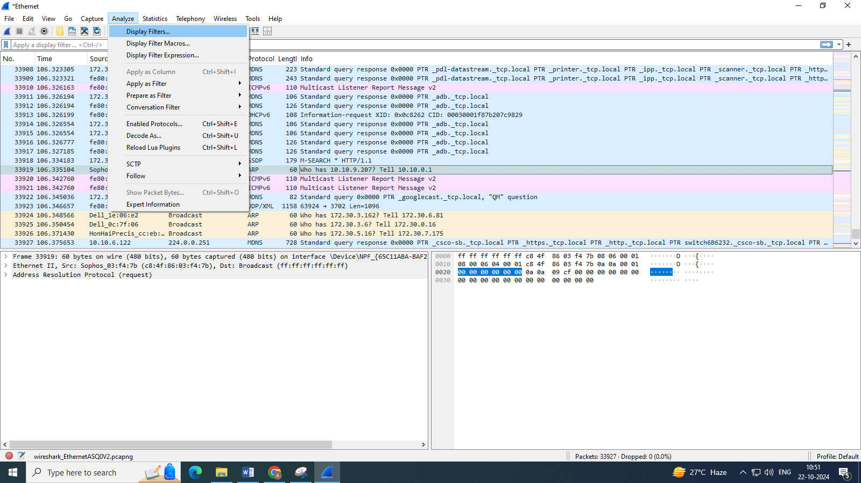
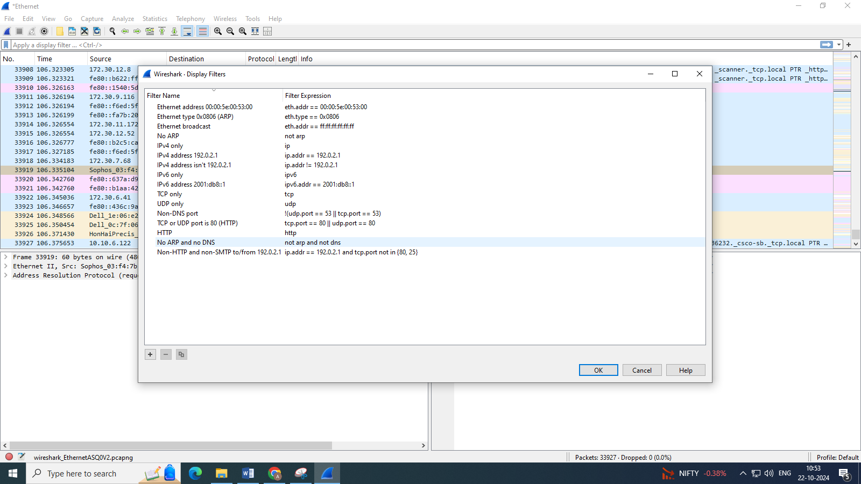
There is filter block below the tool bar, from where a large amount of data can be filtered. The above pictures lists all the filters available to apply.
For Eg: If we apply a filter for HTTP (TCP or UDP etc..) , only the interfaces with the http will be listed.
Then click on blue arrow at right side of the filter bar
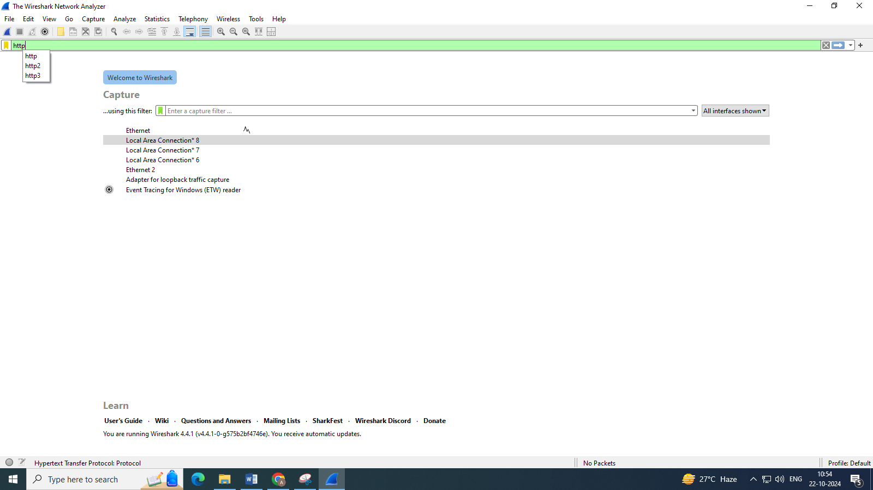

In HTTP, no packets are transmitting here
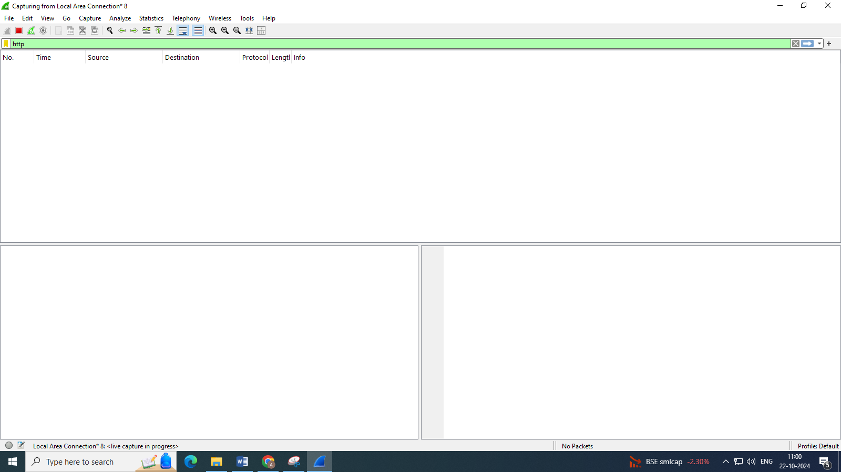
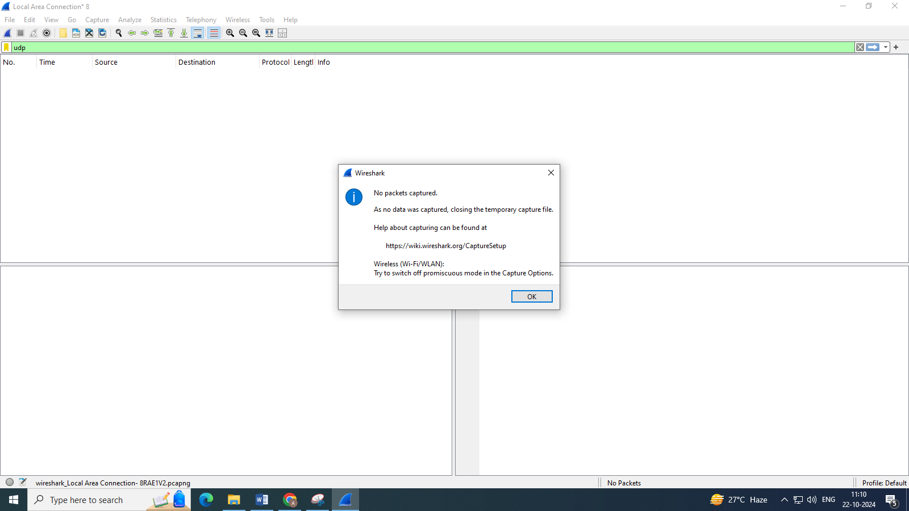

Now try with UDP
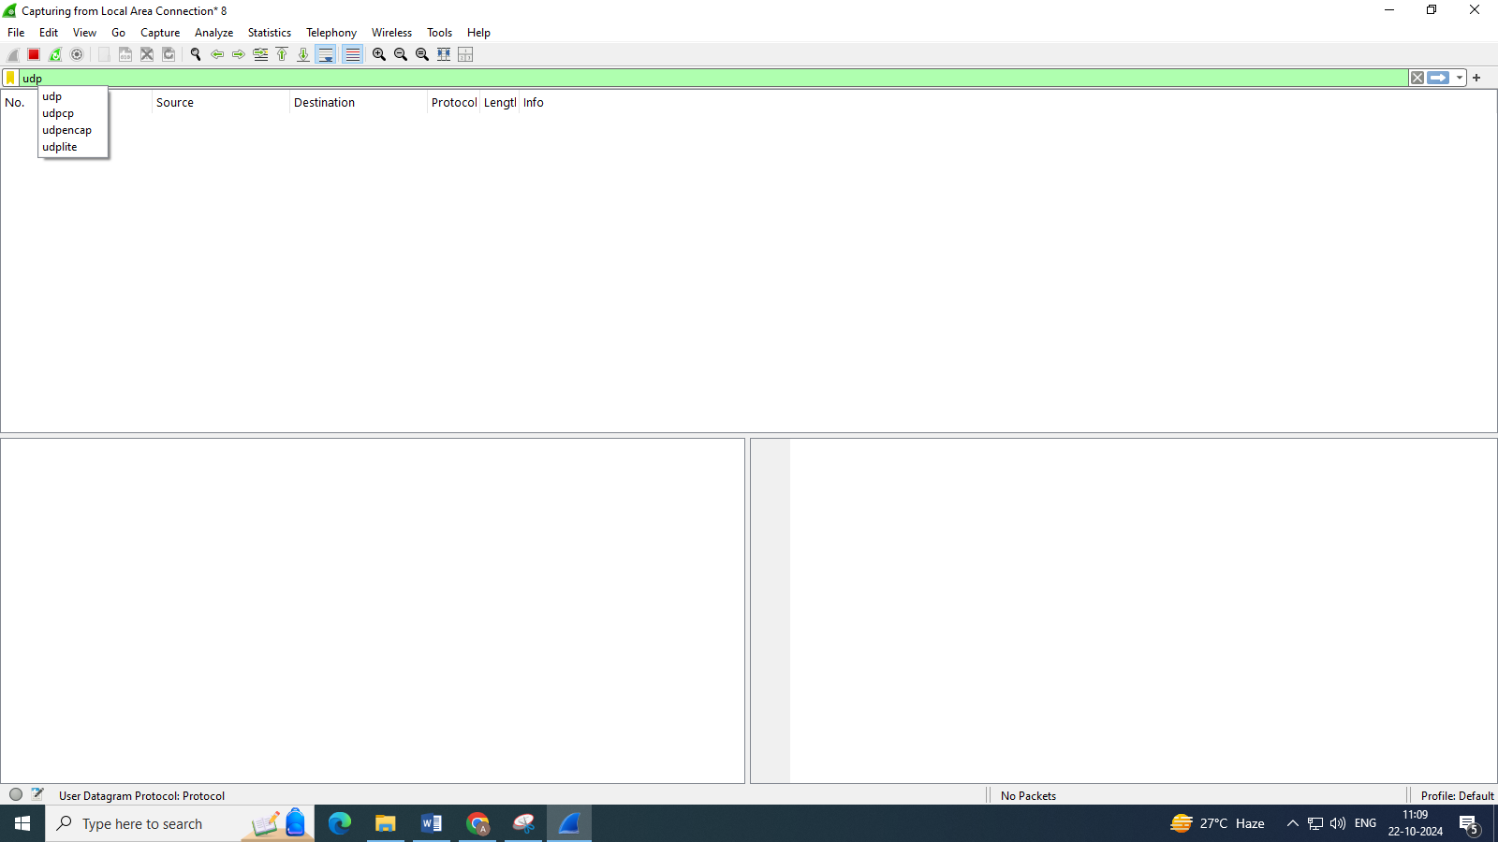
Go to statistics capture file properties to get the detailed analysis and statistics of the captured.
Open any capture filter like Ethernet
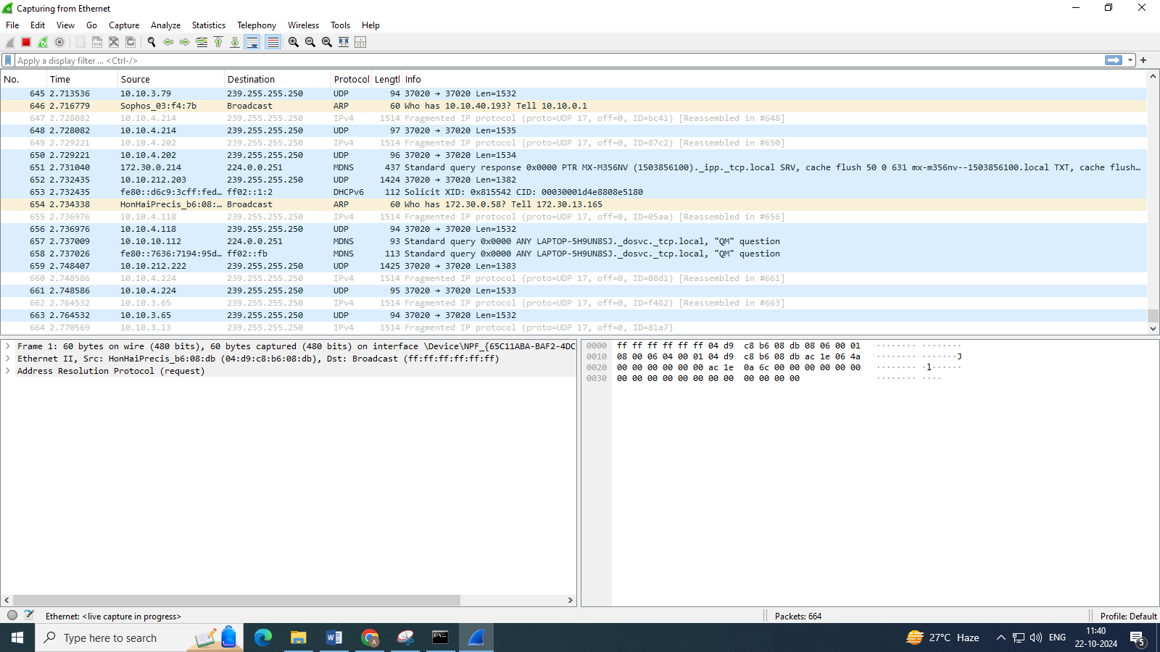
Now go to statistics on menu bar click on capture filter properties
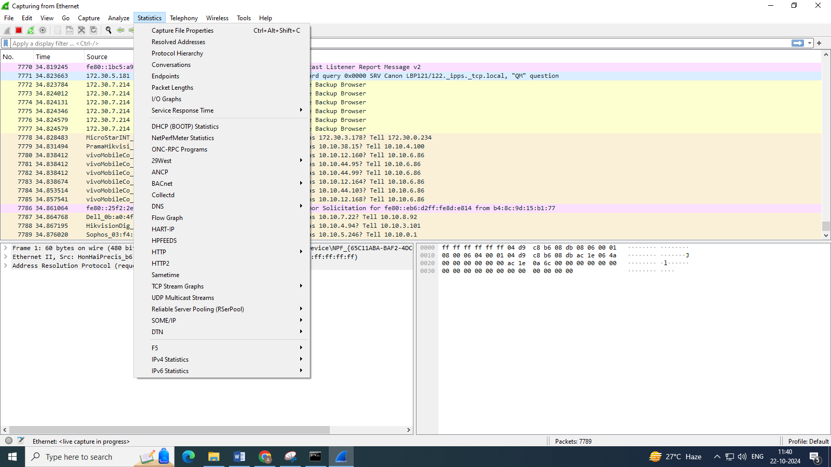

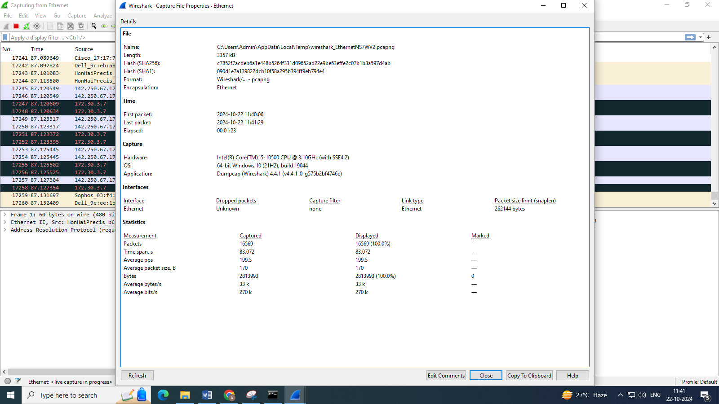

Go to statistics Conservations to get the conversational data i.e., the sender’s address, the receiver’s address, number of packets transferred etc..)
